DEEP HOUSE BIBLE — LOS ANGELES
Dark Ads Performance Report
26 Mar 2026 – 6 May 2026 · Objective: Traffic (Landing Page Views) · Event: Sat 6 Jun 2026, Gin Ling Way, Los Angeles

CAMPAIGN OVERVIEW
TOTAL SPEND | LPVs | IMPRESSIONS | REACH | FREQ | CPM | CTR (LINK)
$1,471.16 | 6,458 | 188,265 | 98,192 | 1.92 | $7.81 | 3.94%

TOTAL CLICKS | LINK CLICKS | CPC (ALL) | CPC (LINK) | COST / LPV
11,334 | 7,426 | $0.13 | $0.20 | $0.23

AD SET BREAKDOWN
AD SET | STATUS | SPEND | LPVs | COST/LPV | IMPR | REACH | FREQ | CLICKS | CPM | CTR
Prospecting - high end artists - 21-45 | ACTIVE | $256.77 | 1,085 | $0.24 | 34,548 | 26,118 | 1.32 | 1,992 | $7.43 | 3.54%
Host Pages - 21-45 | ACTIVE | $251.88 | 970 | $0.26 | 33,386 | 22,756 | 1.47 | 1,810 | $7.54 | 3.30%
no targets - 21-45 | ACTIVE | $229.58 | 1,217 | $0.19 | 26,178 | 19,685 | 1.33 | 1,798 | $8.77 | 5.42%
Host Pages Adv - 21-45 | ACTIVE | $185.42 | 848 | $0.22 | 20,807 | 14,402 | 1.44 | 1,344 | $8.91 | 4.65%
Prospecting - streaming - 21-45 | ACTIVE | $164.06 | 783 | $0.21 | 22,556 | 18,150 | 1.24 | 1,500 | $7.27 | 4.15%
Prospecting - electronic - 21-45 | ACTIVE | $149.77 | 717 | $0.21 | 20,599 | 16,273 | 1.27 | 1,358 | $7.27 | 4.18%
Prospecting - high end artists - 21-45 | INACTIVE | $125.27 | 505 | $0.25 | 16,556 | 13,421 | 1.23 | 885 | $7.57 | 3.12%
no targets - 21-45 – ugc edits | INACTIVE | $42.47 | 169 | $0.25 | 5,065 | 4,663 | 1.09 | 289 | $8.38 | 4.21%
Retargeting - 21-45 | ACTIVE | $36.40 | 63 | $0.58 | 4,203 | 1,972 | 2.13 | 152 | $8.66 | 1.78%
Prospecting - fashion - 21-45 | INACTIVE | $29.54 | 101 | $0.29 | 4,367 | 4,002 | 1.09 | 206 | $6.76 | 2.50%

CREATIVE BREAKDOWN — GROUPED BY CONCEPT
Aggregated across all ad sets and audience targets. Sorted by spend. Green cost/LPV = at or below $0.22 benchmark.
CREATIVE | SPEND | LPVs | COST/LPV | IMPR | REACH | CLICKS | LINK CLK | CPM | CTR | STATUS
Vid 2 - AS | $1,032.02 | 5,147 | $0.20 | 128,718 | 100,126 | 9,092 | 5,990 | $8.33 | 4.65% | ACTIVE
Artwork - AS | $153.75 | 352 | $0.44 | 24,509 | 21,530 | 558 | 408 | $6.24 | 1.66% | ACTIVE
Vid 1 - AS | $132.09 | 552 | $0.24 | 16,722 | 14,385 | 927 | 585 | $7.91 | 3.50% | ACTIVE
Vid 3 - AS | $72.99 | 238 | $0.31 | 8,855 | 7,559 | 404 | 252 | $8.41 | 2.85% | ACTIVE
Promo - DHB | $44.08 | 87 | $0.51 | 5,108 | 2,908 | 190 | 95 | $8.79 | 1.86% | ACTIVE
Vid 4 - AS | $36.23 | 82 | $0.44 | 4,353 | 3,934 | 163 | 93 | $8.98 | 2.14% | ACTIVE

CREATIVE PREVIEWS — click image to open ad preview
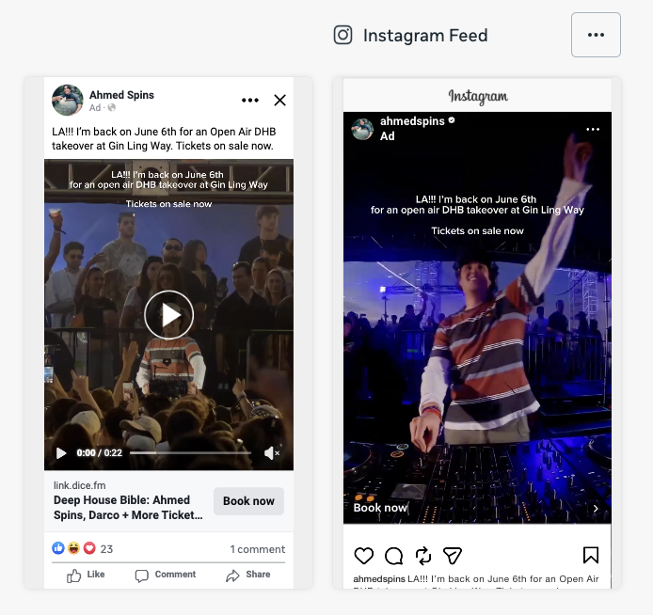 | Vid 2 - AS  Page: Ahmed Spins · ACTIVE  SPEND LPVs COST/LPV IMPRESSIONS  $1,032.02 5,147 $0.20 128,718  REACH CLICKS CPM CTR  100,126 9,092 $8.33 4.65%  View Ad Preview →

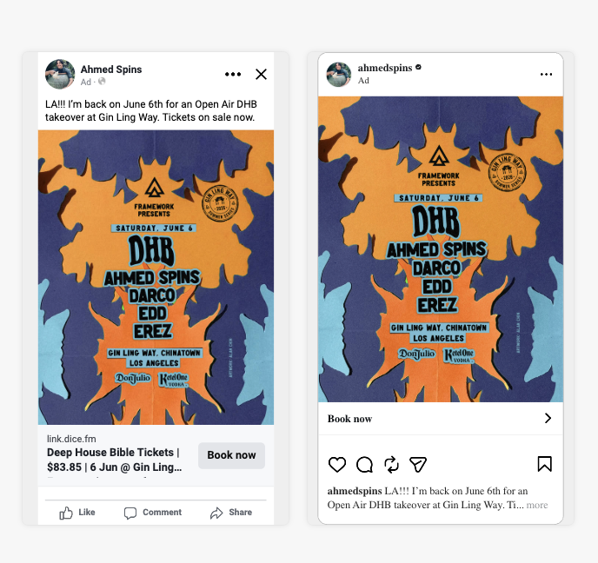 | Artwork - AS  Page: Ahmed Spins · ACTIVE  SPEND LPVs COST/LPV IMPRESSIONS  $153.75 352 $0.44 24,509  REACH CLICKS CPM CTR  21,530 558 $6.24 1.66%  View Ad Preview →

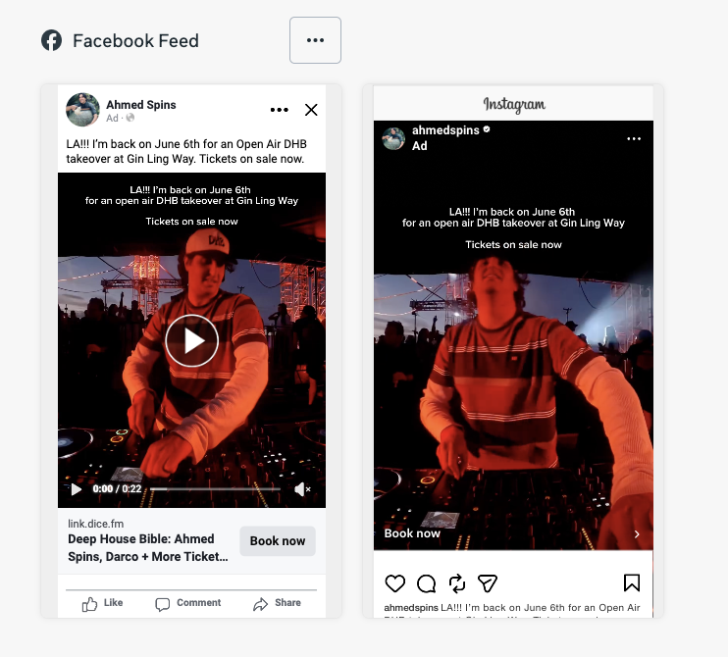 | Vid 1 - AS  Page: Ahmed Spins · ACTIVE  SPEND LPVs COST/LPV IMPRESSIONS  $132.09 552 $0.24 16,722  REACH CLICKS CPM CTR  14,385 927 $7.91 3.50%  View Ad Preview →

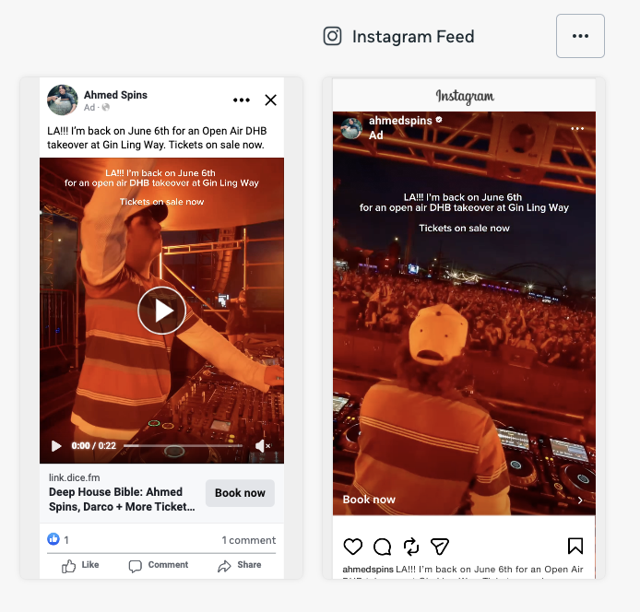 | Vid 3 - AS  Page: Ahmed Spins · ACTIVE  SPEND LPVs COST/LPV IMPRESSIONS  $72.99 238 $0.31 8,855  REACH CLICKS CPM CTR  7,559 404 $8.41 2.85%  View Ad Preview →

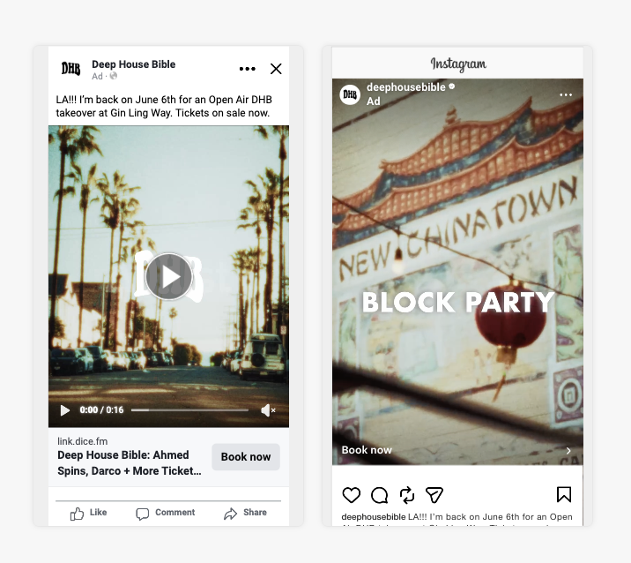 | Promo - DHB  Page: Deep House Bible · ACTIVE  SPEND LPVs COST/LPV IMPRESSIONS  $44.08 87 $0.51 5,108  REACH CLICKS CPM CTR  2,908 190 $8.79 1.86%  View Ad Preview →

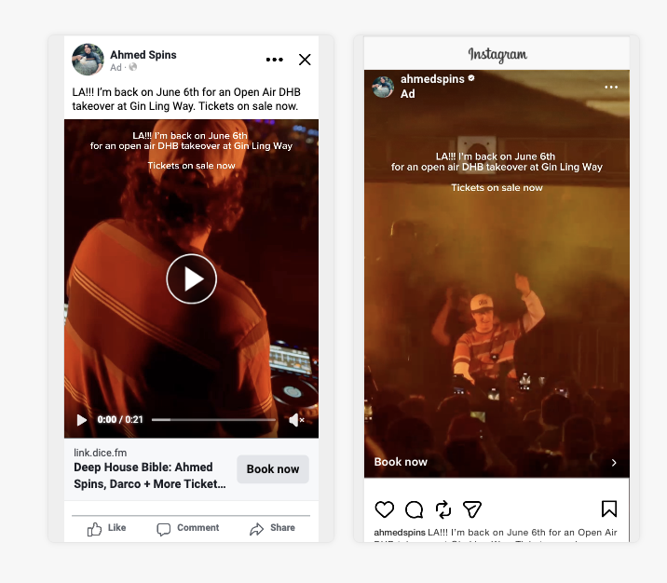 | Vid 4 - AS  Page: Ahmed Spins · ACTIVE  SPEND LPVs COST/LPV IMPRESSIONS  $36.23 82 $0.44 4,353  REACH CLICKS CPM CTR  3,934 163 $8.98 2.14%  View Ad Preview →

KEY OBSERVATIONS
— Campaign has delivered 6,458 landing page views at $0.23 cost per LPV — strong performance against a $0.25–0.35 benchmark for event traffic in the US.
— Vid 2 - AS is the dominant creative, taking 70% of total spend and generating the highest volume of LPVs. Clear signal to keep scaling.
— Best efficiency: Vid 2 - AS at $0.20 cost per LPV — lowest cost among creatives with meaningful volume (50+ LPVs).
— CPM of $7.81 and link CTR of 3.94% are both healthy for a US market traffic campaign targeting a niche music audience.
— Retargeting ad set spent $36.40 at $0.58 cost/LPV — higher CPL is expected at this scale for warm audiences.
— No audience fatigue — frequency sits at 1.92 across the campaign, well within healthy range. All active ad sets continue to deliver.

Report prepared by Off/Pixel · Data: Meta Ads Manager · Period: 26 Mar – 6 May 2026 · No purchase or ROAS tracking active on this campaign.

