St. Thomas EV Battery Plant
Volkswagen has committed to developing a new $7 billion dollar electric vehicle battery plant in St. Thomas, the largest EV related investment in Canadian history. The plant will create 3,000 direct jobs and up to 30,000 indirect jobs. Expected completion in 2027. Plant is expected to produce batteries for up to one million vehicles per year. Construction expected to begin next year.
The government of Ontario has committed to provide $500 million in direct incentives to Volkswagen, as well as hundreds of millions of additional funds to strengthen and grow St. Thomas. Included in the infrastructure improvements is the expansion of Highway 3 from two to four lanes; a four lane bypass will be built to connect to Highway 4, allowing for direct access to Highway 401.
Approximate 800 acre land assembly purchased by the City of St. Thomas in September 2022. The site is south of Ron McNeil Line, east of Highbury Avenue South.
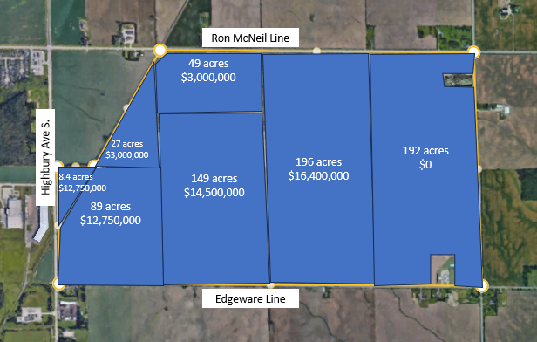

Average purchase price per acre was $335,000. Note one parcel of 192 acres sold for $0, which if looking at the entire land assembly, would impact cost per acre.

Comparable Land Sales:
A separate parcel adjacent to the subject site is currently under contract for $300,000 per acre. Approximately 66 acres, sale price of $20,055,000.

South of the 800 acre land assembly sales, also to the City of St. Thomas:
103 acres $13,119,113 sold Sept 29, 2022 - $127,000 per acre
100 acres $6,542,705, sold Sept 28, 2022 - $65,000 per acre
102 acres $7,637,865 sold Sept 28, 2022 - $74,881 per acre

