L-shape domain

Strong formulation
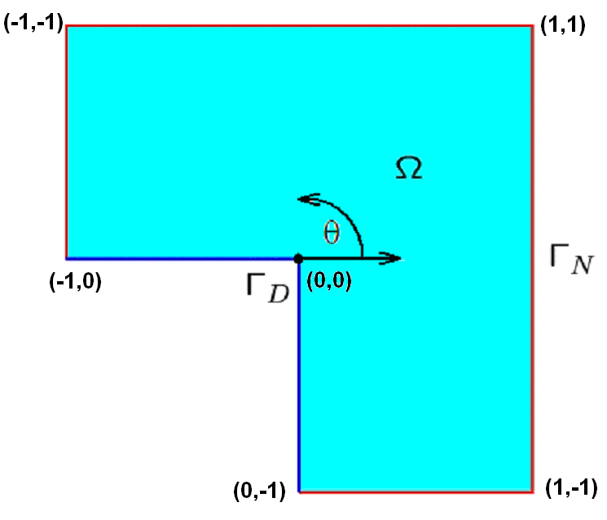
 is defined as [-1,1]x[-1,1] \ [-1,0]x[-1,0] (L-shape domain)
Dirichlet boundary 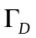 is denoted by blue color
Neumann boundary 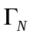 is denoted by red colour

We seek for temperature scalar field
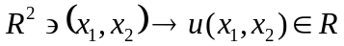 where 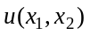 denotes temperature at point 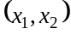.
The strong formulation concerns the heat transfer equation
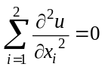 over
(equivalent short notation 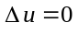)
We introduce the following boundary conditions:
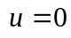 on (zero temperature oper Dirichlet boundary)
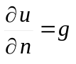 on (derivative in the norma direction is prescribed by g function)
where
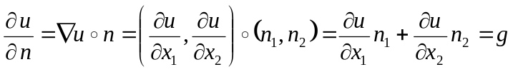
where 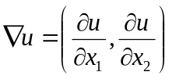 is a gradient and 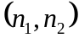 are components of the normal vector;
for example on the bottom of the domain – over (0,-1)-(1,-1) we have
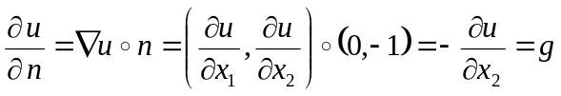
where g is a function defined in polar system of coordinates with the origin at point (0,0)
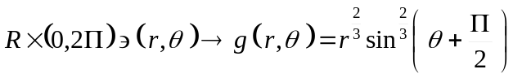

Weak formulation
We get the weak formulation by taking L2 scalar produkt with so called test functions v

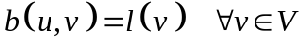
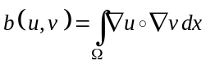 (in other words 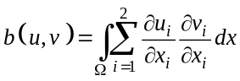 )
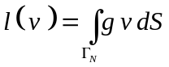
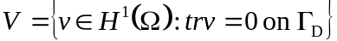

Finie element method
We partition into Finie elements (in this example into three elements E1,E2,E3)
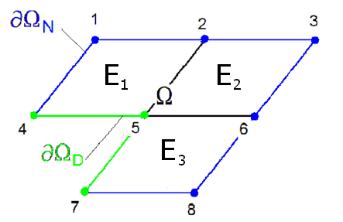
with the following basis functions (p=1)
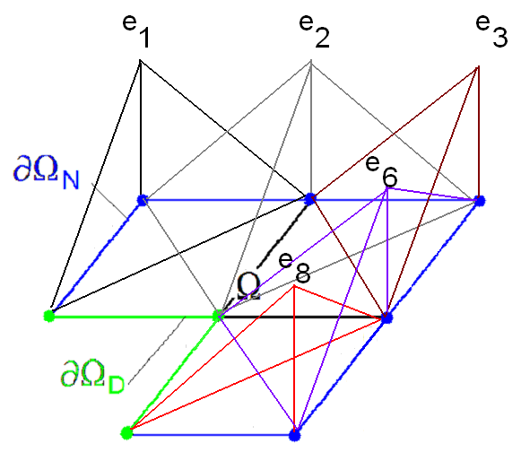
we also generate the system of equations:

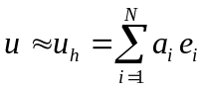
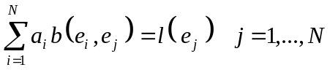
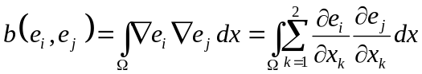
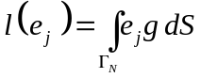
The Dirichlet boundary condition is enforced by setting rows and columns related to notes 4, 5 and 7 to zero.
Some observations necessary for efficient implementation of the algorithm
1. We introduce the following four shape functions over each element (here for p=1)
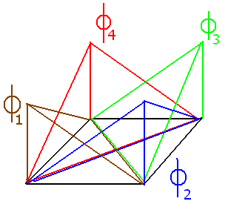
Each basis functions is a sum of one or two shape functions 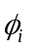
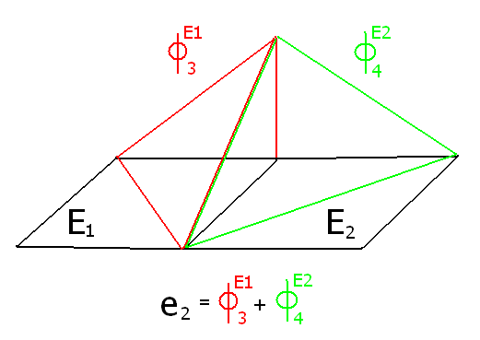
(for example basis function e2 consists of the third shape function over element E1, and fourth basis function over element E2)

2. How can we compute the formula for such arbitrary shape function ?
We introduce so called master element 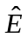 = [0,1]x[0,1] and define template shape functions over the element
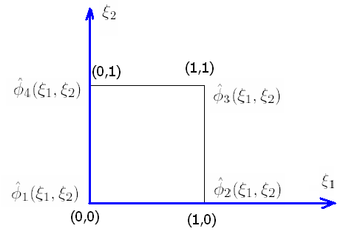
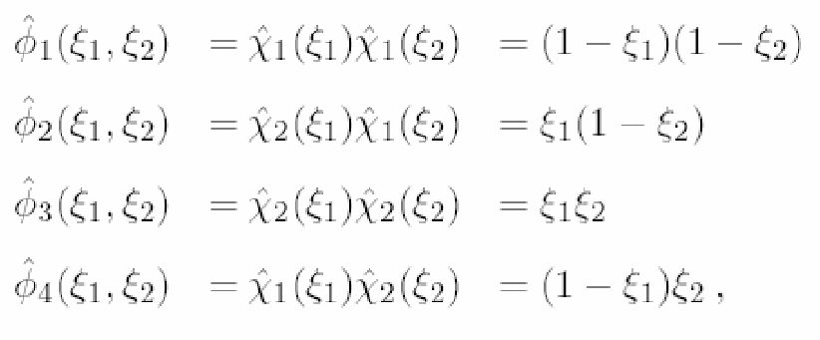
where
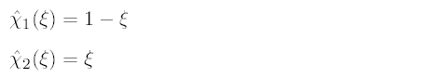

Each rectangular element E can be prescribed by its location (b₁,b₂) as well as its length and height (a₁,a₂)
For example the three exemplary elements E1, E2, E3 are defined as
E1: (b₁,b₂) = (-1,0); (a₁,a₂)=(1,1)
E2: (b₁,b₂) = (0,0); (a₁,a₂)=(1,1)
E3: (b₁,b₂) = (0,-1); (a₁,a₂)=(1,1)

We define the mapping from master element into arbitrary element E
and the reverse mapping
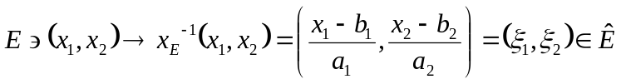
In other words
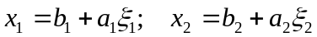
and
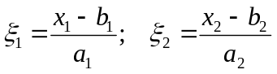
We can prescribe formule for arbitrary shape function , i=1,2,3,4 by using the map x_{E}⁻¹
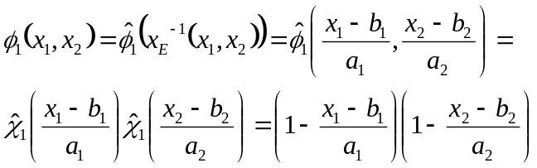
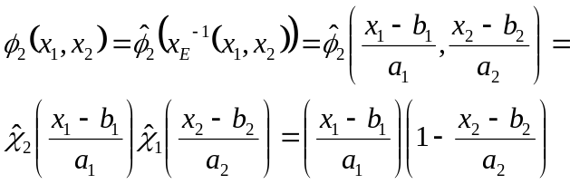
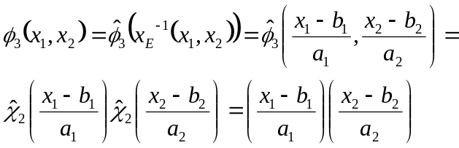
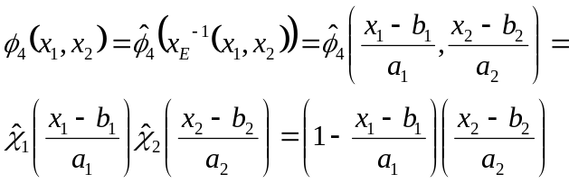

3. The integrals can be partitions according to elements
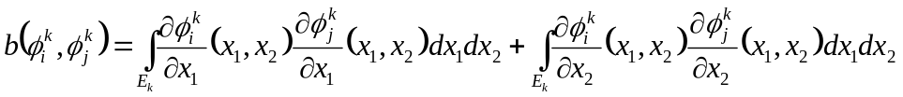
For the first order approximation it is only necessary to take the value at the center of element and the area of the element (a₁*a₂)
In other words
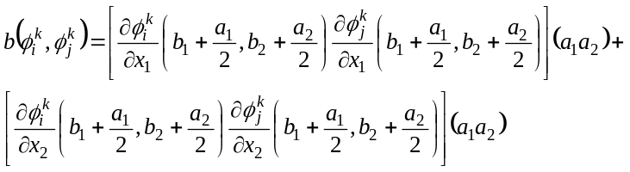
The derivatives 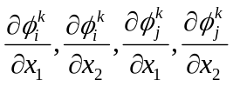 are constant and equal to +/-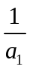 or +/-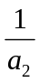,
depending on the function and the direction of the integration.
4. The integral
is assembled into proper row and column of the global matrix.
B(i1,j1)+=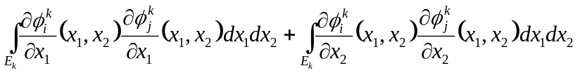
How can we translate i and j into the global row i1 and column j1?
According to the scheme – each row (column) of the matrix is related to one coefficient a_{i} of one basis function e_{i}
In other words (red color denotes the shape functions 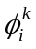 over elements k=1,2,3,4,
black color denotes coresponding basis functions e_{i} = row number / column number in the matrix)
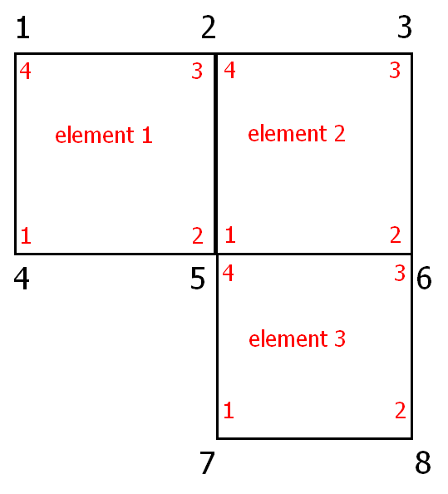
5. Integral over the boundary 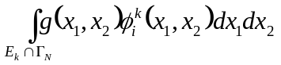
We need to check whether edges of a given element 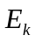 are located on the Neumann boundary .
If the given edge is located on the Neumann boundary, then we need to add the integral over the edge to the right hand side
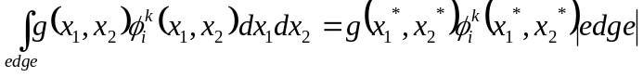
where
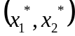 is the point from the centem of the edge
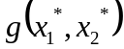 is the function value at the point
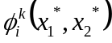 is the value of the shape function at the point (always equal to ½ or 0)
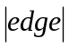 is the length of the edge

Sequential algorithm for global system generation

B(1:8,1:8)=0 (creation of the matrix)
L(1:8)=0 (creation of the right hand side)
Loop with respekt to elements 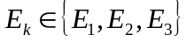
Loop wrt functions of element , 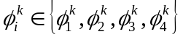
i1 = row of the matrix related with
L(i1)+=
Loop wrt functions 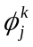 of element , 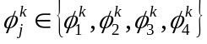
j1 = column of the matrix related with
B(i1,j1)+=
End of loop over functions
End of loop over functions
End of loop over elements
B(4,1:8)=0 (enforcing Dirichlet b.c. at node 4)
B(5,1:8)=0 (enforcing Dirichlet b.c. at node 5)
B(7,1:8)=0 (enforcing Dirichlet b.c. at node 7)
L(4)=0 (enforcing Dirichlet b.c. at node 4)
L(5)=0 (enforcing Dirichlet b.c. at node 5)
L(7)=0 (enforcing Dirichlet b.c. at node 7)
B(4,4)=1 (1 on diagonal at row 4)
B(5,5)=1 (1 on diagonal at row 5)
B(7,7)=1 (1 on diagonal at row 7)

Call frontal solver algorithm for
Ba=L
Get the solution a={a1,...,a8} for

