14/04/2023

The display: inline-block Value

Compared to display: inline, the major difference is that display: inline-block allows to set a width and height on the element.

Also, with display: inline-block, the top and bottom margins/paddings are respected, but with display: inline they are not.

Compared to display: block, the major difference is that display: inline-block does not add a line-break after the element, so the element can sit next to other elements.

Elimino display inline block en la nav bar para usar flexbox.

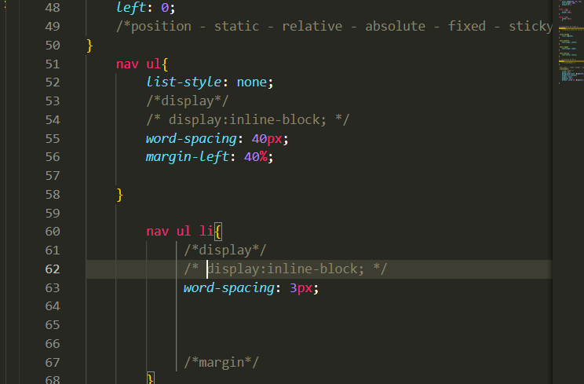

Le agrego a la nav flexbox.

Luego le agrego al nav ul flexbox para separar el logo de la navegación.