Supplementary Material: Longitudinal associations of platelet activation phenotypes with frailty and physical performance in older adults living at high southern latitudes
Atenea Uribe-Ojeda¹, Matías Castillo-Aguilar¹, Ruby Méndez Muñoz¹, Diego Mabe-Castro¹, Antonia Cornejo Soto¹, Pedro Delgado-Floody², Pablo Valdés-Badilla^{3,4}, Jordan Hernandez-Martinez^{5,6}, Cristian Núñez-Espinosa^{1,7}*
¹ Escuela de Medicina, Universidad de Magallanes, Punta Arenas, Chile
² Department of Physical Education, Sport and Recreation, Universidad de La Frontera, Temuco 4811230, Chile. pedro.delgado@ufrontera.cl
³ Department of Physical Activity Sciences, Faculty of Education Sciences, Universidad Católica del Maule, Talca 3460000, Chile. valdesbadilla@gmail.com
⁴ Sports Coach Career, Faculty of Life Sciences, Universidad Viña del Mar, Viña del Mar 2520000, Chile
⁵ Department of Physical Activity Sciences, Universidad de Los Lagos, Osorno 5290000, Chile
⁶ Departamento de Educación, Facultad de Humanidades, Universidad de la Serena, La Serena 1700000, Chile
⁷ Red Interuniversitaria de Envejecimiento Saludable de Latinoamérica y Caribe (RIES-LAC)
* Corresponding author
Cristian Núñez-Espinosa, Escuela de Medicina, Universidad de Magallanes, Punta Arenas, Chile. Centro Asistencial de Docencia e Investigación CADI-UMAG, Chile. e-mail: cristian.nunez@umag.cl. Address: Avenida Bulnes 01855, Box 113-D. Phone: +56 61 13 2201411.

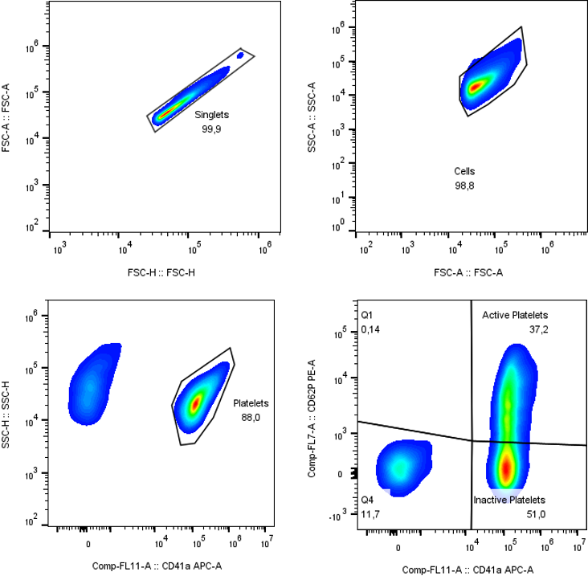
Figure S1. Representative gating for platelet phenotypes. Gating strategy used to identify platelets and their distribution according to CD41 and CD62 expression. Gates were sequentially applied to singlets, cells, and active and inactive platelets. A minimum of 50,000 total events were acquired per sample, of which 40,000 corresponded to CD41+ cells. The upper-right quadrant corresponds to CD41+ CD62+ cells.
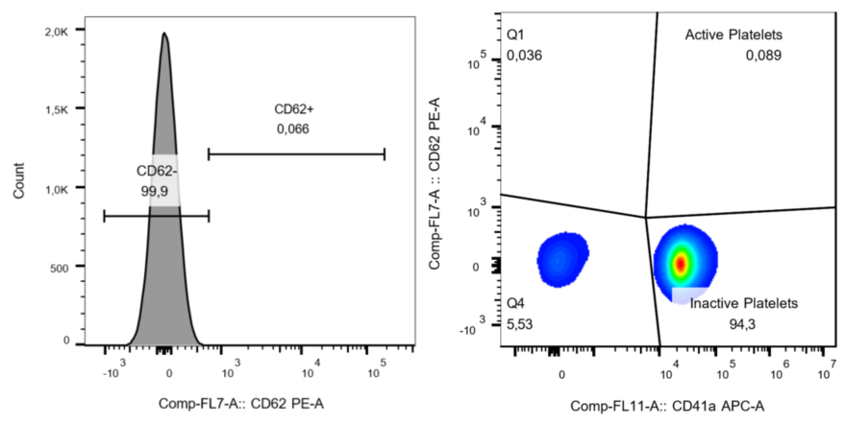
Figure S2. Representative FMO control for platelet phenotypes. The CD62-positive population was selected based on the parameters and gating strategy established using the fluorescence-minus-one (FMO) control.
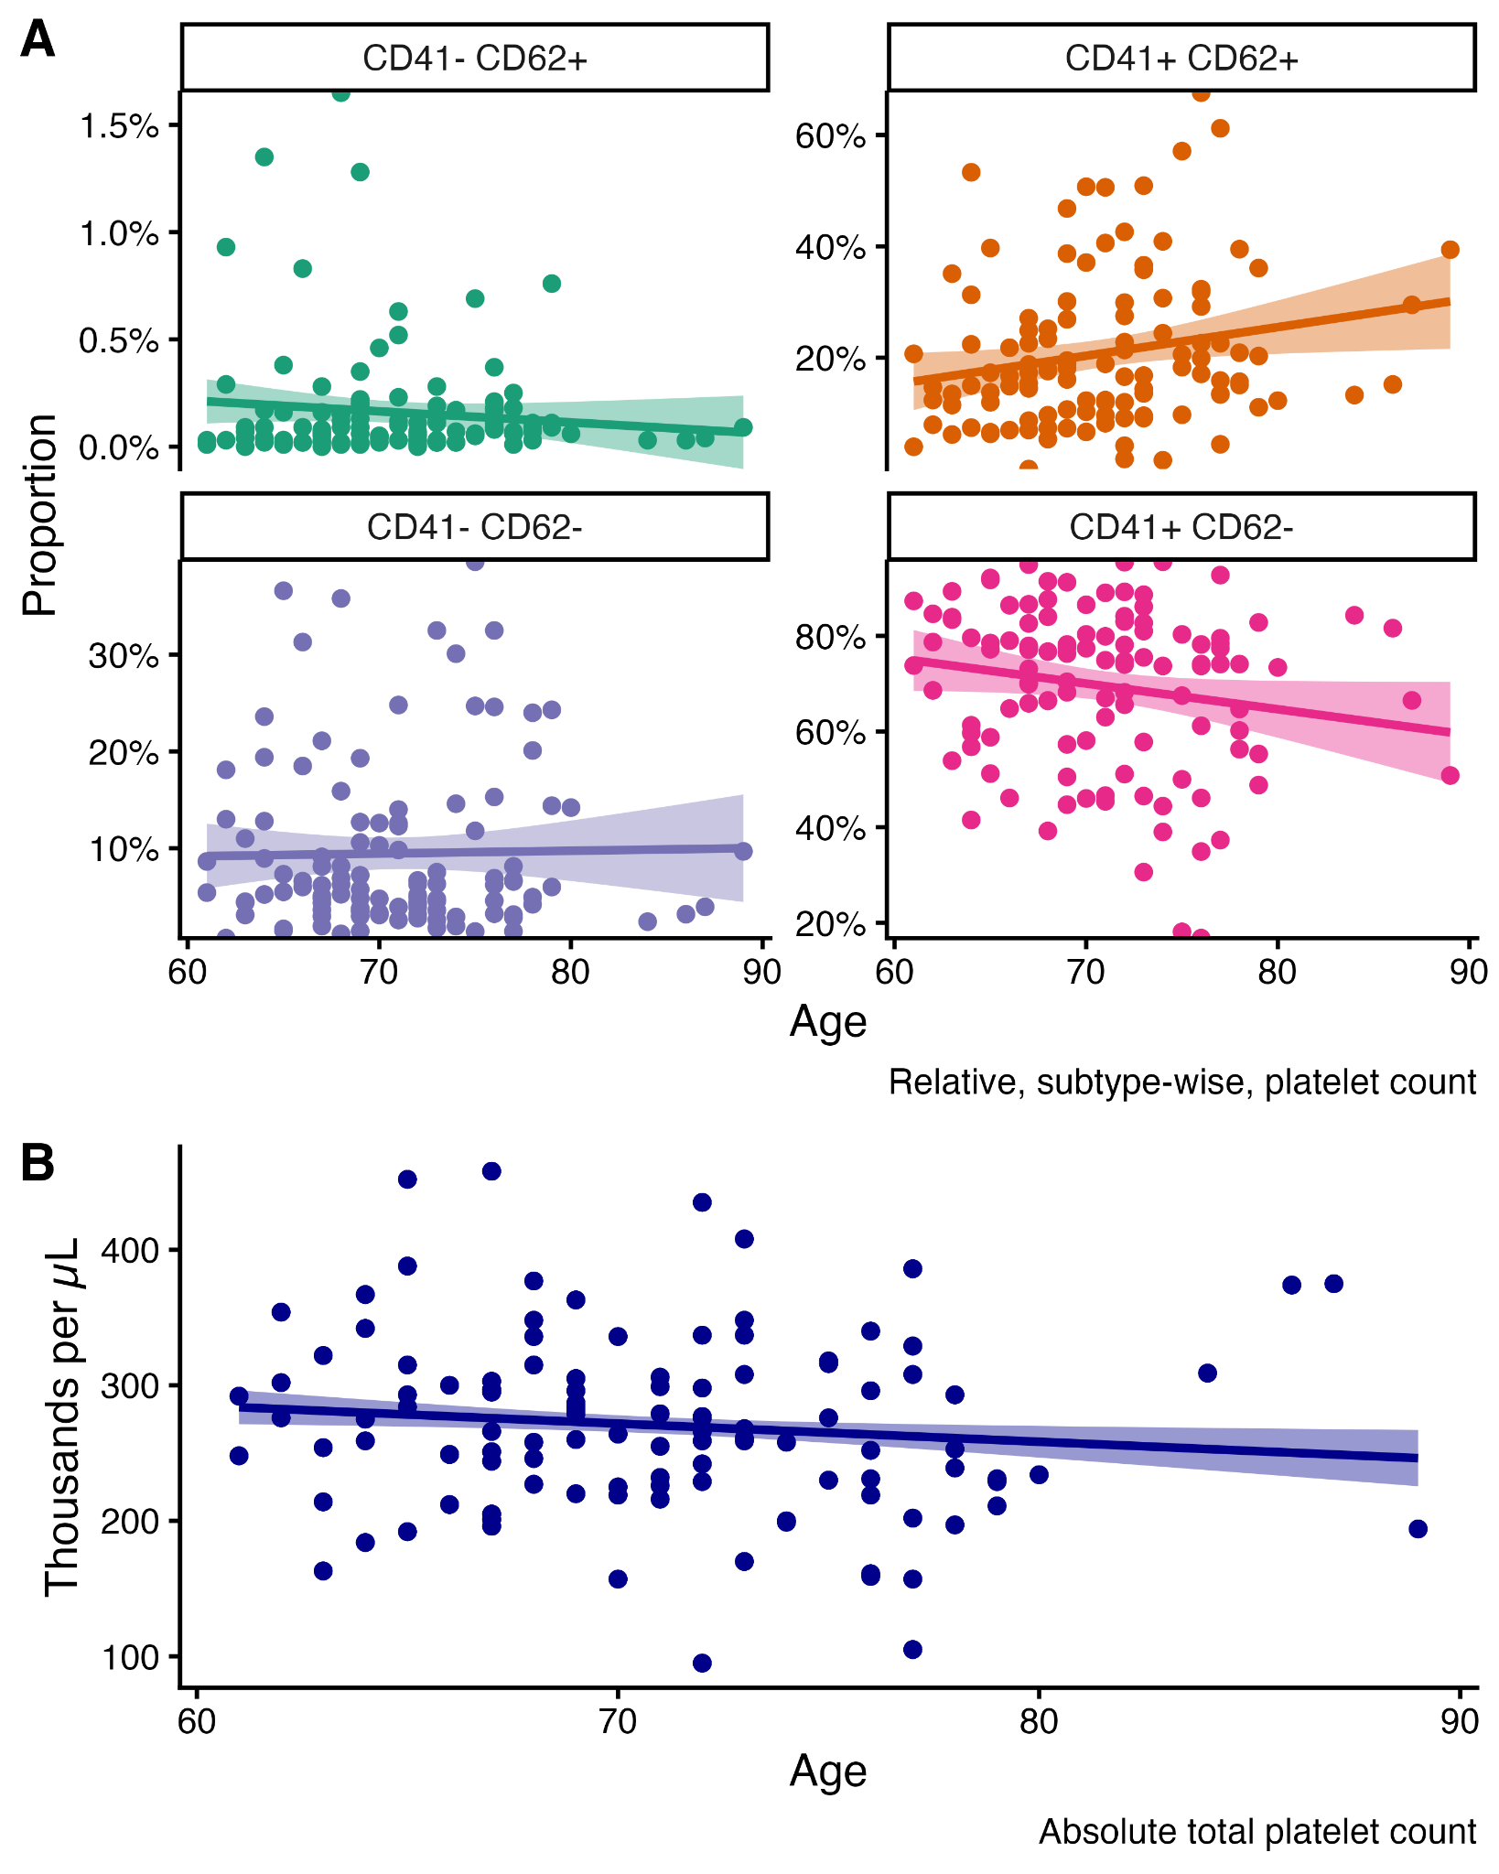
Figure S3. Relationship between platelet subtypes, absolute platelet counts and chronological age. A, Dispersion plot between platelet proportions according to CD41 and CD62 expression and chronological age of the subjects. B, Dispersion plot between absolute platelet counts and chronological age of the subjects. The line displayed in each plot corresponds to the best fit according to ordinary least squares regression. Finally, the empirical, non-parametric, bivariate correlation (Spearman’s method) for the upper panel (A) between age and platelets are the following for CD41-CD62+, rho = 0.08, p-value = 0.383; CD41+CD62+, rho = 0.22, p-value = 0.017; CD41-CD62-, rho = 0.00, p-value = 0.977; CD41+CD62-, rho = -0.18, p-value = 0.057. Moreover, for absolute platelet counts the correlation with age was rho = -0.14, p-value = 0.003.
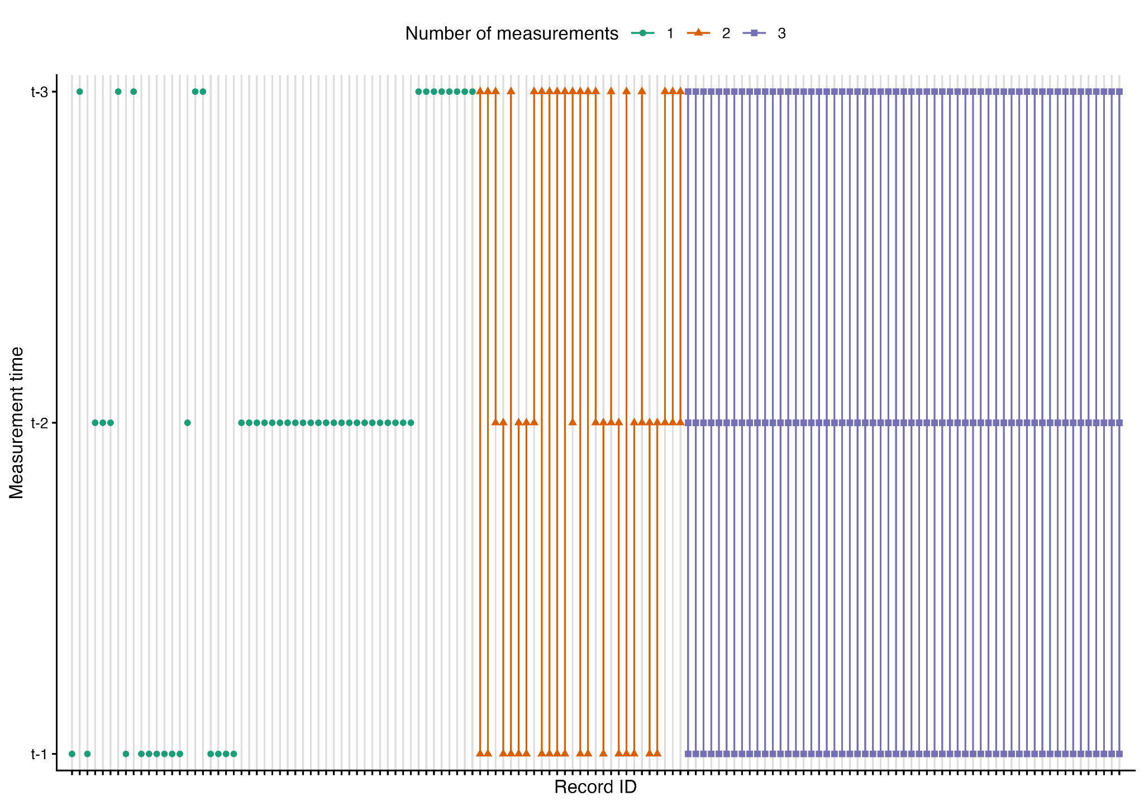
Figure S4. Patient-level measurement plot.Lollipop plot showcasing the individual level measurement across stages. The complete record of subjects spans 137 participants. Assessments per timestamp: baseline, n = 88; 6-months, n = 101; 1-year, n = 89; Unique assessments: one, n = 53, two, n = 27 and three, n = 57, of whom 42 were male and 95 were female.
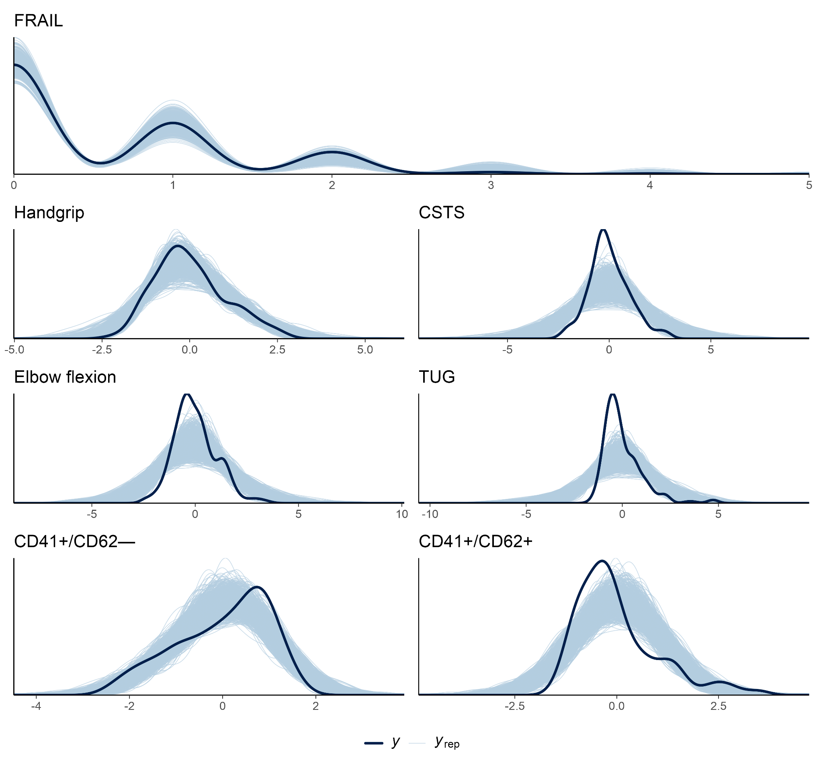
Figure S5. Posterior predictive check for the fitted models. The solid line represents the observed data (y), while the lighter lines represent simulated datasets (y_{rep}) drawn from the posterior predictive distribution for each model and submodel.
1. Model parameters and convergence diagnostics
In this section we present the complete list of model parameter coefficients and convergence diagnostics for each dependent and independent variable in Table S1. Moreover, additional models including the total number of platelets as an independent variable is shown in Table S2.
Table S1. Model parameters from adjusted multivariate models. Estimates and 95% credible intervals (CI) correspond to the median and 95% highest density interval of the posterior distribution of model parameters. Parameter estimates are on standardized scales for both dependent and independent variables. Convergence and diagnostics of posterior distributions are presented as effective sample size (ESS) and potential scale reduction factor (R-hat) for each parameter estimate. BMI, body mass index.

Response | Parameter | Estimate | 95% CI | pd | ps | BF | ESS | R-hat
CD41+CD62+ | Intercept | -0.02 | [-0.18, 0.13] | 0.613 | 0.160 | 0.03 | 11834.3 | 1.000
CD41+CD62+ | Time [Linear] | -0.24 | [-0.46, -0.03] | 0.985 | 0.897 | 0.38 | 20087.2 | 1.000
CD41+CD62+ | Time [Quadratic] | -0.19 | [-0.41, 0.04] | 0.949 | 0.776 | 0.15 | 17485.5 | 1.000
CD41+CD62- | Intercept | 0.01 | [-0.11, 0.14] | 0.587 | 0.091 | 0.02 | 10256.3 | 1.000
CD41+CD62- | Time [Linear] | -0.96 | [-1.14, -0.79] | 1.000 | 1.000 | 6293.71 | 18117.4 | 1.000
CD41+CD62- | Time [Quadratic] | -0.48 | [-0.65, -0.3] | 1.000 | 1.000 | 6496.08 | 16769.0 | 1.000
Chair sit-to-stand | Age | -0.09 | [-0.22, 0.05] | 0.898 | 0.428 | 0.05 | 10409.5 | 1.000
Chair sit-to-stand | BMI | -0.36 | [-0.5, -0.22] | 1.000 | 1.000 | 4065.58 | 17533.0 | 1.000
Chair sit-to-stand | CD41+CD62+ | 0.78 | [-0.23, 1.54] | 0.936 | 0.915 | 0.70 | 796.2 | 1.004
Chair sit-to-stand | CD41+CD62- | 1.13 | [0.19, 1.91] | 0.984 | 0.978 | 2.45 | 1069.9 | 1.001
Chair sit-to-stand | Intercept | 0.29 | [-0.01, 0.59] | 0.974 | 0.901 | 0.35 | 16600.4 | 1.000
Chair sit-to-stand | Sex [Female] | -0.29 | [-0.58, 0] | 0.975 | 0.899 | 0.32 | 19403.8 | 1.000
Chair sit-to-stand | Time [Linear] | 1.29 | [0.49, 2.05] | 0.997 | 0.995 | 7.36 | 2202.0 | 1.000
Chair sit-to-stand | Time [Linear] x Age | -0.02 | [-0.17, 0.12] | 0.629 | 0.153 | 0.03 | 27475.7 | 1.000
Chair sit-to-stand | Time [Linear] x BMI | -0.14 | [-0.28, 0] | 0.974 | 0.716 | 0.17 | 30287.4 | 1.000
Chair sit-to-stand | Time [Linear] x CD41+CD62+ | 0.21 | [-0.01, 0.42] | 0.971 | 0.840 | 0.23 | 16218.1 | 1.000
Chair sit-to-stand | Time [Linear] x CD41+CD62- | 0.29 | [0, 0.57] | 0.972 | 0.899 | 0.33 | 14689.9 | 1.000
Chair sit-to-stand | Time [Linear] x Sex [Female] | 0.08 | [-0.23, 0.39] | 0.695 | 0.449 | 0.06 | 27794.0 | 1.000
Chair sit-to-stand | Time [Quadratic] | 0.54 | [-0.02, 1.08] | 0.970 | 0.943 | 0.63 | 2791.8 | 1.000
Chair sit-to-stand | Time [Quadratic] x Age | 0.03 | [-0.1, 0.16] | 0.683 | 0.151 | 0.02 | 27277.2 | 1.000
Chair sit-to-stand | Time [Quadratic] x BMI | -0.10 | [-0.23, 0.03] | 0.937 | 0.521 | 0.07 | 26677.5 | 1.000
Chair sit-to-stand | Time [Quadratic] x CD41+CD62+ | 0.00 | [-0.28, 0.27] | 0.495 | 0.244 | 0.05 | 6461.6 | 1.000
Chair sit-to-stand | Time [Quadratic] x CD41+CD62- | -0.01 | [-0.39, 0.38] | 0.528 | 0.336 | 0.07 | 5494.3 | 1.000
Chair sit-to-stand | Time [Quadratic] x Sex [Female] | 0.18 | [-0.11, 0.46] | 0.891 | 0.705 | 0.10 | 23308.9 | 1.000
Elbow flexion test | Age | -0.11 | [-0.25, 0.02] | 0.948 | 0.578 | 0.08 | 15305.5 | 1.000
Elbow flexion test | BMI | -0.12 | [-0.26, 0.02] | 0.955 | 0.619 | 0.11 | 18113.6 | 1.000
Elbow flexion test | CD41+CD62+ | 0.65 | [-0.21, 1.36] | 0.930 | 0.899 | 0.50 | 1108.6 | 1.003
Elbow flexion test | CD41+CD62- | 0.90 | [0.01, 1.64] | 0.969 | 0.955 | 1.09 | 1154.8 | 1.001
Elbow flexion test | Intercept | 0.30 | [0.01, 0.6] | 0.975 | 0.902 | 0.36 | 16551.9 | 1.000
Elbow flexion test | Sex [Female] | -0.30 | [-0.6, -0.01] | 0.978 | 0.917 | 0.41 | 20182.5 | 1.000
Elbow flexion test | Time [Linear] | 1.60 | [0.82, 2.37] | 1.000 | 1.000 | 61.31 | 2157.9 | 1.000
Elbow flexion test | Time [Linear] x Age | -0.17 | [-0.33, 0] | 0.979 | 0.788 | 0.21 | 26698.7 | 1.000
Elbow flexion test | Time [Linear] x BMI | -0.17 | [-0.34, -0.01] | 0.980 | 0.810 | 0.24 | 30278.6 | 1.000
Elbow flexion test | Time [Linear] x CD41+CD62+ | 0.23 | [-0.01, 0.48] | 0.968 | 0.857 | 0.23 | 15588.9 | 1.000
Elbow flexion test | Time [Linear] x CD41+CD62- | 0.25 | [-0.07, 0.58] | 0.937 | 0.824 | 0.17 | 13606.1 | 1.000
Elbow flexion test | Time [Linear] x Sex [Female] | -0.12 | [-0.48, 0.21] | 0.757 | 0.547 | 0.07 | 26539.8 | 1.000
Elbow flexion test | Time [Quadratic] | 0.49 | [-0.06, 1.03] | 0.961 | 0.921 | 0.47 | 2871.9 | 1.000
Elbow flexion test | Time [Quadratic] x Age | -0.01 | [-0.15, 0.15] | 0.547 | 0.116 | 0.03 | 29251.8 | 1.000
Elbow flexion test | Time [Quadratic] x BMI | -0.07 | [-0.23, 0.08] | 0.827 | 0.358 | 0.04 | 20137.9 | 1.000
Elbow flexion test | Time [Quadratic] x CD41+CD62+ | -0.04 | [-0.32, 0.23] | 0.618 | 0.344 | 0.05 | 7720.2 | 1.000
Elbow flexion test | Time [Quadratic] x CD41+CD62- | 0.12 | [-0.25, 0.49] | 0.739 | 0.548 | 0.08 | 7247.3 | 1.000
Elbow flexion test | Time [Quadratic] x Sex [Female] | -0.12 | [-0.44, 0.21] | 0.765 | 0.549 | 0.07 | 25441.7 | 1.000
FRAIL score | Age | 0.22 | [0, 0.45] | 0.974 | 0.855 | 0.24 | 14320.9 | 1.000
FRAIL score | BMI | 0.44 | [0.24, 0.66] | 1.000 | 0.999 | 83.55 | 13524.4 | 1.000
FRAIL score | CD41+CD62+ | -0.01 | [-0.35, 0.31] | 0.529 | 0.304 | 0.06 | 5464.9 | 1.000
FRAIL score | CD41+CD62- | -0.20 | [-0.63, 0.22] | 0.826 | 0.680 | 0.11 | 4698.4 | 1.000
FRAIL score | Intercept | -2.52 | [-3.04, -1.99] | 1.000 | 1.000 | 18985.82 | 9090.5 | 1.000
FRAIL score | Sex [Female] | 0.24 | [-0.27, 0.76] | 0.820 | 0.702 | 0.13 | 17511.5 | 1.000
FRAIL score | Time [Linear] | -0.30 | [-1.04, 0.5] | 0.780 | 0.697 | 0.17 | 9942.2 | 1.000
FRAIL score | Time [Linear] x Age | -0.18 | [-0.53, 0.19] | 0.838 | 0.663 | 0.09 | 21698.5 | 1.001
FRAIL score | Time [Linear] x BMI | -0.11 | [-0.42, 0.2] | 0.750 | 0.513 | 0.07 | 22422.1 | 1.000
FRAIL score | Time [Linear] x CD41+CD62+ | 0.23 | [-0.29, 0.72] | 0.815 | 0.696 | 0.13 | 9472.9 | 1.000
FRAIL score | Time [Linear] x CD41+CD62- | 0.28 | [-0.34, 0.92] | 0.812 | 0.716 | 0.16 | 7867.6 | 1.000
FRAIL score | Time [Linear] x Sex [Female] | -0.26 | [-1.01, 0.49] | 0.753 | 0.663 | 0.16 | 13477.9 | 1.000
FRAIL score | Time [Quadratic] | 0.52 | [-0.3, 1.33] | 0.897 | 0.847 | 0.29 | 7006.7 | 1.000
FRAIL score | Time [Quadratic] x Age | 0.05 | [-0.29, 0.39] | 0.611 | 0.387 | 0.06 | 22053.5 | 1.000
FRAIL score | Time [Quadratic] x BMI | -0.15 | [-0.43, 0.15] | 0.847 | 0.641 | 0.08 | 20216.6 | 1.000
FRAIL score | Time [Quadratic] x CD41+CD62+ | -0.25 | [-0.82, 0.36] | 0.788 | 0.680 | 0.14 | 4527.1 | 1.000
FRAIL score | Time [Quadratic] x CD41+CD62- | -0.58 | [-1.35, 0.26] | 0.913 | 0.870 | 0.36 | 3978.9 | 1.000
FRAIL score | Time [Quadratic] x Sex [Female] | -0.33 | [-1.07, 0.47] | 0.802 | 0.722 | 0.18 | 14993.4 | 1.000
Grip strength | Age | -0.12 | [-0.24, -0.01] | 0.984 | 0.663 | 0.20 | 15215.1 | 1.000
Grip strength | BMI | 0.01 | [-0.1, 0.12] | 0.566 | 0.060 | 0.02 | 15072.5 | 1.000
Grip strength | CD41+CD62+ | 0.23 | [-0.21, 0.62] | 0.871 | 0.740 | 0.14 | 2770.4 | 1.001
Grip strength | CD41+CD62- | 0.25 | [-0.23, 0.71] | 0.859 | 0.748 | 0.15 | 1937.5 | 1.000
Grip strength | Intercept | 1.09 | [0.86, 1.32] | 1.000 | 1.000 | 8295.81 | 14519.9 | 1.000
Grip strength | Sex [Female] | -1.51 | [-1.75, -1.27] | 1.000 | 1.000 | 8290.83 | 15066.6 | 1.000
Grip strength | Time [Linear] | 0.15 | [-0.35, 0.65] | 0.732 | 0.581 | 0.10 | 3397.9 | 1.000
Grip strength | Time [Linear] x Age | 0.06 | [-0.06, 0.2] | 0.838 | 0.289 | 0.03 | 31773.7 | 1.000
Grip strength | Time [Linear] x BMI | 0.01 | [-0.12, 0.13] | 0.563 | 0.082 | 0.02 | 35160.2 | 1.000
Grip strength | Time [Linear] x CD41+CD62+ | 0.03 | [-0.16, 0.22] | 0.628 | 0.242 | 0.03 | 14836.0 | 1.000
Grip strength | Time [Linear] x CD41+CD62- | 0.01 | [-0.25, 0.27] | 0.523 | 0.246 | 0.04 | 14316.2 | 1.000
Grip strength | Time [Linear] x Sex [Female] | 0.05 | [-0.22, 0.32] | 0.653 | 0.371 | 0.05 | 29527.9 | 1.000
Grip strength | Time [Quadratic] | 0.27 | [-0.09, 0.63] | 0.928 | 0.825 | 0.18 | 4302.9 | 1.000
Grip strength | Time [Quadratic] x Age | 0.06 | [-0.05, 0.18] | 0.863 | 0.279 | 0.04 | 30849.4 | 1.000
Grip strength | Time [Quadratic] x BMI | 0.02 | [-0.1, 0.14] | 0.632 | 0.096 | 0.02 | 28957.4 | 1.000
Grip strength | Time [Quadratic] x CD41+CD62+ | -0.05 | [-0.27, 0.17] | 0.672 | 0.336 | 0.04 | 6024.6 | 1.001
Grip strength | Time [Quadratic] x CD41+CD62- | 0.02 | [-0.3, 0.31] | 0.538 | 0.295 | 0.05 | 5545.0 | 1.000
Grip strength | Time [Quadratic] x Sex [Female] | -0.11 | [-0.36, 0.14] | 0.814 | 0.543 | 0.06 | 27720.4 | 1.000
Timed-up and go | Age | 0.27 | [0.13, 0.41] | 1.000 | 0.992 | 18.97 | 11970.9 | 1.000
Timed-up and go | BMI | 0.38 | [0.25, 0.52] | 1.000 | 1.000 | 4428.77 | 17174.6 | 1.000
Timed-up and go | CD41+CD62+ | -0.86 | [-1.6, -0.02] | 0.971 | 0.956 | 1.02 | 881.1 | 1.004
Timed-up and go | CD41+CD62- | -0.86 | [-1.59, -0.01] | 0.968 | 0.952 | 1.00 | 1229.8 | 1.000
Timed-up and go | Intercept | -0.40 | [-0.71, -0.12] | 0.996 | 0.979 | 1.60 | 14984.5 | 1.000
Timed-up and go | Sex [Female] | 0.49 | [0.2, 0.78] | 1.000 | 0.996 | 8.75 | 18523.1 | 1.000
Timed-up and go | Time [Linear] | -0.75 | [-1.47, 0] | 0.971 | 0.952 | 0.89 | 2482.6 | 1.000
Timed-up and go | Time [Linear] x Age | -0.15 | [-0.28, -0.01] | 0.987 | 0.766 | 0.25 | 31022.7 | 1.000
Timed-up and go | Time [Linear] x BMI | 0.05 | [-0.08, 0.18] | 0.795 | 0.241 | 0.03 | 33753.0 | 1.000
Timed-up and go | Time [Linear] x CD41+CD62+ | -0.04 | [-0.25, 0.17] | 0.652 | 0.277 | 0.04 | 16736.2 | 1.000
Timed-up and go | Time [Linear] x CD41+CD62- | -0.05 | [-0.34, 0.24] | 0.646 | 0.376 | 0.05 | 15473.2 | 1.000
Timed-up and go | Time [Linear] x Sex [Female] | -0.31 | [-0.59, -0.01] | 0.980 | 0.917 | 0.42 | 32476.2 | 1.000
Timed-up and go | Time [Quadratic] | -0.49 | [-1, 0.04] | 0.964 | 0.930 | 0.51 | 2969.0 | 1.000
Timed-up and go | Time [Quadratic] x Age | 0.01 | [-0.12, 0.13] | 0.539 | 0.069 | 0.02 | 32261.0 | 1.000
Timed-up and go | Time [Quadratic] x BMI | 0.12 | [0, 0.25] | 0.972 | 0.650 | 0.13 | 29175.0 | 1.000
Timed-up and go | Time [Quadratic] x CD41+CD62+ | -0.14 | [-0.4, 0.14] | 0.835 | 0.612 | 0.08 | 5813.8 | 1.001
Timed-up and go | Time [Quadratic] x CD41+CD62- | -0.23 | [-0.59, 0.16] | 0.863 | 0.730 | 0.12 | 5196.6 | 1.001
Timed-up and go | Time [Quadratic] x Sex [Female] | -0.02 | [-0.28, 0.25] | 0.556 | 0.278 | 0.05 | 29334.8 | 1.000

Table S2. Model parameters from adjusted multivariate models considering the inclusion of total platelets as a covariate in independent variables. Estimates and 95% credible intervals (CI) correspond to the median and 95% highest density interval of the posterior distribution of model parameters. Parameter estimates are on standardized scales for both dependent and independent variables. Convergence and diagnostics of posterior distributions are presented as effective sample size (ESS) and potential scale reduction factor (R-hat) for each parameter estimate. BMI, body mass index.

Response | Parameter | Estimate | 95% CI | pd | ps | BF | ESS | R-hat
Absolute platet count | Intercept | 0.00 | [-1.18, 1.18] | 0.499 | 0.432 | 0.20 | 271.0 | 1.002
Absolute platet count | Time [Linear] | -0.18 | [-2.65, 2.25] | 0.558 | 0.526 | 0.41 | 269.9 | 1.002
Absolute platet count | Time [Quadratic] | 0.18 | [-1.23, 1.61] | 0.598 | 0.545 | 0.25 | 269.3 | 1.001
CD41+CD62+ | Intercept | -0.02 | [-0.17, 0.13] | 0.609 | 0.164 | 0.03 | 16655.9 | 1.000
CD41+CD62+ | Time [Linear] | -0.24 | [-0.46, -0.02] | 0.986 | 0.901 | 0.35 | 28660.5 | 1.000
CD41+CD62+ | Time [Quadratic] | -0.19 | [-0.42, 0.03] | 0.949 | 0.776 | 0.15 | 21741.1 | 1.000
CD41+CD62- | Intercept | 0.01 | [-0.11, 0.14] | 0.590 | 0.094 | 0.02 | 14480.4 | 1.000
CD41+CD62- | Time [Linear] | -0.96 | [-1.13, -0.79] | 1.000 | 1.000 | 6134.93 | 25085.8 | 1.000
CD41+CD62- | Time [Quadratic] | -0.48 | [-0.65, -0.3] | 1.000 | 1.000 | 3555.37 | 20609.8 | 1.000
Chair sit-to-stand | Absolute platet count | -0.20 | [-0.93, 0.51] | 0.743 | 0.632 | 0.14 | 406.3 | 1.000
Chair sit-to-stand | Age | -0.09 | [-0.23, 0.05] | 0.905 | 0.455 | 0.06 | 8843.1 | 1.000
Chair sit-to-stand | BMI | -0.36 | [-0.51, -0.23] | 1.000 | 1.000 | 5082.26 | 12290.8 | 1.000
Chair sit-to-stand | CD41+CD62+ | 0.72 | [-0.11, 1.43] | 0.951 | 0.925 | 0.60 | 731.4 | 1.001
Chair sit-to-stand | CD41+CD62- | 0.99 | [0.12, 1.78] | 0.981 | 0.971 | 1.73 | 688.4 | 1.004
Chair sit-to-stand | Intercept | 0.20 | [-0.38, 0.68] | 0.772 | 0.655 | 0.14 | 833.9 | 1.001
Chair sit-to-stand | Sex [Female] | -0.25 | [-0.54, 0.05] | 0.952 | 0.843 | 0.20 | 7963.7 | 1.000
Chair sit-to-stand | Time [Linear] | 0.98 | [-0.35, 2.02] | 0.923 | 0.905 | 0.80 | 756.4 | 1.000
Chair sit-to-stand | Time [Linear] x Absolute platet count | -0.13 | [-0.32, 0.06] | 0.913 | 0.631 | 0.08 | 9280.8 | 1.000
Chair sit-to-stand | Time [Linear] x Age | -0.02 | [-0.17, 0.13] | 0.616 | 0.155 | 0.03 | 20214.9 | 1.000
Chair sit-to-stand | Time [Linear] x BMI | -0.14 | [-0.29, 0] | 0.972 | 0.707 | 0.15 | 22573.6 | 1.000
Chair sit-to-stand | Time [Linear] x CD41+CD62+ | 0.21 | [-0.01, 0.44] | 0.970 | 0.834 | 0.22 | 11224.5 | 1.000
Chair sit-to-stand | Time [Linear] x CD41+CD62- | 0.32 | [0.01, 0.61] | 0.982 | 0.925 | 0.44 | 10399.0 | 1.000
Chair sit-to-stand | Time [Linear] x Sex [Female] | 0.12 | [-0.19, 0.44] | 0.774 | 0.549 | 0.07 | 16411.4 | 1.000
Chair sit-to-stand | Time [Quadratic] | 0.41 | [-0.41, 1.07] | 0.854 | 0.793 | 0.25 | 978.8 | 1.000
Chair sit-to-stand | Time [Quadratic] x Absolute platet count | 0.04 | [-0.12, 0.19] | 0.670 | 0.212 | 0.03 | 13352.4 | 1.000
Chair sit-to-stand | Time [Quadratic] x Age | 0.04 | [-0.1, 0.17] | 0.701 | 0.174 | 0.03 | 20021.8 | 1.000
Chair sit-to-stand | Time [Quadratic] x BMI | -0.10 | [-0.24, 0.03] | 0.934 | 0.528 | 0.07 | 18769.5 | 1.000
Chair sit-to-stand | Time [Quadratic] x CD41+CD62+ | 0.01 | [-0.27, 0.28] | 0.522 | 0.262 | 0.05 | 4830.6 | 1.000
Chair sit-to-stand | Time [Quadratic] x CD41+CD62- | -0.01 | [-0.39, 0.38] | 0.526 | 0.330 | 0.07 | 4472.5 | 1.000
Chair sit-to-stand | Time [Quadratic] x Sex [Female] | 0.17 | [-0.12, 0.48] | 0.865 | 0.676 | 0.10 | 7891.8 | 1.000
Elbow flexion test | Absolute platet count | -0.17 | [-0.84, 0.51] | 0.712 | 0.594 | 0.13 | 392.6 | 1.000
Elbow flexion test | Age | -0.12 | [-0.26, 0.02] | 0.954 | 0.601 | 0.09 | 10450.8 | 1.000
Elbow flexion test | BMI | -0.13 | [-0.27, 0.01] | 0.963 | 0.659 | 0.12 | 13658.2 | 1.000
Elbow flexion test | CD41+CD62+ | 0.59 | [-0.16, 1.25] | 0.935 | 0.903 | 0.48 | 989.1 | 1.001
Elbow flexion test | CD41+CD62- | 0.78 | [-0.02, 1.5] | 0.966 | 0.947 | 0.87 | 981.7 | 1.004
Elbow flexion test | Intercept | 0.19 | [-0.39, 0.63] | 0.776 | 0.650 | 0.13 | 959.7 | 1.002
Elbow flexion test | Sex [Female] | -0.26 | [-0.56, 0.04] | 0.954 | 0.856 | 0.22 | 6789.5 | 1.000
Elbow flexion test | Time [Linear] | 1.30 | [0.09, 2.34] | 0.973 | 0.964 | 1.76 | 1028.8 | 1.000
Elbow flexion test | Time [Linear] x Absolute platet count | -0.13 | [-0.35, 0.09] | 0.886 | 0.623 | 0.08 | 4812.6 | 1.000
Elbow flexion test | Time [Linear] x Age | -0.17 | [-0.33, 0] | 0.976 | 0.790 | 0.19 | 19758.1 | 1.000
Elbow flexion test | Time [Linear] x BMI | -0.17 | [-0.33, 0] | 0.979 | 0.799 | 0.20 | 21107.8 | 1.000
Elbow flexion test | Time [Linear] x CD41+CD62+ | 0.23 | [-0.02, 0.49] | 0.967 | 0.853 | 0.23 | 11259.3 | 1.000
Elbow flexion test | Time [Linear] x CD41+CD62- | 0.27 | [-0.06, 0.61] | 0.946 | 0.847 | 0.20 | 10198.8 | 1.000
Elbow flexion test | Time [Linear] x Sex [Female] | -0.09 | [-0.45, 0.26] | 0.691 | 0.479 | 0.07 | 16387.6 | 1.000
Elbow flexion test | Time [Quadratic] | 0.39 | [-0.35, 1.06] | 0.856 | 0.793 | 0.24 | 1394.3 | 1.000
Elbow flexion test | Time [Quadratic] x Absolute platet count | 0.07 | [-0.12, 0.25] | 0.770 | 0.374 | 0.04 | 11554.9 | 1.000
Elbow flexion test | Time [Quadratic] x Age | 0.00 | [-0.16, 0.14] | 0.485 | 0.090 | 0.03 | 19554.2 | 1.000
Elbow flexion test | Time [Quadratic] x BMI | -0.07 | [-0.22, 0.09] | 0.803 | 0.334 | 0.04 | 17814.8 | 1.000
Elbow flexion test | Time [Quadratic] x CD41+CD62+ | -0.04 | [-0.32, 0.23] | 0.607 | 0.333 | 0.05 | 6060.3 | 1.000
Elbow flexion test | Time [Quadratic] x CD41+CD62- | 0.11 | [-0.28, 0.48] | 0.709 | 0.517 | 0.08 | 5451.8 | 1.000
Elbow flexion test | Time [Quadratic] x Sex [Female] | -0.17 | [-0.52, 0.16] | 0.829 | 0.646 | 0.09 | 12369.8 | 1.000
FRAIL score | Absolute platet count | 0.05 | [-0.23, 0.31] | 0.644 | 0.354 | 0.05 | 10628.1 | 1.000
FRAIL score | Age | 0.22 | [0, 0.46] | 0.972 | 0.853 | 0.24 | 23024.6 | 1.000
FRAIL score | BMI | 0.45 | [0.24, 0.66] | 1.000 | 1.000 | 5405.22 | 20543.0 | 1.000
FRAIL score | CD41+CD62+ | 0.01 | [-0.32, 0.34] | 0.533 | 0.300 | 0.06 | 7663.6 | 1.000
FRAIL score | CD41+CD62- | -0.18 | [-0.6, 0.26] | 0.791 | 0.637 | 0.10 | 6721.6 | 1.000
FRAIL score | Intercept | -2.53 | [-3.24, -1.87] | 1.000 | 1.000 | 19904.32 | 1531.8 | 1.001
FRAIL score | Sex [Female] | 0.22 | [-0.32, 0.73] | 0.784 | 0.664 | 0.12 | 23086.7 | 1.000
FRAIL score | Time [Linear] | -0.17 | [-1.3, 0.98] | 0.631 | 0.555 | 0.19 | 1139.1 | 1.001
FRAIL score | Time [Linear] x Absolute platet count | 0.41 | [-0.04, 0.82] | 0.971 | 0.923 | 0.42 | 11112.8 | 1.000
FRAIL score | Time [Linear] x Age | -0.17 | [-0.53, 0.2] | 0.820 | 0.648 | 0.09 | 28629.0 | 1.000
FRAIL score | Time [Linear] x BMI | -0.12 | [-0.46, 0.19] | 0.771 | 0.551 | 0.07 | 27165.6 | 1.000
FRAIL score | Time [Linear] x CD41+CD62+ | 0.19 | [-0.32, 0.7] | 0.766 | 0.638 | 0.12 | 14035.4 | 1.000
FRAIL score | Time [Linear] x CD41+CD62- | 0.17 | [-0.47, 0.8] | 0.696 | 0.581 | 0.13 | 12076.5 | 1.000
FRAIL score | Time [Linear] x Sex [Female] | -0.42 | [-1.21, 0.36] | 0.854 | 0.790 | 0.23 | 21819.9 | 1.000
FRAIL score | Time [Quadratic] | 0.41 | [-0.53, 1.39] | 0.805 | 0.740 | 0.23 | 2943.1 | 1.000
FRAIL score | Time [Quadratic] x Absolute platet count | -0.16 | [-0.53, 0.22] | 0.806 | 0.624 | 0.09 | 15733.2 | 1.000
FRAIL score | Time [Quadratic] x Age | 0.04 | [-0.3, 0.38] | 0.585 | 0.355 | 0.06 | 28873.8 | 1.000
FRAIL score | Time [Quadratic] x BMI | -0.15 | [-0.45, 0.14] | 0.839 | 0.636 | 0.08 | 28216.3 | 1.000
FRAIL score | Time [Quadratic] x CD41+CD62+ | -0.20 | [-0.77, 0.42] | 0.738 | 0.626 | 0.13 | 6236.7 | 1.001
FRAIL score | Time [Quadratic] x CD41+CD62- | -0.49 | [-1.28, 0.36] | 0.864 | 0.811 | 0.27 | 5497.4 | 1.001
FRAIL score | Time [Quadratic] x Sex [Female] | -0.26 | [-1.05, 0.55] | 0.743 | 0.654 | 0.16 | 20587.5 | 1.000
Grip strength | Absolute platet count | 0.06 | [-0.26, 0.37] | 0.640 | 0.393 | 0.06 | 535.9 | 1.002
Grip strength | Age | -0.12 | [-0.24, -0.01] | 0.986 | 0.663 | 0.21 | 8582.8 | 1.000
Grip strength | BMI | 0.02 | [-0.1, 0.13] | 0.624 | 0.084 | 0.02 | 8998.2 | 1.000
Grip strength | CD41+CD62+ | 0.14 | [-0.23, 0.51] | 0.785 | 0.599 | 0.08 | 1412.1 | 1.000
Grip strength | CD41+CD62- | 0.15 | [-0.29, 0.56] | 0.769 | 0.598 | 0.09 | 1562.3 | 1.001
Grip strength | Intercept | 1.10 | [0.55, 1.65] | 1.000 | 0.999 | 45.59 | 407.7 | 1.001
Grip strength | Sex [Female] | -1.55 | [-1.8, -1.3] | 1.000 | 1.000 | 8043.83 | 5763.4 | 1.000
Grip strength | Time [Linear] | 0.18 | [-0.99, 1.31] | 0.647 | 0.569 | 0.18 | 389.7 | 1.002
Grip strength | Time [Linear] x Absolute platet count | 0.41 | [0.23, 0.58] | 1.000 | 0.998 | 38.57 | 2089.2 | 1.002
Grip strength | Time [Linear] x Age | 0.06 | [-0.07, 0.19] | 0.815 | 0.279 | 0.03 | 15309.8 | 1.000
Grip strength | Time [Linear] x BMI | 0.02 | [-0.12, 0.16] | 0.591 | 0.116 | 0.02 | 14424.0 | 1.000
Grip strength | Time [Linear] x CD41+CD62+ | 0.02 | [-0.19, 0.22] | 0.571 | 0.213 | 0.03 | 6181.3 | 1.000
Grip strength | Time [Linear] x CD41+CD62- | -0.12 | [-0.39, 0.16] | 0.796 | 0.544 | 0.07 | 6202.4 | 1.000
Grip strength | Time [Linear] x Sex [Female] | -0.07 | [-0.38, 0.21] | 0.688 | 0.433 | 0.06 | 6031.5 | 1.000
Grip strength | Time [Quadratic] | 0.24 | [-0.49, 0.91] | 0.770 | 0.677 | 0.16 | 389.5 | 1.001
Grip strength | Time [Quadratic] x Absolute platet count | 0.25 | [0.14, 0.38] | 0.999 | 0.991 | 34.38 | 5478.5 | 1.000
Grip strength | Time [Quadratic] x Age | 0.06 | [-0.04, 0.16] | 0.883 | 0.221 | 0.03 | 17420.9 | 1.000
Grip strength | Time [Quadratic] x BMI | 0.02 | [-0.09, 0.12] | 0.652 | 0.073 | 0.02 | 16153.9 | 1.000
Grip strength | Time [Quadratic] x CD41+CD62+ | -0.01 | [-0.2, 0.19] | 0.520 | 0.170 | 0.03 | 4565.8 | 1.000
Grip strength | Time [Quadratic] x CD41+CD62- | 0.01 | [-0.25, 0.28] | 0.539 | 0.267 | 0.05 | 4047.8 | 1.000
Grip strength | Time [Quadratic] x Sex [Female] | -0.14 | [-0.37, 0.09] | 0.883 | 0.629 | 0.08 | 9018.4 | 1.000
Timed-up and go | Absolute platet count | 0.11 | [-0.57, 0.69] | 0.639 | 0.506 | 0.11 | 402.3 | 1.000
Timed-up and go | Age | 0.28 | [0.14, 0.42] | 1.000 | 0.995 | 35.02 | 10461.7 | 1.000
Timed-up and go | BMI | 0.38 | [0.24, 0.52] | 1.000 | 1.000 | 3026.80 | 11892.4 | 1.000
Timed-up and go | CD41+CD62+ | -0.80 | [-1.54, 0] | 0.971 | 0.954 | 0.94 | 571.0 | 1.002
Timed-up and go | CD41+CD62- | -0.73 | [-1.45, 0.12] | 0.954 | 0.932 | 0.71 | 938.0 | 1.001
Timed-up and go | Intercept | -0.33 | [-0.74, 0.1] | 0.936 | 0.868 | 0.28 | 2282.9 | 1.000
Timed-up and go | Sex [Female] | 0.47 | [0.18, 0.77] | 0.999 | 0.993 | 6.11 | 8033.7 | 1.000
Timed-up and go | Time [Linear] | -0.54 | [-1.48, 0.46] | 0.864 | 0.818 | 0.32 | 1051.4 | 1.001
Timed-up and go | Time [Linear] x Absolute platet count | -0.09 | [-0.25, 0.06] | 0.882 | 0.473 | 0.05 | 14110.2 | 1.000
Timed-up and go | Time [Linear] x Age | -0.15 | [-0.28, -0.01] | 0.984 | 0.759 | 0.23 | 21684.1 | 1.000
Timed-up and go | Time [Linear] x BMI | 0.05 | [-0.08, 0.18] | 0.794 | 0.237 | 0.03 | 27880.9 | 1.000
Timed-up and go | Time [Linear] x CD41+CD62+ | -0.04 | [-0.24, 0.16] | 0.644 | 0.272 | 0.04 | 13249.8 | 1.000
Timed-up and go | Time [Linear] x CD41+CD62- | -0.04 | [-0.31, 0.24] | 0.618 | 0.334 | 0.05 | 11707.7 | 1.000
Timed-up and go | Time [Linear] x Sex [Female] | -0.27 | [-0.57, 0.02] | 0.964 | 0.873 | 0.25 | 19265.2 | 1.000
Timed-up and go | Time [Quadratic] | -0.45 | [-1.05, 0.22] | 0.913 | 0.862 | 0.31 | 1083.0 | 1.000
Timed-up and go | Time [Quadratic] x Absolute platet count | -0.11 | [-0.25, 0.03] | 0.937 | 0.549 | 0.08 | 14814.3 | 1.000
Timed-up and go | Time [Quadratic] x Age | 0.00 | [-0.12, 0.12] | 0.512 | 0.057 | 0.02 | 24987.2 | 1.000
Timed-up and go | Time [Quadratic] x BMI | 0.11 | [-0.02, 0.24] | 0.960 | 0.574 | 0.10 | 23576.9 | 1.000
Timed-up and go | Time [Quadratic] x CD41+CD62+ | -0.15 | [-0.41, 0.11] | 0.857 | 0.642 | 0.08 | 4316.3 | 1.000
Timed-up and go | Time [Quadratic] x CD41+CD62- | -0.21 | [-0.56, 0.18] | 0.851 | 0.706 | 0.12 | 3609.9 | 1.000
Timed-up and go | Time [Quadratic] x Sex [Female] | 0.06 | [-0.22, 0.34] | 0.661 | 0.390 | 0.05 | 10295.3 | 1.000

Table S3. Model parameters from adjusted multivariate models considering the use of the log of the ratio (ILR) between CD41⁺CD62⁺ to CD41⁺CD62– platelets instead of the separated subtype proportions, in addition to total platelets as a covariate in independent variables. Additionally, it is important to note that the ILR physical-function model is not considered within the inferential support due to poor parameter converge diagnostic values, and is only shown for reference alongside the other ILR models. Estimates and 95% credible intervals (CI) correspond to the median and 95% highest density interval of the posterior distribution of model parameters. Parameter estimates are on standardized scales for both dependent and independent variables. Convergence and diagnostics of posterior distributions are presented as effective sample size (ESS) and potential scale reduction factor (R-hat) for each parameter estimate. BMI, body mass index. ILR parameter is computed as (1/√2)*log(CD41+CD62+ / CD41+CD62–).

Response | Parameter | Estimate | 95% CI | pd | ps | BF | ESS | R-hat
Chair sit-to-stand | Age | -0.13 | [-0.28, 0.02] | 0.948 | 0.631 | 0.10 | 42.1 | 1.015
Chair sit-to-stand | BMI | -0.36 | [-0.51, -0.22] | 1.000 | 1.000 | 8360.24 | 454.6 | 1.003
Chair sit-to-stand | ILR [CD41+CD62+ to CD41+CD62- ratio] | 0.76 | [-1.86, 1.54] | 0.593 | 0.593 | 104.52 | 7.8 | 1.060
Chair sit-to-stand | Intercept | 0.18 | [-0.1, 0.48] | 0.894 | 0.715 | 0.11 | 21269.5 | 1.000
Chair sit-to-stand | Sex [Female] | -0.24 | [-0.55, 0.04] | 0.948 | 0.832 | 0.19 | 22978.9 | 1.001
Chair sit-to-stand | Time [Linear] | 0.01 | [-0.55, 0.86] | 0.507 | 0.438 | 0.15 | 10.0 | 1.054
Chair sit-to-stand | Time [Linear] x Age | -0.03 | [-0.18, 0.11] | 0.665 | 0.182 | 0.03 | 17983.3 | 1.001
Chair sit-to-stand | Time [Linear] x BMI | -0.15 | [-0.3, -0.01] | 0.981 | 0.766 | 0.22 | 5986.2 | 1.001
Chair sit-to-stand | Time [Linear] x ILR [CD41+CD62+ to CD41+CD62- ratio] | -0.03 | [-0.21, 0.16] | 0.620 | 0.228 | 0.03 | 2230.0 | 1.001
Chair sit-to-stand | Time [Linear] x Sex [Female] | 0.02 | [-0.29, 0.32] | 0.546 | 0.301 | 0.05 | 37516.1 | 1.000
Chair sit-to-stand | Time [Quadratic] | -0.29 | [-0.84, 0.49] | 0.693 | 0.631 | 0.20 | 10.4 | 1.055
Chair sit-to-stand | Time [Quadratic] x Age | 0.03 | [-0.1, 0.17] | 0.682 | 0.162 | 0.03 | 43615.2 | 1.000
Chair sit-to-stand | Time [Quadratic] x BMI | -0.09 | [-0.23, 0.05] | 0.905 | 0.458 | 0.06 | 39273.8 | 1.000
Chair sit-to-stand | Time [Quadratic] x ILR [CD41+CD62+ to CD41+CD62- ratio] | -0.03 | [-0.19, 0.12] | 0.660 | 0.195 | 0.03 | 76.3 | 1.008
Chair sit-to-stand | Time [Quadratic] x Sex [Female] | 0.15 | [-0.14, 0.44] | 0.849 | 0.634 | 0.08 | 33364.3 | 1.001
Elbow flexion test | Age | -0.14 | [-0.28, 0.01] | 0.966 | 0.689 | 0.13 | 73.1 | 1.008
Elbow flexion test | BMI | -0.12 | [-0.26, 0.02] | 0.949 | 0.611 | 0.09 | 2150.0 | 1.001
Elbow flexion test | ILR [CD41+CD62+ to CD41+CD62- ratio] | 0.69 | [0.46, 1.41] | 0.593 | 0.593 | 96.17 | 7.8 | 1.060
Elbow flexion test | Intercept | 0.17 | [-0.12, 0.46] | 0.875 | 0.674 | 0.09 | 22501.0 | 1.000
Elbow flexion test | Sex [Female] | -0.26 | [-0.55, 0.04] | 0.955 | 0.851 | 0.21 | 23385.3 | 1.001
Elbow flexion test | Time [Linear] | 0.57 | [0, 1.34] | 0.977 | 0.945 | 0.60 | 10.8 | 1.052
Elbow flexion test | Time [Linear] x Age | -0.17 | [-0.33, 0] | 0.972 | 0.778 | 0.18 | 1573.7 | 1.001
Elbow flexion test | Time [Linear] x BMI | -0.18 | [-0.35, -0.02] | 0.985 | 0.839 | 0.30 | 40036.0 | 1.000
Elbow flexion test | Time [Linear] x ILR [CD41+CD62+ to CD41+CD62- ratio] | 0.08 | [-0.16, 0.31] | 0.740 | 0.418 | 0.05 | 827.6 | 1.002
Elbow flexion test | Time [Linear] x Sex [Female] | -0.22 | [-0.57, 0.14] | 0.892 | 0.754 | 0.13 | 34064.0 | 1.000
Elbow flexion test | Time [Quadratic] | -0.16 | [-0.7, 0.56] | 0.625 | 0.551 | 0.19 | 10.9 | 1.053
Elbow flexion test | Time [Quadratic] x Age | -0.01 | [-0.16, 0.14] | 0.545 | 0.120 | 0.03 | 42441.9 | 1.000
Elbow flexion test | Time [Quadratic] x BMI | -0.04 | [-0.2, 0.12] | 0.697 | 0.229 | 0.03 | 40782.6 | 1.000
Elbow flexion test | Time [Quadratic] x ILR [CD41+CD62+ to CD41+CD62- ratio] | -0.08 | [-0.26, 0.09] | 0.827 | 0.428 | 0.04 | 250.8 | 1.003
Elbow flexion test | Time [Quadratic] x Sex [Female] | -0.17 | [-0.5, 0.15] | 0.851 | 0.674 | 0.10 | 37581.2 | 1.000
FRAIL score | Age | 0.21 | [-0.01, 0.43] | 0.975 | 0.850 | 0.25 | 39278.5 | 1.000
FRAIL score | BMI | 0.44 | [0.24, 0.64] | 1.000 | 1.000 | 166.26 | 35120.1 | 1.000
FRAIL score | ILR [CD41+CD62+ to CD41+CD62- ratio] | 0.12 | [-0.13, 0.38] | 0.822 | 0.562 | 0.06 | 30629.3 | 1.000
FRAIL score | Intercept | -2.48 | [-2.93, -2.05] | 1.000 | 1.000 | 27442.41 | 33472.8 | 1.000
FRAIL score | Sex [Female] | 0.23 | [-0.25, 0.73] | 0.825 | 0.704 | 0.13 | 42150.9 | 1.000
FRAIL score | Time [Linear] | 0.03 | [-0.63, 0.67] | 0.531 | 0.410 | 0.11 | 27720.8 | 1.000
FRAIL score | Time [Linear] x Age | -0.16 | [-0.5, 0.18] | 0.820 | 0.633 | 0.09 | 51145.2 | 1.000
FRAIL score | Time [Linear] x BMI | -0.11 | [-0.41, 0.2] | 0.754 | 0.515 | 0.07 | 54250.7 | 1.000
FRAIL score | Time [Linear] x ILR [CD41+CD62+ to CD41+CD62- ratio] | -0.02 | [-0.48, 0.45] | 0.526 | 0.359 | 0.08 | 30169.5 | 1.000
FRAIL score | Time [Linear] x Sex [Female] | -0.28 | [-1.01, 0.47] | 0.776 | 0.687 | 0.16 | 30631.1 | 1.000
FRAIL score | Time [Quadratic] | 0.32 | [-0.33, 1.01] | 0.836 | 0.747 | 0.18 | 28496.2 | 1.000
FRAIL score | Time [Quadratic] x Age | 0.06 | [-0.26, 0.4] | 0.635 | 0.403 | 0.06 | 49491.7 | 1.000
FRAIL score | Time [Quadratic] x BMI | -0.14 | [-0.42, 0.14] | 0.834 | 0.610 | 0.08 | 49904.0 | 1.000
FRAIL score | Time [Quadratic] x ILR [CD41+CD62+ to CD41+CD62- ratio] | 0.02 | [-0.39, 0.41] | 0.541 | 0.346 | 0.07 | 28677.0 | 1.000
FRAIL score | Time [Quadratic] x Sex [Female] | -0.32 | [-1.08, 0.43] | 0.799 | 0.716 | 0.18 | 29216.2 | 1.000
Grip strength | Age | -0.12 | [-0.23, -0.01] | 0.982 | 0.633 | 0.17 | 650.7 | 1.001
Grip strength | BMI | 0.01 | [-0.1, 0.13] | 0.587 | 0.069 | 0.02 | 24291.7 | 1.000
Grip strength | ILR [CD41+CD62+ to CD41+CD62- ratio] | 0.18 | [-0.61, 0.6] | 0.594 | 0.568 | 0.74 | 8.7 | 1.052
Grip strength | Intercept | 1.07 | [0.86, 1.28] | 1.000 | 1.000 | 13266.49 | 22486.4 | 1.000
Grip strength | Sex [Female] | -1.50 | [-1.74, -1.27] | 1.000 | 1.000 | 15272.22 | 22259.2 | 1.000
Grip strength | Time [Linear] | -0.10 | [-0.42, 0.21] | 0.736 | 0.512 | 0.07 | 24.9 | 1.024
Grip strength | Time [Linear] x Age | 0.08 | [-0.05, 0.21] | 0.876 | 0.365 | 0.04 | 15078.3 | 1.001
Grip strength | Time [Linear] x BMI | 0.01 | [-0.12, 0.14] | 0.570 | 0.085 | 0.02 | 59866.6 | 1.000
Grip strength | Time [Linear] x ILR [CD41+CD62+ to CD41+CD62- ratio] | 0.11 | [-0.06, 0.28] | 0.902 | 0.556 | 0.07 | 20041.2 | 1.001
Grip strength | Time [Linear] x Sex [Female] | -0.01 | [-0.29, 0.26] | 0.543 | 0.271 | 0.05 | 33066.2 | 1.000
Grip strength | Time [Quadratic] | 0.10 | [-0.19, 0.4] | 0.750 | 0.506 | 0.06 | 20.3 | 1.030
Grip strength | Time [Quadratic] x Age | 0.08 | [-0.04, 0.2] | 0.898 | 0.359 | 0.05 | 13574.2 | 1.000
Grip strength | Time [Quadratic] x BMI | 0.04 | [-0.09, 0.15] | 0.718 | 0.151 | 0.03 | 48831.5 | 1.001
Grip strength | Time [Quadratic] x ILR [CD41+CD62+ to CD41+CD62- ratio] | -0.02 | [-0.16, 0.13] | 0.612 | 0.134 | 0.03 | 35.3 | 1.017
Grip strength | Time [Quadratic] x Sex [Female] | -0.15 | [-0.4, 0.11] | 0.869 | 0.637 | 0.08 | 36210.3 | 1.000
ILR [CD41+CD62+ to CD41+CD62- ratio] | Intercept | -0.03 | [-0.18, 0.13] | 0.626 | 0.176 | 0.03 | 23423.3 | 1.000
ILR [CD41+CD62+ to CD41+CD62- ratio] | Time [Linear] | 0.38 | [0.18, 0.59] | 1.000 | 0.996 | 15.78 | 44480.9 | 1.000
ILR [CD41+CD62+ to CD41+CD62- ratio] | Time [Quadratic] | 0.24 | [0.02, 0.45] | 0.986 | 0.902 | 0.41 | 39450.4 | 1.000
Timed-up and go | Age | 0.29 | [0.15, 0.44] | 1.000 | 0.995 | 56.45 | 59.6 | 1.010
Timed-up and go | BMI | 0.39 | [0.25, 0.53] | 1.000 | 1.000 | 5582.65 | 5411.1 | 1.001
Timed-up and go | ILR [CD41+CD62+ to CD41+CD62- ratio] | -0.79 | [-1.52, 1.41] | 0.593 | 0.593 | 38.69 | 7.9 | 1.059
Timed-up and go | Intercept | -0.35 | [-0.63, -0.07] | 0.992 | 0.956 | 0.80 | 18757.0 | 1.000
Timed-up and go | Sex [Female] | 0.46 | [0.17, 0.76] | 0.999 | 0.993 | 6.72 | 20525.6 | 1.000
Timed-up and go | Time [Linear] | 0.41 | [-0.29, 0.93] | 0.815 | 0.728 | 0.16 | 10.7 | 1.049
Timed-up and go | Time [Linear] x Age | -0.15 | [-0.28, -0.01] | 0.982 | 0.748 | 0.22 | 42927.3 | 1.000
Timed-up and go | Time [Linear] x BMI | 0.05 | [-0.08, 0.18] | 0.787 | 0.250 | 0.03 | 1642.9 | 1.001
Timed-up and go | Time [Linear] x ILR [CD41+CD62+ to CD41+CD62- ratio] | 0.00 | [-0.2, 0.19] | 0.506 | 0.153 | 0.03 | 57.9 | 1.011
Timed-up and go | Time [Linear] x Sex [Female] | -0.26 | [-0.55, 0.03] | 0.960 | 0.860 | 0.23 | 42065.7 | 1.000
Timed-up and go | Time [Quadratic] | 0.06 | [-0.57, 0.55] | 0.554 | 0.449 | 0.15 | 11.0 | 1.050
Timed-up and go | Time [Quadratic] x Age | 0.01 | [-0.12, 0.14] | 0.575 | 0.085 | 0.02 | 48706.1 | 1.000
Timed-up and go | Time [Quadratic] x BMI | 0.11 | [-0.02, 0.24] | 0.960 | 0.585 | 0.10 | 49002.8 | 1.000
Timed-up and go | Time [Quadratic] x ILR [CD41+CD62+ to CD41+CD62- ratio] | -0.04 | [-0.19, 0.11] | 0.698 | 0.219 | 0.03 | 44.7 | 1.013
Timed-up and go | Time [Quadratic] x Sex [Female] | 0.02 | [-0.24, 0.29] | 0.566 | 0.285 | 0.05 | 4797.9 | 1.001
Total fat | Age | 0.01 | [-0.06, 0.07] | 0.584 | 0.002 | 0.01 | 26909.2 | 1.000
Total fat | BMI | 0.57 | [0.5, 0.64] | 1.000 | 1.000 | 4087.88 | 25306.5 | 1.000
Total fat | ILR [CD41+CD62+ to CD41+CD62- ratio] | 0.06 | [-0.18, 0.35] | 0.722 | 0.380 | 0.04 | 3627.6 | 1.001
Total fat | Intercept | -0.93 | [-1.05, -0.81] | 1.000 | 1.000 | 7543.92 | 27723.1 | 1.000
Total fat | Sex [Female] | 1.32 | [1.18, 1.46] | 1.000 | 1.000 | 8805.47 | 27870.1 | 1.000
Total fat | Time [Linear] | -0.03 | [-0.23, 0.16] | 0.631 | 0.251 | 0.03 | 8559.4 | 1.000
Total fat | Time [Linear] x Age | 0.06 | [-0.03, 0.15] | 0.898 | 0.198 | 0.04 | 32829.6 | 1.000
Total fat | Time [Linear] x BMI | 0.05 | [-0.04, 0.15] | 0.878 | 0.168 | 0.03 | 33470.5 | 1.000
Total fat | Time [Linear] x ILR [CD41+CD62+ to CD41+CD62- ratio] | -0.04 | [-0.16, 0.08] | 0.744 | 0.164 | 0.03 | 24422.7 | 1.000
Total fat | Time [Linear] x Sex [Female] | -0.06 | [-0.25, 0.14] | 0.729 | 0.339 | 0.04 | 22350.5 | 1.000
Total fat | Time [Quadratic] | -0.12 | [-0.29, 0.05] | 0.926 | 0.610 | 0.08 | 13163.0 | 1.000
Total fat | Time [Quadratic] x Age | -0.02 | [-0.1, 0.07] | 0.661 | 0.027 | 0.02 | 34953.9 | 1.000
Total fat | Time [Quadratic] x BMI | 0.02 | [-0.07, 0.11] | 0.688 | 0.040 | 0.02 | 32372.6 | 1.000
Total fat | Time [Quadratic] x ILR [CD41+CD62+ to CD41+CD62- ratio] | 0.01 | [-0.09, 0.1] | 0.574 | 0.026 | 0.02 | 24343.9 | 1.000
Total fat | Time [Quadratic] x Sex [Female] | 0.12 | [-0.06, 0.31] | 0.903 | 0.590 | 0.07 | 20241.9 | 1.000
Total muscle | Age | -0.10 | [-0.2, -0.01] | 0.984 | 0.526 | 0.16 | 13453.0 | 1.000
Total muscle | BMI | 0.35 | [0.26, 0.45] | 1.000 | 1.000 | 6041.13 | 12238.8 | 1.000
Total muscle | ILR [CD41+CD62+ to CD41+CD62- ratio] | 0.02 | [-0.29, 0.34] | 0.561 | 0.297 | 0.05 | 2639.1 | 1.000

Table S4. Empirical bootstrap contrasts assessing the temporal trajectories of relative platelet subtypes in raw scales. Estimate, standard errors (SE) and 95% confidence intervals (CI) correspond to the mean and 95% quantile interval.
Phenotype | Comparison | Estimate | SE | Q2.5 | Q50 | Q97.5
CD41+/CD62— | Baseline to 6-Months | -4.635202 | 2.845275 | -10.416378 | -4.545918 | 0.6883673
CD41+/CD62+ | Baseline to 6-Months | 1.728255 | 2.222094 | -2.585209 | 1.737959 | 5.9981990
CD41+/CD62— | Baseline to 1-Year | -34.108632 | 3.520774 | -40.961088 | -34.139510 | -27.0513431
CD41+/CD62+ | Baseline to 1-Year | -4.078428 | 2.522123 | -8.972995 | -4.052549 | 0.8814167
CD41+/CD62— | 6-Months to 1-Year | -28.428554 | 3.374350 | -34.967764 | -28.450096 | -21.7626490
CD41+/CD62+ | 6-Months to 1-Year | -5.426798 | 2.437330 | -10.144423 | -5.446058 | -0.6217019

Variable | Baseline | 6-Month | 1-Year
CD41-CD62- proportion | 73 | 65 | 70
CD41-CD62+ proportion | 73 | 65 | 70
CD41+CD62- proportion | 73 | 65 | 70
CD41+CD62+ proportion | 73 | 65 | 70
Sex | 88 | 101 | 89
Age | 85 | 101 | 89
Systolic Blood Pressure | 85 | 101 | 89
Diastolic Blood Pressure | 85 | 101 | 89
Mean Arterial Pressure | 85 | 101 | 89
Pulse Pressure | 85 | 101 | 89
Heart Rate | 85 | 101 | 89
Weight | 85 | 98 | 85
Height | 85 | 101 | 88
BMI | 85 | 98 | 85
Waist/Hip ratio | 83 | 96 | 67
Body fat | 85 | 99 | 79
Muscle mass | 85 | 99 | 80
Body water | 85 | 99 | 79
Bone mass | 85 | 99 | 79
FRAIL score | 85 | 101 | 89
CSTS | 84 | 100 | 86
Elbow flexion test | 83 | 100 | 86
TUG | 84 | 98 | 85
Diabetes | 88 | 101 | 89
Hypertension | 88 | 101 | 89
Dyslipidemia | 88 | 101 | 89
Dinamometer (average) | 77 | 100 | 81

Table S6. Model level diagnostics for each of the reported models. These were computed using the rstan R package and the function rstan::check_hmc_diagnostics(), rstan::get_num_max_treedepth(), rstan::get_bfmi() and the rstan::get_num_divergent() function on the fitted models.
Model | BFMI | Divergent transitions | Number of iterations that hit maximum treedepth
Frailty | Per chain: [0.605, 0.573, 0.560, 0.611]; E-BFMI indicated no pathological behavior. | 0 of 20000 iterations ended with a divergence. | 0 of 20000 iterations saturated the maximum tree depth of 50.
Physical function | Per chain: [0.519, 0.542, 0.537, 0.519]; E-BFMI indicated no pathological behavior. | 0 of 20000 iterations ended with a divergence. | 0 of 20000 iterations saturated the maximum tree depth of 50.

2. Missing values and uncertainty propagation
To fully utilize the available longitudinal data and avoid the known biases associated with complete-case analysis (listwise deletion), missing values in the primary platelet composition predictors were handled directly within the Bayesian estimation framework. The analytical pipeline utilizes a fully Bayesian joint modeling approach to address missingness in the standardized percentages of CD41+/CD62- and CD41+/CD62+ platelets.
Rather than relying on external multiple imputation procedures prior to analysis, the missing predictor values are treated as unknown parameters and estimated simultaneously with the main outcome models (frailty, body composition, and physical function). This is implemented using the mi() function within the brms package, which dynamically specifies a multivariate model architecture linking the primary outcome equations with auxiliary sub-models for the incomplete predictors.
2.1. Mathematical Specification of the Imputation Sub-Models
Let $P_{it}^{}$ generically denote one of the standardized platelet subtype predictors (either $P_{it}^{-}$ or $P_{it}^{+}$) for participant $i$ at measurement occasion $t$. The observed data vector can be partitioned into observed components, $P_{obs}^{}$, and missing components, $P_{mis}^{}$. To estimate the joint posterior distribution, the missing data mechanism requires an explicit probabilistic model for $P_{it}^{}$.
Auxiliary Gaussian sub-models are constructed for both $P_{it}^{-}$ and $P_{it}^{+}$. These sub-models are defined to depend on the categorical time factor and a participant-specific random intercept. The structural equation for each missing predictor is formulated as $P_{it}∼N\left(μ^{P_{it}},σ_{P}^{2}\right)$, where the linear predictor for the auxiliary model is strictly defined as $μ^{P_{it}}=γ_{0}+γ_{1}Time_{t}+v_{i}$. In this formulation, $γ_{0}$ represents the intercept, $γ_{1}$ denotes the fixed effect of the measurement occasion, and $v_{i}∼N\left(0,σ_{}^{2}\right)$ is the random intercept for participant $i$. The inclusion of the random intercept ensures that the imputation respects the within-person correlation structure of the repeated measurements across time. Consequently, information from a participant's observed platelet measurements at other time points is explicitly leveraged to inform the estimation of their missing values at a given time point. No other imputation sub-models were considered, so a missing value in other covariates or outcome variables were handled by case-wise deletion for each model.
2.2. Propagation of Uncertainty
By embedding the imputation process directly within the Bayesian model fitting step, the algorithm targets the joint posterior distribution of both the main model parameters (denoted collectively as $Θ$) and the missing data values $P_{mis}^{}$. The joint posterior is proportional to the product of the likelihood of the primary outcomes conditionally on the predictors, the likelihood of the auxiliary predictor models, and the prior distributions.
Because Hamiltonian Monte Carlo (HMC) estimation algorithms evaluate this joint density at each iteration, a new set of plausible values for $P_{mis}^{}$ is drawn based on the current state of $Θ$ and the auxiliary parameters. The main models specify normal prior distributions, normal priors for standard deviations, and HMC sampling is conducted utilizing 4 chains with 10,000 iterations (5,000 for warmup).
This joint parameterization ensures uncertainty propagation. Specifically, the uncertainty regarding the true value of $P_{mis}^{}$ is continuously mapped into the estimation of the regression coefficients linking platelet composition to frailty, body composition, and physical function. Moreover, the resulting posterior credible intervals for the main effects, time interactions, and residual correlations automatically widen to reflect the loss of information due to missingness. Additionally, it inherently prevents the artificial overconfidence in parameter estimates that commonly plagues single-imputation strategies.
Through this structure, the final posterior summaries accurately represent both the natural biological variability of the outcomes and the epistemological uncertainty introduced by the incomplete observation of the longitudinal platelet markers.
3. Model algorithm and settings
All Bayesian multilevel regression models were estimated using the brms package (version 2.21.0) in R, which interfaces with the Stan probabilistic programming language. Posterior distributions were sampled using HMC estimation. For every model in the analytical pipeline, HMC sampling was conducted using 4 parallel chains distributed across 4 computational cores. Each chain was run for 10,000 total iterations, with the initial 5,000 iterations designated as the warmup phase and subsequently discarded, yielding a total of 20,000 post-warmup samples for posterior inference. A fixed random seed of 1234 was applied uniformly across all model fits to guarantee computational reproducibility.
Given the mathematical complexity of the multivariate joint formulations and the simultaneous missing data imputation structures, the sampler's control parameters were strictly adjusted to ensure optimal exploration of the posterior geometry. Specifically, the target average proposal acceptance probability (adapt_delta) was elevated to 0.999 to minimize the risk of divergent transitions. Additionally, the maximum tree depth (max_treedepth) was increased to 50 to prevent premature trajectory termination during sampling. Convergence was assessed and confirmed using standard HMC diagnostics and effective sample size evaluations via the rstan framework.
To mitigate over-parameterization and regularize the estimates, weakly informative prior distributions were applied. For the primary frailty models and the auxiliary missing data sub-models, the fixed-effect regression coefficients (class b) were assigned $N\left(0,1.5\right)$ priors. The variance parameters, including the standard deviations for the participant-level random intercepts (class sd) and the residual standard deviations for the Gaussian imputation models (class sigma), were assigned $N\left(1,1.5\right)$ priors with a strict lower bound of 0 (truncated-normal distributions). The body composition and physical function models utilized the same priors for their multivariate Gaussian structures while explicitly estimating the residual correlation matrices among the joint outcomes using the set_rescor(TRUE) directive.

