Problems to be solved

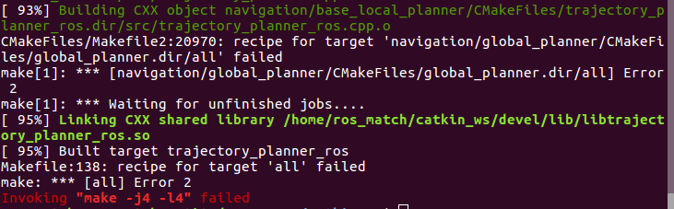
see the CmakeLists.txt of the error file, eg. “[navigation/global_planner/CMakeFiles/global_planner.dir/all] Error”
and add the following command:

add_compile_options(-std=c++11)
set(CMAKE_CXX_FLAGS "${CMAKE_CXX_FLAGS} -std=c++0x")

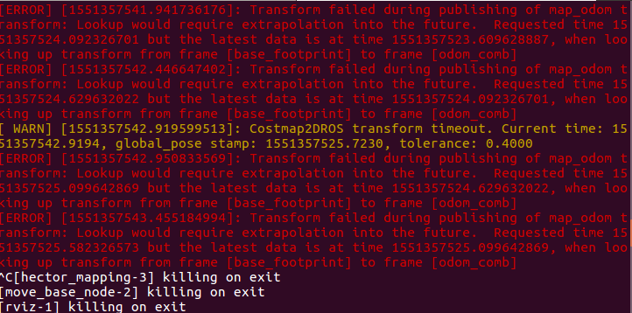

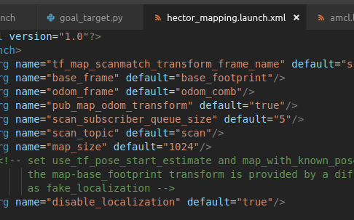

‘disable_localization’ should be ‘true’

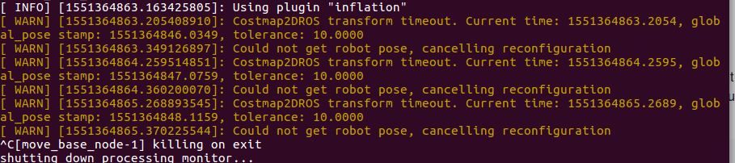
set the time of the laptop. The second of clock should also be same to the time of mir

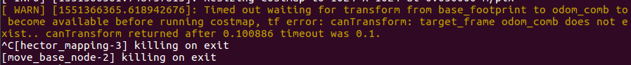
check the tf tree

It’s the odom instead of odom_comb

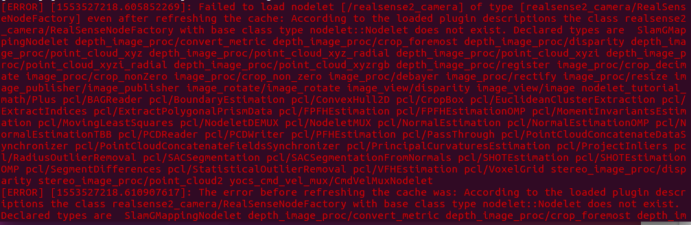
sudo apt-get install 'ros-*-realsense-camera'

False => True

