Assessment Task No. 6
SMS Spam Classification using NLP and Multinomial Naive Bayes
Course | CSST102 – Basic Machine Learning | Term / AY | 1st Semester, 2026-2027
Student Name | FORMELOZA, JILLIAN ROSE O. | Section | CS3B
Due date |  | Points | / 100

Task 1 — Dataset Exploration and Analysis
Dimensions: The 5,572 rows × 5 columns (v1, v2, Unnamed: 2, Unnamed: 3, Unnamed: 4) before the cleaning.
Missing values: The v1 = 0, v2 = 0; the three Unnamed columns are the almost empty (5,522 / 5,560 / 5,566 missing) and were dropped.
Duplicates: The 403 duplicate messages were found and removed.
Cleaning: kept v1 and v2, renamed to class and message. The cleaned dataset: 5,169 rows × 2 columns.
First 10 records (class | message):
# | Class | Message
0 | ham | Go until jurong point, crazy.. Available only in bugis n great world la e buffet... Cine there got amore wat...
1 | ham | Ok lar... Joking wif u oni...
2 | spam | Free entry in 2 a wkly comp to win FA Cup final tkts 21st May 2005. Text FA to 87121 to receive entry question(std txt rate)T&C's apply 08452810075over18's
3 | ham | U dun say so early hor... U c already then say...
4 | ham | Nah I don't think he goes to usf, he lives around here though
5 | spam | FreeMsg Hey there darling it's been 3 week's now and no word back! I'd like some fun you up for it still? Tb ok! XxX std chgs to send, to rcv
6 | ham | Even my brother is not like to speak with me. They treat me like aids patent.
7 | ham | As per your request 'Melle Melle (Oru Minnaminunginte Nurungu Vettam)' has been set as your callertune for all Callers. Press *9 to copy your friends Callertune
8 | spam | WINNER!! As a valued network customer you have been selected to receivea prize reward! To claim call 09061701461. Claim code KL341. Valid 12 hours only.
9 | spam | Had your mobile 11 months or more? U R entitled to Update to the latest colour mobiles with camera for Free! Call The Mobile Update Co FREE on 08002986030

Class | Count | Percentage
Ham | 4,516 | 87.37%
Spam | 653 | 12.63%
Total | 5,169 | 100%
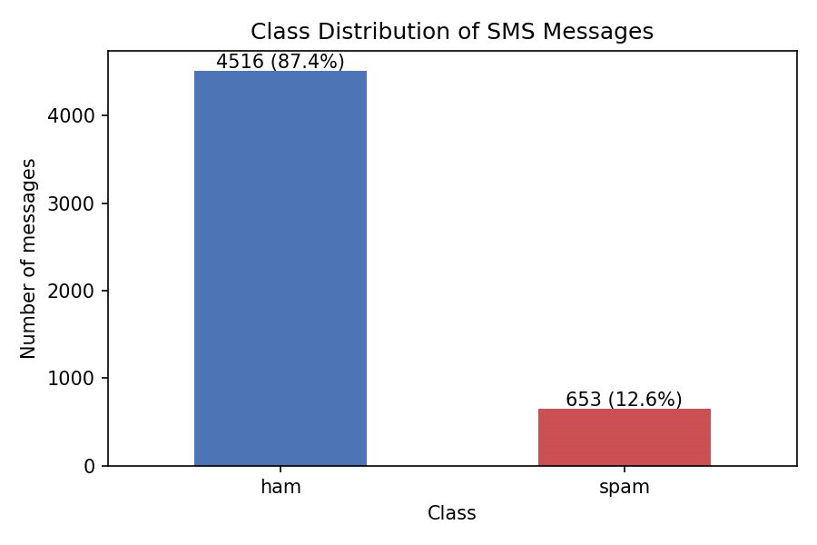
Interpretation: The the dataset is imbalanced. The Ham (87.37%) outnumbers spam (12.63%) by about 7 to 1. A model that always predicts the “ham” would already reach ~87% accuracy, so accuracy alone is the misleading; precision, recall and the F1 for the spam class must also to be checked.
Task 2 — NLP Text Preprocessing
The preprocess() function applies: (1)the lowercase, (2) the remove punctuation and the special characters, (3) the remove digits, (4) the tokenization, (5) The English stopword removal, (6) the Porter stemming. The five original messages and their preprocessed versions:
# | Original | Preprocessed
1 | Go until jurong point, crazy.. Available only in bugis n great world la e buffet... Cine there got amore wat... | go jurong point crazi avail bugi n great world la e buffet cine got amor wat
2 | Ok lar... Joking wif u oni... | ok lar joke wif u oni
3 | Free entry in 2 a wkly comp to win FA Cup final tkts 21st May 2005. Text FA to 87121 to receive entry question(std txt rate)T&C's apply 08452810075over18's | free entri wkly comp win fa cup final tkt st mai text fa receiv entri questionstd txt ratetc appli over
4 | U dun say so early hor... U c already then say... | u dun sai earli hor u c alreadi sai
5 | Nah I don't think he goes to usf, he lives around here though | nah dont think goe usf live around though

Analysis: The preprocessing reduces the noise and the vocabulary size. The Lowercasing, stemming and the removing of punctuation/digits merge variants of the same word (win, wins, winning → win), so the word counts are the less sparse and Naive Bayes that can estimate P(word | class) more reliably. Removing stopwords drops the frequent words that the carry little class information. Since Naive Bayes only relies on the word counts under the an independence assumption, the cleaner input generally gives the better probability estimates.The Over-aggressive cleaning that can hurt, however, e.g. removing the digits discards useful spam cues such as prices and phone numbers.
Task 3 — Text Feature Extraction
 | CountVectorizer | TfidfVectorizer
Feature matrix dimensions | 5,169 × 7,045 | 5,169 × 7,045
Vocabulary size | 7,045 | 7,045
10 example feature names | chg, chic, chick, chicken, chief, chik, chikku, chikkuali, chikkub, chikkudb | chg, chic, chick, chicken, chief, chik, chikku, chikkuali, chikkub, chikkudb

(Matrices fitted on the full cleaned dataset for display only; the models in Task 4 fit the vectorizers on training data only.)
Analysis:The Word frequency (CountVectorizer) is the raw number of times a term appears in the message. TF-IDF multiplies term frequency by inverse document frequency, so the terms that appear in many messages are the down-weighted and rare, distinctive terms receive higher weights (rows are also length-normalised). In theory TF-IDF suits the spam classification because it de-emphasises common words and the highlights discriminative ones such as “prize”, “claim” and “urgent”. In practice, however, the Multinomial Naive Bayes is built for count data, and the experiment in Task 5 shows that raw counts performed better on this dataset.
Task 4 — Naive Bayes Model Development
- Split: 70% train / 30% test, stratified, random_state=42 → 3,618 training and 1,551 test messages (test: 1,355 ham, 196 spam).
- Model A: CountVectorizer + MultinomialNB. Model B: TfidfVectorizer + MultinomialNB.
- Both vectorizers were fitted on the training data only (fit_transform on train, transform on test) to prevent the data leakage; both models use identical train/test records.
- Predictions for the test set were produced for both models (pred_a, pred_b); see the notebook for the full prediction table.
Task 5 — Model Evaluation and Comparison
Evaluation Metric | Model A (CountVectorizer) | Model B (TF-IDF)
Accuracy | 0.9794 (97.94%) | 0.9587 (95.87%)
Precision (spam) | 0.9505 (95.05%) | 0.9925 (99.25%)
Recall (spam) | 0.8827 (88.27%) | 0.6786 (67.86%)
F1-score (spam) | 0.9153 | 0.8061
False Positives | 9 | 1
False Negatives | 23 | 63
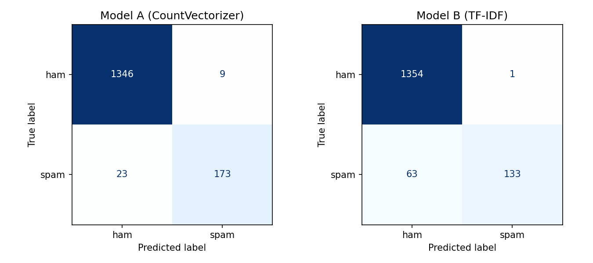
Confusion matrices (rows = actual, columns = predicted): Model A TN=1346, FP=9, FN=23, TP=173. Model B TN=1354, FP=1, FN=63, TP=133.
Which model performs better? Model A (CountVectorizer) performs better overall: higher accuracy, much higher recall and higher F1 (0.9153 vs 0.8061). Model B is more conservative: it nearly never flags a legitimate message (1 false positive vs 9) but lets 63 spam messages through, compared with 23 for Model A. A likely reason is that TF-IDF weights shrink the feature values, so the likelihood evidence from spam words is weaker relative to the strong ham prior (87%), pushing borderline spam to “ham”.
Why precision and recall matter: The Precision tells us how many messages flagged as the spam really are spam. A low precision means legitimate messages (e.g., a bank code, a class announcement) are wrongly sent to the spam folder and may be missed, which is often the costlier error. Recall tells us how much of the real spam is caught; low recall lets spam and scams reach the user. Because the data is imbalanced, accuracy hides these errors, so both metrics (and F1 to balance them) must be reported.
Task 6 — Testing with Unseen Messages
Model used: Model A (CountVectorizer + Multinomial Naive Bayes), the better-performing model by F1-score.
No. | SMS Message | Prediction | P(spam) | P(ham)
1 | Congratulations! You have won a free cash prize. | spam | 1.0000 | 0.0000
2 | Good morning, our class starts at 8 AM tomorrow. | ham | 0.0000 | 1.0000
3 | Claim your reward now by clicking this link. | spam | 0.9998 | 0.0002
4 | Please submit your assignment before Friday. | ham | 0.0567 | 0.9433
5 | URGENT! You have been selected to receive a cash bonus. | spam | 1.0000 | 0.0000

Analysis: All the five predictions match what a human would expect (messages 1, 3, 5 = spam; 2, 4 = ham), so there are no outright misclassifications. The Points worth noting:
- Message 4 (“Please submit your assignment before Friday.”) is correctly ham but has the highest spam probability among the ham messages (P(spam) ≈ 0.057). The words “please” and “submit” lean slightly towards the spam in the training data, and “assignment” is not in the vocabulary, so it is ignored.
- Message 3 contains no money words, but “claim” (a strong spam word) alone pushes it to P(spam) ≈ 0.9998.
- The probabilities are extremely close to 0 or 1 (e.g., 1.0000 for messages 1 and 5). This overconfidence is the typical of Naive Bayes because it multiplies the word probabilities assuming the independence.
- The model only sees individual words, not the context or sender, so a legitimate message that contains words like “free”, “claim” or “prize” could be wrongly flagged as the spam.

