**Deep Learning HW2**

學號：0853412 姓名：吳宛儒

**1 Recurrent Neural Network for Classification**

**i.correlation coefficient between two countries**

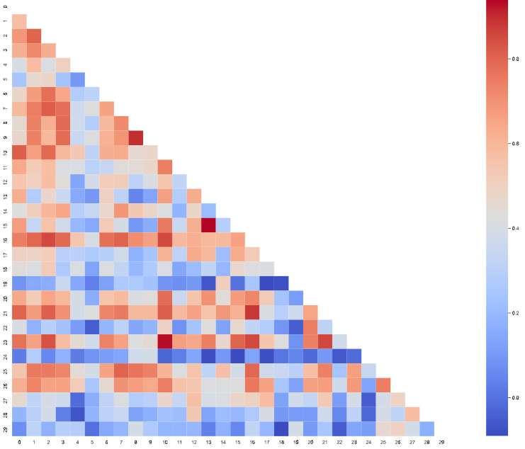

**II. process on you data 解釋如何處理DATA**

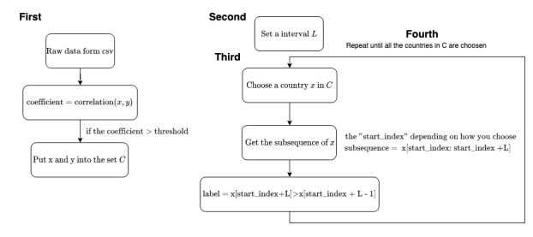

L = 3

threshold = .4

**III. Simple RNN**

**IV. LSTM AND GRU、改變interval L**

LSTM

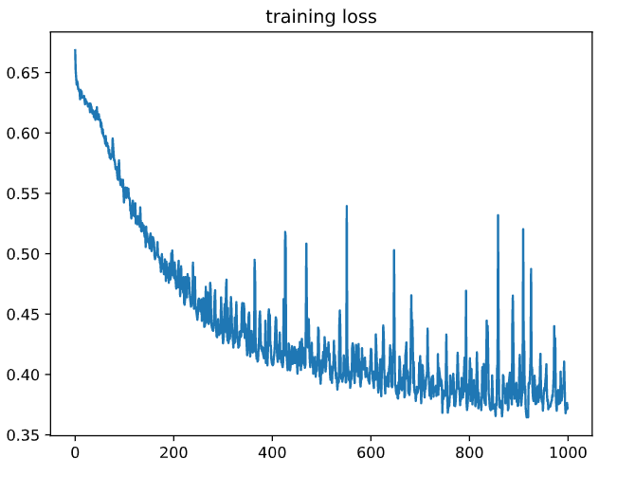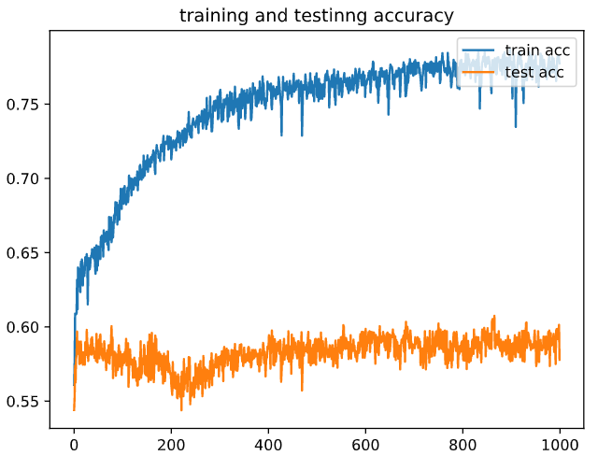

GRU

改變interval L

V. plot

只train300 epoch

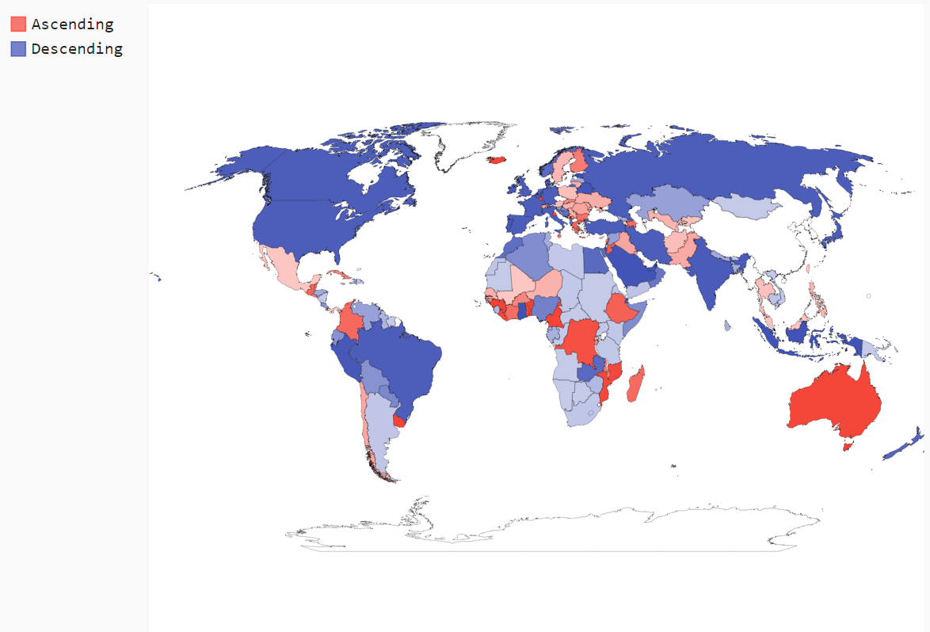

Train1000 epoch(還沒修正沒對到index的問題)!!!!!!!!!!!

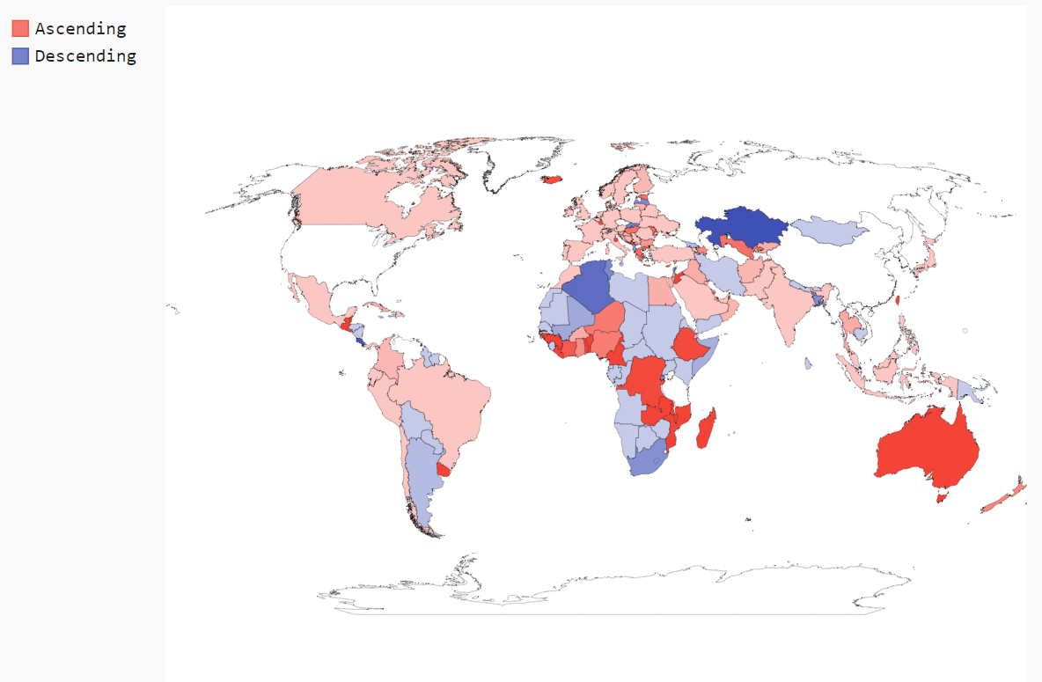

**2 Variational Autoencoder for Image Generation**

i. 如何處理image data resize或是cropping 、如何設計網路架構

fc & CNN

ii.learning curve

iii. some recon_x examples(real&recon 對照)

iv. sample z to synthesize some examples

v. 插值 z 在兩個real samples之間

vi. KL*100 重複ii~v

vii KL*0 重複ii~v

viii 根據結果，討論KL term的變化