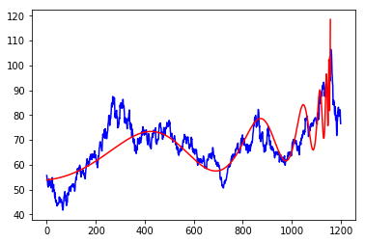

* + Each gene includes 4 non-linear variables tc, β, ω, Φ
    - 1159
    - 0.000975609756097561
    - 6.727920454563199
    - 2.6665225449981658
  + Use linear regression to estimate best A, B, C
    - 79.52649501563545
    - -74.88441279951594
    - 0.0018331754452155533