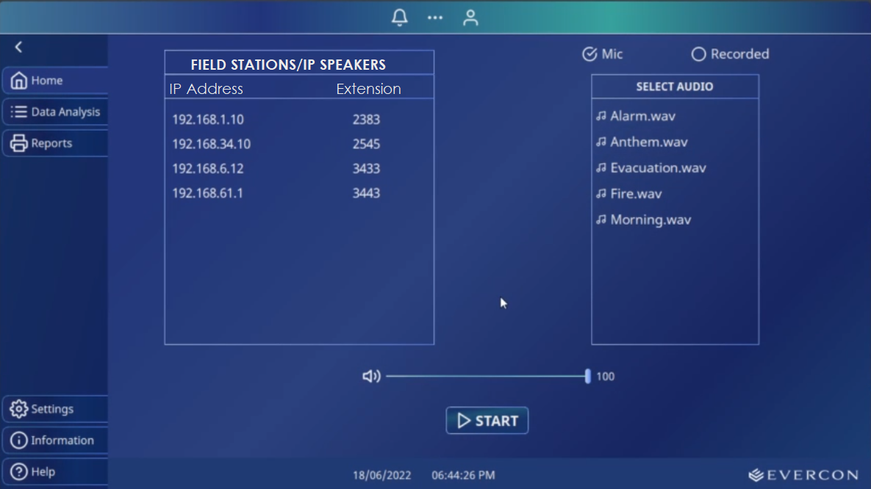

1. Add a heading to the Field stations.
2. Give a little more room for Mic and Recorded buttons.
3. Everything else looks perfectly right. Maybe I will have some feedback while testing it.

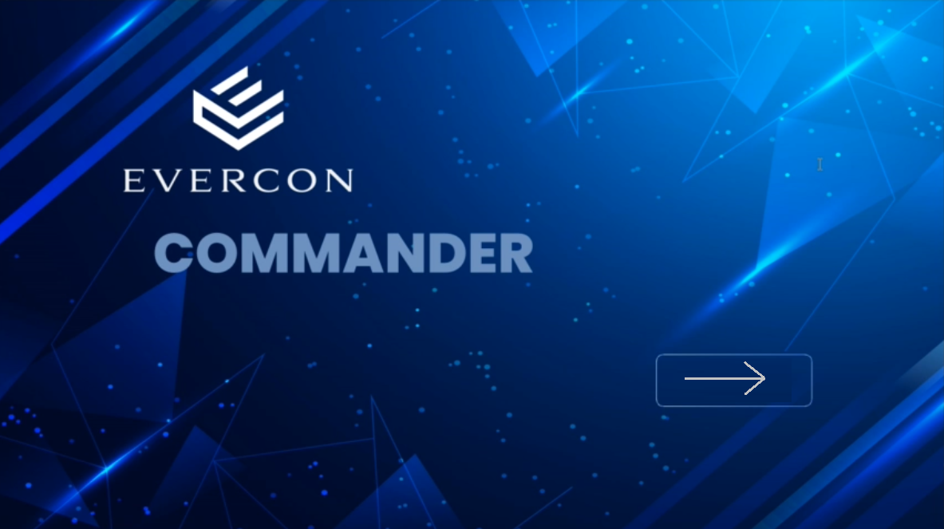

1. To the point, I didn’t like the background image. Choose something not very Eye-catchy but still elegant. Do not highlight the Logo and or the product name ‘Commander’ too much. Show it in a very subtle way. Do not highlight it. Choose something that matches our color theme too. I will send two images I liked, you may pick something similar. Again, Show the title in a gentle and subtle way.
2. Use an Arrow instead of the Text ‘START’

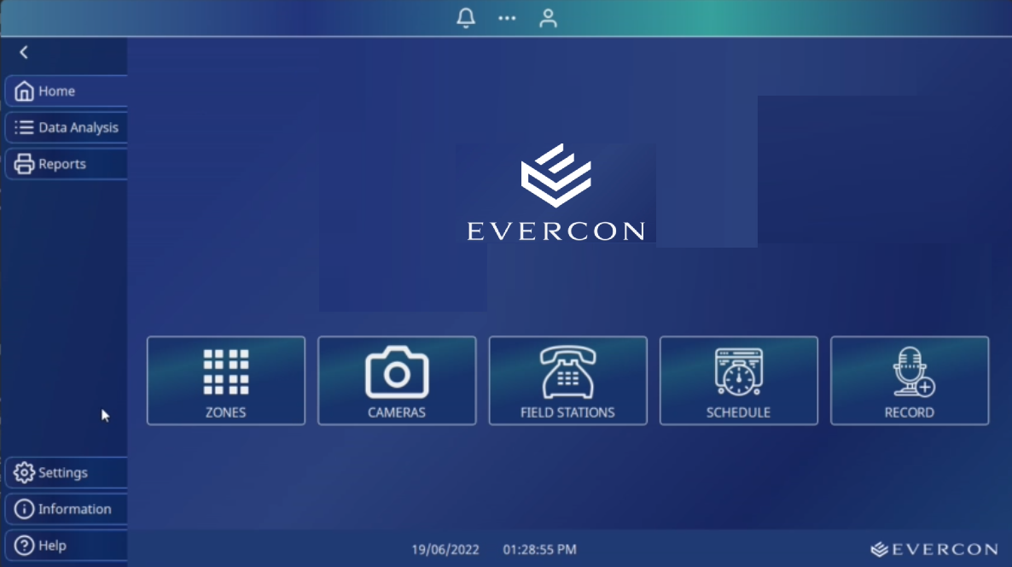

1. It is a good idea to show the Logo in the Main screen but make it smaller. Do not show in White. It is very highlighting. Use some shade of Grey. Everything else looks perfect.

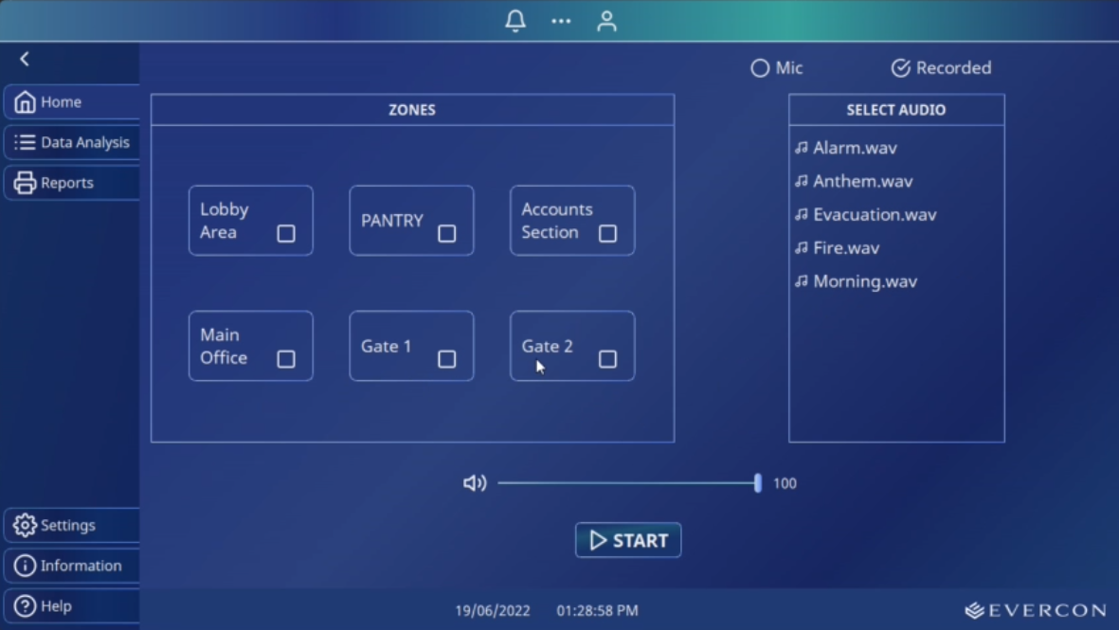

1. Zone screen looks perfect. Hope these will be an automatic slider if there are more items to show (image, we have 10 zones and we can show only 6). The same is applicable to the Field station screen as well.
2. I need a test button here, which I will tell you later as it is outside of what we discussed. I am yet to make up my mind on that too.

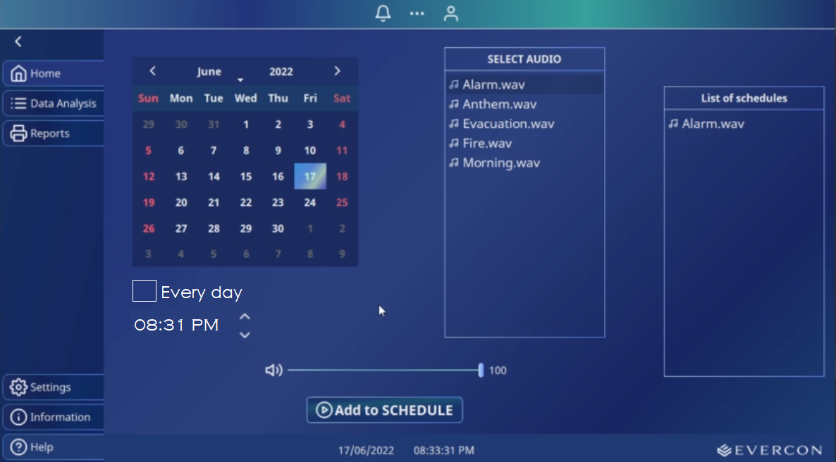

1. Make ‘Everyday’ and Time selection a little more elegant. Use thin Fonts.