=======================init, 18.4 SOLs===========================

Streaming transaction logs mentioning 9MJzW1oEzvjHnmdLdoGRGr1i4hu82g7eEEnxvmifcDZD. Confirmed commitment

Transaction executed in slot 104610180:

Signature: 3imcpEFuYG2zYWSCjpxvYxdYV8iYSuYqhSyDsgPczR9XPCwwBjr4S9k3oM3g3FpK3zJ9UoepFrFV6gJFFY45gVAF

Status: Ok

Log Messages:

Program 11111111111111111111111111111111 invoke [1]

Program 11111111111111111111111111111111 success

Program TokenkegQfeZyiNwAJbNbGKPFXCWuBvf9Ss623VQ5DA invoke [1]

Program log: Instruction: InitializeMint

Program TokenkegQfeZyiNwAJbNbGKPFXCWuBvf9Ss623VQ5DA consumed 2279 of 200000 compute units

Program TokenkegQfeZyiNwAJbNbGKPFXCWuBvf9Ss623VQ5DA success

Transaction executed in slot 104610192:

Signature: 5AhRCLKfrsjvWYUSSpx2yUKnWnnLVpsdHcd5eu2pFo8ba1MGsFJpMP8XLiTj2GaPWgMgCEGomsPG9upvathsjUhz

Status: Ok

Log Messages:

Program ATokenGPvbdGVxr1b2hvZbsiqW5xWH25efTNsLJA8knL invoke [1]

Program log: Transfer 2039280 lamports to the associated token account

Program 11111111111111111111111111111111 invoke [2]

Program 11111111111111111111111111111111 success

Program log: Allocate space for the associated token account

Program 11111111111111111111111111111111 invoke [2]

Program 11111111111111111111111111111111 success

Program log: Assign the associated token account to the SPL Token program

Program 11111111111111111111111111111111 invoke [2]

Program 11111111111111111111111111111111 success

Program log: Initialize the associated token account

Program TokenkegQfeZyiNwAJbNbGKPFXCWuBvf9Ss623VQ5DA invoke [2]

Program log: Instruction: InitializeAccount

Program TokenkegQfeZyiNwAJbNbGKPFXCWuBvf9Ss623VQ5DA consumed 3412 of 179468 compute units

Program TokenkegQfeZyiNwAJbNbGKPFXCWuBvf9Ss623VQ5DA success

Program ATokenGPvbdGVxr1b2hvZbsiqW5xWH25efTNsLJA8knL consumed 24625 of 200000 compute units

Program ATokenGPvbdGVxr1b2hvZbsiqW5xWH25efTNsLJA8knL success

Transaction executed in slot 104610201:

Signature: 65y9o3wsbS6MnzdhP7qHaKZGoKKEXdKverV1TptoHRYUNr8R1zT6BTuv3Je6JNKaH9qNSnotm8qcgmReaZjnB75m

Status: Ok

Log Messages:

Program ATokenGPvbdGVxr1b2hvZbsiqW5xWH25efTNsLJA8knL invoke [1]

Program log: Transfer 2039280 lamports to the associated token account

Program 11111111111111111111111111111111 invoke [2]

Program 11111111111111111111111111111111 success

Program log: Allocate space for the associated token account

Program 11111111111111111111111111111111 invoke [2]

Program 11111111111111111111111111111111 success

Program log: Assign the associated token account to the SPL Token program

Program 11111111111111111111111111111111 invoke [2]

Program 11111111111111111111111111111111 success

Program log: Initialize the associated token account

Program TokenkegQfeZyiNwAJbNbGKPFXCWuBvf9Ss623VQ5DA invoke [2]

Program log: Instruction: InitializeAccount

Program TokenkegQfeZyiNwAJbNbGKPFXCWuBvf9Ss623VQ5DA consumed 3412 of 179468 compute units

Program TokenkegQfeZyiNwAJbNbGKPFXCWuBvf9Ss623VQ5DA success

Program ATokenGPvbdGVxr1b2hvZbsiqW5xWH25efTNsLJA8knL consumed 24625 of 200000 compute units

Program ATokenGPvbdGVxr1b2hvZbsiqW5xWH25efTNsLJA8knL success

Transaction executed in slot 104610210:

Signature: L8RUH2pzgpPmrbPyS8yp4oQhEn48fcjGzJqcs98Gp5iwEp3qSEfLHKFVGkAJu9J3QMmQsXBMGxMovKvbFqJw1EN

Status: Ok

Log Messages:

Program ATokenGPvbdGVxr1b2hvZbsiqW5xWH25efTNsLJA8knL invoke [1]

Program log: Transfer 2039280 lamports to the associated token account

Program 11111111111111111111111111111111 invoke [2]

Program 11111111111111111111111111111111 success

Program log: Allocate space for the associated token account

Program 11111111111111111111111111111111 invoke [2]

Program 11111111111111111111111111111111 success

Program log: Assign the associated token account to the SPL Token program

Program 11111111111111111111111111111111 invoke [2]

Program 11111111111111111111111111111111 success

Program log: Initialize the associated token account

Program TokenkegQfeZyiNwAJbNbGKPFXCWuBvf9Ss623VQ5DA invoke [2]

Program log: Instruction: InitializeAccount

Program TokenkegQfeZyiNwAJbNbGKPFXCWuBvf9Ss623VQ5DA consumed 3412 of 176939 compute units

Program TokenkegQfeZyiNwAJbNbGKPFXCWuBvf9Ss623VQ5DA success

Program ATokenGPvbdGVxr1b2hvZbsiqW5xWH25efTNsLJA8knL consumed 27154 of 200000 compute units

Program ATokenGPvbdGVxr1b2hvZbsiqW5xWH25efTNsLJA8knL success

Transaction executed in slot 104610224:

Signature: 2FLioFRM3VzQd4m4UZKKTwxsdNzUd56LTts4bCzX4327U23xNbBrqaViBEZ9fKyfPjYBkZ36vmhTHkCkEx2LAKXv

Status: Ok

Log Messages:

Program 11111111111111111111111111111111 invoke [1]

Program 11111111111111111111111111111111 success

Program TokenkegQfeZyiNwAJbNbGKPFXCWuBvf9Ss623VQ5DA invoke [1]

Program log: Instruction: InitializeAccount

Program TokenkegQfeZyiNwAJbNbGKPFXCWuBvf9Ss623VQ5DA consumed 3409 of 200000 compute units

Program TokenkegQfeZyiNwAJbNbGKPFXCWuBvf9Ss623VQ5DA success

Program TokenkegQfeZyiNwAJbNbGKPFXCWuBvf9Ss623VQ5DA invoke [1]

Program log: Instruction: MintTo

Program TokenkegQfeZyiNwAJbNbGKPFXCWuBvf9Ss623VQ5DA consumed 2778 of 200000 compute units

Program TokenkegQfeZyiNwAJbNbGKPFXCWuBvf9Ss623VQ5DA success

Program TokenkegQfeZyiNwAJbNbGKPFXCWuBvf9Ss623VQ5DA invoke [1]

Program log: Instruction: Transfer

Program TokenkegQfeZyiNwAJbNbGKPFXCWuBvf9Ss623VQ5DA consumed 3120 of 200000 compute units

Program TokenkegQfeZyiNwAJbNbGKPFXCWuBvf9Ss623VQ5DA success

Program TokenkegQfeZyiNwAJbNbGKPFXCWuBvf9Ss623VQ5DA invoke [1]

Program log: Instruction: Transfer

Program TokenkegQfeZyiNwAJbNbGKPFXCWuBvf9Ss623VQ5DA consumed 3120 of 200000 compute units

Program TokenkegQfeZyiNwAJbNbGKPFXCWuBvf9Ss623VQ5DA success

Program TokenkegQfeZyiNwAJbNbGKPFXCWuBvf9Ss623VQ5DA invoke [1]

Program log: Instruction: Transfer

Program TokenkegQfeZyiNwAJbNbGKPFXCWuBvf9Ss623VQ5DA consumed 3120 of 200000 compute units

Program TokenkegQfeZyiNwAJbNbGKPFXCWuBvf9Ss623VQ5DA success

Program 11111111111111111111111111111111 invoke [1]

Program 11111111111111111111111111111111 success

Program 11111111111111111111111111111111 invoke [1]

Program 11111111111111111111111111111111 success

Program 11111111111111111111111111111111 invoke [1]

Program 11111111111111111111111111111111 success

Program 11111111111111111111111111111111 invoke [1]

Program 11111111111111111111111111111111 success

Program 7Pfq1Lz24RWDrsJxCYaFuw3J9vVwPvcNiPeu38ssLrRo invoke [1]

Program log: [Init 1] Resolve accounts

Program log: [Init 2] The lamports of config account must be enough for rent exemption

Program log: [Init 3] Check if the config account has been initialized

Program log: [Init 4] Initialize ConfigDM

Program log: [Init 5] Save ConfigDM

Program log: [Init 6] Transfer the ownership of reward account to PDA

Program TokenkegQfeZyiNwAJbNbGKPFXCWuBvf9Ss623VQ5DA invoke [2]

Program log: Instruction: SetAuthority

Program TokenkegQfeZyiNwAJbNbGKPFXCWuBvf9Ss623VQ5DA consumed 2153 of 191907 compute units

Program TokenkegQfeZyiNwAJbNbGKPFXCWuBvf9Ss623VQ5DA success

Program log: [Init 7] Done!

Program 7Pfq1Lz24RWDrsJxCYaFuw3J9vVwPvcNiPeu38ssLrRo consumed 10939 of 200000 compute units

Program 7Pfq1Lz24RWDrsJxCYaFuw3J9vVwPvcNiPeu38ssLrRo success

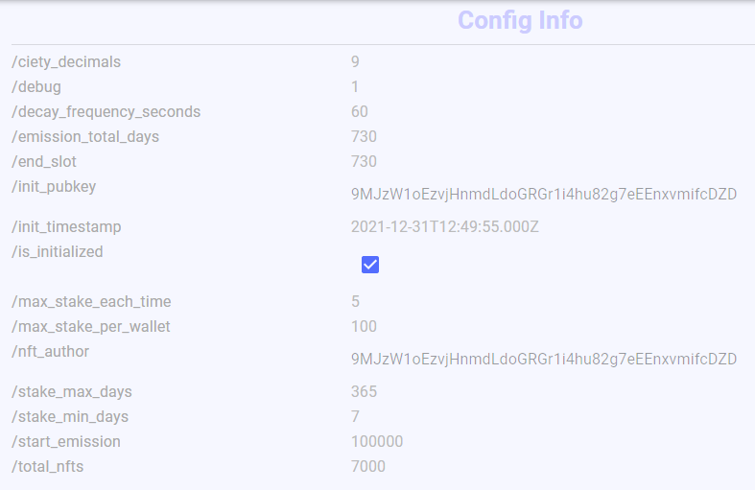

==========================stake 3 NFTs for 7 days=====================

Streaming transaction logs mentioning 9MJzW1oEzvjHnmdLdoGRGr1i4hu82g7eEEnxvmifcDZD. Confirmed commitment

Transaction executed in slot 104610766:

Signature: 3hdy6NxsJkNkHNQW8vL784wqX72NUyCQyBPuTYJJxaLUfwF637LL6rbmTn37naM5kazzBga2dNJjni1ancbzmgMK

Status: Ok

Log Messages:

Program 11111111111111111111111111111111 invoke [1]

Program 11111111111111111111111111111111 success

Program TokenkegQfeZyiNwAJbNbGKPFXCWuBvf9Ss623VQ5DA invoke [1]

Program log: Instruction: Transfer

Program TokenkegQfeZyiNwAJbNbGKPFXCWuBvf9Ss623VQ5DA consumed 3120 of 200000 compute units

Program TokenkegQfeZyiNwAJbNbGKPFXCWuBvf9Ss623VQ5DA success

Program TokenkegQfeZyiNwAJbNbGKPFXCWuBvf9Ss623VQ5DA invoke [1]

Program log: Instruction: Transfer

Program TokenkegQfeZyiNwAJbNbGKPFXCWuBvf9Ss623VQ5DA consumed 3120 of 200000 compute units

Program TokenkegQfeZyiNwAJbNbGKPFXCWuBvf9Ss623VQ5DA success

Program TokenkegQfeZyiNwAJbNbGKPFXCWuBvf9Ss623VQ5DA invoke [1]

Program log: Instruction: Transfer

Program TokenkegQfeZyiNwAJbNbGKPFXCWuBvf9Ss623VQ5DA consumed 3120 of 200000 compute units

Program TokenkegQfeZyiNwAJbNbGKPFXCWuBvf9Ss623VQ5DA success

Program HAoqALFTiyibSRgh63qUWX1sdxt82R3hCqSwAmk8Pysw invoke [1]

Program log: [Stake 1] Resolve accounts

Program log: [Stake 2] Load Config

Program log: [Stake 3] Load Pwdm

Program log: [Stake 4] Load Gcdm

Program log: [Stake 5] Load Gsdm

Program log: [Stake 6] Calculate start_slot and end_slot of staked NFTs

Program log: [Stake 7] Update Gsdm and Gcdm

Program TokenkegQfeZyiNwAJbNbGKPFXCWuBvf9Ss623VQ5DA invoke [2]

Program log: Instruction: SetAuthority

Program TokenkegQfeZyiNwAJbNbGKPFXCWuBvf9Ss623VQ5DA consumed 2153 of 190128 compute units

Program TokenkegQfeZyiNwAJbNbGKPFXCWuBvf9Ss623VQ5DA success

Program TokenkegQfeZyiNwAJbNbGKPFXCWuBvf9Ss623VQ5DA invoke [2]

Program log: Instruction: SetAuthority

Program TokenkegQfeZyiNwAJbNbGKPFXCWuBvf9Ss623VQ5DA consumed 2153 of 182712 compute units

Program TokenkegQfeZyiNwAJbNbGKPFXCWuBvf9Ss623VQ5DA success

Program TokenkegQfeZyiNwAJbNbGKPFXCWuBvf9Ss623VQ5DA invoke [2]

Program log: Instruction: SetAuthority

Program TokenkegQfeZyiNwAJbNbGKPFXCWuBvf9Ss623VQ5DA consumed 2153 of 175296 compute units

Program TokenkegQfeZyiNwAJbNbGKPFXCWuBvf9Ss623VQ5DA success

Program log: [Stake 8] Save Pwdm

Program log: [Stake 9] Save Gcdm

Program log: [Stake 10] Save Gsdm

Program log: [Stake 11] Done!

Program HAoqALFTiyibSRgh63qUWX1sdxt82R3hCqSwAmk8Pysw consumed 28636 of 200000 compute units

Program HAoqALFTiyibSRgh63qUWX1sdxt82R3hCqSwAmk8Pysw success

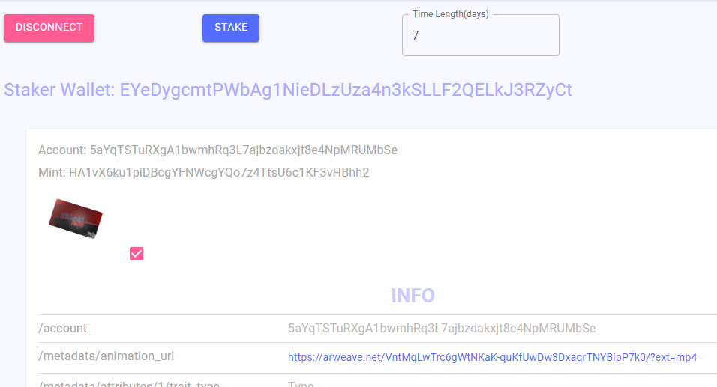

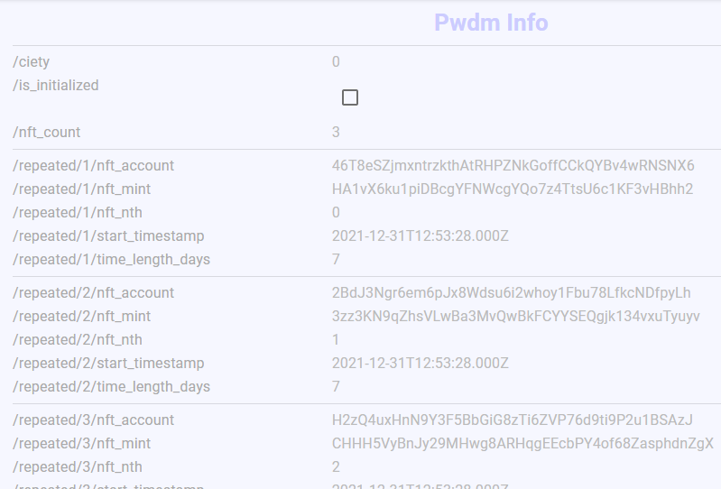

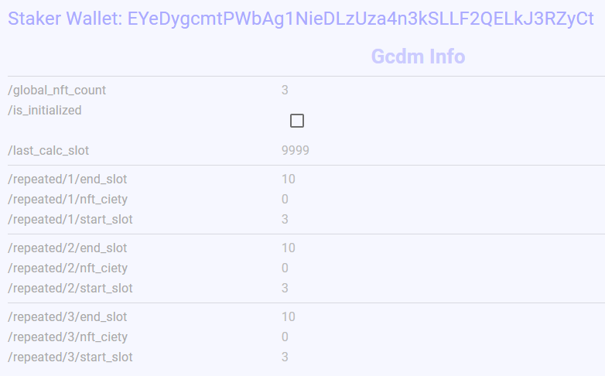

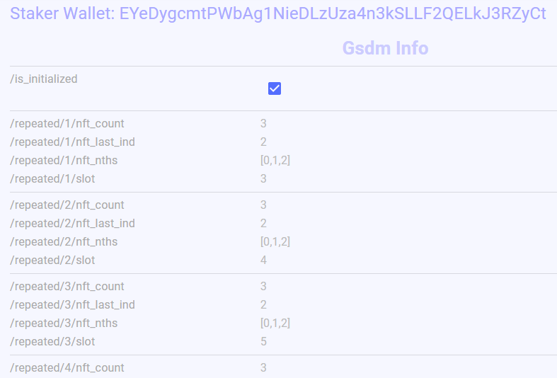

=========================extend 4 days, all 3 expired===================================================

Streaming transaction logs mentioning 9MJzW1oEzvjHnmdLdoGRGr1i4hu82g7eEEnxvmifcDZD. Confirmed commitment

Transaction executed in slot 104611955:

Signature: 1111111111111111111111111111111111111111111111111111111111111111

Status: Ok

Log Messages:

Program HAoqALFTiyibSRgh63qUWX1sdxt82R3hCqSwAmk8Pysw invoke [1]

Program log: [Increse Time Length 1] Resolve accounts

Program log: [Increse Time Length 2] Load config

Program log: [Increse Time Length 3] Load Pwdm

Program log: [Increse Time Length 4] Load Gcdm

Program log: [Increse Time Length 5] Load Gsdm

Program log: [Increse Time Length 6] Update Gcdm and Gsdm

Program log: [Increse Time Length 7] Save Gcdm

Program log: [Increse Time Length 8] Save Pwdm

Program log: [Increse Time Length 9] Save Gsdm

Program log: [Increse Time Length 10] Done!

Program HAoqALFTiyibSRgh63qUWX1sdxt82R3hCqSwAmk8Pysw consumed 2952 of 200000 compute units

Program HAoqALFTiyibSRgh63qUWX1sdxt82R3hCqSwAmk8Pysw success

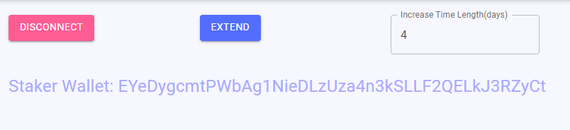

====================trigger reward calc============================

Signature: 2LoBT6QBSY8TBKmTrCjE4ac4mt9zqM86NhH8Pb5SUXQ7cVsDdLDWhfbz2rvc1xf5paTt98nNBEeKFAwmsjrUbYGk

Status: Ok

Log Messages:

Program HAoqALFTiyibSRgh63qUWX1sdxt82R3hCqSwAmk8Pysw invoke [1]

Program log: [Reward Calc 2] Load Config

Program log: [Reward Calc 3] Load Gcdm

Program log: [Reward Calc 4] Load Gsdm

Program log: [Reward Calc 5] Calc ciety emit on given slot

Program log: [Reward Calc 6] Decode nft_count

Program log: [Reward Calc 7] Calc reward share and update Gcdm.nft_ciety correspondingly

Program log: [Reward Calc 8] Save Gcdm

Program log: [Reward Calc 9] Done!

Program HAoqALFTiyibSRgh63qUWX1sdxt82R3hCqSwAmk8Pysw consumed 3457 of 200000 compute units

Program HAoqALFTiyibSRgh63qUWX1sdxt82R3hCqSwAmk8Pysw success

=====================staker view rewards=====================================

Signature: MafVr2B5pQzBxdKdPPuytRmLWYsTTK3h6M6k2F5hWVpd8MA2eadaefW5VKQKEGdLsBUEpsXhASRYE8iriivwt8n

Status: Ok

Log Messages:

Program HAoqALFTiyibSRgh63qUWX1sdxt82R3hCqSwAmk8Pysw invoke [1]

Program log: [Reward_view 1] Resolve accounts

Program log: [Reward_view 2] Load Config

Program log: [Reward_view 3] Load Pwdm

Program log: [Reward_view 4] Load Gcdm

Program log: [Reward_view 5] Update Pwdm

Program log: [Reward_view 6] Save Pwdm

Program log: [Reward_view 7] Done!

Program HAoqALFTiyibSRgh63qUWX1sdxt82R3hCqSwAmk8Pysw consumed 3007 of 200000 compute units

Program HAoqALFTiyibSRgh63qUWX1sdxt82R3hCqSwAmk8Pysw success

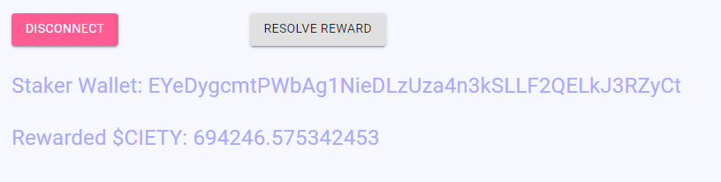

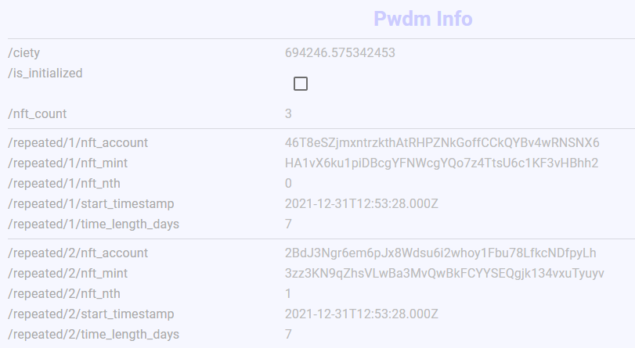

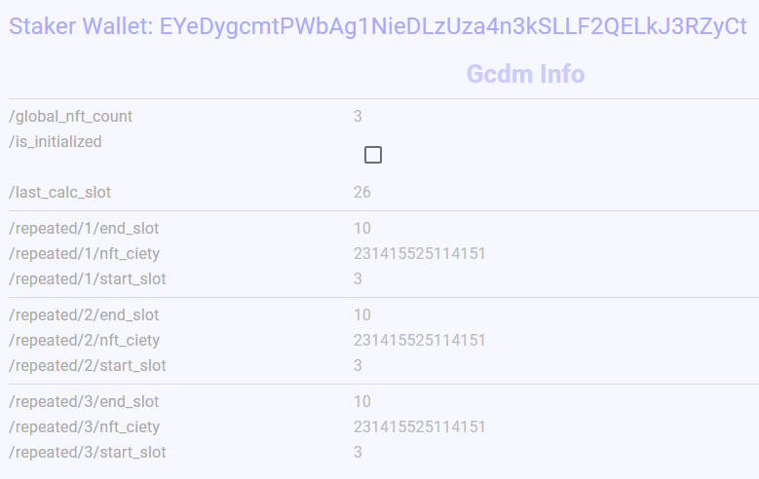

====================================unstake ===========================

Signature: 3Vjtq67RDDH7MJHDybvpi9UaDTJBzjavCEnePxjF7zRLoqpeaBJffYz5Nffc8sbYMu2NMZ8Sx2nX34ugru3jD2WG

Status: Ok

Log Messages:

Program HAoqALFTiyibSRgh63qUWX1sdxt82R3hCqSwAmk8Pysw invoke [1]

Program log: [Unstake 1] Resolve accounts

Program log: [Unstake 2] Load config

Program log: [Unstake 3] Load Pwdm

Program log: [Unstake 4] Load Gcdm

Program log: [Unstake 5] Transfer Solmate NFT to staker

Program log: [Unstake 5.1] Transfer Solmate NFT to staker

Program TokenkegQfeZyiNwAJbNbGKPFXCWuBvf9Ss623VQ5DA invoke [2]

Program log: Instruction: Transfer

Program TokenkegQfeZyiNwAJbNbGKPFXCWuBvf9Ss623VQ5DA consumed 3246 of 190123 compute units

Program TokenkegQfeZyiNwAJbNbGKPFXCWuBvf9Ss623VQ5DA success

Program log: [Unstake 5.2] Close the account which is holding this NFT

Program TokenkegQfeZyiNwAJbNbGKPFXCWuBvf9Ss623VQ5DA invoke [2]

Program log: Instruction: CloseAccount

Program TokenkegQfeZyiNwAJbNbGKPFXCWuBvf9Ss623VQ5DA consumed 2422 of 183871 compute units

Program TokenkegQfeZyiNwAJbNbGKPFXCWuBvf9Ss623VQ5DA success

Program log: [Unstake 5.1] Transfer Solmate NFT to staker

Program TokenkegQfeZyiNwAJbNbGKPFXCWuBvf9Ss623VQ5DA invoke [2]

Program log: Instruction: Transfer

Program TokenkegQfeZyiNwAJbNbGKPFXCWuBvf9Ss623VQ5DA consumed 3246 of 174812 compute units

Program TokenkegQfeZyiNwAJbNbGKPFXCWuBvf9Ss623VQ5DA success

Program log: [Unstake 5.2] Close the account which is holding this NFT

Program TokenkegQfeZyiNwAJbNbGKPFXCWuBvf9Ss623VQ5DA invoke [2]

Program log: Instruction: CloseAccount

Program TokenkegQfeZyiNwAJbNbGKPFXCWuBvf9Ss623VQ5DA consumed 2422 of 168560 compute units

Program TokenkegQfeZyiNwAJbNbGKPFXCWuBvf9Ss623VQ5DA success

Program log: [Unstake 8] Save Pwdm and calc the number of NFTs to be unstaked

Program log: [Unstake 9] Still have 1 NFTs to be unstaked.

Program HAoqALFTiyibSRgh63qUWX1sdxt82R3hCqSwAmk8Pysw consumed 36161 of 200000 compute units

Program HAoqALFTiyibSRgh63qUWX1sdxt82R3hCqSwAmk8Pysw success

Transaction executed in slot 104616542:

Signature: 4K4iVjhyebWbaxDVcbjzLVe86NEz6ZJYtNY6hQ5uF4eEMz6R8Sf2R6bbmtoJ7B475zi5FqSur7JyF4U2F1aihrta

Status: Ok

Log Messages:

Program HAoqALFTiyibSRgh63qUWX1sdxt82R3hCqSwAmk8Pysw invoke [1]

Program log: [Check_expiration 1] Resolve accounts

Program log: [Check_expiration 2] Load config

Program log: [Check_expiration 3] Load Pwdm

Program log: [Check_expiration 4] Load Gcdm

Program log: [Check_expiration 5] Check each NFT's expiration and calculate reward

Program log: [Check_expiration 6] Save Pwdm

Program log: [Check_expiration 7] Done!

Program HAoqALFTiyibSRgh63qUWX1sdxt82R3hCqSwAmk8Pysw consumed 3499 of 200000 compute units

Program HAoqALFTiyibSRgh63qUWX1sdxt82R3hCqSwAmk8Pysw success

Transaction executed in slot 104616555:

Signature: 1111111111111111111111111111111111111111111111111111111111111111

Status: Ok

Log Messages:

Program ATokenGPvbdGVxr1b2hvZbsiqW5xWH25efTNsLJA8knL invoke [1]

Program log: Transfer 2039280 lamports to the associated token account

Program 11111111111111111111111111111111 invoke [2]

Program 11111111111111111111111111111111 success

Program log: Allocate space for the associated token account

Program 11111111111111111111111111111111 invoke [2]

Program 11111111111111111111111111111111 success

Program log: Assign the associated token account to the SPL Token program

Program 11111111111111111111111111111111 invoke [2]

Program 11111111111111111111111111111111 success

Program log: Initialize the associated token account

Program TokenkegQfeZyiNwAJbNbGKPFXCWuBvf9Ss623VQ5DA invoke [2]

Program log: Instruction: InitializeAccount

Program TokenkegQfeZyiNwAJbNbGKPFXCWuBvf9Ss623VQ5DA consumed 3412 of 179574 compute units

Program TokenkegQfeZyiNwAJbNbGKPFXCWuBvf9Ss623VQ5DA success

Program ATokenGPvbdGVxr1b2hvZbsiqW5xWH25efTNsLJA8knL consumed 24487 of 200000 compute units

Program ATokenGPvbdGVxr1b2hvZbsiqW5xWH25efTNsLJA8knL success

Program HAoqALFTiyibSRgh63qUWX1sdxt82R3hCqSwAmk8Pysw invoke [1]

Program log: [Unstake 1] Resolve accounts

Program log: [Unstake 2] Load config

Program log: [Unstake 3] Load Pwdm

Program log: [Unstake 4] Load Gcdm

Program log: [Unstake 5] Transfer Solmate NFT to staker

Program log: [Unstake 5.1] Transfer Solmate NFT to staker

Program TokenkegQfeZyiNwAJbNbGKPFXCWuBvf9Ss623VQ5DA invoke [2]

Program log: Instruction: Transfer

Program TokenkegQfeZyiNwAJbNbGKPFXCWuBvf9Ss623VQ5DA consumed 3246 of 189361 compute units

Program TokenkegQfeZyiNwAJbNbGKPFXCWuBvf9Ss623VQ5DA success

Program log: [Unstake 5.2] Close the account which is holding this NFT

Program TokenkegQfeZyiNwAJbNbGKPFXCWuBvf9Ss623VQ5DA invoke [2]

Program log: Instruction: CloseAccount

Program TokenkegQfeZyiNwAJbNbGKPFXCWuBvf9Ss623VQ5DA consumed 2422 of 183109 compute units

Program TokenkegQfeZyiNwAJbNbGKPFXCWuBvf9Ss623VQ5DA success

Program log: [Unstake 6] Transfer $CIETY to staker

Program 7Pfq1Lz24RWDrsJxCYaFuw3J9vVwPvcNiPeu38ssLrRo invoke [2]

Program log: [Transfer_ciety 1] Resolve accounts

Program log: [Transfer_ciety 2] Transfer $CIETY to staker

Program TokenkegQfeZyiNwAJbNbGKPFXCWuBvf9Ss623VQ5DA invoke [3]

Program log: Instruction: Transfer

Program TokenkegQfeZyiNwAJbNbGKPFXCWuBvf9Ss623VQ5DA consumed 3246 of 169814 compute units

Program TokenkegQfeZyiNwAJbNbGKPFXCWuBvf9Ss623VQ5DA success

Program log: [Transfer_ciety 3] Done!

Program 7Pfq1Lz24RWDrsJxCYaFuw3J9vVwPvcNiPeu38ssLrRo consumed 9596 of 175454 compute units

Program 7Pfq1Lz24RWDrsJxCYaFuw3J9vVwPvcNiPeu38ssLrRo success

Program log: [Unstake 8] Transfer Pwdm SOL to staker and close Pwdm

Program log: [Unstake 9] Completely done!

Program HAoqALFTiyibSRgh63qUWX1sdxt82R3hCqSwAmk8Pysw consumed 35876 of 200000 compute units

Program HAoqALFTiyibSRgh63qUWX1sdxt82R3hCqSwAmk8Pysw success