Practical case

Context:
A company is developing a new authentication protocol. The company cryptographers have been investigating alternatives to password hashing and have found that Zero-Knowledge Proof (ZKP) is a viable alternative to hashing in an authentication schema. Moreover, the cryptographers have found a ZKP protocol suitable for this purpose. As part of an agile team, you have accepted the challenge of implementing the ZKP Protocol and a Proof-of-Concept application that utilizes the protocol to register and authenticate users.

The ZKP Protocol
The ZKP protocol is described in the book
"Cryptography: An Introduction (3rd Edition) Nigel Smart" page 377 section "3. Sigma Protocols" subsection "3.2. Chaum–Pedersen Protocol." We want to adapt this protocol to support 1-factor authentication, that is, the exact matching of a number (registration password) stored during registration and another number (login password) generated during the login process. We now describe the registration and the login processes.

Registration Process
The prover (client) has a secret password x (i.e. it is a number) and wishes to register it with the verifier (server). To do that, they calculate y1 and y2 using public g and h and the secret x and sends to the verifier y1, y2.

Login Process
The login process is done following the ZKP Protocol showed in the diagram. Been the Prover the authenticating party and the Verifier the server running the authentication check:
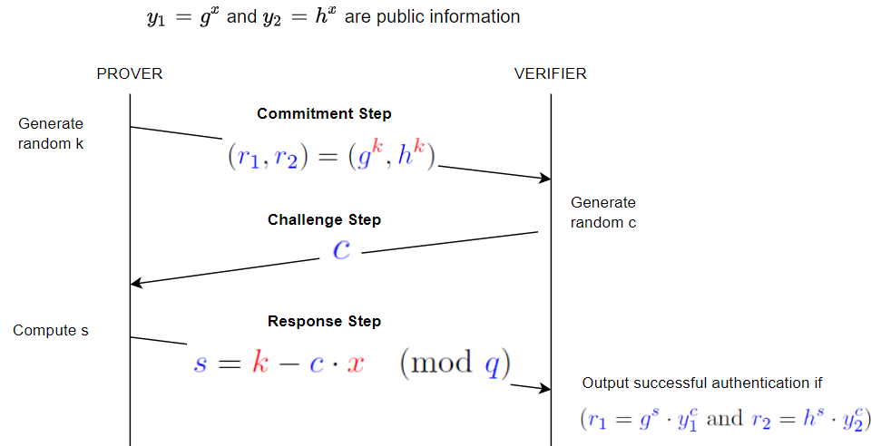

Primary ask
Design and write the code that implements the ZKP Protocol outlined above. The code can be implemented within a very simple authentication application that uses the protocol or it can be written with unit tests proving that it works. In any case we’d like to see how you are thinking about and approach the problem, so a simple description of your approach and how you’d extend it or integrate would be helpful.

Bonus requirements
The following bullet points are all things that would be nice to see in a working implementation. None of them is mandatory, but if there are any of these items you can add to your submission it would be beneficial for us in determining the level of your submission.

- Unit tests, where appropriate
- Functional test of the ZKP Protocol
- Design a network protocol to transfer information of the ZKP Protocol
- A setup to run the Client and the Server.
- Wrapping the code within a service
- Use Rust as language for the implementation
- Performance and optimizations
- Coverage of test cases (not code coverage)
- Code soundness
- Code organization
- Code quality
- Well documented code
- Each instance runs in a separated docker container and have a docker compose to run the setup
- There is code to deploy the two containers in AWS. The client in one machine and the server in another machine
- Implement two flavor: One with exponentiations (as described in the book) and one using Elliptic Curve cryptography (see for example this ZKP implementation in Rust)

High Level Example Solution

As a guide, a likely solution would have the following;

Two structures, one representing the client and the other the server.

The server should have at least the following methods:

- register(user: User, commits: Commits) to register a new user
- create_authentication_challenge(user: User, auth_request: AuthenticationRequest) -> Challenge to create a challenge that the client has to answer
- verify_authentication(user: User, answer: Answer) -> bool that receives the answer to the challenge from the client and returns true if the user has been authenticated

The client should have at least the following methods:

- create_register_commits() -> Commits To create the commits to register the user in the server
- create_authentication_request() -> AuthenticationRequest Creates an authentication request to start the authentication against the Server.
- prove_authentication(challenge: Challenge) -> Answer Returns an answer to the challenge sent by the server

Two applications:

Server:
- The server is able to store users and cryptographic commits (equivalent to passwords) in memory. It is also able to authenticate users using the ZKP Protocol.

Client:
- The client should be able to authenticate against the server. In order to authenticate, the client should register against the server first and then authenticate. Once authenticated, the client should run in an infinite sleep loop. The username and password should be loaded from environment variables.

