CPE301 – SPRING 2019

Design Assignment 2B

Student Name: Matija Tomljenovic

Student #: 1012254710

Student Email: tomljeno@unlv.nevada.edu

Primary Github address: https://github.com/matcroatia/

Directory: https://github.com/matcroatia/DA2B

1. **COMPONENTS LIST AND CONNECTION BLOCK DIAGRAM w/ PINS**

List of components: Internal resistor, Pin C PORT B, Atmega328P

Pins: PB02 and PC02, LED1 and SW1 switch.

1. **INITIAL/MODIFIED/DEVELOPED CODE OF TASK 1/A**

**ASSEMBLY CODE:**

;

; Assignment 2B Amb Code.asm

;

; Created: 3/9/2019 5:31:55 PM

; Author : Mat Tomljenovic

;

.ORG 0

JMP MAIN

.ORG 0x02

JMP EX0_ISR

MAIN:

LDI R20,HIGH(RAMEND) //load high bit of end ram into R20

OUT SPH,R20 //outputting R20 value into stack pointer high

LDI R20,LOW(RAMEND) //load low bit of end ram into R20

OUT SPL, R20 //output R20 value into stack pointer low

LDI R20,0x02 //load 0x02 into R20/ make falling edge triggered

STS EICRA,R20 //store one byte from R20 into EICRA

SBI DDRB, 5 //make PB5 output

SBI PORTD, 2 //make oin D2 input

LDI R20,1<<INT0 //enable INT0

OUT EIMSK, R20 //output R20 into mask register

SEI //enable interrupts

HERE:

JMP HERE //jump to HERE label

EX0_ISR: //loop label

IN R21,PORTB //input value for R21 into PORTB

LDI R22,(1<<5) //shift value in R22 by 5. to toggle PB5

EOR R21,R22 //exclusive or value in R22 and R21

RCALL DELAY_1s //call delay loop of 1 sec

RCALL DELAY_100ms //call dellay loop of 100 mili seconds

RCALL DELAY_100ms

RCALL DELAY_5ms //call delay loop of 5 mili seconds

RCALL DELAY_5ms

RCALL DELAY_5ms

RCALL DELAY_5ms

RCALL DELAY_5ms

RCALL DELAY_5ms

RCALL DELAY_5ms

RCALL DELAY_5ms

RCALL DELAY_5ms

RCALL DELAY_5ms

OUT PORTB,R21 //output value of R21 into PORTB

RETI //return from interrupt

DELAY: //delay label

DELAY_1S: //dealay_1s label

PUSH R16 //stores value in R16 on the stack

LDI R16,200 //load 200 into R16

DELAY_1S1: //DELAY_1S1 label

RCALL DELAY_5MS //call DELAY loop

DEC R16 //decriment vlaue in R16

BRNE DELAY_1S1 //branch if not equal to DELAY_1S1

POP R16 //loads R16 with vlaue form stack

RET //return to function

DELAY_100MS: //Delay label

PUSH R16 //stores value in R16 on the stack

LDI R16,100 //load 100 into R16

DELAY_100MS1: //Dealy label

RCALL DELAY_1MS //call delay loop

DEC R16 //decriment value in R16

BRNE DELAY_100MS1 //branch if not equal to delay loop

POP R16 //loads R16 with value from stack

RET //return to function

DELAY_5MS: //delay label

RCALL DELAY_1MS //call 1 milisecond delay fucntion

RCALL DELAY_1MS

RCALL DELAY_1MS

RCALL DELAY_1MS

RCALL DELAY_1MS

RET

DELAY_1MS: //delay label

PUSH R16 //stores value in R16 to stack

LDI R16,99 //load 99 in R16

DELAY_1MS1: //delay label

NOP //no operation

NOP

NOP

NOP

NOP

NOP

NOP

DEC R16 //decriment value in R16

BRNE DELAY_1MS1 //branch if not equal to delay loop

POP R16 //laods R16 with value from stack pointer

RET //return to function

C CODE:

/*

* Assignment 2B C code.c

*

* Created: 3/9/2019 3:59:29 PM

* Author : Mat Tomljenovic

*/

#define *F_CPU* 8000000UL

#include <avr/io.h>

#include <avr/interrupt.h>

#include <util/delay.h>

int main()

{

DDRB = (1 << PB5); //PB5 as an output

PORTD = 1<<2; //pull-up activated

EICRA = 0x2; //make INT0 falling edge triggered

EIMSK = (1<<INT0); //enable external interrupt 0

sei(); //enable interrupts

while(1); //wait here

{

PORTB = 0x00; //turn LED off

}

}

ISR (INT0_vect) //ISR for external interrupt 0

{

PORTB ^= (1<<5); //toggle PORTB5

*_delay_ms*(150); //delay of 1.2 sec

}

1. **DEVELOPED MODIFIED CODE OF TASK 2/A from TASK 1/A**

Same as above.

1. **SCHEMATICS**

Use fritzing.org

1. **SCREENSHOTS OF EACH TASK OUTPUT (ATMEL STUDIO OUTPUT)**

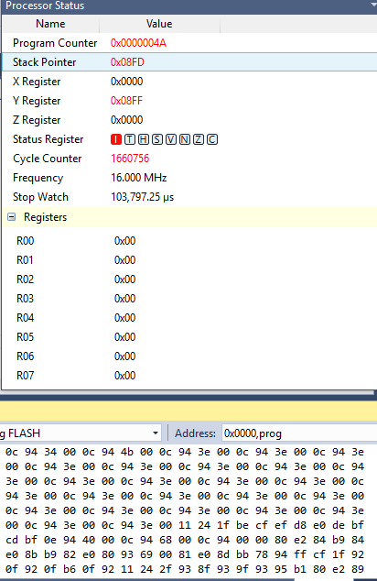

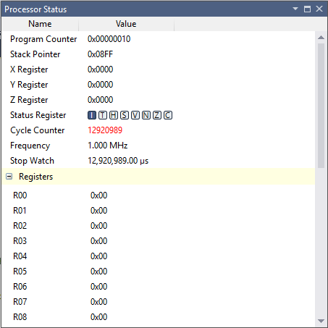

1. **SCREENSHOT OF EACH DEMO (BOARD SETUP)**
2. **VIDEO LINKS OF EACH DEMO**

<https://youtu.be/JopHb_ijJ1I>

<https://youtu.be/wTmhjnCkALU>

1. **GITHUB LINK OF THIS DA**

https://github.com/matcroatia/DA2B

**Student Academic Misconduct Policy**

<http://studentconduct.unlv.edu/misconduct/policy.html>

“This assignment submission is my own, original work”.

MATIJA TOMLJENOVIC