CPE301 – SPRING 2019

Design Assignment 1B

Student Name: Matija Tomljenovic

Student #: 1012254710

Student Email: tomljeno@unlv.nevada.edu

Primary Github address: https://github.com/matcroatia/Submission_da.git

Directory: C:\Users\Some guy\Desktop\CPE301

1. **COMPONENTS LIST AND CONNECTION BLOCK DIAGRAM w/ PINS**

No components or block diagrams.

1. **INITIAL/MODIFIED/DEVELOPED CODE OF TASK 1/A**

;

; Assignment1B.asm

;

; Created: 2/22/2019 4:27:26 PM

; Author : Mat Tomljenovic

;

.org 0 ;program starts at memory 0

ldi xl, low(0x0200) ;load low byte into x register

ldi xh, high(0x0200) ;load high byte into x register

ldi yl, low(0x0400) ;load low byte into y register

ldi yh, high(0x0400) ;load high byte into y register

ldi zl, low(0x0600) ;load low byte into z register

ldi zh, high(0x0600) ;load high byte into z register

ldi r21, 154 ;load 154 into register 21

ldi r23 ,0 ;load 0 into register 23

;loop to incriment r21 and count

start:

inc r21 ;increment value in register 21

st x+, r21 ;store value in r21 into x and increment

mov r22, r21 ;copy value in r21 into r22

cpi r21, 254 ;compare 254 which is 155+99 to vlue in r21

breq hold ;branch if not equal to hold label

;loop for to check if number is divisble by 3

loop1:

subi r22, 3 ;subtract value in r22 by 3

cp r22, r23 ;compare value in r23 to r22

brmi loop3 ;branch if result is negative to label loop3

breq loop2 ;branch if result is equal to 0 to label loop2

rjmp loop1 ;if result is a positive value repat loop1

;loop to store result in y and increment

loop2:

st y+, r21 ;store value in r21 into y and increment

add r16, r21 ;add r21 to r16 and store result in r16

adc r17, r23 ;add carry of previous reult into r17

rjmp start ;jump to label start

;loop to store result of r21 into z and increment

loop3:

st z+, r21 ;store value in r21 into z and increment

add r18, r21 ;add r21 and r18 and store result in r18

adc r19, r23 ;add carry of previous result and store into r19

rjmp start ;jump to label start

hold: break ;label used to break and end program

1. **DEVELOPED MODIFIED CODE OF TASK 2/A from TASK 1/A**

No Developed or modified code.

1. **SCHEMATICS**

No schematics to upload

1. **SCREENSHOTS OF EACH TASK OUTPUT (ATMEL STUDIO OUTPUT)**

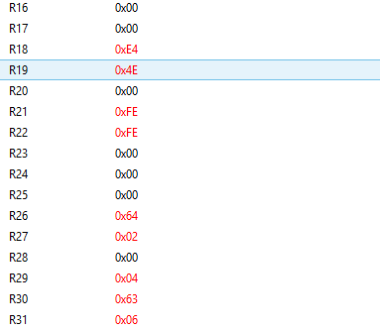

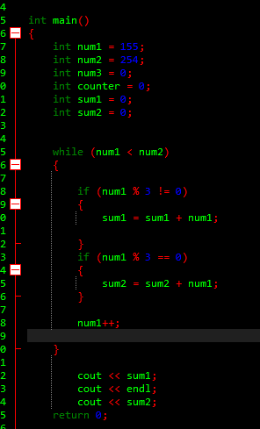



1. **SCREENSHOT OF EACH DEMO (BOARD SETUP)**

NONE:

1. **VIDEO LINKS OF EACH DEMO**

NONE:

1. **GITHUB LINK OF THIS DA**

https://github.com/matcroatia/DA1B.git

**Student Academic Misconduct Policy**

<http://studentconduct.unlv.edu/misconduct/policy.html>

“This assignment submission is my own, original work”.

Matija Tomljenovic