CPE301 – SPRING 2019

Design Assignment 4A

Student Name: Mat Tomljenovic

Student #: 1012254710

Student Email: tomljeno@unlv.nevada.edu

Primary Github address: https://github.com/matcroatia/

Directory: https://github.com/matcroatia/

1. **COMPONENTS LIST AND CONNECTION BLOCK DIAGRAM w/ PINS**

Atmega328, Dual Motor Driver TBN6612FNG, several wires, bread board and small 5V motor.

1. **INITIAL/MODIFIED/DEVELOPED CODE OF TASK 1/A**

/*

* DA4A.c

*

* Created: 4/13/2019 7:35:14 PM

* Author : Mat Tomljenovic

*/

#define *F_CPU* 16000000UL

#include <avr/io.h>

#include <avr/interrupt.h>

#include <util/delay.h>

void adc_func(void); // initializing void function

int motor_spin; // constant for controlling motor spin

int motor = 0; // const for motor on/off

int main(void)

{

DDRD = 0x40; // enable port D as output

DDRC = 0x02; // enable port C as output

PORTC |= (1 << PINC4) | (1 << PINC0); // enable pin 4 and pin 0 as inputs

TCCR0A= 0x03; // set fast PWM and clear overflow flag register on match

TCCR0B= 0x05; // set pre-scaler to 1024

PCICR = 0x02; // enable PCIE1

PCMSK1 = 0x02; // enable pin changes

sei(); // enable global interrupts

adc_func(); // initializes the ADC

while (1)

{

}

}

ISR(PCINT1_vect)

{

if(!(PINC & (1<<PINC1))) // if button is pressed then activate motor for spin selection

{

if(motor == 0) // if button is pressed the motor will stop

{

OCR0A = 0; // register used to stop motor

*_delay_ms*(1000); // delay used to prevent debouncing

}

if (motor == 1) // if button is pressed motor will turn on

{

while((ADCSRA&(1<<ADIF))==0); // loop used to convert ADC

motor_spin = ADC; // set motor_spint to ADC value

OCR0A = motor_spin; // the motor vale is loaded into ORR0A register

*_delay_ms*(1000); // mdelay used to prevent debouncing

}

motor ^= 1; // used to toggle motor

}

}

void adc_func(void) // function used for ADC

{

ADMUX = ( 0 << REFS1); // used to enable ADC

ADCSRA = 0xE7; // used to start conversion process

}

1. **DEVELOPED MODIFIED CODE OF TASK 2/A from TASK 1/A**

Same as above

1. **SCHEMATICS**

Use fritzing.org

1. **SCREENSHOTS OF EACH TASK OUTPUT (ATMEL STUDIO OUTPUT)**

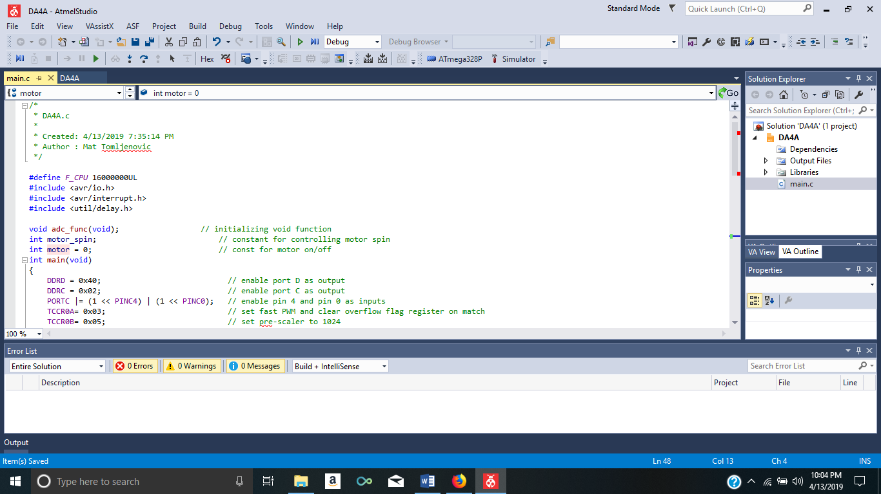

1. **SCREENSHOT OF EACH DEMO (BOARD SETUP)**

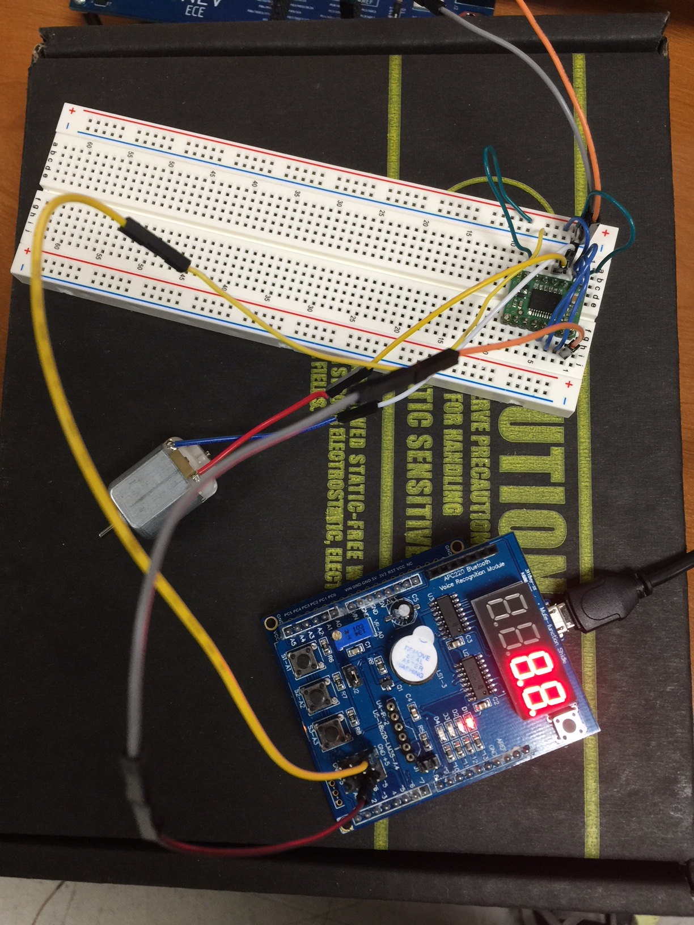

1. **VIDEO LINKS OF EACH DEMO**

<https://youtu.be/qHJPOU9TmyA>

<https://youtu.be/w1Rg4kme--M>

1. **GITHUB LINK OF THIS DA**

https://github.com/matcroatia/DA4A

**Student Academic Misconduct Policy**

<http://studentconduct.unlv.edu/misconduct/policy.html>

“This assignment submission is my own, original work”.

Mat Tomljenovic