CPE301 – SPRING 2019

Design Assignment 5

Student Name: Mat Tomljenovic, Partner: Eric Smith

Student #: 1012254710

Student Email: tomljeno@unlv.nevada.edu

Primary Github address: https://github.com/matcroatia/

Directory: https://github.com/matcroatia/submission_da

1. **COMPONENTS LIST AND CONNECTION BLOCK DIAGRAM w/ PINS**

Atmega 328P microcontroller, NRF24L01 radio frequency transmitter, LM34 temperature sensor.

1. **INITIAL/MODIFIED/DEVELOPED CODE OF TASK 1/A**

/*

* DA5.c

*

* Created: 4/25/2019 10:21:48 PM

* Author : Mat Tomljenovic

*/

#ifndef *F_CPU*

#define *F_CPU* 16000000UL

#endif

#include <avr/io.h>

#include <util/delay.h>

#include <avr/interrupt.h>

#include <stdbool.h>

#include <stdio.h>

#include <string.h>

// Set up UART for printf();

#ifndef BAUD

#define BAUD 9600

#endif

#include "inc/STDIO_UART.h"

// Include nRF24L01+ library

#include "inc/nrf24l01.h"

#include "inc/nrf24l01-mnemonics.h"

#include "inc/spi.h"

void print_config(void);

void read_adc(void); // Function Declarations

void adc_init(void);

volatile unsigned int adc_temp;

char outs[20];

// Used in IRQ ISR

volatile bool message_received = false;

volatile bool status = false;

int main(void)

{

// Set message to send (message cannot exceed 32 characters)

char tx_message[32]; // Define string array

*strcpy*(tx_message,"hello i am cody"); // Copy string into array

// Initialize UART

uart_init();

adc_init();

// Initialize nRF24L01+ and print configuration info

nrf24_init();

print_config();

// Start listening to incoming messages

nrf24_start_listening();

while (1)

{

read_adc();

adc_temp = (adc_temp*500)/1023 + 20;

*snprintf*(outs,sizeof(outs),"%3d\r\n", adc_temp); // print it

*strcpy*(tx_message,outs); // Copy string into array

nrf24_send_message(tx_message);

*_delay_ms*(1500);

if (message_received)

{

// Message received, print it

message_received = false;

*printf*("Received message: %s\n",nrf24_read_message());

// Send message as response

*_delay_ms*(500);

status = nrf24_send_message(tx_message);

if (status == true) *printf*("Message sent successfully\n");

}

}

}

// Interrupt on IRQ pin

ISR(INT0_vect)

{

message_received = true;

}

void print_config(void)

{

*uint8_t* data;

*printf*("Startup successful\n\n nRF24L01+ configured as:\n");

*printf*("-------------------------------------------\n");

nrf24_read(CONFIG,&data,1);

*printf*("CONFIG 0x%02X\n",data);

nrf24_read(EN_AA,&data,1);

*printf*("EN_AA 0x%02X\n",data);

nrf24_read(EN_RXADDR,&data,1);

*printf*("EN_RXADDR 0x%02X\n",data);

nrf24_read(SETUP_RETR,&data,1);

*printf*("SETUP_RETR 0x%02X\n",data);

nrf24_read(RF_CH,&data,1);

*printf*("RF_CH 0x%02X\n",data);

nrf24_read(RF_SETUP,&data,1);

*printf*("RF_SETUP 0x%02X\n",data);

nrf24_read(STATUS,&data,1);

*printf*("STATUS 0x%02X\n",data);

nrf24_read(FEATURE,&data,1);

*printf*("FEATURE 0x%02X\n",data);

*printf*("-------------------------------------------\n\n");

}

/* INIT ADC */

void adc_init(void)

{

/** Setup and enable ADC **/

ADMUX = (0<<REFS1)| // Reference Selection Bits

(1<<REFS0)| // AVcc - external cap at AREF

(0<<ADLAR)| // ADC Left Adjust Result

(1<<MUX2)| // Analog Channel Selection Bits

(0<<MUX1)| // ADC4 (PC4 PIN27)

(0<<MUX0);

ADCSRA = (1<<ADEN)| // ADC ENable

(0<<ADSC)| // ADC Start Conversion

(0<<ADATE)| // ADC Auto Trigger Enable

(0<<ADIF)| // ADC Interrupt Flag

(0<<ADIE)| // ADC Interrupt Enable

(1<<ADPS2)| // ADC Prescaler Select Bits

(0<<ADPS1)|

(1<<ADPS0);

}

/* READ ADC PINS */

void read_adc(void)

{

unsigned char i = 4;

adc_temp = 0;

while (i--)

{

ADCSRA |= (1<<ADSC);

while(ADCSRA & (1<<ADSC));

adc_temp+= ADC;

*_delay_ms*(50);

}

adc_temp = adc_temp / 4; // Average a few samples

}

1. **DEVELOPED MODIFIED CODE OF TASK 2/A from TASK 1/A**

Same as above.

1. **SCHEMATICS**

Use fritzing.org

1. **SCREENSHOTS OF EACH TASK OUTPUT (ATMEL STUDIO OUTPUT)**

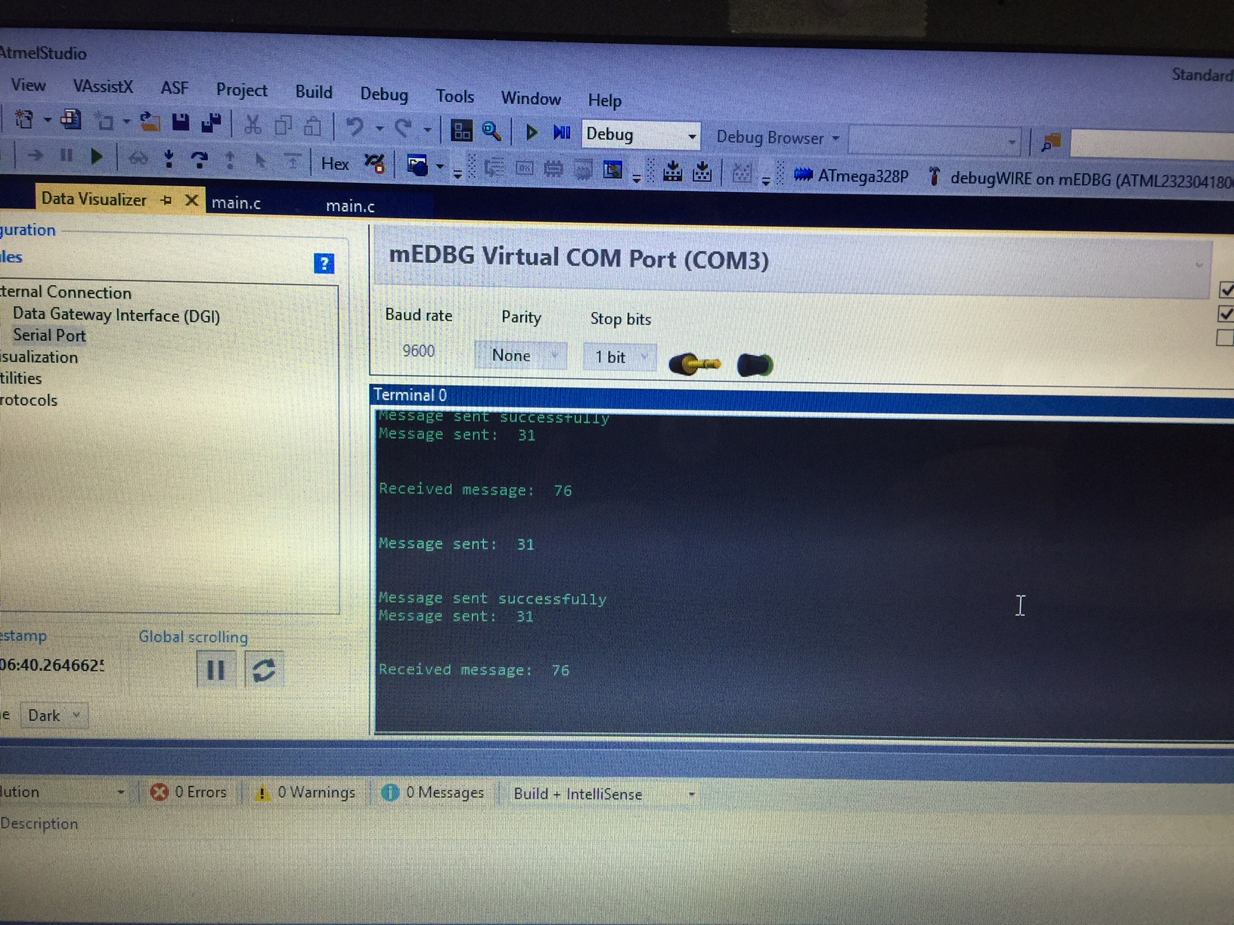

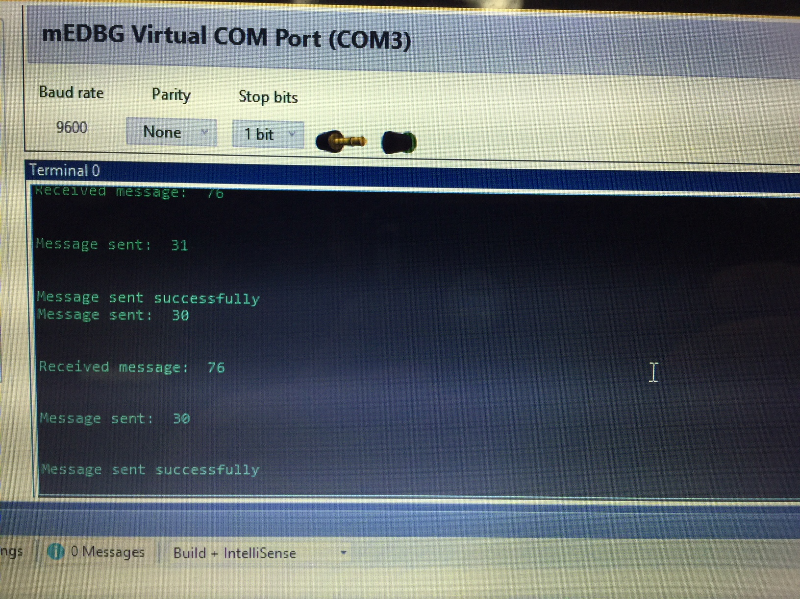

1. **SCREENSHOT OF EACH DEMO (BOARD SETUP)**

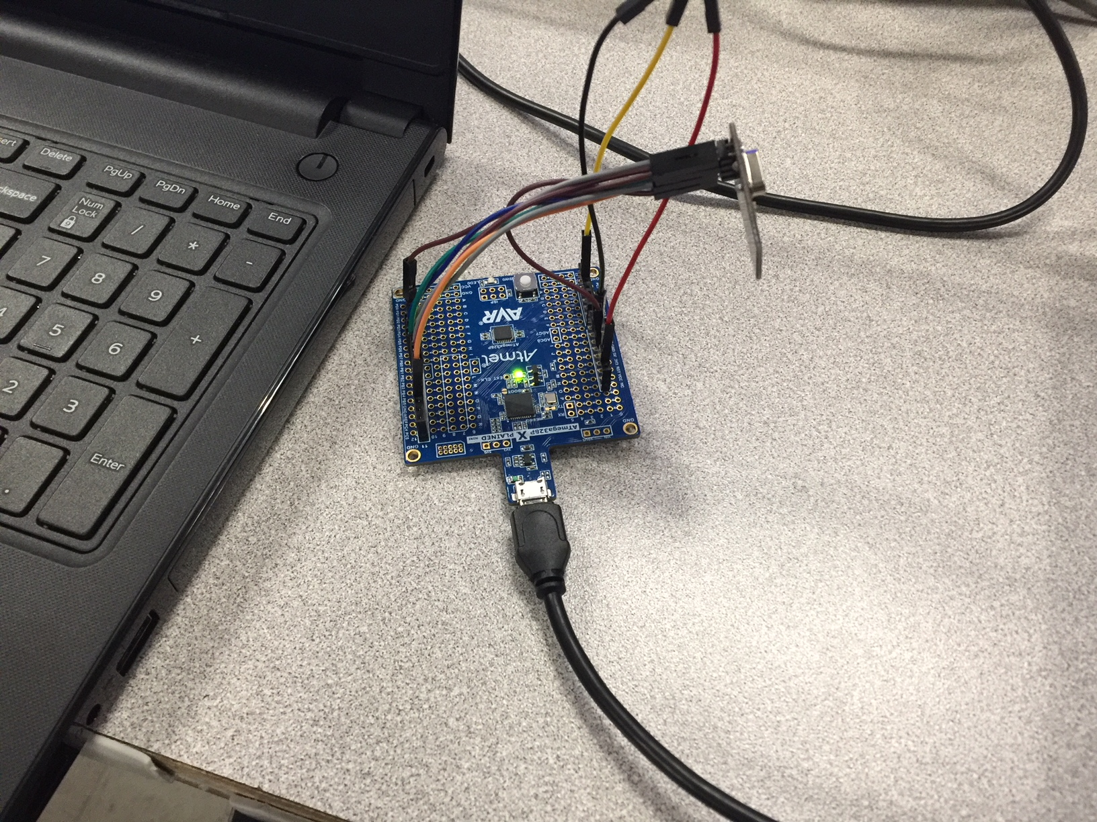

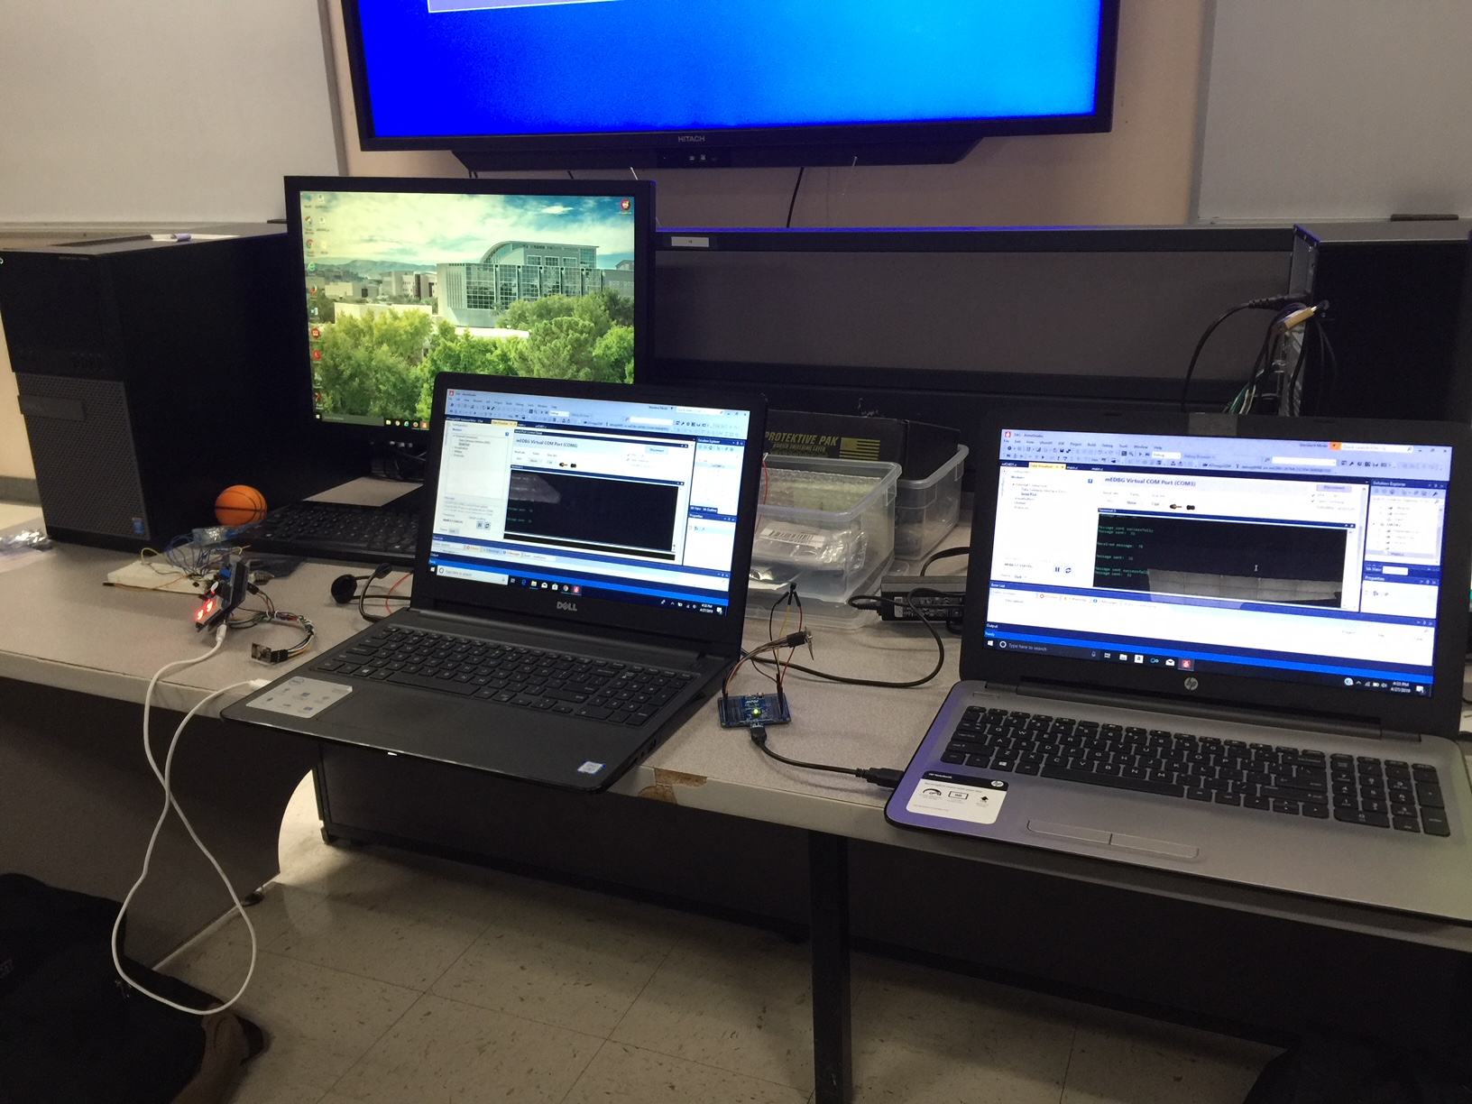

1. **VIDEO LINKS OF EACH DEMO**

<https://youtu.be/8FSChl0G12U>

1. **GITHUB LINK OF THIS DA**

https://github.com/matcroatia/submission_da

**Student Academic Misconduct Policy**

<http://studentconduct.unlv.edu/misconduct/policy.html>

“This assignment submission is my own, original work”.

Mat Tomljenovic