CPE301 – SPRING 2019

Design Assignment 6

Student Name: Mat Tomljenovic

Student #: 1012254710

Student Email: tomljeno@unlv.nevada.edu

Primary Github address: https://github.com/matcroatia/

Directory: https://github.com/matcroatia/submission_da

1. **COMPONENTS LIST AND CONNECTION BLOCK DIAGRAM w/ PINS**

Atmega328P microcontroller, Xplained mini gyroscope.

1. **INITIAL/MODIFIED/DEVELOPED CODE OF TASK 1/A**

/*

* DA6.c

*

* Created: 5/3/2019 5:27:54 PM

* Author : Mat Tomljenovic

*/

#define F_CPU 16000000UL

#include <avr/io.h>

#include <util/delay.h>

#include <inttypes.h>

#include <stdlib.h>

#include <stdio.h>

#include "MPU6050_res_define.h"

#include "I2C_Master_H_file.h"

#include "USART_RS232_H_file.h"

float Acc_x,Acc_y,Acc_z,Temperature,Gyro_x,Gyro_y,Gyro_z;

void MPU6050_Init() /* Gyro initialization function */

{

*_delay_ms*(150); /* Power up time >100ms */

I2C_Start_Wait(0xD0); /* Start with device write address */

I2C_Write(SMPLRT_DIV); /* Write to sample rate register */

I2C_Write(0x07); /* 1KHz sample rate */

I2C_Stop();

I2C_Start_Wait(0xD0);

I2C_Write(PWR_MGMT_1); /* Write to power management register */

I2C_Write(0x01); /* X axis gyroscope reference frequency */

I2C_Stop();

I2C_Start_Wait(0xD0);

I2C_Write(CONFIG); /* Write to Configuration register */

I2C_Write(0x00); /* Fs = 8KHz */

I2C_Stop();

I2C_Start_Wait(0xD0);

I2C_Write(GYRO_CONFIG); /* Write to Gyro configuration register */

I2C_Write(0x18); /* Full scale range +/- 2000 degree/C */

I2C_Stop();

I2C_Start_Wait(0xD0);

I2C_Write(INT_ENABLE); /* Write to interrupt enable register */

I2C_Write(0x01);

I2C_Stop();

}

void MPU_Start_Loc()

{

I2C_Start_Wait(0xD0); /* I2C start with device write address */

I2C_Write(ACCEL_XOUT_H); /* Write start location address from where to read */

I2C_Repeated_Start(0xD1); /* I2C start with device read address */

}

void Read_RawValue()

{

MPU_Start_Loc(); /* Read Gyro values */

Acc_x = (((int)I2C_Read_Ack()<<8) | (int)I2C_Read_Ack());

Acc_y = (((int)I2C_Read_Ack()<<8) | (int)I2C_Read_Ack());

Acc_z = (((int)I2C_Read_Ack()<<8) | (int)I2C_Read_Ack());

Temperature = (((int)I2C_Read_Ack()<<8) | (int)I2C_Read_Ack());

Gyro_x = (((int)I2C_Read_Ack()<<8) | (int)I2C_Read_Ack());

Gyro_y = (((int)I2C_Read_Ack()<<8) | (int)I2C_Read_Ack());

Gyro_z = (((int)I2C_Read_Ack()<<8) | (int)I2C_Read_Nack());

I2C_Stop();

}

int main()

{

char buffer[20], float_[10];

float Xa,Ya,Za,t;

float Xg=0,Yg=0,Zg=0;

I2C_Init(); /* Initialize I2C */

MPU6050_Init(); /* Initialize MPU6050 */

USART_Init(9600); /* Initialize USART with 9600 baud rate */

while(1)

{

Read_RawValue();

Xa = Acc_x/16384.0; /* Divide raw value by sensitivity scale factor to get real values */

Ya = Acc_y/16384.0;

Za = Acc_z/16384.0;

Xg = Gyro_x/16.4;

Yg = Gyro_y/16.4;

Zg = Gyro_z/16.4;

t = (Temperature/340.00)+36.53; /* Convert temperature in °/c using formula */

*dtostrf*( Xa, 3, 2, float_ ); /* Take values in buffer to send all parameters over USART */

*sprintf*(buffer," Ax = %s g\t",float_);

USART_SendString(buffer);

*dtostrf*( Ya, 3, 2, float_ );

*sprintf*(buffer," Ay = %s g\t",float_);

USART_SendString(buffer);

*dtostrf*( Za, 3, 2, float_ );

*sprintf*(buffer," Az = %s g\t",float_);

USART_SendString(buffer);

*dtostrf*( t, 3, 2, float_ );

*sprintf*(buffer," T = %s%cC\t",float_,0xF8); /* 0xF8 Ascii value of degree '°' on serial */

USART_SendString(buffer);

*dtostrf*( Xg, 3, 2, float_ );

*sprintf*(buffer," Gx = %s%c/s\t",float_,0xF8);

USART_SendString(buffer);

*dtostrf*( Yg, 3, 2, float_ );

*sprintf*(buffer," Gy = %s%c/s\t",float_,0xF8);

USART_SendString(buffer);

*dtostrf*( Zg, 3, 2, float_ );

*sprintf*(buffer," Gz = %s%c/s\r\n",float_,0xF8);

USART_SendString(buffer);

}

}

1. **DEVELOPED MODIFIED CODE OF TASK 2/A from TASK 1/A**

Same as above.

1. **SCHEMATICS**

Use fritzing.org

1. **SCREENSHOTS OF EACH TASK OUTPUT (ATMEL STUDIO OUTPUT)**

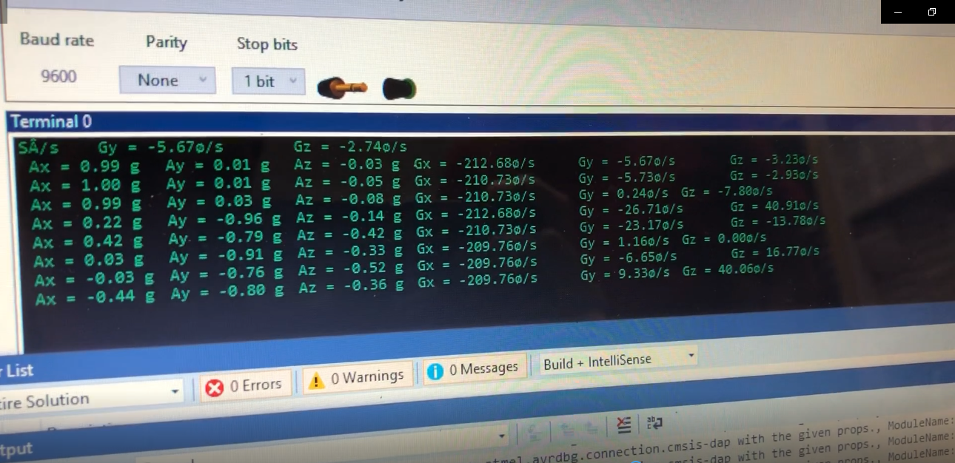

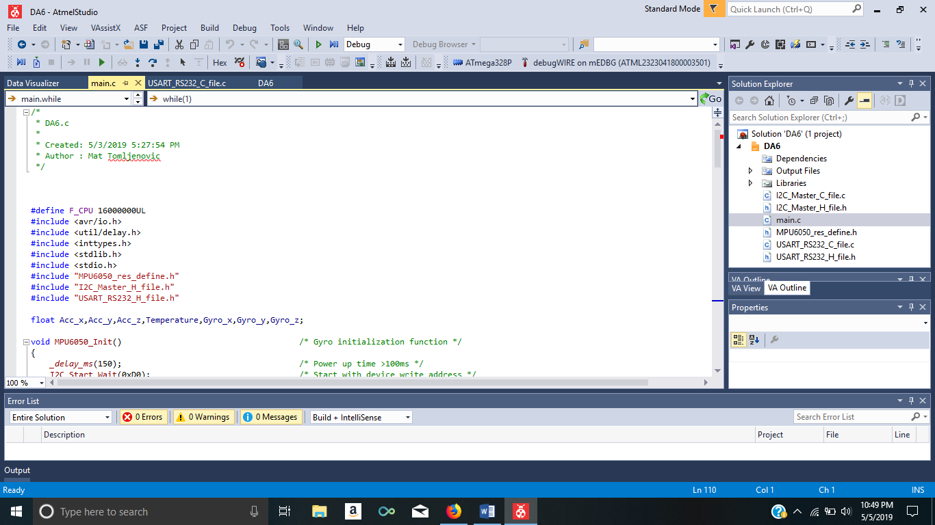

1. **SCREENSHOT OF EACH DEMO (BOARD SETUP)**

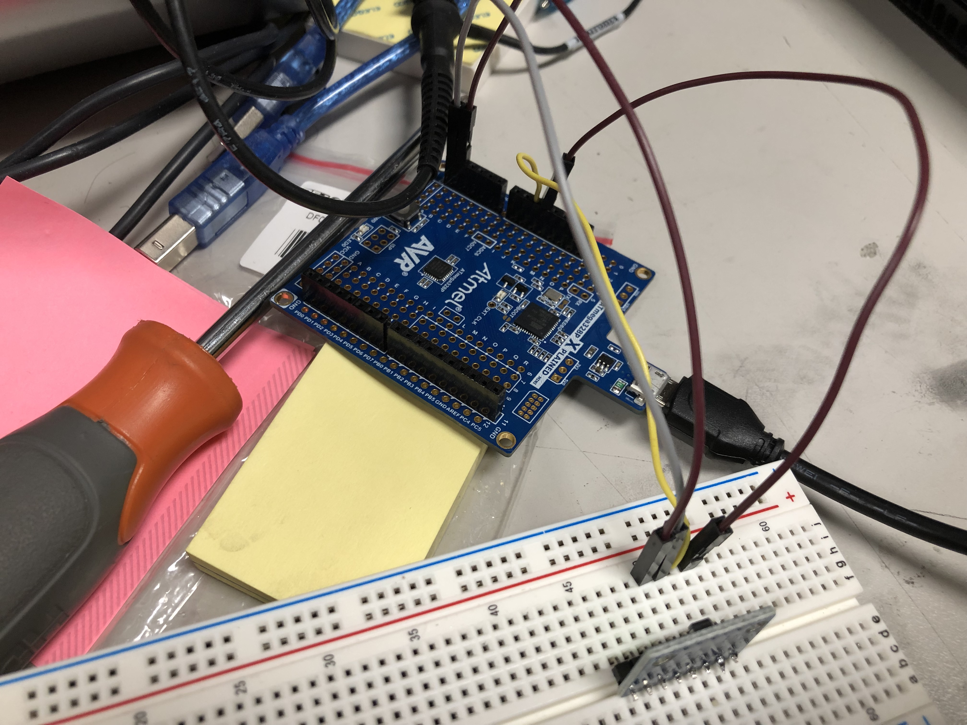

1. **VIDEO LINKS OF EACH DEMO**

<https://youtu.be/G69euUeNAZM>

1. **GITHUB LINK OF THIS DA**

https://github.com/matcroatia/submission_da/DA6

**Student Academic Misconduct Policy**

<http://studentconduct.unlv.edu/misconduct/policy.html>

“This assignment submission is my own, original work”.

Matija Tomljenovic