Receipt and Invoice Digitizer

1. Introduction
This project automates receipt and invoice digitization using OCR. The Receipt and Invoice Digitizer is an automated system designed to convert physical and digital receipts into structured digital data. The main goal of the project is to reduce manual effort involved in handling receipts and invoices. It uses Optical Character Recognition (OCR) to extract text from images and PDFs. The extracted information is then stored in a database for future reference. The system also provides analytical insights to help users understand their spending patterns. This project is useful for personal expense tracking as well as small business financial management.

2. Problem Statement
In today’s digital world, individuals and organizations still rely heavily on paper-based receipts and invoices for expense tracking and financial management. Managing these documents manually is time-consuming, inefficient, and prone to human errors. Receipts are often misplaced, damaged, or difficult to organize, making it challenging to retrieve important financial information when needed. Manual data entry from receipts into spreadsheets or accounting systems requires significant effort and can lead to inaccuracies. Additionally, receipts are generated in various formats, including printed bills, scanned copies, and digital PDFs, which further complicates uniform processing. There is a lack of an automated and centralized system that can extract useful information from these diverse formats and convert it into structured data. Without proper analytics, users also find it difficult to analyze spending patterns and make informed financial decisions.
Hence, there is a strong need for an automated receipt and invoice digitization system that can efficiently extract, store, and analyze financial data with minimal manual intervention. Manual receipt management is inefficient and error-prone.

3. Objectives
• Upload receipts
• Extract data
• Store data
• Analytics

4. Technologies Used
Python, Streamlit, Tesseract OCR, SQLite, OpenCV

5. System Architecture
The system architecture of the Receipt and Invoice Digitizer follows a clear and modular pipeline that ensures smooth data flow from input to analysis. The process begins with the Upload stage, where users upload receipt or invoice files in image or PDF formats. These documents are securely ingested and prepared for processing. In the case of PDFs, the files are converted into images to make them compatible with OCR.
The next stage is OCR Processing, where Optical Character Recognition is applied to convert the visual text in images into machine-readable text. Image preprocessing techniques such as resizing, grayscale conversion, and noise reduction are used to enhance OCR accuracy.
After OCR, the Field Extraction stage processes the raw text to identify important information such as vendor name, date, total amount, and reference number. This extracted data is then passed to the Database, where it is stored in a structured format for persistence and retrieval.
Finally, the Analytics stage uses the stored data to generate visual insights such as charts and trends, helping users analyze their expenses effectively
Upload → OCR → Extraction → Database → Analytics

About OCR (Optical Character Recognition)
OCR is a technology that converts text from images into machine-readable format. In this project, Tesseract OCR is used to extract text from receipt images and PDFs. OCR eliminates the need for manual data entry. It enables automatic extraction of textual information from scanned documents. OCR improves efficiency and accuracy when processing large numbers of receipts. It forms the core component of the digitization process.
The OCR process extracts raw text from the uploaded receipt. This extracted text contains important invoice information such as vendor name, date, and total amount. The raw text is further processed using pattern matching techniques. Regular expressions are used to identify and extract relevant fields. The conversion of unstructured OCR text into structured data makes it suitable for database storage. This step bridges the gap between image data and usable digital information.

6. Modules
Module 1: Document Ingestion
Module 2: OCR Processing
Module 3: Field Extraction
Module 4: Database Storage
Module 5: Analytics Dashboard

Module 1: Document Ingestion
The Document Ingestion module is responsible for accepting receipt and invoice files from the user. It allows users to upload documents in various formats such as JPG, PNG, JPEG, and PDF. Uploaded PDF files are converted into images to make them compatible with OCR processing. This module ensures that all input documents are securely handled and properly prepared for further processing. It acts as the first step in the receipt digitization pipeline and supports multiple document sources efficiently.

Module 2: OCR Processing
The OCR Processing module converts the uploaded receipt images into machine-readable text. It uses Tesseract OCR to extract textual information from both images and PDF-converted images. Image preprocessing techniques such as grayscale conversion, resizing, and noise reduction are applied to improve OCR accuracy. This module eliminates the need for manual data entry by automatically reading text from receipts. It forms the core component of the digitization process.

Module 3: Field Extraction
The Field Extraction module processes the raw text generated by OCR and extracts meaningful information. Important fields such as vendor name, invoice date, total amount, and reference number are identified from the OCR text. Pattern-matching techniques like regular expressions are used to locate these values accurately. This module converts unstructured OCR text into structured data that can be stored and analyzed. It ensures that only relevant invoice information is captured.

Module 4: Database Storage
The Database Storage module stores all extracted invoice data in a structured database. SQLite is used as the backend database due to its lightweight and efficient nature. Each invoice record is saved with a unique reference number to ensure traceability. The database stores details such as vendor name, date, and total amount. This module ensures data persistence, meaning the information remains available even after the application is closed. It supports reliable data management and retrieval.

Module 5: Analytics Dashboard
The Analytics Dashboard module provides visual insights based on the stored invoice data. It retrieves data from the database and presents it using interactive charts and graphs. Pie charts show spending distribution across vendors, bar charts compare expenses, and line graphs display spending trends over time. This module helps users analyze their expenses quickly and effectively. It supports better financial planning and informed decision-making.

Database and History
The database stores all extracted invoice details in a structured format. SQLite is used as the database due to its simplicity and efficiency. Each invoice is saved with a unique reference number for easy identification. The database ensures data persistence even after application restarts. The History module fetches this stored data and displays it in a readable table. Together, the database and history components provide reliable data management and easy access to past records.

Analytical Dashboard
The analytical dashboard transforms stored invoice data into meaningful insights. It visually represents spending information using interactive charts. The dashboard helps users identify high-spending vendors and observe spending trends. It simplifies complex numerical data into easy-to-understand visuals. This module supports better financial planning and decision-making. Overall, the analytical dashboard adds significant value by turning stored data into actionable insights.

7. Conclusion
The Receipt and Invoice Digitizer successfully automates the process of converting physical and digital receipts into structured, meaningful data. By integrating OCR technology with efficient preprocessing and data extraction techniques, the system reduces manual effort and minimizes errors. The use of a database ensures secure and persistent storage of invoice information, while the analytical dashboard provides valuable insights into spending patterns. The modular architecture makes the system scalable and easy to enhance in the future. Overall, the project demonstrates an effective solution for automated expense management and supports better financial tracking and decision-making.The system efficiently digitizes receipts and provides insights.

What is Receipt Data Entry?
Receipt Data Entry is the process of converting information from physical or digital receipts into a structured digital format that can be stored and analyzed in spreadsheets, accounting, or ERP systems.
These records are then used for accounting, expense tracking, and financial management purposes.
There are two methods of receipt data entry: manual and automated.
Manual receipt data entry involves copy-pasting information from paper or scanned receipts into a spreadsheet or accounting system by a human, often by a data entry clerk,
Automated receipt data entry uses tools like Optical Character Recognition (OCR) and AI to extract information accurately, with minimal human intervention.

Challenges in Manual Receipt Data Entry
So manual receipt processing is getting more outdated and businesses are gradually moving away from this method, here is the reason why:
- High employment costs: You need to hire somebody solely only for data entry when dealing with a high volume of receipts, a receipt data entry personnel has a daily rate of around $130.00. This adds up quickly when you need to hire an extra hand.
- Costly inaccuracies: Manual data entry is prone to human error and it is very costly. A single when dealing with a receipt error can lead to 10x extra cost based on the 1-10-100 rule of data entry.
- Data Security and Fraud Risks: Manual processes often lack safeguards, creating opportunities for fraud. As an example, Amazon has reimbursed $350,000 in nonexisting expenses to an employee.
- Limited Scalability: Manual processing is significantly slower and a person can only process 32 to 40 daily. This will then force you to hire another person when your personnel reaches its limit.

Benefits of Automating Receipt Data Entry
With all the challenges mentioned, here are the good sides and the major reasons why businesses are gradually transitioning:
- Cost Reduction: A basic subscription for receipt data entry software is likely below $100.00 per month. This software can easily be operated by a single employee regardless of the number of documents.
- Improved Accuracy and Error Detection: Automated tools generally have an accuracy rate of up to 97%. This is significant compared to manual data entry errors in accounting the some claiming that 14% of the errors are detrimental to costs.
- Maximized Visibility: Automation allows you to easily integrate all your information into software related to processing, making it easier to track information than having piles of files on your desktop
- High Scalability: While manual processing is limited by employee capacity, automated software can handle hundreds of receipts. simultaneously, efficiently scaling with your business growth.

How to Automate Receipt Data Entry
After reflecting on the benefits, you might think that it is difficult to set automation up. But it’s very easy, here’s the steps:

Step 1: Prepare & Digitize the Receipts
Start by preparing your receipts for digitization. Flatten any wrinkled paper receipts and ensure they are smooth for clear scanning.
Use only a scanner to capture high-quality images, ensuring proper lighting and alignment. Avoid using Smartphones as there are a lot of avenues for human errors like tilts and shadows. Be thorough, include all corners and details of each receipt.
For your receipt errors to be more efficient, consider batch scanning multiple receipts and save them in common formats like PDF.

Step 2: Establish a Digital Filing System
Make a digital filing system. This can be very basic where you can organize them according to the clients or businesses you are working for assign them according to time and have a proper naming system. You can organize like “YYYY-MM-DD – Vendor”.
Organize your files into a folder structure that suits your workflow. For instance, you can create separate folders for each client or project, with subfolders for different periods.

Step 3: Use Receipt OCR for Data Extraction
Use a recept OCR data extraction tool that will help you capture the data from the PDF files of receipts that you have. These tools will convert the PDF receipts into CSV or XLS which you can easily then import to your accounting or ERP software.
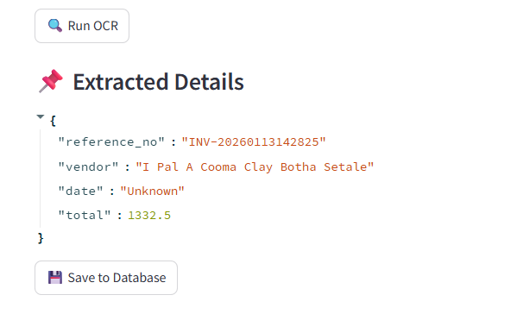
As an example, we are going to look at DocuClipper. In this tool, you can upload as many PDF Receipts as you can and this tool will scan all the necessary data that you will need for automated receipt processing. Then it’ll start converting to a spreadsheet where you can personalize or modify.

Step 4: Import or Export the Data Into Your Accounting or ERP Software
When you already have the CSV format of the receipts, you can easily then upload them to your software, from here your team can start the process like verification and evaluation.
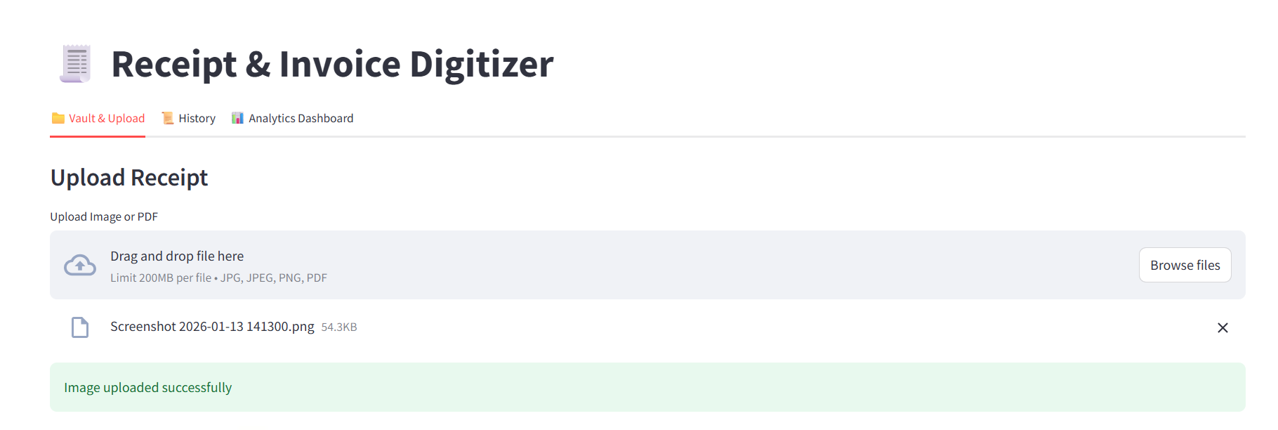
In DocuClipper, you can directly connect it to QuickBooks if you have it. For other software, you can opt for downloading it to CSV, as CSV formats are the most versatile. Just be sure to look at their preferred column organization so you can modify it within DocuClipper’s interface.

Step 5: Archive Your Receipts
After the processing, you can preserve the original records of the receipts because this will be helpful during tax time as auditors will ask for some references of the information you presented them.
The best way to keep this is to store the information on a hard drive. As a backup, you can also print a compilation of these receipts and keep them in organized folders according to chronology.

Best AR Software for Receipt Data Entry
So once you think it’s actually easy to automate your receipt data extraction process, here are the leading software out there.
- DocuClipper: DocuClipper is a financial data extraction OCR tool that converts PDF receipts into formats like Excel, CSV, and QBO with the highest accuracy. It has batch processing for bulked conversions and integrates seamlessly with QuickBooks, Xero, Sage, and other ERP platforms through its API functionality.
- Dext: Dext enhances productivity by automating receipt and invoice management. It helps accountants and businesses organize, sort, and publish financial data effortlessly, reducing manual data entry.
- Veryfi: A tool for capturing and organizing documents into structured data. With APIs and mobile capture technology, It offers fast, accurate, and secure document data extraction for businesses, reducing the need for human intervention.
- Taggun: A real-time OCR software made for scanning and extracting data from receipt documents. Taggun is for expense reporting and integrates easily into process workflows.
- SparkReceipt: A receipt-scanning app that stores financial records in the cloud. It offers easy access to receipts, invoices, and other documents anytime.

Criteria for Selecting the Best Receipt Data Entry Tool
Choosing the right invoice data extraction software is essential for streamlining your accounting processes and ensuring efficiency. Here are key criteria to consider:
- Integration Capabilities: Ensure the tool integrates seamlessly with your accounting software, like Sage or Xero. This allows for smooth data transfers, consistent workflows, and accurate financial records.
- Ease of Use: A user-friendly interface is great for new users. Look for tools with simple designs that make training easy and minimize the learning curve.
- Scalability: As your business grows, the tool should accommodate increasing volumes of receipts without added complexity or excessive costs. Scalable tools ensure long-term efficiency.
- Customer Support: Choose a tool backed by reliable, responsive support. Knowledgeable assistance can help resolve issues quickly and ensure uninterrupted operations.
- Pricing: Evaluate the pricing model, whether it’s per page, per item, or a flat subscription fee. Choose cost-effective tools where the cost remains significantly lower than manual data entry labor.

Types of Receipts
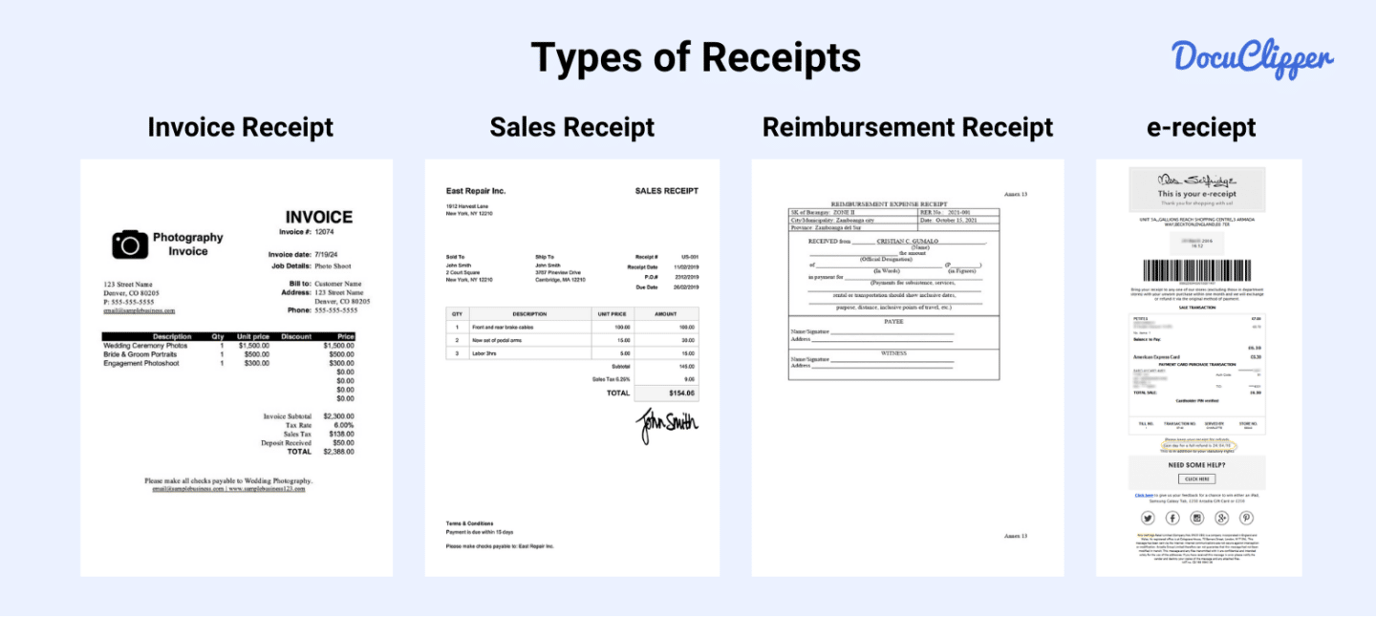
Here are some types of receipts that are being widely used today:
- Sales Receipts: These document transactions between sellers and buyers, often used in retail or online sales. They include details like items sold, prices, and payment methods.
- Payment Receipts: Issued after a payment is made, these receipts confirm the amount received and the payment method, such as cash, card, or bank transfer.
- Expense Receipts: Essential for business expense tracking, these receipts detail purchases made on behalf of the business, like office supplies or travel costs.
- Tax Receipts: Provided for tax-deductible donations or purchases, these receipts are valuable during tax filing. They include the donor’s name, amount, and transaction date.
- Delivery Receipts: These confirm the delivery of goods or services, including details like the delivery date, items received, and recipient’s signature.
- Cash Receipts: Used to acknowledge cash transactions, they are common in small businesses and informal setups.

Why Receipts are Important in Business
Receipts are necessary for maintaining consistent financial records. They serve as documented proof of purchases, helping accountants and your team track expenses and determine how money is spent over time.
Receipts play a vital role in balancing budgets and verifying transactions. They can help your businesses monitor all expenses, reconcile accounts, and serve as critical documentation during tax audits.
Managing receipts effectively protects your business from discrepancies and supports informed decision-making.

Automate Receipt Data Extraction with DocuClipper
DocuClipper is the best OCR receipt software that can scan PDF receipts and extract data in formats such as XLS and CSV. This receipt scanning software is compatible with many receipt formats with consistent accuracy. It also has Receipt OCR API features that allow you to easily connect with any ERP or accounting software.
Aside from processing receipts if you want more of an all-around tool, DocuClipper can go beyond receipts, it can process bank statements, credit card statements, invoices, checks, brokerage statements, and many more. DocuClipper does not limit your potential in accounting.

Final Advice
Automation is the new wave of financial document processing for businesses and the difference between doing it manually in terms of speed, cost, and accuracy is significantly better. Setting it up is very easy and there is no

FAQs about Receipt Data Entry
Here are some frequently asked questions about receipt data entry:

How to extract data from receipts?
You can extract data from receipts manually by copying details or using automated tools like OCR software. OCR scans and converts receipt data into structured formats like CSV or Excel, which can then be imported into accounting systems. Automation saves time, reduces errors, and ensures efficiency in receipt processing.

What data is included on the receipt?
Receipts typically include key details such as the vendor’s name, date of purchase, transaction amount, payment method, item descriptions, quantities, and prices. Some receipts may also feature tax information, discounts, and the total amount paid, depending on the type of transaction and receipt format.

How do you record receipts?
You can record receipts by organizing them digitally or physically and entering the details into accounting software, spreadsheets, or ledgers. Automation tools like OCR for accounting can scan and extract receipt data into structured formats like CSV, streamlining the process while reducing errors and saving time for bookkeeping and financial tracking.

Is a receipt an example of data?
Yes, a receipt is an example of data. It contains structured information such as transaction details, vendor names, purchase dates, amounts, and payment methods. This data is essential for tracking expenses, maintaining financial records, and conducting audits, making receipts valuable in business and accounting processes.

What is receipt details?
Receipt details refer to the specific information documented on a receipt, such as the vendor’s name, purchase date, transaction amount, payment method, item descriptions, quantities, unit prices, tax amounts, and total cost. These details are essential for tracking expenses, verifying transactions, and maintaining accurate financial records.

Is a receipt personal data?
Yes, a receipt can contain personal data, such as a customer’s name, contact details, or payment information, depending on the transaction. Businesses must handle receipts carefully to protect this information and comply with data privacy regulations like GDPR or CCPA, ensuring confidentiality and secure storage.

What is receipt journal entry?
A receipt journal entry records the financial transaction of receiving payment in accounting. It typically includes debiting the cash or bank account and crediting the sales or accounts receivable account, ensuring accurate tracking of received funds in the company’s financial records.

How do I record a receipt in Excel?
To record a receipt in Excel, create a table with columns for the date, vendor, item description, quantity, price, tax, and total amount. Enter the receipt details into the respective columns. Use formulas to calculate totals and organize receipts by categories or dates for easy tracking and analysis.
