

COMP 353

Final Project Report

Group Members

Mathieu Dumais-Savard 6095275
Justin Torres 9356592
Ramez Debbas 9103910
Wadih El-Ghoussoubi 9459510

Table Of Contents

Table Of Contents 2
Database design 3
Context and requirements 3
Changes from warm-up and justification 3
Conversion to 3NF 5
Step 1 - From Entity to relations 5
Step 2 - Looking at the various relations between entities 5
Step 3 - Write down all the modified relation and check for 3NF 7
User interface manual 9
Manager View 9
1. Clients Tab 9
Employee View 9
1. Clients Tab 9
Client View 9
1. Accounts Tab 9
How-to 9
Manage employees 9
Manage clients 10
Manage accounts 13
See my schedule and pay 14
List of members contribution 16
Installation Guide 17
How-to access source code 19

Database design

Context and requirements
Your database will be responsible for supporting
The branch (branch_id, location, phone, fax, opening_date, manager_name, etc.)
The employee (employee_id, title, name, address, start_date, salary, etc.)
The client (client_id, name, date of birth, joining_date, address, category, etc.)
The account (account_number, type, option, balance, etc.)
The services (banking, investment, insurance)
The interest rate (kind of service, type of account, percentage, etc.)
The charge plans (option, limit, charge, etc.)

Changes from warm-up and justification
We added the relationship ClientCard, Employee_Payroll, Employee_Schedule, Employee_Login since they were new requirements, ie: not present during the warm-up project.

We added the relationship Reports_Month to ease report generation.

We added views Client_Overview, Password, billableTransactionSoFarThisMonth and profitability_report to support new requirement and ease information display for the front-end.

Conversion to 3NF

Step 1 - From Entity to relations

Branch(branch_id, fax, location, phone, opening_Date)
Employee(employee_id, title, address, start_date, name, salary)
Client(client_id, category, address, name, date_of_birth, joining_date)
Services(banking, investment, insurance)
Employee_Schedule(ScheduleDay, ScheduleCode, ScheduleHours, StartTime)
Transactions(TransactionID, Amount, Data, Type, Description, Fees)
Charge_plans(plan_id, limit, plan_option, charge)
Interest_Rate(rate_id, percentage, type_of_account, kind_of_service)
Account(account_number, account_option, type, balance, creation_date, credit_limit, level)
ClientCard(ClientCardNumber, Password)
Employee_login(loginPassword)
Employee_payroll(PayId, PayDate, PayAmount)

Step 2 - Looking at the various relations between entities

Relation 1 - ManagedBy between Branch and Employee
A branch must have a manager and only one so we add manager_id references Employee(employeeId) to Branch

Branch(branch_id, fax, location, phone, opening_Date, managedBy)

Relation 2 - Employs between Branch and Employee
An employee is employed by a branch and only one, so we decided to add a branchID references Branch(branchId) to Employee

Employee(employee_id, title, address, start_date, name, salary, branchId)

Relation 3 - Provides between Branch and Services

For this one, we added the 3 fields from Services to Branch by using 3 boolean (T/F) fields to Branch. This avoid the need of a Service relation.

Branch(branch_id, fax, location, phone, opening_Date, managedBy, hasBanking, hasInvestment, hasInsurance)
Services(banking, investment, insurance)

Relation 4 - Has between Branch and Account
Each account belongs to one and only one branch, we added a branchId to Account referencing Branch(branchId).
Account(account_number, account_option, type, balance, creation_date, credit_limit, level, branchId)

Relation 5 - Has between Employees and EmployeeSchedule
Each employee is schedule for several dates, each row in the EmployeeSchedule table represent the working say of a single employee, we added EmployeeID references Employee(EmployeeID) to EmployeeSchedule and added EmployeeID to its primary key.

Employee_Schedule(ScheduleDay, EmployeeID, ScheduleCode, ScheduleHours, StartTime)

Relation 6 - Has between EmployeeLogin and Employee
Each employee has a password but we wanted the passwords to be separate for security reasons, we kept the entity Employee_Login and added EmployeeID references Employee(EmployeeID) and made it its primary key

Employee_login(employeeID, loginPassword)

Relation 7 - Has between Account and ChargePlans
Relation 8 - Has between Account and InterestRate
Each account has a single charge plan and a single interest rate. So we added two fields to account to reference these informations, namely planId REFERENCES Charge_Plan(planID) and RateId REFERENCES Interest_Rate(RateId)

Account(account_number, account_option, type, balance, creation_date, credit_limit, level, branchId, planId, rateId)

Relation 9 - Owns between Client and Account
This is the only many-to-many relationship in our E/R so we had to create a new relation to represent it.

We created the relationship Client_owns_account with two fields. ClientID REFERENCES Client(clientID) and AccountID REFERENCES Account(AccountId), the two fields were primary key of their respectives tables so we took them as the primary key of this new relation.

Client_owns_account(ClientId, AccountId)

Relation 10 - Has between Employee and Employee_Payroll
An employee can have several paycheck but each paycheck belongs to a single employee only. We added employeeId REFERENCES employee(EmployeeID) to Employee_Payroll

Employee_payroll(PayId, EmployeeID, PayDate, PayAmount)

Relation 11 - PerformedOn between Transaction and Account

Each transaction is performed on a single account, so we added an AccountID REFERENCED Account(AccoundID) field to the transaction relation

Transactions(TransactionID, Amount, Data, Type, Description, Fees, AccountId)

Relation 12 - ClientOwnsClientCard between Client and Client Card

We made the assumption that a card represents a client after reading the project description several time. A client can have several cards, each card have its own password associated with it like Desjardins does. We then added the property ClientID REFERENCED Client(ClientID) to ClientCard

ClientCard(ClientCardNumber, Password, ClientID)

Step 3 - Write down all the modified relation and check for 3NF

ClientCard(ClientCardNumber, Password, ClientID)
Transactions(TransactionID, Amount, Data, Type, Description, Fees, AccountId)
Employee_payroll(PayId, EmployeeID, PayDate, PayAmount)
Client_owns_account(ClientId, AccountId)
Account(account_number, account_option, type, balance, creation_date, credit_limit, level, branchId, planId, rateId)
Branch(branch_id, fax, location, phone, opening_Date, managedBy, hasBanking, hasInvestment, hasInsurance)
Employee(employee_id, title, address, start_date, name, salary, branchId)
Employee_login(employeeID, loginPassword)
Employee_Schedule(ScheduleDay, EmployeeID, ScheduleCode, ScheduleHours, StartTime)
Charge_plans(plan_id, limit, plan_option, charge)
Interest_Rate(rate_id, percentage, type_of_account, kind_of_service)

For each of these relations, it turns out the PrimaryKey determine all other information so they are all BCNF wich includes being all in 3NF.

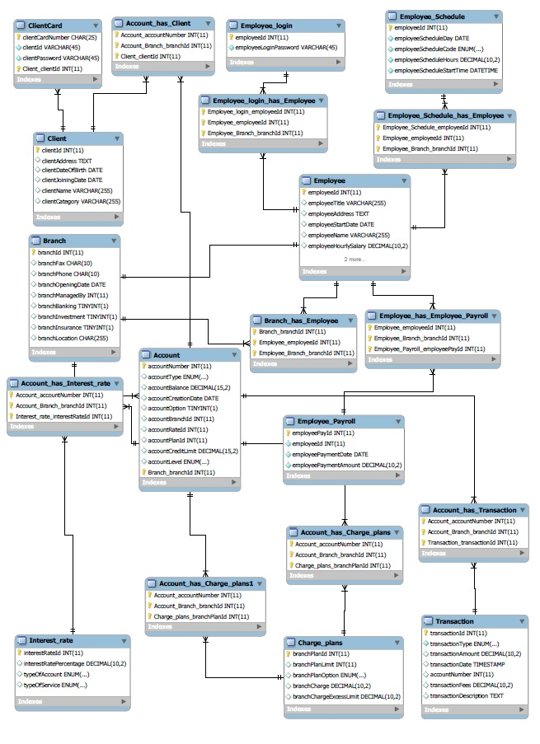

User interface manual

Manager View
Username: 3
Password: admin

Clients Tab
Managing Clients
- Accounts Tab
Managing Accounts
- Employee Tab
Managing Employees
- Manager Information Tab
Viewing Manager Information / Pay stub / work schedual

Employee View
Username: 1
Password: admin

Clients Tab
Managing Clients
- Accounts Tab
Managing Accounts
- Manager Information Tab
Viewing Employee Information/ Pay stub / work schedual

Client View
Username: 5181879446019637
Password: user

Accounts Tab
Managing Accounts such as transfer money between accounts
- Transaction Tab
Viewing Clients Transaction. Also ability to deposit and withdraw money.
- Client Information Tab
Viewing Client Information

How-to

Manage employees
Managers of branches can only manage employees. Once you are logged as a manager, you will have an employee tab where you can add, edit and delete each employee.

Each row of employee has an edit and delete buttons.
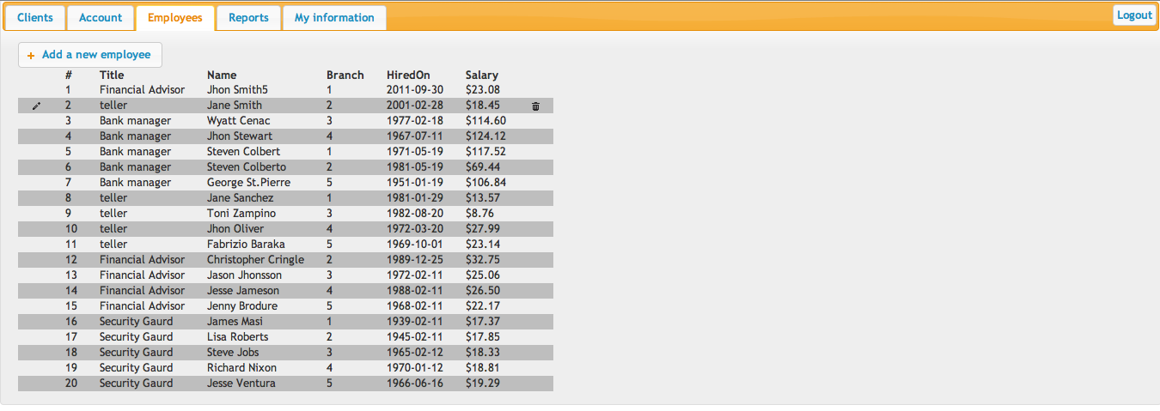

When adding, editing an employee a pop up page will show where you can select an options of that employee.
When deleting an employee, a alert message will show asking you if you want to delete the employee.

Manage clients

- Managers and Employees logged in

Managers and employees of a branch have access to an clients tab. Where they can add, edit and delete clients. Also, on each row there is an extra button where you can associate each client to a specific account that was created before.
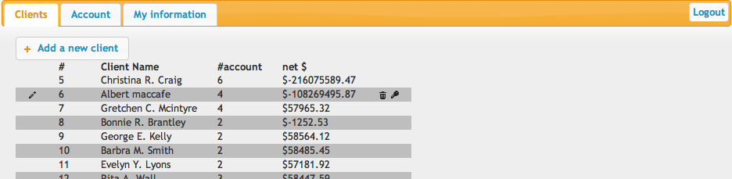

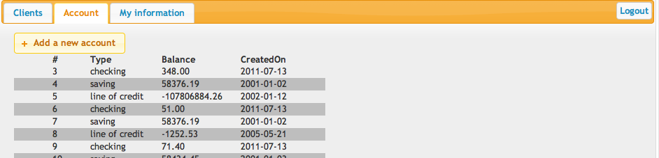

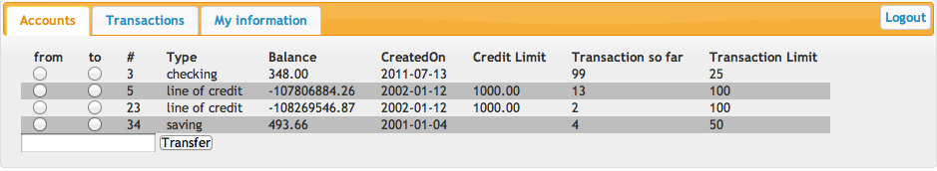
When adding, editing clients a pop up page will show where you can select an options of that client.
When deleting an client, a alert message will show asking you if you want to delete the client.

When associating an account to a client, a prompt pop up will show asking you to enter account id to be associated.
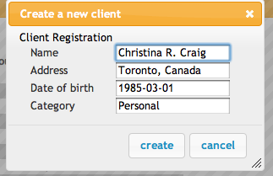
Note: you can associate multiple accounts for every employee . At the same time same account can be associated to many clients as its a joint account.

- Clients logged in

When clients login, they can view their account information under my information tab. Also, under accounts they can view all their account's information's such as account type , balance,and transferring money between them. Transaction tab to view all their past transaction including fees paid if over passed the limit. Also, you can withdraw and deposit money under transaction Tab.
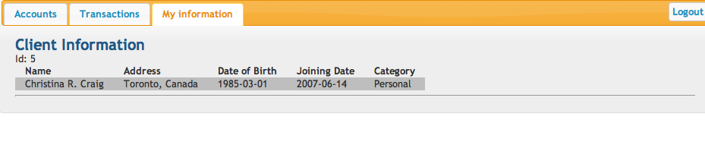

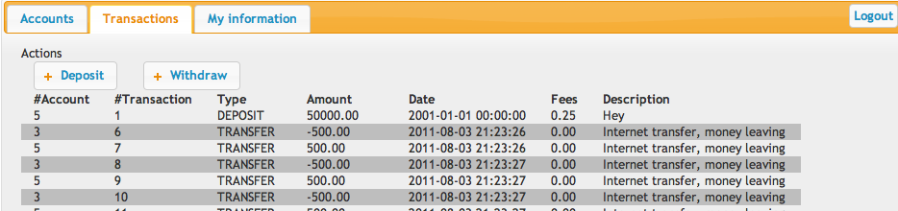

Manage accounts
Managers and employees of a branch have access to an accounts tab. You can add, edit, delete each account.

When adding, editing an account a pop up page will show where you can select an options of that account.
When deleting an account, a alert message will show asking you if you want to delete the account.
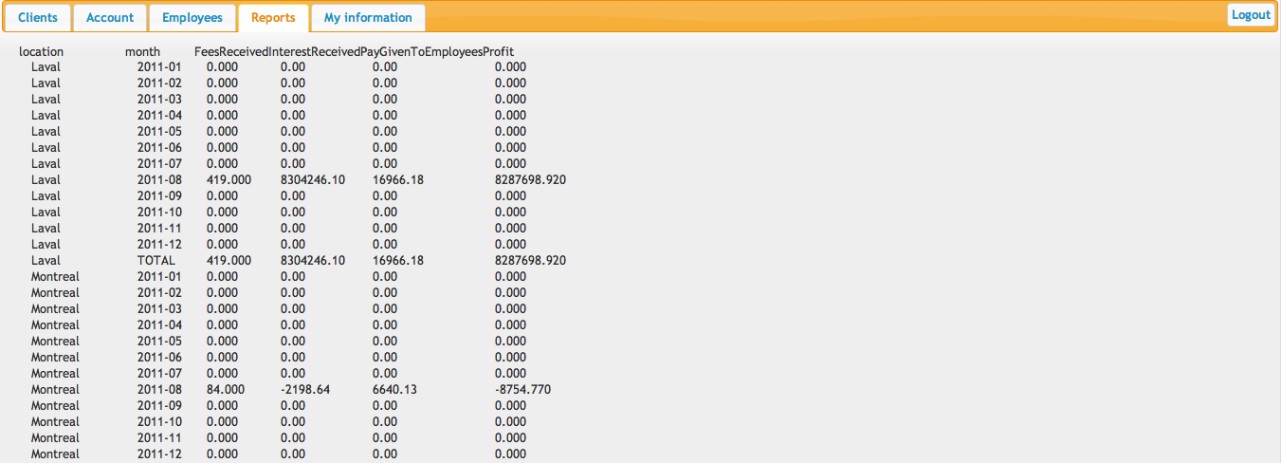
View of banking reports 1

See my schedule and pay
when you login as a employee or manager, under my information tab you will find, schedule and pay stub information.
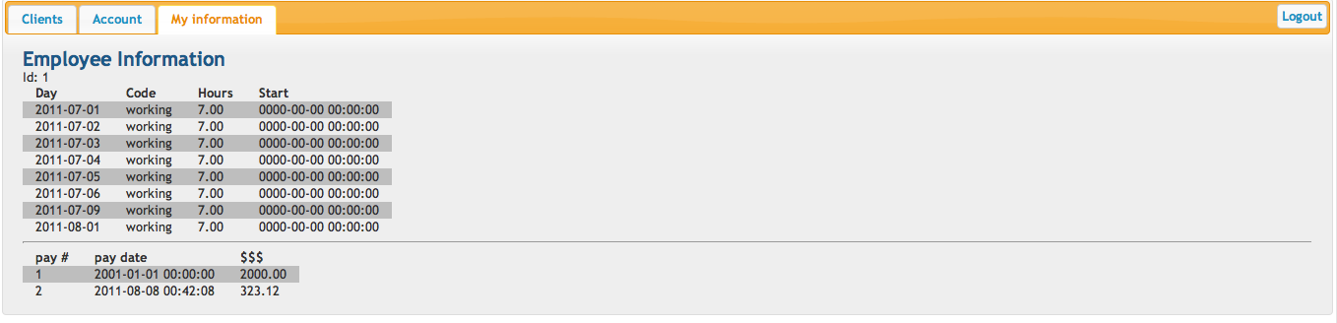

List of members contribution

What | Who
Change model to 3NF | justin
Account ADD FE | mathieu
Account MOD FE | mathieu
Account DEL FE | mathieu
Account ADD BE | mathieu
Account MOD BE | mathieu
Employee DEL BE | ramez
Employee ADD FE | ramez
Employee MOD FE | ramez
Employee DEL FE | ramez
Employee ADD BE | ramez
Employee MOD BE | ramez
Employee DEL BE | ramez
Client information FE | wadih
Client information BE | wadih

employee information FE | wadih
employee informaiton BE | wadih
employee schedule maker FE | mathieu
employee schedule maker BE | mathieu
employee schedule viewer BE | mathieu
employee schedule viewer FE | mathieu
monthly fees BE | mathieu
monthly interest BE | mathieu
calculate profit per branch BE+FE | mathieu
client add fe | mathieu, ramez
Update ER accordingly | justin
Creating Client, Employee HTML Forms | justin
client mod fe | mathieu, ramez
client delete fe | mathieu
client add be | mathieu, ramez
client mod be | mathieu
client delete be | mathieu
Client View Accounts | Ramez
Clients Accounts Transfer | mathieu
Clients Transactions | Ramez, mathieu
Client Withdraw, Deposit | Ramez
Link client with account, BE+FE | Mathieu
Server set-up | Mathieu
*fe => Front End
*be => Back End

Installation Guide
- Obtain the source code by using the instruction given in the section “How-to access source code”.
- Browse to the database folder and locate the most recent dump.
- Execute the following command:
mysql5 -h clipper.encs.concordia.ca -u dmc353_1 -p dmc353_1 < final.sql
At the prompt, enter the password L0ckL0ck
- Execute the following command:
mysql5 -h clipper.encs.concordia.ca -u dmc353_1 -p dmc353_1 < views.sql
At the prompt, enter the password L0ckL0ck
- Move the files from the code folder to the base directory for the website.
mv code/* /www/groups/d/dm_comp353_1/
mv code/.htaccess /www/groups/d/dm_comp353_1/
- Edit application/config/database.php to make sure the database credentials are set-up properly
$db['default']['hostname'] = 'clipper.encs.concordia.ca:3306';
$db['default']['username'] = 'dmc353_1';
$db['default']['password'] = 'L0ckL0ck';
- Access https://clipper.encs.concordia.ca/cgi-bin/cgiwrap/~dmc353_1/index.php in your browser. username/password are dmc353_1:L0ckL0ck. If everything goes well, you should see the login screen.
- As a bank we like to do money and our employee require to get paid once per month as specified in their contract. We need to set-up a job for this.
- type crontab -e
add the following line
0 0 0 * * mysql5 -h clipper.encs.concordia.ca -udmc353_1 -pL0ckL0ck < monthlybookkeeping.sql
This will run the bank book-keeping program every first second of every month. This has for effect of paying the employees, charging for the option plans and charging/paying interest.

How-to access source code
Start a terminal session on a unix-compatible machine with access to the Internet
type the following command
wget https://github.com/matdumsa/comp353/tarball/master comp353.tar.gz --no-check-certificate
tar -xvfz master

This will download the latest version of our project on your computer and extract its content in a folder named matdumsa-comp353-#build number. Enter that directory with cd

The folder is organised as follow:

- code (the main php application, should be put in the root public folder hosting the website).
Note: this site uses code igniter, wich comes with a “way of organising” an application aka MVC. Our code is mostly located in application/controller, application/model, application/view, js/ and css/.
- database (various dumps of the database, the views contained in it and the bank bookkeeping program)
- documentation (documentation for the application, most recent version of this file)

