Business Requirements Document(BRD) Template
Project/Initiative
Month 20YY
Version X.XX

Company Information

Document Revisions
Date | Version Number | Document Changes
05/02/20xx | 0.1 | Initial Draft

Approvals
Role | Name | Title | Signature | Date

Introduction

Project Summary

Objectives
Business Objective: Reduce the operational load on Customer Service by 40-50% within 6 months post-launch by introducing robust automated Self-Service capabilities.
Product Objective: Develop an intuitive User Account interface within the TravelMate platform enabling travelers to seamlessly cancel bookings, modify stay dates, and download financial invoices without customer support agents' intervention.
Integration Objective: Establish real-time data synchronization between the User Account module, core payment gateways (for instant refunds/additional captures), and third-party hotel Channel Managers to update room inventories instantly.

Background
[Provide a brief history of how the project came to be proposed and initiated, including the business issues/problems identified, and expected benefit of implementing the project/developing the product.]

Business Drivers
[List the business drivers that make development of this product important. These can be financial, operational, market or environmental.]

Project Scope

In Scope Functionality
- Development of the User Account dashboard with dedicated tabs for "Active", "Completed", and "Cancelled" trips.
- Implementation of the automated cancellation logic with dynamic penalty assessment (enforcing the 24-hour business rule).
- Implementation of the date-modification wizard featuring real-time room availability checks and a "Before/After" price comparison grid.
- Automated server-side generation and client-side download of official payment invoices in PDF format.

Out of Scope Functionality
- Modifying room types or transferring a reservation to a different hotel within the existing booking window (only date adjustments for the identically booked room category are permitted).
- Self-service processing of "Non-refundable" tariff cancellations (these boundary cases are routed straight to manual support tickets).
- Integration with external airline frequent-flyer loyalty systems.
- Any features, requirements, or system components that are not directly and explicitly described in the 'In-Scope' shall be considered out of scope for this stage of development.

System Perspective
[Provide a complete description of the factors that could prevent successful implementation or accelerate the projects, particularly factors related to legal and regulatory compliance, existing technical or operational limitations in the environment, and budget/resource constraints.]

Assumptions

Constraints

Risks

- .

Issues

Business Process Overview
[Describe how the current process(es) work, including the interactions between systems and various business units. Include visual process flow diagrams to further illustrate the processes the new product will replace or enhance.
Use case documentation and accompanying activity or process flow diagrams can be used to create the description(s) of the proposed or “To-Be” processes.]

Current Business Process (As-Is)
At any point during or after deployment of web apps or web sites (internal or external) to support business activities, development/support teams may create and deploy widgets.
- CMS / database administrators for the employee portal use the CMS tool to create widgets. They can test widgets in the designated staging environment, then register them and deploy to production.
- Development teams may deploy widgets to development and testing environments set up for their development projects. They must check widget code into and out of the source code repository according to their projects’ development schedule.
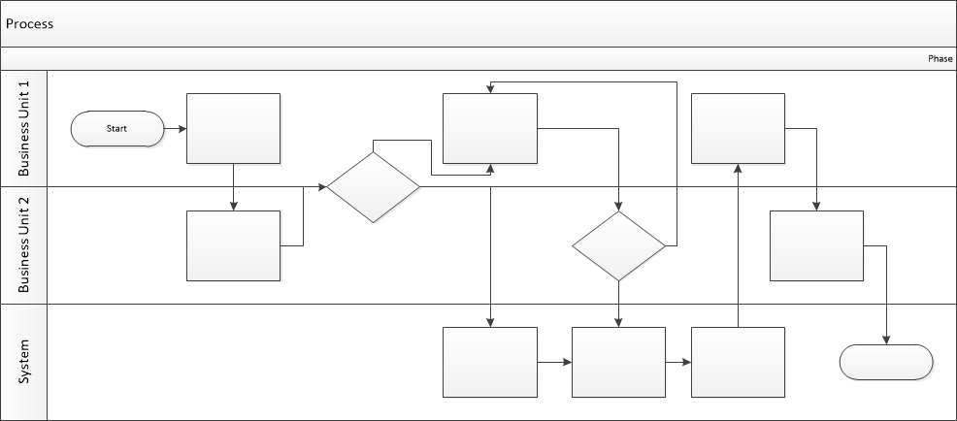

Proposed Business Process (To-Be)
- Technical Lead searches repository
- If widget is not found, user creates a new widget name record.
- WINS validates that all fields have been completed.
- WINS confirms that no similar widgets exist
- User confirms record to be created.

- User searches repository to locate existing widget description.
- WINS displays record
- User selects Edit to open and modify record
- WINS validates all fields completed correctly
- User confirms changes.
- WINS confirms changes and updates Audit table.


Stakeholder Requirements
Business Owner:
- The platform must strictly enforce financial protection rules, specifically levying a 100% first-night penalty charge if a user cancels less than 24 hours prior to scheduled check-in.
- Any inventory modification (date change or cancellation) must reflect in the hotel supply ledger instantly to neutralize the risk of double-bookings or unallocated vacant rooms.
End User (The Traveler):
- I need the ability to update or terminate my travel itineraries online with a single click, omitting long customer service queues.
- I need an explicit financial preview contrasting previous costs against new quotes before committing to change dates, ensuring there are no hidden operational markups.
- I need instantaneous access to corporate-ready PDF receipts to fulfill expense reports for business trips.

The requirements in this document are prioritized as follows:
Value | Rating | Description
1 | Critical | This requirement is critical to the success of the project. The project will not be possible without this requirement.
2 | High | This requirement is high priority, but the project can be implemented at a bare minimum without this requirement.
3 | Medium | This requirement is somewhat important, as it provides some value but the project can proceed without it.
4 | Low | This is a low priority requirement, or a “nice to have” feature, if time and cost allow it.
5 | Future | This requirement is out of scope for this project, and has been included here for a possible future release.

Functional Requirements
Req# | Priority | Description | Rationale | Use Case Reference | Impacted Stakeholders
General / Base Functionality
FR-G-001 | 1 | The system shall display a traveler’s reservations within their personal account, grouped by their booking status: Active, Completed, or Cancelled. | To structure account navigation based on survey findings (User Survey, Q3). | UC-User-01 | Traveler
FR-G-002 | 1 | The system shall allow automated cancellation of active bookings and calculate refunds/penalties dynamically. | To scale self-service capabilities while protecting supplier revenue as requested by the Business Owner. | UC-Cancel-02 | Business Owner, Traveler
FR-G-003 | 1 | Before confirming a traveler's request to change dates, the system must verify that the selected room is available for the new period. | To eradicate supplier overbooking risks and maintain synchronization with Channel Managers. | UC-Change-03 | Business Owner, Hotels
FR-G-004 | 2 | The system shall show a financial comparison between the original booking cost and the new total price before a traveler finalizes any date modifications. | Solves the primary user pain point highlighted in the survey regarding price change opacity (User Survey, Q2). | UC-Change-03 | Traveler
FR-G-005 | 2 | The system shall provide an option to download a PDF Invoice for completed reservation. | Required by 90% of surveyed users for professional accounting alignment (User Survey, Q1). | UC-Invoice-04 | Traveler, Accounting
Security Requirements
FR-S-001 | 1 | The system shall require the user to complete an extra security verification check before confirming high-value date changes or cancellations (more than 1000$ per day) | Mitigates the risk of accidental or unauthorized booking modifications and financial losses for the traveler. | UC-Sec-05 | Traveler, Security Team
Reporting Requirements
FR-R-001 | 2 | The system shall automatically generate and distribute a weekly analytical report showing the total number of self-service changes and cancellations processed. | Tracks the KPI target of shifting 40-50% of routine modifications away from manual helpdesks. | UC-Rep-06 | Business Owner, PM
Audit Requirements
FR-A-001 | 1 | The system shall record details of all financial transactions—including User ID, time, and unique Transaction ID—in the activity log. | Vital for anti-fraud detection, financial compliance, and external banking reconciliations. | UC-Audit-08 | Financial Analyst, Bank

Non-Functional Requirements
[Include technical and operational requirements that are not specific to a function. This typically includes requirements such as processing time, concurrent users, availability, etc.]
ID | Requirement
NFR-001 | Performance: The system latency for compiling dynamic penalty fees or producing a downloadable PDF document shall not exceed 3 seconds under a concurrent system load of 1,000 active sessions.
NFR-002 | Availability: The User Account module must guarantee a 99.9% operational availability uptime layer, restricting scheduled maintenance windows to off-peak periods between 02:00 AM and 04:00 AM EET.
NFR-003 | Scalability: The relational database engine must support linear expansion models, handling up to 500,000 concurrent user profile records without degradation of data-fetching response rates.
NFR-004 | Compliance: All storage, processing, and movement of user personal data within the system dashboard shall fully comply with the General Data Protection Regulation (GDPR) provisions.
NFR-005 | Security: The system shall ensure that all credit card payments and processing comply with international security standards (PCI-DSS).
NFR-006 | Data Consistency: Following a booking cancellation, the room availability status must sync back to the master supply inventory (Channel Manager) within a strict maximum window of 5 seconds.

Appendices

List of Acronyms
[If needed, create a list of acronyms used throughout the BRD document to aid in comprehension.]

Glossary of Terms
[If needed, identify and define any terms that may be unfamiliar to readers, including terms that are unique to the organization, the technology to be employed, or the standards in use.]

Related Documents
[Provide a list of documents or web pages, including links, which are referenced in the BRD.]

