Business Requirements Document(BRD) Template
Project/Initiative
Month 20YY
Version X.XX

Company Information

Document Revisions
Date | Version Number | Document Changes
05/02/20xx | 0.1 | Initial Draft

Approvals
Role | Name | Title | Signature | Date

Introduction

Project Summary

Objectives
[These should describe the overall goal in developing the product, high level descriptions of what the product will do, how they are aligned to business objectives, and the requirements for interaction with other systems.]
Reduce the load on Support team on 40%-50% and automate the process of recalculating the amount after cancellation by providing a Self-Service mechanism.

Background
[Provide a brief history of how the project came to be proposed and initiated, including the business issues/problems identified, and expected benefit of implementing the project/developing the product.]

Business Drivers
[List the business drivers that make development of this product important. These can be financial, operational, market or environmental.]

Project Scope
[Describe what work is in scope for the project, and specifically what work is out of scope… beyond the current budget, resources and timeline as approved by the project stakeholders. This is designed to prevent “scope creep” of additional features and functions not originally anticipated.]
Guests cancel the booking by one button.

In Scope Functionality
- Booking status recording
- Checking the booking status by stuff
- Cancellation booking by stuff
- Confirmation regarding cancellation
- Payment processing by card
- Refund policy
- Download invoice
- Change the date of booking
- Compare price(it was/it is)
- Automate calculated the fine
- Review after checking out of the hotel

Out of Scope Functionality
- Communication between guests and hotel staff via chat
- Payment processing by cash
- Payment processing by crypto

System Perspective
[Provide a complete description of the factors that could prevent successful implementation or accelerate the projects, particularly factors related to legal and regulatory compliance, existing technical or operational limitations in the environment, and budget/resource constraints.]

Assumptions

Constraints

Risks

- .

Issues

Business Process Overview
[Describe how the current process(es) work, including the interactions between systems and various business units. Include visual process flow diagrams to further illustrate the processes the new product will replace or enhance.
Use case documentation and accompanying activity or process flow diagrams can be used to create the description(s) of the proposed or “To-Be” processes.]

Current Business Process (As-Is)
At any point during or after deployment of web apps or web sites (internal or external) to support business activities, development/support teams may create and deploy widgets.
- CMS / database administrators for the employee portal use the CMS tool to create widgets. They can test widgets in the designated staging environment, then register them and deploy to production.
- Development teams may deploy widgets to development and testing environments set up for their development projects. They must check widget code into and out of the source code repository according to their projects’ development schedule.
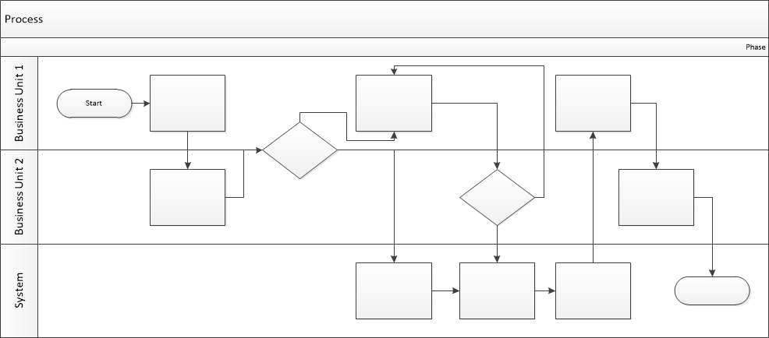

Proposed Business Process (To-Be)
- Technical Lead searches repository
- If widget is not found, user creates a new widget name record.
- WINS validates that all fields have been completed.
- WINS confirms that no similar widgets exist
- User confirms record to be created.

- User searches repository to locate existing widget description.
- WINS displays record
- User selects Edit to open and modify record
- WINS validates all fields completed correctly
- User confirms changes.
- WINS confirms changes and updates Audit table.


Stakeholder Requirements
SR-001
Guests must be able to cancel the booking
SR-002
Guest must be able to download an invoice
SR-003
Guests must be able to see price difference if they want to reschedule the booking
SR-004
Hotel staff must be able to track booking status for refresh available rooms.
The requirements in this document are prioritized as follows:
Value | Rating | Description
1 | Critical | This requirement is critical to the success of the project. The project will not be possible without this requirement.
2 | High | This requirement is high priority, but the project can be implemented at a bare minimum without this requirement.
3 | Medium | This requirement is somewhat important, as it provides some value but the project can proceed without it.
4 | Low | This is a low priority requirement, or a “nice to have” feature, if time and cost allow it.
5 | Future | This requirement is out of scope for this project, and has been included here for a possible future release.

Functional Requirements
Req# | Priority | Description | Rationale | Use Case Reference | Impacted Stakeholders
General / Base Functionality
FR-G-001 | 1 | The guest must be able to cancel the booking by pressing button “Cancellation” | Help the guest cancel the booking |  | Guest
FR-G-002 | 1 | After guest press the button “Cancellation” the system must show a pop-up with information about booking (date, time, price, hotel) and with buttons “Yes, i want to cancel my booking” and “No, i don’t want to cancel my booking” | Prevent cancellation by mistake |  | Guest
FR-G-003 | 1 | The system must show the guest during cancellation the fine (100% for the first night) in case if guest did a cancellation less than 24 hours before check-in | Prevent unpaid operation |  | Stakeholder
FR-G-004 | 3 | The guest must be able to leave the review | Help the stakeholders to understand what guest like and what they don’t like about using service |  | Stakeholder
FR-G-005 | 1 | The guest must be notify about their status of booking via email. | Help guest to understand their booking status |  | Guest
FR-G-006 | 1 | The guest must be able to do payment by card | Help the guest to pay online |  | Guest
FR-G-007 | 3 | The guest must be able to change the booking dates by pressing button “Change the dates” | Help the guest change the booking dates |  | Guest
FR-G-008 | 1 | The system must calculate and show the difference price in case if guest wants to change the booking dates. | Help guest to understand what amount they have to pay or receive as a bonus money on account for further booking |  | Guest
FR-G-009 | 1 | In case if calculated price higher than previous one, the guest must pay the difference by pressing button ”Pay the difference” | Help the guest to change the date in current booking |  | Guest
FR-G-0010 | 1 | In case if calculated price lower than previous one, the guest must be able to get the amount of difference back on their bank account | Help the guest to change the date in current booking |  | Guest
FR-G-0010 | 2 | In case if guest refuse to pay the difference price, the system must allow the guest to go on previous page of booking | Help the guest refuse to pay in case if was chosen the date by mistake |  | Guest
FR-G-0011 | 1 | The system must notify the hotel stuff regarding cancellation | To minimize mistaken cancellation |  | Hotel stuff
Security Requirements
FR-S-001 | 1 | The authorized hotel administration able to confirm or refuse the cancellation
FR-S-002 | 1 | The system must withdraw 100% payment for the first night in case if guest cancel booking after 24 hours and choose the option “Non-Refundable” during booking
Reporting Requirements
FR-R-001 | 2
Usability Requirements
FR-U-001 | 1
Audit Requirements
FR-A-001 | 1 | The system must record the date, time and user who confirm or cancel booking

Non-Functional Requirements
[Include technical and operational requirements that are not specific to a function. This typically includes requirements such as processing time, concurrent users, availability, etc.]
ID | Requirement
NFR-001 | Booking cancellation data must be stored securely in database in encrypted form.
NFR-002 | The guests must be able to cancel the booking less than 30 sec
NFR-003 | The system must be calculated the difference price less than 5 sec
NFR-004
NFR-005

Appendices

List of Acronyms
[If needed, create a list of acronyms used throughout the BRD document to aid in comprehension.]

Glossary of Terms
[If needed, identify and define any terms that may be unfamiliar to readers, including terms that are unique to the organization, the technology to be employed, or the standards in use.]

Related Documents
[Provide a list of documents or web pages, including links, which are referenced in the BRD.]

