**DESIGN DOCUMENT**

*Table of Contents*

1. ***Domain Model 2***
   1. ***UML***
   2. ***Description***
2. ***System Sequence Diagram 3***
   1. **Start a new game**
   2. **Choose start configuration**
   3. **Load a saved game**
   4. **Move blocks and moves counter**
   5. **Undo moves**
   6. **Next best move**
   7. **Save game**
   8. **Reset game**
3. ***Design class model 3***
4. ***Internal sequence diagram 4***
   1. **Start a new game**
   2. **Choose start configuration**
   3. **Load a saved game**
   4. **Move blocks and moves counter**
   5. **Undo moves**
   6. **Next best move**
   7. **Save game**
   8. **Reset game**
5. **Domain Model**
   1. **UML**

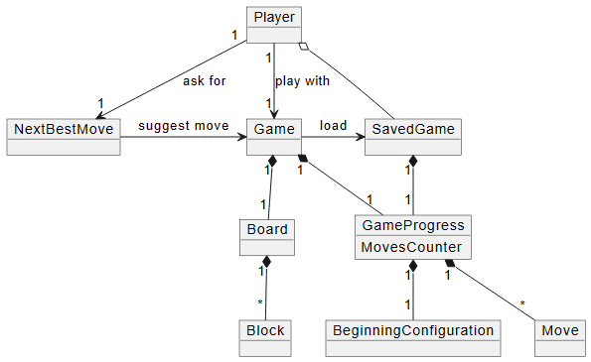

* 1. **Description**

1. **System sequence diagram**
   1. **Start new game**

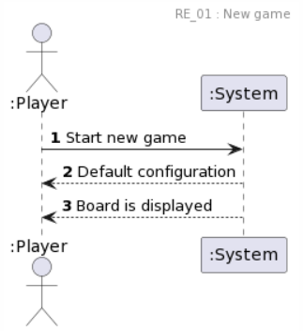

* 1. **Choose start configuration**

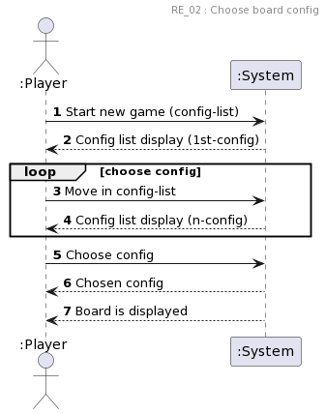

* 1. **Load saved game**

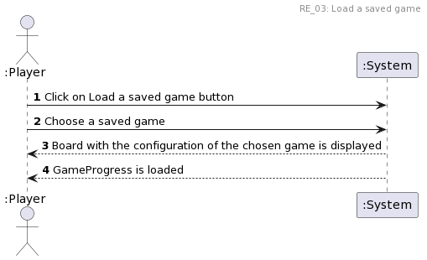

* 1. **Move blocks and moves counter**

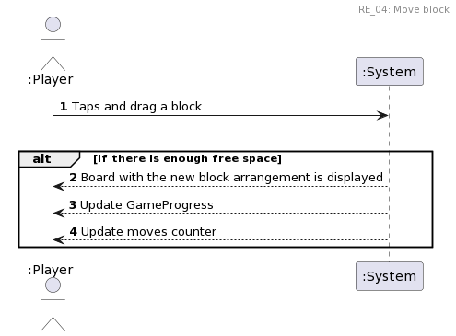

* 1. **Undo moves**

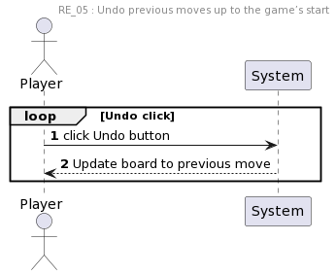

* 1. **Next best move**

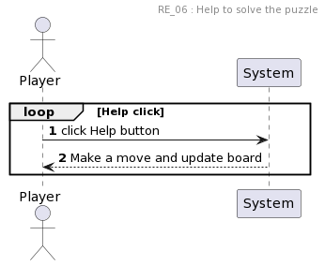

* 1. **Save game**

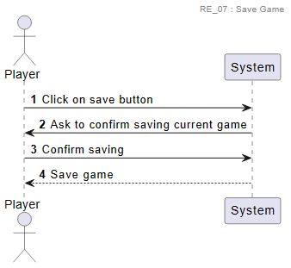

* 1. **Reset game**

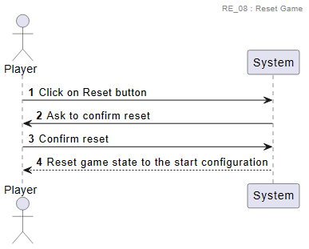

1. **Design class model**

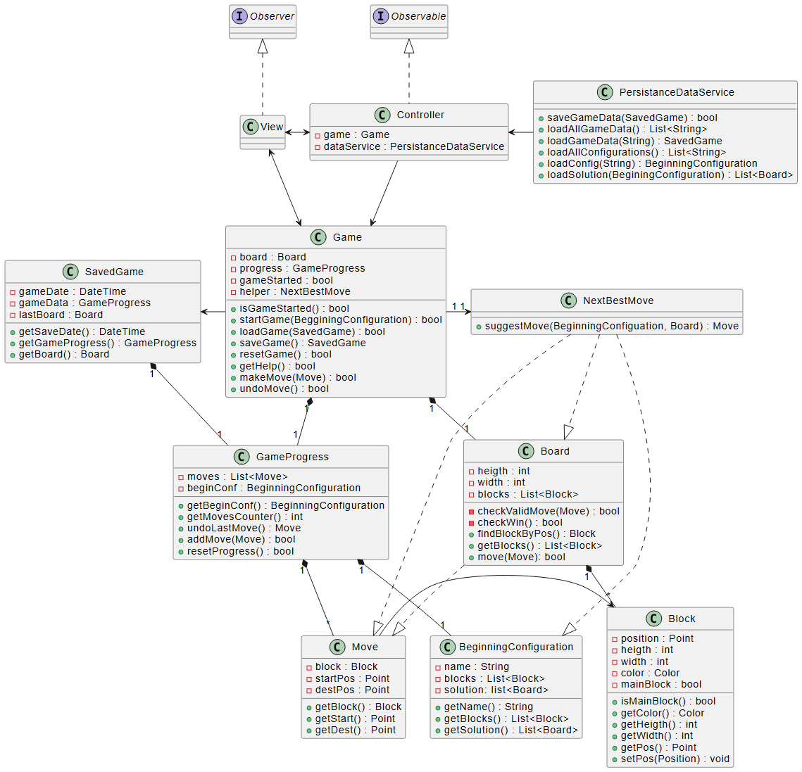

1. **Internal Sequence Diagram**
   1. **Start new game**

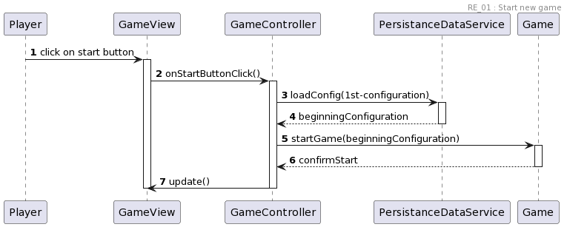

* 1. **Choose start configuration**

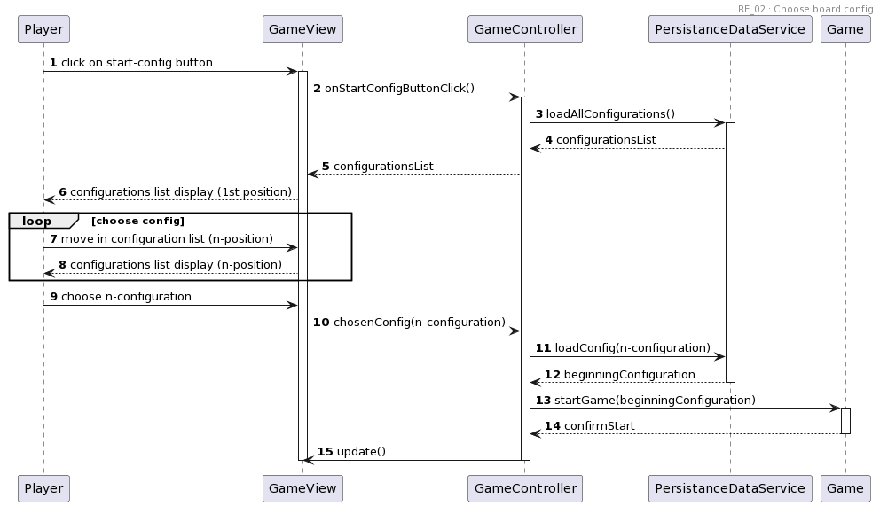

* 1. **Load saved game**

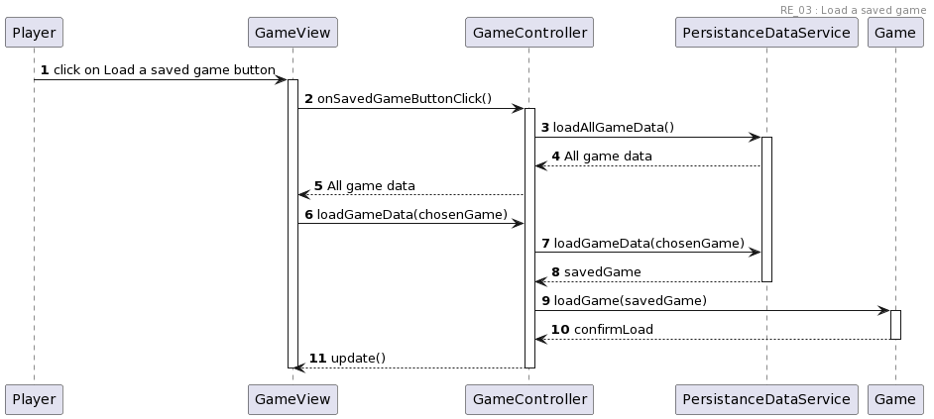

* 1. **Move blocks and moves counter**

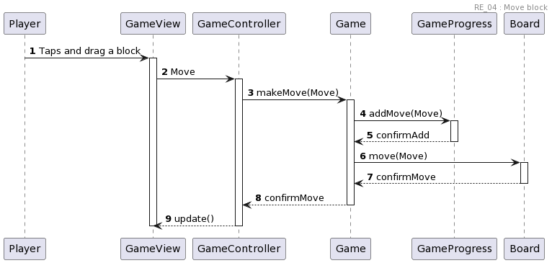

* 1. **Undo moves**

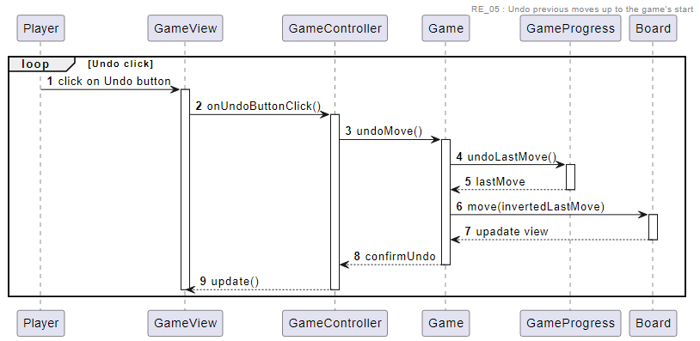

* 1. **Next best move**

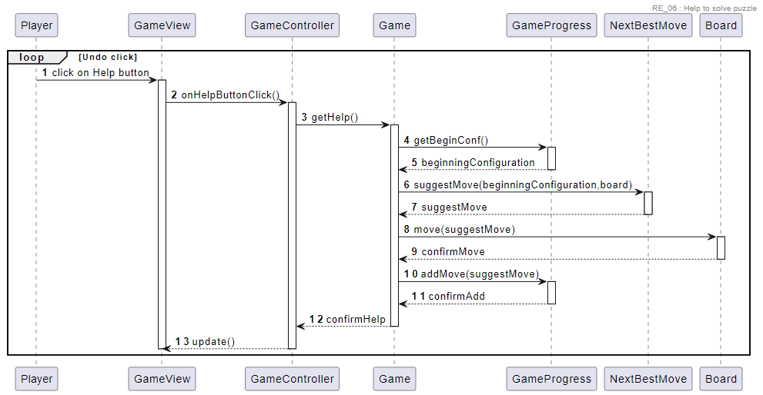

* 1. **Save game**

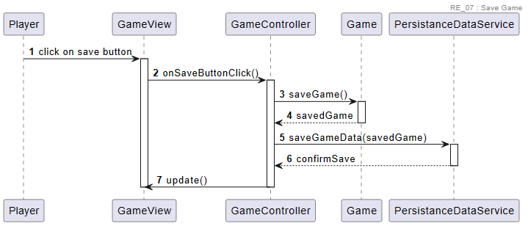

* 1. **Reset game**

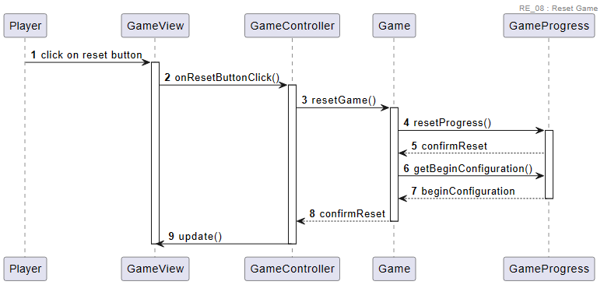

UML Code

* Domain Model:

@startuml

object Player

object Game

object GameProgress {

MovesCounter

}

object BeginningConfiguration

object Board

object Block

object Move

object NextBestMove

object SavedGame

Board "1" *-down- "*" Block

GameProgress "1" *-down- "*" Move

GameProgress "1" *-down- "1" BeginningConfiguration

SavedGame "1" *-right- "1" GameProgress

Game "1" *-down- "1" Board

Game "1" *-down- "1" GameProgress

Player "1" -down-> "1" NextBestMove : ask for

Player "1" -down-> "1" Game : play with

NextBestMove -right-> Game : suggest move

Player o- SavedGame

Game -> SavedGame : load

@enduml

Silvia

1. Start a new game
2. Choose the start board configuration between many alternatives.

Elisa

1. Load a saved game.
2. Move blocks by GUI interactions and keep moves counter.

Greta

1. Undo previous moves up to the game’s start.
2. Help to solve the puzzle.

Matteo

1. Save the actual game’s state.
2. Reset the game.

@startuml

header RE_01 : New game

autonumber

actor ":Player"

":Player" -> ":System": Start new game

":System" --> ":Player": Default configuration

":System" --> ":Player": Board is displayed

@enduml

@startuml

header RE_02 : Choose board config

autonumber

actor ":Player"

":Player" -> ":System": Start new game (config-list)

":System" --> ":Player": Config list display (1st-config)

loop choose config

":Player" -> ":System": Move in config-list

":System" --> ":Player": Config list display (n-config)

end

":Player" -> ":System": Choose config

":System" --> ":Player": Chosen config

":System" --> ":Player": Board is displayed

@enduml

@startuml

header RE_03: Load a saved game

autonumber

actor ":Player"

":Player" -> ":System": Click on Load a saved game button

":Player" -> ":System": Choose a saved game

":System" --> ":Player": Board with the configuration of the chosen game is displayed

":System" --> ":Player": GameProgress is loaded

@enduml

@startuml

header RE_04: Move block

autonumber

actor ":Player"

":Player" -> ":System": Taps and drag a block

loop

alt if there is enough free space

":System" --> ":Player": Board with the new block arrangement is displayed

":System" --> ":Player": Update GameProgress

":System" --> ":Player": Update moves counter

end

@enduml

@startuml

header RE_05 : Undo previous moves up to the game’s start

autonumber

actor "Player"

loop Undo click

"Player" -> "System": click Undo button

"System" --> "Player": Update board to previous move

end

@enduml

@startuml

header RE_06 : Help to solve the puzzle

autonumber

actor "Player"

loop Help click

"Player" -> "System": click Help button

"System" --> "Player": Make a move and update board

end

@enduml

@startuml

header RE_07 : Save Game

autonumber

actor "Player"

"Player" -> "System": Click on save button

"System" -> "Player": Ask to confirm saving current game

"Player" -> "System" : Confirm saving

"System" --> "Player" : Save game

@enduml

@startuml

header RE_08 : Reset Game

autonumber

actor "Player"

"Player" -> "System": Click on Reset button

"System" -> "Player": Ask to confirm reset

"Player" -> "System" : Confirm reset

"System" --> "Player" : Reset game state to the start configuration

@enduml

@startuml

class Game{

- board : Board

- progress : GameProgress

- gameStarted : bool

- helper : NextBestMove

+ isGameStarted() : bool

+ startGame(BegginingConfiguration) : bool

+ loadGame(SavedGame) : bool

+ saveGame() : SavedGame

+ resetGame() : bool

+ getHelp() : bool

+ makeMove(Move) : bool

+ undoMove() : bool

}

class GameProgress {

- moves : List<Move>

- beginConf : BeginningConfiguration

+ getBeginConf() : BeginningConfiguration

+ getMovesCounter() : int

+ undoLastMove() : Move

+ addMove(Move) : bool

+ resetProgress() : bool

}

class BeginningConfiguration{

- name : String

- blocks : List<Block>

- solution: list<Board>

+ getName() : String

+ getBlocks() : List<Block>

+ getSolution() : List<Board>

}

class Board {

- heigth : int

- width : int

- blocks : List<Block>

- checkValidMove(Move) : bool

- checkWin() : bool

+ findBlockByPos() : Block

+ getBlocks() : List<Block>

+ move(Move): bool

}

class Block{

- position : Point

- heigth : int

- width : int

- color : Color

- mainBlock : bool

+ isMainBlock() : bool

+ getColor() : Color

+ getHeigth() : int

+ getWidth() : int

+ getPos() : Point

+ setPos(Position) : void

}

class Move{

- block : Block

- startPos : Point

- destPos : Point

+ getBlock() : Block

+ getStart() : Point

+ getDest() : Point

}

class NextBestMove{

+ suggestMove(BeginningConfiguation, Board) : Move

}

class SavedGame {

- gameDate : DateTime

- gameData : GameProgress

- lastBoard : Board

+ getSaveDate() : DateTime

+ getGameProgress() : GameProgress

+ getBoard() : Board

}

class PersistanceDataService{

+ saveGameData(SavedGame) : bool

+ loadAllGameData() : List<String>

+ loadGameData(String) : SavedGame

+ loadAllConfigurations() : List<String>

+ loadConfig(String) : BeginningConfiguration

+ loadSolution(BeginingConfiguration) : List<Board>

}

class Controller implements Observable{}

class View implements Observer {}

Controller -down-> Game

View <-right-> Controller

Game <-up-> View

PersistanceDataService -left-> Controller

Board "1" *-down- "*" Block

Board ..|> Move

GameProgress "1" *-down- "*" Move

GameProgress "1" *-down- "1" BeginningConfiguration

SavedGame "1" *-right- "1" GameProgress

Game "1" *-down- "1" Board

Game "1" *-down- "1" GameProgress

Game -left-> SavedGame

Game "1" -right-> "1" NextBestMove

Move -> Block

NextBestMove ..|> Move

NextBestMove ..|> BeginningConfiguration

NextBestMove ..|> Board

@enduml

@startuml

header RE_01 : Start new game

autonumber

Player -> GameView : click on start button

activate GameView

GameView -> GameController : onStartButtonClick()

activate GameController

GameController -> PersistanceDataService: loadConfig(1st-configuration)

activate PersistanceDataService

PersistanceDataService --> GameController : beginningConfiguration

deactivate PersistanceDataService

GameController -> Game: startGame(beginningConfiguration)

activate Game

Game --> GameController: confirmStart

deactivate Game

GameController -> GameView : update()

deactivate GameController

deactivate GameView

@enduml

@startuml

header RE_02 : Choose board config

autonumber

Player -> GameView : click on start-config button

activate GameView

GameView -> GameController : onStartConfigButtonClick()

activate GameController

GameController -> PersistanceDataService: loadAllConfigurations()

activate PersistanceDataService

PersistanceDataService --> GameController : configurationsList

GameController --> GameView : configurationsList

GameView --> Player : configurations list display (1st position)

loop choose config

Player -> GameView : move in configuration list (n-position)

GameView --> Player : configurations list display (n-position)

end

Player -> GameView : choose n-configuration

GameView -> GameController : chosenConfig(n-configuration)

GameController -> PersistanceDataService: loadConfig(n-configuration)

PersistanceDataService --> GameController : beginningConfiguration

deactivate PersistanceDataService

GameController -> Game: startGame(beginningConfiguration)

activate Game

Game --> GameController: confirmStart

deactivate Game

GameController -> GameView : update()

deactivate GameController

deactivate GameView

@enduml

@startuml  
header RE_03 : Load a saved game  
autonumber  
Player -> GameView : click on Load a saved game button  
activate GameView  
GameView -> GameController : onSavedGameButtonClick()  
activate GameController  
GameController -> PersistanceDataService : loadAllGameData()  
activate PersistanceDataService  
PersistanceDataService -->GameController : All game data  
GameController--> GameView: All game data  
GameView-> GameController:loadGameData(chosenGame)  
GameController -> PersistanceDataService : loadGameData(chosenGame)  
PersistanceDataService --> GameController : savedGame   
deactivate PersistanceDataService  
GameController -> Game: loadGame(savedGame)  
activate Game  
Game --> GameController: confirmLoad   
deactivate Game  
GameController --> GameView : update()  
deactivate GameController  
deactivate GameView  
@enduml

@startuml

header RE_04 : Move block

autonumber

Player -> GameView : Taps and drag a block

activate GameView

GameView -> GameController : Move

activate GameController

GameController -> Game: makeMove(Move)

activate Game

Game -> GameProgress : addMove(Move)

activate GameProgress

GameProgress --> Game: confirmAdd

deactivate GameProgress

Game->Board: move(Move)

activate Board

Board-->Game: confirmMove

deactivate Board

Game --> GameController: confirmMove

deactivate Game

GameController --> GameView : update()

deactivate GameController

deactivate GameView

@enduml

@startuml

header RE_05 : Undo previous moves up to the game’s start

autonumber

loop Undo click

Player -> GameView : click on Undo button

activate GameView

GameView -> GameController : onUndoButtonClick()

activate GameController

GameController -> Game: undoMove()

activate Game

Game -> GameProgress: undoLastMove()

activate GameProgress

GameProgress --> Game: lastMove

deactivate GameProgress

Game -> Board : move(invertedLastMove)

activate Board

Board --> Game : upadate view

deactivate Board

Game --> GameController: confirmUndo

deactivate Game

GameController -->GameView: update()

deactivate GameController

deactivate GameView

end

@enduml

@startuml

header RE_06 : Help to solve puzzle

autonumber

loop Undo click

Player -> GameView : click on Help button

activate GameView

GameView -> GameController : onHelpButtonClick()

activate GameController

GameController -> Game: getHelp()

activate Game

Game -> GameProgress: getBeginConf()

activate GameProgress

GameProgress --> Game: beginningConfiguration

deactivate GameProgress

Game -> NextBestMove: suggestMove(beginningConfiguration,board)

activate NextBestMove

NextBestMove --> Game: suggestMove

deactivate NextBestMove

Game -> Board : move(suggestMove)

activate Board

Board --> Game : confirmMove

deactivate Board

Game -> GameProgress : addMove(suggestMove)

activate GameProgress

GameProgress --> Game: confirmAdd

deactivate GameProgress

Game --> GameController: confirmHelp

deactivate Game

GameController -->GameView: update()

deactivate GameController

deactivate GameView

end

@enduml

@startuml

header RE_07 : Save Game

autonumber

Player -> GameView : click on save button

activate GameView

GameView -> GameController : onSaveButtonClick()

activate GameController

GameController -> Game: saveGame()

activate Game

Game --> GameController: savedGame

deactivate Game

GameController -> PersistanceDataService : saveGameData(savedGame)

activate PersistanceDataService

PersistanceDataService --> GameController : confirmSave

deactivate PersistanceDataService

GameController -> GameView : update()

deactivate GameController

deactivate GameView

@enduml

@startuml

header RE_08 : Reset Game

autonumber

Player -> GameView : click on reset button

activate GameView

GameView -> GameController : onResetButtonClick()

activate GameController

GameController -> Game: resetGame()

activate Game

Game -> GameProgress : resetProgress()

activate GameProgress

GameProgress --> Game : confirmReset

Game -> GameProgress : getBeginConfiguration()

GameProgress --> Game : beginConfiguration

deactivate GameProgress

Game --> GameController: confirmReset

deactivate Game

GameController -> GameView : update()

deactivate GameController

deactivate GameView

@enduml