**DESIGN DOCUMENT**

*Table of Contents*

1. ***Domain Model 1***
   1. ***UML***
2. ***System Sequence Diagram 2***
   1. **Start a new game**
   2. **Choose start configuration**
   3. **Load a saved game**
   4. **Move blocks and moves counter**
   5. **Undo moves**
   6. **Next best move**
   7. **Save game**
   8. **Reset game**
3. ***Design class model 4***
4. ***Internal sequence diagram 5***
   1. **Start a new game**
   2. **Choose start configuration**
   3. **Load a saved game**
   4. **Move blocks and moves counter**
   5. **Undo moves**
   6. **Next best move**
   7. **Save game**
   8. **Reset game**
5. **Domain Model**
   1. **UML**

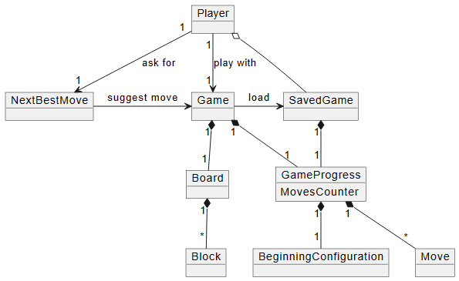

1. **System sequence diagram**

|  |  |
| --- | --- |
| * 1. **Start new game** | * 1. **Choose start configuration** |
| * 1. **Load saved game** | * 1. **Move blocks and moves counter** |

|  |  |
| --- | --- |
| * 1. **Undo moves** | * 1. **Next best move** |
| * 1. **Save game** | * 1. **Reset game** |

1. **Design class model**

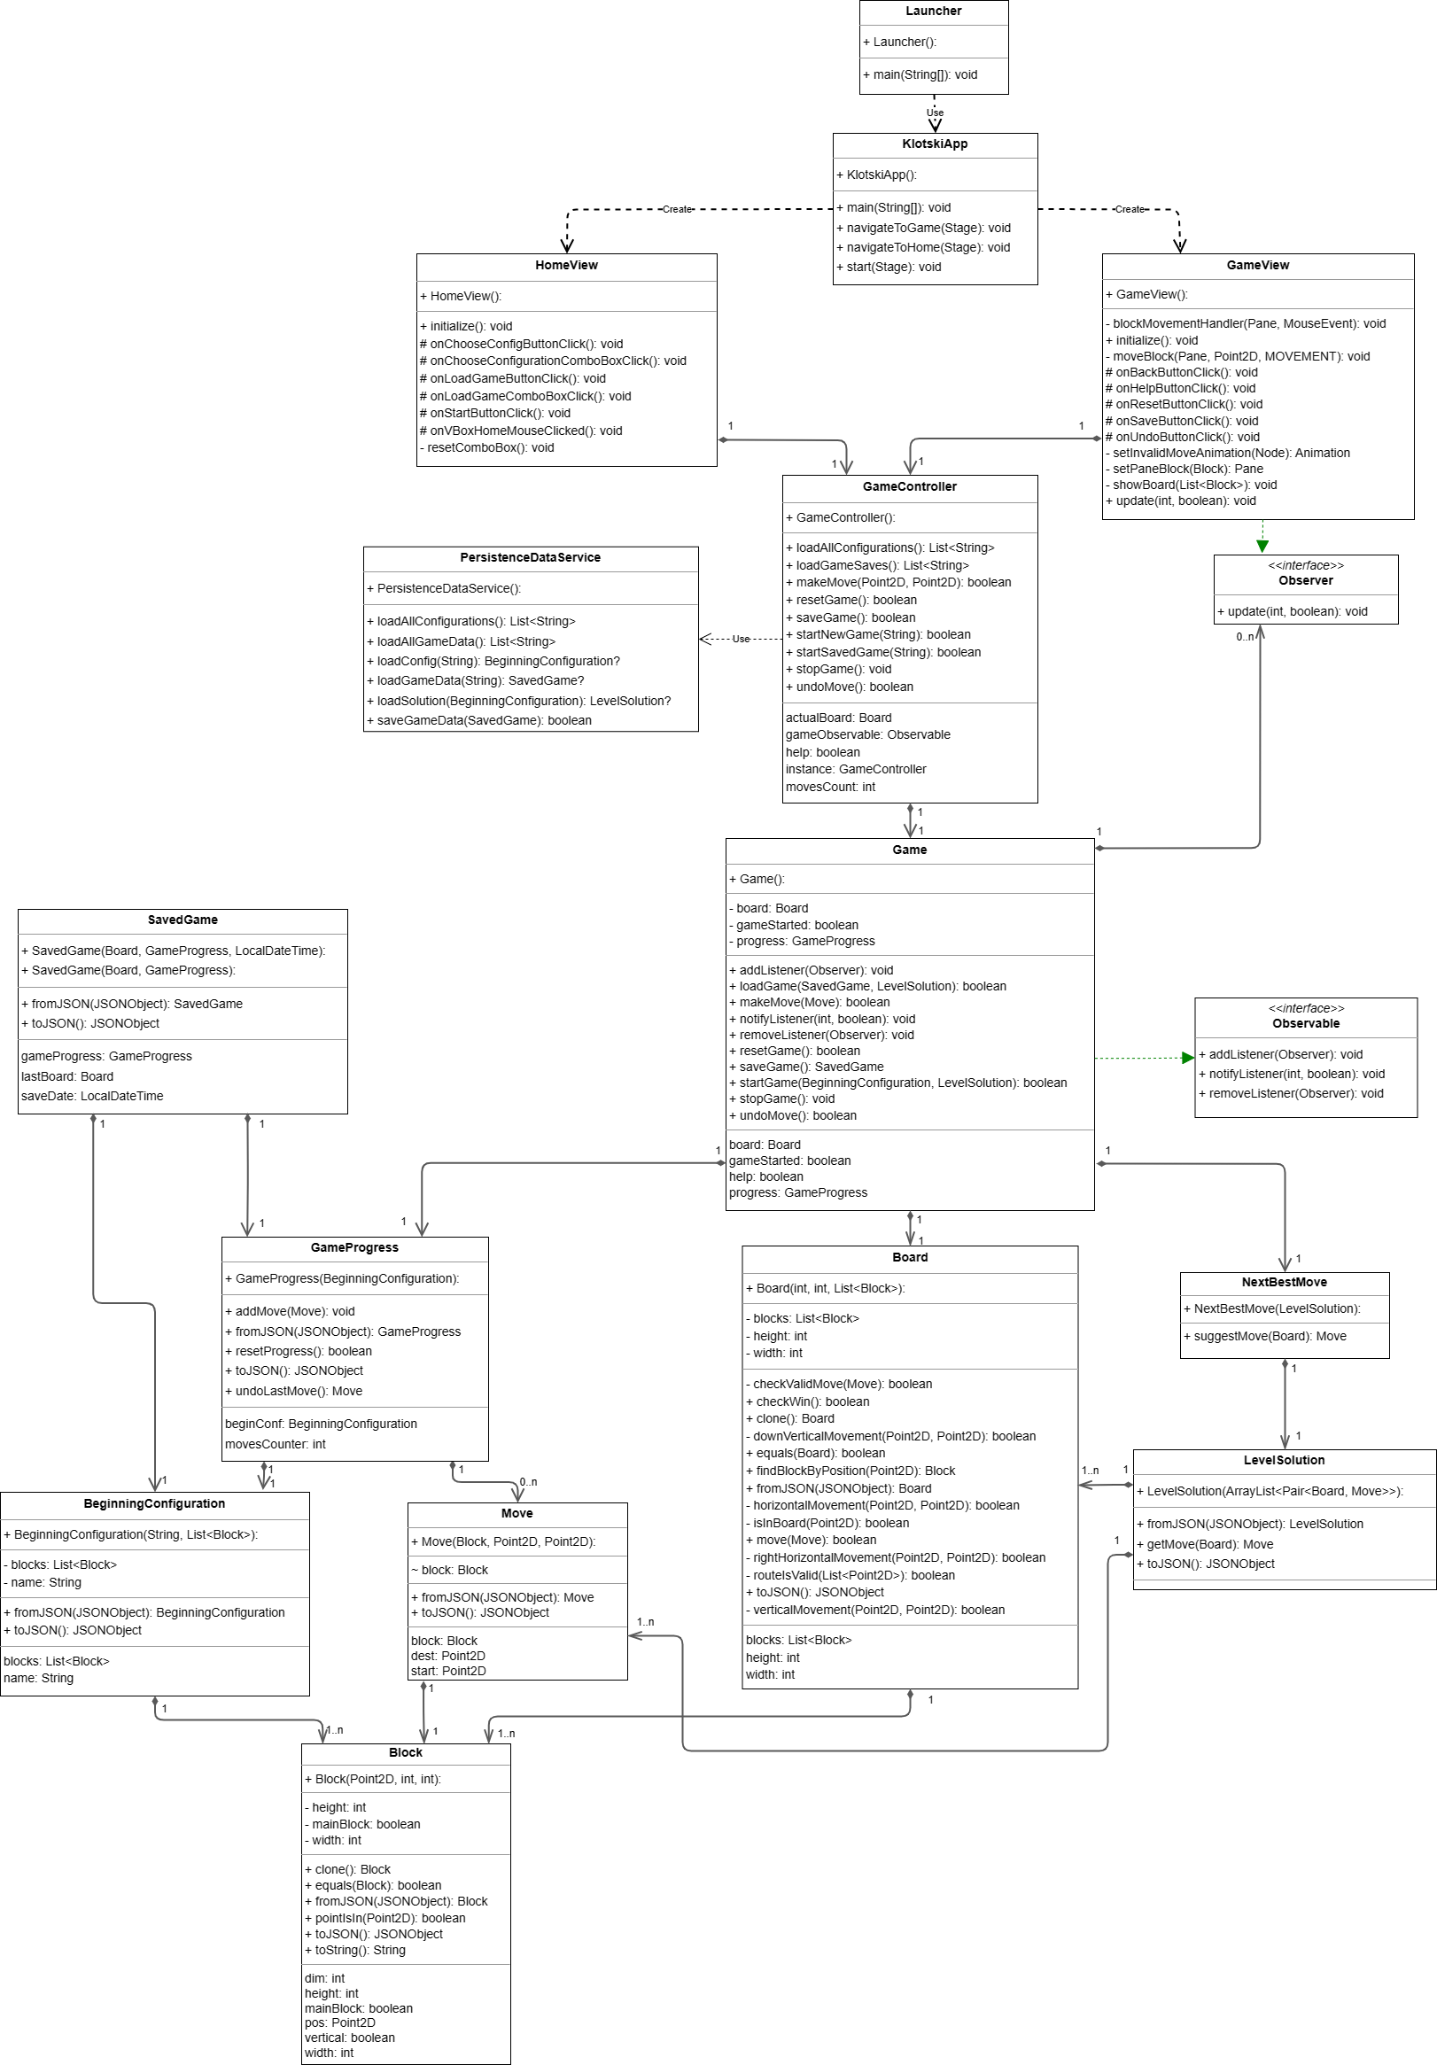

1. **Internal Sequence Diagram**
   1. **Start new game**

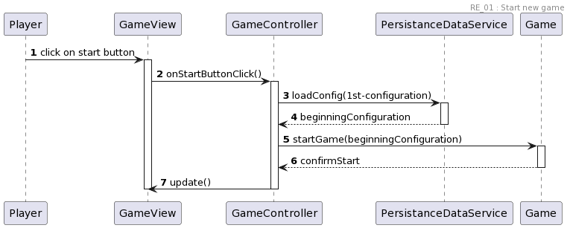

* 1. **Choose start configuration**

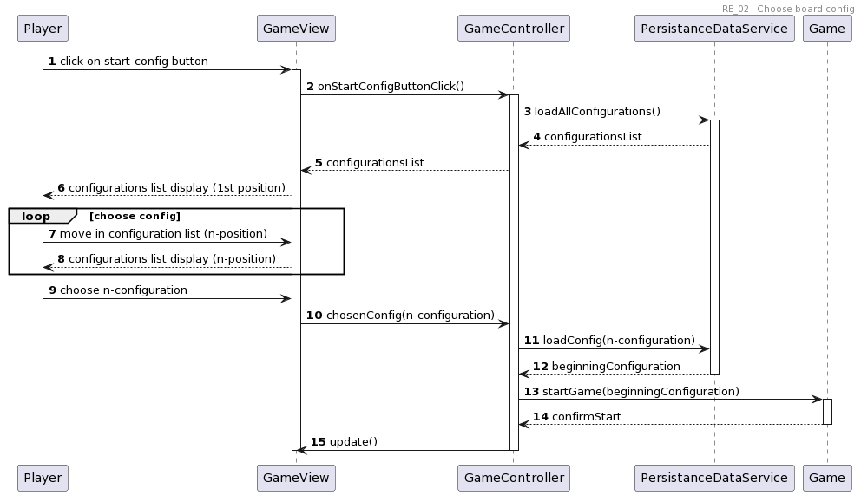

* 1. **Load saved game**

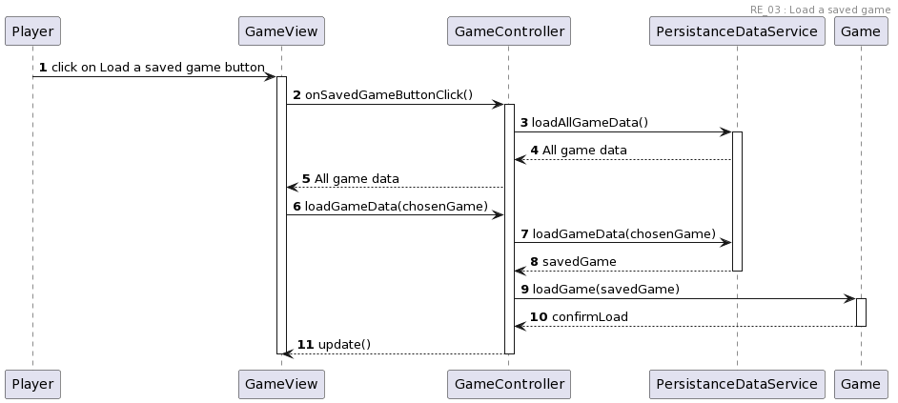

* 1. **Move blocks and moves counter**

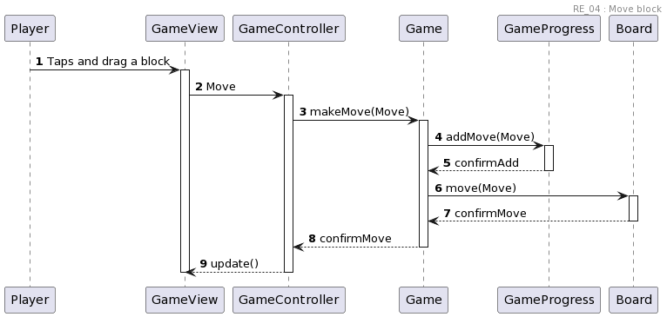

* 1. **Undo moves**

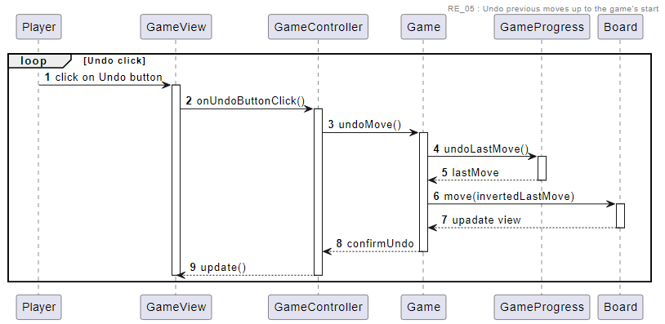

* 1. **Next best move**

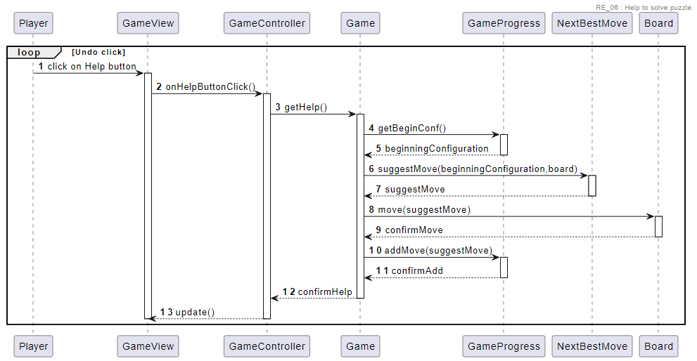

* 1. **Save game**

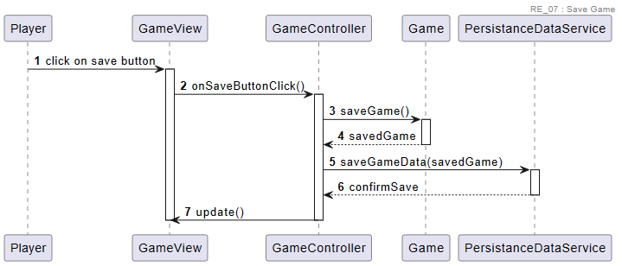

* 1. **Reset game**

