**SOFTWARE REQUIREMENTS**

*Table of Contents*

1. ***Introduction 1***
   1. ***Scope of project***
   2. ***Software description***
2. ***Overall Description 2***
   1. ***Use Cases***
   2. ***UML Use case diagram***
3. ***Specific Requirements 3***
4. **Introduction**

The following subsections of the Software Requirements Specifications (SRS) document provide an overview of the entire document. A general description of scope of project and software to produce.

* 1. **Scope of project**

Produce a Klotski game version documenting the whole process of analysis and development of the requirements and of the system.

* 1. **Software Description**

A desktop version of Klotski game with fancy graphical user interface to choose from many start configurations, saving and loading game states and get help for solving the puzzle.

1. **Overall Description**
   1. **Use Cases**
2. Start a new game
3. Choose the start board configuration between many alternatives.
4. Load a saved game.
5. Move blocks by GUI interactions and keep moves counter.
6. Undo previous moves up to the game’s start.
7. Help to solve the puzzle.
8. Save the actual game’s state.
9. Reset the game.
   1. **UML Use case diagram**

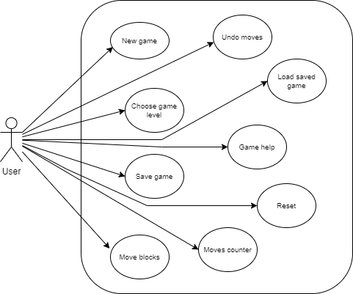

1. **Specific Requirements**

| **ID** | RE_01 |
| --- | --- |
| **Name** | New game |
| **Description** | User wants to start a new game |
| **Actors** | User |
| **Triggers** | “Play” button is pressed |
| **Preconditions** | “Play” button must be visible |
| **Post Conditions** | Game screen is displayed, where cells are placed on the first move.  Player can now make the next move. |

| **ID** | RE_02 |
| --- | --- |
| **Name** | Choose game level |
| **Description** | User can choose the start board configuration between many alternatives |
| **Actors** | User |
| **Triggers** | User asks to start a new game (before to go in game screen) RE_01 |
| **Preconditions** | There must be a number of possible game configurations available |
| **Post Conditions** | A screen is displayed, where one of the configurations can be chosen (entering it is positioned on the first configuration).  After desired configuration chosen, a new game starts |

| **ID** | RE_03 |
| --- | --- |
| **Name** | Load saved game |
| **Description** | Player wants to continue a previous saved game |
| **Actors** | User |
| **Triggers** | “Load” button is pressed |
| **Preconditions** | A previous partial game must be saved  “Load” button must be visible |
| **Post Conditions** | It will be possible to choose between previously saved games.  Game screen is displayed, with last played move and moves number = last played move |

| **ID** | RE_04 |
| --- | --- |
| **Name** | Move block |
| **Description** | Move a block to a free position equal in size to the block or greater and keep a moves counter |
| **Actors** | User |
| **Triggers** | User taps and drags a block in the direction he wants to move it |
| **Preconditions** | User has to start a game or load a previous one |
| **Post Conditions** | If there is enough free space the move is made and the moves counter is incremented, otherwise the block is not moved |

| **ID** | RE_05 |
| --- | --- |
| **Name** | Undo move |
| **Description** | Undo of the last move made and restoration of the previous situation. It is possible to return to the beginning of the game by undoing all the moves made |
| **Actors** | User |
| **Triggers** | Click on undo button |
| **Preconditions** | User has to start a game or load a previous one and do any moves. |
| **Post Conditions** | The position of the blocks is restored to the penultimate move or eventually it returns to the beginning of the game. |

| **ID** | RE_06 |
| --- | --- |
| **Name** | Next best move |
| **Description** | Help to solve the puzzle by making the best move |
| **Actors** | User |
| **Triggers** | Click on next best move button |
| **Preconditions** | User has to start a game or load a previous one |
| **Post Conditions** | The best move to solve the puzzle is made and eventually the puzzle is solved |

| **ID** | RE_07 |
| --- | --- |
| **Name** | Save Game |
| **Description** | Option to save game progress |
| **Actors** | User |
| **Triggers** | Click on save button |
| **Preconditions** | User has to start a game or load a previous one and do any moves |
| **Post Conditions** | Game is saved and ready to be loaded again |

| **ID** | RE_08 |
| --- | --- |
| **Name** | Reset |
| **Description** | Reset game level to initial situation |
| **Actors** | User |
| **Triggers** | Click on reset button |
| **Preconditions** | User has to start a game or load a previous one and do any moves |
| **Post Conditions** | Progress are setted to initial state |