**Manual**

**Game description**

Klotski is a puzzle game whose goal is to move, in the fewest number of moves, the main block to the bottom central position.

The game can start from different blocks position on the board.

All movements are saved and can be undone.

A solver can be used to recommend next best move.

- Main view

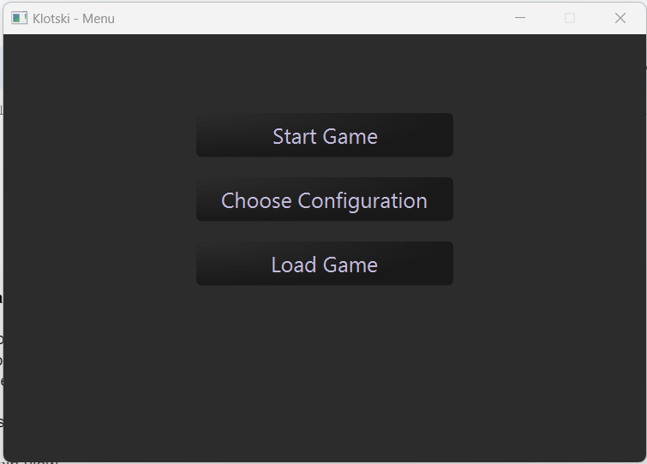

 Starts a new game

 Allows to choose a starting configuration from several

 Allows to load and continue a previously saved game

- Game view

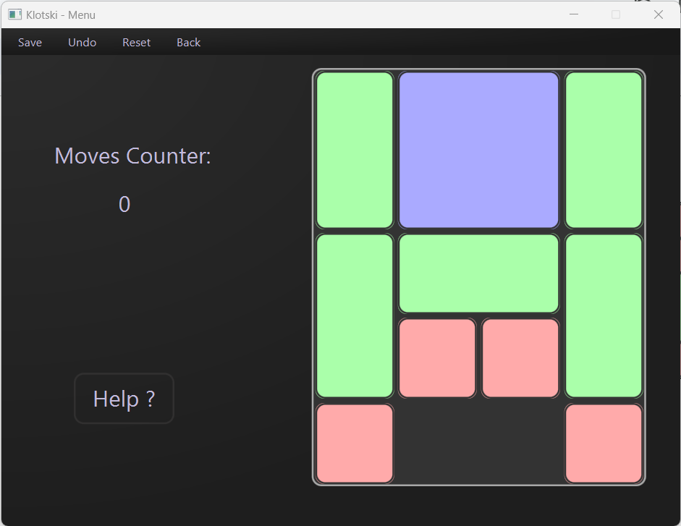

The blocks are displayed inside the board in the actual position.

Each single block, selected by mouse, can be dragged horizontally or vertically into the adjacent free position.

 Save the game in the current situation

 Undo last move

 Returns to initial configuration

 Returns to the main window

 Solver recommends the next move

 Shows moves number made since game start

Programs files like savings are placed under User Home/KlotksiGame

**System Requirements:**

* OS : Windows (10 or Newer)
* Java: JDK 20 or newer needed to run this program
* IDE: IntelliJ IDEA 2023

**Installation Instruction:**

1. Checkout repository from GitHub
2. Double click on .jar file to run the program.

**Building Instruction:**

1. Open “klotski_project” folder in your IDE
2. Click on Build > Build Artifacts…

1. Select klotski_project:jar
2. Click on Build or double click on “klotski_project:jar”

1. Builded artifact is saved in …\klotski_project\out\artifacts\klotski_project_jar\

**Run directly from IDE:**

1. Click on Run > Edit Configurations…

1. Click on “Add New…”
2. Select “Application” from the list

1. Choose a name for configuration
2. Select “Launcher” as Main Class
3. Click on Run

**External Libaries:**

* **org.json:**

Library used for json serialization to save manage persistent game data.

This library implements JSONObject type to represent JSON data.

Main method used are *put (String, Object)* to add new key/value pair to json object and *getJSON…(String)* to get value from json object.