Oviedo
From Wikipedia, the free encyclopedia
This article is about the city in Spain. For other uses, see Oviedo (disambiguation).
Oviedo
Municipality
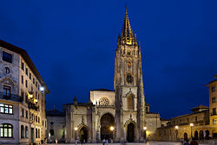
Oviedo Cathedral
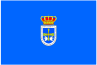  Flag | 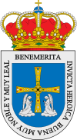  Coat of arms

Motto: Benemérita, invicta, heroica, buena, muy noble, muy leal
(Meritorious, undefeated, heroic, good, very noble, very loyal)
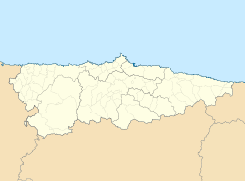
Oviedo
Location in Asturias
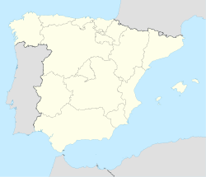
Oviedo
Location in Spain
Coordinates: 43°21′36″N 5°50′42″W
Country | Spain
Autonomous community | Principado de Asturias
Province | Asturias
Comarca | Oviedo
Capital | Oviedo
Government
• Alcalde | Wenceslao López Martinez (since 2015) (FSA-PSOE)
Area
• Total | 186.65 km² (72.07 sq mi)
Elevation | 232 m (761 ft)
Population (2014)
• Total | 222,917
• Density | 1,200/km² (3,100/sq mi)
Demonym | ovetense or, coloqually, carbayón
Time zone | CET (UTC+1)
• Summer (DST) | CEST (UTC+2)
Postal code | 33001 and 33013
Official language(s) | Spanish
Website | Official website
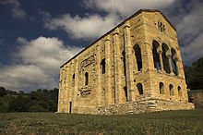
Santa María del Naranco (Pre-Romanesque shrine)
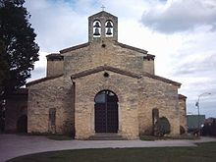
San Julián de los Prados (Pre-Romanesque shrine)
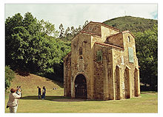
San Miguel de Lillo (Pre-Romanesque shrine)
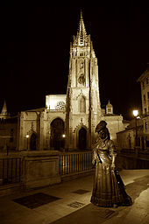
Cathedral of San Salvador (founded in 781 A.C.), and the Statue of La Regenta
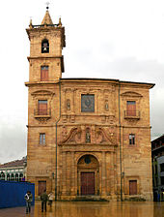
San Isidoro El Real Church
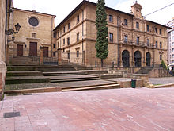
San Pelayo Monastery
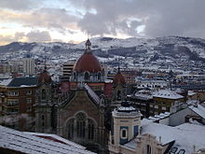
San Juan El Real church at winter
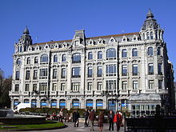
Building at Plaza de La Escandalera
Oviedo (Spanish pronunciation: [oˈβjeðo]; Asturian: Uviéu) is the capital city of the Principality of Asturias in northernSpain and the administrative and commercial centre of the region. It is also the name of the municipality that contains the city. The city lends its name to the sudarium of Oviedo a religious relic^{[1]} revered there since the 9th century. Oviedo is located approximately 20 km (12 mi) south of neighbouring cities Gijón and Avilés, in the shoreline of the Bay of Biscay. Its proximity to the ocean renders Oviedo to have a maritime climate, in spite of it not being located on the shoreline itself.

Contents
[hide]
- 1 History
- 2 Geography
- 3 Economy
- 4 Architecture
- 5 Plazas and squares
- 6 Culture
- 7 Sports
  - 7.1 Teams based in Oviedo
  - 7.2 Annual sports events
  - 7.3 Sports museum complex
- 8 Feasts and traditions
- 9 Climate
- 10 Notable people
- 11 Other places in the municipality
- 12 International relations
  - 12.1 Twin towns — sister cities
- 13 References
- 14 External links

History[edit]
The Kingdom of Asturias began in 720, with a Visigothic Aristocrat Pelagius's (685-737) revolt against the Muslims occupying most of Spain at the time. The Arab invasion of the Iberian Peninsula in 711 took control of most of the peninsula until the revolt in the northern mountains by Pelagius. The resulting Kingdom of Asturias, located in an economically poor region of the peninsula, was largely ignored by the Muslims. In 720, the area where Oviedo was located was still uninhabited.^{[2]}
It is said that two monks, Máximo and Fromestano, founded the city in 761. That settlement was soon to be completed with the construction of a small church dedicated to Saint Vincent. Oviedo was established on an uninhabited hillside, with no Visigothic or Roman foundation before it became an Asturian city.^{[3]} Following Pelagius, who died in 737, Alfonso I (739-57) founded a dynasty that would last until 1037. The Asturian Kingdom was on hostile terms with southern Arab Spain. In 794, Oviedo was sacked by Caliph Hisham I in one of his numerous campaigns against the Christian kingdoms.^{[4]}
King Alfonso I is said to have "set in place the whole order of the Goths, as it had been in Toledo, as much in the church as in the palace."^{[5]} The intention with Oviedo was to shape it into a city similar to that of Visigothic Toledo. Once kings had settled in Oviedo, they adopted as much of the architectural style and imagery of Toledo. Even with this in mind, Oviedo did not necessarily resemble the old Visigothic capital in Toledo. The churches and buildings of Oviedo follow instead late provincial Roman tradition. Since Asturias at the time was an agriculturally poor area of Spain the scale of the buildings is quite impressive.^{[6]}
Oviedo’s rich architectural tradition began with King Fruela I (757-768). King Fruela I of Asturias, the fourth of the Asturian monarchs, was the first decided promoter of the city as may be witnessed by his construction of both a palace and a nearby church. This church was later restored by Alfonso II. Oviedo owes to a later king, Alfonso II The Chaste (791-842), its establishment as a capital city and ruling seat as a result of the moving of the court fromPravia and the creation of the Pilgrim’s Route to Santiago de Compostela, a major event in the history of Oviedo, a church dedicated to The Saviour, the Cathedral of San Salvador, and a royal palace formed the nucleus of Oviedo. Also constructed during Alfonso II's reign was the San Julian de los Prados church, which is one of best preserved Asturian churches. Alfonso II's successor, Ramiro I (842-850), continued Alfonso II's construction streak. Ramiro I constructed two buildings, the Church Santa Maria de Naranco and San Miguel de Lillo. The Church Santa Maria de Naranjo was likely to originally be Ramiro I's palace and later changed into a church.^{[7]} By this time the Court of the Palace was centered in Oviedo, which was the main royal residence. This court was controlled by member of the Austurian nobility.^{[8]}
Ramiro I's (842-850) eight-year tenure was uneasy, he faced rebellions from the Counts of the Palace. The first rebellion against Ramiro I was led by Alroitus, and the second rebellion was led by Piniolus. Both of these rebellions were unsuccessful in removing Ramiro I. These rebellions may have been why Ramiro I built his palace in the mountains surrounding Oviedo, presumably away from the violence.^{[8]} During the 9th century in Oviedo, Roman style property law is common. 9th century documents also indicate small scale aristocracies across the kingdom, as well as a large presence of a landowning peasantry.^{[9]}
Following Ramiro I's reign, Ordoño I (850-866) came into power and began the Asturian king’s father-son succession. Ordoño I was the first king to push southwards into Arab territory.^{[9]} Following Ordoño I's death on May 27, 866, usurpers attempted to take the throne. The following king Alfonso III (866-910), who was thirteen at the time, took refuge in Castile until his followers had killed the usurper.^{[10]}
Alfonso III's contributions to building construction are not nearly as well documented as Ramiro I's or Alfonso II's contributions. The Chronicle of Alfonso III does not mention any buildings created by Alfonso III, neither does the Chronicle of Albelda. In 882, the body of the Cordoban martyr Eulogius was sent to Oviedo. This was meant a diplomatic gift from Emir Muhammad I (852-886). Eulogius was executed in 859. The body was likely accompanied by Eulogius's book collection.^{[10]}In the 16th century, the only manuscript of Eulogius's writings was discovered in the Oviedo Cathedral Library. Here it was copied once before it disappeared completely from the library. Following an offensive in 881 against an Umayyad army, Alfsonso III returned to Oviedo to rebuild churches. It was at this time he constructed one or more palaces. The Chronicle of Albelda and the Chronicle of Sampiro tie Alfonso III's victories in battle to his program of church building in Oviedo.^{[11]} In 908, Alfonso III commissioned a gold and jewelled cross to contain the cross carried by Pelagius I at Covadonga. This "Cross of Victory" is located in the Camara Sancta in the Oviedo Cathedral. However, recent Carbon14 analysis of the wooden cross indicates that it was no older than the golden casing created to surround the cross. The commission of the casing shows us Alfonso III’s interest in perpetuating the legend of Pelagius I. Fabrication it seems, is a running tradition in Oviedo. Bishop Pelayo de Oviedo "el fabulador," or the storyteller made many fabrications during the 12th century.^{[11]}
Towards the end of Alfonso III's reign, he faced many challenges. In 901, a prophet named Alhaman led a "great army of Arabs" and attempted to take Zamora. To add to this, Alfonso III's brother Vermudo revolted in Astorga. There were several attempts at the aging Alfonso III's life by his sons. Alfonso III was overthrown by sons, and died in Zamora. His body was taken to Oviedo for burial.
The moving of the royal court to León, after the death of Alfonso III, 'The Great', links the life of the city to the relics preserved in its cathedral and the passing of pilgrims that visit El Salvador, and continue on their way to Santiago de Compostela. Kings spent less and less time in Oviedo following the change, and spent more time in the rich Duero Plains. León was built up after it became the capital, and eventually surpassed Oviedo in terms of construction.
During the 12th century, many Royal Charters were fabricated by Bishop Pelayo de Oviedo. Since were few checks on internal bookkeeping in the Asturian kingdom actions like this were commonplace in the kingdom. When original documents faded, they were copied onto cartularies and often with alterations that suited the needs of those who copied the documents. The most glaring example can be seen in the Liber Testamentorum, which was compiled by Bishop Pelayo de Oviedo in 1109. This document contained many confirmation rights and property rights of the Oviedo cathedral by Asturian and Leonese Kings. Bishop Pelayo’s intent behind this was to try to gain the independence of his see from the archbishop of Toledo or Santiago, as well as to promote Oviedo as a pilgrim destination.^{[12]} According to Sánchez-Albornoz, "He (Bishop Pelayo) always, always, always falsified."^{[13]} It is assumed that Bishop Pelayo never committed forgery for the enjoyment, but primarily to promote the church of Oviedo.^{[14]}
The following centuries (12th-16th) witness the development of the medieval city, the outlines of which are still preserved today, the construction of the city walls, a devastating fire which took place on Christmas Eve in 1521, and the aqueduct works, Los Pilares, constructed in order to provide the city with water throughout the 16th century.
The foundation of the Arts College (University of Oviedo) by Fernando de Valdés Salas, at the beginning of the 17th century, opened Oviedo to a progressive urban expansion. Further impulse was in the 18th century by the regional nobility and the construction of remarkable palaces; in the 19th century by industrial growth and the suburban development of Uría Street; and finally in the 20th century by administrative and commercial development.
In October 1934 there was a left-wing revolt against the conservative government, based in several cities. In Asturias the fighting developed into a small, short-lived civil war: the Asturian miners' strike of 1934. 50,000 workers, mostly miners, armed themselves with dynamite and captured Oviedo after heavy fighting. They gained control of the arsenal with 30,000 rifles and machine guns. The Army Chief of Staff, General Francisco Franco sent in soldiers who overpowered the rebels after severe street fighting that left 3000 rebels dead and 7000 wounded. The cathedral was badly damaged, with its eighth-century chapel blown up by a mine. In the aftermath many false atrocity stories circulated.^{[15]}
The Siege of Oviedo in 1936 was a memorable event in the Spanish Civil War. The army garrison rose in support of the coup d'étatand stood a siege of three months by an improvised force, loyal to the Second Spanish Republic until relieved in 1937.

Geography[edit]
Oviedo is located in the centre of Asturias between the Nalón River and Nora River. To the north lie Las Regueras and Llanera, to the south Mieres and Ribera de Arriba, to the east Siero and Langreo, and to the east Grado and Santo Adriano. The altitude of Oviedo is between 80 and 709 metres above sea level. The city is protected against strong winds by Monte Naranco in the north and the Sierra del Aramo in the south. The city centre is rather hilly.

Economy[edit]
The economy is strongly dependent on the tertiary sector, with many office buildings in the city centre. Oviedo's status as the administrative centre of the region supports a large number of jobs in public administration. The manufacturing sector, which remains important in this part of Spain, is not prevalent in Oviedo itself, but is more important in the adjacent municipalities ofSiero and Llanera which lie to the north of the city, between Oviedo and Gijon. In 2009 the Oviedo municipality had a total debt of €135,185,000.00.^{[16]}

Architecture[edit]
Oviedo contains a very rich architectural history, with many buildings dating back to the early medieval period. Many of the building projects were undertaken during Alfonso II's (791-842) reign and Ramiro I's (842-850) reign. Alfonso III's contributions are not as well documented.
Alfonso II is said to have built four churches, one dedicated to Christ the Saviour, the Blessed Virgin Mary, St. Tyrsus, and SS Julian and Basilissa. There are few traces of the churches dedicated to the Saviour, the Virgin Mary, and St. Tyrsus. TheSan Salvadore church, which was dedicated to the Saviour, is likely beneath the Cathedral of Oviedo. The church of Santa Maria de la Corte, which was dedicated to the Virgin Mary, was demolished in 1702.^{[17]} As for St. Tyrsus, the church dedicated to him exists today as the church of San Tirso. Only a wall and a three light window are believed to have been built by Alfonso II, the majority of the rest of the church is dated to the 14th century.^{[18]} The best preserved church constructed during Alfonso II's time was San Julian de los Prados.
Two buildings are said to have been built during Ramiro I's reign, one was a church dedicated to the Virgin Mary and the other construction was a palace. These were built just outside of Oviedo, on Monte Lignum. The church Santa Maria de Naranco seems to originally have been a palace, but later repurposed into a church. The church has an atypical plan from other churches at its time, possibly because it was supposed to contain a throne room for the king. The other church built during Ramiro I's time was San Miguel de Lillo.^{[17]}
The Chronicle of Albelda, one of the primary sources used to discern which King commissioned which building, only extends to 883. Because of this, constructions undertaken during Alfonso III's time as king were not documented.^{[11]}
The following is a list of the notable architectural sites in Oviedo:
- Cathedral of San Salvador, was erected in 1388 over the previous cathedral, which was founded in the 8th century. The original church was built by Fruela I the cruel (757), and then built upon by Alfonso II (791-842). The Tower on the south side of the church was erected in 1556. The north tower was never completed.^{[19]}
- Cámara Santa de Oviedo. Dating from 802. It is located within the Cathedral, attached to the southern transept of the cathedral, and it is a UNESCO World Heritage Site. Houses the Arca Santa chest reliquary of the Sudarium of Oviedo. The Cámara Sancta houses many Christian treasures. It contained the great gold and jeweled cross of victory for Alfonso III, which was made for housing a wooden cross used by the first Asturian king, Pelayo. The wooden cross was supposedly used in the Asturian victory at the battle of the Covadonga in 718. The Arca Sancta itself, which is covered with decorated silver plates, was commissioned by Alfonso VI (1072-1109)^{[19]}
- Santa María del Naranco Hall, 9th century. A relatively large pavilion, part of a palace complex built for the King Ramiro I.
- San Miguel de Lillo (small church), 9th century.
- Basilica of San Julián de los Prados. This church was originally constructed by Alfonso II (791-842), and is one of the best preserved Asturian churches. The church features a fresco decoration style. Although it was reported to have been placed near a palace, no trace of such palace has been found. Ideologically it would appear that church was opposed to religious imagery, which seems to parallel the iconoclast movement in the Byzantine Empire. However, there was no documentation of this ideal circulating in Spain at this point in time, so the Asturian stance on iconoclasm should not be inferred from this fact.^{[20]}
- La Foncalada. Fountain of the 9th century. It is the only preserved Pre-Romanesque civil work in the whole of Europe.
- The University of Oviedo was created in 1574, but only inaugurated on September 21, 1608, the feast of Saint Matthew. It was funded by the terms of the will of Archbishop D. Fernando Valdés Salas, minister and General Inquisitor under Charles V, Holy Roman Emperor and Philip II.
- Town Hall (Casa Consistorial). Dates from 1662.
- La Balesquida Chapel (13th century). Associated with Oviedo's taylors' guild. Repeatedly restored in the 17th, 19th and 20th centuries. It is dedicated to the Virgin of Hope.
- House of the Llanes (18th century). It is the best Baroque façade in the whole of Asturias.
- Deán Payarinos' House (20th century). A building on the Beaux Arts style. Nowadays, it houses the Eduardo Martínez Torner Conservatory.
- The Monastery of San Vicente (8th century). At the moment, home of the Archaeological Museum of Asturias.
- The Convent Church of Santo Domingo, Oviedo (16th century). One of the monastic settlements outside the city walls. The original building burnt down in 1934 and it was heavily reconstructed after the Civil War.
- El Fontán Market (17th-18th centuries). A simple but rather monumental complex; an 18th-century porticoed square, which housed the vegetable market. It fell victim to speculative manoeuvres. It was left to deteriorate on its own; claiming that it was beyond repair, it was then demolished on 1998 and rebuilt offering all modern amenities, but with its original proportions radically changed; the original complex being much lower than its modern replacement.
- Casas del Cuito, early 20th century Art Nouveau apartment building.
- Palacio de Congresos de Oviedo projected by Santiago Calatrava.
- Church of San Tirso, or the Church of Saint Thyrsus, is located south west of the main cathedral. Only the east end of the church can trace its roots to Alfonso II's reign, with the rest of the church created during the 14th century. The triple arcaded window and east wall are the only portions of the church made during early 9th century.^{[19]}
- Camposagrado Palace built in 1728 and 1744 combining baroque and neo-classical architectures. It is presently the home of the Regional Court of Asturias.^{[21]}

Plazas and squares[edit]
- Plaza de la Escandalera, located in the downtown area
- Plaza del Fontán, located in the old quarters of the city. It has been used as a marketplace for many centuries.
- Corrada del Obispo

Culture[edit]
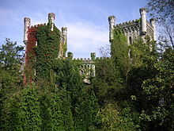
Castle of San Juan de Priorio
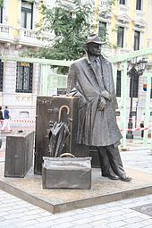
Statue dedicated to the traveller in Oviedo.
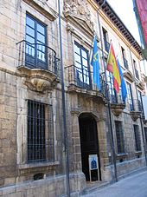
Fine Arts Museum of Oviedo of the Asturies.
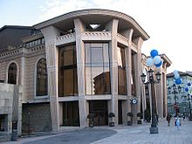
Prince Felipe Auditorium
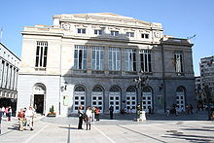
Campoamor Theatre
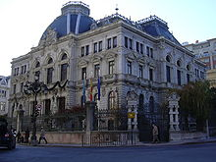
Building of the executive of the Principality of Asturies
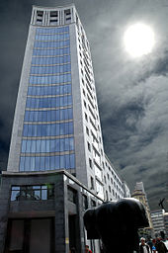
The Jirafa Building, in the commercial zone of the city.
Oviedo inspired the fictional city of Vetusta in Leopoldo Alas' La Regenta. Other Spanish writers were inspired by the city, including Ramón Pérez de Ayala in Tigre Juan and Dolores Medio in her novel Nosotros los Rivero.
Oviedo was featured prominently in Woody Allen's movie Vicky Cristina Barcelona.
Museums in Oviedo:
- Archaeological Museum of Asturias
- Museum of Fine Arts of Asturias
- Camara Santa within the Cathedral houses the Arca Santa and Sudarium of Oviedo
- Diocesan Museum
- Tabularium Artis Asturiensis
- Center for the reception and understanding of Preromanesque Art
- (future) Museum of the Militar Technology and Industry
Other cultural centres in Oviedo:
- Campoamor Theatre
- Filarmónica Theatre
- Palacio de Congresos de Oviedo
  - Prince Felipe Auditorium
  - Princess Letizia Congress Palace
Cultural institutions: Orquesta Sinfonica del Principado de Asturias is the premier orchestra of the region, the Principality of Asturias. This full-time symphony orchestra performs a wide range of the classical repertoire with world class soloists and conductors. It is based in the Auditorio Principe Felipe in Oviedo, but it also performs regularly at the main concert venues in Gijón and Avilés. It is Internationally recognized as one of the best orchestras in Spain, it is also committed to adventurous programing with strong emphasis on education and community partnerships.Rossen Milanov is the Music Director.
Oviedo also hosts the annual Princess of Asturias Awards (previously called the Prince of Asturias Awards). This prestigious event, held in the city's Campoamor Theatre, recognizes international achievement in eight different categories. Previous award winners include Oscar Niemeyer, Bob Dylan and Francis Ford Coppola in the category of Arts; Nelson Mandela, the International Space Station and Al Gore in the category of International Cooperation; and Mario Bunge, CNNand Quino in the category of Communications and Humanities.
Oviedo University's international campus attracts many foreign scholars from all over the globe.

Sports[edit]

Teams based in Oviedo[edit]
- Real Oviedo, football team. (Segunda División league)
- Oviedo Rugby Club, rugby union team. (División de Honor B)
- Oviedo CB, basketball team. (LEB Oro, second division)
- Oviedo Hockey Club, roller hockey team. (Primera División B, second division)
- Oviedo Moderno CF, football team. (Primera División league)

Annual sports events[edit]
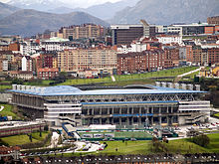
Estadio Carlos Tartiere
- International Showjumping Competition
- City of Oviedo Horse Show
- City of Oviedo San Silvestre* Outdoor Sports Climbing
- Vuelta a España (Cycling)
- Vuelta a Asturias (Cycling)
- Ascent of Naranco (Cycling)
- City of Oviedo Mountain Bike Open
- City of Oviedo Cycle Criterium
- Base Hockey International Tournament
- Prince of Asturias International Rally
- National Auto-Cross Championship
- International Hurdles Competition
- International Chess Open
- Boxing Nights
- City of Oviedo Weightlifting Championship
- Ascension Bowls Tournament
- San Mateo Bowls Tournament

Sports museum complex[edit]
- Fernando Alonso Museum , Asturais.

Feasts and traditions[edit]
The Festive Calendar:
- Cabalgata de los Reyes Magos de Oriente: The traditional Twelve Night parade, where the Three Wise Men of the East and their retinue parade through the city main streets, reaching the Cathedral Square, where they make their offering to the Child Jesus.
- L'Antroxu (Carnival)
- The Sudarium of Oviedo is displayed to the public three times a year: Good Friday, the Feast of the Triumph of the Crosson 14 September, and its octave on 21 September.
- The Feast of the Ascension
- La Foguera de San Xuan (Saint John's Bonfire):
- La Balesquida or Martes del Bollu or Martes del campo: A public holiday in the city, on a Tuesday in mid-May
- The Feast of San Mateo, a week-long festival with concerts in the cathedral square and other spectacles.
- El Desarme (Disarmament's Day), commemorating the cunning victory of the locals over a Carlist army during the First Carlist War, during the 1830s
Gastronomy:
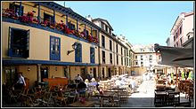
El Fontán Market
- Fabada, bean stew with selected cuts of pork, etc.
- Callos, tripe
- Carne gobernada, (chunks of meat, prepared with onion, garlic and white wine sauce)
- Chorizo a la sidra, (chorizo sausage prepared in cider)
- Paxarines, figures made from breadcrumb and egg coloured with saffron
- Carbayones, Oviedo's typical almond pastry
- Sidra, (cider), Asturian typical drink, fermented apple cider
- Arroz con leche, similar to rice pudding
- Frixuelos, similar to a crepe

Climate[edit]
Oviedo's climate is temperate oceanic (Cfb in the Köppen climate classification).
[hide]Climate data for Oviedo 336m (1981-2010)
Month | Jan | Feb | Mar | Apr | May | Jun | Jul | Aug | Sep | Oct | Nov | Dec | Year
Record high °C (°F) | 22  (72) | 24.6  (76.3) | 26.8  (80.2) | 31.5  (88.7) | 32  (90) | 35.5  (95.9) | 35  (95) | 35.6  (96.1) | 36.4  (97.5) | 31.7  (89.1) | 26.6  (79.9) | 23  (73) | 36.4  (97.5)
Average high °C (°F) | 12.0  (53.6) | 12.7  (54.9) | 14.9  (58.8) | 15.7  (60.3) | 18.2  (64.8) | 20.9  (69.6) | 22.8  (73) | 23.3  (73.9) | 22.1  (71.8) | 18.7  (65.7) | 14.6  (58.3) | 12.4  (54.3) | 17.4  (63.3)
Daily mean °C (°F) | 8.3  (46.9) | 8.7  (47.7) | 10.5  (50.9) | 11.3  (52.3) | 13.9  (57) | 16.7  (62.1) | 18.7  (65.7) | 19.1  (66.4) | 17.6  (63.7) | 14.6  (58.3) | 10.9  (51.6) | 8.9  (48) | 13.3  (55.9)
Average low °C (°F) | 4.6  (40.3) | 4.7  (40.5) | 6.1  (43) | 6.8  (44.2) | 9.5  (49.1) | 12.4  (54.3) | 14.5  (58.1) | 14.8  (58.6) | 13.1  (55.6) | 10.4  (50.7) | 7.2  (45) | 5.3  (41.5) | 9.1  (48.4)
Record low °C (°F) | −6  (21) | −3.8  (25.2) | −3.6  (25.5) | −0.5  (31.1) | 1.6  (34.9) | 5.6  (42.1) | 7.4  (45.3) | 8.6  (47.5) | 5.2  (41.4) | 2.4  (36.3) | −4.2  (24.4) | −3.6  (25.5) | −6  (21)
Average precipitation mm (inches) | 84  (3.31) | 81  (3.19) | 78  (3.07) | 100  (3.94) | 82  (3.23) | 57  (2.24) | 45  (1.77) | 56  (2.2) | 66  (2.6) | 99  (3.9) | 115  (4.53) | 99  (3.9) | 960  (37.8)
Avg. precipitation days (≥ 1 mm) | 11 | 10 | 10 | 12 | 12 | 8 | 7 | 8 | 8 | 11 | 12 | 12 | 122
Avg. relative humidity (%) | 76 | 75 | 74 | 76 | 78 | 79 | 79 | 80 | 78 | 79 | 79 | 77 | 78
Mean monthly sunshine hours | 115 | 122 | 153 | 161 | 167 | 167 | 177 | 176 | 167 | 138 | 109 | 105 | 1,756
Source: Agencia Estatal de Meteorología^{[22]}

Notable people[edit]
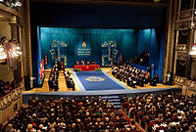
Prince of Asturias Awards
- Leopoldo Alas Clarín, 19th century novelist and literary critic
- Fernando Alonso, Formula One driver and a two-time world champion (2005 and 2006)
- Antonio Gamoneda winner of the 2006 Cervantes Prize
- Ángel González, poet
- HM Queen Letizia of Spain the consort of the Spanish King Felipe VI
- Sid Lowe, well known international football journalist predominantly known for his contributions to The Guardian, studied in the University of Oviedo.
- Juan Mata, Manchester United F.C. footballer
- Melendi, popular singer.
- Michu, Swansea City footballer
- Ramón Pérez de Ayala, writer
- Carmen Polo, wife of Spain's dictator Francisco Franco
- Indalecio Prieto, socialist politician. One the leaders of the Spanish Socialist Workers' Party up to the end of the Civil War and the posterior exile
- Samuel Sánchez, cyclist. 2008 Olympic Road Race Champion.
- Tioda, 9th-century architect who designed several of the city pre-romanesque buildings.

Other places in the municipality[edit]
- Trubia
- Colloto (divided between two municipalities: Oviedo and Siero)
- San Claudio
- San Esteban de les Cruces
- Latores
- Olloniego

International relations[edit]
See also: List of twin towns and sister cities in Spain
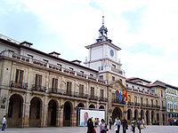
Oviedo's City Hall.
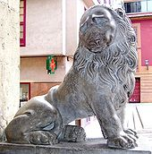
"Estatua del León" (probably 17th century) outside at City Hall.

Twin towns — sister cities[edit]
Oviedo is twinned with:^{[23]}
- Valparaíso, Chile, since 1976^{[23]}
- Bochum, Germany, since 1979^{[23]}
- Buenos Aires, Argentina, since 1983^{[23]}
- Veracruz, Mexico, since 1983^{[23]}
- Clermont-Ferrand, France, since 1988^{[23][24]}
- Tampa, USA, since 1991^{[23][25]}
- Santiago de Compostela, Spain, since 1993^{[23]}
- Santa Clara, Cuba, since 1995^{[23]}
- Jersey City, USA, since 1998^{[23]}
- Holon, Israel, since 1999^{[23]}
- Zamora, Spain, since October 9, 2001^{[23]}
- Torrevieja, Spain, since January 2, 2004^{[23]}
- Hangzhou, China, since 2006^{[23]}
- Valencia de Don Juan, Spain, since 2006^{[23]}
- Viseu, Portugal, since April 10, 2007^{[23]}
- Maranello, Italy, since April 28, 2010^{[23]}

