Installation, Operation & Maintenance Instruction

Table of Contents
1. Installation Instruction
- Delivery Inspection
- Civil Works
- Mechanical
- Electrical

2. Operation and Maintenance Instruction Manual

3. Safety Precautions Warning

4. Operations Instruction
- General
- Lubricating System for the Compressor 4.2.1 Lubrication Mechanics
- Main Equipment of the Gas Compressor Unit

- Compressor
- Oil Reservoir
- Oil Cooler
- Oil Filters
- Oil Pump

5. Outline of Control System
- Check before Operation
- Check on the Compressor Unit
- Valve Operation

- Inspection and Adjustment
6.1 Periodic Inspection
- Pre-Commissioning

- Confirmation Items
- Coupling
- Unit Appearance Check
- Unit Tightening Section Check
- Check on Heat Exchangers

8. Annual Inspection of Aux. Items
- Oil Pump
- Centering Adjustment Alignment
- Process Gas Piping Leakage Check
- Pressure Gauge Check
- Cleaning of Filter
- Control Panel Inspection

9. Maintenance
- Oil Filter Maintenance
- Heat Exchanger Maintenance

10. Long Term Shutdown
- Shutdown
- Restart after Long Term Shutdown
- System Evacuation for Long Term Shutdown

- Air Purging
- Charging of Operation Utilities

- Oil Charging
- Operational Utilities

- Rigging and Lifting
13.1 Gas Compressor Unit
- Utilities Hook-Up

- Compressor Motor Power
- Oil Pump Motor Power
- Control Panel Power
- Tie-in-points

15. Motor Alignment
1. INSTALLATION INSTRUCTION 1.1 Delivery Inspection

NOTE: COMPLETE COMPRESSOR PACKAGE IS SHIPPED TO CUSTOMER
WITH THE FOLLOWING SHIPPING PREPARATIONS:
- The unit is pressurized with 100 kPaG of nitrogen. Tie in connections are covered by blind flanges. The pipings are to check for rust if the pressure shown on the gauges have reached 0 bar.
- Coupling spacer and additional oil filter elements are shipped loose in a separate wooden box.
- Control panel is vacuum packed in wooden crate.

Upon receipt of the equipment at the site, it is essential that the unit be inspected for damage in transit, and that all such damage be fully documented and reported immediately.

Components which are shipped for field installation are identified with tags in accordance with packing list. All parts for commissioning are tagged and shipped in a separate crate (box) with the unit.
1.2 Civil Works

Confirm the satisfactory completion, installation or adjustment of the following items before starting-up the unit.

ITEM | CONFIRMATION REQUIREMENT
Basement | Concrete Slab is at flat level base.
 | No Foreign particles and dirt is found on the basement.
Grounding Lug | Dimension and location is correctly located, including the anchor bolt dimension & location.
Grouting | Grouting layer is prepared as per suggested in the drawing or refer to customer's Civil Engineer's instruction.

1.3 Mechanical

Confirm the satisfactory completion, installation or adjustment of the following items before starting-up the unit.

ITEM | CONFIRMATION REQUIREMENT
Piping Flange Bolts | Securely fastened to all flanges.
Oil Filter & Gas Filter | Clean Elements Installed
System Valves &  Manifolds | Confirm correct open/close status of the following valves:  - Pressure gauges  - Manifolds  - Oil line stop valve  - Cooling water stop valve  - All other valves
Coupling | Coupling spacer is correctly installed, with compressor & motor alignment adjusted.
Shipped Loose Items | They are to be installed on the package as shown in Instrument Hook Up , or as per Customer specification.
Tie-In Points | All tie-in points to be connected to the customer lines & supported by customer at site. Compressor package does not provide support for piping out of the skid. Connection size & type, direction and name of TP points are specified in P&ID.
ITEM | CONFIRMATION REQUIREMENT
Nitrogen, Instrument Air Lines | Pressure & Flow rate to be supplied as specified in BEDD & required by the Compressor & connected as shown in P&ID.
Water Supply | Pressure & Flow rate to be supplied as specified in BEDD & required by the Compressor, and connected as shown in P&ID.

Shipped Loose Items to be installed at site.

Shipped Loose Items | Connection Type
3",6" butterfly valve coolers water inlet/out let | Flange connection
6" discharge check valve | Flange connection
Control panel | Safe area
Local control panel support and panel | Bolt
Strainer pipe spool | Flange connection
Ventilation fan | Bolt
Sound Enclosure | Bolt
Shaft coupling and coupling hub | Flg Hex hd capscrews
Gas Cooler | Flange connection
2" gate valve motor water inlet/outlet | Flange connection
TI-0250,TI-0271 | NPT
TI-0251, TI-0254 | Remote gauge board
PI-0253A | NPT
Gas Detectors | Bolt
6" Discharge Flow transmitter | Butt weld, Important (please refer to Emerson Installation manual)

1.4 Electrical

Confirm the satisfactory completion, installation or adjustment of the following items before starting-up the unit.

ITEM | CONFIRMATION REQUIREMENT
Electrical Wiring | All electrical termination checked & tested point to point.
Power Source | Voltage within 10% of specified voltage. Phase to base voltage unbalance within 3%.
MCC | MCC to connect to  a. Main Motor JB  b. Aux Motor terminal box  c. Mist eliminator motor terminal box  d. Oil Heater
Anti-Surge Panel | To be installed next to the compressor package.
Junction Boxes | Refer to Attached JB Drawings for Connections.

2. OPERATION AND MAINTENANCE INSTRUCTION MANUAL

FOREWORD

In preparing this manual, efforts have been made to present the information and data in an easily understandable manner. However, it has been assumed that the personnel assigned to operate and maintain this equipment has sufficient technical knowledge and experience to apply good safety and operating practice and have a general understanding of the equipment covered.

The manual covers generally the description, installation, operation, and maintenance of the compressor, its auxiliaries and accessories. It does not propose to cover all details or variations in the equipment nor provide for every possible situation connected with the unit. Should further information be desired or problems arise which are not covered sufficiently, for the purchaser's purpose, the matter should be referred to Cameron Milan's Engineering Office.

It is highly recommended that the Customer avail himself of the manufacturer's services for installation and assistance at the time of start-up.

Many components installed on this unit are specially designed or modified as per Cameron's specifications. It is highly recommended that replacement parts be ordered from Cameron to ensure adherence to original set of specification and to prevent any malfunction.
3. SAFETY PRECAUTIONS WARNING

Rotating parts can cause serious or fatal injury. The use of this machinery, like all other utilization of concentrated power and rotating equipment, can be hazardous.

Installation, operation and maintenance of this machinery and of the electric equipment associated with it should be performed by qualified personnel.

For equipment covered by this instruction book, it is important to observe safety precautions to protect personnel from possible injury. Among the many considerations, personnel should be instructed to:
- Avoid contact with energized circuits or rotating parts.
- Avoid extended exposure in close proximity to machinery with high noise levels.
- Avoid by-passing or rendering inoperative any safeguards or protective devices.
- Use proper care and procedures in handling, lifting, installing, operating and maintaining this equipment.

Safe maintenance practices by qualified personnel are imperative.

Before initiating maintenance procedure, all power sources should be disconnected from the machine and accessories to avoid electrical shock.

Electric components and the machine should be grounded in accordance with the national electrical code and consistent with sound and local practice.
4. OPERATION INSTRUCTION
4.1 GENERAL OVERVIEW

This Instruction, Operation and Maintenance (IOM) Manual is written to serve as a guideline for the start-up and operational personnel. A sound understanding of the total system in general and compressor with its sequence of operation in particular is an essential pre-requisite to the commissioning of the unit. It is therefore highly recommended that the concerned personnel acquaint themselves with this IOM and the actual system as thoroughly as possible.

The system as furnished by Cameron's Milan packager - ITMI is skid mounted.

Cameron's Scope of Supply includes the following: One integral geared compressor, driven by electric motor, one oil reservoir, one horizontal Shell & Tube oil and gas water cool type, one aux. oil pump, duplex lube oil filters, and junction boxes.

All the equipments are mounted on skid and they are piped and completed with all auxiliary items for proper operation of this system.
4.2 LUBRICATING SYSTEM FOR THE COMPRESSOR.

4.2.1 Lubrication Mechanics

The oil to compressor is supplied for the following purpose:

a.
Lubrication of bull gear & pinion in the gear box.

b. Lubricating oil provides a thin oil film to damp the vibration for the rotor.
- Lubrication oil reduces power consumption by dropping frictional losses, thus prolongs part life and protect parts from corrosion.
- Heat is carried away from parts and flushes foreign particles from the gear box.

Oil is then collected in the oil reservoir, and pumped to the filter and gear box again for another cycle.
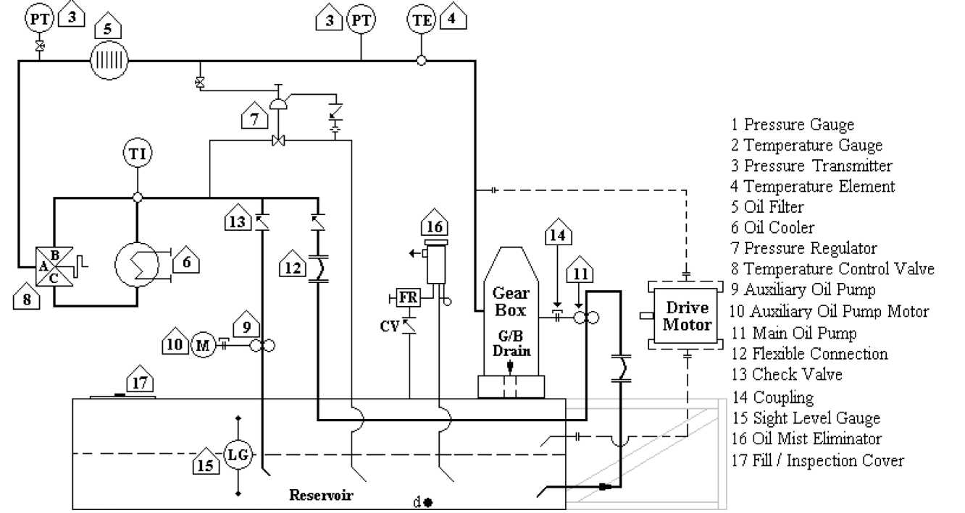
* For detail lubrication oil system please refer to Piping & Instrument Diagram
Sheet 2.

4.3 MAIN EQUIPMENT OF THE GAS COMPRESSOR UNIT
- COMPRESSOR

The compressor compresses gas dynamically. For centrifugal compressor, the velocity of the gas is increased using centrifugal force. Pressure is increased by converting imparted kinetic energy to potential energy. As gas passes to the inducer of the impeller, the impeller rotates the gas & the centrifugal force causes the gas to move away from the center of rotation. This rotation throws the gas outward at a very high velocity. As high velocity gas leaves the impeller and enters the diffuser area, the velocity is decreased while the pressure is increase.

Refer to compressor manual for further details of compressor operation.
- OIL RESERVOIR

This vessel is designed to collect the lubrication oil from the gear box. The oil reservoir is supplied with level gauge & level transmitter. The oil color should be constantly monitored. If it appears in dark color, analyze the oil and replace it if necessary. Oil heater is provided in the reservoir to heat up the oil during cold season.
- OIL COOLER

The oil lubrication system is a closed lube cycle. As the oil absorbs the heat of compression the excessive heat must be dissipated to keep the oil at constant temperature and viscosity to assure for proper lubrication and sealing of compressor. Therefore an oil cooler is utilized to exchange the excessive oil heat with cooling water. The oil cooler is of shell and tube type with oil on the shell side and cooling water on the tube side.

NOTE: IF SHUTDOWN OF THE UNIT OCCURS FOR A LONG PERIOD OF
TIME AND THE AMBIENT TEMPERATURE REACHES FREEZING POINT, IT IS HIGHLY RECOMMENDED TO KEEP THE COOLING WATER SUPPLY RUNNING OR STOP THE SUPPLY AND THOROUGHLY DRAIN THE WATER FROM OIL COOLER. A PERIODIC INSPECTION OF TUBE SIDE
FOR CORROSION AND FOULING IS ALSO RECOMMENDED.
4.3.4 OIL FILTERS.

The longevity of the compressor operation depends on its lubrication. Proper temperature, viscosity, and filtration are the major factors.

The lubrication oil is filtered to 10 microns before entering the compressor.

It is mandatory to oil flush the system prior to commissioning, assuring cleanliness.

At any time the differential pressure across element reaches 1.0 barD, the element(s) should be replaced.

4. 3.5 OIL PUMP

The oil pump, a high quality screw gear pump is selected. The pump is furnished with an integral relief valve, and some special features such as ball bearings, mechanical seal. Aux. spare pump is provided for start-up or backup in case the oil pressure drops.

5.
OUTLINE OF CONTROL SYSTEM.

GENERAL

The main function of the Cameron Gas Compressor package is to compress the Methane gas.

The operation is achieved with the aid of several instruments, which are designed for specific purposes. The combined control system of the ASC (anti surge controller), ESD (emergency shutdown) and the DCS (distributed control system) are design for proper protection, monitoring and operation of the package.

Cameron is providing a PLC base ANTI SURGE control system, with instruments, gauges, indicator lights and selector switches installed at the compressor skids.

The operator interface for the ANTI SURGE control system is through the DCS.

The System is set to be started locally at the skid by manipulating the selector switches at the local control station.

There is a defined logic sequence for starting and stopping the compressor:
The system can only be start locally via the selector switch, It can only be stop
locally via the selector switch.

METHOD OF OPERATION.
- CHECK BEFORE OPERATION.

Before operating the Unit, check that there is no personnel in its vicinity. In particular the revolving parts (compressor, pump, motor) must be checked for safety. Also, check from time to time the revolving part protective covers for slackness, etc.
- CHECK ON THE COMPRESSOR UNIT.

The following items must be verified before starting the operation:
- Check lubricating oil system before start-up of the compressor. The lubricating oil system shall be commissioned per section 11.1 of this manual.
- Check oil reservoir oil level via the level gauge and make sure the oil level is kept between the optimum oil level.
- Check all pressure and temperature gauges and make sure their indicators are not damaged.

5.3 VALVE OPERATION. See P & I D Drawing
- Valve Close:

- Process Gas Line.
No shut-off valve installed.
- Lube Oil Line. Gate Valves Globe Valves
- Valve Opening :
1. Lube Oil Line. Gate Valves Globe Valves
ATTENTION!
- PRESSURE INDICATING CONTROLLER IS ADJUSTED TO THE MOST SUITABLE CONDITION AT THE JOB SITE. IMPREDENT CHANGES OF THE SETTING VALUES CAN DAMAGE THE COMPRESSOR, UPSET THE SYSTEM OPERATION, AND SHUTDOWN THE UNIT.
- CONSULT T.A. ENGINERRING DEPARTMENT FOR ANY CHANGES IN THE SYSTEM "SETUP" VALUES.

At Emergency Shutdown:

In case that the "EMERGENCY SHUTDOWN" switch push button is activated, all the equipments are immediately shut down.
6. INSPECTION AND ADJUSTMENT.

The gas compression unit rarely fails. However, daily and periodic inspections are very important in prolonging the service life and in maintaining the machine in a good operating condition. The daily and periodic inspections must be carried out also in order to understand the performance well and to prevent accidents.

The unit operation, maintenance, etc. must be carried out by the person-in-charge only.

6.1 PERIODIC INSPECTION.

The periodic inspection (at intervals of daily, monthly or yearly) are as follows. For motor inspection, please refer to Motor Supplier Inspection Manual or consult motor supplier technician.


INSPECTION AND PREVENTATIVE MAINTENANCE

Immediately after the compressor is placed into operation, a routine of inspection and preventative maintenance must be initiated. The following table presents minimum inspection and preventative maintenance standards and as such should be integrated with the overall system schedule: (Unusual or unanticipated operating conditions may require more frequent mtervals of inspection than are indicated in the table.)

Assembly or Part | Inspection
DAILY
Gear Case | 1. Check for:  a. Vibration or unusual noise.  b. High bearing temperature.  c. Low oil pressure.  d. Oil leaks.  e. Frayed or worn electrical cables.  f. Damaged pressure and temperature  gauges.  g. Loose mounting bolts.  h. Air ejector system failure.  2. Wipe off all accumulated dirt.
Compressor Scrolls, Piping and Impellers | 1. Check for:  a. Vibration or unusual noise.  b. System gas (or an) leakage.  c. Damaged gauges and switches.  2. Wipe off all accumulated dm.
Intercooler and Aftercooler | 1. Check for:  a. System gas (or an) leakage.  b. Cooling water leakage.  c. High cooling water temperature.  d. Damaged cooling water temperature  eauees.  e. Loose anchor bolts.  f. Fault\- op eration of c onden s ate  traps.  2. Wipe off all accumulated dnt.
Assembly or Part | Inspection
Lube Oil System | 1. Check for:  a. Low oil level m reservoir.  b. Low oil pressure.  c. High oil temperature.  d. Oil le ale age.  e. Damaged gauges and switches.  f. Frayed or worn electrical cables.  g. Cooling water leakage.  h. Loose mounting bolts or anchor  bolts  2. Wipe off all accumulated dm.  3. Check oil level m automatic air stream  lubricator. (Auxiliary pump air motor.)
Compressor Drive Motor or Turbine | 1. Check for:  a. Erratic or noisy operation.  b. Frayed or worn electric al c ab les.  c. Over speed or trip switches (if  turbine drive).  d. Loose mountms bolts or anchor  bolts.  2. Wipe off all accumulated dm.  3. Inspect driver in accordance with  manufacturer's recommendations.
MONTHLY
Lube Oil System | 1. Check for:  a. Water or acid m oil.  b. Dirty or clogged oil filter.  2. Test auxiliary pump ah'motor. Operate  air motor for brief period to remove  condensates.

YEARLY

Gear Case

- Inspect thrust bearings and journal bearings for signs of wear.
- Check thrust bearing axial clearance.
- Inspect bull gear and pinions for signs of wear and cracked or broken teeth.
- Inspect pinion shaft shoulders for signs of wear.
- Check axial clearance between pinion shaft shoulders and bull gear.
- Inspect oil seals for signs of rubbing.

Compressor Scrolls. Piping and Impellers

- Inspect impellers and scrolls for signs of wear, rubbing and cracking.
- Check clearance between impellers and scrolls.
- Check impeller nut torques.
- Inspect labyrinth seals for signs of nibbing.
- Clean impellers with brass brush and steel wool to remove deposits of foreign material, which may cause impeller unbalance.

Inter coolers and After cooler

- Inspect intercooler tubes. Clean tubes with rotary brush. Clean fins on air (or gas) side with an or steam as required to remove deposits of foreign material.
- Test cooling water for excessive concentration of treating chemicals.

Lube Oil System

- Dram, flush and refill with new oil.
- Inspect oil cooler tube bundle. Clean both oil and water sides.

Compressor Drive Motor or Turbine | 1. Inspect driver in accordance with  manufacturer's recommendation.  2. Inspect mam drive coupling for signs of  wear.  3. Check main drive coupling alignment.  Remove coupling spacer and check  alignment with dial indicator. (Refer to  Installation section.)
Oil Pressure Gauges | 1. Install tee and test gauge between oil pressure gauge and gauge cock to calibrate pressure gauge.
Oil Temperature Gauge | 1. Remove oil temperature gauge from oil system piping and immerse stem in liquid of known temperature to calibrate gauge.
Air Temperature Gauge | 1. Remove air temperature gauge from compressor inlet and immerse stem in liquid of known temperature to calibrate gauge.

• It is recommended that Temperature and pressure gauges be inspected and calibrated at six-month intervals. However, if conditions permit, the period between inspections can be longer than six months, but in no case should be allowed to exceed one year.

In addition to the normal inspection and preventative maintenance procedure, it is recommended that all gauges, meters and other indicating devices be tested periodically for accuracy. Provision also should be made for the periodic removal of condensates from the instrument an supply.

To a great extent, the simple function of listening to the compressor will be sufficient to detect the potential failure of one or more components in the system. After a reasonably brief period, the operator should become accustomed to the sound of a smoothly running machine so that any change in the noise or vibration level should become immediately noticeable. Excessive vibration can be caused by any of the following:
- Shaft Misalignment - Angular (face-to-face) misalignment of the drive coupling (with spacer removed) should not exceed .002 TIR. Parallel or rim misalignment should not exceed .002 TIR. Refer to the Installation section and the coupling manufac turer' s instruc tions.
- Impeller Unbalance - If the system gas (or air) is duty, a build-up on the impellers of minute particles of foreign matter can cause imbalance, which can lead to impeller rub.
3. Piping Loads - If piping loads are above the specified limits, due to expansion or contraction, the compressor or driver can be pushed out of line.

SYSTEM TROUBLE ANALYSIS

The following table presents the recommended procedures for determining the cause of a malfunction in the compressor and its operating systems.

When a malfunction occurs, scan the "Trouble" column witliin the applicable group (preliminary setup or operating cycle) to locate the correct trouble analysis step. One or more probable causes are listed together with the suggested remedial procedure for each step.

When problems are encountered winch are beyond the experience of operating personnel, assistance can be requested from C ameron Compression Systems. Buffalo. New York.

Step | Trouble | Probable Cause | Remedy
 | Preliminary Step
1. | No primary voltage. | Defective primary power | Rep ah⁻ or replace
 |  | source. | primary power source,
 |  |  | as necessary.
 |  | Defective circuit breaker | Check circuit breakers in
 |  | in primary power source. | primary power source.
 |  |  | Replace if defective.
 |  | Defective | Check all connections.
 |  | interconnecting cabling. | Perform continuity
 |  | or loose or broken | check on cabling.
 |  | connection. | Rep an or replace, as
 |  |  | necessary.
2 | No instrument air | Defective instrument air | Rep an or replace air
 | pressure (or low air | compressor. | compressor, as
 | pressure). |  | necessary.
 |  | Instrument air supply | Open air supply valve.
 |  | valve closed.
 |  | Ruptured or pinched | Replace airline.
 |  | airline.
 |  | Leaks around fittings. | Tighten or replace
 |  |  | fittings, as necessary.
Step | Trouble | Probable Cause | Remedv
5. | No lube oil pressure (or | Defective mam lube oil | Repair or replace pump,
 | low oil pressure). | pump. | as necessary.
 |  | Clogged or leaking oil | Clean or replace filter as
 |  | filter. | necessary.
 |  | Leaks around fittings. | Tighten or replace
 |  |  | fittings, as necessary.
 |  | Ruptured or pinched oil | Replace oil line.
 |  | line.
 | Op era tins Cycle
4. | Vibration | Compressor and driver | Refer to alignment
 |  | shafts misaligned. | procedures in
 |  |  | Installation Section.
 |  | Worn or defective shaft | Replace shaft coupling.
 |  | coupling.
 |  | Worn or defective | Replace journal bearing.
 |  | compressor journal
 |  | bearing.
 |  | Worn or defective | Replace thrust bearing.
 |  | compressor thrust
 |  | bearing.
 |  | Damaged bull gear or | Replace bull gear or
 |  | pinion. | pinion.
 |  | Loose anchor bolts. | Tighten bolts.
 |  | Defective driver. | Repan or replace driver,
 |  |  | as necessary.
5 | High lube oil | Water flow to oil cooler | Check cooling water
 | temperature. | interrupted. | svstem.

Step | Trouble | Probable Cause | Remedy
6. | Loss of lube oil pressure | Main lube oil pump | Replace motor.
 | (or low pressure) | motor burned out.
 | auxiliary pump
 | operating | Defective mam lube oil | Same as step 3.
 |  | pump.
 |  | Clogged or leaking oil | Same as step 3.
 |  | filter. | Same as step 3.
 |  | Leaks around fittings. | Same as step 3.
 |  | Ruptured or pinched oil | Same as step 3.
 |  | hue.
7. | Loss of lube oil pressure | Defective instrument air | Same as step 2.
 | (or low pressure) | compressor.
 | auxiliary pump NOT
 | operating. | Defective auxiliary | Rep an or replace motor.
 |  | pump motor. | as necessary.
 |  | Defective auxiliary lube | Rep an or replace pump.
 |  | oil pump. | as necessary.
 |  | Low lube oil level. | Add oil to oil tank.
 |  | Refer to step 6 for | Same as step 6.
 |  | additional causes.
8. | High bearing | Lube oil system | Same as steps 6 and 7.
 | temperature. | malfunctioning. | Same as steps 6 and 7.
 |  | Defective bearing. | Replace bearing.
9. | High discharge an | Water flow to | Check cooling water
 | temperature. | intercoolers interrupted. | system.

DISASSEMBLY

1. Impellers

CAUTION
Impellers and pinion shafts can be easily damaged if excessive force or improper removal techniques are employed. Follow carefully the directions below to prevent damage. Most current Compression Systems" Centrifugal Compressors are manufactured with precision press fits on the first and third stages and precision slip fits on the second and fourth stage impellers. For pmion removal the second and fourth stage impellers are normally removable in the field.
- Remove the inlet piping for impeller to be removed.
- Remove the air inlet casma attaching bolts and lock washers.
- Remove the an inlet casma. Remove and discard the O-ring seal.
- Remove the impeller locknut and spacers, if used. Do not remove from the impeller keyed washers which are bolted to the impeller.
- Grasp the impeller firmly and slide it forward to remove from shaft. Be careful so as not to damage the extremities of the impeller or the pmion shaft.

f If the impeller does not come off m tins maimer, do not attempt other methods. Call Cameron Compression Systems for advise.
- Bull Gear Oil Seal

- Remove attaching bolts and lock washers and remove upper and lower halves of bull gear oil seal.
- Remove and discard gaskets.
- Pivot Shoe Journal Bearings

- Disconnect and tag all electrical cables and wires from temperature detectors and vibration pickup, if supplied.
- Remove temperature detector probes from bearmgs.
- If air ejector is furnished, disconnect piping from gear¹ case cover.
- Remove bull gear end cover and attaching bolts and lock washers.
- Remove and discard end cover gaskets.
- Remove attaching bolts and lock washers, and remove upper half of bull gear oil seal; remove bolts holding upper half of thrust bearing to gear case cover (size 12 and size 20 compressors only).
- Remove taper pin assemblies from gear case cover by tightening nuts on threaded portion extending above flange.
- Remove gear case split-line bolts.

i. Attach lifting sling and hoist to gear case cover and take up slack.
j. Gradually lift cover off gear case.

CAUTION
Upper halves of pinion oil seals may drop free of gear case cover, causing damage to parts.

Life gear case cover carefully to avoid striking bull gear thrust faces.

k. Lift off upper half of j ournal bearings.

NOTE
On some models, bearing halves are jomed at the split-line by cap screws or hexagon head bolts.

1. Raise pmion slightly to release journal bearings.

NOTE
Support pinion using blocks of soft wood to prevent damage to machined surfaces.

m. Rotate out lower half of journal bearing from gear case.

NOTE
Do not disassemble journal bearing further. Best results can be obtamed by replacmg complete journal bearing.

Thrust Bearing
- Perform steps a. through j. of paragraph 3.
- Remove cap screws and lift off upper half of thrust bearing.
- Remove bolts attaching lower half of thrust bearing to gear case (size 12 and size 20 compressor only).
- Rotate out lower half of thrust bearing.
- Pinion Oil Seals

- Per foiin steps a. through j. of paragraph 3.
- Remove upper half of pinion oil seal from gear case cover.
- Rotate out lower half of pinion oil seal.
- Air Seals

- Perform steps a. through j. of paragraph 3.
- Perform step c. of paragraph 5.
- Remove attaching bolts and lock washers and withdraw seal from scroll bore.

NOTE
Tapped holes (1/4-20 UNC-2B) are provided m seal for puller bolts.

d. Lift out an seal by removing split-line bolts and separating seal halves.

e. Remove and discard air seal o-ring.
REASSEMBLY

Reassembly is essentially the reverse of disassembly. Thoroughly clean and dry all parts and interior of gear case and scroll prior to reassembly, making sure that gear case split-lme flange is free from foreign material. Inspect impellers, bearings, seals, gears, shaft journals and all machined surfaces for scoring, pitting, cracks, corrosion or other damage incurred during disassembly or storage. Inspect shaft journals for roughness and remove rough spots with crocus cloth or fine oilstone. Replace all o-imgs and gaskets. Apply thin coating of lubricating oil to all surfaces subject to wear such as journal bearings, thrust bearings, shaft journals and bull gear thrust faces.

When installing new journal bearings or thrust bearings, establish drill points for temperature detector probes. Tins procedure will insure more accurate temperature indication than could be obtained from flat surface.

Blow out all oil passages with dry. compressed air.

¹VYARMNG
Goggles should be worn when using compressed air. Flving chips or metallic dust can cause eye damage.
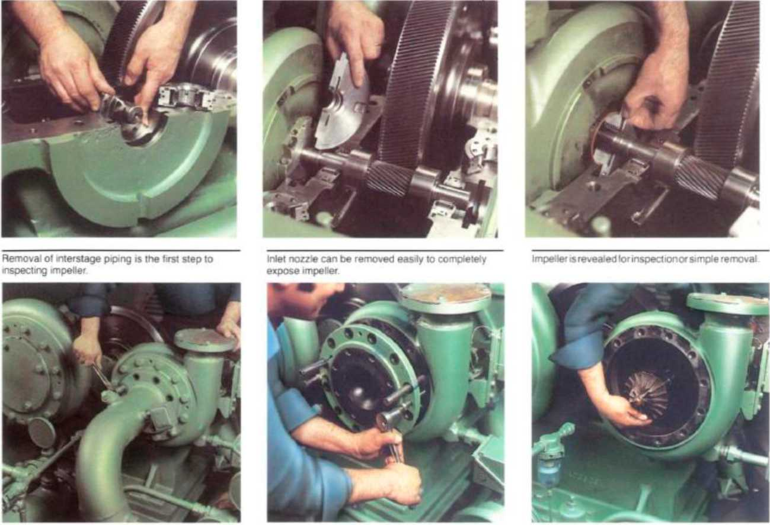
MAINTENANCE RECOMMENDATIONS
Bearing removal is simpleSplit labyrinth od seal removalSpirt labyrinth air seal removal
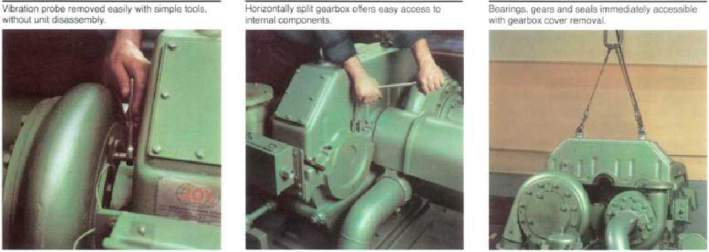
NOTE: When installing new journal bearings or thrust bearings, establish drill points for temperature detector probes if equipped. This procedure will insure more accurate temperature indication than could be obtained from flat surface.

Blow out all oil passages with dry, compressed air.
- Impellers
NOTE: if the shaft and impeller are assembled by hydraulic fit procedure, you may follow specification IL-2468. However, this procedure should be performed by a Cameron serviceman.
- Pivot Shoe Journal Bearings

- Rotate lower half of journal bearing under pinion shaft.
- Lower shaft onto lower half of journal bearing.
- Assemble and bolt upper half of journal bearing onto lower half.
- Thrust Bearings

- Rotate lower half of thrust bearing under bull gear shaft.
- Assemble and bolt upper half of thrust bearing onto lower half.
- Position a dial indicator near thrust face and as close to shaft of bull gear as possible.
- Shift bull gear axially away from dial indicator until it stops against thrust bearing.
- Set dial indicator against thrust face of bull gear and adjust indicator to zero indication.
- Record total end play as indicated on dial indicator.
- Grind and install shims between thrust beatings and gear case to reduce bull gear end play. (Refer to the Gear Case Assembly drawing for slum locations and end play limits.)
CAUTION
After grinding, both slums must be of equal thickness within .001 so that, in the event the shims are reversed during installation, the impeller clearances will not be changed, hi addition, both faces of the slums must be flat and parallel.
3A: SPLIT-LINE SEALING
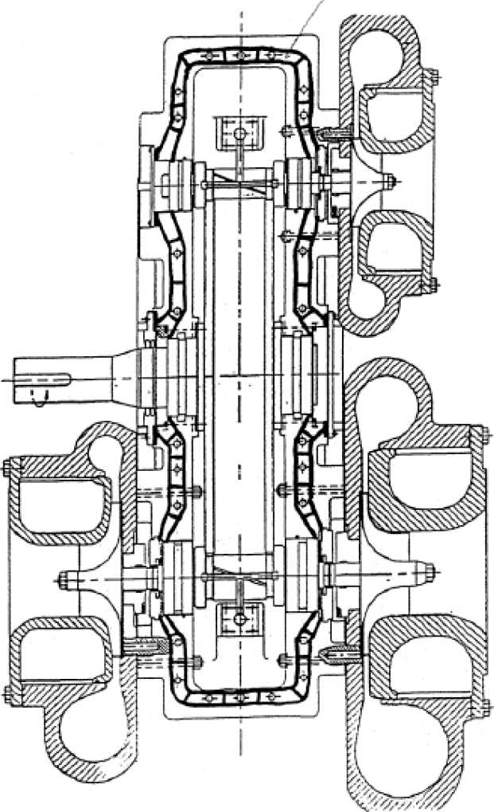
- Use Permatex #2 on pilot outside diameter of pinion oil seals and groove-mounted blank covers.
FIGURE 1
- Apply thin layer of Astroseal to oil seal split-lines.
3B: GEAR CASE INSTALLATION

Inspect interiors of gear case and its cover for cleanliness.

h. Remove any dirt, oil. butts, metal risings or other residue from the mating flanges of
the gear case and its cover.

i. Install new gearbox split o-ring.

j. Manually rotate pinions and bullgear to ensure freedom of rotation.

k. Carefully lower the cover onto the gear case and install the taper-pin assemblies to align the cover and the gear case. Apply Molykote to split-line dowel pins before installing them.

1. Install and torque cover bolts hi proper sequence to specified torque values. (Grade 5 bolts are used for pinion-in-tlie-cover units.) Part numbers and torque values are shown on air end assembly drawings. (Normally, this cover will not be removed again before field operation.)

m. Check drive shaft for freedom of rotation.

n. Check the gear pattern in accordance with the instiuctions contained in the Installation Section of this manual.
* Section 4.1 is taken from Cameron Compressor Manual Appendix J - Maintenance Recommendations.
7. PRE-COMMISSIONING. 7.1 Confirmation Items.

Confirm the satisfactory completion, installation or adjustment of the following items before starting-up the unit.

ITEM | CONFIRMATION REQUIREMENT
Anchor Bolts | Securely fastened
Piping Flange Bolts | Securely fastened
Oil Filter | Elements Installed.
Electrical Wiring | All contacts securely fastened (particular attention given to external tie-in connections).
Safety and Control Devices | Safety valves connected to the proper discharge.
System Valves | Confirm correct open/close status of the following valves:  - Pressure gauges  - Root valves of safety valves  - Delivery stop valve  - Oil line stop valve  - Cooling water stop valve  - All other valves
Compressor Shaft | Compressor shaft rotates smoothly when turned manually  after beefing aligned prior to initial start-up
Main Motor Grease | Grease-up (Reference to Motor Instruction Manual).
Compressor Oil | Oil level at approximate mid point of oil level ^{gauge.}
Power Source | Voltage within 10% of specified voltage. Phase to base voltage unbalance within 3%.


7.2 Coupling
Inspection Item: | Method of Inspection: | Judgment | Method of Maintenance:
Noise | Check whether noise which cannot be heard during normal operation is generated. | If abnormal noise is generated, check the coupling fixing bolts and nuts for slackness. | 1. Re-tighten if slacked. Replace, if worn.
7.3 Unit Appearance Check.
Inspection Item: | Method of Inspection: | Judgment | Method of Maintenance:
Painting | Visual | Repair, if paint faded or peeled. | Repair and touch up to the designated color.
7.4 Unit Tightening Section Check.
Inspection Item: | Method of Inspection: | Judgment | Method of Maintenance:
UnitTightening section. Process gas leakage. | Visual. Spray soap suds or gupoflex onto the tightening section. | Leaking, if bubbles form on the tightening section. | 1. Re-tighten to stop  leakage2. Stop the  operation. Drain  liquid fromthe leaking portion and repair

7.5 Check on Heat Exchangers.
Inspection | Method of Inspection: | Judgment | Method of
Item: |  |  | Maintenance:
Heat | Check the temperature | The heat | 1. For an oil line, the
Exchangers' | difference at the heat | exchanging rate | oil may be
Heat | exchanger inlet/ outlet. | is assumed to have | decayed or there
Exchanging |  | dropped, if the | may be scales,
Condition. |  | temperature | etc. Change
 |  | difference at the | oil or clean the
 |  | inlet/outlet is | heat exchanger
 |  | significantly | shell interior.
 |  | smaller than during
 |  | normal operation. | For process gas line,
 |  |  | the carried oil may
 |  | - Contamination | be dirty. Drain the
 |  | of the heat | liquid from the heat
 |  | exchanger | exchanger and clean
 |  | interior. | its tube interior. For
 |  |  | water, clean or route
 |  |  | tubes.

8. ANNUAL INSPECTION of AUX. ITEMS

In addition to the periodic inspection items, the filter and coalescing elements installed on the unit should be checked and cleaned. Also the pressure and temperature Gauges, pressure and temperature switches should be checked for normal operation, corrected if necessary, and so on.
8.1 Oil Pump
Inspection Item: | Method of Inspection: | Judgment | Method of Maintenance:
Bearing | Check for abnormal noise | If there is abnormal
metal | generated and vibration. | noise generated or
 |  | vibration.
 |  | 1. Bearing | 1. Open the seal
 |  | Breakdown or | Cover or blind
 |  | abrasion. | cover, and
 |  |  | check, repair, or
 |  |  | replace the
 |  |  | bearing.
 |  | 2. Pump centering | 2. Re-center.
 |  | faulty.
 |  | 3. Faulty or | 3. Disassemble the
 |  | Unbalanced | coupling. Replace
 |  | mounting of | the coupling.
 |  | coupling.
Oil relief valve | Check normal operation by raising and lowering the oil pressure by means of the oil relief valve. | If the operation is not normal.1. Foreign matter  has entered the  oil relief valve  mechanism.2. The oil relief valve  spring is broken. | 1. Dismantle, clean  and reassemble the  oil relief valve.2. Replace the spring.

As for the compressor, refer to compressor manufacturer.
8.2 Centering Adjustment Alignment.
Inspection Item: | Method of Inspection: | Judgment | Method of Maintenance:
Centering adjustment | Measure eccentricity and angle of deflection with a dial gauge. | Eccentricity measurement: Difference between readings to be within 0.127 mm. Angle of deflection measurement: Difference between readings to be within 0.127 mm. | Re-center, if either of the ranges shown at left is exceeded.
8.3 Process Gas Piping Leakage Check.
Inspection Item: | Method of Inspection: | Judgment | Method of Maintenance:
Process gas leakage check | Visual.Spray soap suds onto tightening section. | Leaking, if bubbles form on the tightening section. | 1. Tighten to stop the  leakage.2. Stop the  operation, purge  the gas from  leaking section  and then repair.
8.4 Pressure Gauge Check.
Inspection Item: | Method of Inspection: | Judgment | Method of Maintenance:
Pressure gauge | Calibrate by using the pressure gauge calibrating apparatus. | Calibrate, if there is a difference in indication against calibration gauge. | Calibrate the pressure gauge to indicate the correct working pressure.

8.5 Cleaning of Filter
Inspection Item: | Method of Inspection: | Judgment | Method of Maintenance:
Oil filters | Check whether the differential pressure is 103 kPaD or more on the lube oil filter pressure differential gauge. | Elements are dirty if the differential pressure is 103 kPaD or more. | Check and replace.
8.6 Control Panel Inspection.
Inspection Item: | Method of Inspection: | Judgment | Method of Maintenance:
Back of G/C Control Panel. | Visual. Check by hearing and smelling. | Discoloring of electrical. Electric equipment noisy. Electric equipment appears burned. | Change equipment.
Connection of Wiring. | Visual check. Check by using screw driver. | Loose wire and screw. | Tighten.
Continuity Test and Meager Test. | Using electric tester. | Wire resistance values. | Check or repair electrical equipment.

Compression Systems

9. MAINTENANCE

9.1 OIL FILTER MAINTENANCE.
Smooth flow of oil is vital to peak compressor performance and durability, consequently, oil filtering is an important function.

At commissioning there is usually more oil contamination than later during regular operation because of the inevitable dirt and scale that enters the system when it is set-up.

During normal operation, check the pressure difference (DP) across the oil filter. If pressure difference is larger than 1.0 barD, the oil filter is probably clogged and requires replacing the filter elements as follows:
- Open inlet and outlet valves of stand-by oil filter, close inlet and outlet valve of the oil filter in operation.
- Provide a drain pan under the oil filter.
- Carefully open the purging valve and drain valve slowly releasing the pressure and drain oil from the filter.
- Remove mounting bolts from the cover on oil filter.
- Slowly, pull out the oil filter element.
- Remove element and replace it.
- After installation of the element, reassemble the oil filter.
- Close the drain and purging valve.
- Open the inlet valve and then carefully purge the air through purging valve.
- After purging, close the purging valve and oil filter inlet valve and open oil filter outlet valve.
9.2 HEAT EXCHANGER MAINTENANCE

The heat exchanger tubes in the water-type cooler must be cleaned at regular intervals, depending on the purity of water used. After a long period of use, deposits from the water will adhere to the core surface of the tubes thereby retarding heat transfer. This will, of course, retard cooling.
- Prepare the necessary tools and materials for cleaning the tubes. A wire brush will be needed if the tubes are excessively clogged.
- Stop process gas plant operation.
- Close the main water shut-off valves (in customer's piping).
- Open the air purge on the topside of the water cover and drain off the excess water.
- Slacken off the cover bolts and drop both end covers.
- Using a portable hand lamp, inspect all of the tubes for core deposits.
- If a wire brush has to be used on oil coolers it should be 20 mm in diameter and attached to a suitable rod. By clamping the rod in an electric drill bit, the revolving wire brush can be pushed back and forth down the tube until the tube is finally clean. A water hose should then be used to clear the tube of any remaining residue.

The shell side of after-coolers shall be cleaned chemically since the cooling water runs on the shell side.
- After cleaning, carefully inspect the tube core for any excessive pitting or corrosion. This inspection is vitally important toward prevention of water entering the system.
- When replacing the end covers, make sure the gaskets are the right way round and the covers are the right way up. When fitting the covers, they should be carefully eased on and positioned before tightening the bolts. Incorrect positioning of the covers could lead to either crushing of the tube ends or a malfunction in the operation of the cooler.
10. LONG TERM SHUTDOWN
10.1 SHUTDOWN
Carefully check out the entire system for process gas and lubricating oil leakage.
Drain the cooling water completely from the oil cooler, after-cooler and the cooling water piping to ensure that it does not freeze and fracture the piping during long-term shutdown.

Apply a nitrogen blanket and maintain a pressure of 150 kPaG.
- RESTART AFTER LONGTERM SHUTDOWN.

As oil in the mechanical sections of the compressor, such as the bearings, will have drained, operate the oil pump manually for several minutes prior to start-up as highlighted per section 4.1.
Measure the insulation resistance of the compressor motor.
Commence regular operations.
- SYSTEM EVACUATION FOR LONG TERM SHUTDOWN.
Whenever it is necessary to replace major parts such as compressor, or ready to bring the package down, the unit should be prepared as follows:

Disconnect or shut-off all the electrical power.

Carefully clean all the surfaces. It is good to clean the entire mechanism, as this will reduce the chance of dirt or other contamination entering the system.

Remove process gas. It must be purged by venting it to a safe location in accordance with the Environmental Protection Agency (EPA) and by using oil charge tank ball valve.

Venting rate shall be done very slowly in order to avoid dropping the metal temperature. The process gas temperature in the unit shall be monitored at all time during venting.
11. AIR PURGING.

Air purging is the evacuation of all air from the gas compression unit prior to charging with process gas. The air purging procedure is as follows:

Close suction shut-off valve and (by customer, if supplied). Open compressor suction control valve.

Connect the nitrogen tank to the oil tank vent valve.

Charge the oil reservoir with lubricating oil (Refer to Section 11).

Compressor suction and by-pass control valves should be set for manual operation and opened by hand.

Charge the gas compression package with nitrogen.

Bleed air from all instrument tubing by loosing the tube fitting nut at each instrument. Make sure to re-tighten all nuts after venting.

Start oil pump and flow oil through the tube oil lines, tube oil cooler, and oil filters for about an hour in order to force air out of the oil lines.

After the above procedure has been successfully completed, set compressor suction and by-pass control valves to auto operation mode.

Open compressor suction shut-off valve and allow process gas to pressurize the unit.
12. CHARGING OF OPERATION UTILITIES.


12.1 OIL CHARGING

The proper quantity of oil should be charged at startup and the oil level monitored regularly to assure that the system always has sufficient oil.

Oil charging is carried out (1) at pre-commissioning (initial charging) and (2) during normal operation whenever necessary (replenishment).
- Pre-commissioning Oil Charging.

(a) Initial Oil Charging Prior to Purging Air;

Lubricating oil is normally charged into to gas compression unit prior to air purging and while it is at ambient pressure. Close the oil filter discharge valves or X-valve (if applicable) on the oil line, connect one end of the oil charging hose to the oil cooler drain valve. Make sure the oil header does not contain any air pocket. Stop charging when the oil level in the oil reservoir reaches max level. Then distribute the oil evenly through the system by operating the oil pump. When this is done, the oil level may fall slightly in this case, charge more oil to bring the level up to the max oil level again.
- Charging During Normal Operation.

Oil in the system must be replenished from time to time during operation. In order to do this, the following procedure shall be followed:
- Vent the oil charge tank to a safe location.
- Charge oil into the oil charge tank, while the tank is at ambient pressure until oil spills out of the vent valve.
- Open oil charge tank equalizing valve to equalize the pressure in both vessels, oil charge tank and oil reservoir

e. Monitor oil level in the oil reservoir to reach the oil max level.

CAUTION!

WHEN CHARGING ALWAYS USE FRESH AND CLEAN OIL FREE OF MOISTURE AND DIRT CONTAMINATION.

•
ALWAYS USE THE SPECIFIED GRADE OF OIL.

NOTE: THE CHARGING TIME SHOULD BE AS SHORT AS POSSIBLE, BECAUSE THE SYSTEM WILL BE SUBJECTED TO UPSET CONDITION.

12.2 OPERATIONAL UTILITIES.
The required operational utilities before start-up (initial) are as follows:
- Compressor Oil.
Recommended oil: High Grade Turbine Oil, ISO VG-46, with nominal viscosity of 200 SSU at 100 DegF.
- Motor Grease.

Refer to Motor Instruction Manual.
13 RIGGING AND LIFTING.

They should be lifted with the use of spreader bars (furnished by customers) to prevent damage to the equipment.

13.1 GAS COMPRESSION UNIT (S).
The following procedure should be used to install the gas compression skid assembly:
- Thoroughly clean the foundation surface. Remove any rust, scale or oil from the skid bottom.
- Set each skid at orientation so to fit customer's process connection.
- Grout the bottom surface of the base plate prior to grout filling as recommended per T.A.
- Tie in all the inlet/outlet process connections as per Machinery Arrangement Drawing.

14. UTILITIES HOOK-UP.
- Compressor Motor Power
Connect the electrical power MCC to the motor junction box.
- Oil Pump Motor Power
Connect the electrical power to the MCC to the motor. The aux oil pump is driven by an electric motor.
NOTE: CUSTOMER HAS TO WIRE AUXILIARY CONTACT FROM MCC TO THE MOTOR JUNCTION BOX. THIS WIRING IS REQUIRED SO THAT THE OPERATION OF THE MOTOR IS CONTROLLED BY THE MCC.
- Control Panel Power.

Connect the electrical power to the control panel, only as per T.A. Control System Wiring Diagram. The customer's electrical connections are required between the junction boxes to the local control panel. All electrical terminals to be used by customer are identified on the control panel terminal blocks and on the terminal boxes details.
NOTE: CHARGE SEALING COMPOUND IN EACH SEALING FITTING FOR
INSTRUMENTS, AFTER WIRING AND TESTING OF WIRING CONTINUITY, AND PROPER CONNECTIONS BETWEEN JB AND INSTRUMENTATION.
Compression Systems


14.4 Tie-in Points.
The customer tie-in points are listed below:
Please refer to Piping & Instrument Diagram for the details.
- Cooling water supply piping to cooling water header.
- Cooling water return piping from cooling water header.
- Process inlet piping to suction line.
- Process outlet piping from gas compression package.
- Cooling Water Safety valve outlet.
- Drain Line.
- Instrument air line from IA manifold to the control valves. Note: Clean up the surfaces of flanges, insert gasket and tie the flange studs/nuts.

CAUTION:
BEFORE REMOVING ANY BLIND FLANGES, DE-PRESSURIZE THE
SYSTEM BY ANY PURGING VALVE. THE SYSTEM IS PRESSURIZED WITH
100 kPaG OF NITROGEN.

15.
MOTOR ALIGNMENT

Alignment
The correct alignment of machinery is very important for r educing the stress and vibr ation of the shaft and the wear of the bearing and coupling. In case a coupling maker gives those instructions, it is recommended that the instr uctions be followed.
Flexible Coupling
The flexible coupling set forth herein means the one driven thr ough the rubber brush or the leather brush including the gear coupling. In aligning the motor equipped with the sleeve bearing, attention is to be paid to the endplay of the motor bearing and to the position of the coupling. The center of the motor bearing endplay is indicated by the endplay indicator. The bearing endplay can be equally divided by setting the endplay indicator to the standard line of the shaft as shown in Fig. 3.
SHAFT LINE
~L
(

Fig. 3 Endplay indicator

in case the coupling is used, it may be considered that the rotor can he easily moved in the axial direction, in fact, however, it hardly slides in the axial direction at the coupling as the torque grows greater. When by some reason the rotor has undergone some axial
^CAUTION
movement, and the coupling does not provide enough slip to allow the rotor to return to the magnetic center of the motor, It will continue to operate with the bearing end In contact with the shoulder of the journal.
Rigid coupling
In case of the sleeve bearing, when both flanges are connected to each other, the endplay indicator is refer red to install the flexible coupling in order to determine the position of the motor.

Alignment

note: The foot plane is of concern for each unit of rotating equipment, check driven equipment if necessary.

Alignment is made to bring the shaft centers of the motor and machine combined with it into the same line; the parallel and eccentricity are measured through the coupling. Generally a thickness gauge or a taper gauge is used in measur ing the parallel, and in measuring the eccentricity, a dial gauge is to be fitted to the coupling on one side: the both shafts are to be turned by 0 deg, 90 deg, 180 deg and 270 deg; and the dial gauge reading is to be taken at the four points as shown in Fig. 4. The alignment accuracy is to be generally 0.025 mm or less (both plate and circle).
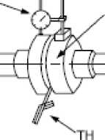
MARKING MARK
ICKNESS GAUGE
Fig. 4 Procedure for Alignment

DIAL GAUGE

Measurement of Eccentricity
The both shafts are to be simultaneously turned; the values shall be obtained from the measurement made at four points by means of a dial gauge and are to be recorded; and the corrected value is to be obtained in the following manners.

90 deg

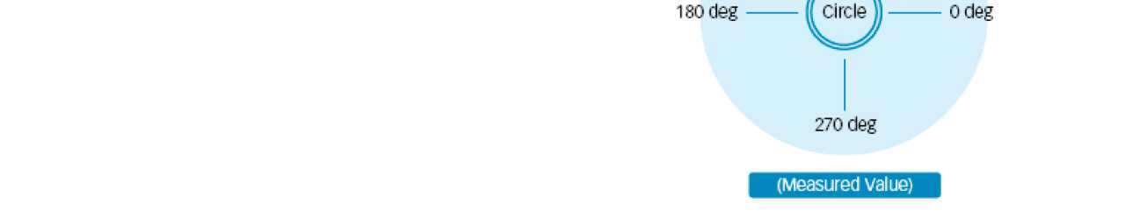

F2

G2


E2

H2

(Measured value)
(Measured value)

corrected value of left and right
A-c
corrected value of left and right (F1 +F2)-(H1 +H2)

Corrected value of left and right
A-c

corrected value of left and right
(E1+E2)-(G1+G2)

(Corrected value)
(Corrected value)

A CAUTION
The difference between the total of the measured values at the left and right points (A-C) and the total of the measured values at the top and bottom points (B- D) should not exceed 0.03 mm. The Improper fitting of the dial gauge and the erection of the fitting arm, if any, may cause greater difference.

Measurement of parallelism
The values at the four points of El, F1, G1 and H1 are to be corrected after measurement made by means of a thickness gauge at the position where both shafts were connected to each other at the time of eccentricity measurement; and measurements are to be made again at the points of E2,F2, G2 and H2 after turning both shafts.
HI
(Measured value)

F1
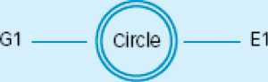

Coupling Balance
The coupling should be dynamically balanced to G2.5 or better. The motor is dynamically balanced with a half key fitted; therefore, the proposed coupling shou Id be balanced accordingly, and the correct key profile fitted.
KEY
Fig. 7 coupling Balance

KEV


3.9 Test Run of Motor

carry out the Initial operation In accordance with contractual agreements. The initial operation may only be carried out by trained personnel who have been assigned to do this by the person responsible for the plant.

SHAF,COUPI |N<3

Frame Distortion Test
In addition to ensure the proper alignment of the coupling, care should be taken to ensure that the motor frame is not distor ted during alignment.

To confirm that distortion has not occurred, we recommend the following procedure be adopted:
- Align the motor within tolerances as required by section "alignment."
- Apply a dial gauge between the motor frame adjacent to one mounting foot and the foundation and set indicator to zero.
- Loosen hold down bolt and record movement of dial gauge measurement.
- Re-torque hold down bolt.
- Repeat steps 1- 4 for all hold down bolts, one at a time.
After coupling with the load machine, the motor is inching operated at first.

When both motor and load machine show no abnormality, the motor is restarted with a minimum load. At that time, the current, supplied voltage is checked and recorded. While the motor is running continuously, the motor vibr ations on the bear ing housing are controlled by Fig. 8.
do not exceed number of hyundai-specified hot and cold starts per hour
will cause overheating.
Allow time between starts to permit
stator windings and rotor cage to ceo I.

* Motor Alignment is taken from Hyundai O&M
Manual as an example.

