chaos_an_introduction_dynamical_systems_Kathleen_C01

Kathleen

Introduction

BACKGROUND
p5

Sir Isaac Newton brought to the world the idea of modeling the motion of
physical systems with equations. It was necessary to invent calculus along the
way, since fundamental equations of motion involve velocities and accelerations,
which are derivatives of position. His greatest single success was his discovery that
the motion of the planets and moons of the solar system resulted from a single
fundamental source: the gravitational attraction of the bodies. He demonstrated
that the observed motion of the planets could be explained by assuming that there
is a gravitational attraction between any two objects, a force that is proportional
to the product of masses and inversely proportional to the square of the distance
between them. The circular, elliptical, and parabolic orbits of astronomy were
no longer fundamental determinants of motion, but were approximations of laws
specified with differential equations. His methods are now used in modeling
motion and change in all areas of science.
.-------------------------------------
brought to the world - traído al mundo
along the way - a lo largo del camino
His greatest single success - Su mayor éxito individual
were no longer fundamental determinants of motion - ya no eran determinantes fundamentales del movimiento

Subsequent generations of scientists extended the method of using differential
equations to describe how physical systems evolve. But the method had
a limitation. While the differential equations were sufficient to determine the
behavior—in the sense that solutions of the equations did exist—it was frequently
difficult to figure out what that behavior would be. It was often impossible to write
down solutions in relatively simple algebraic expressions using a finite number of
terms. Series solutions involving infinite sums often would not converge beyond
some finite time.
.--------------------------------------
how physical systems evolve - cómo evolucionan los sistemas físicos
to figure out what that behavior would be - para averiguar cuál sería ese comportamiento

When solutions could be found, they described very regular motion. Generations
of young scientists learned the sciences from textbooks filled with examples
of differential equations with regular solutions. If the solutions remained in
a bounded region of space, they settled down to either (A) a steady state, often
due to energy loss by friction, or (B) an oscillation that was either periodic or
quasiperiodic, akin to the clocklike motion of the moon and planets. (In the solar
system, there were obviously many different periods. The moon traveled around
the earth in a month, the earth around the sun in about a year, and Jupiter around
the sun in about 11.867 years. Such systems with multiple incommensurable
periods came to be called quasiperiodic.)
.------------------------------------
they settled down - Ellas se establecieron
akin to the clocklike motion - Parecido al movimiento de reloj
incommensurable - inconmensurable

Scientists knew of systems which had more complicated behavior, such as
a pot of boiling water, or the molecules of air colliding in a room. However, since
these systems were composed of an immense number of interacting particles, the
complexity of their motions was not held to be surprising.
.--------------------------------------
a pot of boiling water - una olla de agua hirviendo
the molecules of air colliding in a room - las moléculas de aire chocando en una habitación
was not held to be surprising - no se consideró sorprendente

Around 1975, after three centuries of study, scientists in large numbers
around the world suddenly became aware that there is a third kind of motion, a
type (C) motion, that we now call “chaos”. The new motion is erratic, but not
simply quasiperiodic with a large number of periods, and not necessarily due to
a large number of interacting particles. It is a type of behavior that is possible in
very simple systems.

A small number of mathematicians and physicists were familiar with the
existence of a third type of motion prior to this time. James Clerk Maxwell, who
studied the motion of gas molecules in about 1860, was probably aware that even
a system composed of two colliding gas particles in a box would have neither
motion type A nor B, and that the long term behavior of the motions would for
all practical purposes be unpredictable. He was aware that very small changes
in the initial motion of the particles would result in immense changes in the
trajectories of the molecules, even if they were thought of as hard spheres.
.--------------------------

prior to this time - antes de este tiempo
of two colliding gas particles - de dos partículas de gas en colisión
and that the long term behavior of the motions would for all practical purposes be unpredictable - y que el comportamiento a largo plazo de los movimientos sería impredecible para todos los propósitos prácticos
in immense changes - en inmensos cambios

pag7

Maxwell began his famous study of gas laws by investigating individual
collisions. Consider two atoms of equal mass, modeled as hard spheres. Give the
atoms equal but opposite velocities, and assume that their positions are selected
at random in a large three-dimensional region of space. Maxwell showed that if
they collide, all directions of travel will be equally likely after the collision. He
recognized that small changes in initial positions can result in large changes in
outcomes. In a discussion of free will, he suggested that it would be impossible
to test whether a leopard has free will, because one could never compute from a
study of its atoms what the leopard would do. But the chaos of its atoms is limited,
for, as he observed, “No leopard can change its spots!”
.--------------------------
collide - chocar
in outcomes - en resultados
In a discussion of free will - En una discusión sobre el libre albedrío

Henri Poincar e in 1890 studied highly simplified solar systems of three
bodies and concluded that the motions were sometimes incredibly complicated.
(See Chapter 2). His techniques were applicable to a wide variety of physical
systems. Important further contributions were made by Birkhoff, Cartwright and
Littlewood, Levinson, Kolmogorov and his students, among others. By the 1960s,
there were groups of mathematicians, particularly in Berkeley and in Moscow,
striving to understand this third kind of motion that we now call chaos. But
only with the advent of personal computers, with screens capable of displaying
graphics, have scientists and engineers been able to see that important equations
in their own specialties had such solutions, at least for some ranges of parameters
that appear in the equations.
.-------------------------------
Important further contributions - Importantes contribuciones adicionales
striving to understand - esforzándose por entender

In the present day, scientists realize that chaotic behavior can be observed
in experiments and in computer models of behavior from all fields of science. The
key requirement is that the system involve a nonlinearity. It is now common for
experiments whose previous anomalous behavior was attributed to experiment
error or noise to be reevaluated for an explanation in these new terms. Taken
together, these new terms form a set of unifying principles, often called dynamical
systems theory, that cross many disciplinary boundaries.
.---------------------------------
the system involve a nonlinearity - el sistema implica una no linealidad
of unifying principles - de principios unificadores

The theory of dynamical systems describes phenomena that are common
to physical and biological systems throughout science. It has benefited greatly
from the collision of ideas from mathematics and these sciences. The goal of
scientists and applied mathematicians is to find nature’s unifying ideas or laws
and to fashion a language to describe these ideas. It is critical to the advancement
of science that exacting standards are applied to what is meant by knowledge.
.---------------------------------------
throughout - a lo largo de
It has benefited greatly - Se ha beneficiado mucho
is to find nature’s unifying ideas - es encontrar las ideas unificadoras de la naturaleza

Beautiful theories can be appreciated for their own sake, but science is a severe
taskmaster. Intriguing ideas are often rejected or ignored because they do not
meet the standards of what is knowledge.
.---------------------------
for their own sake - por su propio bien
taskmaster - capataz

The standards of mathematicians and scientists are rather different. Mathematicians
prove theorems. Scientists look at realisticmodels. Their approaches are
somewhat incompatible. The first papers showing chaotic behavior in computer
studies of very simple models were distasteful to both groups. The mathematicians
feared that nothing was proved so nothing was learned. Scientists said that models
without physical quantities like charge, mass, energy, or acceleration could not be
relevant to physical studies. But further reflection led to a change in viewpoints.
.---------------------------------
were distasteful to both groups - fueron desagradables para ambos grupos
The mathematicians feared - Los matemáticos temían

pag 8

Mathematicians found that these computer studies could lead to new ideas that
slowly yielded new theorems. Scientists found that computer studies of much more
complicated models yielded behaviors similar to those of the simplistic models,
and that perhaps the simpler models captured the key phenomena.

Finally, laboratory experiments began to be carried out that showed unequivocal
evidence of unusual nonlinear effects and chaotic behavior in very
familiar settings. The new dynamical systems concepts showed up in macroscopic
systems such as fluids, common electronic circuits and low-energy lasers that were
previously thought to be fairly well understood using the classical paradigms. In
this sense, the chaotic revolution is quite different than that of relativity, which
shows its effects at high energies and velocities, and quantum theory, whose effects
are submicroscopic. Many demonstrations of chaotic behavior in experiments are
not far from the reader’s experience.
.-----------------------------------
to be carried out - para ser llevado a cabo
of unusual nonlinear effects - de efectos no lineales inusuales

In this book we study this field that is the uncomfortable interface between
mathematics and science. We will look at many pictures produced by computers
and we try to make mathematical sense of them. For example, a computer study of
the driven pendulum in Chapter 2 reveals irregular, persistent, complex behavior
for ten million oscillations. Does this behavior persist for one billion oscillations?
.----------------------------------------
the uncomfortable interface - la incómoda interfaz
the driven pendulum - el péndulo impulsado

The only way we can find out is to continue the computer study longer. However,
even if it continues its complex behavior throughout our computer study, we
cannot guarantee it would persist forever. Perhaps it stops abruptly after one
trillion oscillations; we do not know for certain. We can prove that there exist
initial positions and velocities of the pendulum that yield complex behavior
forever, but these choices are conceivably quite atypical. There are even simpler
models where we know that such chaotic behavior does persist forever. In this
world, pictures with uncertain messages remain the medium of inspiration.
.----------------------------------
we cannot guarantee it would persist forever - no podemos garantizar que persistirá para siempre
but these choices are conceivably quite atypical - pero estas opciones son posiblemente bastante atípicas

There is a philosophy of modeling in which we study idealized systems
that have properties that can be closely approximated by physical systems. The
experimentalist takes the view that only quantities that can be measured have
meaning. Yet we can prove that there are beautiful structures that are so infinitely
intricate that they can never be seen experimentally.
.------------------------
There is a philosophy of modeling - Hay una filosofía de modelado.

For example, we will see
immediately in Chapters 1 and 2 the way chaos develops as a physical parameter
like friction is varied. We see infinitely many periodic attractors appearing with
infinitely many periods. This topic is revisited in Chapter 12, where we show
how this rich bifurcation structure, called a cascade, exists with mathematical
certainty in many systems. This is a mathematical reality that underlies what
the experimentalist can see.
.-------------------------------

We know that as the scientist finds ways to make
the study of a physical system increasingly tractable, more of this mathematical
structure will be revealed. It is there, but often hidden from view by the noise of
the universe. All science is of course dependent on simplistic models. If we study
a vibrating beam, we will generally not model the atoms of which it is made.
If we model the atoms, we will probably not reflect in our model the fact that
the universe has a finite age and that the beam did not exist for all time. And
we do not include in our model (usually) the tidal effects of the stars and the
planets on our vibrating beam. We ignore all these effects so that we can isolate
the implications of a very limited list of concepts.

It is our goal to give an introduction to some of the most intriguing ideas in
dynamics, the ideas we love most. Just as chemistry has its elements and physics
has its elementary particles, dynamics has its fundamental elements: with names
like attractors, basins, saddles, homoclinic points, cascades, and horseshoes. The
ideas in this field are not transparent. As a reader, your ability to work with these
ideas will come from your own effort.We will consider our job to be accomplished
if we can help you learn what to look for in your own studies of dynamical systems
of the world and universe.

pag 9

ABOUT T H E BOOK

As we developed the drafts of this book, we taught six one semester classes at
George Mason University and the University of Maryland. The level is aimed at
undergraduates and beginning graduate students. Typically, we have used parts
of Chapters 1–9 as the core of such a course, spending roughly equal amounts of
time on iterated maps (Chapters 1–6) and differential equations (Chapters 7–9).
Some of the maps we use as examples in the early chapters come from differential
equations, so that their importance in the subject is stressed. The topics of stable
manifolds, bifurcations, and cascades are introduced in the first two chapters and
then developed more fully in the Chapters 10, 11, and 12, respectively. Chapter
13 on time series may be profitably read immediately after Chapter 4 on fractals,
although the concepts of periodic orbit (of a differential equation) and chaotic
attractor will not yet have been formally defined.

The impetus for advances in dynamical systems has come from many
sources: mathematics, theoretical science, computer simulation, and experimenix
tal science. We have tried to put this book together in a way that would reflect
its wide range of influences.

We present elaborate dissections of the proofs of three deep and important
theorems: The Poincar e-Bendixson Theorem, the Stable Manifold Theorem, and
the Cascade Theorem. Our hope is that including them in this form tempts you
to work through the nitty-gritty details, toward mastery of the building blocks as
well as an appreciation of the completed edifice.

Additionally, each chapter contains a special feature called a Challenge,
in which other famous ideas from dynamics have been divided into a number
of steps with helpful hints. The Challenges tackle subjects from period-three
implies chaos, the cat map, and Sharkovskii’s ordering through synchronization
and renormalization.We apologize in advance for the hints we have given, when
they are of no help or even mislead you; for one person’s hint can be another’s
distraction.

The Computer Experiments are designed to present you with opportunities
to explore dynamics through computer simulation, the venue through which
many of these concepts were first discovered. In each, you are asked to design
and carry out a calculation relevant to an aspect of the dynamics. Virtually all
can be successfully approached with a minimal knowledge of some scientific
programming language. Appendix B provides an introduction to the solution of
differential equations by approximate means, which is necessary for some of the
later Computer Experiments.

If you prefer not to work the Computer Experiments from scratch, your
task can be greatly simplified by using existing software. Several packages
are available. Dynamics: Numerical Explorations by H.E. Nusse and J.A. Yorke
(Springer-Verlag 1994) is the result of programs developed at the University of
Maryland. Dynamics, which includes software for Unix and PC environments,
was used to make many of the pictures in this book. The web site for Dynamics
is www.ipst.umd.edu/dynamics. We can also recommend Differential and
Difference Equations through Computer Experiments by H. Kocak (Springer-Verlag,
1989) for personal computers. A sophisticated package designed for Unix platforms
is dstool, developed by J. Guckenheimer and his group at Cornell University.
In the absence of special purpose software, general purpose scientific computing
environments such as Matlab, Maple, and Mathematica will do nicely.

The Lab Visits are short reports on carefully selected laboratory experiments
that show how the mathematical concepts of dynamical systems manifest
themselves in real phenomena.We try to impart some flavor of the setting of the
experiment and the considerable expertise and care necessary to tease a new secret
from nature. In virtually every case, the experimenters’ findings far surpassed
what we survey in the Lab Visit.We urge you to pursue more accurate and detailed
discussions of these experiments by going straight to the original sources.

pag 17

CHAPTER ONE
One-Dimensional Maps

THE FUNCTION f(x) = 2x is a rule that assigns to each number x a number
twice as large. This is a simple mathematical model. We might imagine that x
denotes the population of bacteria in a laboratory culture and that f(x) denotes
the population one hour later. Then the rule expresses the fact that the population
doubles every hour. If the culture has an initial population of 10,000 bacteria,
then after one hour there will be f(10,000) 20,000 bacteria, after two hours
there will be f(f(10,000)) 40,000 bacteria, and so on.

A dynamical system consists of a set of possible states, together with a
rule that determines the present state in terms of past states. In the previous
paragraph, we discussed a simple dynamical system whose states are population
levels, that change with time under the rule xn = f(x(n-1)) = 2x(n-1). Here the
variable n stands for time, and xn designates the population at time n. We will
require that the rule be deterministic, which means that we can determine the
present state (population, for example) uniquely from the past states.

No randomness is allowed in our definition of a deterministic dynamical
system. A possible mathematical model for the price of gold as a function of time
would be to predict today’s price to be yesterday’s price plus or minus one dollar,
with the two possibilities equally likely. Instead of a dynamical system, this model
would be called a random, or stochastic, process. A typical realization of such a
model could be achieved by flipping a fair coin each day to determine the new
price. This type of model is not deterministic, and is ruled out by our definition
of dynamical system.

We will emphasize two types of dynamical systems. If the rule is applied
at discrete times, it is called a discrete-time dynamical system. A discrete-time
system takes the current state as input and updates the situation by producing a
new state as output. By the state of the system, we mean whatever information
is needed so that the rule may be applied. In the first example above, the state is
the population size. The rule replaces the current population with the population
one hour later.We will spend most of Chapter 1 examining discrete-time systems,
also called maps.

The other important type of dynamical system is essentially the limit of
discrete systems with smaller and smaller updating times. The governing rule in
that case becomes a set of differential equations, and the term continuous-time
dynamical system is sometimes used. Many of the phenomena we want to explain
are easier to describe and understand in the context of maps; however, since the
time of Newton the scientific view has been that nature has arranged itself to
be most easily modeled by differential equations. After studying discrete systems
thoroughly, we will turn to continuous systems in Chapter 7.

1 .1 ONE-D I M E N S I O N A L MA P S

One of the goals of science is to predict how a system will evolve as time progresses.
In our first example, the population evolves by a single rule. The output of the
rule is used as the input value for the next hour, and the same rule of doubling is
applied again. The evolution of this dynamical process is reflected by composition
of the function f. Define f2(x) f(f(x)) and in general, define fk(x) to be the
result of applying the function f to the initial state k times. Given an initial
value of x, we want to know about fk(x) for large k. For the above example, it is
clear that if the initial value of x is greater than zero, the population will grow
without bound. This type of expansion, in which the population is multiplied by
a constant factor per unit of time, is called exponential growth. The factor in this
example is 2.

WHY STUDY MODELS?

We study models because they suggest how real-world processes behave.
In this chapter we study extremely simple models.

Every model of a physical process is at best an idealization. The goal
of a model is to capture some feature of the physical process. The
feature we want to capture now is the patterns of points on an orbit.
In particular, we will find that the patterns are sometimes simple, and
sometimes quite complicated, or “chaotic”, even for simple maps.

The question to ask about a model is whether the behavior it exhibits
is because of its simplifications or if it captures the behavior despite
the simplifications. Modeling reality too closely may result in an
intractable model about which little can be learned. Model building
is an art. Here we try to get a handle on possible behaviors of maps
by considering the simplest ones.

The fact that real habitats have finite resources lies in opposition to the
concept of exponential population increase. From the time of Malthus (Malthus,
1798), the fact that there are limits to growth has been well appreciated. Population
growth corresponding to multiplication by a constant factor cannot continue
forever. At some point the resources of the environment will become compromised
by the increased population, and the growth will slow to something less
than exponential.

In other words, although the rule f(x) 2x may be correct for a certain range
of populations, it may lose its applicability in other ranges. An improved model,
to be used for a resource-limited population, might be given by g(x) 2x(1 x),
where x is measured in millions. In this model, the initial population of 10,000
corresponds to x .01 million. When the population x is small, the factor (1 x)
is close to one, and g(x) closely resembles the doubling function f(x). On the other
hand, if the population x is far from zero, then g(x) is no longer proportional to
the population x but to the product of x and the “remaining space” (1-x). This is
a nonlinear effect, and the model given by g(x) is an example of a logistic growth
model.

Using a calculator, investigate the difference in outcomes imposed by the
models f(x) and g(x). Start with a small value, say x 0.01, and compute fk(x)
and gk(x) for successive values of k. The results for the models are shown in
Table 1.1. One can see that for g(x), there is computational evidence that the
population approaches an eventual limiting size, which we would call a steadystate
population for the model g(x). Later in this section, using some elementary
calculus, we’ll see how to verify this conjecture (Theorem 1.5).
There are obvious differences between the behavior of the population size
under the two models, f(x) andg(x). Under the dynamical system f(x), the starting
population size x 0.01 results in arbitrarily large populations as time progresses.
Under the system g(x), the same starting size x 0.01 progresses in a strikingly
similar way at first, approximately doubling each hour. Eventually, however, a
limiting size is reached. In this case, the population saturates at x 0.50 (onehalf
million), and then never changes again.

So one great improvement of the logistic model g(x) is that populations
can have a finite limit. But there is a second improvement contained in g(x). If

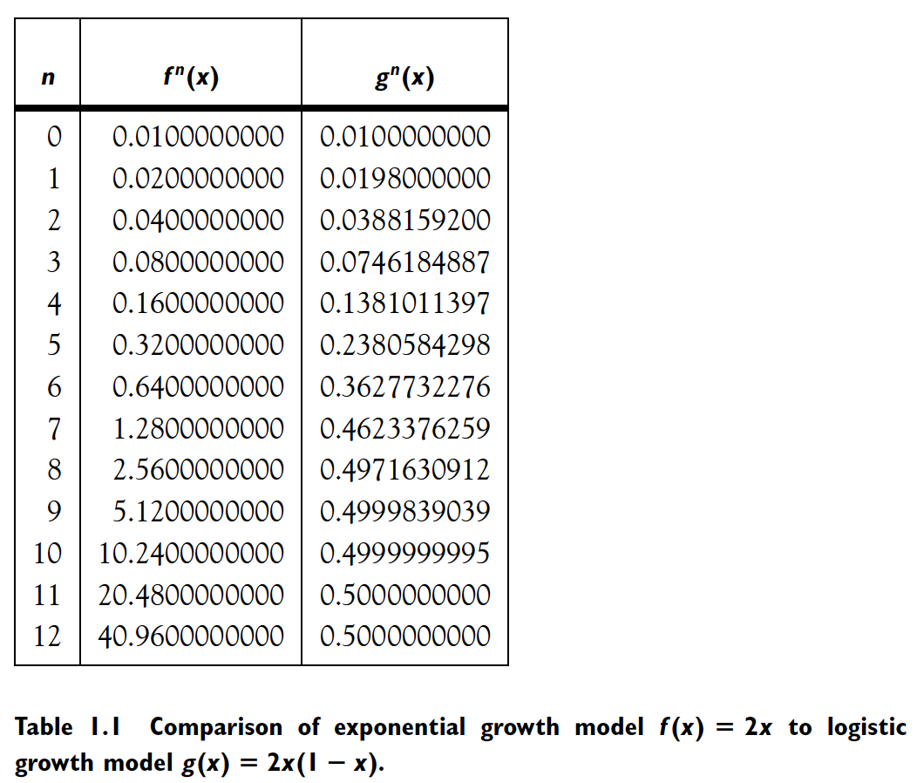
The exponential model explodes, while the logistic model approaches a steady state.

we use starting populations other than x= 0.01, the same limiting population
x=0.50 will be achieved.

➮ C O M P U T E R E X P E R I M E N T 1 . 1

Confirm the fact that populations evolving under the rule g(x) 2x(1 x)
prefer to reach the population 0.5. Use a calculator or computer program, and try
starting populations x0 between 0.0 and 1.0. Calculate x1 g(x0), x2 g(x1),
etc. and allow the population to reach a limiting size. You will find that the size
x 0.50 eventually “attracts” any of these starting populations.

Our numerical experiment suggests that this population model has a natural
built-in carrying capacity. This property corresponds to one of the many ways
that scientists believe populations should behave—that they reach a steady-state
which is somehow compatible with the available environmental resources. The
limiting population x 0.50 for the logistic model is an example of a fixed point
of a discrete-time dynamical system.

Definition 1.1 A function whose domain (input) space and range (output)
space are the same will be called a map. Let x be a point and let f be a map.
The orbit of x under f is the set of points x, f(x), f2(x), . . . . The starting point
x for the orbit is called the initial value of the orbit. A point p is a fixed point of
the map f if f(p) p.

For example, the function g(x) 2x(1 x) from the real line to itself is a
map. The orbit of x 0.01 under g is 0.01, 0.0198, 0.0388, . . . , and the fixed
points of g are x 0 and x 1 2.

1 .2 COBWEB P L OT: GR A P H I C A L
R E P R E S E N TAT I O N O F AN OR B I T

For a map of the real line, a rough plot of an orbit—called a cobweb plot—can be
made using the following graphical technique. Sketch the graph of the function
f together with the diagonal line y = x. In Figure 1.1, the example f(x) =2x and
the diagonal are sketched. The first thing that is clear from such a picture is the
location of fixed points of f. At any intersection of y=f(x) with the line y=x,

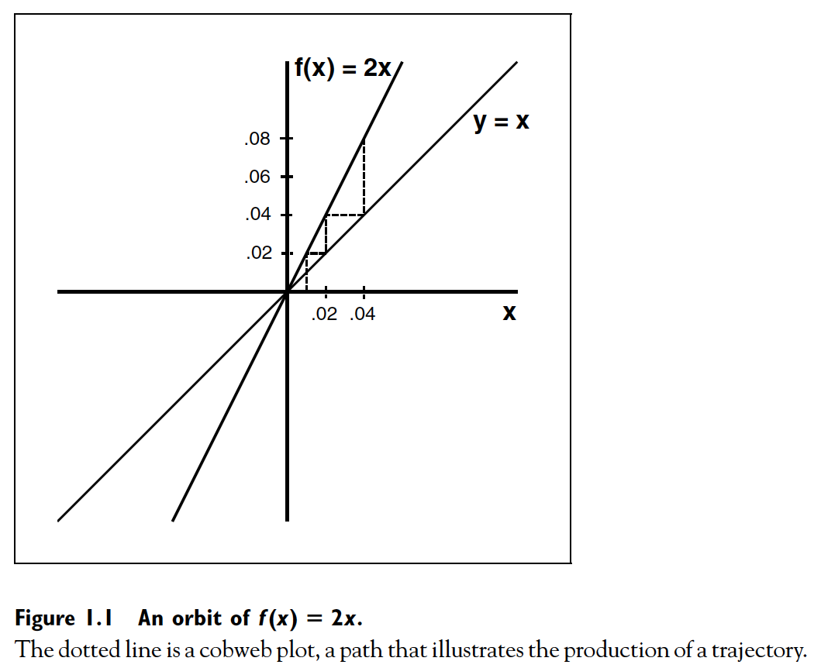

the input value x and the output f(x) are identical, so such an x is a fixed point.
Figure 1.1 shows that the only fixed point of f(x)=2x is x = 0.

Sketching the orbit of a given initial condition is done as follows. Starting
with the input value x .01, the output f(.01) is found by plotting the value
of the function above .01. In Figure 1.1, the output value is .02. Next, to find
f(.02), it is necessary to consider .02 as the new input value. In order to turn an
output value into an input value, draw a horizontal line from the input–output
pair (.01, .02) to the diagonal line y x. In Figure 1.1, there is a vertical dotted
line segment starting at x .01, representing the function evaluation, and then
a horizontal dotted segment which effectively turns the output into an input so
that the process can be repeated.

Then start over with the new value x .02, and draw a new pair of vertical
and horizontal dotted segments. We find f(f(.01)) f(.02) .04 on the graph
of f, and move horizontally to move output to the input position. Continuing in
this way, a graphical history of the orbit .01, .02, .04, . . . is constructed by the
path of dotted line segments.

EXAMPLE 1.2

A more interesting example is the map g(x)=2x(1-x). First we find fixed
points by solving the equation x 2x(1 x). There are two solutions, x 0

COBWEB PLOT
A cobweb plot illustrates convergence to an attracting fixed point of
g(x) 2x(1 x). Let x0 0.1 be the initial condition. Then the
first iterate is x1 g(x0) 0.18. Note that the point (x0, x1) lies on
the function graph, and (x1, x1) lies on the diagonal line. Connect
these points with a horizontal dotted line to make a path. Then find
x2 g(x1) 0.2952, and continue the path with a vertical dotted
line to (x1, x2) and with a horizontal dotted line to (x2, x2). An entire
orbit can be mapped out this way.

In this case it is clear from the geometry that the orbit we are following
will converge to the intersection of the curve and the diagonal,
x 1 2. What happens if instead we start with x0 0.8? These are
examples of simple cobweb plots. They can be much more complicated,
as we shall see later.

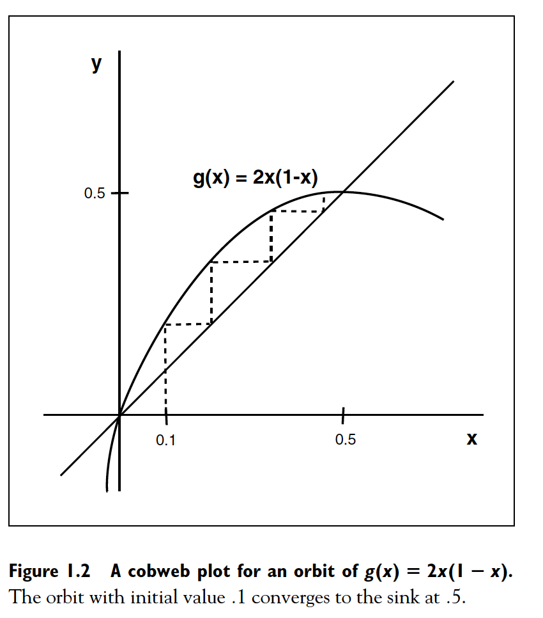

and x 1 2, which are the two fixed points of g. Contrast this with a linear
map which, except for the case of the identity f(x) x, has only one fixed point
x 0. What is the behavior of orbits of g? The graphical representation of the
orbit with initial value x 0.1 is drawn in Figure 1.2. It is clear from the figure
that the orbit, instead of diverging to infinity as in Figure 1.1, is converging to the
fixed point x 1 2. Thus the orbit with initial condition x 0.1 gets stuck, and
cannot move beyond the fixed point x 0.5.Asimple rule of thumb for following
the graphical representation of an orbit: If the graph is above the diagonal line
y x, the orbit will move to the right; if the graph is below the line, the orbit
moves to the left.

EXAMPLE 1.3

Let f be the map of R given by f(x) = (3x - x^3)/2. Figure 1.3 shows
a graphical representations of two orbits, with initial values x=1.6 and 1.8,
respectively. The former orbit appears to converge to the fixed point x=1 as the
map is iterated; the latter converges to the fixed point x=-1.

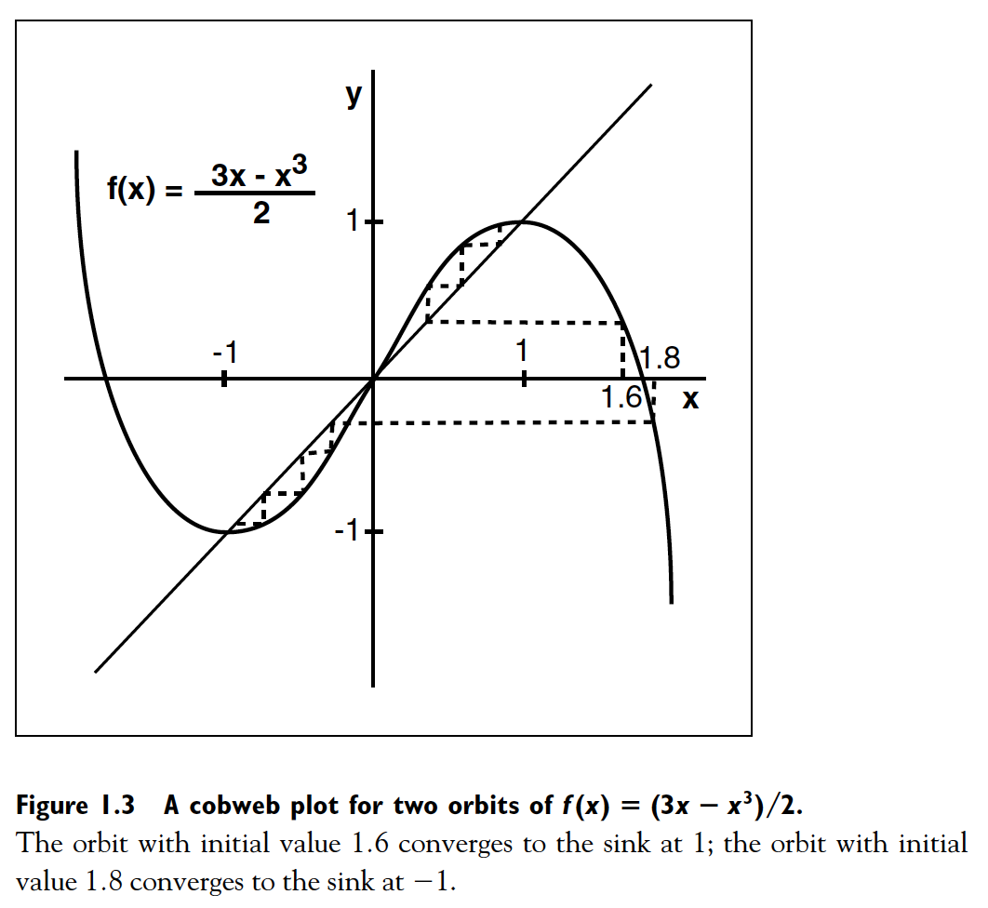

Fixed points are found by solving the equation f(x)=x. The map has
three fixed points, namely 1, 0, and 1. However, orbits beginning near, but not
precisely on, each of the fixed points act differently. You may be able to convince
yourself, using the graphical representation technique, that initial values near 1
stay near 1 upon iteration by the map, and that initial values near 1 stay near 1.
On the other hand, initial values near 0 depart from the area near 0. For example,
to four significant digits, f(.1) 0.1495, f2(.1) 0.2226, f5(.1) 0.6587, and
so on. The problem with points near 0 is that f magnifies them by a factor
larger than one. For example, the point x .1 is moved by f to approximately
.1495, a magnification factor of 1.495. This magnification factor turns out to be
approximately the derivative f (0) 1.5.

1 .3 S TA B I L I T Y OF F I X E D P O I N T S

With the geometric intuition gained from Figures 1.1, 1.2, and 1.3, we can describe
the idea of stability of fixed points. Assuming that the discrete-time system exists
to model real phenomena, not all fixed points are alike. A stable fixed point has
the property that points near it are moved even closer to the fixed point under
the dynamical system. For an unstable fixed point, nearby points move away as
time progresses. A good analogy is that a ball at the bottom of a valley is stable,
while a ball balanced at the tip of a mountain is unstable.

The question of stability is significant because a real-world system is constantly
subject to small perturbations. Therefore a steady state observed in a
realistic system must correspond to a stable fixed point. If the fixed point is unstable,
small errors or perturbations in the state would cause the orbit to move away
from the fixed point, which would then not be observed.

Example 1.3 gave some insight into the question of stability. The derivative
of the map at a fixed point p is a measure of how the distance between p and a
nearby point is magnified or shrunk by f. That is, the points 0 and .1 begin exactly
.1 units apart. After applying the rule f to both points, the distance separating
the points is changed by a factor of approximately f’(0).We want to call the fixed
point 0 “unstable” when points very near 0 tend to move away from 0.

The concept of “near” is made precise by referring to all real numbers within
a distance of p as the epsilon neighborhood Ne(p). Denote the real line by R.
Then Ne(p) is the interval of numbers {x in R : |x p| <e}. We usually think
of e as a small, positive number.

Definition 1.4 Let f be a map on R and let p be a real number such that
f(p)=p. If all points sufficiently close to p are attracted to p, then p is called a
sink or an attracting fixed point. More precisely, if there is an 0 such that
for all x in the epsilon neighborhood N (p), limk→ fk(x) p, then p is a sink. If
all points sufficiently close to p are repelled from p, then p is called a source or a
repelling fixed point. More precisely, if there is an epsilon neighborhood N (p)
such that each x in N (p) except for p itself eventually maps outside of N (p),
then p is a source.

In this text, unless otherwise stated, we will deal with functions for which
derivatives of all orders exist and are continuous functions.We will call this type
of function a smooth function.
Theorem 1.5 Let f be a (smooth) map on R , and assume that p is a fixed
point of f.

1. If |f’(p)| <1, then p is a sink.
2. If |f’(p)| > 1, then p is a source.

Proof: PART 1. Let a be any number between |f (p)| and 1; for example, a
could be chosen to be (1 |f (p)|) 2. Since
lim
x→p
|f(x) f(p)|
|x p| |f (p)|,
there is a neighborhood N (p) for some 0 so that
|f(x) f(p)|
|x p| a
for x in N (p), x p.
In other words, f(x) is closer to p than x is, by at least a factor of a (which is
less than 1). This implies two things: First, if x N (p), then f(x) N (p); that
means that if x is within of p, then so is f(x), and by repeating the argument, so
are f2(x), f3(x), and so forth. Second, it follows that
|fk(x) p| ak|x p| (1.1)
for all k 1. Thus p is a sink.

✎ EXERCISE T1.1

Show that inequality (1.1) holds for k=2. Then carry out the mathematical
induction argument to show that it holds for all k=1, 2, 3, . . .

EXERCISE T1.2

Use the ideas of the proof of Part 1 of Theorem 1.5 to prove Part 2.

Note that the proof of part 1 of Theorem 1.5 says something about the rate
of convergence of fk(x) to p. The fact that |fk(x) p| ak|x p| for a 1 is
described by saying that fk(x) converges exponentially to p as k → .
Our definition of a fixed-point sink requires only that the sink attract some
epsilon neighborhood (p , p ) of nearby points. As far as the definition
is concerned, the radius of the neighborhood, although nonzero, could be
extremely small. On the other hand, sinks often attract orbits from a large set
of nearby initial conditions. We will refer to the set of initial conditions whose
orbits converge to the sink as the basin of the sink.
With Theorem 1.5 and our new terminology, we can return to Example
1.2, an example of a logistic model. Setting x g(x) 2x(1 x) shows that the
fixed points are 0 and 1 2. Taking derivatives, we get g (0) 2 and g (1 2) 0.
Theorem 1.5 shows that x 1 2 is a sink, which confirms our suspicions from
Table 1.1. On the other hand, x 0 is a source. Points near 0 are repelled from
0 upon application of g. In fact, points near 0 are repelled at an exponential
magnification factor of approximately 2 (check this number with a calculator).
These points are attracted to the sink x 1 2.
What is the basin of the sink x 1 2 in Example 1.2? The point 0 does
not belong, since it is a fixed point. Also, 1 does not belong, since g(1) 0
and further iterations cannot budge it. However, all initial conditions from the
interval (0, 1) will produce orbits that converge to the sink. You should sketch
a graph of g(x) as in Figure 1.1 and use the idea of the cobweb plot to convince
yourself of this fact.
There is a second way to show that the basin of x 1 2 is (0, 1), which
is quicker and trickier but far less general. That is to use algebra (not geometry)
to compare |g(x) 1 2| to |x 1 2|. If the former is smaller than the latter, it
means the orbit is getting closer to 1 2. The algebra says:
|g(x) 1 2| |2x(1 x) 1 2|
2|x 1 2||x 1 2| (1.2)
Now we can see that if x (0, 1), the multiplier 2|x 1 2| is smaller than one.
Any point x in (0, 1) will have its distance from x 1 2 decreased on each iteration
by g. Notice that the algebra also tells us what happens for initial conditions
outside of (0, 1): they will never converge to the sink x 1 2. Therefore the
basin of the sink is exactly the open interval (0, 1). Informally, we could also
say that the basin of infinity is ( , 0) (1, ), since the orbit of each initial
condition in this set tends toward .
Theorem 1.5 also clarifies Example 1.3, which is the map f(x) (3x
x3) 2. The fixed points are 1, 0, and 1, and the derivatives are f ( 1) f (1)
0, and f (0) 1.5. By the theorem, the fixed points 1 and 1 are attracting fixed
points, and 0 is a repelling fixed point.
Let’s try to determine the basins of the two sinks. Example 1.3 is already
significantly more complicated than Example 1.2, and we will have to be satisfied
with an incomplete answer. We will consider the sink x 1; the other sink has
very similar properties by the symmetry of the situation.
First, cobweb plots (see Figure 1.3) convince us that the interval I1
(0,

3) of initial conditions belongs to the basin of x 1. (Note that f(

3)
f(

3) 0.) So far it is similar to the previous example. Have we found the
entire basin? Not quite. Initial conditions from the interval I2 [ 2,

3)
map to (0, 1], which we already know are basin points. (Note that f( 2) 1.)
Since points that map to basin points are basin points as well, we know that the
set [ 2,

3) (0,

3) is included in the basin of x 1. Now you may be
willing to admit that the basin can be quite a complicated creature, because the
graph shows that there is a small interval I3 of points to the right of x 2 that
map into the interval I2 [ 2,

3), and are therefore in the basin, then a
small interval I4 to the left of x 2 that maps into I3, and so forth ad infinitum.
These intervals are all separate (they don’t overlap), and the gaps between them
consist of similar intervals belonging to the basin of the other sink x 1. The
intervals In get smaller with increasing n, and all of them lie between

5 and
5. Since f(

5)

5 and f(

5)

5, neither of these numbers is in
the basin of either sink.
✎ EXERCISE T1.3
Solve the inequality |f (x) 0| |x 0|, where f (x) (3x x3) 2. This
identifies points whose distance from 0 increases on each iteration. Use
the result to find a large set of initial conditions that do not converge to
any sink of f .
There is one case that is not covered by Theorem 1.5. The stability of a
fixed point p cannot be determined solely by the derivative when |f (p)| 1 (see
Exercise 1.2).
12
So far we have seen the important role of fixed points in determining the
behavior of orbits of maps. If the fixed point is a sink, it provides the final state for
the orbits of many nearby initial conditions. For the linear map f(x) ax with
|a| 1, the sink x 0 attracts all initial conditions. In Examples 1.2 and 1.3,
the sinks attract large sets of initial conditions.
✎ EXERCISE T1.4
Let p be a fixed point of a map f . Given some 0, find a geometric
condition under which all points x in N (p) are in the basin of p. Use
cobweb plot analysis to explain your reasoning.
1 .4 PE R I O D I C P O I N T S
Changing a, the constant of proportionality in the logistic map ga(x) ax(1 x),
can result in a picture quite different from Example 1.2. When a 3.3, the fixed
points are x 0andx 23 33 .69 .696969 . . . , both of which are repellers.
Now that there are no fixed points around that can attract orbits, where do they
go? Use a calculator to convince yourself that for almost every choice of initial
condition, the orbit settles into a pattern of alternating values p1 .4794 and
p2 .8236 (to four decimal place accuracy). Some typical orbits are shown in
Table 1.2. The orbit with initial condition 0.2 is graphed in Figure 1.4. This
figure shows typical behavior of an orbit converging to a period-2 sink p1, p2 . It
is attracted to p1 every two iterates, and to p2 on alternate iterates.
There are actually two important parts of this fact. First, there is the apparent
coincidence that g(p1) p2 and g(p2) p1. Another way to look at this is that
g2(p1) p1; thus p1 is a fixed point of h g2. (The same could be said for p2.)
Second, this periodic oscillation between p1 and p2 is stable, and attracts orbits.
This fact means that periodic behavior will show up in a physical system modeled
by g. The pair p1, p2 is an example of a periodic orbit.
Definition 1.6 Let f be a map on .We call p a periodic point of period
k if fk(p) p, and if k is the smallest such positive integer. The orbit with initial
point p (which consists of k points) is called a periodic orbit of period k.We will
often use the abbreviated terms period-k point and period-k orbit.
Notice that we have defined the period of an orbit to be the minimum
number of iterates required for the orbit to repeat a point. If p is a periodic point
of period 2 for the map f, then p is a fixed point of the map h f2. However, the
converse is not true. A fixed point of h f2 may also be a fixed point of a lower
13
iterate of f, specifically f, and so may not be a periodic point of period two. For
example, if p is a fixed point of f, it will be a fixed point of f2 but not, according
to our definition, a period-two point of f.
EXAMPLE 1.7
Consider the map defined by f(x) x on . This map has one fixed point,
at x 0. Every other real number is a period-two point, because f2 is the identity
map.
✎ EXERCISE T1.5
The map f (x) 2x2 5x on has fixed points at x 0 and x 3. Find a
period-two orbit for f by solving f 2(x) x for x.
What about the stability of periodic orbits? As in the fixed point case, points
near the periodic orbit can be trapped or repelled by the orbit. The key fact is that
a periodic point for f is a fixed point for fk.We can use Theorem 1.5 to investigate
the stability of a periodic orbit. For a period-k orbit, we apply Theorem 1.5 to the
map fk instead of f.
Definition 1.8 Let f be a map and assume that p is a period-k point. The
period-k orbit of p is a periodic sink if p is a sink for the map fk. The orbit of p is
a periodic source if p is a source for the map fk.
It is helpful to review the chain rule of calculus, which shows how to expand
the derivative of a composition of functions:
(f ◦ g) (x) f (g(x))g (x) (1.3)
Our current interest in the chain rule is for f g, in which case we have (f2) (x)
f (f(x))f (x). If x happens to be a period-two point for f, the chain rule is saying
something quite simple: the derivative of f2 at a point of a period-two orbit
is simply the product of the derivatives of f at the two points in the orbit. In
particular, the derivative of f2 is the same, when evaluated at either point of the
orbit. This agreement means that it makes sense to talk about the stability of a
period-two orbit.
Now the period-two behavior of g(x) 3.3x(1 x) we found in Table 1.2
can be completely explained. The periodic orbit .4794, .8236 will be a sink
as long as the derivative (g2) (p1) g (p1)g (p2) (g2) (p2) is smaller than 1 in
absolute value. Aneasy calculation shows this number to be g (.4794)g (.8236)
0.2904.
15
If instead we consider yet another version of the logistic map, g(x)
3.5x(1 x), the situation is again changed. The fixed points are x 0 and
x 5 7. Checking derivatives, g (0) 3.5 and g (5 7) 1.5, so they are
sources. The orbit 3 7, 6 7 is a period-two orbit for g. Check that (g2) at each
of the orbit points is 5 4, so that this period-two orbit repels nearby points.
Now where do points end up?
➮ C O M P U T E R E X P E R I M E N T 1 . 2
Write a computer program with the goal of redoing Table 1.2 for the logistic
map ga(x) ax(1 x), using a 3.5. What periodic behavior wins out in the
long run? Try several different initial conditions to explore the basin of the
attracting periodic behavior. Then try different values of a 3.57 and report
your results.
Now that we have some intuition from period-two orbits, we note that
the situation is essentially the same for higher periods. Let p1, . . . , pk denote a
period-k orbit of f. The chain rule says that
(fk) (p1) (f(fk 1)) (p1)
f (fk 1(p1))(fk 1) (p1)
f (fk 1(p1))f (fk 2(p1)) f (p1)
f (pk)f (pk 1) f (p1). (1.4)
STABILITY TEST FOR PERIODIC ORBITS
The periodic orbit p1, . . . , pk is a sink if
|f (pk) f (p1)| 1
and a source if
|f (pk) f (p1)| 1.
This formula tells us that the derivative of the kth iterate fk of f at a point
of a period-k orbit is the product of the derivatives of f at the k points of the
orbit. In particular, stability is a collective property of the periodic orbit, in that
(fk) (pi) (fk) (pj) for all i and j.
1 .5 THE FA M I L Y OF L O G I S T I C MA P S
We are beginning to get an overall view of the family ga(x) ax(1 x) associated
with the logistic model. When 0 a 1, the map has a sink at x 0, and we
will see later that every initial condition between 0 and 1 is attracted to this sink.
(In other words, with small reproduction rates, small populations tend to die out.)
The graph of the map is shown in Figure 1.5(a).
If 1 a 3, the map, shown in Figure 1.5(b), has a sink at x (a 1) a,
since the magnitude of the derivative is less than 1. (Small populations grow to
a steady state of x (a 1) a.) For a greater than 3, as in Figure 1.5(c), the
fixed point x (a 1) a is unstable since |g
a (x)| 1, and a period-two sink
takes its place, which we saw in Table 1.2 for a 3.3. When a grows above
1

6 3.45, the period-two sink also becomes unstable.
✎ EXERCISE T1.6
Verify the statements in the previous paragraph by solving for the fixed
points and period-two points of ga(x) and evaluating their stability.
C O M P U T E R E X P E R I M E N T 1 . 3
Use your logistic map program to investigate the long-run behavior of ga
for a near a 1

6. Repeat Table 1.2 for values of a slightly smaller than
a . What qualitative or quantitative conclusions can be made about the speed
of convergence to the period-two orbit as a gets closer to a ? What happens to
iterations beginning at a period-two point for a slightly larger than a ?
For slightly larger values of a, the story of the periodic points of ga(x)
becomes significantly more complicated. Many new periodic orbits come into
existence as a is increased from 3.45 to 4. Figure 1.6 shows the limiting behavior
of orbits for values of a in the range 1 a 4. This computer-generated picture
was made by repeating the following procedure: (1) Choose a value of a, starting
with a 1, (2) Choose x at random in [0,1], (3) Calculate the orbit of x under
ga(x), (4) Ignore the first 100 iterates and plot the orbit beginning with iterate
101. Then increment a and begin the procedure again. The points that are plotted
will (within the resolution of the picture) approximate either fixed or periodic
sinks or other attracting sets. This figure is called a bifurcation diagram and shows
the birth, evolution, and death of attracting sets. The term “bifurcation” refers to
significant changes in the set of fixed or periodic points or other sets of dynamic
interest.We will study bifurcations in detail in Chapter 11.
We see, for example, that the vertical slice a 3.4 of Figure 1.6 intersects
the diagram in the two points of a period-two sink. For a slightly larger than
3.45, there appears to be a period-four sink. In fact, there is an entire sequence of
periodic sinks, one for each period 2n, n 1, 2, 3, . . .. Such a sequence is called a
“period-doubling cascade”. The phenomenon of cascades is the subject of Chapter
12. Figure 1.7 shows portions of the bifurcation diagram in detail. Magnification
near a period-three sink, in Figure 1.7(b) hints at further period-doublings that
are invisible in Figure 1.6.
For other values of the parameter a, the orbit appears to randomly fill out the
entire interval [0, 1], or a subinterval. A typical cobweb plot formed for a 3.86
is shown in Figure 1.8. These attracting sets, called “chaotic attractors”, are harder
to describe than periodic sinks.We will try to unlock some of their secrets in later
chapters. As we shall see, it is a characteristic of chaotic attractors that they can
abruptly appear or disappear, or change size discontinuously. This phenomenon,
called a “crisis”, is apparent at various a values. In particular, at a 4, there is a
Figure 1.6 Bifurcation diagram of ga (x) ax(1 x).
The fixed point that exists for small values of a gives way to a period-two orbit at the
“bifurcation point” a 3, which in turn leads to more and more complicated orbits
for larger values of a. Notice that the fixed point is only plotted while it is a sink.
When the period-two orbit appears, the fixed point is no longer plotted because it
does not attract orbits. See Lab Visit 12 for laboratory versions.
crisis at which the chaotic attractor disappears. For a 4, there is no attracting
set.
The successive blow-ups of the bifurcation diagrams reveal another interesting
feature, that of “periodic windows”. The period-three window, for example,
is apparent in Figure 1.7(a) and is shown in magnified form in Figure 1.7(b). This
refers to a set of parameter values for which there is a periodic sink, in this case
a period-three sink. Since a period-three point of ga is a fixed point of the third
iterate g3
a , the creation of the period-three sink can be seen by viewing the de-
Figure 1.7 Magnifications of the logistic bifurcation diagram.
(a) Horizontal axis is 3.4 a 4.0 (b) Horizontal axis is 3.82 a 3.86.
velopment of the graph of g3
a as a moves from 3.82 to 3.86. This development is
shown in Figure 1.9.
In Figure 1.9(a), the period-three orbit does not exist. This parameter value
a 3.82 corresponds to the left end of Figure 1.7(b). In Figure 1.9(b), the periodthree
orbit has been formed. Of course, since each point of a period-three orbit of g
Figure 1.8 Cobweb plot for the logistic map.
A single orbit of the map g(x) 3.86x(1 x) shows complicated behavior.
Figure 1.9 Graphs of the third iteration g3(x) of the logistic map ga (x)
ax(1 x).
Three different parameter values are shown: (a) a 3.82 (b) a 3.84 (c) a 3.86.
is a fixed point of g3, the period-three orbit will appear as three intersections with
the diagonal y x. As you can see from the figure, the shape of the graph forces
two period-three orbits to be created simultaneously. This is called a saddle-node
bifurcation, or alternatively, a tangency bifurcation. The “node” is the sink, which
is the set of three points at which the graph intersects the diagonal in negative
slope. (Can you explain why the three negative slopes are exactly equal? Use the
chain rule.) The fact that it is a sink corresponds to the fact that the negative
slopes are between 1 and 0. The “saddle” is a period-three source consisting of
the three upward sloping points. A vertical slice through the middle of Figure
1.7(b) shows that all initial conditions are attracted to the period-three sink.
In Figure 1.9(c), the period-three sink has turned into a source. This parameter
value a 3.86 corresponds to the right side of Figure 1.7(b).
There are many more features of Figure 1.7 that we have to leave unexplained
for now. The demise of the period-three sink as an attractor coincides with
a so-called period-doubling bifurcation, which creates a period-six sink, which
then meets a similar fate. There are periodic windows of arbitrarily high period.
We will try to unlock some of the deeper mysteries of bifurcations in Chapter 11.
What happens to the bifurcation diagram if different x values are selected?
(Recall that for each a, the orbit of one randomly chosen initial x is computed.)
Surprisingly, nothing changes. The diagram looks the same no matter what initial
condition is picked at random between 0 and 1, since there is at most one
attracting fixed or periodic orbit at each parameter value. As we shall see, however,
there are many unstable, hence unseen, periodic orbits for larger a.
1 .6 THE L O G I S T I C MA P G (x ) 4x (1 x )
In the previous sections we studied maps from the logistic family g(x) ax(1 x).
For a 2.0, 3.3, and 3.5, we found the existence of sinks of period 1, 2, and 4,
respectively.Next, we will focus on one more case, a 4.0, which is so interesting
that it gets its own section. The reason that it is so interesting is that it has no
sinks, which leads one to ask where orbits end up.
The graph of G(x) g4(x) 4x(1 x) is shown in Figure 1.10(a). Although
the graph is a parabola of the type often studied in elementary precalculus
courses, the map defined by G has very rich dynamical behavior. To begin with,
the diagonal line y x intersects y G(x) 4x(1 x) in the points x 0 and
x 3 4, so there are two fixed points, both unstable. Does G have any other
periodic orbits?
One way to look for periodic orbits is to sketch the graph of y Gn(x).
Any period-two point, for example, will be a fixed point of G2(x). Therefore we
can find periodic points graphically.
1
0
0 1
(a)
0 1
(b)
0 1
(c)
Figure 1.10 Graphs of compositions of the logistic map.
(a) the logistic map G(x) 4x(1 x). (b) The map G2(x). (c) The map G3(x).
The graph of y G2(x) is shown in Figure 1.10(b). It is not hard to verify
by hand the general shape of the graph. First, note that the image of [0,1] under
G is [0,1], so the graph stays entirely within the unit square. Second, note that
G(1 2) 1 andG(1) 0 implies thatG2(1 2) 0. Further, sinceG(a1) 1 2
for some a1 between 0 and 1 2, it follows that G2(a1) 1. Similarly, there is
another number a2 such that G2(a2) 1.
It is clear from Figure 1.10(b) that G2 has four fixed points, and thereforeG
has four points that have period either one or two. Two of these points are already
known to us—they are fixed points for G. The new pair of points, p1 and p2, make
up a period-two orbit: that is, G(p1) p2 and G(p2) p1. This reasoning should
have you convinced that the period-two orbit exists. The next exercise asks you
to explicitly find p1 and p2.
✎ EXERCISE T1.7
Find the period-two orbit of G(x) 4x(1 x).
Does G have any period-three points? There is a point b1 between 0 and a1
for which G(b1) a1. This implies that G3(b1) 1. The same holds for three
other points in [0,1], so y G3(x) has four relative maxima of height 1 in [0,1].
Since G(1) 0, G3 has roots at x 0, a1, 1 2, a2, and 1, which separate the
maxima. The graph of G3 is shown in Figure 1.10(c).
The map G3 has eight fixed points, two of which were known to be the
fixed points 0 and 3 4 of G. The period-two points of G are not fixed points of
G3. (Why not?) There remain six more points to account for, which must form
two period-three orbits. You should be able to prove to yourself in a similar way
that G4 has 16 24 fixed points, all in [0, 1]. With each successive iteration of
G, the number of fixed points of the iterate is doubled. In general, we see that Gk
has 2k fixed points, all in [0, 1]. Of course, for k 1, G has fewer than 2k points
of period-k. (Remember that the definition of period-k for the point p is that k is
the smallest positive integer for which fk(p) p.) For example, x 0 is a period
one point and therefore not a period-k point for k 1, although it is one of the
2k fixed points of Gk.
✎ EXERCISE T1.8
Let G(x) 4x(1 x). Prove that for each positive integer k, there is an
orbit of period-k.
Table 1.3 The periodic table for the logistic map.
The nth iterate of the map G(x) 4x(1 x) has 2n fixed points, which are periodic
orbits for G.
The number of orbits of the map for each period can be tabulated in the
map’s periodic table . For the logistic map it begins as shown in Table 1.3. The
first column is the period k, and the second column is the number of fixed points
of fk, which is 2k, as seen in Figure 1.10. The third column keeps track of fixed
points of Gk which correspond to orbits of lower period than k. When these are
subtracted away from the entry in the second column, the result is the number of
period-k points, which is divided by k to get the number of period-k orbits.
✎ EXERCISE T1.9
Let G(x) 4x(1 x).
(a) Decide whether the fixed points and period-two points of G are
sinks.
(b) Continue the periodic table for G begun in Table 1.3. In particular,
how many periodic orbits of (minimum) period k does G have, for each
k 10?
Is this what we mean by “chaos”? Not exactly. The existence of infinitely
many periodic orbits does not in itself imply the kind of unpredictability usually
associated with chaotic maps, although it does hint at the rich structure present.
Chaos is identified with nonperiodicity and sensitive dependence on initial conditions,
which we explore in the next section.
1 .7 S E N S I T I V E DEPENDENCE ON
I N I T I A L C O N D I T I O N S
EXAMPLE 1.9
Consider the map f(x) 3x (mod 1) on the unit interval. The notation y
(mod 1) stands for the number y n, where n is the unique integer that makes
0 y n 1. For example, 14.92 (mod 1) .92 and 14.92 (mod 1) .08.
For a positive number y, this is the fractional part of y. See Figure 1.11(a) for
a graph of the map. Because of the breaks at x 1 3, 2 3, this function is not
continuous.
This map is not continuous, however the important property that we are
interested in is not caused by the discontinuity . It may be more natural to view
f as a map on the circle of circumference one. Glue together the ends of the unit
interval to form a circle, as in Figure 1.11(b). If we consider f(x) as a map from
this circle to itself, it is a continuous map. In Figure 1.11(b), we show the image
of the subinterval [0, 1 2] on the circle. Whether we think of f as a discontinuous
map on the unit interval or as a continuous map on the circle makes no difference
for the questions we will try to answer below.
We call a point x eventually periodic with period p for the map f if for
some positive integer N, fn p(x) fn(x) for all n N, and if p is the smallest
0 1
1
0
1/2
(a) (b)
Figure 1.11 The 3x mod 1 map.
(a) The map f(x) 3x (mod 1) is discontinuous on the unit interval. (b) When
the points 0 and 1 are identified, turning the unit interval into a circle, the map is
continuous. The inner dashed semicircle is the subinterval [0, 1 2], and the outer
dashed curve is its image under the map. If x and y are two points that are close
together on the circle, then f(x) and f(y) will be 3 times further apart than x and y.
25
such positive integer. This says exactly that the orbit of x eventually maps directly
onto a periodic orbit. For example, x 1 3 is an eventually periodic point, since
it maps under f to the period one orbit 0.
✎ EXERCISE T1.10
Show that a point x is eventually periodic for Example 1.9 if and only if x is
a rational number.
✎ EXERCISE T1.11
Construct the periodic table for f in Example 1.9 (follow the form given by
Table 1.3).
The 3x mod 1 map demonstrates the main characteristic of chaos: sensitive
dependence on initial conditions. This refers to the property that pairs of points,
which begin as close together as desired, will eventually move apart. Table 1.4
shows the beginning of two separate orbits whose initial conditions differ by .0001.
In fact, no matter how close they begin, the difference between two nearby orbits
is—as measured on the circle—magnified by a factor of 3 on each iteration. This
idea is important enough to be assigned a formal definition.
n f n (x0) f n (y0)
0 0.25 0.2501
1 0.75 0.7503
2 0.25 0.2509
3 0.75 0.7527
4 0.25 0.2581
5 0.75 0.7743
6 0.25 0.3229
7 0.75 0.9687
8 0.25 0.9061
9 0.75 0.7183
10 0.25 0.1549
Table 1.4 Comparison of the orbits of two nearly equal initial conditions
under the 3x mod 1 map.
The orbits become completely uncorrelated in fewer than 10 iterates.
Definition 1.10 Let f be a map on . A point x0 has sensitive dependence
on initial conditions if there is a nonzero distance d such that some points
arbitrarily near x0 are eventually mapped at least d units from the corresponding
image of x0. More precisely, there exists d 0 such that any neighborhood N of
x0 contains a point x such that |fk(x) fk(x0)| d for some nonnegative integer
k. Sometimes we will call such a point x0 a sensitive point.
Ordinarily, the closer x is to x0, the larger k will need to be. The point x will
be sensitive if it has neighbors as close as desired that eventually move away the
prescribed distance d for some sufficiently large k.
✎ EXERCISE T1.12
Consider the 3x mod 1 map of the unit interval [0, 1]. Define the distance
between a pair of points x, y to be either |x y| or 1 |x y|, whichever is
smaller. (We are measuring with the “circle metric”, in the sense of Figure
1.11, corresponding to the distance between two points on the circle.)
(a) Show that the distance between any pair of points that lie within
1 6 of one another is tripled by the map. (b) Find a pair of points whose
distance is not tripled by the map. (c) Show that to prove sensitive dependence
for any point, d can be taken to be any positive number less than
1 2 in Definition 1.10, and that k can be chosen to be the smallest integer
greater than ln(d |x x0|) ln 3.
✎ EXERCISE T1.13
Prove that for any map f , a source has sensitive dependence on initial
conditions.
1 .8 I T I N E R A R I E S
The fact that the logistic map G(x) 4x(1 x) has periodic orbits of every
period is one indication of its complicated dynamics. An even more important
reflection of this complexity is sensitive dependence on initial conditions, which
is the hallmark of chaos.
In this section we will show for the logistic map G g4 that for any initial
point in the unit interval and any preset distance 0, no matter how small,
there is a second point within units of the first so that their two orbits will
map at least d 1 4 units apart after a sufficient number of iterations. Since 1 4
unit is 25% of the length of the unit interval, it is fair to say that the two initial
conditions which began very close to one another are eventually moved by the
map so they are no longer close, by any reasonable definition of “close”.
In order to investigate sensitive dependence, we introduce the concept of
the itinerary of an orbit. This is a bookkeeping device that allows much of the
information of an orbit to be coded in terms of discrete symbols.
For the logistic map, assign the symbol L to the left subinterval [0, 1 2],
and R to the right subinterval [1 2, 1]. Given an initial value x0, we construct its
itinerary by listing the subintervals, L or R, that contain x0 and all future iterates.
For example, the initial condition x0 1 3 begets the orbit 1
3 , 89
, 32
81, . . . , whose
itinerary begins LRL . . . . For the initial condition x0 14
, the orbit is 1
4 , 34
, 34
, . . . ,
LL LR RR RL
LLL LLR LRR LRL RRL RRR RLR RLL
L R
Figure 1.12 Schematic itineraries for G(x) 4x(1 x).
The rules: (1) an interval ending in L splits into two subintervals ending in LL and
LR if there is an even number of R’s; the order is switched if there are an odd number
of R’s, (2) an interval ending in R splits into two subintervals ending in RL and RR
if there are an even number of R’s; the order is switched if there are an odd number
of R’s
28
which terminates in the fixed point x 34
. The itinerary for this orbit is LRR . . .,
which we abbreviate by LR; the overbar indicates that the R repeats indefinitely.
Notice that there is a special orbit, or group of orbits, for which the itinerary
is not uniquely defined. That is because the intervals L and R overlap at x 1 2.
In particular, consider the initial condition x0 1 2. The corresponding orbit
is 1 2, 1, 0, 0, . . . , which can be assigned itinerary RRL or LRL. This particular
orbit (and some others like it) are assigned two different names under this naming
system. Except for the case of orbits which land precisely on x 1 2 at some
point of the orbit (and therefore end up mapping onto the fixed point 0), the
itinerary is uniquely defined.
Once we are given this way of assigning an itinerary to each orbit, we can
map out, on the unit interval, the locations of points that have certain itineraries.
Of course, an itinerary is in general an infinite sequence, but we could ask: what
is the set of points whose itinerary begins with, say, LR? These points share the
property of beginning in the L subinterval and being mapped to the R subinterval
by one iterate of the map. This set, which we could call the LR set, is shown in
Figure 1.12, along with a few other similar sets.
We would like to identify the sets of all initial points whose itineraries begin
with a specified sequence of symbols. For example, the set of initial conditions
whose itinerary begins with LR forms a subinterval of the unit interval. The
subintervals in Figure 1.12 give information about the future behavior of the
initial conditions lying in them. Another example is the subinterval marked LRL,
which consists of orbits that start out in the interval L [0, 1 2], whose first
iterate lands in R [1 2, 1], and whose second iterate lands in [0, 1 2]. For
example, x 1 3 lies in LRL. Likewise, x 1 4 lies in LRR because its first and
second iterate are in R.

✎ EXERCISE T1.14
(a) Find a point that lies in the subinterval LLR. (You are asked for a specific
number.) (b) For each subinterval corresponding to a sequence of length 3,
find a point in the subinterval.

You may see some patterns in the arrangement of the subintervals of Figure
1.12. It turns out that the rule for dividing an interval, say LR, into its two
subintervals is the following: Count the number of R’s in the sequence (one in
this case). If odd, the interval is divided into LRR, LRL in that order. If even, the
L subinterval precedes the R subinterval. With this information, the reader can
continue Figure 1.12 schematically to finer and finer levels.

EXERCISE T1.15
Continue the schematic diagram in Figure 1.12 to subintervals corresponding
to length 4 sequences.

✎ EXERCISE T1.16
Let x0 be a point in the subinterval RLLRRRLRLR. (a) Is x0 less than, equal
to, or greater than 1 2? (b) Same question for f 6(x0)

A graphical way of specifying the possible itineraries for the logistic map is
shown in Figure 1.13.We call this the transition graph for the subintervals L and
R. An arrow from L to R, for example, means that the image f(L) contains the
interval R. For every path through this graph with directed edges (arrows), there
exists an orbit with an itinerary satisfying the sequence of symbols determined
by the path. It is clear from Figure 1.12 that the image of each of the intervals L
and R contains both L and R, so the transition graph for the logistic map is fully
connected (every symbol is connected to every other symbol by an arrow). Since
the graph is fully connected, all possible sequences of L and R are possible.

The concept of itineraries makes it easy to explain what we mean by
sensitive dependence on initial conditions. In specifying the first k symbols of the
itinerary, we have 2k choices. If k is large, then most of the 2k subintervals are
forced to be rather small, since the sum of their lengths is 1. It is a fact (that we
will prove in Chapter 3) that each of the 2k subintervals is shorter than 2k 1
in length.

Consider any one of these small subintervals for a large value of k, corresponding
to some sequence of symbols S1 Sk, where each Si is either R or L.
This subinterval in turn contains subintervals corresponding to the sequences
S1 SkLL, S1 SkLR, S1 SkRR and S1 SkRL. If we choose one point from
each, we have four initial conditions that lie within 2k 1 (since they all lie
L R
Figure 1.13 Transition graph for the logistic map G(x) 4x(1 x).
The leftmost arrow tells us that f maps the interval L over itself, i.e., that f(L)
contains L. The top arrow says that f(L) contains R, and so forth.
in S1 Sk), but which map k iterates later to subintervals LL, LR, RR, and RL,
respectively. (If this step isn’t clear, itmay help to recall Exercise T1.16.) In Figure
1.12, the width of the LR and RR subintervals are greater than 1 4, so that the
LR and RL subintervals, for example, lie over 1 4 unit apart.
It is now possible to see why every point in [0, 1] has sensitive dependence
on initial conditions under the logistic map G. To find a neighbor close to x0 that
eventually separates by a distance of at least d 1 4, identify which subinterval
of level k 2 that x0 belongs to, say S1 SkLR. Then it is always possible to
identify a subinterval within 2k 1 which maps 1 4 unit away after k iterates,
such as S1 SkRL. Therefore every point exhibits sensitive dependence with
neighbors that are arbitrarily close.
We illustrate for k 1000: There is a pair of initial conditions within
2 1001 10 300 that eventually are mapped at least 1 4 unit apart. This is an
expansion of 1000 factors of 2 in 1000 iterates, for an average multiplicative
expansion rate of approximately 2. In Chapter 3 we will introduce the term
“Lyapunov number”, which will quantify the average multiplicative separation
rate of a map, which is in this case 21000 1000 2 per iterate. The fact that this
number is greater than 1 will mean that repeated expansion is occurring.
The impact of sensitive dependence is that changes in initial measurements
or errors in calculation along the orbit can result in quite different outcomes. The
consequences of this behavior were not fully appreciated until the advent of
computers and the computer simulation of dynamical models.

➮ C O M P U T E R E X P E R I M E N T 1 . 4

Use a computer program to illustrate sensitive dependence for the logistic
map G(x)=4x(1- x). Start with two different initial conditions that are very
close together, and iterate G on each. The two orbits should stay near one
another for a while, and then separate for good. By collecting statistics on your
experiments, try to quantify how many iterations are required for the points to
move apart, say 1/2 unit, when the initial separation is .01, .001, etc. Does the
location of the initial pair matter?

CHALLENGE 1
Period Three Implies Chaos
IN CHAPTER 1 we have studied periodic orbits for continuous maps and the
idea of sensitive dependence on initial conditions. In Challenge 1 you will prove
the fact that the existence of a period-three orbit alone implies the existence of
a large set of sensitive points. The set is infinite (in fact, uncountably infinite, a
concept we will study in more detail later in the book). This surprising fact was
discovered by T.Y. Li and J.A. Yorke (Li and Yorke, 1975).
A chaotic orbit is a bounded, non-periodic orbit that displays sensitive
dependence. When we give a precise definition of chaos, we will find that the
discussion is simplified if we require a stronger definition of sensitivity, namely
that chaotic orbits separate exponentially fast from their neighbors as the map is
iterated.
Amuch simpler fact about continuous maps is that the existence of a periodthree
orbit implies that the map has periodic orbits of all periods (all integers).
See Exercise T3.10 of Chapter 3. This fact doesn’t say anything directly about
sensitive dependence, although it guarantees that the map has rather complicated
dynamical behavior.

We show a particular map f in Figure 1.14 that has a period-three orbit,
denoted A, B,C . That is, f(A) =B, f(B)=C, and f(C)=A.We will discover
that there are infinitely many points between A and C that exhibit sensitive
dependence on initial conditions. To simplify the argument, we will use an assumption
that is explicitly drawn into Figure 1.14: the map f(x) is unimodal,
which means that it has only one critical point. (A critical point for a function
f(x) is a point for which f (x) 0 or where the derivative does not exist.) This
assumption, that f(x) has a single maximum, is not necessary to prove sensitive
dependence—in fact sensitive dependence holds for any continuous map with a
period-three orbit. The final step of Challenge 1 asks you to extend the reasoning
to this general case.
The existence of the period-three orbit in Figure 1.14 and the continuous
nature of f together guarantee that the image of the interval [A, B] covers [B,C];
that is, that f[A, B] [B,C]. Furthermore, f[B,C] [A,C].We will try to repeat
our analysis of itineraries, which was successful for the logistic map, for this
new map. Let the symbol L represent the interval [A, B], and R represent [B,C].
Figure 1.14 A map with a period-three orbit.
The dashed lines follow a cobweb orbit, from A to B to C to A.
Unlike the logistic map example, notice that in the itinerary of an orbit, L must be
followed by R, although R can be followed by either L or R. Some of the itinerary
subintervals are shown schematically in Figure 1.15.
A second difference from the logistic map example is that there may be gaps
in the interval, as shown in Figure 1.15. For example, points just to the left of B
are mapped to the right of C, and therefore out of the interval [A,C]; we do not
include these points in our analysis. (A more sophisticated analysis might include
these points, but we can demonstrate sensitive dependence without considering
these orbits.) To simplify our analysis, we will not assign an itinerary to points
that map outside [A,C].
The corresponding transition graph is shown in Figure 1.16. The transition
graph tells us that every finite sequence of the symbols L and R corresponds to
a subinterval of initial conditions x, as long as there are never two consecutive
L’s in the sequence. (This follows from the fact that the left-hand interval [A, B]
does not map over itself.)
The proof that period three implies chaos is given below in outline form.
In each part, you are expected to fill in a reason or argument.
Step 1 Let d denote the length of the subinterval RR. Denote by J
S1 SkR any subinterval that ends in R. (Each Si denotes either R or L.) Show
Figure 1.15 Schematic itineraries for period-three map.
The rules: (1) an interval ending in R splits into two subintervals ending in RR and
RL; the order is switched if there is an even number of R’s, (2) an interval ending
in L contains a shorter subinterval ending in LR, and a gap on the left (for an odd
number of R’s) or the right (for an even number).
that J contains a pair of points, one in each of the subintervals S1 SkRRL and
S1 SkRLR, that eventually map at least d units apart.
Step 2 Show that inside J there are 3 subintervals of type S1 SkRSk 2
Sk 3R. Explain why at least 2 of them must have length that is less than half the
length of J.
L R
Figure 1.16 Transition graph for map with period-three orbit.
The three arrows imply that f(L) R, f(R) R, and f(R) L.
34
Step 3 Combine the two previous steps. Show that a subinterval J of form
S1 SkR must contain a subinterval J1 of form S1 SkRSk 2Sk 3RLR with the
following property. Each point x of J1 has a neighbor y within length(J) 2 whose
pairwise distance upon further iteration eventually exceeds d.
Step 4 Let h C A be the length of the original interval. Show that for
each positive integer k there are 2k disjoint subintervals (denoted by sequences of
5k 1 symbols) of length less than 2 kh, each of which contain a point that has
sensitive dependence on initial conditions. Therefore, there are infinitely many
sensitive points.
Step 5 Quantify the number of sensitive points you have located in the
following way. Show that there is a one-to-one correspondence between the
sensitive points found in Step 4 and binary numbers between 0 and 1 (infinite
sequences of form .a1a2a3 , where each ai is a 0 or 1). This means that the set
of sensitive points is uncountable, a concept we will meet in Chapter 4.
Step 6 Our argument is based on Figure 1.14, where f(A) B, f(B)
C, f(C) A, and where A B C. How many other distinct “cases” need to
be considered? Does a similar argument work for these cases? What changes are
necessary?
Step 7 Explain how to modify the arguments above to work for the case
where f is any continuous map with a period-three orbit. (Begin by identifying
one-piece subintervals of [A, B] and [B,C] that are mapped onto [A, B] and
[B,C].)
Postscript. The subintervals described in the previous argument, although many in
number, may comprise a small proportion of all points in the interval [A,C]. For example,
the logistic map g(x) 3.83x(1 x) has a period-three sink. Since there is a period-three
orbit (its stability does not matter), we now know that there are many points that exhibit
sensitive dependence with respect to their neighbors. On the other hand, the orbits of most
points in the unit interval converge to one or another point in this periodic attractor under
iteration by g3. These points do not exhibit sensitive dependence. For example, points that
lie a small distance from one of the points p of the period-three sink will be attracted
toward p, as we found in Theorem 1.5. The distances between points that start out near
p decrease by a factor of approximately |(g3) (p)| with each three iterates. These nearby
points do not separate under iteration. There are, however, infinitely many points whose
orbits do not converge to the period-three sink. It is these points that exhibit sensitive
dependence.
35
EXERCISES
1.1. Let l(x) ax b, where a and b are constants. For which values of a and b does l
have an attracting fixed point? A repelling fixed point?
1.2. (a) Let f(x) x x2. Show that x 0 is a fixed point of f, and describe the
dynamical behavior of points near 0.
(b) Let g(x) tan x, 2 x 2. Show that x 0 is a fixed point of g,
and describe the dynamical behavior of points near 0.
(c) Give an example of a function h for which h (0) 1 and x 0 is an
attracting fixed point.
(d) Give an example of a function h for which h (0) 1 and x 0 is a repelling
fixed point.
1.3. Let f(x) x3 x. Find all fixed points of f and decide whether they are sinks or
sources. You will have to work without Theorem 1.5, which does not apply.
1.4. Let x1 x8 be the eight fixed points of G3(x), where G(x) 4x(1 x), as
in 1.10(c). Clearly, x1 0.
(a) For which i is xi 3 4?
(b) Group the remaining six points into two orbits of three points each. It may
help to consult Figure 1.10(c). The most elegant solution (that we know of) uses
the chain rule.
1.5. Is the period-two orbit of the map f(x) 2x2 5x on a sink, a source, or neither?
See Exercise T1.5.
1.6. Define the map f(x) 2x (mod 1) on the unit interval [0, 1]. Let L denote the
subinterval [0, 1 2] and R the subinterval [1 2, 1].
(a) Draw a chart of the itineraries of f as in Figure 1.12.
(b) Draw the transition graph for f.
(c) Establish sensitive dependence for orbits under this map. Show that each
point has neighbors arbitrarily near that eventually map at least 1 2 unit apart.
1.7. Define the tent map on the unit inverval [0, 1] by
T(x)

2x if 0 x 1 2
2(1 x) if1 2 x 1
.
(a) Divide the unit interval into two appropriate subintervals and repeat parts
(a)–(c) of Exercise 1.6 for this map.
(b) Complete a periodic table for f, similar to the one in Table 1.3, for periods
less than or equal to 10. In what ways, if any, does it differ from the periodic
table for the logistic map G?
1.8. Let f(x) 4x(1 x). Prove that there are points in I [0, 1] that are not fixed
points, periodic points, or eventually periodic points of f.
1.9. Define xn 1 (xn 2) (xn 1).
(a) Find L limn→ xn for x0 0.
(b) Describe the set of all negative x0 for which the limit limn→ xn either exists
and is not equal to the L in part (a) or does not exist (for example, x0 1).
1.10. For the map g(x) 3.05x(1 x), find the stability of all fixed points and period-two
points.
1.11. Let f be a one-to-one smooth map of the real line to itself. One-to-one means that
if f(x1) f(x2), then x1 x2. A function f is called increasing if x1 x2 implies
f(x1) f(x2), and decreasing if x1 x2 implies f(x1) f(x2).
(a) Show that f is increasing for all x or f is decreasing for all x.
(b) Show that every orbit x0, x1, x2, . . . of f2 satisfies either x0 x1 x2 . . .
or x0 x1 x2 . . . .
(c) Show that every orbit of f2 either diverges to or or converges to a
fixed point of f2.
(d) What does this imply about convergence of the orbits of f?

1.12. The map g(x) 2x(1 x) has negative values for large x. Population biologists
sometimes prefer maps that are positive for positive x.
(a) Find out for what value of a the map h(x) axe x has a superstable fixed
point x0, which means that h(x0) x0 and h (x0) 0.
(b) Investigate the orbit starting at x0 0.1 for this value of a using a calculator.
How does the behavior of this orbit differ if a is increased by 50%?
(c) What is the range of a 1 for which h(x) has a positive sink?
1.13. Let f : [0, ) → [0, ) be a smooth function, f(0) 0, and let p 0 be a fixed
point such that f (p) 0. Assume further that f (x) is decreasing. Show that all
positive x0 converge to p under f.
1.14. Let f(x) x2 x. Find all fixed points of f. Where do nonfixed points go under
iteration by f?
1.15. Prove the following explicit formula for any orbit x0, x1, x2, . . . of the logistic map
G(x) 4x(1 x):
xn
1
2

1
2
cos(2n arccos(1 2x0)).
Caution: Not all explicit formulas are useful.
1.16. Let f be a map defined on the real line, and assume p is a fixed point. Let 0 be
a given number. Find a condition that guarantees that every initial point x in the
interval (p , p ) satisfies fn(x)→ p as n→ .
1.17. Let f(x) 4x(1 x). Prove that LLL . . . L, the interval of initial values x in [0, 1]
such that 0 fi(x) 1 2 for 0 i k, has length [1 cos( 2k)] 2.
LAB VI S I T 1
Boom, Bust, and Chaos in the Beetle Census
DAMAGE DUE TO flour beetles is a significant cost to the food processing
industry. One of the major goals of entomologists is to gain insight into the
population dynamics of beetles and other insects, as a way of learning about insect
physiology. A commercial application of population studies is the development
of strategies for population control.
A group of researchers recently designed a study of population fluctuation
in the flour beetle Tribolium. The newly hatched larva spends two weeks feeding
before entering a pupa stage of about the same length. The beetle exits the pupa
stage as an adult. The researchers proposed a discrete map that models the three
separate populations. Let the numbers of larvae, pupae, and adults at any given
time t be denoted Lt, Pt, and At, respectively. The output of the map is three
numbers: the three populations Lt 1, Pt 1, and At 1 one time unit later. It is most
convenient to take the time unit to be two weeks. A typical model for the three
beetle populations is
Lt 1 bAt
Pt 1 Lt(1 l)
At 1 Pt(1 p) At(1 a), (1.5)
where b is the birth rate of the species (the number of new larvae per adult each
time unit), and where l, p, and a are the death rates of the larva, pupa, and
adult, respectively.
We call a discrete map with three variables a three-dimensional map, since
the state of the population at any given time is specified by three numbers Lt, Pt,
and At. In Chapter 1, we studied one-dimensional maps, and in Chapter 2 we
move on to higher dimensional maps, of which the beetle population model is an
example.
Tribolium adds an interesting twist to the above model: cannibalism caused
by overpopulation stress. Under conditions of overcrowding, adults will eat pupae
Costantino, R.F., Cushing, J.M., Dennis, B., Desharnais, R.A., Experimentally induced
transitions in the dynamic behavior of insect populations. Nature 375, 227–230 (1995).
39
and unhatched eggs (future larvae); larvae will also eat eggs. Incorporating these
refinements into the model yields
Lt 1 bAt exp( ceaAt celLt)
Pt 1 Lt(1 l)
At 1 Pt(1 p) exp( cpaAt) At(1 a). (1.6)
The parameters cel 0.012, cea 0.009, cpa 0.004, l 0.267, p 0, and
b 7.48 were determined from population experiments. The mortality rate of
the adult was determined from experiment to be a 0.0036.
The effect of calling the exterminator can be modeled by artificially changing
the adult mortality rate. Figure 1.17 shows a bifurcation diagram from Equations
(1.6). The horizontal axis represents the mortality rate a. The asymptotic
value of Lt—found by running the model for a long time at a fixed a and recording
the resulting larval population—is graphed vertically.
Figure 1.17 suggests that for relatively low mortality rates, the larval population
reaches a steady state (a fixed point). For a .1 (representing a death
rate of 10% of the adults over each 2 week period), the model shows oscillation
between two widely-different states. This is a “boom-and-bust” cycle, well-known
to population biologists. A low population (bust) leads to uncrowded living con-
Figure 1.17 Bifurcation diagram for the model equations (1.6).
The bifurcation parameter is a, the adult mortality rate.
40
ditions and runaway growth (boom) at the next generation. At this point the
limits to growth (cannibalism, in this system) take over, leading to a catastrophic
decline and repeat of the cycle.
The period-doubling bifurcation near a 0.1 is followed by a periodhalving
bifurcation at a 0.6. For very high adult mortality rates (near 100%),
we see the complicated, nonperiodic behavior.
The age-stratified population model discussed above is an interesting mathematical
abstraction. What does it have to do with real beetles? The experimenters
put several hundred beetles and 20 grams of food in each of several half-pint milk
bottles. They recorded the populations for 18 consecutive two-week periods. Five
different adult mortality rates, a 0.0036 (the natural rate), 0.04, 0.27, 0.50,
0.73, and 0.96 were enforced in different bottles, by periodically removing the
requisite number of adult beetles to artificially reach that rate. Each of the five
experiments was replicated in four separate bottles.
Figure 1.18 shows the population counts taken from the experiment. Populations
of adults from the four separate bottles are graphed together in the boxes
on the left. The four curves in the box are the adult population counts for the
four bottles as a function of time. The boxes on the right are similar but show
the population counts for the larvae. During the first 12 weeks, the populations
were undisturbed, so that the natural adult mortality rate applied; after that, the
artificial mortality rates were imposed by removing or adding adult beetles as
needed.
The population counts from the experiment agree remarkably well with the
computer simulations from Figure 1.18. The top two sets of boxes represent a
0.0036 and 0.04, which appear experimentally to be sinks, or stable equilibria, as
predicted by Figure 1.18. The period-two sink predicted also can be seen in the
populations for a 0.27 and 0.50. For a 0.96, the populations seem to be
governed by aperiodic oscillations.
42

