INT_LINEAR_TIME-INVARIANT_DY_SYS_STUDENTS_ENG_C01
William L. Hallauer, Jr.

Chapter 1 Introduction; examples of 1st and 2nd order systems, timeresponse
analysis and graphing with MATLAB1

1.1 Introduction

The subject of this book is the dynamic behavior of physical systems,

A system, as defined in this book, is a combination of two or more simple physical elements or components,
these being connected together in such a way that they all influence the dynamic behavior of the entire system.

An element or component, as defined in this book, is usually a discrete object, such as a mechanical spring or an electrical resistor.

Dynamic behavior is the variation in time of some physical response quantity of the system,

1-2 Linear, time-invariant (LTI) systems and ordinary differential equations
(ODEs)

as linear, time-invariant (LTI) systems

Then an LTI ODE that models an LTI physical system might have the form

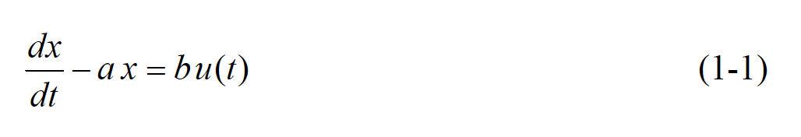

In the study of systems, an independent excitation u(t) is often called an input, and a dependent response x(t) is often called an output.

The linearity of Eq. (1-1) is manifested by the linear appearance of x(t) and all of its derivatives in the ODE.

Moreover, the important principle of superposition applies to linear ODEs, but not to nonlinear ODEs.

The time invariance of Eq. (1-1) is manifested by the constant coefficients of x(t) and all of its derivatives in the ODE.

1-3 The mass-damper system: example of 1st order LTI system and ODE

Consider a rigid body of mass m that is constrained to sliding translation x(t) in only one direction, Fig. 1-1. The mass is subjected to an externally applied, arbitrary

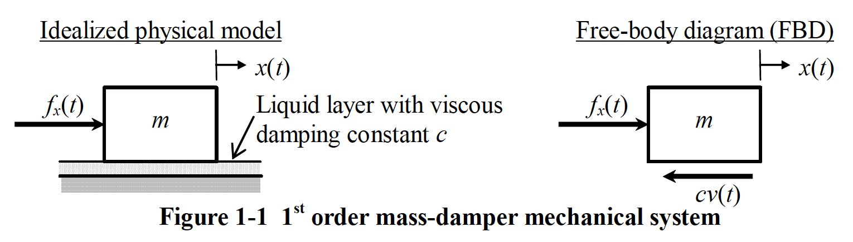

force fx(t), and it can slide on a thin, viscous liquid layer such as water or oil.

the viscous damping constant

Mass m and viscous damping constant c are positive physical quantities.

Isaac Newton, 1642-1727)

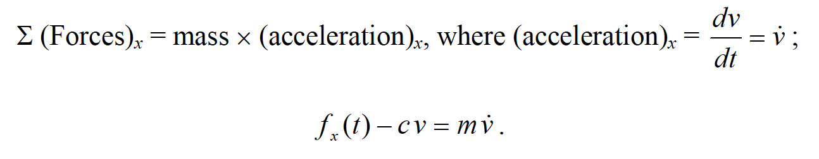

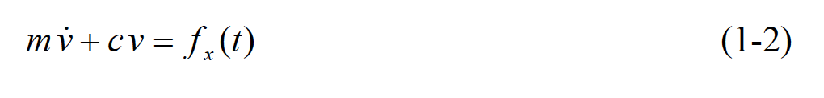

ODE (1-2) is clearly linear in the single dependent variable, velocity v(t), and time-invariant, assuming that m and c are constants.

1-4 A short discussion of engineering models

The mass-damper of Fig. 1-1 can be used to represent approximately (i.e., to model) some actual physical systems.

a surface ship

its own propulsion

tugboat.

hydroplaning on a wet road.

We are able to derive

The actual physical system, on the other hand, might be so complicated that it cannot be characterized mathematically with absolute precision.

a surface ship or a hydroplaning car

1-5 The mass-damper system (continued): example of solving the 1st order LTI
ODE for time response, given a pulse excitation and an IC

An input of limited duration, typically called a pulse, is a very common type of excitation imposed onto systems.

when a hammer strikes a nail

A real pulse such as hammer impact force

Let the force acting on the mass in Fig. 1-1 be the half-sine pulse described by the following figure and Eq. (1-5):

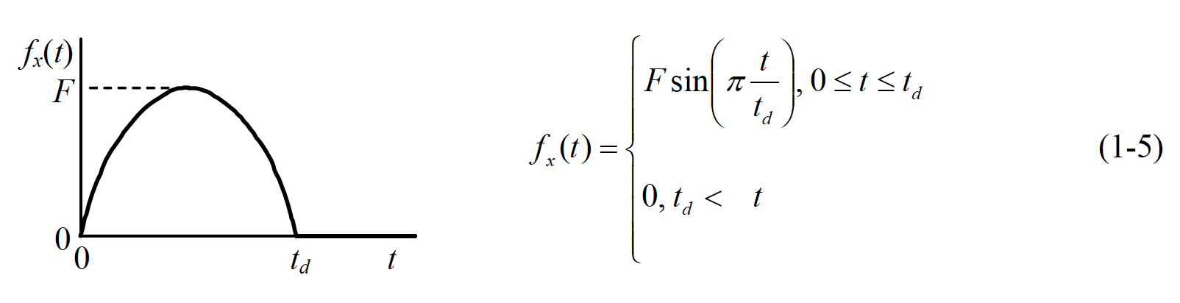

the circular frequency of oscillation, in radians per second

In this case, clearly the circular frequency is expressed in terms of the pulse duration as d ω =π/ td.

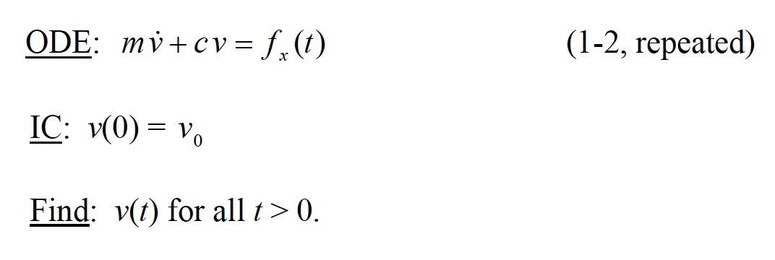

First, we find the homogeneous (also called complementary) solution vh(t) , which is the solution of the homogeneous ODE, the version of Eq. (1-2) with zero right-hand side:

