NONLINEAR_DYNAMICS_AND_CHAOS_C01

PREFACE TO THE SECOND EDITION

Welcome to this second edition of Nonlinear Dynamics and Chaos, now available in e-book format as well as traditional print.

In the twenty years since this book first appeared, the ideas and techniques of nonlinear dynamics and chaos have found application in such exciting new fields as systems biology, evolutionary game theory, and sociophysics. To give you a taste of these recent developments, I’ve added about twenty substantial new exercises that I hope will entice you to learn more. The fields and applications include (with the associated exercises listed in parentheses):

En los veinte años transcurridos desde la publicación de este libro, las ideas y técnicas de la dinámica no lineal y el caos se han aplicado en campos tan emocionantes como la biología de sistemas, la teoría de juegos evolutiva y la sociofísica. Para que se hagan una idea de estos avances recientes, he añadido unos veinte ejercicios nuevos y sustanciales que espero les animen a aprender más. Los campos y aplicaciones incluyen (con los ejercicios asociados entre paréntesis):

Animal behavior: calling rhythms of Japanese tree frogs (8.6.9)
Classical mechanics: driven pendulum with quadratic damping (8.5.5)
Ecology: predator-prey model; periodic harvesting (7.2.18, 8.5.4)
Evolutionary biology: survival of the fittest (2.3.5, 6.4.8)
Evolutionary game theory: rock-paper-scissors (6.5.20, 7.3.12)
Linguistics: language death (2.3.6)
Prebiotic chemistry: hypercycles (6.4.10)
Psychology and literature: love dynamics in Gone with the Wind (7.2.19)
Macroeconomics: Keynesian cross model of a national economy (6.4.9)
Mathematics: repeated exponentiation (10.4.11)
Neuroscience: binocular rivalry in visual perception (8.1.14, 8.2.17)
Sociophysics: opinion dynamics (6.4.11, 8.1.15)
Systems biology: protein dynamics (3.7.7, 3.7.8)

Thanks to my colleagues Danny Abrams, Bob Behringer, Dirk Brockmann, Michael Elowitz, Roy Goodman, Jeff Hasty, Chad Higdon-Topaz, Mogens Jensen, Nancy Kopell, Tanya Leise, Govind Menon, Richard Murray, Mary Silber, Jim Sochacki, Jean-Luc Thiffeault, John Tyson, Chris Wiggins, and Mary Lou Zeeman for their suggestions about possible new exercises. I am especially grateful to Bard Ermentrout for devising the exercises about Japanese tree frogs (8.6.9) and binocular rivalry (8.1.14, 8.2.17), and to Jordi Garcia-Ojalvo for sharing his exercises about systems biology (3.7.7, 3.7.8).

In all other respects, the aims, organization, and text of the first edition have been left intact, except for a few corrections and updates here and there. Thanks to all the teachers and students who wrote in with suggestions.

It has been a pleasure to work with Sue Caulfield, Priscilla McGeehon, and Cathleen Tetro at Westview Press. Many thanks for your guidance and attention to detail.

Finally, all my love goes out to my wife Carole, daughters Leah and Jo, and dog Murray, for putting up with my distracted air and making me laugh.

Steven H. Strogatz Ithaca, New York 2014

1 OVERVIEW

1.0 Chaos, Fractals, and Dynamics

There is a tremendous fascination today with chaos and fractals. James Gleick’s book Chaos (Gleick 1987) was a bestseller for months—an amazing accomplishment for a book about mathematics and science. Picture books like The Beauty of Fractals by Peitgen and Richter (1986) can be found on coffee tables in living rooms everywhere. It seems that even nonmathematical people are captivated by the infinite patterns found in fractals (Figure 1.0.1). Perhaps most important of all, chaos and fractals represent hands-on mathematics that is alive and changing. You can turn on a home computer and create stunning mathematical images that no one has ever seen before.

Hoy en día existe una enorme fascinación por el caos y los fractales. El libro de James Gleick, Caos (Gleick, 1987), fue un éxito de ventas durante meses, un logro asombroso para un libro sobre matemáticas y ciencia. Libros ilustrados como La belleza de los fractales, de Peitgen y Richter (1986), se pueden encontrar en las mesas de centro de cualquier sala de estar. Parece que incluso las personas sin conocimientos de matemáticas quedan cautivadas por los infinitos patrones que se encuentran en los fractales (Figura 1.0.1). Quizás lo más importante de todo es que el caos y los fractales representan matemáticas prácticas, vivas y cambiantes. Puedes encender un ordenador y crear impresionantes imágenes matemáticas nunca antes vistas.

The aesthetic appeal of chaos and fractals may explain why so many people have become intrigued by these ideas. But maybe you feel the urge to go deeperto learn the mathematics behind the pictures, and to see how the ideas can be applied to problems in science and engineering. If so, this is a textbook for you. The style of the book is informal (as you can see), with an emphasis on concrete examples and geometric thinking, rather than proofs and abstract arguments. It is also an extremely “applied” book—virtually every idea is illustrated by some application to science or engineering. In many cases, the applications are drawn from the recent research literature. Of course, one problem with such an applied approach is that not everyone is an expert in physics and biology and fluid mechanics . . . so the science as well as the mathematics will need to be explained from scratch. But that should be fun, and it can be instructive to see the connections among different fields.

El atractivo estético del caos y los fractales podría explicar por qué a tanta gente le han intrigado estas ideas. Pero quizás sienta la necesidad de profundizar en las matemáticas que se esconden tras las imágenes y ver cómo se pueden aplicar a problemas de ciencia e ingeniería. Si es así, este libro es para usted. El estilo del libro es informal (como puede ver), con énfasis en ejemplos concretos y pensamiento geométrico, en lugar de demostraciones y argumentos abstractos. Además, es un libro extremadamente "aplicado": prácticamente cada idea se ilustra con alguna aplicación a la ciencia o la ingeniería. En muchos casos, las aplicaciones provienen de la literatura de investigación reciente. Por supuesto, un problema con este enfoque aplicado es que no todos son expertos en física, biología y mecánica de fluidos... por lo que tanto la ciencia como las matemáticas deberán explicarse desde cero. Pero eso debería ser entretenido, y puede ser instructivo ver las conexiones entre diferentes campos.

Before we start, we should agree about something: chaos and fractals are part of an even grander subject known as dynamics. This is the subject that deals with change, with systems that evolve in time. Whether the system in question settles down to equilibrium, keeps repeating in cycles, or does something more complicated, it is dynamics that we use to analyze the behavior. You have probably been exposed to dynamical ideas in various places—in courses in differential equations, classical mechanics, chemical kinetics, population biology, and so on. Viewed from the perspective of dynamics, all of these subjects can be placed in a common framework, as we discuss at the end of this chapter.

Antes de empezar, debemos concordar en algo: el caos y los fractales forman parte de un tema aún más amplio conocido como dinámica. Este aborda el cambio, los sistemas que evolucionan en el tiempo. Ya sea que el sistema en cuestión alcance el equilibrio, se repita en ciclos o realice algo más complejo, es la dinámica la que utilizamos para analizar su comportamiento. Probablemente hayas estado expuesto a conceptos dinámicos en diversos ámbitos: en cursos de ecuaciones diferenciales, mecánica clásica, cinética química, biología de poblaciones, etc. Desde la perspectiva de la dinámica, todos estos temas pueden enmarcarse en un marco común, como explicamos al final de este capítulo.

Our study of dynamics begins in earnest in Chapter 2. But before digging in, we present two overviews of the subject, one historical and one logical. Our treatment is intuitive; careful definitions will come later. This chapter concludes with a “dynamical view of the world,” a framework that will guide our studies for the rest of the book.

Nuestro estudio de la dinámica comienza en serio en el Capítulo 2. Pero antes de profundizar, presentamos dos perspectivas generales del tema: una histórica y otra lógica. Nuestro tratamiento es intuitivo; más adelante se presentarán definiciones detalladas. Este capítulo concluye con una "visión dinámica del mundo", un marco que guiará nuestros estudios durante el resto del libro.

1.1 Capsule History of Dynamics

Although dynamics is an interdisciplinary subject today, it was originally a branch of physics. The subject began in the mid-1600s, when Newton invented differential equations, discovered his laws of motion and universal gravitation, and combined them to explain Kepler’s laws of planetary motion. Specifically, Newton solved the two-body problem—the problem of calculating the motion of the earth around the sun, given the inverse-square law of gravitational attraction between them. Subsequent generations of mathematicians and physicists tried to extend Newton’s analytical methods to the three-body problem (e.g., sun, earth, and moon) but curiously this problem turned out to be much more difficult to solve. After decades of effort, it was eventually realized that the three-body problem was essentially impossible to solve, in the sense of obtaining explicit formulas for the motions of the three bodies. At this point the situation seemed hopeless.

Aunque la dinámica es una disciplina interdisciplinaria hoy en día, originalmente era una rama de la física. La disciplina surgió a mediados del siglo XVII, cuando Newton inventó las ecuaciones diferenciales, descubrió las leyes del movimiento y la gravitación universal, y las combinó para explicar las leyes de Kepler sobre el movimiento planetario. Específicamente, Newton resolvió el problema de los dos cuerpos: el problema de calcular el movimiento de la Tierra alrededor del Sol, dada la ley del inverso del cuadrado de la atracción gravitatoria entre ellos. Las generaciones posteriores de matemáticos y físicos intentaron extender los métodos analíticos de Newton al problema de los tres cuerpos (por ejemplo, el Sol, la Tierra y la Luna), pero curiosamente este problema resultó ser mucho más difícil de resolver. Después de décadas de esfuerzo, finalmente se comprendió que el problema de los tres cuerpos era esencialmente imposible de resolver, en el sentido de obtener fórmulas explícitas para los movimientos de los tres cuerpos. En este punto, la situación parecía desesperada.

The breakthrough came with the work of Poincaré in the late 1800s. He introduced a new point of view that emphasized qualitative rather than quantitative questions. For example, instead of asking for the exact positions of the planets at all times, he asked “Is the solar system stable forever, or will some planets eventually fly off to infinity?” Poincaré developed a powerful geometric approach to analyzing such questions. That approach has flowered into the modern subject of dynamics, with applications reaching far beyond celestial mechanics. Poincaré was also the first person to glimpse the possibility of chaos, in which a deterministic system exhibits aperiodic behavior that depends sensitively on the initial conditions, thereby rendering long-term prediction impossible.

El gran avance llegó con el trabajo de Poincaré a finales del siglo XIX. Introdujo un nuevo punto de vista que enfatizaba las cuestiones cualitativas en lugar de las cuantitativas. Por ejemplo, en lugar de preguntar por las posiciones exactas de los planetas en todo momento, se preguntó: "¿Es el sistema solar estable para siempre o algunos planetas eventualmente se dispersarán hacia el infinito?". Poincaré desarrolló un poderoso enfoque geométrico para analizar estas cuestiones. Este enfoque ha florecido en la disciplina moderna de la dinámica, con aplicaciones que van mucho más allá de la mecánica celeste. Poincaré también fue el primero en vislumbrar la posibilidad del caos, en el cual un sistema determinista exhibe un comportamiento aperiódico que depende sensiblemente de las condiciones iniciales, lo que imposibilita la predicción a largo plazo.

But chaos remained in the background in the first half of the twentieth century; instead dynamics was largely concerned with nonlinear oscillators and their applications in physics and engineering. Nonlinear oscillators played a vital role in the development of such technologies as radio, radar, phase-locked loops, and lasers. On the theoretical side, nonlinear oscillators also stimulated the invention of new mathematical techniques—pioneers in this area include van der Pol, Andronov, Littlewood, Cartwright, Levinson, and Smale. Meanwhile, in a separate development, Poincaré’s geometric methods were being extended to yield a much deeper understanding of classical mechanics, thanks to the work of Birkhoff and later Kolmogorov, Arnol’d, and Moser.

Pero el caos permaneció en segundo plano durante la primera mitad del siglo XX; en cambio, la dinámica se centró principalmente en los osciladores no lineales y sus aplicaciones en física e ingeniería. Los osciladores no lineales desempeñaron un papel vital en el desarrollo de tecnologías como la radio, el radar, los bucles de enganche de fase y el láser. En el ámbito teórico, los osciladores no lineales también estimularon la invención de nuevas técnicas matemáticas; entre los pioneros en esta área se incluyen van der Pol, Andronov, Littlewood, Cartwright, Levinson y Smale. Mientras tanto, en un desarrollo independiente, los métodos geométricos de Poincaré se estaban ampliando para proporcionar una comprensión mucho más profunda de la mecánica clásica, gracias al trabajo de Birkhoff y, posteriormente, de Kolmogorov, Arnol'd y Moser.

The invention of the high-speed computer in the 1950s was a watershed in the history of dynamics. The computer allowed one to experiment with equations in a way that was impossible before, and thereby to develop some intuition about nonlinear systems. Such experiments led to Lorenz’s discovery in 1963 of chaotic motion on a strange attractor. He studied a simplified model of convection rolls in the atmosphere to gain insight into the notorious unpredictability of the weather. Lorenz found that the solutions to his equations never settled down to equilibrium or to a periodic state—instead they continued to oscillate in an irregular, aperiodic fashion. Moreover, if he started his simulations from two slightly different initial conditions, the resulting behaviors would soon become totally different. The implication was that the system was inherently unpredictable—tiny errors in measuring the current state of the atmosphere (or any other chaotic system) would be amplified rapidly, eventually leading to embarrassing forecasts. But Lorenz also showed that there was structure in the chaos—when plotted in three dimensions, the solutions to his equations fell onto a butterfly-shaped set of points (Figure 1.1.1). He argued that this set had to be “an infinite complex of surfaces”today we would regard it as an example of a fractal.

Lorenz’s work had little impact until the 1970s, the boom years for chaos. Here are some of the main developments of that glorious decade. In 1971, Ruelle and Takens proposed a new theory for the onset of turbulence in fluids, based on abstract considerations about strange attractors. A few years later, May found examples of chaos in iterated mappings arising in population biology, and wrote an influential review article that stressed the pedagogical importance of studying simple nonlinear systems, to counterbalance the often misleading linear intuition fostered by traditional education. Next came the most surprising discovery of all, due to the physicist Feigenbaum. He discovered that there are certain universal laws governing the transition from regular to chaotic behavior; roughly speaking, completely different systems can go chaotic in the same way. His work established a link between chaos and phase transitions, and enticed a generation of physicists to the study of dynamics. Finally, experimentalists such as Gollub, Libchaber, Swinney, Linsay, Moon, and Westervelt tested the new ideas about chaos in experiments on fluids, chemical reactions, electronic circuits, mechanical oscillators, and semiconductors.

Although chaos stole the spotlight, there were two other major developments in dynamics in the 1970s. Mandelbrot codified and popularized fractals, produced magnificent computer graphics of them, and showed how they could be applied in a variety of subjects. And in the emerging area of mathematical biology, Winfree applied the geometric methods of dynamics to biological oscillations, especially circadian (roughly 24-hour) rhythms and heart rhythms.

By the 1980s many people were working on dynamics, with contributions too numerous to list. Table 1.1.1 summarizes this history.

1.2 The Importance of Being Nonlinear

Now we turn from history to the logical structure of dynamics. First we need to introduce some terminology and make some distinctions.

There are two main types of dynamical systems: differential equations and iterated maps (also known as difference equations). Differential equations describe the evolution of systems in continuous time, whereas iterated maps arise in problems where time is discrete. Differential equations are used much more widely in science and engineering, and we shall therefore concentrate on them. Later in the book we will see that iterated maps can also be very useful, both for providing simple examples of chaos, and also as tools for analyzing periodic or chaotic solutions of differential equations.

Now confining our attention to differential equations, the main distinction is between ordinary and partial differential equations. For instance, the equation for a damped harmonic oscillator

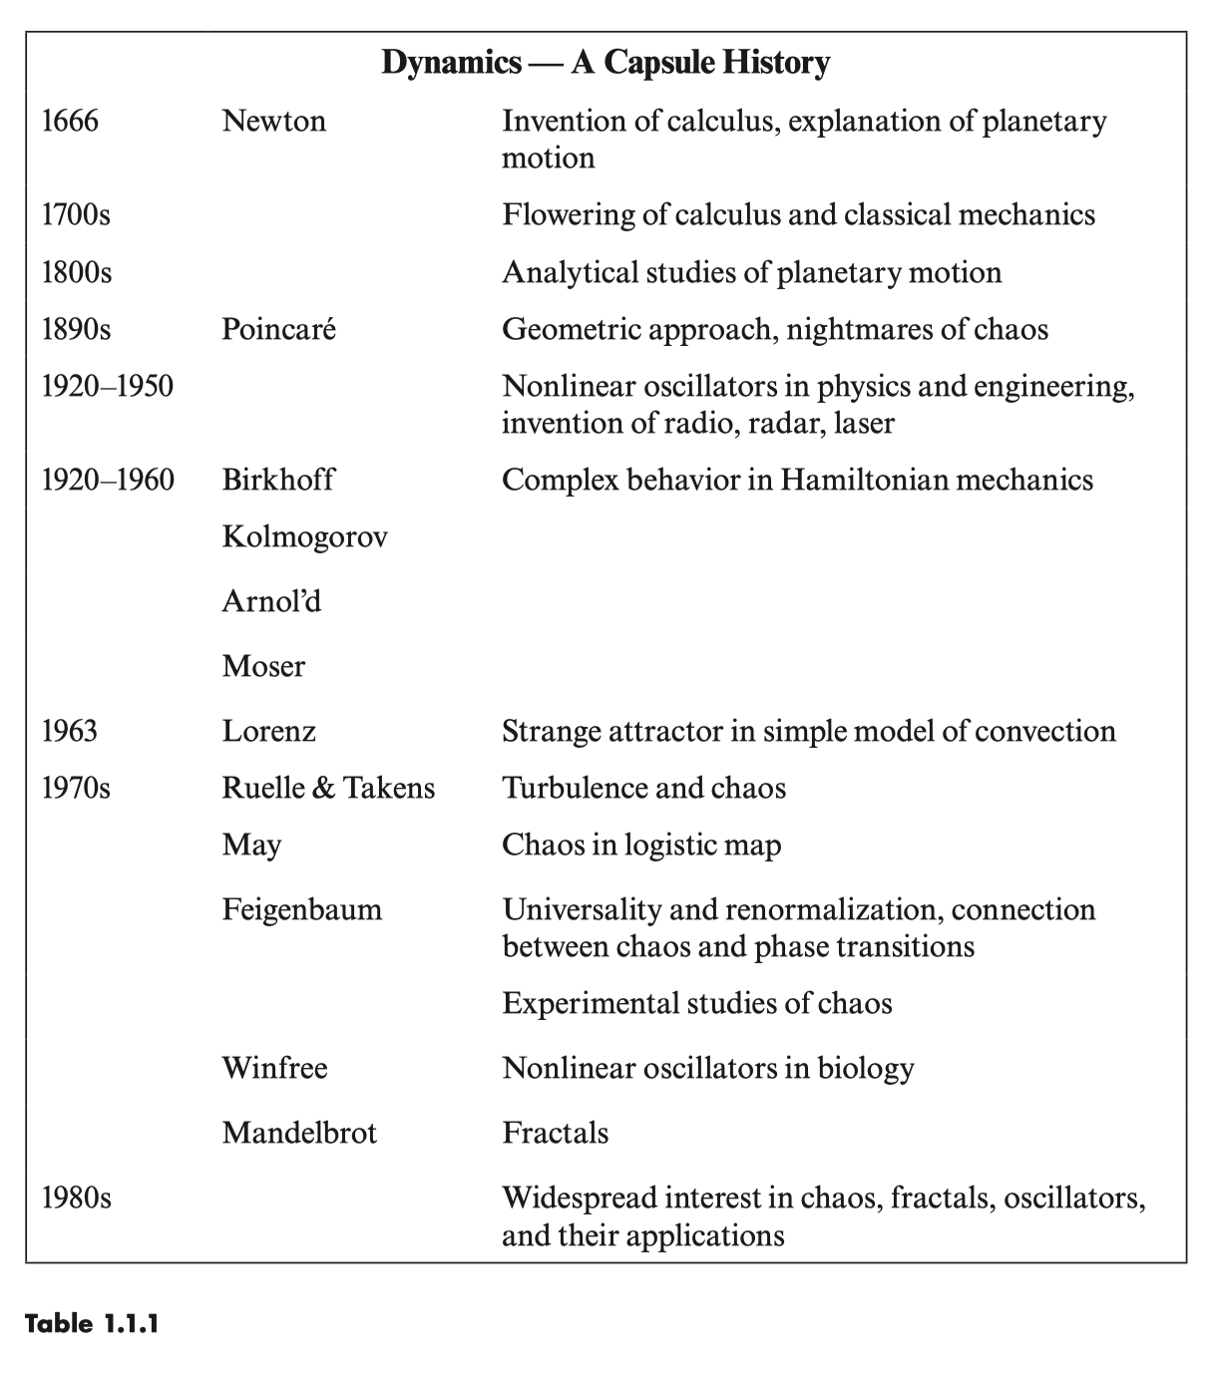

d 2 x dx m 2 + b + kx = 0 dt dt

(1)

is an ordinary differential equation, because it involves only ordinary derivatives dx / dt and d2 x / dt2 . That is, there is only one independent variable, the time t. In contrast, the heat equation

∂u ∂ 2 u = ∂t ∂x2

is a partial differential equation—it has both time t and space x as independent variables. Our concern in this book is with purely temporal behavior, and so we deal with ordinary differential equations almost exclusively.

A very general framework for ordinary differential equations is provided by the system

x 1 f 1 ( x 1 , … , x n )

(2)

x n f n ( x 1 , … , x n ) .

Here the overdots denote differentiation with respect to t. Thus x x dx i /dt . The variables x1 , … , x n might represent concentrations of chemicals in a reactor, populations of different species in an ecosystem, or the positions and velocities of the planets in the solar system. The functions f1 , … , f n are determined by the problem at hand.

For example, the damped oscillator (1) can be rewritten in the form of (2), thanks to the following trick: we introduce new variables x 1 x and x 2 x . Then x 1 x 2 , from the definitions, and

b k x 2 = x = − x x m m

b k =− x2 x1 m m

from the definitions and the governing equation (1). Hence the equivalent system (2) is

x 1 = x2

b k x 2 = − − . x2 x1 m m

This system is said to be linear, because all the x i on the right-hand side appear to the first power only. Otherwise the system would be nonlinear. Typical nonlinear terms are products, powers, and functions of the x i , such as x 1 x2 , ( x 1 )3 , or cos x2.

For example, the swinging of a pendulum is governed by the equation

g x + sin x = 0, L

where x is the angle of the pendulum from vertical, g is the acceleration due to gravity, and L is the length of the pendulum. The equivalent system is nonlinear:

x 1 = x2

g x 2 = − sin x 1 . L

Nonlinearity makes the pendulum equation very difficult to solve analytically. The usual way around this is to fudge, by invoking the small angle approximation sin x y x for x 1. This converts the problem to a linear one, which can then be solved easily. But by restricting to small x, we’re throwing out some of the physics, like motions where the pendulum whirls over the top. Is it really necessary to make such drastic approximations?

It turns out that the pendulum equation can be solved analytically, in terms of elliptic functions. But there ought to be an easier way. After all, the motion of the pendulum is simple: at low energy, it swings back and forth, and at high energy it whirls over the top. There should be some way of extracting this information from the system directly. This is the sort of problem we’ll learn how to solve, using geometric methods.

Here’s the rough idea. Suppose we happen to know a solution to the pendulum system, for a particular initial condition. This solution would be a pair of functions x1 (t) and x2 (t), representing the position and velocity of the pendulum. If we construct an abstract space with coordinates (x1 , x 2 ), then the solution ( x1 (t), x2 (t)) corresponds to a point moving along a curve in this space (Figure 1.2.1).

x2

(x1 (t), x2 (t))

x1

(x1 (0), x2 (0))

Figure 1.2.1

This curve is called a trajectory, and the space is called the phase space for the system. The phase space is completely filled with trajectories, since each point can serve as an initial condition.

Our goal is to run this construction in reverse: given the system, we want to draw the trajectories, and thereby extract information about the solutions. In many cases, geometric reasoning will allow us to draw the trajectories without actually solving the system!

Some terminology: the phase space for the general system (2) is the space with coordinates x1 , … , xn . Because this space is n-dimensional, we will refer to (2) as an n-dimensional system or an nth-order system. Thus n represents the dimension of the phase space.

Nonautonomous Systems

You might worry that (2) is not general enough because it doesn’t include any explicit time dependence. How do we deal with time-dependent or nonautonomous equations like the forced harmonic oscillator mx + bx + kx = F cos t ? In this case too there’s an easy trick that allows us to rewrite the system in the form (2). We let x 1 x and x 2 x as before but now we introduce x 3 t. Then x 3 1 and so the equivalent system is

x 1 = x2

1 x 2 = (−kx 1 − bx 2 + F cos x 3 ) m

(3)

x 3 = 1

which is an example of a three-dimensional system. Similarly, an nth-order time-dependent equation is a special case of an (n 1)-dimensional system. By this trick, we can always remove any time dependence by adding an extra dimension to the system.

The virtue of this change of variables is that it allows us to visualize a phase space with trajectories frozen in it. Otherwise, if we allowed explicit time dependence, the vectors and the trajectories would always be wiggling—this would ruin the geometric picture we’re trying to build. A more physical motivation is that the state of the forced harmonic oscillator is truly three-dimensional: we need to know three numbers, x, x , and t, to predict the future, given the present. So a three-dimensional phase space is natural.

The cost, however, is that some of our terminology is nontraditional. For example, the forced harmonic oscillator would traditionally be regarded as a second-order linear equation, whereas we will regard it as a third-order nonlinear system, since (3) is nonlinear, thanks to the cosine term. As we’ll see later in the book, forced oscillators have many of the properties associated with nonlinear systems, and so there are genuine conceptual advantages to our choice of language.

Why Are Nonlinear Problems So Hard?

As we’ve mentioned earlier, most nonlinear systems are impossible to solve analytically. Why are nonlinear systems so much harder to analyze than linear ones? The essential difference is that linear systems can be broken down into parts. Then each part can be solved separately and finally recombined to get the answer.

This idea allows a fantastic simplification of complex problems, and underlies such methods as normal modes, Laplace transforms, superposition arguments, and Fourier analysis. In this sense, a linear system is precisely equal to the sum of its parts.

But many things in nature don’t act this way. Whenever parts of a system interfere, or cooperate, or compete, there are nonlinear interactions going on. Most of everyday life is nonlinear, and the principle of superposition fails spectacularly. If you listen to your two favorite songs at the same time, you won’t get double the pleasure! Within the realm of physics, nonlinearity is vital to the operation of a laser, the formation of turbulence in a fluid, and the superconductivity of Josephson junctions.

1.3 A Dynamical View of the World

Now that we have established the ideas of nonlinearity and phase space, we can present a framework for dynamics and its applications. Our goal is to show the logical structure of the entire subject. The framework presented in Figure 1.3.1 will guide our studies thoughout this book.

The framework has two axes. One axis tells us the number of variables needed to characterize the state of the system. Equivalently, this number is the dimension of the phase space. The other axis tells us whether the system is linear or nonlinear.

For example, consider the exponential growth of a population of organisms. This system is described by the first-order differential equation x rx where x is the population at time t and r is the growth rate. We place this system in the column labeled “n 1” because one piece of information—the current value of the population x—is sufficient to predict the population at any later time. The system is also classified as linear because the differential equation x rx is linear in x.

As a second example, consider the swinging of a pendulum, governed by

g x + sin x = 0. L

In contrast to the previous example, the state of this system is given by two vari ables: its current angle x and angular velocity x . (Think of it this way: we need the initial values of both x and x to determine the solution uniquely. For example, if we knew only x, we wouldn’t know which way the pendulum was swinging.) Because two variables are needed to specify the state, the pendulum belongs in the n 2 column of Figure 1.3.1. Moreover, the system is nonlinear, as discussed in the previous section. Hence the pendulum is in the lower, nonlinear half of the n 2 column.

One can continue to classify systems in this way, and the result will be something like the framework shown here. Admittedly, some aspects of the picture are

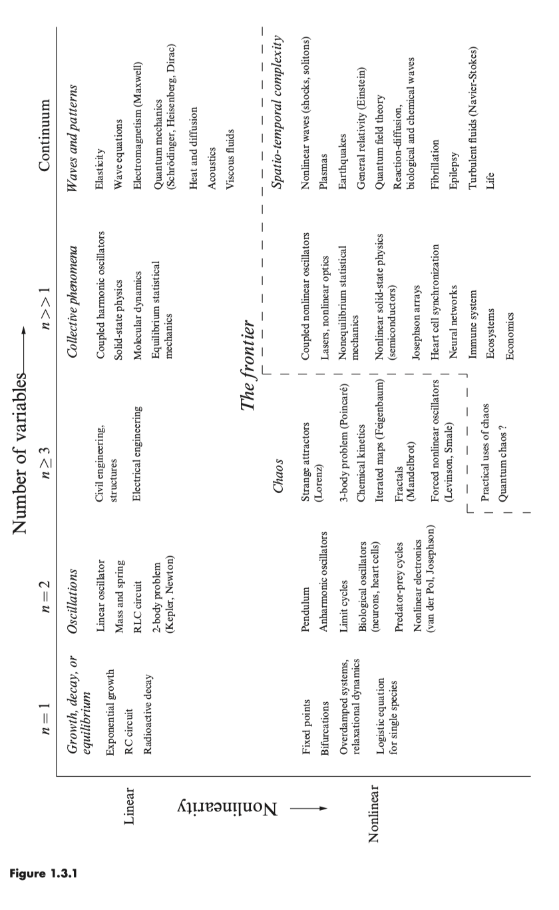

debatable. You might think that some topics should be added, or placed differently, or even that more axes are needed—the point is to think about classifying systems on the basis of their dynamics.

There are some striking patterns in Figure 1.3.1. All the simplest systems occur in the upper left-hand corner. These are the small linear systems that we learn about in the first few years of college. Roughly speaking, these linear systems exhibit growth, decay, or equilibrium when n 1, or oscillations when n 2. The italicized phrases in Figure 1.3.1 indicate that these broad classes of phenomena first arise in this part of the diagram. For example, an RC circuit has n 1 and cannot oscillate, whereas an RLC circuit has n 2 and can oscillate.

The next most familiar part of the picture is the upper right-hand corner. This is the domain of classical applied mathematics and mathematical physics where the linear partial differential equations live. Here we find Maxwell’s equations of electricity and magnetism, the heat equation, Schrödinger’s wave equation in quantum mechanics, and so on. These partial differential equations involve an infinite “continuum” of variables because each point in space contributes additional degrees of freedom. Even though these systems are large, they are tractable, thanks to such linear techniques as Fourier analysis and transform methods.

In contrast, the lower half of Figure 1.3.1—the nonlinear half—is often ignored or deferred to later courses. But no more! In this book we start in the lower left corner and systematically head to the right. As we increase the phase space dimension from n 1 to n 3, we encounter new phenomena at every step, from fixed points and bifurcations when n 1, to nonlinear oscillations when n 2, and finally chaos and fractals when n 3. In all cases, a geometric approach proves to be very powerful, and gives us most of the information we want, even though we usually can’t solve the equations in the traditional sense of finding a formula for the answer. Our journey will also take us to some of the most exciting parts of modern science, such as mathematical biology and condensed-matter physics.

You’ll notice that the framework also contains a region forbiddingly marked “The frontier.” It’s like in those old maps of the world, where the mapmakers wrote, “Here be dragons” on the unexplored parts of the globe. These topics are not completely unexplored, of course, but it is fair to say that they lie at the limits of current understanding. The problems are very hard, because they are both large and nonlinear. The resulting behavior is typically complicated in both space and time, as in the motion of a turbulent fluid or the patterns of electrical activity in a fibrillating heart. Toward the end of the book we will touch on some of these problems—they will certainly pose challenges for years to come.

