**First problem.**

I preferred to use the terminal from VS Code for a better experience (eg using linux commands like "grep, cd", etc.) :

As for the final code, I didn’t create a function for each task, because some of them had one-line answers and I considered it could be a little redundant.

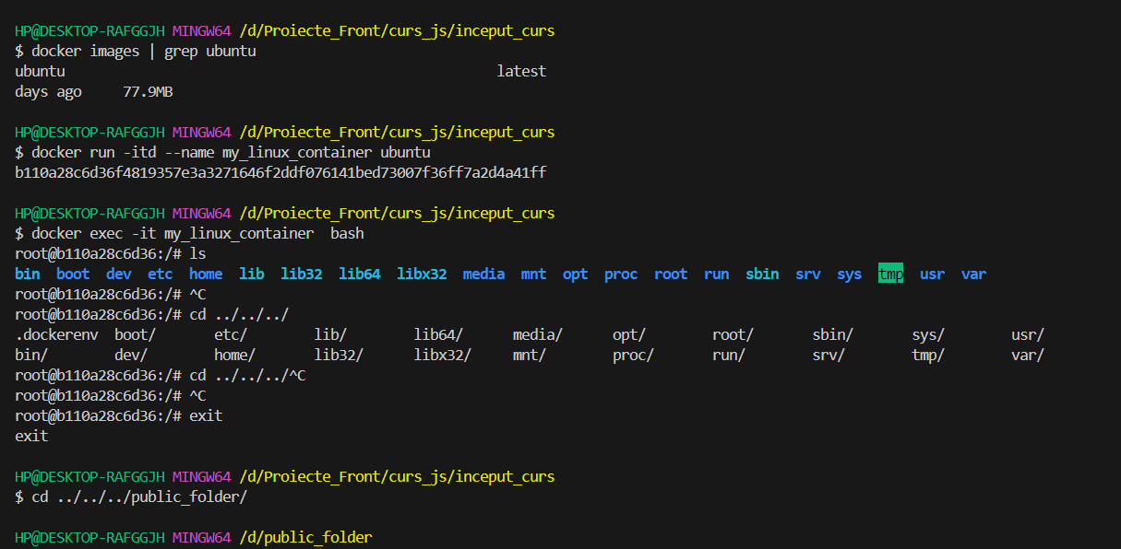

We observe that the image was pulled succesfully (used grep to locate it as I already have many more images inside my Docker Desktop). I decided to run the container in DETACHED mode (-d), because I don’t like them attached to any of my terminals. I then connected to it with:

***docker exec -it my_linux_container bash***

After that:

***touch create_large_file.sh*** 🡺create file.

Preparing to edit the file:

***apt-get update***

***apt-get install vim***

***vi create_large_file.sh***  🡺 edit file, paste the github content in.

The script looks like this:

(The script creates a file of 1*50 = 50Mb and moves it to /home/john)

***adduser john* 🡺** add user:

***cat /etc/passwd | grep john* 🡺** Making sure user is created.

Obviously, there is an error when trying to execute the script:

We need to modify the script, as there is a typo “lage” instead of “laRge”.

Everything seems fine now:

I created the script file “**my_script.sh**”, then I made sure it has execution privilleges:

**Task 0:**

Wrote a function called “**check_file_name**” inside the bash script:

Execution:

As for the rest of the tasks, I will simply print the outputs together as there are too many of them to be displayed separately.

Meanwhile, I needed to install **iproute2** and **curl** with apt-get.

***apt-get install -y iproute2***

***apt-get install -y curl***

Outputs:

Code is explained in the script’s comments.

**Tasks Done.**