UNIVERSITY DATABASE
MANAGEMENT SYSTEM
Academic Database Design & SQL Data Manipulation Project

1 Purpose and Requirements of the Experiment
- Database environment: SQL Server or MySQL or SQLite,etc. The database should be created, managed, and manipulated with SQL statements.
- This experiment is a design type experiment.
2 Experimental Environment
Environment: Win7 of later, SQL Server or MySQL or SQLite, etc.
3 The tasks of the Experiment
- Create a database named University.he University database has several tables, including student table,faculty table, course table, offering table and enrollment table. The schema is listed below. You should create these tables using SQL statement.
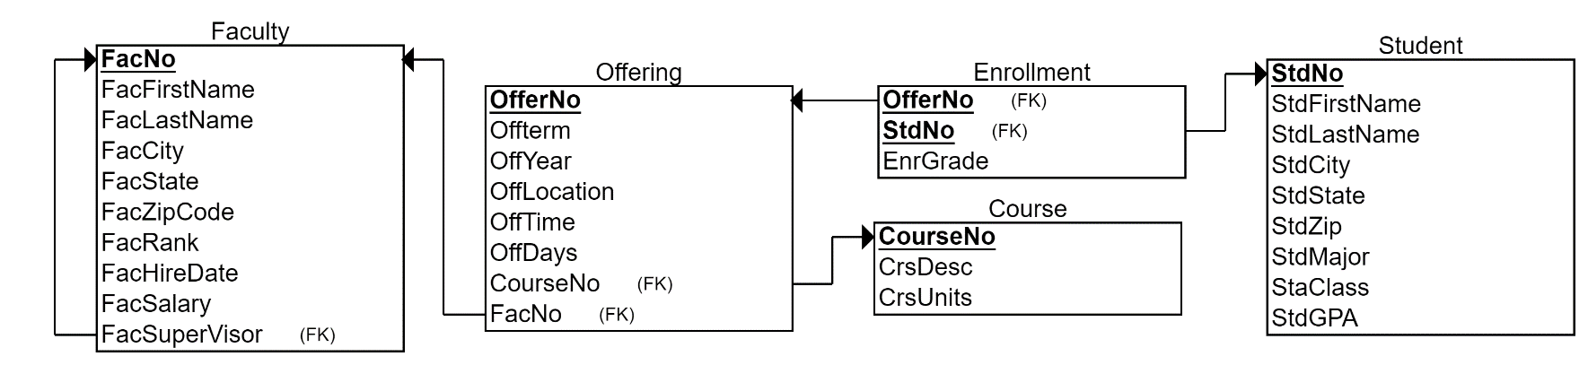

The relational schema of University is:
The structure of the student table:

Attributes | Data types | Length | Memo
StdNo | varchar | 6 | Primary key
StdFirstName | varchar | 30
StdLastName | varchar | 30
StdCity | varchar | 30
StdState | varchar | 2
StdZip | varchar | 10
StdMajor | varchar | 6
StdClass | varchar | 2
StdGPA | numeric | 3,2

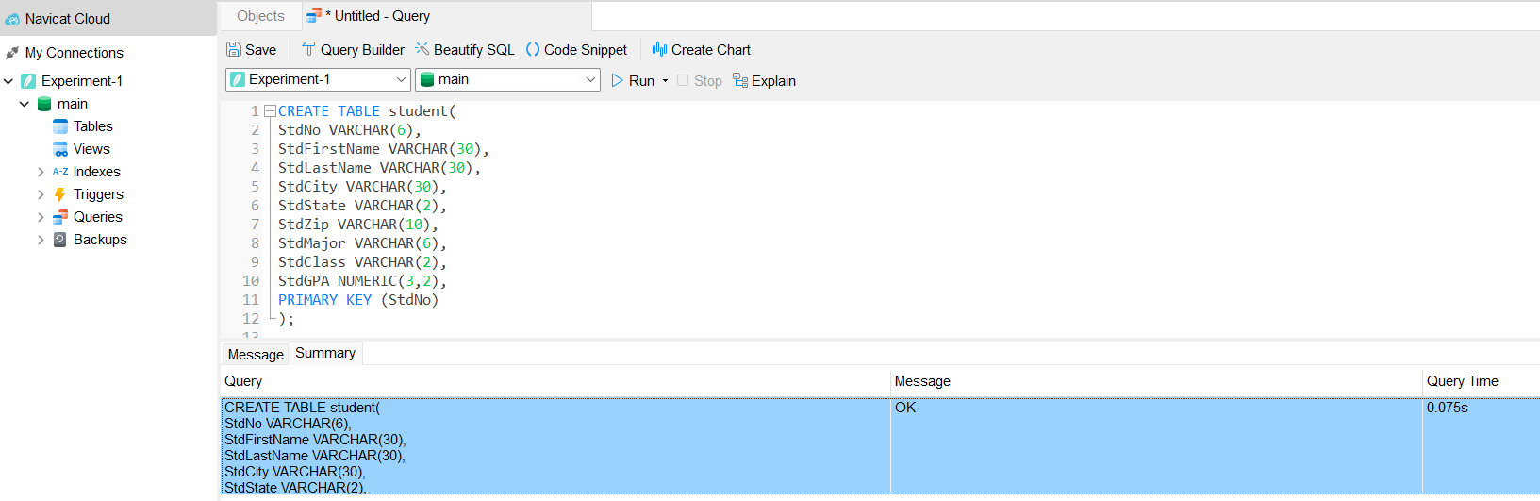

The structure of the faculty table:

Attributes | Data types | Length | Memo
FacNo | varchar | 6 | Primary key
FacFirstName | varchar | 30
FacLastName | varchar | 30
FacCity | varchar | 30
FacState | varchar | 2
FacZipCode | varchar | 10
FacRank | varchar | 4
FacHireDate | date
FacSalary | numeric | 10,2
FacSuperVisor | varchar | 11
FacDept | varchar | 6

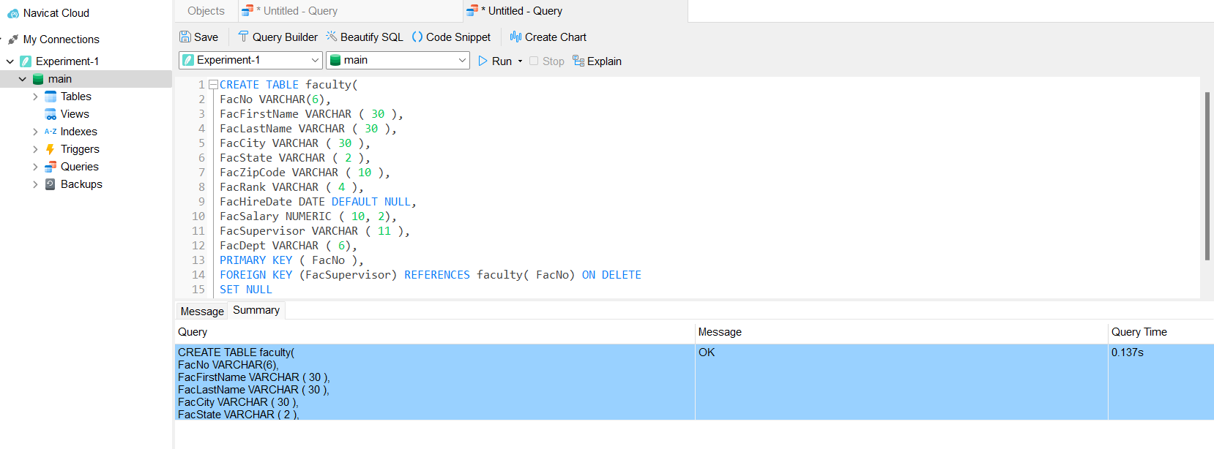

The structure of the course table:

Attributes | Data types | Length | Memo
CourseNo | varchar | 6 | Primary key
CrsDesc | varchar | 50
CrsUnits | numeric | 1,0

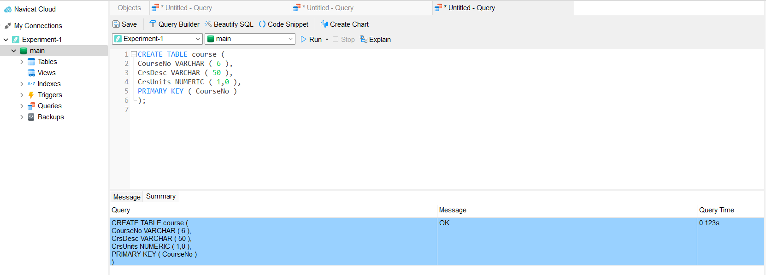

The structure of the offering table:

Attributes | Data types | Length | Memo
OfferNo | numeric | 3,0 | Primary key
CourseNo | varchar | 6 | Foreign key with the course table
OffTerm | varchar | 6
OffYear | year
OffLocation | varchar | 30
OffTime | time
FacNo | varchar | 6 | Foreign key with the faculty table
OffDays | varchar | 3

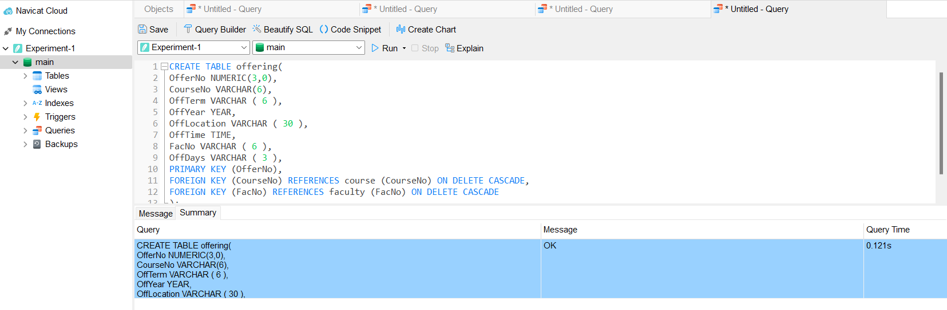

The structure of the enrollment table:

Attributes | Data types | Length | Memo
OfferNo | numeric | 3,0 | Primary key and foreign key with the offering table
StdNo | varchar | 6 | Primary key and foreign key with the student table
EnrGrade | varchar | 2

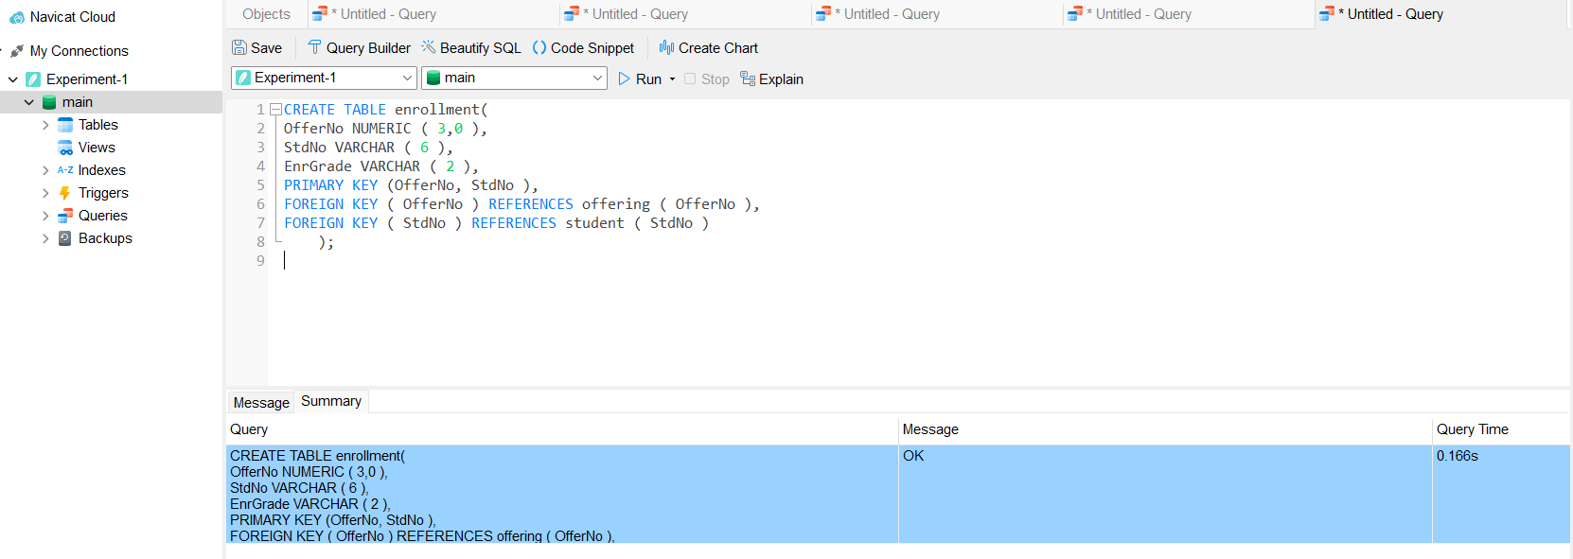

2). use the ‘insert’ statement to input the following data.

- Student：
StdNo | StdFirstName | StdLastName | StdCity | StdState | StdZip | StdMajor | StdClass | StdGPA
171001 | Samuel | Morse | Broward | FL | 2154884561 | LAW | 1 | 2.80
171002 | Margaret | Sanger | Broward | FL | 2154884891 | SE | 2 | 3.20
171003 | Joseph | Smith | Collier | FL | 5162691615 | SE | 1 | 3.13
171004 | Horace | Mann | Escambia | FL | 7503365641 | CS | 1 | 1.90
171005 | Louis | Sullivan | Franklin | FL | 2151221561 | SE | 2 | 2.40
171006 | William | Faulkner | Jefferson | FL | 2642998941 | CS | 1 | 3.62
171007 | Samuel | Gompers | Flagler | FL | 7503361651 | SE | 1 | 2.64
171008 | William | James | Allentown | PA | 5283086854 | BIO | 1 | 3.50
171009 | Jane | Addams | Altoona | PA | 7503365456 | PHY | 2 | 3.20
171010 | Elvis | Presley | Harrisburg | PA | 9990395641 | PHY | 1 | 2.89

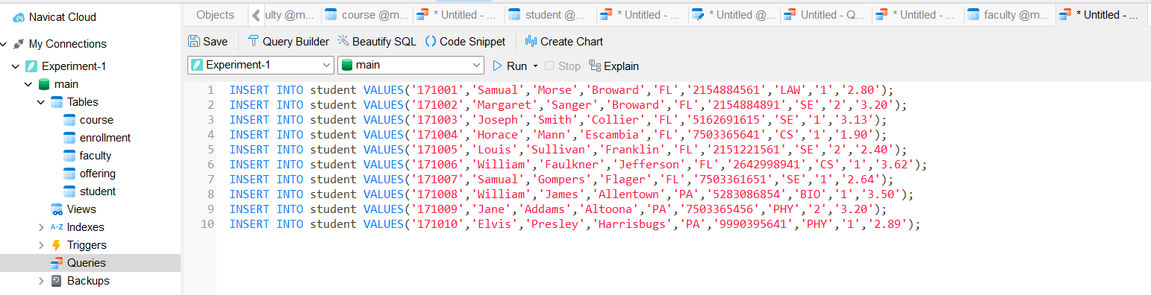

- Faculty：

FacNo | FacFirstName | FacLastName | FacCity | FacState | FacZipCode | FacRank | FacHireDate | FacSalary | FacSuperVisor | FacDept
101001 | Samuel | Morse | Broward | FL | 2154884561 | B | 2015-06-18 | 66000.00 | null | Law
101002 | Margaret | Sanger | Broward | FL | 2154884891 | B | 2018-06-15 | 70000.00 | 101005 | Comp
101003 | Louis | Armstrong | Collier | FL | 5162691655 | B | 2017-02-02 | 68000.00 | null | Bio
101004 | Margaret | Mead | Escambia | FL | 7503365671 | A | 2010-05-16 | 95000.00 | null | Phy
101005 | George | Gallup | Franklin | FL | 2151221561 | A | 2005-01-16 | 95700.00 | null | Comp
101006 | Thurgood | Marshall | Jefferson | FL | 2642996241 | A | 2006-10-12 | 92000.00 | null | Comp
101007 | Benjamin | Spock | Flagler | FL | 7503361551 | C | 2019-10-21 | 45000.00 | 101005 | Comp

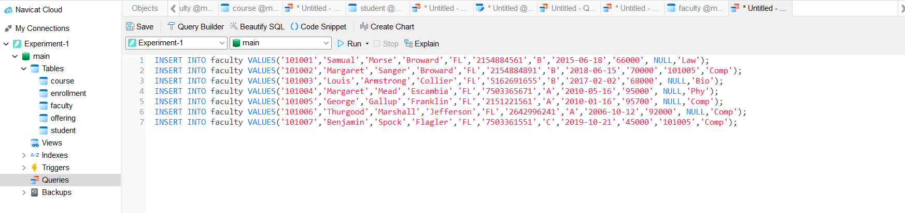

- Course：

CourseNo | CrsDesc | CrsUnits
010001 | DataBase | 4
010002 | Java | 6
010003 | Python | 6
010004 | UNIX | 2
010005 | C++ | 8
010006 | Digital Electronic Tech | 8
020001 | Genetics | 5
030001 | Optics | 2
030002 | Dynamics | 2
040001 | Penal Law | 2

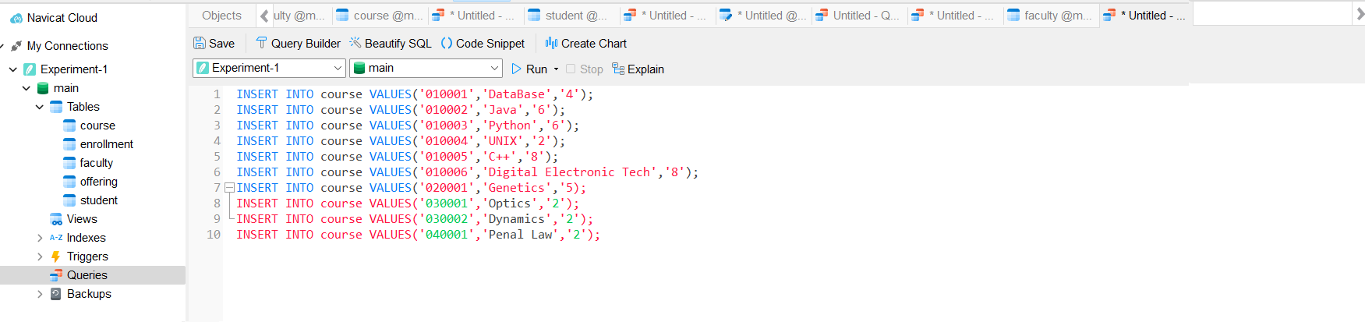

- Offering：

OfferNo | CourseNo | OffTerm | OffYear | OffLocation | OffTime | FacNo | OffDays
1 | 010004 | Spring | 2020 | Class room 107 | 13:00:00 | 101006 | THU
2 | 010005 | Fall | 2020 | Class room 208 | 15:00:00 | 101002 | FRI
3 | 010006 | Summer | 2020 | Class room 512 | 16:40:00 | 101002 | TUE
4 | 010001 | Fall | 2020 | Class room 318 | 08:00:00 | 101006 | MON
5 | 010002 | Summer | 2020 | Class room 118 | 09:00:00 | 101006 | TUE
6 | 010003 | Fall | 2020 | Class room 308 | 11:00:00 | 101005 | WED
7 | 020001 | Spring | 2020 | Class room 301 | 09:00:00 | 101003 | THU
8 | 030001 | Summer | 2020 | Class room 401 | 17:00:00 | 101004 | FRI
9 | 030002 | Fall | 2020 | Class room 601 | 15:00:00 | 101004 | WED
10 | 040001 | Spring | 2020 | Class room 109 | 13:00:00 | 101001 | MON

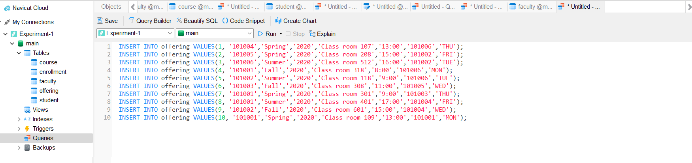

(5) Enrollment

OfferNo | StdNo | EnrGrade
1 | 171002 | A
1 | 171006 | F
2 | 171003 | A-
2 | 171004 | B+
3 | 171003 | A-
3 | 171004 | C
4 | 171005 | A
4 | 171007 | B-
5 | 171007 | C+
6 | 171006 | A
7 | 171008 | C
8 | 171009 | B
9 | 171010 | A
10 | 171001 | A

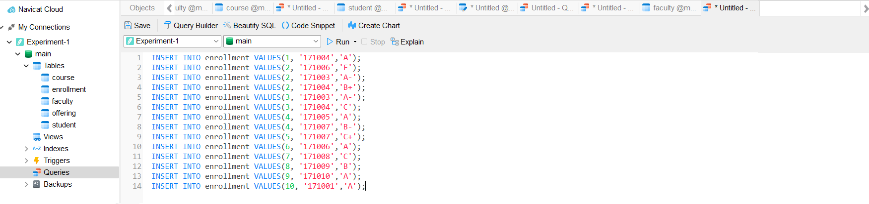

3).Use the ‘insert’ statement to finish the following questions and write out the results of the operation.
(1)Add a record to the student table with StdNo is 171011, StdFirstName is Samuel, StdLastName is Goldwyn, StdCity is Flagler, StdState is FL, StdZip is 7503361652, StdMajor is SE, StdClass is 2 and StdGPA is 3.52.

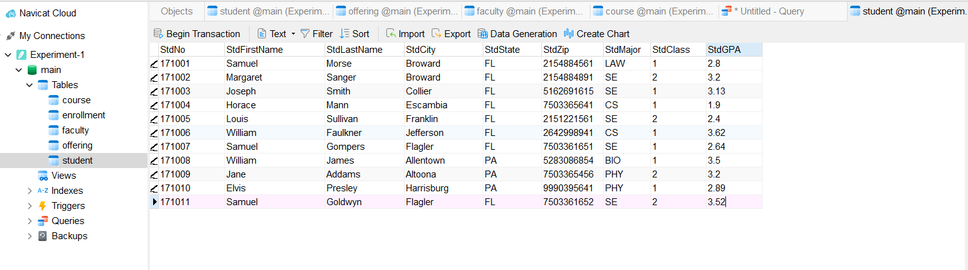
INSERT INTO student VALUES ('171011', 'Samuel', 'Goldwyn','Flagler', 'FL', '7503361652', 'SE','2','3.52');

(2)Add a record to the faculty table with FacNo is 101008, FacFirstName is Ralph, FacLastName is Nader, FacCity is Flagler, FacState is FL, FacZip is 7503365124, FacRank is C, FacHireDate is 2020-4-10, FacSalary is 40000, FacSuperVisor is 101006 and FacDept is Comp.

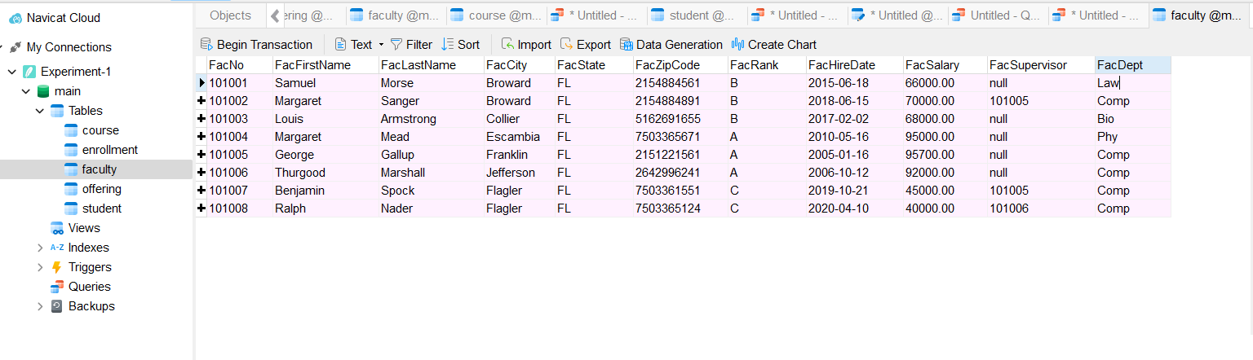
INSERT INTO faculty VALUES ('101008', 'Ralph', 'Nader', 'Flagler', 'FL', '7503365124', 'C', '2020-04-10', '40000', '101006', 'Comp');

4. Requirements of the Experimental Report
1). Test every SQL statement with the computer.
2). Analysis of experimental results.
3). Your harvest and experience.
REQUIREMENTS ARE FILLED ☑

