Corporate Office Solutions



|  |
| --- |
|  |
| Budget Estimate  for the implementation of  Microsoft Dynamics CRM |
|  |
|  |
| **Submitted by: Matricia Solutions** |
| **February 3, 2012** |

|  |
| --- |
|  |



Content

[PREFACE 5](#_Toc316050173)

[Confidentiality 5](#_Toc316050174)

[Non-Disclosure 5](#_Toc316050175)

[Basis of Submission 5](#_Toc316050176)

[Executive Summary 6](#_Toc316050177)

[Summary COSTS 7](#_Toc316050178)

[Why choose to work with Matricia 8](#_Toc316050179)

[Our Valued Customers and Implementations 9](#_Toc316050180)

[Bidder Company Background 10](#_Toc316050181)

[Functionality Requirements Matrix 11](#_Toc316050182)

[Proposed Solution Recommendation 22](#_Toc316050183)

[Microsoft Dynamics CRM 2011 - Description 22](#_Toc316050184)

[Product Functionality 27](#_Toc316050185)

[Sales Force Automation 27](#_Toc316050186)

[Marketing 30](#_Toc316050187)

[Customer Service 33](#_Toc316050188)

[Extended CRM 34](#_Toc316050189)

[Budgetary Pricing Estimate 35](#_Toc316050190)

[Microsoft Dynamics CRM – Online 35](#_Toc316050191)

[Microsoft Dynamics CRM – On-Premise 37](#_Toc316050192)

[Implementation Services 38](#_Toc316050193)

[Implementation 40](#_Toc316050194)

[Project Timeline 40](#_Toc316050195)

[Implementation Methodology - Metrics 41](#_Toc316050196)

[Project Phases 41](#_Toc316050197)

[Project management! Risk management! 42](#_Toc316050198)

[Analysis Phase 43](#_Toc316050199)

[Configuration Phase 44](#_Toc316050200)

[System Test and Acceptance 44](#_Toc316050201)

[Training Phase 45](#_Toc316050202)

[Data Migration Phase 46](#_Toc316050203)

[Go Live Phase 46](#_Toc316050204)

[Training Services 48](#_Toc316050205)

[Customer Support 50](#_Toc316050206)

[References 53](#_Toc316050207)

[CRM System Requirements 54](#_Toc316050208)

[Microsoft Dynamics CRM Server 2011 hardware requirements 54](#_Toc316050209)

[Microsoft Dynamics CRM Server 2011 software requirements 54](#_Toc316050210)

[Windows Server operating system 55](#_Toc316050211)

[Supported Windows Server 2008 editions 55](#_Toc316050212)

[Server virtualization 55](#_Toc316050213)

[Active Directory modes 56](#_Toc316050214)

[Internet Information Services (IIS) 56](#_Toc316050215)

[SQL Server editions 56](#_Toc316050216)

[SQL Server Reporting Services 57](#_Toc316050217)

[Software component prerequisites 57](#_Toc316050218)

[Verify prerequisites 58](#_Toc316050219)

[Microsoft Dynamics CRM for Outlook hardware requirements 58](#_Toc316050220)

[Microsoft Dynamics CRM for Outlook software requirements 59](#_Toc316050221)

[Microsoft Dynamics CRM for Outlook software component prerequisites 59](#_Toc316050222)

[Microsoft Dynamics CRM Web client software requirements 60](#_Toc316050223)

[64-bit supported configurations 61](#_Toc316050224)

[“Professional Services” Add-on 62](#_Toc316050225)

[The Professional Services add-on – Modules Overview 62](#_Toc316050226)

[Sales module 63](#_Toc316050227)

[Marketing Module 63](#_Toc316050228)

[Project Management Module 64](#_Toc316050229)

[Customer Services Module 64](#_Toc316050230)

[Target and Goal Management Module 65](#_Toc316050231)

[Benefits of the Professional Services add-on 65](#_Toc316050232)

# PREFACE

## Confidentiality

All of the information gathered during the information discovery and review exercise is acknowledged as being confidential and will be treated in commercial confidence.

## Non-Disclosure

All information contained in this document, including any price(s) quoted, is to be treated as confidential information provided for the purpose of evaluation by the Customer in connection with its requirements. None of the information may be used by the Customer for any purpose, nor may it be disclosed by the Customer, other than to members of the customer’s staff who will be engaged in the evaluation and to representatives of any organization acting in the capacity of professional advisers to the Customer. Before making this document available for evaluation the Customer must bring this notice to the attention of those concerned.

## Basis of Submission

This document does not constitute an offer in law and acceptance of this proposal or submission shall be subject to agreement of a contract satisfactory to both parties. Any software described in this document is furnished under a license and may be used or copied only in accordance with the terms of such license. No responsibility is assumed for the use or reliability of software or equipment that is supplied by a 3rd party.

**Amendment Record**

|  |  |  |  |
| --- | --- | --- | --- |
| **Issue Level** | **Details of Amendment** | **Issue Date** | **Prepared By** |
| 1.0 | First Issue | 2/3/2012 | Elena Caciula, Diana Lungulescu,  Marius Motofei |
|  |  |  |  |
|  |  |  |  |

# Executive Summary

We wish to thank Corporate Office Solutions for the opportunity to outline this proposal for the CRM implementation project.

Matricia is a business and technology consulting organization supplying high quality solutions to customers in the private sector in Romania and other geographies in the European market space, as well as in Russia.

ROMANIA

BULGARIA

UKRAINE

GERMANY

IRELAND

CYPRUS

RUSSIA

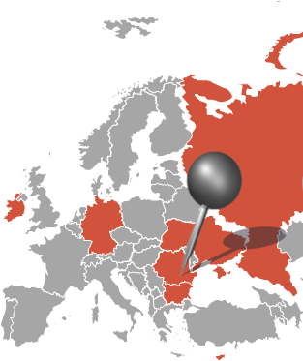

Our approach embraces three key objectives for our customers:

- To develop and demonstrate an understanding of their business and the issues it faces

- To use the best of current technology available

- To provide high quality business and IT skills to apply these technologies to meet their needs

Experience showed us that successful projects require a sound understanding of business processes – technology is merely a tool to address those. A team of professional, committed people is another critical prerequisite. This is the fundamental approach Matricia employs.

By means of communication and continuous support, of a rigorous, open and honest spirit we build together with our customers a partnership based on loyalty and commitment and we share a common purpose, that of establishing a solid foundation for long-term success.

## Summary COSTS

**ONLINE\***

|  |  |  |  |  |
| --- | --- | --- | --- | --- |
| Licenses | Users No | Unit Price per User (€) | Price per Month (€) | Total per Year (€) |
| Microsoft Dynamics CRM 2011 Online | 13 | 40.25 | 523 | 6,279 |
| Services | Man-days |  |  | Total |
| Services up to GO-Live | 28 |  |  | 8,680 |
| TOTAL investment First year |  |  |  | 14,959 |

**Note**: Software Assurance is included in the monthly fee

**ON PREMISE**

|  |  |  |  |  |  |
| --- | --- | --- | --- | --- | --- |
| License | Users No | Unit Price (€ ) | Total Price (€) | Discount  (30%) (€) | TOTAL (€) |
| Microsoft Dynamics CRM 2011 On-Premise Server | 1 | 3,857 | 3,857 | 1,157 | 2,700 |
| Microsoft Dynamics CRM 2011 Full CALs | 13 | 871 | 11,329 | 3,399 | 7,930 |
| “Professional Services” Add-on Full CALs | 13 | 70 | 910 | 273 | 637 |
| TOTAL Licenses |  |  | 16,096 | 4,829 | 11,267 |
| Services | Man-days |  | Total Price (€) |  | TOTAL (€) |
| Services up to GO-Live | 28 |  | 8,680 |  | 8,680 |
| TOTAL investment First year |  |  |  |  | 19.947 |

**Note** :

1. Software Assurance for the first year is free of charge. For the following years the software assurance fee is 20% of the license costs.

**2. The 30% discount is valid for an order placed to Matricia before end of March 2012.**

## Why choose to work with Matricia

* **Track record of success in over 50 CRM projects over the past 9 years.** Matricia has been implementing complex CRM / xRM solutions for 9 years and has gained considerable experience in the customization and rapid implementation of CRM projects. This valuable business process and technology know-how is a significant advantage that few other CRM providers can match.
* **Dedicated team.** Matricia is currently employing a team of 7 dedicated CRM resources, most of them senior consultants holding various Microsoft Dnamics CRM certifications, out of which 2 Project Managers with 8+ years of experience in running international CRM projects.
* **Experience in running complex integration solutions.** In most of our projects, we implemented complex integration solutions, connecting CRM with ERP systems (iScala, Dynamics AX, SAP, etc.) or other back-office solutions. Our consultants are not only experienced in implementing CRM solutions, but also a range of other business management software: ERP, ECM (Enterprise Content Management) or BI (Business Intelligence), which brings along a holistic understanding of process flows and requirements in terms of systems integration.
* **International projects exposure.** Over the course of the past 9 years, Matricia consultants have been involved in many international CRM projects and are skilled at managing large multi-cultural teams in foreign geographies. References:
* **Les Laboratoires Servier group** – pilot project in Romania (250 users), roll out to Russia (600 users), Ukraine (200 users), Bulgaria (100 users), managed by Matricia team. Local support ensured by Matricia (remote and onsite) and by local IT Partner Company in each country.
* **Egis Pharmaceuticals group** – pilot project in Romania, roll out to Bulgaria and Slovakia, managed by Matricia team. Local support ensured by Matricia (remote and onsite) and by local IT partner company in each country.
* **Lifeline** – pilot project in Cyprus, roll out to Romania. Local support ensured by Matricia only (remote and onsite).
* **Proven project implementation methodology**. Matricia uses a proprietary project implementation methodology, METRICS, which rigorously manages all the project steps until successful completion. During the implementation we perform a full Analysis of the business and technical requirements, establishing from the very start the precise scope of the project, as well as its optimum organization and progress: tasks, deliverables, due dates and responsible persons.

## Our Valued Customers and Implementations

We boast a wide portfolio of CRM/xRM projects implemented in variety of industries, each with their specific business processes: telecom, pharmaceuticals, wholesale & distribution, media & advertising, professional and financial services.

****

# Bidder Company Background

|  |  |
| --- | --- |
| Bidder Company name and address | Matricia Solutions SRL  No. 34 Daniel Danielopolu St, apt B24  Sector 1, Bucharest |
| Contact name, title, address, email, phone | Diana Lungulescu, Managing Director  [Diana.lungulescu@matricia.ro](mailto:Diana.lungulescu@matricia.ro)  +40 732 113031 |
| Headquarter address (if different) | No. 34 Daniel Danielopolu St, apt B24  Sector 1, Bucharest |
| Local sales address (if different) | No. 34 Daniel Danielopolu St, apt B24  Sector 1, Bucharest |
| Years in business | Matricia Solutions was founded in January 2008 by a team of professional consultants, with more than a decade experience in business and IT consulting, project and risk management, supplying high quality solutions to customers in the private sector in Romania and other geographies in the European market space, as well as in Russia. |
| Total number of employees | 15 |
| List your five primary product offerings, ranked by contribution to revenue. | 1. Consulting Services 2. Microsoft Dynamics CRM 3. Microsoft Dynamics AX 4. OnBase – Document Management 5. Reporting and Business Intelligence 6. Support services |

# Functionality Requirements Matrix

|  |  |
| --- | --- |
| SUP | Supported as delivered "out-of-the-box" |
| MOD | Supported via modifications (screen configurations, reports, GUI tailoring, etc) |
| 3RD | Supported via a third party solution |
| CST | Supported via customization (changes to source code) |
| FUT | Will be supported in a future release |
| NS | Not supported |

| ***Software Function / Requirement*** | ***Support Level*** | ***Notes*** |
| --- | --- | --- |
| ***Sales Force Automation (SFA) Functionality*** | | |
| Contact management | SUP |  |
| Opportunity management | SUP |  |
| Account management | SUP |  |
| Territory management | SUP |  |
| Order tracking | SUP |  |
| Access to marketing materials? | SUP |  |
| Lead qualification and management | SUP |  |
| Calendaring and scheduling | SUP |  |
| **Dynamic scripting of cross-sells and up-sells** | SUP |  |
| **Lead routing based on analysis of lead data** | SUP |  |
| Global forecasting | SUP |  |
| Data quality management | SUP |  |
| ***Sales Reporting Metrics*** | | |
| Number of prospects | SUP |  |
| Number of new customers | SUP |  |
| Number of retained customers | SUP |  |
| Number of open opportunities | SUP |  |
| Close rate | MOD | The existing Sales History Report can be customized by adding the Close Rate indicator also |
| Renewal rate | MOD | The existing Sales History Report can be customized by adding the Renewal rate indicator also |
| Number of sales calls | SUP |  |
| Number of sales calls per opportunity | SUP |  |
| Amount of new revenue | SUP |  |
| Amount of recurring revenue | SUP |  |
| Time to close by representative | SUP |  |
| Margin | MOD | Via a report or a calculated field. The cost information is already available in the Product entity |
| Days sales outstanding | SUP |  |
| Revenue by representative | SUP |  |
| Profit by customer | MOD | Via a report, based on the cost information stored in the Product entity |
| Number of sales calls made | SUP |  |
| Deal margin | MOD | Via a report, based on the cost information stored in the Product entity and propagated to the Opportunity Product entity |
| ***Marketing Functionality*** | | |
| Email campaign generation and tracking | SUP |  |
| Campaign management | SUP |  |
| Auto response Email | MOD | Via workflow configuration. Campaigns’ responses are tracked automatically. When a campaign response is stored within CRM, an automatic response can be generated using the Dynamics CRM’s embedded workflow engine |
| List segmentation and management | SUP |  |
| ***Marketing Reporting Metrics*** | | |
| Number of campaigns | SUP |  |
| Number of responses by campaign | SUP |  |
| Number of purchases by campaign | MOD |  |
| Revenue generated by campaign | SUP |  |
| Cost per interaction by campaign | MOD |  |
| Number of new customers acquired by campaign | MOD | Via a report |
| Customer retention rates | MOD | Via a report |
| Number of new product leads generated | SUP |  |
| Number of customer referrals | MOD | Via a report or a view |
| ***Content Management*** | | |
| Content creation, posting, electronic distribution | SUP |  |
| Single source product catalog, sales literature library | SUP |  |
| Ability to attach client documents to opportunities or cases | SUP |  |
| ***User Functionality*** | | |
| Language support for English | SUP |  |
| Language support for Romanian | SUP |  |
| Web Interface | SUP |  |
| Remote synchronization via FTP | NS | Dynamics CRM synchronizes offline to online via http or https using BCP data files which is one of the faster synchronization methods. |
| Database access while disconnected from the server | SUP | Yes, via the client application Microsoft Dynamics CRM for Microsoft Office Outlook with offline access |
| Database and application access via a Web interface | SUP | Via the Administration module, you can access - via web interface - the application functions and the system metadata (tables/entities and fields). This is the supported way to access the system metadata. |
| Remote synchronization via email | NS | Dynamics CRM synchronizes offline to online via http or https using BCP data files which is one of the faster synchronization methods. |
| Web access password protection | SUP |  |
| Customizable user interface | SUP |  |
| Keyword searchable online help | SUP |  |
| ***Architecture*** | | |
| Wireless technology support | SUP |  |
| Networks supported:  -PC LAN Server | SUP |  |
| ***Support for Server Operating System (s)*** | | |
| Apple Mac OS X | NS |  |
| MS Windows | SUP |  |
| ***Support for Client Operating Systems*** | | |
| Apple Mac OSX | FUT | At the moment, neither web or outlook client are available on Apple Mac OSX systems.  As written in the article posted at this [link](http://community.dynamics.com/product/crm/crmtechnical/b/crmbusiness/archive/2011/09/06/microsoft-dynamics-crm-will-offer-cross-browser-support-chrome-firefox-and-safari-in-future-updates.aspx), in the future, Dynamics CRM will be available on browsers used on Apple Mac OSX systems (Safari, Chrome or Firefox).  Still there are some workaround solutions available right now:   1. Use Dynamics CRM Mobile Express client – this is an html client designed especially for mobile phones or tablets and can be used from any browser. Still, not all system features are available, but regular update, read, delete actions are available 2. You can use a remote connection to the Windows server 3. You can use a virtual machine with a Microsoft OS installed 4. You can use one of the third party add-ons designed for Apple devices (iPhone, tablets): for e.g. CWR Mobility. |
| MS Windows | SUP |  |
| Hosted/online | SUP |  |
| ***Software – General*** | | |
| Open License with ability to add additional stations in current location | SUP | The Microsoft Open License is a good choice if you are a corporate, academic, charitable, or government organization that wants to pay as you go. You must have a minimum initial purchase of five software licenses for an Open License agreement, but you can acquire additional licensed products through Open License in any quantity at any time during the two-year agreement term. |
| Modular software package to enable purchase of additional modules as required | NS | Microsoft Dynamics CRM can be bought as a whole, with all modules included (Sales, Marketing and Customer Service) |
| 24 x 7 support |  | Support is included as part of the monthly subscription fee to Microsoft Dynamics CRM Online. The first line of support is the Microsoft Operations Center—globally distributed with failover capabilities, and staffed 24/7/365 with engineers able to triage, mitigate, and escalate issues as they occur in real time.  Matricia Solutions might offer also a 24/7/365 line of support both for Online and On-Premise deployments under a signed Service License Agreement (SLA) form. |
| Customer can apply releases and upgrades supplied by vendor | SUP |  |
| Published release schedule | SUP | Microsoft Dynamics CRM releases updates two times per year. In general there is one minor release followed by one major release each year. The minor release will offer updated product capabilities and will be delivered through an automatic update to the service. The major releases may include updated product capabilities as well as platform updates. Using a convenient scheduling wizard, customers will have a 12-month window to schedule and opt-in to a major release upgrade.  The last version, Microsoft Dynamics CRM (2011) Online was released in January 2011.  Microsoft Dynamics CRM 2011 On Premise was launched in February 2011.  Since then, 6rollups (releases) were issued with different application fixes and functionality improvements.  A new major version (not release) is scheduled to appear in 2 years. |
| User fields/function keys to allow easy customization | SUP |  |
| Is the ability to create end-user specific "views" provided by the proposed software? | SUP |  |
| How many users per application server are supported by the proposed software? | SUP | Both Dynamics CRM Online and On premise are solutions that support both mid and large organizations’ architectures.  In June 2009, Microsoft and Intel completed a benchmark testing of Microsoft Dynamics CRM on Microsoft® Windows Server® 2008 OS and Microsoft SQL Server® 2008 database software running Intel Xeon 5500 series processors and using Intel® X25-E Extreme Solid State Drives. The results were the following:   |  |  | | --- | --- | | **Concurrent Users** | **50,000** | | Average Response Time | **.12 seconds** | | Web Requests | 2.4 M/hr. | | Business Transactions | 374,400/hr. | | SQL Server CPU Utilization | 57.2% | | CRM Server CPU Utilization | 60.9% | |
| Hosted/web-based software license | SUP |  |
| ***Other*** | | |
| ***Responses to requirements specified at pages 3-4 in the RFP document*** | | |
| Sales Force Automation: |  |  |
| 1. Lead qualification and management (i.e. instantly light up the most promising leads with conditional formatting, streamline lead scoring and conversion, instantly segment the customer database to identity new leads) | SUP |  |
| 1. Opportunity management (i.e. close deals faster by centrally tracking key information, establish consistent sales processes company-wide with predefined workflows) | SUP |  |
| 1. Calendaring and scheduling | SUP |  |
| 1. Pipeline management (i.e. instantly track sales quota versus attainment at individual or group level, identify key trends for win/losses and optimize the sales process, increase accuracy of revenue projections with individual or rollup forecasting) | SUP |  |
| 1. Track all activities and interactions for each account and each contact (multiple contacts / account) | SUP |  |
| 1. Identify and track influencers for each account (i.e. special fields for Real Estate Company, facility manager, architect, Project Management Company, etc.) | SUP |  |
| 1. Automatically track lease contract renewals dates and details for each tenant/client and set alerts for expiration date of lease | MOD | By configuring workflow processes |
| 1. Simplify workflow processes (i.e. automatically create and assign tasks and activities when rules are triggered, sets alerts for milestones or key events) | SUP |  |
| 1. Identity cross-sell and up-sell opportunities with embedded analytics | SUP |  |
| 1. Leverage guided communication across the sales department | SUP |  |
| 1. Improve decision making through analytics (flexible dashboard and inline data visualization, create sales and ad-hoc reports) | SUP |  |
| 1. User fields/function keys to allow easy customization: preview panes, personal views, record pinning, most recently used data etc. | SUP |  |
| 1. Bidirectional synchronization between the CRM Software and Microsoft Office (Excel, Outlook) would be ideal. Additionally, please provide information on other products/software which can be seamlessly integrated with your CRM Software solution | SUP |  |
| Marketing: |  |  |
| 1. Add Outlook contacts to marketing lists with a few mouse clicks | SUP |  |
| 1. Create lists of clients/prospects and associate them with campaigns | SUP |  |
| 1. Share target lists with colleagues from the Sales department | SUP |  |
| 1. Export lists into multiple formats | SUP |  |
| 1. Plan and track activities, tasks, budgets and details for each marketing activity | SUP |  |
| 1. Set alerts and reminders for campaign milestones | SUP |  |
| 1. Create client survey campaigns as html pages and send off to target lists | MOD | This feature - html pages - requires additional configuration and custom development. The emailing feature for the target lists is natively supported. |
| 1. Automatically register client survey results and build reports | MOD |  |
| 1. Easily track and manage all events and customer details | SUP |  |
| 1. Streamline mass mailings with in-build mail merge capabilities | SUP |  |
| 1. Dynamically assign tasks to the most appropriate resource using configurable rules | SUP |  |
| 1. Instantly light up the most promising leads with conditional formatting | SUP |  |
| 1. Use guided dialogs to streamline the lead qualification process | SUP |  |
| 1. Measure the key marketing performance indicators | MOD | Use existing KPI and create additional ones via reports if necessary |
| 1. Flexible dashboards and inline data visualization | MOD |  |

# Proposed Solution Recommendation

## Microsoft Dynamics CRM 2011 - Description

With over 23,000 customers and more than 1,400,000 users, you know you are in good company with your choice of Microsoft Dynamics CRM.

Its first version, Microsoft CRM 1.0 launched in January 2003. The system is now at the 5th major version, Microsoft CRM 2011 which was released at the beginning of 2011 (February 2011).

The system is implemented in Romania in more than 100 companies, some of them being illustrated below:

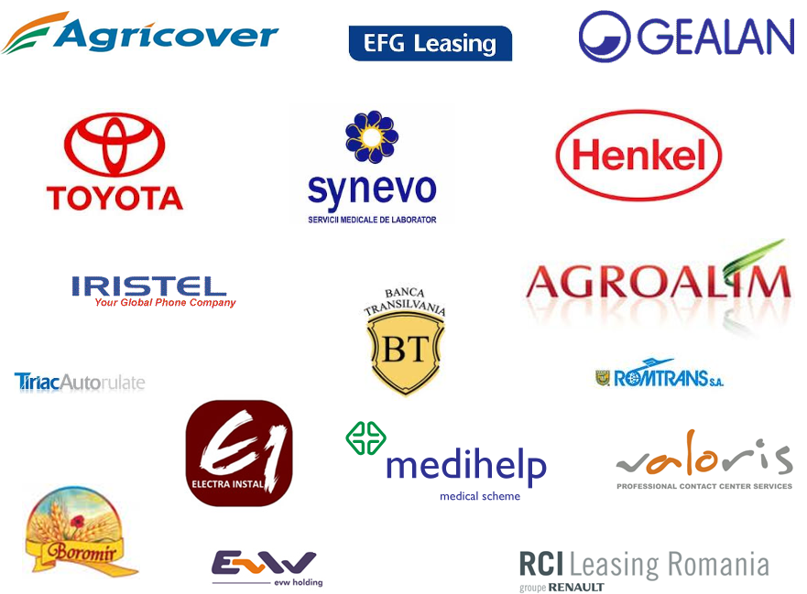

The top reasons organizations choose Microsoft Dynamics CRM to create world-class customer experiences include the following:

* Leadership
* Value
* Familiarity
* Choice
* Cloud
* Flexibility
* Global
* Insight
* Partners
* Solutions

**LEADERSHIP**

With a strong balance sheet, consistent growth, a long-term commitment to innovation, and thousands of world-class engineers, you can be secure in your choice of Microsoft.

Additionally, Microsoft Dynamics CRM has seen impressive momentum in the CRM market and is recognized as a leader in the CRM industry by many third-party experts and analyst firms:

* Gartner Magic Quadrant for [CRM Customer Service Contact Centers](http://www.gartner.com/technology/media-products/reprints/microsoft/vol3/article2/article2.html)
* Gartner Magic Quadrant for [Sales Force Automation](http://www.gartner.com/technology/media-products/reprints/microsoft/vol10/article18/article18.html)
* The Forrester Wave™ [CRM Suites Customer Service Solutions](http://www.microsoft.com/presspass/itanalyst/docs/07-19-10CRM.aspx)
* The Forrester Wave™ [CRM Suites for Midsized Organizations](http://www.microsoft.com/presspass/itanalyst/docs/06-16-10SuitesMidsized.PDF)
* The Forrester Wave™ [CRM Suites for Large Organizations](http://www.microsoft.com/presspass/itanalyst/docs/06-16-10SuitesLarge.PDF)

[The Forrester Wave™: CRM Suites for Large Organizations, June 2010.](http://www.microsoft.com/presspass/itanalyst/docs/06-16-10SuitesLarge.PDF)

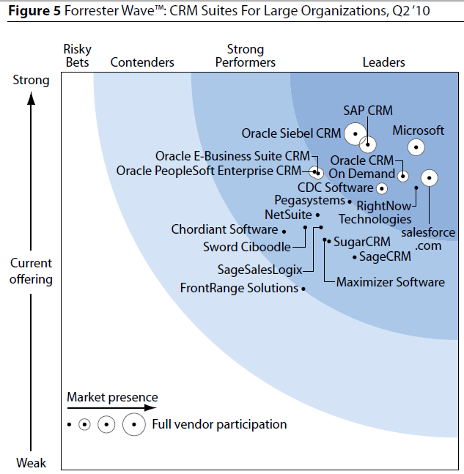

[Gartner Magic Quadrant for Sales Force Automation (SFA), July 2010.](http://www.gartner.com/technology/media-products/reprints/microsoft/vol10/article18/article18.html)

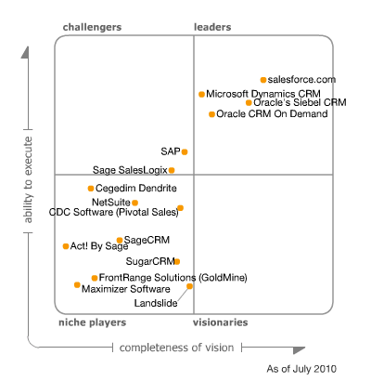

**VALUE**

When considering factors that affect total cost of ownership (TCO)—such as licensing, services, training, deployment, administration, and maintenance—Microsoft Dynamics CRM is regarded by many customers and industry analysts as one of the best values in the industry. Organizations like Pfizer, Mitsubishi-Caterpillar, ISS, VisionShare, and Equinox have won awards for their successful CRM implementations and the value they derived from Microsoft Dynamics CRM.

**FAMILIARITY**

Microsoft Dynamics CRM provides you with a powerful set of CRM capabilities right within the natural and familiar Microsoft® Outlook® client. And with over 500 million Outlook users worldwide, you can be confident that Microsoft Dynamics CRM provides your people with a leading CRM solution that works the way they do.

**CHOICE**

At the end of the day organizations want choice. Microsoft Dynamics CRM offers a choice of on-premises, on-demand, and partner-hosted solutions based on the same architecture and code base so you can select the best model for your organization. Organizations can also access Microsoft Dynamics CRM from Outlook, a web browser, or any Internet-enabled mobile device.

**CLOUD**

Microsoft has invested over U.S. $2.3 billion dollars to create a world-class cloud infrastructure. Microsoft Dynamics CRM Online is a full-featured on-demand CRM solution offered at the compelling price of $44 per user per month and runs in geo-replicated data centers that are SAS 70 and ISO 27001 compliant. And you have peace of mind knowing that Microsoft Dynamics CRM Online is supported by a 99.9% uptime financially backed service level agreement.

**FLEXIBILITY**

In today’s ultra-competitive environment, organizations need the ability to rapidly react to change. With point-and-click customization, role-based forms, declarative design, and powerful developer tools, Microsoft Dynamics CRM can be easily customized to support your changing needs. Extend Microsoft Dynamics CRM beyond customer management to manage other critical relationships with partners, suppliers, contractors, assets, and other key elements.

**GLOBAL**

Microsoft Dynamics CRM is used by customers globally in over 82 countries, is available in over 41 languages, and provides full multi-currency and multi-language support. Local staff and partners around the world can help make your Microsoft Dynamics CRM implementation world-class no matter where you do business.

**INSIGHT**

Microsoft Dynamics CRM provides your users with a range of insightful business intelligence capabilities including real-time dashboards, inline data visualization, flexible reports, and in-depth analytics, so your organization can identify key trends and track key performance metrics.

**PARTNERS**

Thousands of partners in over 82 countries sell, service, and support Microsoft Dynamics CRM. With their unique expertise and skills, these leading partners are a huge asset for your CRM project. Additionally, the introduction of the Microsoft Dynamics Marketplace, a cloud-based repository of partner solutions and community insight, helps you increase the relevancy and value of your Microsoft Dynamics CRM implementation.

**SOLUTIONS**

Microsoft invests over $9 billion annually in a wide variety of productivity-focused solutions. Microsoft Dynamics CRM incorporates many powerful capabilities from Microsoft Office, Microsoft SharePoint® Server, Microsoft Lync™, Microsoft Dynamics ERP, and other leading solutions so you can maximize your Microsoft investment and increase your productivity.

**EXTENDED CRM**

In addition to their relationship with customers, organizations need to manage and maximize other critical relationships—with partners, suppliers, and contractors, to name a few. Microsoft Dynamics CRM can be easily customized to support these extended xRM (any relationship management solution) scenarios.

## Product Functionality

Microsoft Dynamics CRM gives organizations a unified view of customer information and interactions through integrated sales, marketing, and customer service features. This enables organizations to share information, accelerate and improve sales, identify new revenue opportunities, and deliver consistent and improved customer service.

Organizations also need to manage other relationships that are integral to success – employees, partners, suppliers, distributors, vendors and many other critical stakeholders. Microsoft Dynamics CRM can easily be customized for these “Extended CRM” scenarios and enhance the value of all relationships, improve business relevance and fit, drive operational excellence and increase business insights.

As described in the section [Functionality Requirements Matrix](#_Functionality_Requirements_Matrix) , Dynamics CRM responds natively to the business requirements expressed by Corporate Office Solutions. The next chapters give a general overview of the features included in the standard solution.

### Sales Force Automation

You can optimize your sales efforts with the familiar and intelligent features of Microsoft Dynamics CRM. The solution offers a highly intuitive interface and embedded Microsoft Office capabilities to increase time with customers, shorten sales cycles, increase close rates and achieve real-time insight.

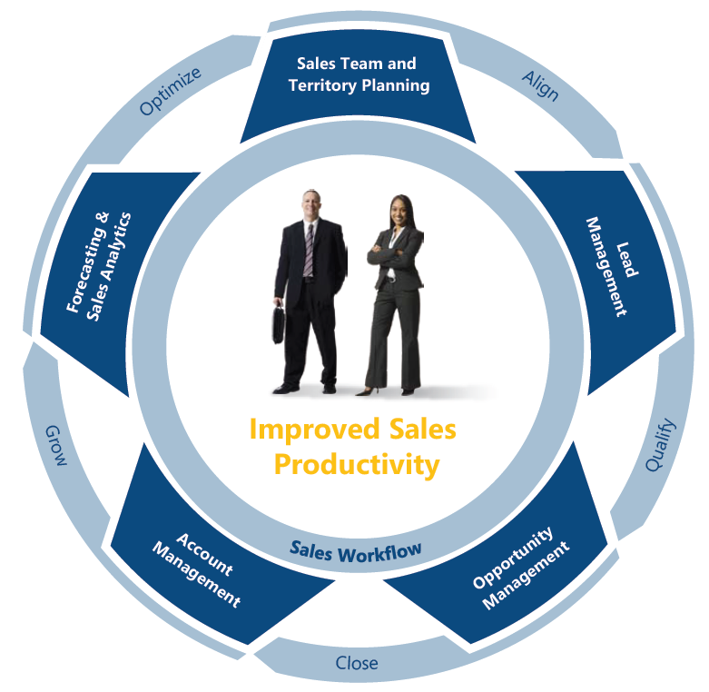

By using Dynamics CRM you can:

* Improve sales planning and management
  + Set up territories and teams for optimal organizational efficiency.
  + Create price lists, discounts and unit groups to streamline offer management.
  + Post sales best practices and tips in the Resource Centre.
  + Use strong role-based and group-based permissions for easy information distribution
* Automate your lead system
  + Better coordinate with marketing by tracking leads in one centralized system.
  + Automatically associate email messages with relevant leads or opportunities.
  + Assign leads and tasks automatically based on predefined rules.
  + Instantly light up the most promising leads with conditional formatting.
  + Use guided dialogues to streamline the qualification process.
  + Streamline lead scoring and conversion.
  + Instantly segment your customer database to identify new leads.
* Manage opportunities effectively
  + Close deals faster by centrally tracking key deal information.
  + Enable more effective team selling with team-based ownership.
  + Create and monitor customized offers and pricing for each opportunity.
  + More effectively position against the competition with seamless competitor tracking.
  + Better identify and leverage extended relationships (lawyers, consultants) in the sales process.
  + Streamline proposal creation with embedded document management capabilities.
  + Establish a consistent sale processes enterprise-wide with predefined workflows.
  + Track generated revenue with out-of-box order and invoice tracking.
  + Use leading sales methodologies like Miller Heiman, SPI and TAS right within Microsoft Dynamics CRM.
* Streamline account management
  + Track all activities and interactions for each contact and account.
  + Identify influencers, constituents, allies and roadblocks for each account.
  + Quickly identify cross-sell and up-sell opportunities with embedded analytics.
  + Automatically track contract renewal dates and details.
  + Better understand complex organizational structures with hierarchal relationship tracking.
* Boost sales productivity
  + Use Microsoft Dynamics CRM right within Microsoft Office Outlook.
  + Instantly find the information you need with preview panes, personal views, record pinning and Most Recently Used lists.
  + Improve communication and team collaboration through seamless integration with Microsoft Office products.
  + Promote Office Outlook contacts and email messages to Microsoft Dynamics CRM with a few clicks.
  + Reduce wasted cycles with robust data import and data de-duplication features.
  + Ensure your sales people are working on the most current data with bidirectional data synch between Microsoft Office Excel and Microsoft Dynamics CRM.
* Enhance pipeline management
  + Easily track the sales pipeline for improved financial planning.
  + Increase accuracy of revenue projections with individual or rollup forecasting.
  + Track revenue goals by dates, financial periods or other predefined criteria.
  + Instantly track sales quota versus attainment at individual or group level.
  + Identify key trends for deals won or lost and optimize the sales process.
* Simplify workflow processes
  + Improve productivity with personal, team and organizational workflows.
  + Leverage guided dialogues across the sales organization to reduce training and ramp-up time.
  + Automatically create or assign tasks and activities when rules are triggered.
  + Automate simple or multilevel approvals with predefined workflows.
  + Automate scoring and distribution of leads.
  + Set alerts for key events or milestones. Define and enforce consistent sales processes enterprise-wide.
* Give sales force mobility
  + Empower your sales force with real-time access to customer data from any web-enabled device.
  + Better prepare for customer meetings via real-time account details.
  + Rapidly respond to customer requests while on the road.
  + Continuously work details by updating and receiving leads 24/7. Discover new up-sell and cross-sell opportunities right on the spot.
* Gain visibility and improve decision making with the right analytics
  + Gain business insight with flexible dashboards and inline data visualization.
  + View key performance indicators in real time with prebuilt dashboards.
  + Use built-in sales reports to conduct detailed analyses without IT assistance.
  + Use robust data cubes for insightful trending analysis.
  + Employ predictive analytics to identify key selling scenarios.
  + Take advantage of the intuitive Report Wizard to instantly create ad-hoc reports.



### Marketing

Dynamics CRM comprises a marketing solution that is flexible, easy to use and engineered to fit your business. You can transform every touch point into a marketing opportunity and harness the undiscovered potential within your customer base. With familiar and intelligent marketing capabilities in Microsoft Dynamics CRM, you can market more effectively, improve productivity and gain actionable insight into your marketing efforts.

Here are some of the objectives you can attain with Microsoft Dynamics CRM:

* Manage your data effectively
  + Effortlessly import data from other sources into Microsoft Dynamics CRM.
  + Use predefined data-mapping rules or create new ones on the fly.
  + Confirm data import status with automatic e-mail notification.
  + Intelligently cleanse your data to eliminate duplications and decrease your cost per engagement (CPE).
* Pinpoint your marketing efforts by using a good segmentation
  + Use natural-language queries to instantly segment customers or prospects.
  + Create highly targeted lists and associate them with campaigns.
  + Set up personal or public views for reuse.
  + Easily share target lists with colleagues and vendors.
  + Export lists into multiple formats for bulk email or direct-mail communications.
* Streamline campaign planning
  + Plan and track activities, tasks, budgets and details for each marketing activity.
  + Set up product catalogues, price lists and discounts for optimal offers.
  + Tailor messages and offers to highly targeted lists.
  + Save time and money with reusable campaign templates.
  + Use predefined workflows to streamline processes and approvals.
  + Create Internet landing page for campaigns without any coding.
  + Easily create marketing plans with embedded document management capabilities.
* Simplify campaign execution
  + Initiate and distribute campaigns and communications instantly.
  + Track and manage all event and customer details in one central platform.
  + Use embedded Mail Merge capabilities to instantly send mass communications.
  + Manually or automatically assign marketing tasks and leads.
  + Create on-the-fly campaigns with the Quick Campaign Wizard.
  + Create rules to trigger responses based on customer interest.
* Improve response management
  + Centrally capture and track responses for marketing campaigns.
  + Automatically capture and categorize responses from Internet landing pages.
  + Score responses using predefined rules.
  + Instantly assign responses to most qualified resources for follow-up.
  + Instantly convert responses to leads.
* Streamline lead tracking
  + Better coordinate with sales by tracking leads in one centralized system.
  + Automatically assign or score leads based on predefined workflows.
  + Instantly light up the most promising leads with conditional formatting.
  + Use guided dialogues to streamline the lead qualification process.
  + Ensure your marketing staff is working on the most current leads with bidirectional data synch with Excel.
* Extend value with Microsoft Office – Timesavers
  + Use Microsoft Dynamics CRM within Microsoft Office Outlook for improved productivity.
  + Instantly find the information you need with preview panes, personal views, record pinning and Most Recently Used lists.
  + Eliminate redundant email tracking through Office Outlook synchronization.
  + Better collaborate with co-workers with embedded presence feature.
  + Streamline mass mailings with built-in mail-merge capabilities.
  + Add Office Outlook contacts to marketing lists with a few mouse clicks.
* Automate workflows
  + Boost productivity with personal, team or organizational workflows.
  + Dynamically assign tasks to the most appropriate resource using configurable rules.
  + Accelerate approvals using predefined workflows.
  + Automate follow-up with predefined triggers.
  + Set alerts and reminders for campaign milestones.
* Mobile Express for Microsoft Dynamics CRM
  + Access customer data from any web-enabled device anywhere, anytime.
  + Track budgets and push through approvals while on the road.
  + Create or update campaigns on the fly.
  + Update, qualify or assign leads while on the road.
  + Track key marketing metrics while on the road with rich offline reporting.
* Gain key insights for decision making
  + Measure your marketing success with key performance indicators (KPIs).
  + Gain business insight with flexible dashboards and inline data visualization.
  + Follow key marketing objectives with comprehensive goal-tracking capabilities.
  + Track key campaign indicators with built-in reports.
  + Identify trends and allocate resources with powerful predictive analytics.
  + Use robust data cubes for trending analysis.

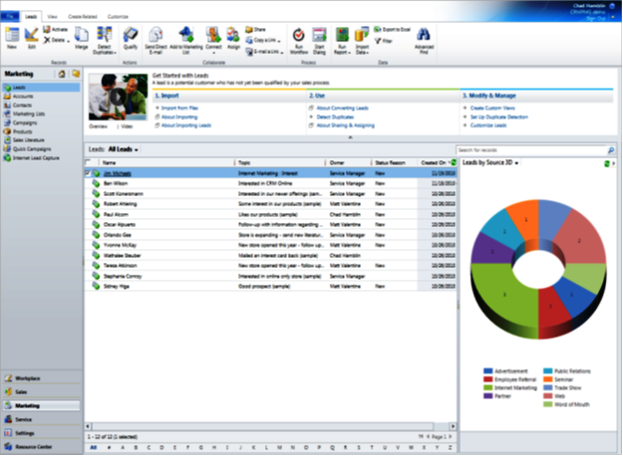

### Customer Service

Microsoft Dynamics CRM meets the changing expectations of customers with a service solution that is robust and flexible. Users find familiar functionality and an interface that let them work in a personal, natural way. This intelligent solution informs customer service professionals with guidance that is insightful and actionable. The result is a connected, collaborative and integrated organization.

By implementing the Customer Service module of Dynamics CRM you can achieve the followings:

* Manage accounts with insight and collaboration
* Enhance customer service with insightful, actionable intelligence
* Respond to cases quickly and precisely
* Simplify contract management
* Get the right information at the right time by using the system knowledgebase
* Integrate Mobile Express for Microsoft Dynamics CRM
* Streamline scheduling with all resources required to perform a service
* Establish processes that facilitate a connected organization that is collaborative and integrated

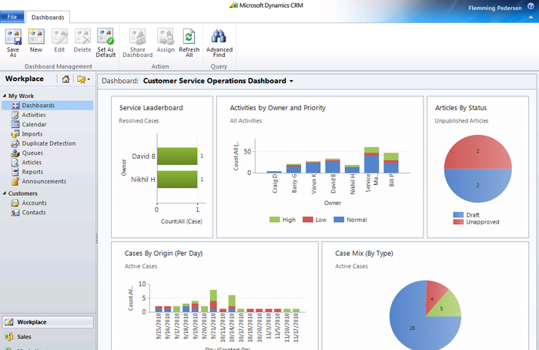

### Extended CRM

Organizations also need to manage other relationships that are integral to success – employees, partners, suppliers, distributors, vendors and many other critical stakeholders. Microsoft Dynamics CRM can easily be customized for these “Extended CRM” scenarios and enhance the value of all relationships, improve business relevance and fit, drive operational excellence and increase business insights.

With Dynamics CRM you can benefit from:

* xRM framework, Rapid customizations, dynamic services and prebuilt functionality
  + Point-and-click customization of data management, workflow, user experience, access and security, analytics and reporting
  + Ability to deploy customizations either in your data center or in the cloud
  + Application integration based on well-supported industry standards
  + Extension of familiar and scalable technologies such as the Microsoft Office System, Microsoft SQL Server, Microsoft Visual Studio, the Microsoft .NET Framework and Windows Server
* Configurable rules, processes and workflows
  + Point-and-click customization and configuration Personal, team or organizational workflows Ability to build processes with conditional branching and nesting Automated actions with triggers based on events, time or business logic
* Superior scalability and performance
  + Multi-tenancy for multiple concurrent applications High availability, load balancing and clustering 100,000 concurrent users with virtualization Reduced power consumption, rack space and management overhead
* Third-party plug-ins and applications
  + Ability to add and remove programs and features Support for secure code on the server Intellectual property protection Change management and versioning
* Discover solutions with the new Microsoft Dynamics Marketplace
  + Ability to discover, download and deploy applications Both application and professional services listings New, optimized search logic Solution ratings and reviews Direct integration with Microsoft Dynamics CRM 2011 View more information on Microsoft Dynamics Marketplace.

## Budgetary Pricing Estimate

Microsoft Dynamics CRM allows you either an in-house deployment (On-Premise), either a Microsoft hosted CRM solution (Online / On-Demand).

The budgetary pricing estimate below includes both options.

### Microsoft Dynamics CRM – Online

Microsoft Dynamics CRM Online is a software-as-a-service per user subscription based model available in 40 geographies, including Romania.

|  |  |  |  |  |  |
| --- | --- | --- | --- | --- | --- |
| License Type | Users No | Unit Price per User € | Price per Month € | Price per Year € | Annual Price per User € |
| Microsoft Dynamics CRM 2011 Online | 13 | 40.25 | 523 | 6,279 | 483 |

The price above includes the software assurance as well as the followings:

| **Microsoft Dynamics CRM Online** | |
| --- | --- |
| Application Components | |
| * Workflows | 2001 |
| * Custom Entities | 3001 |
| * Storage | 5 GB1,2 |
| * User Access | Online & offline |
| * Mobility Support | Included |
| Application Administration | |
| * Unlimited Application Troubleshooting | Included |
| * Patch Installations | Included |
| * Version Upgrades | Included |
| * Data Migration Tools | Included |
| Monitoring | |
| * Proactive Response to Alerts | Included |
| * Port and Network Device Monitoring | Included |
| * Proactive Hardware Failure Monitoring | Included |
| * System Software Monitoring | Included |
| * Application Server Monitoring | Included |
| * Database Monitoring | Included |
| Backup and Recovery | Included |
| Security | Included |
| Service Level Agreement | Included 99.9% financially-backed3 |
| Professional Support Plan | Included |
| 40.25 per user, per month | |

Some of the benefits a cloud solution offers are:

* Rapid Time to Value: Meet tight time to market requirements that may challenge in-house resources
* Management Simplicity: Minimize your need to manage multiple vendors or internal support resources thanks to ongoing application monitoring and maintenance
* Improved Quality of Service: Obtain reliable performance supported by a financially-backed 99.9 percent service level agreement (SLA)
* Flexibility: Scale the number of users up or down based on your need
* Cost Predictability: Change capital expenditures into predictable operating expenses and eliminate the additional costs an in-house solution requires (like for e.g. hardware, basic software – operating system or database management system, system overall administration)
* Software will always be up to date
* Can use applications from any device anywhere
* Will have access to new services and apps that you wouldn’t have so fast and easy in-house

### Microsoft Dynamics CRM – On-Premise

|  |  |  |  |  |  |
| --- | --- | --- | --- | --- | --- |
| License | Users No | Unit Price (€ ) | Total Price (€) | Discount  (30%) (€) | TOTAL (€) |
| Microsoft Dynamics CRM 2011 On-Premise Server | 1 | 3,857 | 3,857 | 1,157 | 2,700 |
| Microsoft Dynamics CRM 2011 Full CALs | 13 | 871 | 11,329 | 3,399 | 7,930 |
| “Professional Services” Add-on Full CALs | 13 | 70 | 910 | 273 | 637 |
| TOTAL Licenses |  |  | 16,096 | 4,829 | 11,267 |

Microsoft Dynamics CRM 2011 Servers are licensed under the Microsoft Server/CAL licensing model, meaning that they require a separate Server license for each Server on which the software is installed, plus a User Client Access License (CAL) for every internal user who accesses CRM.

The Microsoft Dynamics CRM 2011 Full CAL provides a user with full read-write access to all capabilities within Microsoft Dynamics CRM 2011.

“Professional Services” Add-on Full CALs is the add-on developed by Matricia for organizations delivering professional services, having their activity organized by projects. The features included in this add-on are listed in the chapter [“Professional Services” Add-on](file:///C:\Users\marius.motofei\AppData\Local\Microsoft\Windows\Temporary%20Internet%20Files\Content.Outlook\I68WSL6L\Professional_Services#_).

#### Software assurance for Microsoft Dynamics CRM – On-Premise

Software assurance is a percent of the net license price and is paid annually (20%).

The software assurance includes the following services:

* Unlimited Online Training
* Product Updates
* Investment Protection
* Customer Source
* Ability to Make Suggestions for Future Products and New Features
* Ability to Purchase Add’l Products, Users and Services
* Service Packs/Fixes
* Knowledge Base
* Access to public Newsgroups

### Implementation Services

Based on the gross requirements expressed in the RFP document we estimate as required the following implementation services.

| Project Stage | Task | Man-days |
| --- | --- | --- |
| 1. Analysis | Kick-off & business requirements analysis | 2 |
| Requirements analysis document | 1 |
| Document validation | 1 |
| 2. Project Organization | Project Organization (detailed project plan) | 1 |
| 3.System Configuration | System Deployment (installation or online site activation) | 1 |
| Implementation team training on standard features | 2 |
| System Configuration | 4 |
| Configured System Documentation | 2 |
| 4. System Testing | Training for the testing users | 1 |
| System Test, Fine-Tuning and Acceptance | 3 |
| 5. Training | Users training on configured system | 2 |
| Training on reports design & administration | 2 |
| 6. Data Migration & Go-Live | Support for data migration | 1.5 |
| Go-Live Support | 2.5 |
| 7. Project Management | Project Management | 2 |
| **TOTAL MAN-DAYS** | | **28 days** |
| **TOTAL COSTS** | | **8,680 euro** |

The budget above is an estimate. A +/- 15% contingency rate should be considered. A final assessment of the amount of required services will be provided after the Analysis step of the implementation project.

# 

# Implementation

## Project Timeline

The estimated timeline for the implementation project is described above. The project might occur during a period of 12 weeks. This is a projection. The real times depend very much not only on the supplier’s ability to deliver the required features but on the client’s determination and possibilities to follow the commonly agreed schedule and tasks.

|  |  |  |  |  |  |  |  |  |  |  |  |  |  |
| --- | --- | --- | --- | --- | --- | --- | --- | --- | --- | --- | --- | --- | --- |
| Stage | Task | W1 | W2 | W3 | W4 | W5 | W6 | W7 | W8 | W9 | W10 | W11 | W12 |
| 1. Analysis | Kick-off & business requirements analysis |  |  |  |  |  |  |  |  |  |  |  |  |
| Requirements analysis document |  |  |  |  |  |  |  |  |  |  |  |  |
| Document validation |  |  |  |  |  |  |  |  |  |  |  |  |
| 2. Project Organization | Project Organization (detailed project plan) |  |  |  |  |  |  |  |  |  |  |  |  |
| 3. System Configuration | System Deployment (installation or online site activation) |  |  |  |  |  |  |  |  |  |  |  |  |
| Implementation team training on standard features |  |  |  |  |  |  |  |  |  |  |  |  |
| System Configuration |  |  |  |  |  |  |  |  |  |  |  |  |
| Configured System Documentation |  |  |  |  |  |  |  |  |  |  |  |  |
| 4. System Testing | Training for the testing users |  |  |  |  |  |  |  |  |  |  |  |  |
| System Test, Fine-Tuning and Acceptance |  |  |  |  |  |  |  |  |  |  |  |  |
| 5. Training | Users training on configured system |  |  |  |  |  |  |  |  |  |  |  |  |
| Training on reports design & administration |  |  |  |  |  |  |  |  |  |  |  |  |
| 6. Data Migration & Go-Live | Support for data migration |  |  |  |  |  |  |  |  |  |  |  |  |
| Go-Live Support |  |  |  |  |  |  |  |  |  |  |  |  |
| 7. Project Management | Project Management |  |  |  |  |  |  |  |  |  |  |  |  |

# 

## Implementation Methodology - Metrics

The implementation project will be conducted in accordance with Matricia`s standard implementation methodology, Metrics, designed to help clients implement software solutions in a timely and cost effective way.

Developed, improved and proven over tens of projects, Metrics enables us to deliver well-managed projects, ensuring a successful implementation for every client.

**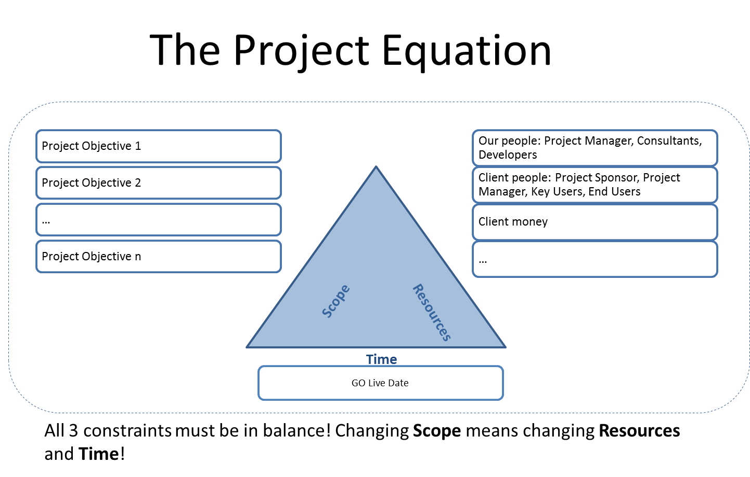**

### Project Phases

Projects are organized by phases. The main phases of the Metrics methodology are described below:

**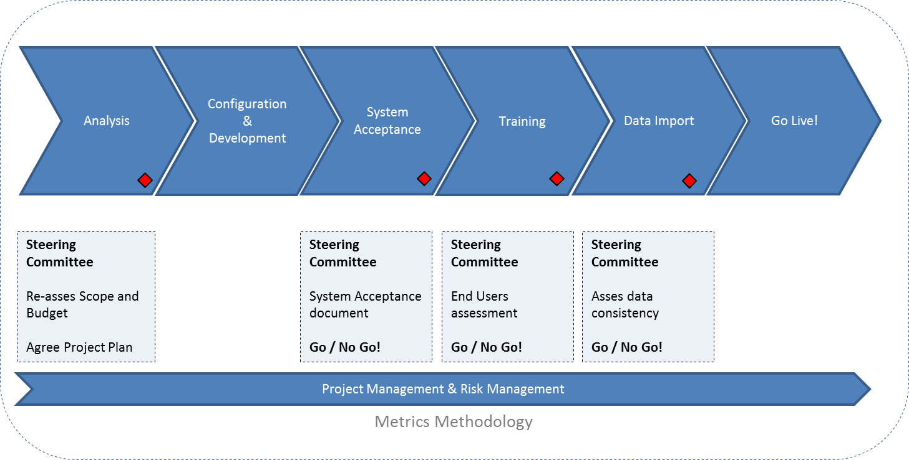**

### Project management! Risk management!

Regardless of the project phase, during the implementation project we rollout project control and management activities; risks are permanently assessed to ensure a successful implementation.

Here are the main project management actions, pillars of our project management, according to the Metrics methodology:

1. **Planning**

Planning actions are meant to provide the implementation team with the details and direction they need for a productive participation within the project:

* + Define tasks and milestones
* Project plan with activities, tasks and key-phases, responsible persons and deadlines
* Correct risk assessments and strategies for risk minimization and avoidance
* Stick to the agreed plan!

Risk management focuses on the pro-active identification and analysis of eventual risks and problems that may arise in a project; once identified, these risks must be recorded in writing and communicated to the decision factors. Project teams, both from Matricia and the client’s side, must be aware of these risks and avoid them or minimize and control them, in case they cannot be avoided!

**2. Monitoring**

* + Measure what has been done. Measure what’s left and take the necessary measures.
  + Asses the risks and plan to mitigate them

**3. Adjust**

Adjustment management means the control of project objectives as per the requirements document approved in the analysis phase. Deviations from the initial objectives must be registered in change order forms that must be analyzed, verified and approved by the client before being implemented.

* Make the smallest possible corrections
* Adjust budget, resources, reschedule tasks
* Undertake the changes!

**4. Communicate**

Communication management involves communication activities between project teams, but also from the teams towards the organization, communication which must take place at all levels.

* Steering Committee Meetings are of high importance!
* We make sure that the relevant people **receive and understand** all project related information
* Speak up each time is needed!

Communication includes “kick-off” meetings, analysis and project status report meetings, communications about past and future project steps, as well as e-mail or other similar correspondence.

### Analysis Phase

During the Analysis stage, we collect the **information** from client (requirements of different importance are mentioned: scope related, out of scope requirements, end users’ requirements, micro-requirements).

Our team assesses all these and segregates which are the business requirements that help meeting the **project goals**. The way we guide the client team in this process is as follows:

* Provide people with best business knowledge
* Keep it simple! Complexity is difficult to understand, adopt and change in future
* End users must not set business objectives, otherwise, system will end up implementing other business objectives than initially agreed

The business requirements expressed by client, translated to system requirements are documented in a requirements analysis document which is discussed and agreed with the client.

**After final project scope is agreed, the project managers will detail the project plan, organize the teams, responsibilities and due terms.**

### Configuration Phase

This is the stage when the platform systems are installed and configuration and development tasks are performed. As features are performed (screens ready, workflows setup, functionality developed, etc.) our team presents them to the client’s team, obtaining immediate feedback and validation. These actions are performed as soon as possible, so our team will be able to correct in due time the eventual discrepancies with the client’s requirements.

During this stage, we have in mind, the following main considerations:

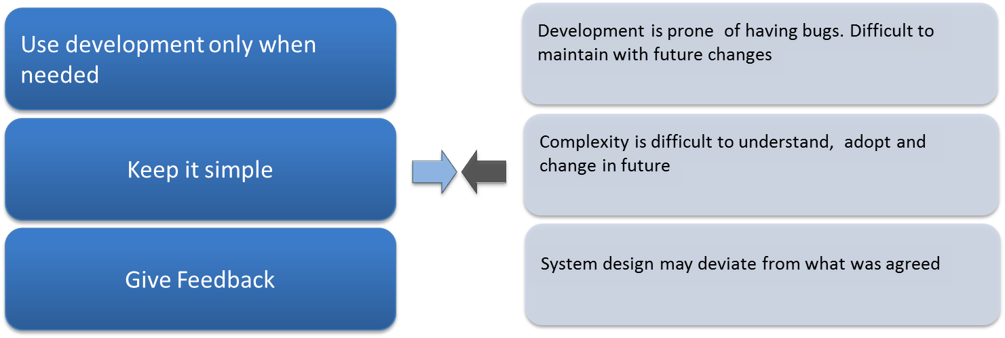

### System Test and Acceptance

Before tests are performed by the client, preliminary tests are performed internally. Test cases are shaped and written, based on the system requirements and initial feedback obtained in the Configuration phase.

Client testing team should be made not only by testers, but from members of the implementation team also, people aware of the client organization processes and project scope.

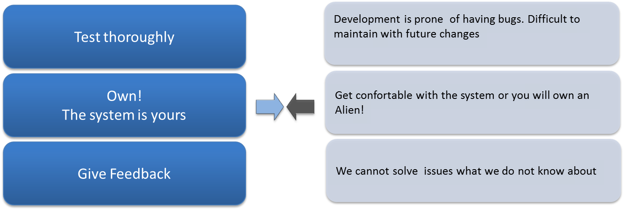

Testers and implementation team must realize once again, that the system is implemented to attain organizations’ goals and their involvement is essential, so they must test the system with responsibility and check seriously how this respond to the initial goals established in the Analysis stage.

### Training Phase

**Documentation is prepared: user guides, administrator guides, training materials.**

Usually we train the trainers. If requested we train end-users also, but definitely in the presence of client project manager or department managers. In this way, eventual business questions asked by end-users will be adequately responded and, also, the message about the system importance will be absolutely transferred by members of the client organization.

How we organize our training sessions:

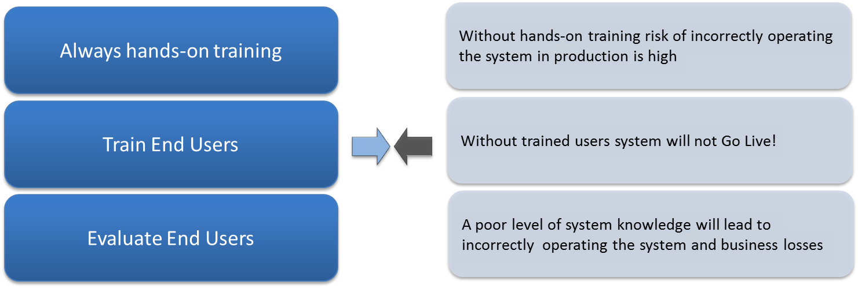

### Data Migration Phase

Early in the Configuration stage our consultants are providing the client with formats and requirements of data to be migrated. The client team should start preparing the data since this early stage, since the consistence and correctness of data is a factor so important in the project scope.

Prepared data is checked by both teams, and test data imports are performed before the final data migration.

During “Data Migration” stage, all testing data from the system is cleaned. All relevant data (data prepared manually or data extracted from the legacy systems) is imported into the system. During the import, new data is validated and successive backups are performed in order to keep all the changes.

A final copy of the system with all data migrated is performed when the process is done.

### Go Live Phase

**Hand over, encourage, involve!**

Users will start working in the system prepared for going live.

Hand over is performed, the system administrator(s) will start monitoring the system and perform maintenance activities.   
People are encouraged and sustained during first days of working. Support can be done on-site or via help desk. Eventual bugs or dis-functionalities are reported, classified and solved according with their importance.

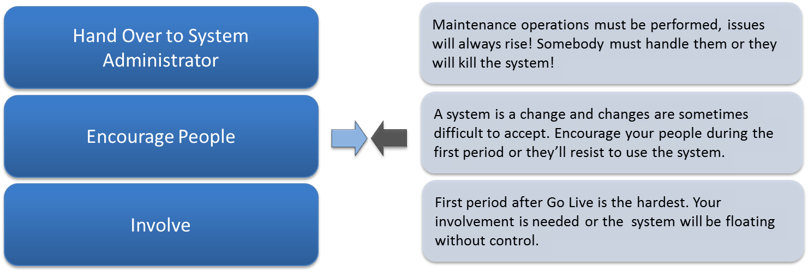

At the end of this stage, implementation project is closed, client organization entering a new phase, Customer Support.

Customer satisfaction surveys may be performed in order to measure the effectiveness and success of the implementation.

# Training Services

The transfer of knowledge, training, is an essential aspect of the transfer of property over the system to the client. Proper training of the team members is essential not only for the success of the implementation but also to ensure satisfaction and adjustment of the users to the new solution.

According to the Metrics methodology, we train the users applying the “Train the Trainers” method. A train-the-trainer session takes place with the client’s team which will later train the final users. This session prepares the client’s team members and develops their necessary skills to deliver, in their turn, such training.

But, upon the client’s request, we provide the final users’ training, but only in the presence of the project manager and/or the client’s department managers. This way, business questions of the final users can be answered properly. Also, the message regarding the importance of the system will be reiterated by members of the client organization to the final users.

There are several options for planning and delivering the training, according to the special needs of each client. It is important to obtain the client’s involvement for the allocation of proper human resources, both at the beginning of the project and right before go-live.

As observed in the section [Project Timeline](#_Project_Timeline) users’ training will take place in several phases of the project.

1. In the System Configuration phase we will supply the implementation core team a training on product standard functionalities. The purpose is to provide the client’s team members a set of basic information regarding the system to be implemented. This focuses on the training of the client’s team members who will actively participate in making decisions regarding the modality in which the software will be implemented.
2. The training in the Testing and Acceptance phase focuses on training the client’s team members to participate at the testing activities.
3. Finally, the end users’ training is a personalized training, focusing only on the activities of each type of users. This must always be a “hands-on” training, accompanied by didactic materials and finalized with an evaluation session. After the users’ evaluation, it is decided whether the system can go live or additional training sessions are needed.
4. The last training session we proposed is the training for reports design and administration of the system. These sessions are meant to give the client’s team a level of autonomy in performing basic reporting and administration tasks.

Each kind of training must be supplied together with the required supporting materials:

* Training room
* Multimedia projector
* Computers
* PowerPoint presentations with agenda and course support on paper and electronic format
* Users guide in electronic format
* Trainee evaluation form
* Trainer evaluation form
* System administration documentation:
  + Backup & recovery recommendations
  + Administration guides
  + System troubleshooting

# Customer Support

After the system is live, at the end of the Go-Live support period, the IT system is transferred to the support and maintenance team.

In a Steering Committee Meeting, the project manager must ensure that the support team has understood the importance of these activities (supports and maintenance) through which the client’s investment is secured, the value of the solution is maximized and the organization’s general productivity is improved.

The autonomy of the support team is ensured by providing online support, tools to monitor the solution and training. The efficient utilization of these available resources not only reduces the number of support calls but increases the client’s satisfaction with using the solution. It is important that all interested parties (project sponsor, project manager, IT team, human resources and training, financial team, etc.) should have access to these instruments which enable them and the new users to benefit from and easily adjust with the new system.

It is also important that all documentation related to the newly implemented system, prepared throughout the project – including back-up and maintenance recommendations, troubleshooting documentation, users’ guides and administration guides, the solution design document – should be transferred to the assigned support team, ensuring the technical transfer of knowledge and information about the system.

**Depending on the type of support agreed in the contracting phase, the Service Level Agreement – different than the Software Assurance Agreement - comes into force, thus the post-implementation support can be provided by Matricia’s support team.**

Matricia’s support team acts as a sole point of contact regardless of the origin/producer of the solution components, based on a helpdesk procedure.

All problems raised by the system users will be taken over by Matricia’s helpdesk via agreed communication channels (web, mail, fax, telephone) and will be recorded in the helpdesk application.

The client will appoint a single representative for his relation with Matricia’s support service. It is advisable that this person is the Client’s System Administrator.

Matricia’s support services include, at a minimal level, the following activities:

* Incidents recording and monitoring until their closing;
* Access to online Incidents Tracker system based on client user name and password
* Incidents analysis and diagnosis;
* Providing solutions for solving the incidents, under the form of adjusted work procedures, modification of functional application components, changes of the content or database structure, etc.;
* Communication with the client’s system administrator in order to analyze the status of open incidents, through Matricia’s ticketing application;
* Standard on-site and/or online support: between 09:00-18:00, Romania time, from Monday to Friday, except legal holidays;
* Golden on-site and/or online support: 24/7, except legal holidays;
* Evaluation of compliance of application performance with the SLA and draw-up of periodical reports.

The definitions below apply within an SLA agreement:

* **Service Level Agreement (SLA)** – establishes the response time for incidents, identifies the minimum standard for the application functioning and defines the procedures by which Matricia provides support services to the Client’s users.
* **Helpdesk** – the technical assistance service which takes over requests received by telephone, fax, web and e-mail, which is operated by Matricia’s technical support staff, providing assistance for all components of the integrated solution.
* **Time of response** – The time elapsed from the initial communication of the incident by the client’s system administrator to the helpdesk, and the moment when the incident’s reception is confirmed by Matricia’s technical support team
* **Duration of temporary remediation** - Action (change) made by Matricia specialists in order to avoid the effects of functional problems, without eliminating the main cause of the problem
* **Solving duration** – the time elapsed until the solution to the problem is provided.

The SLA established the following priority levels applicable to the support services provided:

| **Priority Level** | **Description** |
| --- | --- |
| Critic | Major impact upon the functioning of the system, the problem prevents the proper rollout of the activity or the activity is seriously affected due to the loss of critical functionalities. |
| Major | Significant impact upon the functioning of the system, the problem prevents the normal activity of the users, an alternative solution is not available, users can rollout their activity but in a restrictive manner. |
| Medium | Medium impact upon the functioning of the system, the problem affects the system functionalities in a small degree, the impact is an inconveniency which requires an alternative for the recovery of the functionalities. |
| Minor | Minimum impact upon the functioning of the system, the problem does not affect the functionalities of the system, the effect is a minor error which does not prevent the proper rollout of users’ activity. |

Matricia can assume the following response times to registered incidents:

|  |  |  |  |
| --- | --- | --- | --- |
| **Priority Level** | **Response Time** | **Remedying Time** | **Incident Closing Time** |
| Critic | 2 hours | 24 hours | 3 working days |
| Major | 4 hours | 48 hours | 4 working days |
| Medium | 8 hours | 4 working days | 6 working days |
| Minor | 24 hours | 8 working days | 12 working days |

The above response time to incidents are agreed with the client, times calculated from the moment when Matricia’s helpdesk service is informed about the occurrence of the incident.

For errors in the source code of the applications (which fall under the incidence of the Software Assurance Agreement), the solving time will be that provided by the producer of the respective application, Matricia’s support service will ensure the transfer of the incidents to the provider’s support service in the shortest time possible and, to the possible degree, will provide temporary solutions until the problem is solved.

All support services will be provided under the incidence of confidentiality clauses which will be established through the technical support service agreement.

# References

|  |  |
| --- | --- |
|  | CRM platform for ASMs, KAM and top management, consolidating customer information (distributors & end clients) from ERP and SFA.  Client bought and implemented Dynamics CRM in 2010 for the area sales management and sales top management teams.  During 2011 the client added new functionality for the key account management team |
|  | Iristel uses Dynamics CRM since 2006. At the end of 2010 decided to upgrade the solution to the latest Dynamics CRM version (2011) and decided to do this with Matricia.  Dynamics CRM is used by Customer Care. Integration with several LoBA (billing, installments, destinations and fees, etc.) |
|  | Last year (2011), the client decided migrate the existing CRM system (Ascent CRM) to Microsoft Dynamics CRM Online.  The project scope is to attain the client 360°’s view by managing the entire lead generation, sales and after-sales processes. The online solution shall be also integrated with iScala ERP. |
|  | In 2008, Vodafone Romania implemented together with Matricia a sales force automation system used by 600 users of large accounts direct sales and telesales teams. The SFA Integrated with 8 back-office applications. |
| C:\home\Matricia\LOGOS\Logos Clients\servier_3.jpg | Les Laboratoires Servier is one of the biggest worldwide pharmaceutical producers. The CRM story begun in June 2003 in Romania, with 60 users, now, the Romanian subsidiary has now 250 users. The CRM was roll-out in Russia (600 users, Bulgaria and Ukraine), all projects were managed by Matricia’s team. |

# CRM System Requirements

|  |
| --- |
| ***Existing configuration*** |
| *System model: Hp Pro Liant DL380 65*  *Hardware:*  *Processor: Intel Xeon E5310 1.60GHz Dual Core*  *RAM: 3GB*  *HDD: 70GB*  *Video adapter: ATI ES 1000 32Mb*  *Network: HP NC 373i Multifunctional Gigabit Server Adapter*  *Software:*  *Win Server 2003 SE Service Pack 2 86x* |

If considering an in-house implementation, the existing server (acquiring year: 2007) accomplishes the minimum hardware required by the Dynamics CRM 2011 server. The server operating system MUST be upgraded to Windows Server 2008 (64bits).

Please follow the next pages for a detailed description of the required hardware and software both for server (on-premise installation) and client applications (on-premise and online).

**NOTE: For the online deployment consider please only the Client hardware & software prerequisites.**

## Microsoft Dynamics CRM Server 2011 hardware requirements

The following table lists the minimum and recommended hardware requirements for Microsoft Dynamics CRM Server 2011 running in a Full Server configuration. These requirements assume that additional components such as Microsoft SQL Server, Microsoft SQL Server Reporting Services, Microsoft SharePoint, or Microsoft Exchange Server are not installed or running on the system.

| Component | \*Minimum | \*Recommended |
| --- | --- | --- |
| Processor | x64 architecture or compatible dual-core 1.5 GHz processor | Dual-core x64 architecture 2 GHz CPU or higher |
| Memory | 2 GB RAM | 4 GB RAM or more |
| Hard disk | RAID 1 for Operating System and SQL database | RAID 5 for Operating System and SQL database |

## Microsoft Dynamics CRM Server 2011 software requirements

This section lists the software and application requirements for Microsoft Dynamics CRM Server 2011.

### Windows Server operating system

Microsoft Dynamics CRM 2011 Server can be installed only on Windows Server 2008 x64-based computers. The specific versions and editions of Windows Server that are supported for installing and running Microsoft Dynamics CRM Server 2011 are listed in the following section.

Important

The Windows Server 2003 family of operating systems are not supported for installing and running Microsoft Dynamics CRM 2011 Server.

### Supported Windows Server 2008 editions

The following editions of the Microsoft Windows Server 2008 operating system are supported for installing and running Microsoft Dynamics CRM 2011 Server:

* Windows Server 2008 Standard (x64 versions) SP2 or later version
* Windows Server 2008 Enterprise (x64 versions) SP2 or later version
* Windows Server 2008 Datacenter (x64 versions) SP2 or later version
* Windows Web Server 2008 (x64 versions) SP2 or later version
* Windows Small Business Server 2008 Premium x64 or later version
* Windows Small Business Server 2008 Standard x64 or later version

Important

* Windows Server 2008 installed by using the Server Core installation option is not supported for installing and running Microsoft Dynamics CRM 2011 Server.
* Virtualization technology such as Hyper-V is only required if you want to install and run Microsoft Dynamics CRM in a virtual environment.
* Windows Server 2008 for Itanium-based systems is not supported for installing and running Microsoft Dynamics CRM 2011.
* The Windows Small Business Server 2008 Standard edition does not include SQL Server. You must have a supported version of SQL Server available to install Microsoft Dynamics CRM on Windows Small Business Server 2008 Standard edition.

### Server virtualization

Microsoft Dynamics CRM servers can be deployed in a virtualized environment by using Windows Server 2008 with Hyper-V or virtualization solutions from vendors who participate in the Microsoft Windows Server Virtualization Validation Program (SVVP). You must understand the limitations and best practices of server virtualization before you try to virtualize your installation of Microsoft Dynamics CRM. For information about Hyper-V, see the Microsoft Virtualization (<http://go.microsoft.com/fwlink/?linkid=145119> ) Web site.

### Active Directory modes

The computer on which Microsoft Dynamics CRM 2011 is running must be a domain member in a domain that is running in one of the following Active Directory directory service domain modes:

* Windows 2000 Mixed
* Windows 2000 Native
* Windows Server 2003 Interim
* Windows Server 2003 Native
* Windows Server 2008 Interim
* Windows Server 2008 Native

Important

* The computer on which Microsoft Dynamics CRM is running cannot function as an Active Directory domain controller, unless it is running Windows Small Business Server 2008.
* When you install Microsoft Dynamics CRM in a Windows 2000 Mixed-mode domain, you cannot add users to Microsoft Dynamics CRM that are located in a different domain.
* Installing Microsoft Dynamics CRM Server 2011 in a domain that is running in Active Directory Application Mode (ADAM) is not supported.

All Active Directory forest modes are supported. For more information about Active Directory domain and forest modes, see the Active Directory Domains and Trusts MMC snap-in Help.

### Internet Information Services (IIS)

We recommend that you install and run IIS 7.0 or a later version in Native Mode before you install Microsoft Dynamics CRM Server 2011. However, if IIS is not installed and it is required for a Microsoft Dynamics CRM server role, Microsoft Dynamics CRM Server Setup will install it.

### SQL Server editions

Any one of the following Microsoft SQL Server editions is required and must be installed on a Windows Server 2008 64-bit or later version, running, and available for Microsoft Dynamics CRM:

* Microsoft SQL Server 2008, Standard Edition, x64 SP1 or later version
* Microsoft SQL Server 2008, Enterprise Edition, x64 SP1 or later version
* Microsoft SQL Server 2008 Datacenter x64 SP1 or later version
* Microsoft SQL Server 2008 Developer x64 SP1 or later version (for non-production environments only)

Important

* 32-bit versions of SQL Server 2008 database engine or Reporting Services are not supported for this version of Microsoft Dynamics CRM.
* Microsoft SQL Server 2008 Workgroup, Web, Compact, or Microsoft SQL Server 2008 Express Edition editions are not supported for running Microsoft Dynamics CRM Server 2011.
* Microsoft SQL Server 2000 and Microsoft SQL Server 2005 editions and are not supported for this version of Microsoft Dynamics CRM.
* Running 64-bit SQL Server 2008 versions for Itanium (IA-64) systems in conjunction with Microsoft Dynamics CRM will receive commercially reasonable support. Commercially reasonable support is defined as all reasonable support efforts by Microsoft Customer Service and Support that do not require Microsoft Dynamics CRM code fixes. Microsoft Dynamics CRM Server 2011 supports a named instance of SQL Server for configuration and organization databases.

### SQL Server Reporting Services

Specific SQL Server Reporting Services editions are used for reporting functionality.

Any one of the following Microsoft SQL Server editions is required and must be installed on a Windows Server 2008 64-bit or later version, running, and available for Microsoft Dynamics CRM:

* Microsoft SQL Server 2008, Standard Edition, x64 SP1 or later version
* Microsoft SQL Server 2008, Enterprise Edition, x64 SP1 or later version
* Microsoft SQL Server 2008 Datacenter x64 SP1 or later version
* Microsoft SQL Server 2008 Developer x64 SP1 or later version (for non-production environments only)

Important

* Microsoft SQL Server 2008 Workgroup, Web, Compact, or Microsoft SQL Server 2008 Express Edition editions are not supported for running Microsoft Dynamics CRM Server 2011.
* Running 64-bit SQL Server 2008 versions for Itanium (IA-64) systems in conjunction with Microsoft Dynamics CRM will receive commercially reasonable support. Commercially reasonable support is defined as all reasonable support efforts by Microsoft Customer Service and Support that do not require Microsoft Dynamics CRM code fixes.
* Microsoft SQL Server 2008 Workgroup is not supported for running the Microsoft Dynamics CRM Reporting Extensions. This is because SQL Server 2008 Workgroup does not support custom data extensions. Therefore, features such as creating, running, or scheduling Fetch-based or SQL-based reports will not work.

### Software component prerequisites

The following SQL Server components must be installed and running on the computer that is running SQL Server before you install Microsoft Dynamics CRM Server 2011:

* SQL word breakers

This is only required for some Microsoft Dynamics CRM language editions. For more information about word breaker versions for languages supported by SQL Server see Word Breakers and Stemmers (<http://go.microsoft.com/fwlink/?linkid=127754>).

* SQL Server Agent service
* SQL Server Full Text Indexing

The following components must be installed and running on the computer where Microsoft Dynamics CRM Server 2011 will be installed:

* Services
* Indexing Service

To install this service, see the Windows Server documentation.

* IIS Admin
* World Wide Web Publishing
* Windows Data Access Components (MDAC) 6.0 (This is the default version of MDAC with Windows Server 2008.)
* Microsoft ASP .NET (Must be registered, but does not have to be running.)

### Verify prerequisites

Before you install Microsoft Dynamics CRM Server 2011, you should understand the following:

* Microsoft SQL Server can be, but is not required to be, installed on the same computer as Microsoft Dynamics CRM Server 2011.
* If Microsoft Dynamics CRM Server 2011 and SQL Server are installed on different computers, both computers must be in the same Active Directory directory service domain.
* SQL Server can be installed by using either Windows authentication or mixed-mode authentication. (Windows authentication is recommended for increased security and Microsoft Dynamics CRM will use only Windows authentication).
* The service account that SQL Server uses to log on to the network must be either a domain user account (recommended) or the local system account. Installation of Microsoft Dynamics CRM will fail if the SQL Server service account is the local administrator.
* The SQL Server service must be started and can be configured to automatically start when the computer is started.
* The SQL Server Reporting Services service must be started and configured to automatically start when the computer is started.
* The SQL Server Agent service must be started. This service can be configured to automatically start when the computer is started.
* Although it is optional, we recommend that you accept the SQL Server default settings for Collation Designator, Sort Order, and SQL Collation. Microsoft Dynamics CRM supports both case-sensitive and case-insensitive sort orders.
* Microsoft Dynamics CRM Server Setup requires at least one network protocol to be enabled to authenticate by using SQL Server. By default, TCP/IP protocol is enabled when you install SQL Server. You can view network protocols in SQL Server Configuration Manager.

### Microsoft Dynamics CRM for Outlook hardware requirements

The following table lists the minimum and recommended hardware requirements for Microsoft Dynamics CRM for Microsoft Office Outlook.

| Component | \*Minimum | \*Recommended |
| --- | --- | --- |
| Processor (32-bit) | 750-MHz CPU, or comparable | Multi-core 1.8-GHz CPU or higher |
| Processor (64-bit) | x64 architecture or compatible 1.5 GHz processor | Multi-core x64 architecture 2GHz CPU or higher such as AMD Opteron or Intel Xeon systems |
| Memory | 2-GB RAM | 4-GB RAM or more |
| Hard disk | 1.5 GB of available hard disk space | 2 GB of available hard disk space |
| Display | Super VGA with a resolution of 1024 x 768 | Super VGA with a resolution higher than 1024 x 768 |

\* Actual requirements and product functionality may vary based on your system configuration and operating system.

Note

Successful network installation of Microsoft Dynamics CRM for Outlook requires a reliable and high-throughput network. Otherwise, installation might fail. The recommended minimum available bandwidth of the network connection is 300 Kbps.

### Microsoft Dynamics CRM for Outlook software requirements

Microsoft Dynamics CRM for Outlook works the way that you do by providing a seamless combination of Microsoft Dynamics CRM features in the familiar Outlook environment. This section lists software and software requirements for Microsoft Dynamics CRM for Outlook and Microsoft Dynamics CRM for Outlook with Offline Access.

Any one of the following operating systems is required:

* Windows 7 (both 64-bit and 32-bit versions)
* Windows Vista (both 64-bit and 32-bit versions)
* Microsoft Windows XP Professional SP3
* Microsoft Windows XP Tablet SP3
* Windows XP Professional x64 Edition

Important

* Windows XP Media Center Edition is not supported for installing and running Microsoft Dynamics CRM for Outlook.

### Microsoft Dynamics CRM for Outlook software component prerequisites

The following components must be installed and running on the computer before you run Microsoft Dynamics CRM for Outlook Setup:

* Microsoft Internet Explorer
* Internet Explorer 7 or a later version
* Internet Explorer 8 or a later version
* Microsoft Office
* Microsoft Office 2003 with SP3 or later version
* 2007 Microsoft Office system
* Office 2010
* Indexing Service (must be installed and running)

Important

Microsoft Internet Explorer 6 or earlier versions are not supported.

Microsoft Office XP and Microsoft Outlook 2000 versions are not supported for installing and running Microsoft Dynamics CRM for Outlook.

To install and run the 64-bit version of Microsoft Dynamics CRM for Outlook, a 64-bit version of Office 2010 is required.

Before you run the Configuration Wizard to configure Microsoft Dynamics CRM for Outlook, a Microsoft Office Outlook profile must exist for the user. Therefore, Outlook must be run at least once to create the user's Outlook profile.

If the following components are missing, they will be installed by Microsoft Dynamics CRM for Outlook Setup:

* Microsoft SQL Server 2008 Express Edition (Microsoft Dynamics CRM for Outlook with Offline Access only)
* Microsoft .NET Framework 4.0
* Microsoft Windows Installer (MSI) 4.5.
* MSXML 4.0
* Microsoft Visual C++ Redistributable
* Microsoft Report Viewer 2010
* Microsoft Application Error Reporting
* Windows Identity Framework (WIF)

### Microsoft Dynamics CRM Web client software requirements

This section lists the operating system and software requirements for the Microsoft Dynamics CRM Web client.

The following operating systems are supported for the Microsoft Dynamics CRM Web client:

* Windows 7 (all versions)
* Windows Vista (all versions)
* Microsoft Windows XP Professional SP3
* Microsoft Windows XP Home SP3
* Windows XP Media Center Edition SP3
* Microsoft Windows XP Tablet SP3

In addition, the Microsoft Dynamics CRM Web client requires one of the following Internet Explorer Web browser versions:

* Internet Explorer 8 or a later version
* Internet Explorer 7 or a later version

To use Microsoft Dynamics CRM with Microsoft Office integration features, such as Export to Excel and Mail Merge, you must have one of the following installed Microsoft Office versions on the computer that is running the Microsoft Dynamics CRM Web client:

* Microsoft Office 2003 SP3 or later version
* 2007 Microsoft Office system SP2 or later version
* Office 2010

Note

Microsoft Windows 2000 editions are not supported for installing and running the Microsoft Dynamics CRM Web client.

### 64-bit supported configurations

Installing and running Microsoft Dynamics CRM and connecting to database, reporting services, and e-mail components running on other 32-bit computers is generally supported. For example:

* Exchange Server 2007 and Microsoft Exchange Server 2010 editions, which are available only for 64-bit systems, are supported, and can run 64-bit, or 32-bit, editions of the Microsoft Dynamics CRM E-mail Router.
* Microsoft Dynamics CRM for Outlook includes a 64-bit version that can be installed on any of the supported 64-bit Windows operating systems.
* The 32-bit version of Microsoft Dynamics CRM for Outlook can be installed and run on a Windows 64-bit operating system but the version of Outlook must be 32-bit.

Important

32-bit versions of SQL Server 2008 database engine are not supported with Microsoft Dynamics CRM 2011 Server. You cannot use a computer that is running a SQL Server 2008 32-bit edition as the database server for Microsoft Dynamics CRM 2011 Server.

# “Professional Services” Add-on

**The Professional Services add-on is built on Microsoft Dynamics CRM platform specifically for the companies providing this type of services. Be they Management or IT consulting companies, Architecture or Home decoration cabinets, law firms, PR or Marketing advisors or installation services companies, The Professional Services add-on provides functionalities that are generally suitable to all of them, as well as functionalities tailored for each business domain.**

**The platform is designed for the use of Sales, Marketing, Project Management and Customer Services departments and provides a comprehensive 360 degree view of both projects and customers.**

**The global picture of the company’s projects with all the project details (calendar, phases, people allocated, time used, equipment, sites) allows management to analyze the professional staff’s activity, to reduce wastes and consequently allocate resources (staff, time, skills, knowledge, equipment) in a more efficient way and establish more realistic targets. It also represents the unique place where all the relevant information regarding the projects can be found, ensuring its availability and reusability to all the entitled staff.**

**The full data regarding the company’s customers or prospective customers available in the system, including the full history of interactions (contacts, networks, calls, meetings and correspondence history, contracts, cases etc.) provides the possibility of enhanced promptness of responses independent of the staff turnover, ensuring therefore an increased rate of deals won and customer retention.**

**The Professional Services add-on is a useful tool for the sales and marketing staff, providing a unique tool for organizing their activity and the relevant information (lead qualification, marketing activities, campaigns, documentation etc.), leading to a better pipeline management and increased success rate.**

## The Professional Services add-on – Modules Overview

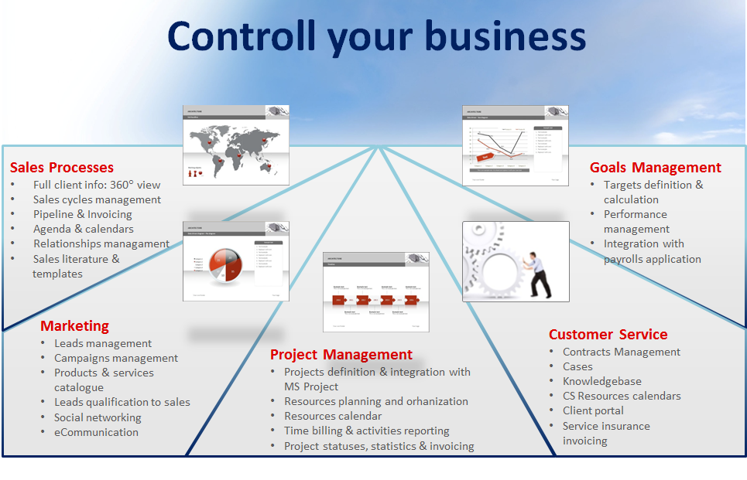

### Sales module

**The sales module provides the sales department the following functionalities, allowing a better organization and management of their activity:**

* Full database of customers - all customers data can be input into the system (company, contacts, contact details, qualification etc.)
* Sales cycle management – allows lead qualification in accordance with the organization’s procedures: lead -> opportunity -> prospect -> won/lost deal.
* Sales team activity management allows the input of all the actions of the sales staff (meetings, phone calls, call reports, correspondence, offers, tasks), their follow up, providing the organization the full history of all interactions with prospective customers;
* Pipeline management and reporting allows both sales consultants and sales management to have a full view of all opportunities in different stages and to analyze them;
* Prospects allocation / de-allocation permits sales management to allocate / de-allocate prospective customers to the sales consultants

### **Marketing Module**

**The marketing module allows the input and organization of information, activity and follow up, providing the organization a single point of access for the entire marketing data, irrespective of the staff presence.**

* Marketing targeted lists of companies (leads) can be imported in the system segmented by industry/ turnover/ other important characteristics as initial opportunities;
* Input of activities performed on the targeted lists (calls, follow up calls and call reports)
* Allocation of qualified opportunities to sales people
* Establishing complex relationships between companies, contacts, recommenders
* Possibility of establishing interactions via social networks
* Campaign management functionality allows the marketing staff to create events (seminars, e-mail marketing campaigns, webinars, product launches, customer days etc) and allocate target audience (contacts, companies) to specific events. All the interactions during the campaign can be generated and tracked in the CRM system (ex: budgeting and monitoring, participation, personalized e-mails, responses, etc.), as well as the campaign follow up (feed-back to questionnaires, campaign success measurement, follow up calls, etc.).

### Project Management Module

The Project Management Module offers a comprehensive picture of the company’s current and past projects, being an important tool for an efficient management of resources and activities. In this respect The Professional Services add-on offers the following functionalities:

* Project database creation and update by inputting all the relevant information: (budget, scoping, special terms)
* Creation and update of resources database containing all the relevant information like:
  + 1. Skills & qualifications
    2. Allocation of resources by the Project Managers that can be visualized in MS Outlook (teams/sites/equipment), representing an important tool for the management
* Input or import from MS Project of project phases and activity generation for the allocated people that can be visualized in the system’s Outlook type calendar, providing a comprehensive view of resources allocation that is not allowed in MS Project
* Activity reporting (time sheets) creation and management gives the possibility to generate timesheets and compare them with the time allocation in the calendar, leading to the possibility of reducing unexploited time
* Sharing the relevant project documentation among the project team’s members is enabled through an integrated MS SharePoint platform, providing them with all the necessary information, at any time
* Project Management Reporting – the system generates reports regarding the billable or not billable hours, as well as efficiency reports and analysis
* Services invoicing – based on the timesheets created, the system can generate invoice specification to be sent or exported to the company’s ERP for invoicing.

### Customer Services Module

The Customer Services Module functionalities enable a better management of cases and incidents, allowing prompter responses to customers’ problems, increased transparency of the solving process and therefore increased customer satisfaction.

* SLA can be input into the system in accordance with the corresponding contracts that can be attached as well, all the relevant staff having access to the needed information;
* Incidents reporting and management – incidents/cases can be input into the system that allows their follow up in different stages till completion;
* Customers can directly input cases into the CRM and follow them up in different stages on the MS SharePoint portal integrated in The Professional Services add-on;
* Service insurance invoicing functionality allows the Customer Services staff to generate the basis for invoices related to service insurance that can be then exported into the ERP.

### Target and Goal Management Module

Using the relevant info from Sales and Customer Services departments, this provides management the basis for target setting, performance evaluation and bonus allocation.

* The Sales management and /or the Customer Services Manager can input the targets for their relevant subordinates
* Reporting regarding realized vs. target are generated by the system, based on the targets set and the timesheets generated
* Based on the above mentioned reports, the system provides the basis for calculation of commissions/bonuses for the relevant staff
* Possibility to be exported so any external payroll system can import this information and use it for payroll and bonuses calculation.

## Benefits of the Professional Services add-on

* 360 view of project and customers with full history of interactions
* Possibility to better identify and manage sales opportunities through the entire sales cycle (lead to won/lost deal).
* Having in one place all the relevant information helps the sales organization to increase sales effectiveness (won/lead ratio).
* Having all the relevant information stored in the system provides Company with independent of sales force turnover ...
* Tool that Gives marketing staff ... replaces dozens of Excel spreadsheets from marketing people increasing their activity’s efficiency due to having all the information in one place
* Provides a tool for a better and more efficient resources allocation and usage (overall and per project). Loss time reduction
* Allows Client Services Manager to better manage clients, projects and resources. – info regarding the activity
* Helps people in the project teams working better together by providing the possibility of sharing relevant documents and info about the projects they are involved in.
* More transparent and better incident management that increases customer satisfaction and consequently providing increased customer retention and new sales opportunities.
* Provides Sales Management and customer services management an easy tool to measure individual performance and allowing meantime the employees to have a transparent view of the specific measurements.
* Helps PS organizations to close the loop between sales, marketing, project delivery, after sales support allowing the organization to have happy customers and improve the bottom line.
* And all these can be achieved in a simple way:
* The principles applied when we created the product were simplicity, ease of use, fast to implement, industry tailored, using the best available technology and vision about future. In this respect some of benchmarking numbers and ideas were used as foundation of this solution:
  + A user should be able to learn and use properly the system after 1 day of training
  + Normally a company should be able to adopt the new CRM strategy in less than 2 months
  + 75-80% of industry functionality and best practice is embedded in the product or based on prebuilt configurations.
  + The Microsoft Dynamics CRM platform comes with extraordinary advantages in Outlook integration and mobility, in the way a user can do the entire work using the familiar Outlook Interface on their computer and get it deployed and synchronized with their mobile devices (laptops, smartphones, PDAs)

**Besides considering the critical needs of the distribution industry, we are aware that increased competitiveness needs visionary approaches.**