**Functional Requirements Document**

Project Documentation Downloader & Notes for Rejection Report



|  |  |
| --- | --- |
| Author | Radu Cazacu |
| Author Role | Project Manager |
| Date | 10/02/2014 |

**Revision and Signoff Sheet**

**Change Record**

|  |  |  |  |
| --- | --- | --- | --- |
| **Date** | **Author** | **Version** | **Change reference** |
| 02/10/2014 | Radu Cazacu | 1.0 | Initial draft for review/discussion |
| 02/19/2014 | Radu Cazacu | 1.1 | Sent for approval after review iteration 1 |
| 02/24/2014 | Radu Cazacu | 1.2 | Sent for approval after review iteration 2 |
| 02/27/2014 | Radu Cazacu | 1.3 | Approved version (all changes of v1.2 accepted) |

**Approvers**

|  |  |  |  |
| --- | --- | --- | --- |
| **Name** | **Version approved** | **Position** | **Date** |
| Radu Cazacu |  | Project Manager |  |
| Waldir Silvestre |  | Project Manager |  |
|  |  |  |  |

**Details**

|  |  |
| --- | --- |
| **Item** | **Details** |
| Document Title | Functional Requirements Document |
| Client | OneSubsea - Taubate |
| Author | Radu Cazacu |
| Creation Date | 02/10/2014 |
| Last Updated | 02/27/2014 |

**TABLE of Contents**

Contents

Change Record 1

TABLE of Contents 0

1 Introduction 2

1.1 Target Audience 2

1.2 Purpose of this document 2

1.3 Definitions, acronyms and abbreviations 2

1.4 Stakeholders 3

2 Project Overview 5

2.1 CLIENT Context 5

2.1.1 Infrastructure 5

2.1.2 High Level Map 5

2.1.3 ITP File 6

2.1.4 Traceability Map – OnBase correspondence 7

2.1.5 NOI 7

2.1.6 Custom Query Sample 8

2.2 Project Objectives 8

2.2.1 OnBase Data Download Program – (Project Documentation Downloader) 8

2.2.2 Notes for Rejection Report 8

2.3 Project Scope 8

2.3.1 Deliverables 8

2.3.2 Out of Scope 9

2.4 Initial Project Risk Assessment 11

2.5 Assumptions and Constraints 0

2.6 Issue Management 0

2.7 Communication Plan 1

2.8 Acceptance criteria 2

3 Application Requirements 4

3.1 Project Documentation Downloader 4

3.1.1 Operating flow and application usage assumptions 4

3.1.2 Application user interface 5

3.1.3 Parsing Traceability Map 6

3.1.4 Creating tree folder structure 7

3.1.1 Query OnBase documents 8

3.1.2 Document downloading 9

3.1.3 Document conversion (tiff to pdf) 9

3.1.4 Download log and progress 10

3.1.5 Resume mechanism 10

3.1.1 Application settings 12

3.2 Notes for Rejections report 12

3.2.1 Context 12

3.2.2 Parameters 13

3.2.3 Query 14

3.2.4 Output 14

4 Exit Criteria 16

4.1 Engagement Exit Criteria 16

Introduction

This document provides the functional/business requirements of CLIENT’s Customer Relationship Management Solution from user’s viewpoint.

## Target Audience

The document is aimed towards Project Manager, Business Decision Makers and CLIENT’s management, particularly Quality management, and managers of MRB team.

## Purpose of this document

This document details the business needs of the envisioned solution. The purpose of the functional requirement document is to communicate business needs in common terms to all project and technical team members and to ensure the end product meets the business objectives. This document represents the deliverable for the first phase of the Systems Development Life Cycle, Analysis.

During the system implementation, this document will be used to:

* Plan the solution to be delivered.
* Design how the solution will be delivered.
* Test that requirements are delivered correctly.
* Measure the quality of the project deliverables and outcome.

In order for the project to advance to the Design and Configuration phase this document must be agreed upon both sides MATRICIA and CLIENT.

Other requirements encountered during the project, which are not included in this document, will be included in the change control documentation ("Project Status Report", "Minutes of the meeting", "Service Order Form").

The requirements will be examined and agreed upon by project managers. If a level of agreement is not reached between the project managers, these requirements will be escalated and discussed at higher levels (project sponsor).

## Definitions, acronyms and abbreviations

|  |  |
| --- | --- |
| ***Definitions*** |  |
| Traceability Map | Control of all traceability items assembled in each Project |
|  |  |

|  |  |
| --- | --- |
| *Acronyms* | |
| MRB | Manufacturing Record Book |
| TM | Traceability Map |
| PEQ | Project Quality Engineers |
| ITP | Inspection and Test Plan |
| NOI | Notification of Inspection |
| MS, QP, PSL | Types of certificates |
| QAI | Setout/Air sheet documents |
| WIP | Work in Process |

## Stakeholders

The requirements described in this document were gathered in the course of the analysis interviews and email communication held between MATRICIA’s application consultants and CLIENT’s project team members.

**Project Team Assignments - MATRICIA**

|  |  |  |
| --- | --- | --- |
| Role | Assigned | E-mail |
| **Project Manager** | Radu Cazacu | [Radu.cazacu@matricia.ro](mailto:Radu.cazacu@matricia.ro) |
| **Account Executive** | Horia Negulescu | [horia.negulescu@matricia.ro](mailto:horia.negulescu@matricia.ro) |
| **Solution Architect(s)** | Radu Cazacu |  |
| **Application Consultant(s)** | Catalin Safta  Ana Maria Ignat | [catalin.safta@matricia.ro](mailto:catalin.safta@matricia.ro)  ana-mariai.ignat@matricia.ro |
| **Development Consultant(s)** | Catalin Safta | [dragos.bobolea@matricia.ro](mailto:dragos.bobolea@matricia.ro) |
| **Infrastructure Consultant(s)** | Catalin Olaru | [Catalin.olaru@matricia.ro](mailto:Catalin.olaru@matricia.ro) |

**Project Team Assignments - CLIENT**

|  |  |  |
| --- | --- | --- |
| Role | Assigned | E-mail |
| **Executive Sponsor** | Darin Craig | [Darin.craig@onesubsea.com](mailto:Darin.craig@onesubsea.com) |
| **Project Manager** | Waldir Silvestre | [Waldir.silvetre@onesubsea.com](mailto:Waldir.silvetre@onesubsea.com) |
| **BDM – Quality** | Darin Craig |  |
| **BDM – Technic** | Walter Silva | [Walter.silva@onesubsea.com](mailto:Walter.silva@onesubsea.com) |
| **Development Consultant** | NA |  |
| **Business Consultant** | Ricardo Mantavoni  Alves Rodolfo | [Ricardo.Mantavoni@onesubsea.com](mailto:Ricardo.Mantavoni@onesubsea.com)  [Rodolfo.alves@onesubsea.com](mailto:Rodolfo.alves@onesubsea.com) |
| **IT Consultant** | Tiago Andrade  Dumitru Mina | [Tiago.andrade@c-a-m.com](mailto:Tiago.andrade@c-a-m.com)  [Dumitru.mina@c-a-m.com](mailto:Dumitru.mina@c-a-m.com) |
| **Key Users** | Waldir Silvestre  Rafaela Bissoli  Gabriela Oliveira  Marcelo Castro  Celso Viana | [Waldir.silvetre@onesubsea.com](mailto:Waldir.silvetre@onesubsea.com)  [Rafaela.bissoli@onesubsea.com](mailto:Rafaela.bissoli@onesubsea.com)  [Gabriela.oliveira@onesubsea.com](mailto:Gabriela.oliveira@onesubsea.com)  [Marcelo.castro@onesubsea.com](mailto:Marcelo.castro@onesubsea.com)  [Celso.viana@onesubsea.com](mailto:Celso.viana@onesubsea.com) |
| **End Users** | PEQ |  |

Project Overview

## CLIENT Context

OneSubsea is a Cameron & Schlumberger company that delivers integrated solutions, products, systems and services for the subsea oil and gas market. OneSubsea leverages Cameron’s flow control expertise, process technologies and world-class manufacturing and aftermarket capabilities, along with Schlumberger’s petro-technical leadership, reservoir and production technology, and R&D capabilities.

OneSubsea currently has more than 6,000 employees in over 23 countries operating in six divisions - Integrated Solutions, Production Systems, Processing Systems, Control Systems, Swivel and Marine Systems, and Subsea Services – that provide products and services to oil and gas operators around the world.

Project’s beneficiary is OneSubsea - Taubate Manufacturing.

### Infrastructure

Hyland OnBase system is used in OneSubsea - Taubate for quality document management system. A number of predefined documents are uses to capture supplier and manufacturer data.

Kofax is used to import document data and extract indexing information in keywords and E-forms are used for customer approvals.

A custom query is used to select all documents specific to 4104 plant.

Different methods and platforms are used during the data book creation process (Excel, Kofax, OnBase and Email communication).

### High Level Map

Below is the high level map of the current process showing different methods and platform used:

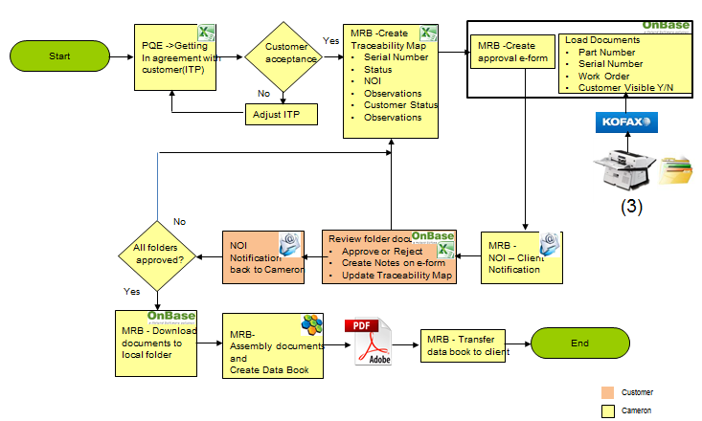

• PEQ – Project Quality Engineers are initiating the ITP file using BOM explosion and get the customer agreement regarding documentation required and holding points for the project. This communication is done through a shared excel file.

• MRB team uses the ITP file to create the Traceability Map file (adding a number of columns to keep traceability). This will be the shared file used in communication with customer once a serial number has been added and all documents are available for review in OnBase.

• Once all documents are ready for a specific serial number an e-form is released in OnBase for customer approval.

• In addition to this form a list (excel) with serial numbers is sent to customer.

• Customer review the list and run the OnBase custom query for each serial number. Depending on findings he can approve all documents or reject asking for additional documents or details.

• Once all documents for traceability map serial numbers have been approved these are manually (one by one) downloaded to a local folder.

• Next step is to assembly all these documents (Nuance) and create data book. As a rule, data book copy the product structure approved by PQE and customer at the initial phase with some additional cover sheets for each level items.

### ITP File

2 lines for each BOM part number. One with Cameron details specifying MS, QP, PSL and all the required certificates. Customer reviews the proposal and change / add additional requirements.

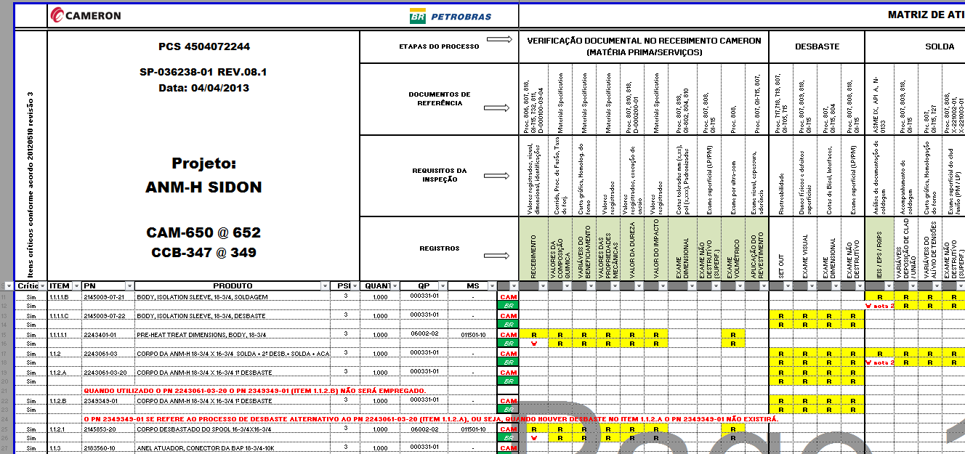

### Traceability Map – OnBase correspondence

MRB team change the layout and keep only the lines containing customer requirements. This file is shared with customer to get details about serial numbers used and execution process status (Cameron and customer)

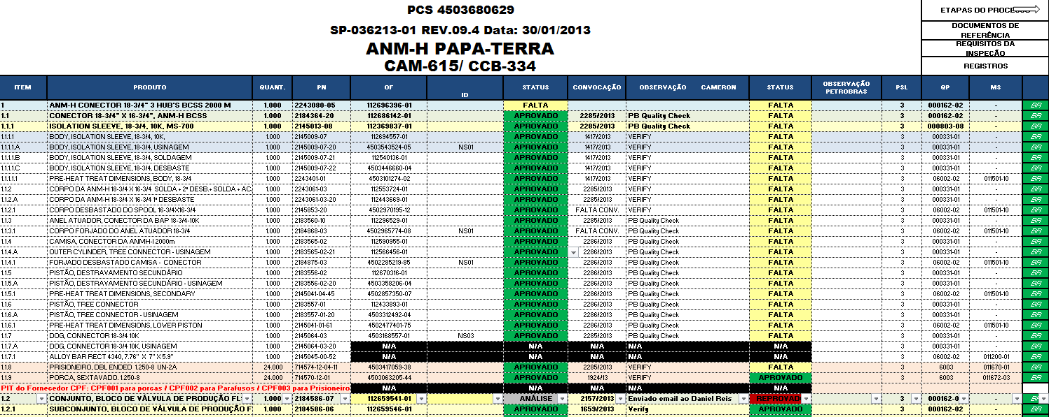

### NOI

When documents are ready e-form is released for documents approval and customer is notified by email (NOI form). A list with available serial numbers is attached for review.

Sample NOI:

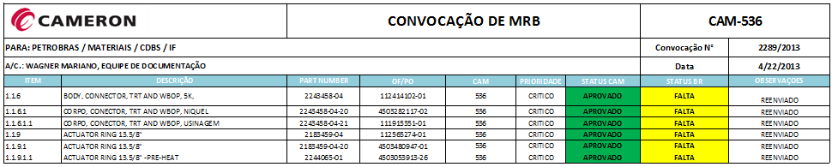

### Custom Query Sample

Below is a query result for one specific serial number

- SN: 112696396-01 query results (ANM-H CONECTOR 18-3/4" 3 HUB'S BCSS 2000 M)

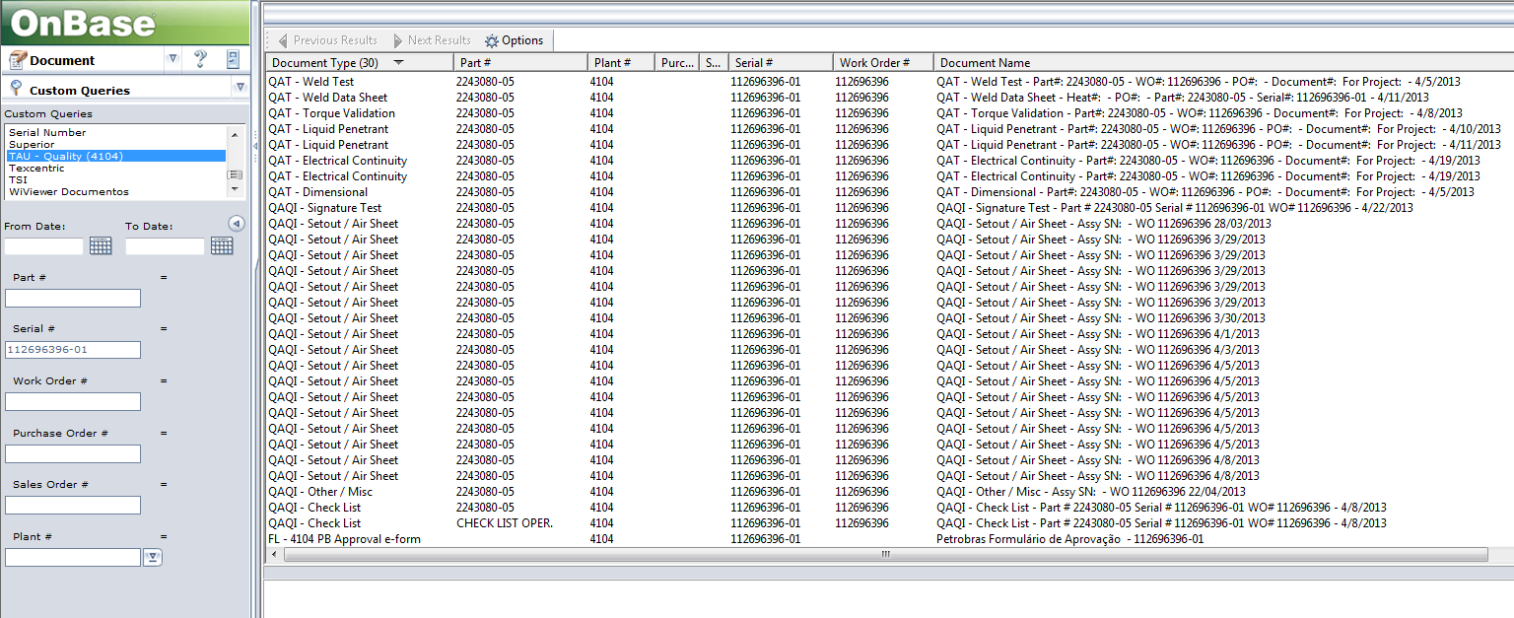

Different document types returned according with ITP file.

To minimize the number of QAI – Setout/Air sheet documents type a 6 sigma project has been started. This will decrease the number of these scanned documents associated with assembly parts and will put a better control on WIP.

## Project Objectives

This project addresses the issues described above to automate the operation processes.

### OnBase Data Download Program – (Project Documentation Downloader)

An application to automate data extraction based on traceability map file maintained by MRB team. The proposed application will be configured to load on demand the Excel file, parse and extract the necessary information (part number, serial number, project code, product index), identify the OnBase documents and create the folder structure containing the exported documents.

### Notes for Rejection Report

A report to extract all the notes for each serial number from OnBase. The report should provide a number of selection criteria (project, list or serial numbers, only s/n with rejection notes, a specific time interval).

Report will be published on the existing Microsoft Reporting Services server

## Project Scope

### Deliverables

|  |  |
| --- | --- |
| **Deliverable** | **Description** |
| Analysis documentation | All the project documentation that includes “Project Charter”, “Minutes of the Meeting”, “Functional Requirements Document” |
| Project Documentation Downloader | The windows application setup for installing the Project Documentation Downloader |
| Notes for Rejections report | The report installed on reporting services and the URL to access this report from the browser |
| System Tests | Test Case documents with testing results |
| System Installation | Installation and configuration of the Notes for Rejections report on the reporting server.  A step-by-step for Project Documentation Downloader installation guide will be provided by Matricia to the IT team. |
| Key Users Training | Two Webinar sessions using a remote presentation technology agreed before Training phase |
| User Guide | User guides for using the delivered applications. This documentation will be delivered as one or two .pdf files. |
| Support GO Live | User support on email and on call for using the delivered applications and solving potential errors. |
| Project Management | Project initiation, planning, monitoring and controlling, closing specific documents. This includes project timeline, project cost, project status |

### Out of Scope

The subsequent activities are considered not to be included in the project:

* Install Project Documentation Downloader or other applications on final user’s workstations.
* Prerequisites for project deliverables or other Microsoft or third party applications needed to install and run the project deliverables.
* The input file will not be processed by the application prior to import. The file must have the standard structure that is agreed in this Functional Requirements Document.
* Providing of the prerequisite components for this application (including necessary licenses) are not in the scope of this project. The application will use installed Microsoft Office Excel components to read the input file. The application will use OnBase API framework (Unity API) to access OnBase documents and keywords.
* The application will not validate OnBase data nor the output results. For example if a serial number is part of a project according to the input file but in OnBase the serial number correspond to another project the application will export according to the data present in the input file.
* The naming of the folders and files will be limited by the naming restrictions in the Windows operating system
* Changes to the reports output template specified in this document.
* Project and Serial Numbers parameters will not support selection from a prepopulated list.
* Parameters are not dependent meaning one for example can select a serial number not applicable for the selected project(s).
* Project Documentation Downloader application will not generate the final MRB .pdf file it will only download all project files in separate folders as specified in this document.
* Other requirements that are not specified in this document. The approved version of this document will represent the scope baseline for the project.

## Initial Project Risk Assessment

|  |  |  |  |  |
| --- | --- | --- | --- | --- |
| **No** | **Risk** | **Impact** | **Probability** | **Strategy** |
| **1** | Reporting Services 2008 platform has technical limitation at viewer (front end) layer that cannot be overcome using custom development. | High | High | The requirements will be adapted to the platform limitations but answering to the business needs.  If this strategy will not be acceptable the change management procedure will be launched |
| **2** | Folder hierarchy generated by the Downloader application is limited in depth by the Windows platform. | Medium | High | Client will launch the change management procedure to change the folder structure generation mechanism  Client will assure that TM file has no path longer than 250 starting from C:\ and/or the users will be forced to download project with long (deep) paths on C:\ |
| **3** | Communication channels available and the fact that our teams are virtual can affect the understanding of the scope and the response time during the project.  Time, scope, cost and quality can be affected. | High | Medium | Use of different communication channels like Live Sessions (including video) and Share Screen presentation in order to maximize the understanding.  Organize physical meetings with client’s stakeholders.  Ad-hoc Live meetings or call conferences if needed. |

## Assumptions and Constraints

|  |
| --- |
| ***Assumptions*** |
| Version and build number of OnBase system is 10.0.0.93 |
| Unity API integration toolkit license exists |
| Windows operating system on all workstations that will use the deliverables of this project is Windows 7 64bit Enterprise Edition. |
| The testing environment is ready to use, OnBase server name is HTXQOIM01VM  Citrix portal is https:\\apps.c-a-m.com. Authentication credentials will be Cameron network credentials provided upon vendor registration.  If direct connection is required then direct access to server HTXQOIM01VM can be provided immediately. |
| Test environment is a copy from production |
| If Citrix access is not sufficient to run activities, then Cameron will provide with a Cameron issued laptop with the adequate VPN connector. |
| The test environment can be accessed from supplier office remotely using VPN and/or Remote Desktop Connection software. |
| Onbase version is: 10.0.0.93 |
| OneSubsea uses the Office Professional Plus 2010, all the TM file will be in Excel 2010 format. |
| Rejection Notes Report is developed using Reporting Services 2008 platform. |
|  |
| ***Constraints*** |
| Connection bandwidth for Taubate is 10Mbps and for Houston CyrusOne datacenter is 2x60Mbps with and ongoing upgrade to 2x80mbps.  Download speed can vary. |
| The application will be compatible only with the versions of OnBase and Microsoft Office specified above |
| The folders structure created by the Downloaded application will be limited by the Windows folder path limitation of max 250 characters. If there are line in TM that must generate a path longer than this limit an error will occur in the application. |
|  |

## Issue Management

The information contained within this document will likely change as the project progresses. While change is both certain and required, it is important to note that any changes to the document will impact at least one of three critical success factors: Available Time, Available Resources (Financial, Personnel), or Project Quality. The decision by which to make modifications to the project plan (including project scope and resources) should be coordinated using the following process:

**Step 1**: As soon as a change which impacts project scope, schedule, staffing or spending is identified, the Project Manager will document the issue.

**Step 2**: The Project Manager will review the change and determine the associated impact to the project and will forward the issue, along with a recommendation, to the Steering Committee for review and decision.

**Step 3**: Upon receipt, the Steering Committee should reach a consensus opinion on whether to approve, reject or modify the request based upon the information, the Project Manager’s recommendation and their own judgment. Should the Steering Committee be unable to reach consensus on the approval or denial of a change, the issue will be forwarded to the Project Sponsor, for ultimate resolution.

**Step 4:** If required due to a lack of consensus, the Project Sponsor shall review the issue(s) and render a final decision on the approval or denial of a change.

**Step 5**: Following an approval or denial (by the Steering Committee or Project Sponsor), the Project Manager will notify the original requestor of the action taken. There is no appeal process.

The information contained within the Project Plan will likely change as the project progresses. While change is both certain and required, it is important to note that any changes to the Project Plan will impact at least one of three critical success factors: Available Time, Available Resources (Financial, Personnel), or Project Quality. The decision by which to make modifications to the Project Plan (including project scope and resources) should be coordinated using the following process:

The information contained within the Project Plan will likely change as the project progresses. While change is both certain and required, it is important to note that any changes to the Project Plan will impact at least one of three critical success factors: Available Time, Available Resources (Financial, Personnel), or Project Quality. The decision by which to make modifications to the Project Plan (including project scope and resources) should be coordinated using the following process:

## Communication Plan

Distributing knowledge about the project is essential to the project’s success. Project participants desire knowledge of what the status of the project is and how they are affected. Furthermore, they are anxious to participate. The more that people are educated about the progress of the project and how it will help them in the future, the more they are likely to participate and benefit.

***Communications Methodology*** - The communications methodology utilizes three directions for effective communication:

***Top-Down***: It is absolutely crucial that all participants in this project sense the executive support and guidance for this effort. The executive leadership of the organization needs to speak with a unified, enthusiastic voice about the project and what it holds for everyone involved. This will be 'hands-on' change management, if it is to be successful. Not only will the executives need to speak directly to all levels of the organization, they will also need to listen directly to all levels of the organization, as well.

***Bottom-Up:*** To ensure the buy-in and confidence of the personnel involved in bringing the proposed changes to reality, it will be important to communicate the way in which the solutions were created. If the perception in the organization is that only the Steering Committee created the proposed changes, resistance is likely to occur. However, if it is understood that all participants were consulted, acceptance seems more promising.

***Middle-Out***: Full support at all levels, where the changes will have to be implemented, is important to sustainable improvement. At this level (as with all levels), there must be an effort to find and communicate the specific benefits of the changes. People need a personal stake in the success of the project management practices.

***Communications Outreach -*** The following is a list of communication documents that have been established for this project:

|  |  |  |  |  |
| --- | --- | --- | --- | --- |
| **Communication** | **Description** | **Frequency** | **Format** | **Recipients** |
| Functional Requirements Document | Document containing functional requirements analysis. | At the end of analysis phase within the project | E-mail | Steering Committee |
| Project Plan | Document containing a detailed assignments within the project, with resources, deadlines and deliverables | At the end of analysis phase within the project | E-mail | Client Project Manager |
| Minutes of Meeting | Document containing relevant information from meetings | After each meeting with CLIENT team | E-mail | Participants at the meeting and Steering Committee |
| Activity Reports | Document containing tasks made | Once a week | E-mail | Client Project Manager |
| Status Report | Document containing  the status of the project in terms of consumed and remaining time and budget | At the end of each week | E-mail | Steering Committee |
| System Test and Acceptance Form | Final acceptance after testing period | At the end of each phase | E-mail | Client Project Manager |
| Service Order Form | Document containing all requests for changes that are out of project scope and need to be done in order to satisfy success criteria of the project. This document supplements project budget | As necessary | E-mail | Steering Committee |

## Acceptance criteria

This document represents the scope baseline for the project.

Client will accept this project deliverables based on the scope baseline.

Deliverables will be validated by the client performing the acceptance test cases provided by the supplier.

The test cases will be according to the specifications in this document and they will be provided in the System Tests phase.

There will be two full test iterations. All iterations will be run on the test environment. Each session is 3 business days long.

The first iteration start after deployment on the test environment is completed by the supplier.

During the iteration, if there are blocking issues found the supplier will correct and deliver the correction as soon as possible. After the corrections the iteration continues.

At the end of the first iteration client will deliver the test results according to the acceptance test cases and a list of all the issues found for each item in the test case.

The supplier will resolve all the issues found and will deliver the changes on the test environment.

The second iteration will start after the supplier delivers all the corrections and notifies the client it is ready for testing. In the second iteration client will retest all the steps in the test cases.

During the iteration, if there are blocking issues found the supplier will correct and deliver the correction as soon as possible. After the corrections the iteration continues.

At the end of the second iteration, if there are no blocking issues found project will be accepted with known issues. The list of issues will be specified in the acceptance form. The supplier will correct this issues before the Go Live if possible or after the Go Live if it is not acceptable to delay the Go Live phase.

All this issue corrections for second iteration will be included in a single delivery. The Client validates the deployment of the version on Live environment by retesting the issues reported on test environment.

GO Live phase will start only if client approves the deliverables as ready to deploy.

Application Requirements

## Project Documentation Downloader

### Operating flow and application usage assumptions

**Operating flow**

The NOI document for a specific project (excel format) is sent to the client for approval. During the Asset & Test process OneSubsea sends many NOIs to its clients.

Client approves each line in the NOI (this process can have more than one iteration).

When all lines from NOI are approved by client, NOI document is final and approve process ends.

From the approved NOIs the MRB process concludes and the Traceability Map files is updated accordingly.

Traceability Map file[1] is used in Project Documentation Downloader application to download all the documents for each line from OnBase.

The result of the download of a Traceability Map file is a folder with the name of the project specified in the file that contains subfolders for each of its lines. Each subfolder will contain the existing documents in OnBase for that specific TM line corresponding to that subfolder.

Download application is used only when all lines in Traceability Map file are approved and so, for a project, only one download operation is done.

**Usage parameters:**

|  |  |
| --- | --- |
| **Parameter** | **Values and description** |
| Number of users for the application | 40 |
| Application usage frequency | During the month: once per day per each user  End of the month: two or three times per day for each user |
| The average **size** all documentation for a project (that will be downloaded for one Traceability Map) | 5Gb |
| The average **number of lines** per project (this is the number of subfolders for a project) | 926 |
| The average **number of files** to be downloaded for **each line** | 8 |
| The average **number of files for a project** | 7500 |
| The maximum expected download time for a project documentation of 5GB split in 7500 files | 4 to 6 hours |
| Re-downloading all documents for a project | Rarely situation |
| Downloaded files format | .pdf |
| Download URL (production environment) | http://htnim01/onbase |

|  |
| --- |
| **Assumption** |
| OnBase Unity API license exists and is installed on OnBase System. |
| Project Documentation Downloader application will be windows forms (desktop) application and it will be installed on each workstation |
| The application will be installed by the client system administrator on each workstation following the provided installation procedure |
| There is one TM Excel file for each project (Equipment or CAM). There are many TM’s, but there is only one for each project. |
| The application can download only one project documentation at a time |
| The same project documentation cannot be downloaded with two application instances on the same local machine |
| The final technical solution can vary from the description in this document because of some technical limitations  The final technical solution must meet the business needs specified in this document. |
| The replacement character map for each unpermitted character (folder and files names):   |  |  | | --- | --- | | **Not permitted** | **Replace with** | | **\** | - | | **/** | - | | **|** | - | | **:** | - | | **\*** | # | | **?** | . | | **“** | inch | | **>** | # | | **<** | # | |

### Application user interface

The application interface consists from the following elements:

**Application Menu**

The following menus will be available:

* File
  + Settings: Opens the settings are for the application
  + Exit: Closes the application
* Help
  + User Guide: Opens the .pdf file containing the application user guide.
  + About: Application version details and Matricia details.

**Action Bar**

On this bar the following actions will be available:

* Add a Project Download: Opens the Open File dialog to select a TM file or Opens the Open Folder dialog to select an existing project download folder.
* Start Download: Starts the added project download operation according to the options specified at starting point.
* Stop Download: Stop the current download without changing the current project that is downloaded

**Download Progress Area**

In this area the application will contain the following information:

* Project Name: The name of the added project: CAM-615
* Status: The download status for this project: Running/Paused
* Total Folders: The total number of lines in TM that will be downloaded
* Downloaded Folders: The total number of lines downloaded
* TM Lines: The list with all the lines in TM for that project
  + ITEM – Column A from TM
  + Serial # - Column F from TM
  + Product – Column B from TM
  + Total Files – Total number of files in OnBase for Serial #
  + Files Downloaded – Total number of files downloaded from OnBase
* Application and Download Errors

**Status Bar**

In this area the application will display the current operation that is performed.

|  |
| --- |
| **Assumption** |
|  |

### Parsing Traceability Map

The application will use .Net Framework 4.5 for parsing and extracting the information from the TM Excel file.

The sheet used for extracting information will be the one specified in the application (hard-coded): **TRACEABILITY MAP**.

The parsing mechanism generates all the information needed to:

- create the folders and the folder structure

- query the documents in OnBase for each folder

The paring result contains the OnBase query parameter (Serial Number value) needed for download and the destination subfolder for each line in TM.

The application creates the folder for the project in the root download folder where the TM paring result will be stored. This will also be used for tracking the download execution.

The column indexes for the parsed columns will be hard-coded into the application and will have the following values:

|  |  |  |  |
| --- | --- | --- | --- |
| **Column** | **Excel column** | **Index** | **Description** |
| ITEM | A | 0 | Level of the folder in folder hierarchy. |
| PRODUTO | B | 1 | This is the name of the product |
| QUANT. | C | 2 |  |
| PN | E | 4 | The part number. This value will NOT be used. |
| **OF** | **F** | **5** | **The serial number.**  **This value will be used to search by Serial Number keyword in OnBase.** |
| ID | G | 6 | This value will NOT be used. |
| STATUS | H | 7 | The approval status of the line.  The application will skip downloading files for the lines that have value different than the exact text: “APROVADO”. Still, the folder will be created. |

|  |
| --- |
| **Assumption** |
| The first line number for import is line 7 |
| The project identifier in the input file will always be in cell A4. |
| The only sheet from TM that will be parsed by the application is named “**TRACEABILITY MAP**”. |
| The specified structure of TM will not change. Any change of this structure will trigger the change management procedure. |

### Creating tree folder structure

The application iterate the paring result (in the same order as in TM) and for each line (corresponding to a TM line) generates the folder using the “Folders hierarchy” and “Folder naming” rules described below under the project folder already created at paring time.

**Folders hierarchy:**

The parent child relation between folders is specified by column ITEM from TM file.

This column specifies the level of the folder in folder hierarchy.

If we download a TM file with column ITEM like in the image below,

|  |  |
| --- | --- |
| 1 | Level 1 |
| 1.1 | Level 2 |
| 1.1.1 | Level 3 |
| 1.1.1.1 | Level 4 |
| 1.1.1.1.A | Level 5 |
| 1.1.1.1.B | Level 5 |
| 1.1.1.1.C | Level 5 |
| 1.1.1.1.1 | Level 5 |

the generated structure is:

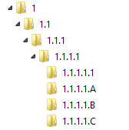

The fact that the last level is .A, .B, .C and .1 instead of .1,.2,.3,.4 has no implication in the folder tree creating mechanism. .A, .B and .C in the sample above represent subfolders folders (of Level 5) for parent folder 1.1.1.1 (of Level 4).

**Folder naming:**

For each line in TM a folder (an only one) will be created in the folders hierarchy.

A folder name will be generated by the following rule:

[ITEM] # [OF]

For example for naming the folder for line:

|  |  |  |  |  |  |  |
| --- | --- | --- | --- | --- | --- | --- |
| **ITEM** | **PRODUTO** | **QUANT.** | **PN** | **OF** |  | **STATUS** |
| **ID** |
| **1.1** | **CONECTOR 18-3/4" X 16-3/4", ANM-H BCSS** | **1.000** | **2184364-20** | **112686142-01** |  | **FALTA** |

The folder created for the line above will be:

1.1 # 112686142-01

The final output folder structure should look like the sample below:

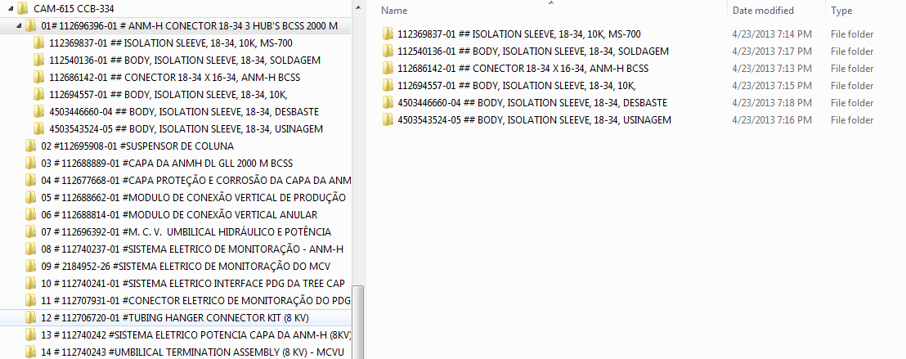

|  |
| --- |
| **Assumption** |
| The application will create folder only for the lines that we have information in the column “F”.  The rule is: F <> “” or F<> “N/A” |

### Query OnBase documents

The application queries OnBase for each line in the paring result as it iterates them to get the file list corresponding to that line/subfolder.

Each paring result line has saved the query parameter used to query the OnBase for files.

The corresponding TM Column “F” is the keyword to find the documents on OnBase - that will be the OF column, indexed 5 in the table from the Parsing .xlsx section.

### Document downloading

For each file in the list of files returned for a parsing result line/subfolder the application executes the OnBase download action which saves the file in that current subfolder on the local machine.

The name of the file saved will be according to the “File Naming” rules described below.

Before downloading the application can start converting the file to .pdf as described in the “Document Conversion” section.

Even if this is an unlikely scenario, when the user selects to save documents of a project in a location where the project folder already exists (he already downloaded some/all documents of that project) the application will activate the Resume Mechanism described below.

**Files naming:**

For each document returned by the OnBase Query a file will be downloaded on the local hardrive.

A file name will be generated by the following rule:

[DOCUMENT HANDLE] # [DOCUMENT NAME].[EXTENSION]

**DOCUMENT HANDLE** is the unique identifier in OnBase system and it is a number. This ensures the unicity of the files in a folder and avoids accidental overwrites.

**DOCUMENT NAME** is the document name in OnBase system and can already contain the Serial Number. If it is needed the application can append the Serial Number in the file name.

**EXTENSION** is the file extension in OnBase system. It can be .pdf or .tiff or other extension.

|  |
| --- |
| **Assumption** |
| The application will download the default version of the document in OnBase. |
| Application will get the data using only the OnBase API. |
| The application will download documents only for the lines that have information in the column “F” and has the value APROVADO in column “H”  The rule is: H = “APROVADO” AND (F <> “” OR F<> “N/A”) |
| The application will download the files folder by folder. |
| The application will download the files within a folder iteratively |

### Document conversion (tiff to pdf)

The application converts all .tiff documents in OnBase to .pdf files using the standard OnBase mechanism and quality available[2].

This behavior is intended to

- optimize the speed and bandwidth used by the application

- local disk space used

- automatically convert the documentation in the final format used for deliver the MRB, this is .pdf

|  |
| --- |
| **Assumption** |
| Tiff to pdf mechanism used will be the standard OnBase mechanism. The output pdf layout resulted from standard conversion cannot be modified by custom code. |
| If there are other formats (not .tiff nor .pdf) found in OnBase the application will download them with their OnBase extensions. |

### Download log and progress

The log will contain each parsed line in the TM file with additional information containing the download result of each line/folder. The log will be saved in the project folder and it’s an xml file.

This file can be used to review results and correct errors.

The application will halt at any Application Error and it will continue execution for any Download Error.

Types of errors are described below

**Application Errors**

Any error that blocks the application to start the folder creation and the files download.

Examples

- Error in Parsing TM: the application will stop because it has no paring result to iterate in.

- Error authenticating to OnBase: the application cannot continue if the user is not authorized

- Folder creation errors that cannot be skipped: not enough disk space

- Runtime errors: if the application crashes for some reason the download will not start/continue

This errors will be saved in the log at project level.

**Download Errors**

Any error that can be skipped by the application and to continue downloading. This errors can occur when downloading a specific folder (TM line) or a specific file in a folder.

- File Name invalid

- Folder creation that can be skipped: invalid folder name

- File1 conversion failed

This errors will be saved in the project download log at folder level.

**Download Progress**

The application will display the download progress as:

- number of files downloaded for a folder

- number of folders downloaded for a project

|  |
| --- |
| **Constraints** |
| Because of the query documents mechanism the download progress will refer to the number of files/folders not to the size of the files/folders. |
| The application will not have the information regarding the total number of files and their total size for a project but only the total number of folders for that project. This is the optimum way to query OnBase because it eliminates additional queries for counting the total number of files per project. |

### Resume mechanism

**The generic mechanism for resuming**

*In the front end:*

User can start the download based on an existing paring result (existing project folder in the download destination folder).

When starting a download, the user has the following options:

- Re-download the project = this will delete all folders and files in the project folder)

- overwrite the existing files/folders = start from the beginning of the TM file and will overwrite all the existing folders and files corresponding to the lines in the new TM. If some existing folders in the destination download folder doesn’t exist in the new TM file, this folders will be left alone.

- skip the existing files/folders = will skip all the existing files in the folders that already exists corresponding to the lines in TM; all the folders that were downloaded but are not present in the new TM will be left alone.

*In the backend the application will execute:*

Paring: The existing parsing result is used to iterate thru the lines.

Folder creation: If the folders exists and the skip option was selected the application will skip that folder.

Query files: The query will be executed against OnBase server

Document conversion: If needed

File download: If the file exists and the skip option was selected the application will skip that file.

**The resuming scenario are described below:**

*Restart a stopped download (the application didn’t close):*

User can restart current download. The download can be:

- from scratch – using re-download option.

- update all files – overwrite existing option.

- continue download – skip the existing option.

*Restart a stopped download (the application did close):*

User can select an existing download (project folder) from the download destination folder and start the download again like in the first scenario.

*Restart download for a selected line in parsing result:*

User wants to download only one line or a subset of lines from TM. User creates a TM with that line(s) and start downloading.

- if user wants to append lines from this TM that were not already downloaded to an existing project folder will select: skip the existing files/folders

- if user wants to re-download all the folders and files for the lines in this TM (all other folder will not be deleted) will select: overwrite the existing files/folders

- if user wants to re-download all the folders and files from scratch (all the folders in the destination folder will be deleted and the new TM lines will be downloaded) will select: Re-download the project

*Start downloading a new TM for an existing project download folder:*

User wants to download a new TM file to an existing project download folder.

If the project from TM is different from the project in download folder selected the application will display an error: “The selected destination folder contains another project.”.

If the project from TM is identical to the project in download folder the application will behave like in

|  |
| --- |
| **Assumption** |
|  |

### Application settings

The application has the following settings available

|  |  |
| --- | --- |
| **Setting** | **Description** |
| Destination Download Folder | The path to the destination download folder.  This path will be also used when the application selects the existing project download folders and paring results for resuming. |

## Notes for Rejections report

|  |
| --- |
| **Assumption** |
| A read access user to OnBase database will be provided for this report data source. |
| Microsoft Reporting Services 2008 is installed and fully configured to publish this report. |
| Data volume will affect report performance. To increase report performance, users will run restrict data volume using the filter criteria provided. |
| The report will be accessed using Internet Explorer browser version 8 or above |
| The report will NOT be accessible from OnBase. |

### Context

Once all required documents are added on serial number the approval e-form is started the customer is notified through NOI on email.

NOI sample:



Customer analyze all documents and decide to approve (all documents) or to reject the proposal creating a rejection note showing rejection reason, then return back the NOI file with Rejected status for the specific serial number.

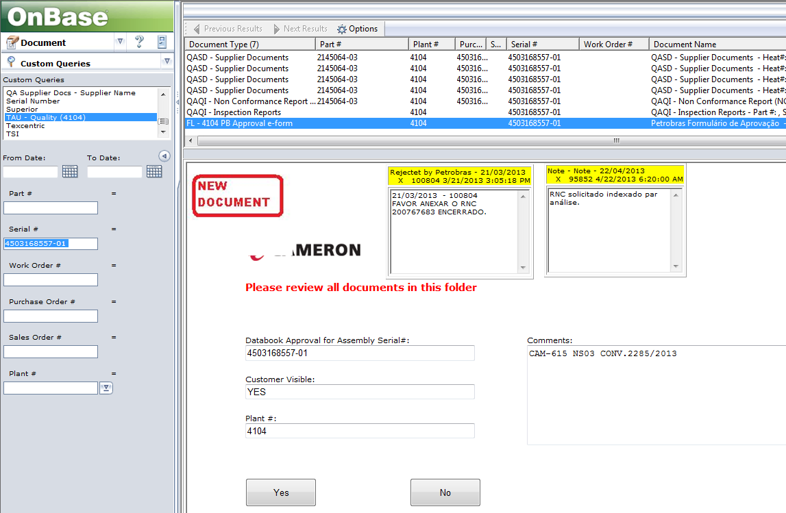

### Parameters

The report should provide the selection criteria below:

**Project:**

Report supports filtering the notes by a Project Code.

The user must enter the correct project code exactly as it is set on OnBase documents.

If user enters an invalid or incomplete project code the report will return no data.

If this parameter is not specified (empty value) the report will NOT apply this parameter. This means that one can search only by Serial Numbers.

Example:

User input: Project: CAM-615

Report Output: Report will display all notes added to all “PL 4104 – Approval eform” documents that have the keyword Project Name[3] set to: CAM-615.

**Serial Numbers:**

Report supports filtering the notes by a specific list of SNs. The list of SNs is a comma separated SN list like:

“SN1,SN2,SN3”.

Example: If user enters in parameter

Serial Numbers: 1125512,1125513,1125514

Report Output: Report will display all notes added to all “PL 4104 – Approval eform” documents that have the keyword Serial # set to: 1125512 OR 1125513 OR 1125514

The SN List must be a single line of text. This means that entering the SN List like:

4503101274-02

112553724-01

112443669-01

is **NOT** possible because of technical limitations.

Entering the list above like: 4503101274-02,112553724-01,112443669-01 is acceptable.

Do the SN needs to be separated by comma and space or just comma?

The SN list can contain space and comma, the spaces will be eliminated before query the data.

**Only with Rejection Notes:**

Report supports filtering the notes by type. This is a checkbox parameter

If this is checked: the report will return the “Rejected by PB”[4] type of notes for "PL 4104 – Approval eform" document type.

If this is unchecked: the report will return all types of notes for "PL 4104 – Approval eform" document type

|  |
| --- |
| **Assumption** |
| All the criteria are logically bound with an AND logical operator.  (ex. If both a Project and a SN are specified then the report will apply this condition: If Project = “Proj1” AND SN = “Sn1” |
| Any criteria that has no value will be ignored. |

### Query

In OnBase only one “PL 4104 – Approval eform” eform is created for a Serial #. On this eform all the rejection notes and other internal notes will be created for that specific Serial Number

The report gets all the documents with document type "PL 4104 – Approval eform" that satisfy the report “Serial Numbers” parameter.

For this documents the report will get all the Notes that are created in OnBase.

|  |
| --- |
| **Assumption** |
| This query of this report depends on the output information needed and the report’s criteria.  If the output and/or the criteria are modified then the query must be modified accordingly.  Keep in mind that adding some criteria that is are not a keyword(s) on the PL 4104 – Approval eform eform or the Note itself will have great impact on the query of the report. |

### Output

**Grouping and sorting**

The report will display all the notes grouped by Project and Serial #.

The table in this report is not sortable.

**Output Table**

The report result is a table with the following columns:

* **Project**: The Project Name keyword value entered at "PL 4104 – Approval eform" eform level. This can be empty value.
* **Serial #**: The Serial # keyword value entered at "PL 4104 – Approval eform" eform level. This cannot be empty.
* **Note Title**: The title of the Note.
* **Date**: The note creation date and time in the system.

Date and time of each note like the picture bellow:

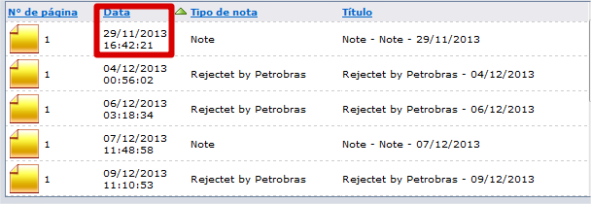

**Sample**

Report output sample:

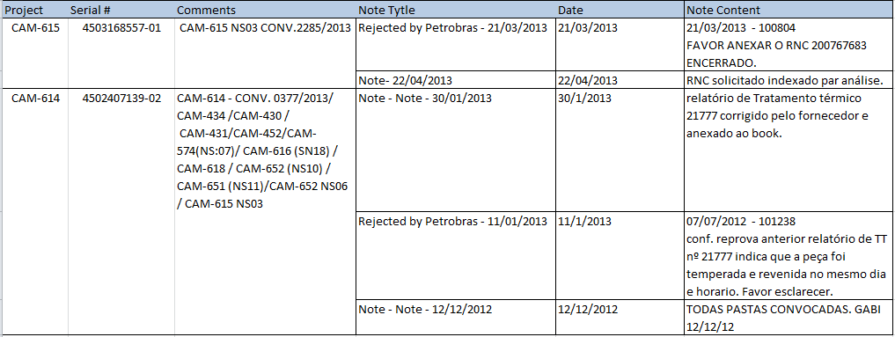

**Exporting the report**

The results of this report are exportable in Excel 2003 format.

|  |
| --- |
| **Assumption** |
| This report has a static (fixed) design implemented. If the design changes then the report must be modified and redeployed. |

Exit Criteria

These criteria must be met to denote successful completion of the project.

## Engagement Exit Criteria

* The deliverables in this scope are accepted by the client according to the Acceptance Criteria section in this document
* Transition to support has occurred and CLIENT’s system administrator is aware of all available resources support.
* A Project Closure meeting has occurred.

1. Any Traceability Map file is a file with the same structure as the sample excel file attached to the project documentation
2. This can result in low quality or content alteration of the .tiff files. The mechanism of conversion cannot be changed, this is a technical limitation.
3. This keyword is not added at PL 4104 – Approval eform document type level. For documents already imported into OnBase this parameter cannot be used because it has no value, only if the existing documents are indexed again and value will be added for the Project name
4. There are different types of notes: We use “note” and the Customer use “Rejected by PB”