Contents

Taubate OnBase Data Book process overview 2

General Process Overview 2

Top 5 issues 2

Current OnBase System Review - AS-IS High Level Process Overview 3

ITP File 4

Traceability Map – OnBase correspondence 4

Custom Query - SN: 112696396-01 query results (ANM-H CONECTOR 18-3/4" 3 HUB'S BCSS 2000 M) 5

Issue #1 Proposed Solution - OnBase Data Download Program 6

OnBase Data Download Proposed Results 6

Proposed Folder Structure 7

Data processing log file 7

Issue #2 Proposed Solution – Link to Project 8

Query documents for project 9

Issue #3 Proposed Solution - Notes for Rejection Report 10

Notes for Rejection Report Template 10

Issue #4 Proposed Solution - OnBase DIP from FTP 11

Issue #5 Proposed Solution - Downgrade approval level 12

# Taubate OnBase Data Book process overview

## General Process Overview

OnBase system is used in Taubate for quality document management system. A number of predefined documents are uses to capture supplier and manufacturer data.

Kofax is used to import document data and extract indexing information in keywords and E-forms are used for customer approvals.

A custom query is used to select all documents specific to 4104 plant.

Different methods and platforms are used during the data book creation process (Excel, Kofax, OnBase and Email communication).

## Top 5 issues

Discussed with Quality management team and identified top 5 claimed issues.

1. **Manual Extraction of Documents**
   * Each OnBase documents is manually downloaded for further processing (data book). This is a time consuming process with several people working on it.
   * Data Book assembly is not considered on this phase. There can be huge improvements on removing the excel spreadsheets and use product templates for data book creation.
2. **Link to Tree# (Project)**
   * This is a need to link all documents to a specific project.
3. **Notes for Rejections**
   * No report or method available to automatically track the customer approval and Cameron reaction time to rejections. This adds additional time for data book.
4. **Importing files from FTP**
   * Currently all vendors were instructed to send their certificates through FTP (a 3rd patty is used). Once goods are received for inspection vendor documents are printed and GR_Slip attached printed and scanned through Kofax. The request is to interface current system with OnBase in order to avoid printing, scanning and Kofax indexing.
5. **Downgraded approval level**
   * Once a *folder* has been approved, any other addition or document change to remove the approved status and restart the e-form for customer approval.

## Current OnBase System Review - AS-IS High Level Process Overview

Below is the high level map of the current process showing different methods and platform used.

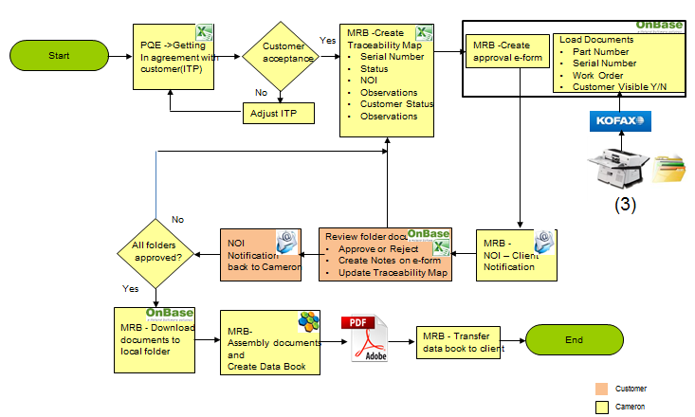

* PEQ – Project Quality Engineers are initiating the ITP file using BOM explosion and get the customer agreement regarding documentation required and holding points for the project. This communication is done through a shared excel file.
* MRB team uses the ITP file to create the Traceability Map file (adding a number of columns to keep traceability). This will be the shared file used in communication with customer once a serial number has been added and all documents are available for review in OnBase.
* Once all documents are ready for a specific serial number an e-form is released in OnBase for customer approval.
* In addition to this form a list (excel) with serial numbers is sent to customer.
* Customer review the list and run the OnBase custom query for each serial number. Depending on findings he can approve all documents or reject asking for additional documents or details.
* Once all documents for traceability map serial numbers have been approved these are manually (one by one) downloaded to a local folder.
* Next step is to assembly all these documents (Nuance) and create data book. As a rule, data book copy the product structure approved by PQE and customer at the initial phase with some additional cover sheets for each level items.

## ITP File

2 lines for each BOM part number. One with Cameron details specifying MS, QP, PSL and all the required certificates. Customer reviews the proposal and change / add additional requirements.

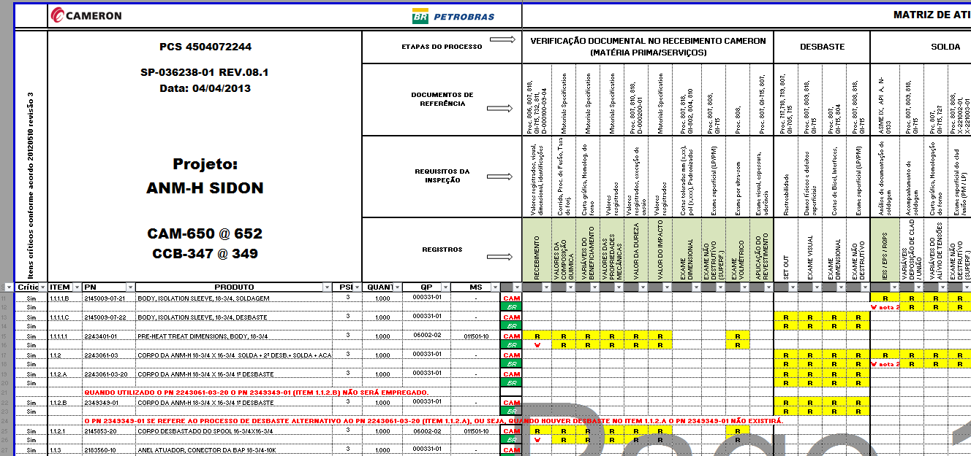

## Traceability Map – OnBase correspondence

MRB team change the layout and keep only the lines containing customer requirements. This file is shared with customer to get details about serial numbers used and execution process status (Cameron and customer)

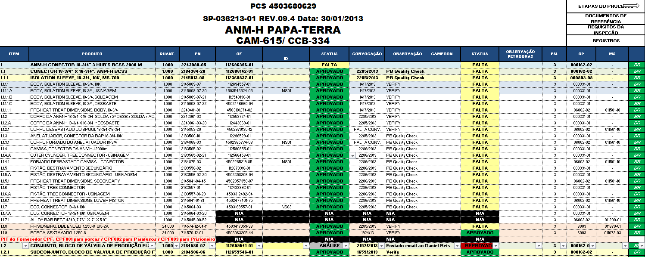

When documents are ready e-form is released for documents approval and customer is notified by email (NOI form). A list with available serial numbers is attached for review.

Sample NOI:

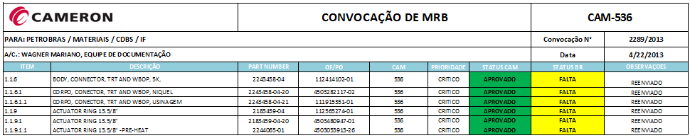

## Custom Query - SN: 112696396-01 query results (ANM-H CONECTOR 18-3/4" 3 HUB'S BCSS 2000 M)

Below is a query result for one specific serial number:

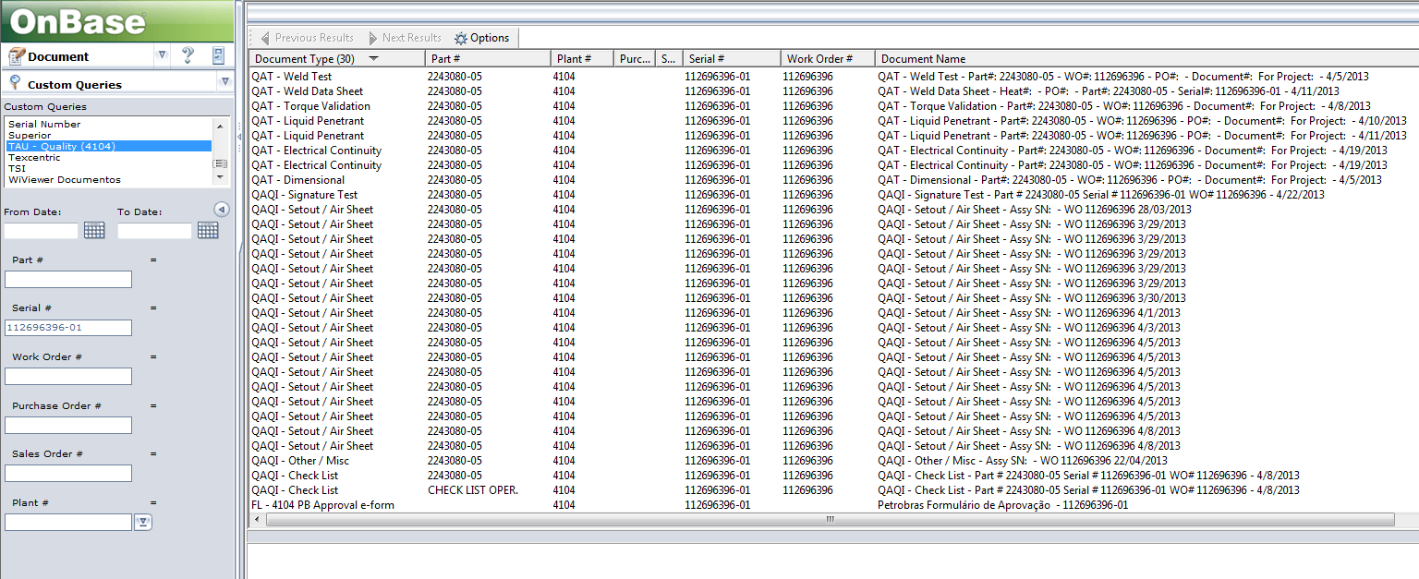

Different document types returned according with ITP file.

To minimize the number of QAI – Setout/Air sheet documents type a 6 sigma project has been started. This will decrease the number of these scanned documents associated with assembly parts and will put a better control on WIP.

## Issue #1 Proposed Solution - OnBase Data Download Program

Below is a proposed application to automate data extraction based on traceability map file maintained by MRB team. The proposed application will be configured to load on demand the Excel file, parse and extract the necessary information (part number, serial number, project code, product index), identify the OnBase documents and create the folder structure containing the exported documents.

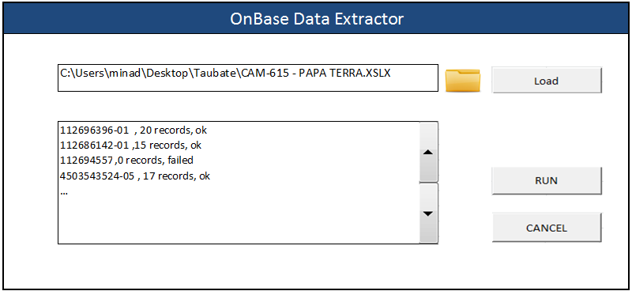

### OnBase Data Download Proposed Results

Two outputs planned for this application:

* A folder structure (similar with traceability map file). Planned convention name is level + serial number + part description. These folders will be populated with OnBase documents (API function used to get this data).
* A log file containing data extraction results. This file can be used to review results and correct errors.

### Proposed Folder Structure

Home folder (Project Name)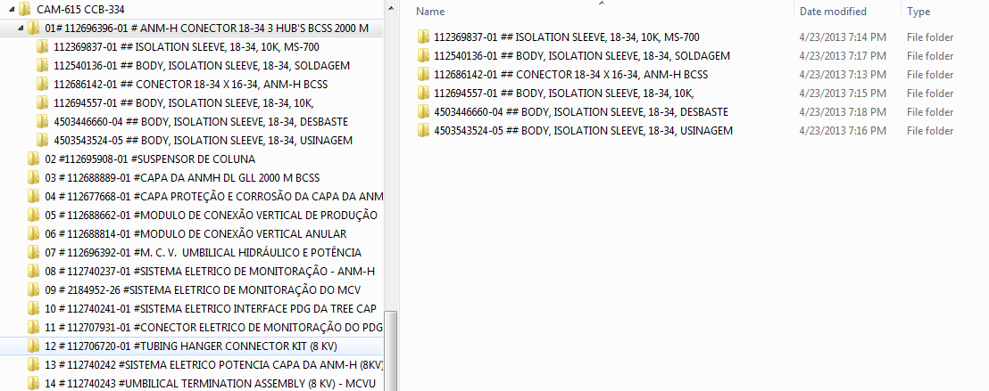

### Data processing log file



The processing log file will be contain the results of each run in a comma separated file. Can be used for download review (as usual there are more than 1000 s/n for project).

# Issue #2 Proposed Solution – Link to Project

Prerequisite: The proposed solution is to use OnBase Configuration module to add the Project Name keyword to all used documents. Also the Custom Query “TAU - Quality (4104)” will be updated with the new keyword Project Name as parameter.

Using OnBase Configuration we can add also a keyword “Document Name” to the necessary documents and custom query.

In order to perform the above actions, we need access to OnBase Configuration console.

Not all documents are index properly. The system will be configured to set the Project Name keyword as mandatory at document import (this will be configured as needed, on document type level). Below are 2 documents linked to the same serial number with and without Project name keyword updated.

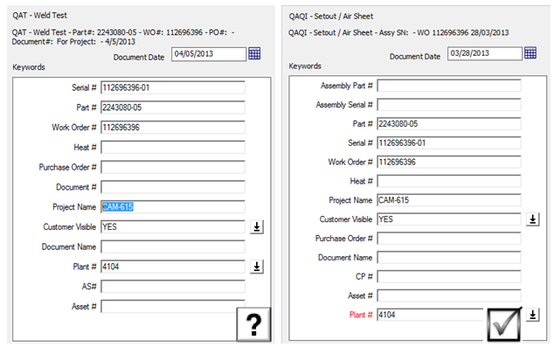

### Query documents for project

There is a need to query OnBase documents related to a specific project. Custom query created for 4104 can be easy changed to accommodate Project Name keyword.

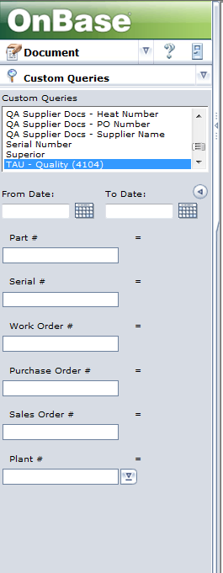

Proposed to add Project Name on Custom Query

## Issue #3 Proposed Solution - Notes for Rejection Report

* Once all required documents are added on serial number the approval e-form is started the customer is notified through NOI on email.

NOI sample:



* Customer analyze all documents and decide to approve (all documents) or to reject the proposal creating a rejection note showing rejection reason, then return back the NOI file with Rejected status for the specific serial number.

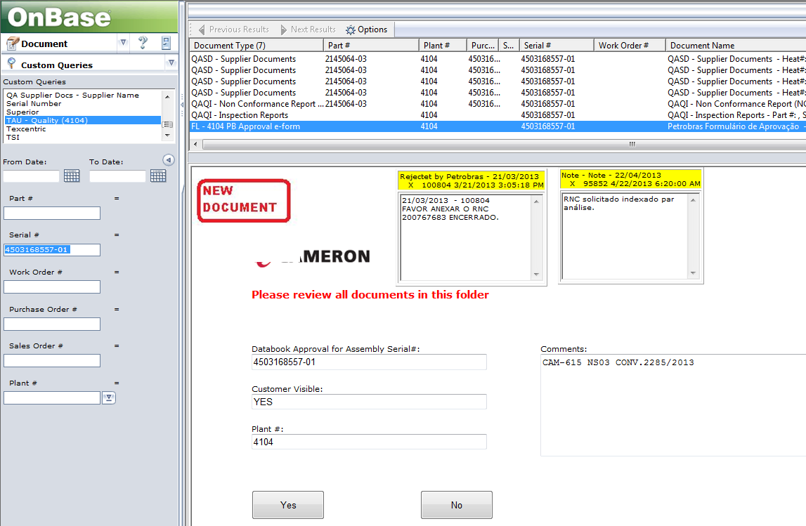

### Notes for Rejection Report Template

For each serial number all the notes will be extracted. The program should provide a number of selection criteria (project, list or serial numbers, only s/n with rejection notes, a specific time interval). Report will be published on the existing Microsoft Reporting Services server.

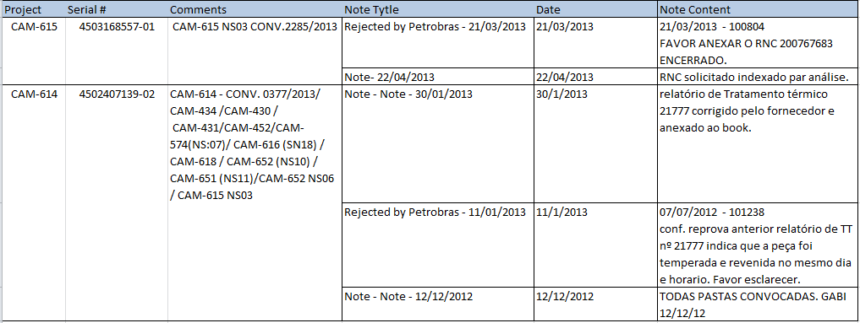

## Issue #4 Proposed Solution - OnBase DIP from FTP

Option 1 (preferred): Build an application which should be executed by vendors when they load certificates. Need vendor acceptance. The application will move the indexing work on vendor side for serialization. Cameron will have to review document for conformance. Data will be imported through OnBase DIP (Document Import Processor).

Option 2: Vendors will continue the existing process and Cameron will need to index documents directly in OnBase to assure serialization and data quality.

Both solutions will eliminate the need for print / scan and index with Kofax.

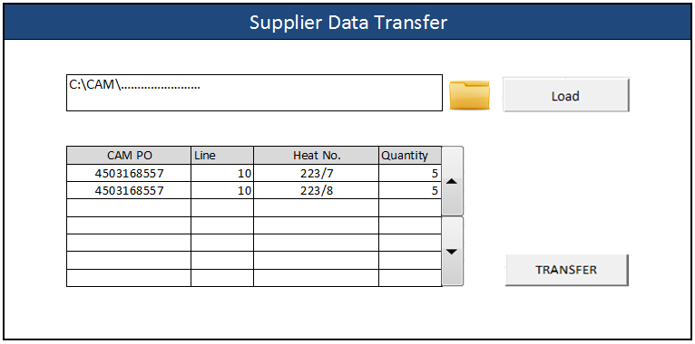

## Issue #5 Proposed Solution - Downgrade approval level

On the current system setup, the project approvals are configured using notes on documents. In order to track the approved projects in OnBase a system reconfiguration is required. The proposed solution is to use a test OnBase environment for the necessary changes (add needed keyword to track status, display a message when you import a document after the project is approved). After the system testing the configuration will be moved to production environment.

We assume the test OnBase environment exists and we have access to it. Also access to production environment is required for roll out the configuration changes.