Q:

EA.Plugin.ProtocolHandler.Program|Begin:Main, nr. of arguments: '1', D:\ProiecteCSharp\EAPTCProtocolHandler\bin\Debug\EAPtc.ProtocolHandler.exe

string[] args

Q:

<https://stackoverflow.com/questions/18984274/how-to-get-image-files-out-of-imageliststreamer-in-resx>

<https://www.motobit.com/util/base64-decoder-encoder.asp>

Copiem din fisierul resx toata secventa hexa

<data name="pbCanonic.Image" type="System.Drawing.Bitmap, System.Drawing" mimetype="application/x-microsoft.net.object.bytearray.base64">

<value>

iVBORw0KGgoAAAANSUhEUgAAAZ8AAABSCAYAAACL49lKAAAAAXNSR0IArs4c6QAAAARnQU1BAACxjwv8

YQUAAAAgY0hSTQAAeiYAAICEAAD6AAAAgOgAAHUwAADqYAAAOpgAABdwnLpRPAAAwLlJREFUeF7lvYef

……

Aleg urmatoarele optiuni

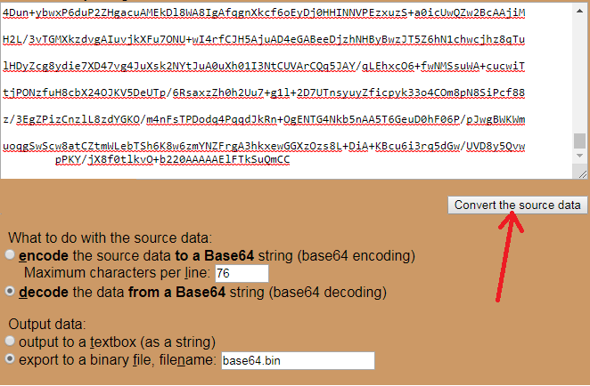

Fisierul base64.bin il redenumesti ca .png

Q:

NLog.Logger

NLog.Config

<https://stackoverflow.com/questions/52869467/nlog-logger-errorstring-exception-param-objects-args-function-doesnt-log>

In some older Version you had:

_logger.ErrorException("My Message", myException);

Now the first param ist of Type Exception:

_logger.Error(myException, "My Message: {0}", myException.Message);

..ErrorException() is now obsolete..

<https://github.com/NLog/NLog/wiki/Tutorial>

<https://github.com/nlog/NLog/wiki/Configuration-file>

NLog can be configured using XML by adding a NLog.config file to your application project

(File Properties: Copy Always).

|  |
| --- |
| <?xml version="1.0" encoding="utf-8" ?>  <nlog xmlns="http://www.nlog-project.org/schemas/NLog.xsd"  xmlns:xsi="http://www.w3.org/2001/XMLSchema-instance"  autoReload="true">  <targets>  <target xsi:type="OutputDebugString" name="ds" layout="${longdate} [${threadid}:${threadname}] ${level} ${callsite} ${message} ${exception:format=type,message,stacktrace:separator=|}"/>  <target name="logfile" xsi:type="File" fileName="D:\Emails\NLog.txt" />  <target name="logconsole" xsi:type="Console" />  </targets>  <rules>  <logger name="*" minlevel="Trace" writeTo="ds" />  <logger name="*" minlevel="Info" writeTo="logconsole" />  <logger name="*" minlevel="Debug" writeTo="logfile" />  </rules>  </nlog> |

Q:

<https://stackoverflow.com/questions/16105097/why-isnt-messagebox-topmost>

topmost MessageBox topmost

//Should be MessageBox.Show() below

MessageBox.Show(this, "My top most message");

Q:

tablou la string

array la string

public static string ListToString(string[] args)

{

return string.Join("','", args) ;

}

Q:

List to string

List la string

Lista la string

toString

Cum convertesc lista la string ?

List<string> existingRuleTypes = …..

string listContent = string.Join(",", existingRuleTypes.ToArray());

string listContent = "'" + string.Join("','", existingRuleTypes.ToArray()) + "'";

Q:

<https://sourceforge.net/projects/eaprotocol/files/>

Q:

public void EA_OnPostInitialized(EA.Repository Repository)

{

//log.Debug("EA_OnPostInitialized");

}

Q:

EAAddins.RequirementsAddin

HKEY_CURRENT_USER\Software\Sparx Systems\EAAddins\Requirement

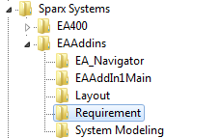

2018-09-10 19:01:20,042 : INFO : EAAddins.SystemArchitectureAddin : Continental System Architecture Addins Version 2.6.1.1. (c) 2008-2018 CEMASBA - modified by P TR E CE Tools&Methods team 10-09-2018

Q:

|  |
| --- |
| copy D:\ProiecteCSharp\EAAddInVEDSimplificatFaraOracle2.6.1.0\EAPlugins\EAAddins\bin\Release\$(TargetName).* "C:\Program Files (x86)\Sparx Systems\EA"  copy D:\ProiecteCSharp\EAAddInVEDSimplificatFaraOracle2.6.1.0\EAPlugins\EAAddins\bin\Release\fme.* "C:\Program Files (x86)\Sparx Systems\EA"  copy D:\ProiecteCSharp\EAAddInVEDSimplificatFaraOracle2.6.1.0\EAPlugins\EAAddins\bin\Release\MksrmTools.* "C:\Program Files (x86)\Sparx Systems\EA"  copy D:\ProiecteCSharp\EAAddInVEDSimplificatFaraOracle2.6.1.0\EAPlugins\EAAddins\bin\Release\CAUtils.* "C:\Program Files (x86)\Sparx Systems\EA"  copy D:\ProiecteCSharp\EAAddInVEDSimplificatFaraOracle2.6.1.0\EAPlugins\EAAddins\bin\Release\Aga.Controls.* "C:\Program Files (x86)\Sparx Systems\EA"  copy D:\ProiecteCSharp\EAAddInVEDSimplificatFaraOracle2.6.1.0\EAPlugins\EAAddins\bin\Release\IKVM.OpenJDK.* "C:\Program Files (x86)\Sparx Systems\EA"  copy D:\ProiecteCSharp\EAAddInVEDSimplificatFaraOracle2.6.1.0\EAPlugins\EAAddins\bin\Release\mksapi.dll "C:\Program Files (x86)\Sparx Systems\EA"  copy D:\ProiecteCSharp\EAAddInVEDSimplificatFaraOracle2.6.1.0\EAPlugins\EAAddins\bin\Release\OSHelpersUtils.dll "C:\Program Files (x86)\Sparx Systems\EA"  copy D:\ProiecteCSharp\EAAddInVEDSimplificatFaraOracle2.6.1.0\EAPlugins\EAAddins\bin\Release\*.xsd "C:\Program Files (x86)\Sparx Systems\EA"  cd /D C:\Program files (x86)\Sparx Systems\EA  C:\Windows\Microsoft.NET\Framework\v2.0.50727\regasm.exe SystemModelingAddins.dll /unregister /verbose  C:\Windows\Microsoft.NET\Framework\v2.0.50727\regasm.exe SystemModelingAddins.dll |

Q:

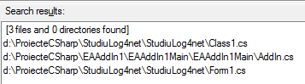

Q:

Se pare ca din C# se poate accesa **mksapi.dll** scris pentru C++

În felul acesta o aplicatie scrisa in C# poate evita dependenta de clientul de MKS instalat pe acelasi calculator

[**https://support.ptc.com/appserver/cs/view/solution.jsp?n=CS161216**](https://support.ptc.com/appserver/cs/view/solution.jsp?n=CS161216)

Q:

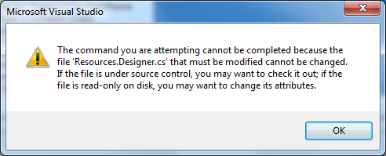

File.WriteAllText("d:\\Emails\\tfn.txt", tfn);

File.WriteAllText("d:\\Emails\\SEARCH_ALL_CLASSIFIERS.txt", SEARCH_ALL_CLASSIFIERS);

File.WriteAllText("d:\\Emails\\SEARCH_ALL_PROPERTY_CLASSIFIERS.txt", SEARCH_ALL_PROPERTY_CLASSIFIERS);

File.WriteAllText("d:\\Emails\\SEARCH_CLASSIFIER_BY_STEREOTYPE.txt", SEARCH_CLASSIFIER_BY_STEREOTYPE);

File.WriteAllText("d:\\Emails\\SEARCH_ALL_SW_BLOCKS_BY_NAME.txt", SEARCH_ALL_SW_BLOCKS_BY_NAME);

File.WriteAllText("d:\\Emails\\SEARCH_ALL_DATA_VALUE_TYPES_BY_NAME.txt", SEARCH_ALL_DATA_VALUE_TYPES_BY_NAME);

File.WriteAllText("d:\\Emails\\ADDINS_SEARCH_MDG.txt", ADDINS_SEARCH_MDG);

log.Debug(SEARCH_ALL_CLASSIFIERS == sac);

log.Debug(SEARCH_ALL_PROPERTY_CLASSIFIERS == sapc);

log.Debug(SEARCH_CLASSIFIER_BY_STEREOTYPE == scs);

log.Debug(SEARCH_ALL_SW_BLOCKS_BY_NAME == sabn);

log.Debug(SEARCH_ALL_DATA_VALUE_TYPES_BY_NAME == savtn);

log.Info("ADDINS_SEARCH_MDG == technology: "+(ADDINS_SEARCH_MDG == technology));

log.Info(string.Format("Lungimi: {0}, {1}", technology.Length, ADDINS_SEARCH_MDG.Length));

Q:

<http://www.icodeguru.com/design/enterprise-architect/deploying_mdg_technologies.htm>

ResourceManager rm = new ResourceManager("EAAddins.Properties.Resources",

this.GetType().Assembly);

rm.GetString("testcasesFolderName")

Repository.AddDefinedSearches(SEARCH_ALL_CLASSIFIERS);

Repository.AddDefinedSearches(SEARCH_ALL_PROPERTY_CLASSIFIERS);

Repository.AddDefinedSearches(SEARCH_CLASSIFIER_BY_STEREOTYPE);

Repository.AddDefinedSearches(SEARCH_ALL_SW_BLOCKS_BY_NAME);

Repository.AddDefinedSearches(SEARCH_ALL_DATA_VALUE_TYPES_BY_NAME);

public static void AddSearches(EA.Repository Repository)

{

Repository.AddDefinedSearches(SEARCH_ALL_OBJECT_ELEMENTS);

Repository.AddDefinedSearches(SEARCH_ALL_PORT_ELEMENTS);

Repository.AddDefinedSearches(SEARCH_ALL_REQUIREMENTS);

Repository.AddDefinedSearches(SEARCH_ALL_PROPERTIES);

Repository.AddDefinedSearches(SEARCH_ALL_ELEMENTS);

Repository.AddDefinedSearches(SEARCH_ALL_PACKAGES);

Repository.AddDefinedSearches(SEARCH_ALL_EA_RULES);

Repository.AddDefinedSearches(SEARCH_ALL_PROPERTY_TYPES);

Repository.AddDefinedSearches(SEARCH_ALL_PROFILES);

}

Q:

Deploy An MDG Technology

<https://www.codeproject.com/Articles/289028/White-An-UI-Automation-tool-for-windows-applicatio>

public String EA_OnInitializeTechnologies(EA.Repository r)

{

       string technology = "";

       Assembly assem = this.GetType().Assembly;

       using (Stream stream = assem.GetManifestResourceStream("MyTechnology.xml"))

       {

               try

               {

                       using( StreamReader reader = new StreamReader(stream) )

                       {

                               technology = reader.ReadToEnd();

                       }

               }

               catch(Exception e)

               {

                       System.Windows.Forms.MessageBox.Show("Error Initializing Technology");

               }

       }

       return technology;

}

Q:

repository.AddDefinedSearches

<https://stackoverflow.com/questions/28203087/enterprise-architect-model-search-xml-format>

Q:

file:// D:\ProiecteCSharp\Enterprise-Architect-Add-in-Framework-master\EAAddinFramework\EAAddinBase.cs

EA_OnInitializeTechnologies

/// <summary>

/// The EA_FileNew event enables the Add-In to respond to a File New event. When Enterprise Architect creates a new model file, this event is raised and passed to all Add-Ins implementing this method.

/// The event occurs when the model being viewed by the Enterprise Architect user changes, for whatever reason (through user interaction or Add-In activity).

/// Also look at EA_FileClose and EA_FileOpen.

/// </summary>

/// <param name="Repository">An EA.Repository object representing the currently open Enterprise Architect model.

/// Poll its members to retrieve model data and user interface status information.</param>

public virtual void EA_FileNew(EA.Repository Repository){}

/// <summary>

/// EA_OnPostCloseDiagram notifies Add-Ins that a diagram has been closed.

/// Also look at EA_OnPostOpenDiagram.

/// </summary>

/// <param name="Repository">An EA.Repository object representing the currently open Enterprise Architect model.

/// Poll its members to retrieve model data and user interface status information.</param>

/// <param name="DiagramID">Contains the Diagram ID of the diagram that was closed.</param>

public virtual void EA_OnPostCloseDiagram(EA.Repository Repository ,int DiagramID){}

/// <summary>

/// EA_OnPostOpenDiagram notifies Add-Ins that a diagram has been opened.

/// Also look at EA_OnPostCloseDiagram.

/// </summary>

/// <param name="Repository">An EA.Repository object representing the currently open Enterprise Architect model.

/// Poll its members to retrieve model data and user interface status information.</param>

/// <param name="DiagramID">Contains the Diagram ID of the diagram that was opened.</param>

public virtual void EA_OnPostOpenDiagram(EA.Repository Repository ,int DiagramID){}

/// <summary>

/// EA_OnPreExitInstance is not currently used.

/// </summary>

/// <param name="Repository">An EA.Repository object representing the currently open Enterprise Architect model.

/// Poll its members to retrieve model data and user interface status information.</param>

public virtual void EA_OnPreExitInstance(EA.Repository Repository){}

/// <summary>

/// **EA_OnPostInitialized** notifies Add-Ins that the Repository object has finished loading and any necessary initialization steps can now be performed on the object.

/// For example, the Add-In can create an Output tab using **Repository.CreateOutputTab**.

/// </summary>

/// <param name="Repository">An EA.Repository object representing the currently open Enterprise Architect model.

/// Poll its members to retrieve model data and user interface status information.</param>

public virtual void EA_OnPostInitialized(EA.Repository Repository){}

/// <summary>

/// EA_OnPostTransform notifies Add-Ins that an MDG transformation has taken place with the output in the specified target package.

/// This event occurs when a user runs an MDG transform on one or more target packages. The notification is provided for each transform/target package immediately after all transform processes have completed.

/// </summary>

/// <param name="Repository">An EA.Repository object representing the currently open Enterprise Architect model.

/// Poll its members to retrieve model data and user interface status information.</param>

/// <param name="Info">Contains the following EventProperty objects for the transform performed:

/// - Transform: A string value corresponding to the name of the transform used

/// - PackageID: A long value corresponding to Package.PackageID of the destination package. </param>

/// <returns>Reserved for future use.</returns>

public virtual bool EA_OnPostTransform(EA.Repository Repository, EA.EventProperties Info){return true;}

/// <summary>

/// EA_OnRetrieveModelTemplate requests that an Add-In pass a model template to Enterprise Architect.

/// This event occurs when a user executes the Add a New Model Using Wizard command to add a model that has been defined by an MDG Technology. See the Incorporate Model Templates topic for details of how to define such model templates.

/// </summary>

/// <param name="Repository">An EA.Repository object representing the currently open Enterprise Architect model.

/// Poll its members to retrieve model data and user interface status information.</param>

/// <param name="sLocation">The name of the template requested. This should match the location attribute in the [ModelTemplates] section of an MDG Technology File. For more information, see the Incorporate Model Templates in a Technology topic.</param>

/// <returns>Return a string containing the XMI export of the model that is being used as a template.</returns>

public virtual string EA_OnRetrieveModelTemplate(EA.Repository Repository,string sLocation){return string.Empty;}

/// <summary>

/// EA_OnTabChanged notifies Add-Ins that the currently open tab has changed.

/// Diagrams do not generate the message when they are first opened - use the broadcast event EA_OnPostOpenDiagram for this purpose.

/// </summary>

/// <param name="Repository">An EA.Repository object representing the currently open Enterprise Architect model.

/// Poll its members to retrieve model data and user interface status information.</param>

/// <param name="TabName">The name of the tab to which focus has been switched.</param>

/// <param name="DiagramID">The diagram ID, or 0 if switched to an Add-In tab.</param>

public virtual void EA_OnTabChanged(EA.Repository Repository,string TabName ,int DiagramID){}

Q:

"D:\ProiecteCSharp\EAAddIn1\EAAddIn1Main\EAAddIn1Main\AddIn.*cs*"

Q:

<http://www.informit.com/articles/printerfriendly/662894>

<http://legeronline.blogspot.ro/2011/03/mvp-design-patterns-with-winforms.html>

We must be careful to separate the business behavior from the UI behavior.

To do so, we'll use the M*ODEL* V*IEW* P*RESENTER* design pattern.

You can see that the design has three components: the model, the view, and the presenter.

The presenter glues the UI to the actual processing in the model

Q:

<https://stackoverflow.com/questions/3491213/logging-exception-in-c-sharp?utm_medium=organic&utm_source=google_rich_qa&utm_campaign=google_rich_qa>

log Exception details

try

{

}

catch (Exception ex)

{

Console.WriteLine(ex.ToString());

}

Also, when you deploy a release build of your code to a production environment for instance, don't forget to include the **.pdb files in the release package**.

You need that file to get the line number of the code that excepted

(see [How much information do pdb files contain? (C# / .NET)](https://stackoverflow.com/questions/596512/how-much-information-do-pdb-files-contain-c-net)

Is is wise to redistribute the pdb files along with a commercial application?

Occasionally, I'm using the stack trace to get a more detailed error reporting logs from the deployed applications; can this functionality be achieved without relying to those files?

Q:

De modificat

"C:\Program Files (x86)\Sparx Systems\EA\SystemModelingAddins.dll.config"

Inlcuieste ALL cu INFO ca sa nu mai apara toate DEBUG-urile logate !!

<root>

<**level value="ALL"/>**

<appender-ref ref="LogFileAppender"/>

<appender-ref ref="EATabAppender"/>

</root>

Q:

DateTime.Now.ToString("dd'-'MM'-'yyyy HH:mm:ss")

<https://stackoverflow.com/questions/18824263/datetime-now-tostringdd-mm-yyyy-hhmmss-does-not-account-my-format>

File.AppendAllText("D:\\Emails\\SystemArchitectureLogMatei.txt", String.Format("{0}, EA_OnInitializeTechnologies\r\n", DateTime.Now.ToString("dd-MM-yyyy HH:mm:ss")));

File.AppendAllText("D:\\Emails\\SystemArchitectureLogMatei.txt", String.Format("{0}, connection string: {1}\r\n", DateTime.Now.ToString("dd-MM-yyyy HH:mm:ss"), connectStrng));

"D:\EBSEASYSARCHADDINS\addin_Log-2018-05-25_12-17-24.txt"

<https://www.sparxsystems.com/enterprise_architect_user_guide/13.0/automation/pre-new_events.html>

<https://www.sparxsystems.com/enterprise_architect_user_guide/13.0/automation/ea_oninitialize_technologies.html>

Ordinea evenimentelor

04-06-2018 16:49:40, EATabAppender get Repository

04-06-2018 16:49:40, EATabAppender Append DEBUG : MksrmTools.MksProperties : MksProperties getInstance

04-06-2018 16:49:40, EATabAppender get Repository

04-06-2018 16:49:40, EATabAppender get TabName

04-06-2018 16:49:40, EATabAppender get Repository

04-06-2018 16:49:40, EATabAppender Append DEBUG : MksrmTools.MksProperties : MksProperties Instance was null

04-06-2018 16:49:40, EATabAppender get Repository

04-06-2018 16:49:40, EATabAppender get TabName

04-06-2018 16:49:40, EATabAppender get Repository

04-06-2018 16:49:40, EATabAppender get TabName

04-06-2018 16:49:40, EATabAppender get Repository

04-06-2018 16:49:40, EATabAppender get TabName

04-06-2018 16:49:40, EATabAppender get Repository

04-06-2018 16:49:40, EATabAppender Append DEBUG : MksrmTools.MksProperties : Exiting MksProperties constructor

04-06-2018 16:49:41, EATabAppender get Repository

04-06-2018 16:49:41, EATabAppender Append DEBUG : MksrmTools.MksProperties : Exit: MksProperties.InitMksProperties

31-05-2018 10:07:26, EA_Connect

31-05-2018 10:07:26, EA_OnInitializeTechnologies

31-05-2018 10:07:29, EA_OnPostInitialized

Q:

<https://www.cancan.ro/cubul-rubik-google-doodle-40-de-ani-de-la-inventia-cubului-rubik-15006133>

mathjax tutorial AMSmath.js

rubik cube javascript site:stackoverflow.com

<http://www.w3.org/Math/MJ/Overview.html>

<https://stackoverflow.com/questions/7450955/basics-of-3d-to-draw-rubiks-cube>

<https://stackoverflow.com/questions/7450955/basics-of-3d-to-draw-rubiks-cube>

<https://html-online.com/articles/rubiks-cube-solver-html-css-javascript/>

<https://github.com/joews/rubik-js>

<https://github.com/ldez/cubejs>

<https://html-online.com/articles/css3-cube/>

<http://beust.com/rubik/>

<https://stackoverflow.com/questions/7450955/basics-of-3d-to-draw-rubiks-cube>

<https://stackoverflow.com/questions/47733159/random-move-javascript-scrambler-for-the-rubiks-cube>

<https://stackoverflow.com/questions/1354949/easiest-to-code-algorithm-for-rubiks-cube>

<http://www.chessandpoker.com/rubiks-cube-solution.html>

<http://www.html5rubik.com/tutorial/>

[**https://stackoverflow.com/questions/500221/how-would-you-represent-a-rubiks-cube-in-code**](https://stackoverflow.com/questions/500221/how-would-you-represent-a-rubiks-cube-in-code)

[**https://stackoverflow.com/questions/36161432/three-js-cube-layers**](https://stackoverflow.com/questions/36161432/three-js-cube-layers)

[**https://stackoverflow.com/questions/46835765/how-can-i-guarantee-that-my-rubiks-cube-scrambling-algorithm-doesnt-select-the**](https://stackoverflow.com/questions/46835765/how-can-i-guarantee-that-my-rubiks-cube-scrambling-algorithm-doesnt-select-the)

Q:

direct3d nine colours cube

<https://nrich.maths.org/768>



Q:

direct3d rubik cube

<https://www.gamedev.net/forums/topic/682810-how-to-put-different-textures-on-different-sides-of-a-cube-in-directx-11/>

<http://zophusx.byethost11.com/tutorial.php?lan=dx9&num=11>

<http://www.real3dtutorials.com/tut00012.php>

<https://github.com/akos-sereg/opengl-rubiks-cube>

<http://www.algosome.com/articles/rubiks-cube-computer-visualize.html>

<https://github.com/zdd/RubikCube>

<https://stackoverflow.com/questions/352771/how-to-animate-rotating-cube-in-c>

<http://www.vcskicks.com/3d-graphics-improved.php>

<http://www.songho.ca/opengl/gl_vbo.html>

<http://www.vcskicks.com/3d_gdiplus_drawing.php>

Q:

convert vb.net to c#

<http://converter.telerik.com/?utm_medium=product&utm_source=converter&utm_campaign=verA>

<https://www.carlosag.net/tools/codetranslator/>

<https://www.developerfusion.com/tools/convert/vb-to-csharp/>

<https://stackoverflow.com/questions/5453013/convert-vb-net-to-c-sharp?utm_medium=organic&utm_source=google_rich_qa&utm_campaign=google_rich_qa>

Q:

<https://stackoverflow.com/questions/4018924/mixed-mode-assembly-is-built-against-version-v1-1-4322?utm_medium=organic&utm_source=google_rich_qa&utm_campaign=google_rich_qa>

The error is: Mixed mode assembly is built against version 'v1.1.4322' of the runtime and cannot be loaded in the 4.0 runtime without additional configuration information.

you need to add an app.Config file and set [useLegacyV2RuntimeActivationPolicy](http://msdn.microsoft.com/en-us/library/bbx34a2h.aspx) to true.

Q:

direct3d rotate cube

<https://docs.microsoft.com/en-us/previous-versions/windows/desktop/apps/hh452744(v=win.10)>

<http://zophusx.byethost11.com/tutorial.php?lan=dx9&num=14&i=1>

<https://github.com/gametutorials/tutorials/tree/master/Direct3D/Rotating%20Cube>

<https://gamedev.stackexchange.com/questions/116893/directx-rotation-of-a-3d-cube-inconsistent>

<https://stackoverflow.com/questions/33559678/how-to-make-spinning-cube-in-directx?utm_medium=organic&utm_source=google_rich_qa&utm_campaign=google_rich_qa>

<https://github.com/Microsoft/DirectXTK/wiki/Getting-Started>

<https://github.com/Microsoft/DirectXTK>

<https://forum.facepunch.com/f/nerds/pfhb/Direct3D-rotating-a-programmed-cube-via-user-input/1/>

<http://www.directxtutorial.com/Lesson.aspx?lessonid=9-4-7>

<http://zophusx.byethost11.com/tutorial.php?lan=dx9&num=14&i=1>

<http://www.vbforums.com/showthread.php?625045-draw-3D-cube-Direct3D>

Well I made one in WPF which supports meshes and all kinds of things

Easy enough and nothing new since WPF natively uses Direct3D and

has plenty of support for simple 3D operations

<http://www.scproject.biz/MRV1.0.php>

<http://www.scproject.biz/MRV1.0.zip>

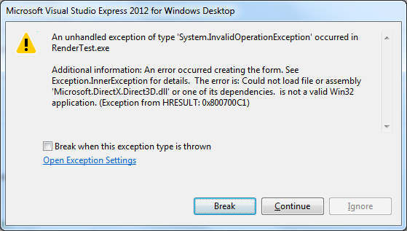

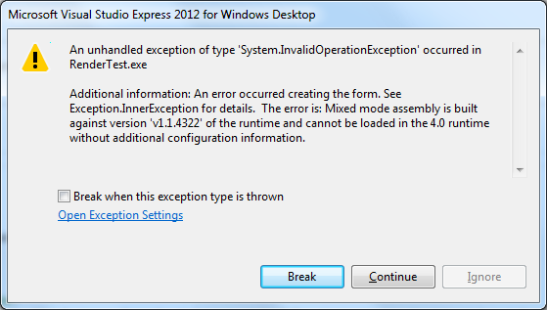

Q:

<https://blogs.msdn.microsoft.com/thottams/2006/08/11/accessing-createprocess-from-c-and-vb-net/>

<https://msdn.microsoft.com/en-us/library/windows/desktop/ms682499(v=vs.85).aspx>

<https://stackoverflow.com/questions/510805/can-a-win32-console-application-detect-if-it-has-been-run-from-the-explorer-or-no>

<http://www.webtropy.com/articles/art9-1.asp?f=GetStartupInfo>

<https://stackoverflow.com/questions/4956435/get-size-of-struct-in-c-sharp?utm_medium=organic&utm_source=google_rich_qa&utm_campaign=google_rich_qa>

Q:

sql server localdb management studio

sql server localdb multiple versions

(localdb) v11.0

<https://stackoverflow.com/questions/18780941/sql-server-localdb-v11-0-explained?utm_medium=organic&utm_source=google_rich_qa&utm_campaign=google_rich_qa>

# **SQL Server 2012 Express LocalDB**

<https://docs.microsoft.com/en-us/previous-versions/sql/sql-server-2012/hh510202(v=sql.110)>

# **SQL Server 2016 Express LocalDB**

<https://docs.microsoft.com/en-us/sql/database-engine/configure-windows/sql-server-2016-express-localdb?view=sql-server-2017>

C:\Program Files\Microsoft SQL Server\110\Tools\Binn

<http://nikgupta.net/2015/12/10/connect-localdb-from-management-studio/>

<https://dotnetthoughts.net/connecting-localdb-using-sqlserver-management-studio/>

<http://www.sqlserverlogexplorer.com/how-to-attach-mdf-file-without-ldf-file/>

(LocalDb)\MSSQLLocalDB

Why don't you use "(localdb)\mssqllocaldb" as your connection string?

If you have multiple versions of localdb exists, this won't work.

<https://social.msdn.microsoft.com/Forums/sqlserver/en-US/f7579b47-dc2b-4212-a58b-65e25c04d698/how-to-connect-local-db-by-sql-server-management-studio?forum=sqldatabaseengine>

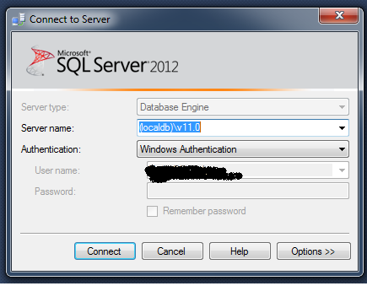

Q:

The file 'D:\ProiecteCSharp\P_TR_DiffMerge\P_TR_DiffMerge\Form2.cs' does not support code parsing or generation because it is not contained within a project that supports code.

C:\LegacyApp\Microsoft Visual Studio 11.0\Common7\IDE\WDExpress.sln

devenv /ResetSettings

WDExpress.exe /ResetSettings

reset via CLI VS settings: vswindexpress /resetuserdata

Repajr !!

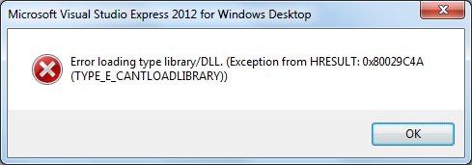

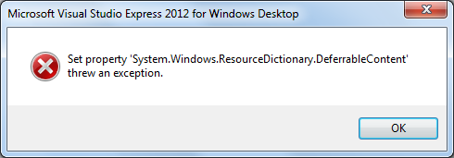

<https://stackoverflow.com/questions/35454956/error-loading-type-library-dll-when-i-try-to-add-file-in-vs-hresult-0x80029c4a>

<https://docs.microsoft.com/en-us/previous-versions/visualstudio/visual-studio-2008/aa983433(v=vs.90)>

Q:

"C:\Users\All Users\Microsoft\Windows\Start Menu\Programs\Startup"

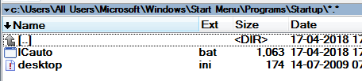

"C:\Users\MateiA05\AppData\Roaming\Microsoft\Windows\Start Menu\Programs\Startup"

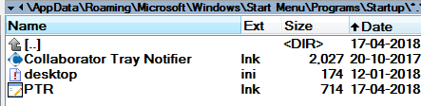

Q:

What is a Delegate

c# when to use delegates

What is an interface ?

Lazy instantiation

When to Use Delegates Instead of Interfaces (C# Programming Guide)

<https://msdn.microsoft.com/ro-ro/library/ms173173.aspx>

Both delegates and interfaces enable a class designer to separate type declarations and implementation.

A given [interface](https://msdn.microsoft.com/ro-ro/library/87d83y5b.aspx) can be inherited and implemented by any [class](https://msdn.microsoft.com/ro-ro/library/0b0thckt.aspx) or [struct](https://msdn.microsoft.com/ro-ro/library/ah19swz4.aspx).

A [delegate](https://msdn.microsoft.com/ro-ro/library/900fyy8e.aspx) can be created for a method on any class, as long as the method fits the method signature for the delegate.

An interface reference or a delegate can be used by an object that has no knowledge of the class that implements the interface or delegate method.

Given these similarities, **when** should a class designer use a **delegate** and when should it use an **interface**?

Use a delegate in the following circumstances:

* A design based on events is used.
* You need a type safe parameter receiving a pointer to a function

A delegate can be seen as a placeholder for a method

A Delegate is an object that knows how to call a method.

Use an interface in the following circumstances:

* Create a hierarchy of classes starting from a base class
* We want to achieve polymorphism

Provide different implementations of the same method in each derived class.

Polymorphism - We tell an object to do something conceptually through a reference,

and we want different behavior, depending upon the specific type of derived object I have.

<https://stackoverflow.com/questions/3948721/how-to-add-a-delegate-to-an-interface-c-sharp>

Q:

using System;

using System.Collections.Generic;

using System.Linq;

using System.Text;

using MyLibrary;

namespace DelegateApp {

/// <summary>

/// A class to define a person

/// </summary>

public class Person {

public string Name { get; set; }

public int Age { get; set; }

}

class Program {

//Our delegate

public delegate bool FilterDelegate(Person p);

static void Main(string[] args) {

//Create 4 Person objects

Person p1 = new Person() { Name = "John", Age = 41 };

Person p2 = new Person() { Name = "Jane", Age = 69 };

Person p3 = new Person() { Name = "Jake", Age = 12 };

Person p4 = new Person() { Name = "Jessie", Age = 25 };

//Create a list of Person objects and fill it

List<Person> people = new List<Person>() { p1, p2, p3, p4 };

//Invoke DisplayPeople using appropriate delegate

DisplayPeople("Children:", people, IsChild);

DisplayPeople("Adults:", people, IsAdult);

DisplayPeople("Seniors:", people, IsSenior);

Console.Read();

}

/// <summary>

/// A method to filter out the people you need

/// </summary>

/// <param name="people">A list of people</param>

/// <param name="filter">A filter</param>

/// <returns>A filtered list</returns>

static void DisplayPeople(string title, List<Person> people, FilterDelegate filter) {

Console.WriteLine(title);

foreach (Person p in people) {

if (filter(p)) {

Console.WriteLine("{0}, {1} years old", p.Name, p.Age);

}

}

Console.Write("\n\n");

}

//==========FILTERS===================

static bool IsChild(Person p) {

return p.Age < 18;

}

static bool IsAdult(Person p) {

return p.Age >= 18;

}

static bool IsSenior(Person p) {

return p.Age >= 65;

}

}

}

Q:

<https://stackoverflow.com/questions/26798832/cannot-create-files-in-c-programdata-even-after-granting-users-group-full-perm?rq=1>

I have found that a clone copy of the database has been put in to following folder: C:\Users\\AppData\Local\VirtualStore\ProgramData\

Applications written with the assumption that the user will be running with administrator privileges experienced problems in earlier versions of Windows when run from limited user accounts, often because they **attempted to write to machine-wide or system directories** (such as Program Files) or registry keys (notably HKLM)

UAC attempts to alleviate this using File and Registry Virtualization, which **redirects writes** (and subsequent reads) to a per-user location within the user's profile.

For example, if an application attempts to write to a directory such as

"C:\Program Files\appname\settings.ini" to which the user does not have write permission,

the write will be redirected to

"C:\Users\username\AppData\**Local\VirtualStore**\Program Files\appname\settings.ini".

The redirection feature is only provided for **non-elevated** 32-bit applications

and only if they do not include a manifest that requests specific privileges.[13]

Q:

<https://www.howtogeek.com/278562/what-is-the-programdata-folder-in-windows/>

Modern versions of Windows limit the permissions programs have, and applications shouldn’t be able to write to system folders during normal operation.

However, some applications—Steam, for example—still store their settings and other data files in their Program Files directory.

Q:

<https://stackoverflow.com/questions/22107812/privileges-owner-issue-when-writing-in-c-programdata>

|  |
| --- |
| No, C:\ProgramData, aka FOLDERID_ProgramData, has restricted security settings.  Standard users can create files there.  But these files are, by default, secured so **that only the user that created the file** can subsequently modify the file.  On Windows 7, at least, the default permissions for ProgramData do allow any user to write to it;  Specifically, to create new files and folders.  **However, only the user who creates any given file has permission by default to write to it.**  The recommended solution is for your installer to create a sub directory of C:\ProgramData for your shared storage.  And that sub directory **must be given a permissive ACL by the installation program**.  That is what grants the desired access to all standard users.  I do wonder whether you really need shared writeable data.  **Most configuration data tends to be per user.**  Normally I'd expect to see shared configuration be something that is specified at install time  and modified infrequently by administrators. |

## What Do Programs Store in ProgramData?

There’s also the ProgramData folder.

This folder has most in common with the Application Data folders, but—instead of having an individual folder for each user—**the ProgramData folder is shared among all the user accounts on your PC.**

On Windows XP, there was no C:\ProgramData folder.

Instead, there was a “C:\Documents and Settings\All Users\Application Data” folder.

Starting with **Windows Vista**, the All Users application data folder was moved to **C:\ProgramData**.

You can still see this today. If you plug C:\Users\All Users\ into File Explorer or Windows Explorer on Windows 10, Windows will automatically redirect you to the C:\Program Data folder. It’ll redirect any program that tries to write to C:\Users\All Users\ to the C:\ProgramData folder, too.

As Microsoft [puts it](https://msdn.microsoft.com/en-us/library/windows/desktop/bb762494(v=vs.85).aspx), “this folder is used for application data that is **not** user specific”.

For example, a program you use might download a spelling dictionary file when you run it.

Rather than store that spelling dictionary file under a user-specific Application Data folder, it should store it in the ProgramData folder.

It can then **share** that spelling dictionary with all users on the computer, **instead of storing multiple copies** in a bunch of different Application Data folders.

Tools that run with system permissions may also store their settings here.

For example, an antivirus application may store its settings, virus logs, and quarantined files at C:\ProgramData. These settings are then shared system-wide for all users of the PC.

Q:

String contains

bool found = "My Name is".IndexOf("name", StringComparison.OrdinalIgnoreCase) >= 0;

if (str.ToLower().Contains("top") == true)

<https://stackoverflow.com/questions/2912476/using-c-sharp-to-check-if-string-contains-a-string-in-string-array>

<https://stackoverflow.com/questions/36906418/how-to-determine-if-string-contains-specific-substring-ignoring-the-case-sensiti>

Q:

<https://social.msdn.microsoft.com/Forums/en-US/9271b9c1-857f-487e-b67f-fc9de9b7343c/environmentexpandenvironmentvariablescdbuilddate44date102date72time112?forum=csharpgeneral>

%CD%

Q:

SendKeysToMKS.zip

Q:

<http://www.oracle.com/technetwork/topics/dotnet/downloads/odacmsidownloadvs2017-3806459.html>

**Oracle Developer Tools for Visual Studio 2017 (12.2.0.1.0)**

<http://www.oracle.com/technetwork/topics/dotnet/downloads/odacmsidownloadvs2013-2756823.html>

**Oracle Developer Tools for Visual Studio 2013 (12.1.0.2.4)**

<http://www.oracle.com/technetwork/topics/dotnet/downloads/odacmsidownload-2745497.html>

**Oracle Developer Tools for Visual Studio 2015 (12.2.0.1.0)**

**Oracle Data Provider for .NET** (ODP.NET).

Important: Before you install this package please make sure there is no ODAC/Oracle Universal Installer (OUI)

version of Oracle Developer Tools for Visual Studio installed on the machine.

If there is then please use OUI to uninstall Oracle Developer Tools for Visual Studio before proceeding with this install.

This download includes:

Oracle Developer Tools for Visual Studio 12.1.0.2.4

**Oracle Data Provider for .NET 4**, Managed Driver 12.1.0.2.160719

Oracle Providers for ASP.NET 4 12.1.0.2.0

Q:

<https://docs.microsoft.com/en-us/dotnet/framework/data/adonet/oracle-and-adonet>

Note+

The types in [System.Data.OracleClient](https://docs.microsoft.com/en-us/dotnet/api/system.data.oracleclient) are deprecated.

The types remain supported in the current version of.NET Framework but will be removed in a future release.

Microsoft recommends that you use a third-party Oracle provider. +

This section describes features and behaviors that are specific to the .NET Framework Data Provider for Oracle.

System.Data.OracleClient.dll

Q:

<https://social.msdn.microsoft.com/Forums/en-US/baabb66f-c663-4a50-90a9-9c96f2b17ce0/c-is-it-not-possible-to-do-oracle-connection-through-code-without-installing-oracle-client?forum=adodotnetentityframework>

|  |
| --- |
| created an exe in c# which is a ADO.NET application and talks to oracle db for data. when i tried this exe in some other system i got error as 'Exception occured :System.Data.OracleClient requires Oracle client software vers ion 8.1.7 or greater. at System.Data.OracleClient.OCI.DetermineClientVersion()'  Is it not possible to use oracle server in our ADO.net app without installing any **oracle client**. i am planning to share this exe and i dont want to install oracle client whereever i use this exe.  cant i use the oracle client dll only for this |

Oracle instant client

<https://jeremybranham.wordpress.com/2011/04/25/oracle-instant-client-with-odp-net/>

<http://alderprogs.blogspot.ro/2009/04/deploying-odpnet-with-oracle-instant.html>

|  |
| --- |
| In the coming post we will write a complete program connecting to any Oracle database and  running arbitrary SQL statement passed as a parameter,  with no need for any Oracle software installed on the client. |

|  |  |  |  |  |  |
| --- | --- | --- | --- | --- | --- |
| **Instant Client Downloads for Microsoft Windows 32-bit**  <http://www.oracle.com/technetwork/topics/winsoft-085727.html> | |  |  |  |  | | --- | --- | --- | --- | |  | Instant Client Package - Basic: All files required to run OCI, OCCI, and JDBC-OCI applications   |  | | --- | | Downloadinstantclient-basic-nt-12.2.0.1.0.zip (71,881,824 bytes) (cksum - 3943816961) | | The 12.2 Basic package requires the [Microsoft Visual Studio 2013 Redistributable](https://support.microsoft.com/en-us/kb/2977003#bookmark-vs2013). | | |

|  |  |  |  |  |  |
| --- | --- | --- | --- | --- | --- |
| Instant Client Downloads for Microsoft Windows (x64) 64-bit  <http://www.oracle.com/technetwork/topics/winx64soft-089540.html> | |  |  |  |  | | --- | --- | --- | --- | |  | Basic Package - All files required to run OCI, OCCI, and JDBC-OCI applications   |  | | --- | | Downloadinstantclient-basic-windows.x64-12.2.0.1.0.zip (75,062,441 bytes) (cksum - 1462971172) | | The 12.2 Basic package requires the [Microsoft Visual Studio 2013 Redistributable](https://support.microsoft.com/en-us/kb/2977003#bookmark-vs2013) | | |

|  |
| --- |
| No, the oracle client is required. But you could **deploy** the [Oracle Instant Client](http://www.oracle.com/technetwork/database/features/instant-client/index-097480.html) in **your application.**  From the post in StackOverFlow: <http://stackoverflow.com/questions/15924329/accessing-an-oracle-db-via-c-sharp-without-forcing-the-user-to-install-an-oracle>  we could note this:  This is a complete Oracle client but it doesn't require installation, it can be used directly.  However, you need to be aware of the following:   1. The instant client is over 120 MB in size. 2. You need different versions of the instant client for x86 and x64, bringing the size to about 250 MB.   **The advantage of using the instant client is that you don't have to worry about the installed version of the Oracle client**.  Even if the computer already has an incompatible version installed, your application will work, because it comes with the correct version. |

<http://www.oracle.com/technetwork/database/database-technologies/instant-client/overview/index.html>

[The managed ODP.net client](http://www.oracle.com/technetwork/topics/dotnet/index-085163.html) is exactly what you want. Now that there's a 12c version out, it's a simple single assembly that you can deploy with your application and not have to worry about Oracle installations.

[There's also a nuget package that you can use if you don't want to install on your system.](https://twitter.com/OracleDOTNET/status/556251239294332929) That is very painless to get up and running. Here's some links to those:

* [Main package](http://www.nuget.org/packages/Oracle.ManagedDataAccess/)
* [Second package to use Entity Framework 6/Code First](http://www.nuget.org/packages/Oracle.ManagedDataAccess.EntityFramework/)





Q:

Oracle Data Provider for .NET

using System.Data.OracleClient;

<http://www.oracle.com/technetwork/topics/dotnet/index-085163.html>

**System.Data.OracleClient** is the one provided by Microsoft in the framework, and **is the depreciated one**.

**Oracle.DataAccess** is the one provided by Oracle for .net 2 and 4, and is not depreciated

Q:

<https://community.oracle.com/thread/2398475>

<https://www.devexpress.com/Support/Center/Question/Details/Q521057/attempt-to-load-oracle-client-libraries-threw-badimageformatexception>

<https://stackoverflow.com/questions/24104210/badimageformatexception-this-will-occur-when-running-in-64-bit-mode-with-the-32>

attempt to load oracle client libraries threw badimageformatexception

The issue is unlikely related to our components. It appears that your application's target platform is "Any CPU" and you are launching it on the x64 machine.

In this case, the application will be launched in x64 mode, and thus it will not be able to load x86 assemblies of the Oracle client.

To solve this problem, either use x64 Oracle assemblies or set the application's target platform to x86.

*Attempt to load Oracle client libraries threw BadImageFormatException.   
This problem will occur when running in 64 bit mode with the 32 bit Oracle client components installed.*

<https://stackoverflow.com/questions/15498391/attempt-to-load-oracle-client-libraries-threw-badimageformatexception>

This error indicates that you have a mismatch between 32 bits and 64 bits components in your application.

When you run an application in 64 bits Windows, it may run as either 64 bits or 32 bits.

If you have set the platform target as x86, it will run as 32 bits. If you have set your platform target as x64 or AnyCpu it will run as 64 bits.

**Oracle has different versions of its client**, **one is 32 bits and the other is 64 bits**.

So, if your application is running in 32 bits mode, you need to make sure your 32 bits Oracle client is installed.

Q: Latex

<http://www.hostmath.com/>

Q:

Ceva simpatic. Poate aveti colegi care sunt interesati de Mathlab

<http://syllabus.cs.manchester.ac.uk/pgt/2017/COMP61011/materials/matlabworkout61011.pdf>

The COMP61011 Matlab Workout If you think you’re really that hot a Matlab programmer, try some of these….

MATLAB AMATEUR Write a script to find out how many steps the Collatz Conjecture takes to converge if we start with the number 61011. <http://en.wikipedia.org/wiki/Collatz_conjecture> While doing so, try not to read this: <http://xkcd.com/710/>

MATLAB NINJA If we list all the natural numbers below 10 that are multiples of 3 or 5, we get 3, 5, 6 and 9. The sum of these multiples is 23. Find the sum of all the multiples of 3 or 5 below 1000.

MATLAB SUPERMAN Write a script to generate solutions to the 8-queens puzzle. <http://en.wikipedia.org/wiki/Eight_queens_puzzle>

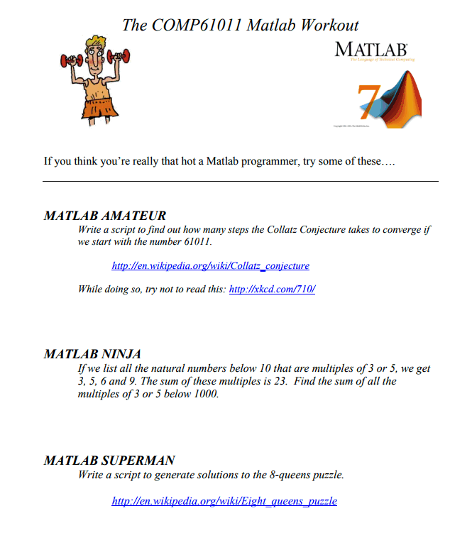

Q:

<https://stackoverflow.com/questions/158151/how-can-i-save-a-screenshot-directly-to-a-file-in-windows>

print screen

<http://svn.code.sf.net/p/sdaaubckp/code/xp-take-screenshot/>

<https://www.howtogeek.com/forum/topic/program-to-auto-save-a-screen-capture-with-a-hotkey>

Q:

Process Creation Flags

<https://msdn.microsoft.com/en-us/library/windows/desktop/ms684863(v=vs.85).aspx>

<https://stackoverflow.com/questions/22438497/pass-multiple-process-creation-flags-to-createprocess>

Q:

Show Hide console window

<https://stackoverflow.com/questions/34440916/hide-the-console-window-from-a-console-application>

<https://stackoverflow.com/questions/3571627/show-hide-the-console-window-of-a-c-sharp-console-application/3571628>

<https://social.msdn.microsoft.com/Forums/vstudio/de-DE/ea8b0fd5-a660-46f9-9dcb-d525cc22dcbd/hide-console-window-in-c-console-application?forum=csharpgeneral>

<http://www.i-programmer.info/programming/c/1039-using-the-console.html>

Q:

Ghilimele duble in string

Double quotes

<https://stackoverflow.com/questions/14480724/escape-double-quotes-in-string>

string test = @"He said to me, ""Hello World"". How are you?";

Either use verbatim string literals as you have, or escape the " using backslash.

You can use backslash either way;

string str = "He said to me, \"Hello World\". How are you?";

It prints;

He said to me, "Hello World". How are you?

which is exactly same prints with;

string str = @"He said to me, ""Hello World"". How are you?";

Q:

<https://stackoverflow.com/questions/814936/get-pid-from-ms-word-applicationclass>

Consider this code:

using Microsoft.Office.Interop.Word;

ApplicationClass _application = new ApplicationClass();

Can I get the PID from the Winword.exe process that was launched by the _application?

I can't search for the winword.exe process and kill it, because I will have several, and I don't know which one to kill. If I can get a PID for each ApplicationClass, I could just kill the correct winword.exe process that is giving me troubles to quit.

No, unfortunately there is no way to associate an instance of ApplicationClass with a running process of Word.

Why do you need to kill the instance of Word? Couldn't you just ask it to close all of its documents and then simply stop using that instance? If you remove all references to the class eventually the [GC](http://en.wikipedia.org/wiki/Garbage_collection_%28computer_science%29) will kick in and take down the [COM](http://en.wikipedia.org/wiki/Component_Object_Model) server.

Q:

<https://stackoverflow.com/questions/14049206/microsoft-office-interop-excel-dll-not-included-in-build-folder>

Check if the Copy Local is set to true for the referenced DLL.   
  
You will first need to set "Embed Interop Types" property to false. Then you can set the Copy Local" property to true.   
  
 Embed Interop Types property was [introduced in VS 2010](http://blogs.msdn.com/b/samng/archive/2010/01/24/the-pain-of-deploying-primary-interop-assemblies.aspx) to remove the dependency of deploying PIAs.

<https://stackoverflow.com/questions/19575961/process-start-with-word-running-fails-to-wait-for-exit> important

Q:

Compare Word files

<https://social.msdn.microsoft.com/Forums/en-US/b7f4b480-ca1c-49a1-a2ea-b1d1cf5ad56b/how-do-you-compare-two-word-documents-in-c>

<https://msdn.microsoft.com/en-us/library/ee342218(v=vs.100).aspx>

<https://stackoverflow.com/questions/2606467/open-microsoft-word-in-compare-document-mode-from-command-prompt>

Q:

c# execute batch command with input

<https://stackoverflow.com/questions/25872507/give-user-input-for-batch-file-via-c-sharp-code>

Q:

<https://msdn.microsoft.com/en-us/library/ms182532.aspx>

<https://msdn.microsoft.com/en-us/library/ms182532.aspx#BKMK_Create_a_unit_test_project>

In the Reference Manager dialog box, expand **Solution** and then check the **Bank** item.

On the **Build** menu, choose **Build Solution**.

If there are no errors, the UnitTestExplorer window appears

using P_TR_DiffMerge;

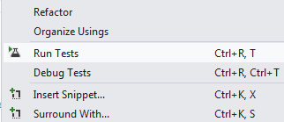

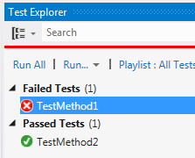

Q:

Process.Start

Starts a process resource and associates it with a [Process](https://msdn.microsoft.com/en-us/library/system.diagnostics.process(v=vs.110).aspx) component.

/*

System.Diagnostics.Process myProcess = new System.Diagnostics.Process();

System.Diagnostics.ProcessStartInfo startInfo = new System.Diagnostics.ProcessStartInfo();

startInfo.FileName = "cscript.exe";

startInfo.RedirectStandardOutput = true;

startInfo.UseShellExecute = false;

startInfo.Arguments = ",,,,,";

myProcess.StartInfo = startInfo;

myProcess.Start();

//StreamReader myStreamReader = myProcess.StandardOutput;

// Read the standard output of the spawned process.

string myString = myProcess.StandardOutput.ReadToEnd();

//myProcess.Close();

myProcess.WaitForExit();

*/

Q:

<https://stackoverflow.com/questions/3491213/logging-exception-in-c-sharp?utm_medium=organic&utm_source=google_rich_qa&utm_campaign=google_rich_qa>

Q:

Merge si asa

<appender name="LogFileAppender" type="log4net.Appender.FileAppender">

**<level value="DEBUG"/>**

<param name="File" type="log4net.Util.PatternString" value="d:/EBSEASYSARCHADDINS/addin_Log-%date{yyyy-MM-dd_HH-mm-ss}.txt"/>

<param name="AppendToFile" value="false"/>

<layout type="log4net.Layout.PatternLayout">

<param name="ConversionPattern" value="%date : %-5level : %-logger : %message%newline"/>

</layout>

</appender>

<root>

<appender-ref ref="LogFileAppender"/>

<appender-ref ref="EATabAppender"/>

</root>

Q:

Multiple configuration files

<https://stackoverflow.com/questions/2775386/log4net-configure-using-multiple-configuration-files>

<https://stackoverflow.com/questions/13024523/log4net-configure-using-multiple-configurations>

<https://stackoverflow.com/questions/33777032/log4net-multiple-configurations-in-single-config-file>

<http://logging.apache.org/log4net/release/manual/repositories.html>

Calling XmlConfigurator.Configure from one of the plugins overrides the host's app.config log4net definitions

Is there an easy way to append configurations instead of overriding them?

<http://www.kopf.com.br/kaplof/using-multiple-configuration-files-with-log4net>

Q:

win32 exit power saving mode

<https://msdn.microsoft.com/en-us/library/windows/desktop/aa373243(v=vs.85).aspx>

<https://stackoverflow.com/questions/713498/turn-on-off-monitor>

Q: Cum aflu pozitia unui control pe ecran ?

<https://stackoverflow.com/questions/1478022/c-sharp-get-a-controls-position-on-a-form>

Point locationOnForm = control.FindForm().PointToClient(

control.Parent.PointToScreen(control.Location));

public int GetUserControlHeight()

{

return GetPositionInForm(PortOffsetUpDown).Y + PortOffsetUpDown.Size.Height;

}

public Point GetPositionInForm(Control ctrl)

{

Point p = ctrl.Location;

Control parent = ctrl.Parent;

while (!(parent is Form))

{

p.Offset(parent.Location.X, parent.Location.Y);

parent = parent.Parent;

}

return p;

}

Q:

Cum adaug un control pe o forma ?

<https://stackoverflow.com/questions/15471550/add-user-control-to-a-form>

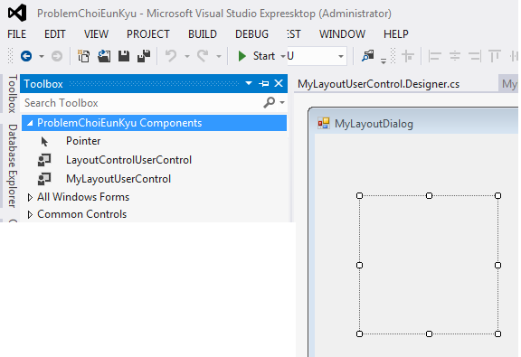

After creating your user control, you should build the project (F6 or Ctrl+Shift+B).

Then Visual Studio automatically adds the control to the **Toolbox**. You should drag the control from the **Toolbox** (Ctrl+Alt+X) to the form.

If after successfully building the project, the control is not on the Toolbox, make sure that you have **Automatically Populate Toolbox** set to true: Go to **Tools->Options**, select **Windows Forms Designer** node, and set **Automatically Populate Toolbox** to **true**.

You can also manually add your user control to the toolbox (if "Automatically Populate Toolbox" is not set, and you don't want to set it!). It is highly recommended that you create an additional **Tab** on the Toolbox for your specific user controls: Right click on an empty area of the Toolbox and click **Add Tab**, then give the new tab a name.

Q:

DPI settings

Setari DPI

<https://stackoverflow.com/questions/9373260/detect-windows-font-size-100-125-150>

AutoScaleMode

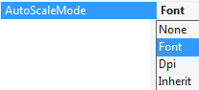

Q:

public string EA_Connect

<http://www.sparxsystems.com/forums/smf/index.php/topic,2072.msg111297.html#msg111297>

<http://www.sparxsystems.com/forums/smf/index.php/topic,2945.msg114605.html#msg114605>

<http://www.sparxsystems.com/forums/smf/index.php/topic,2706.msg113621.html#msg113621>

<http://www.sparxsystems.com/forums/smf/index.php/topic,2706.msg113621.html#msg113621>

<http://www.sparxsystems.com/enterprise_architect_user_guide/13.0/automation/repository3.html>

**Code:**[[Select]](javascript:void(0);)

Repository.WriteOutput("System", "Hello World", 0)More methods are available for interacting with EA's output window on the EA.Repository object, including CreateOutputTab(), EnsureOutputVisible(), and ClearOutput().

Resolved after I specified Output Tab name as a const:  
  
private **const** string myTabName = "My codegen output";  
  
Looks like EA compares tab names via "==" comparision instead of "equals(...)"?

public void EA_Load(EA.Repository Repository)

{

//nu e correct sa fie pe Load, nu merge

Repository.EnsureOutputVisible("System");

Repository.WriteOutput("**System**", "Start Delay Load all System Architecture EA_Connect Constructor Code", 0);

Repository.CreateOutputTab(**myTabName**);

Repository.WriteOutput(**myTabName**, "Start Delay Load all System Architecture EA_Connect Constructor Code", 0);

//EnsureOutputVisible practic seteaza focusul pe acel tab !

//Repository.EnsureOutputVisible(myTabName);

}

catch (Exception ev)

{

Repository.EnsureOutputVisible("System");

Repository.WriteOutput("**System**", ev.Message, 0);

}

Q: constructor chain

chain constructor

<https://stackoverflow.com/questions/1814953/c-sharp-constructor-chaining-how-to-do-it>

public LayoutControlDialog(EA.Repository rep) :this()

Q:

<https://superuser.com/questions/1093919/is-there-such-a-thing-as-korean-microsoft-windows-10-or-is-it-just-regular-win/1119703>

Going to post my own answer to this even though I already accepted another answer, in order to maybe help others.

I discovered that, as pointed out by user6759519, the default font and font size used by WinForms applications can be different depending on the country or region Windows was installed.

For example, as I found out, the default font used by WinForms applications running on UK/US Windows is **'Microsoft Sans Serif 9pt'**, whereas on Korean Windows it is 'Gulim 9pt'.

This resulted in numerous panels having incorrect dimensions resulting in clipping, and various places where text did not fit in controls properly.

The solution was to programmatically override this by setting the default font back to Sans Serif in the constructor of the top-level panel in our application, just after the call to InitializeComponent, for example:

Font = new Font(

familyName: "Microsoft Sans Serif",

emSize: 9f,

style: FontStyle.Regular,

unit: GraphicsUnit.Pixel);

This setting automatically cascades down to all child panels and controls as far as I an tell, and pretty much everything now looks correct (I've also confirmed this in the Japanese edition of Windows 10).

Note: There may still be issues on some child panels even after overriding the default font, depending on the setting of some or all of the following in the child panel designer code:

AutoScaleMode

AutoScaleDimensions

AutoSize

Note: One more thing (after re-reading my question), I was never able to reproduce our Korean customer's issue by making my UK installation of Windows 'more Korean' (i.e. no setting I found changes the default font picked by WinForms) - instead I had to download Korean Windows from MSDN, and install it in VmWare. In order to use it without learning Korean(!), I was then able to change the default language into English, by navigating the relevant settings screens side by side with another PC running UK Windows - tricky but it is possible! I was then able to install Visual Studio and solve my issue programmatically as explained above).

Q:

d. In Winforms, if you do not assign a font to a form then the .NET framework will use the font returned by [SystemFonts.DefaultFont](http://msdn.microsoft.com/en-us/library/system.drawing.systemfonts.defaultfont.aspx).

SystemFonts.DefaultFont on an English version of Windows will return **Microsoft Sans Serif 8.25**.

On East Asian versions of Windows 7, the fonts returned by SystemFonts.DefaultFont are as follows:

 i.    Simplified Chinese: SimSun 9  宋体

ii.    Traditional Chinese: PMingLiU 9 新細明體

iii.    Japanese: MS UI Gothic 9

iv.    Korean: Gulim 9  굴림

 This means that if you develop a Winforms application on any  version of Windows and if you do not explicitly set the font on the form then when you run the application on English Windows 7, the font that is used will be Microsoft Sans Serif 8.25.

If you run this same application on a Simplified Chinese version of Windows then the font used by the form will be the font returned by SystemFonts.DefaultFont which is SimSun 9  宋体.

 If you don’t want the .NET Framework to use the font provided by [SystemFonts.DefaultFont](http://msdn.microsoft.com/en-us/library/system.drawing.systemfonts.defaultfont.aspx) then you need to **explicitly set the font** for the form either through the designer or in code. The child controls will generally inherit the font from the parent form. Changing the font in  <FormName>.Designer.cs or <FormName>.Designer.vb is not supported.

 The East Asian fonts’ Latin glyphs tend to be wider than their Western counter parts. If you are using the default font then there will generally be expansion when going from English systems to East Asian systems.  So as mentioned above, leaving space especially between controls that can autosize is a good idea.

If you specify a font like Microsoft Sans Serif 8.25 which does not contain Chinese, Japanese or Korean glyphs then font linking will be used to provide a link to a font which contains the desired East Asian glyphs.  See [Globalization Step-by-Step](http://msdn.microsoft.com/en-us/goglobal/bb688134.aspx) for more details.

Q:

.NET application config file

<https://stackoverflow.com/questions/13043530/what-is-app-config-in-c-net-how-to-use-it>

When you compile an application, its app.config is copied to the bin directory1 with a name that matches your exe.

For example, if your exe was named "test.exe", there should be a "text.exe.config" in your bin directory.

You can change the configuration without a recompile, but you will need to edit the config file that was created at compile time, not the original app.config.

The app.config gets copied at compile time to another config file named for your exe. For example, if your exe was named "test.exe", there should be a "text.exe.config" in your bin

**App.config** is an XML based file format that holds the Application Level Configurations.

You can access the configurations by using [ConfigurationManager](https://msdn.microsoft.com/en-us/library/system.configuration.configurationmanager%28v=vs.110%29.aspx) as shown in the piece of code snippet below:

var value = System.Configuration.ConfigurationManager.AppSettings["Key"]

.ToString();

Q:

<https://benhollis.net/blog/2007/04/11/setting-the-correct-default-font-in-net-windows-forms-apps/>

Q:

<http://passthrough.fw-notify.net/download/508036/http://downloads.academy.telerik.com/svn/seminars/2014-12-iOS-Apps-with-Swift/iOS-apps-with-Swift.pdf>

learn swift programming on windows

<https://swift.sandbox.bluemix.net/#/repl>

<https://swiftforwindows.github.io/>

<https://dzone.com/articles/learn-swift-on-a-windows-machine>

<https://docs.docker.com/docker-for-windows/#explore-the-application-and-run-examples>

<https://www.apple.com/everyone-can-code/>

<https://www.apple.com/swift/playgrounds/>

<https://www.apple.com/newsroom/2016/06/swift-playgrounds-app-makes-learning-to-code-easy-and-fun/>

<http://www.macworld.co.uk/how-to/mac-software/how-learn-swift-3-3597812/>

<https://developer.apple.com/library/content/referencelibrary/GettingStarted/DevelopiOSAppsSwift/>

<https://teamtreehouse.com/learn-swift>

<http://www.learningipadprogramming.com/>

ipad learn programming

<http://macadmins.psu.edu/wp-content/uploads/sites/24696/2015/07/psumac2015-119-Basic_App_Development_with_Swift.pdf>

Q:

<https://msdn.microsoft.com/en-us/library/windows/desktop/dn469266(v=vs.85).aspx>

<https://msdn.microsoft.com/en-us/library/windows/desktop/dd464659(v=vs.85).aspx>

# Windows Graphics Programming: Win32 GDI and DirectDraw

<http://www.bbc.co.uk/accessibility/guides/change_fonts/computer/win/win7/> - fain articol

Q:

<https://www.olx.ro/oferta/macpro4-1-ID8gxKW.html#7d811f8624> model 2009

Q:

develop mac apps on windows

<https://www.apple.com/ro/mac/compare/>

<https://www.apple.com/ro/mac-pro/>

<https://www.olx.ro/electronice-si-electrocasnice/laptop-calculator/q-hackintosh/>

<https://www.olx.ro/oferta/mac-pro-i5-3-4ghz-16gb-hackintosh-accesorii-apple-gratis-ID6F1IM.html>

<https://www.olx.ro/oferta/mac-pro-i5-ssd-256gb-hackintosh-tastatura-si-mouse-apple-gratis-ID6sTcA.html#a8ff126492>

<http://blazinglist.com/top-10-best-laptops-hackintosh-2015/>

<http://www.wikigain.com/install-macos-sierra-pc/>

hackintosh sierra download

Q:

<https://learnappmaking.com/>

<https://learnappmaking.com/develop-ios-apps-on-windows-pc/>

<https://www.bluecloudsolutions.com/blog/develop-apps-on-windows-pc/>

<http://www.hackintosh.com/>

<http://www.macworld.com/article/3196994/macs/how-to-build-a-hackintosh.html>

<https://www.tonymacx86.com/threads/unibeast-install-macos-sierra-on-any-supported-intel-based-pc.200564/>

* + [4.11 OS X 10.9 Mavericks](https://en.wikipedia.org/wiki/MacOS#OS_X_10.9_Mavericks)
  + [4.12 OS X 10.10 Yosemite](https://en.wikipedia.org/wiki/MacOS#OS_X_10.10_Yosemite)
  + [4.13 OS X 10.11 El Capitan](https://en.wikipedia.org/wiki/MacOS#OS_X_10.11_El_Capitan)
  + [4.14 macOS 10.12 Sierra](https://en.wikipedia.org/wiki/MacOS#macOS_10.12_Sierra)
  + [4.15 macOS 10.13 High Sierra](https://en.wikipedia.org/wiki/MacOS#macOS_10.13_High_Sierra)

Q:

<https://www.olx.ro/oferta/apple-imac-21-5-i7-3-1ghz-16gb-256gb-ssd-geforce-gt-750m-ID6JdDe.html#7f19585768>

<http://www.itarena.ro/sisteme_brand/sistem_desktop_apple_mac_mini_intel_dualcore_i5_25ghz_4gb_ddr3_ram_500gb_hdd_os_x_yosemite.html?utm_source=price-ro>

<https://www.olx.ro/oferta/schimb-apple-imac-mini-schimb-cu-iphone-7-ID6rToK.html#cd6caf98c7>

<https://www.emag.ro/sistem-desktop-pc-mac-mini-cu-procesor-intelr-dual-coretm-i5-1-40ghz-haswelltm-4gb-500gb-intelr-hd-graphics-5000-os-x-yosemite-mgem2rc-a/pd/DD4FGBBBM/>

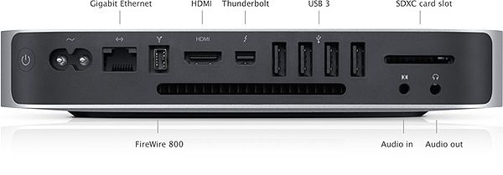

<https://altex.ro/sistem-all-in-one-apple-imac-mk452ro-a-21-5-ips-4k-display-quad-core-intelr-coretm-i5-pana-la-3-6ghz-8gb-1tb-intelr-iristm-pro-graphics-6200-os-x-el-capitan-tastatura-layout-ro>

<http://www.cel.ro/calculatoare-desktop/apple/1c-1>

<http://www.cel.ro/cauta/laptop-laptopuri/mac+pro/diagonala-lcd-i409/15.4/4j-1>

<https://altex.ro/sistem-all-in-one-apple-imac-mmqa2ze-a-21-5-ips-full-hd-intelr-coretm-i5-pana-la-3-6ghz-8gb-1tb-intel-iris-plus-graphics-640-macos-sierra-tastatura-layout-int>

<https://altex.ro/sistem-it-apple-mac-mini-mgen2rc-a-intel-core-i5-pana-la-3-1ghz-8gb-1tb-intel-iris-graphics-os-x-yosemite-ro>

<https://www.olx.ro/oferta/imac-late-2012-21-5-2-7ghz-i5-8gb-ddr3-ID93JRx.html#274e6b1ce0>

<https://support.apple.com/en-us/HT202214>

imac ports

imac vs mac mini

mac mini pret

<http://www.istyle.eu/ro/mac/mac-mini.html>

<https://www.imore.com/mac-mini-vs-imac-vs-mac-pro-which-apple-desktop-should-you-get>

<https://www.price.ro/preturi_apple_mac_mini_(mgen2rc_a)_1097717.htm>

core i5 2.6 GHz

De ce spun ca e ultimul Mac mini OK? Pentru ca poti sa il duci la 16 GB de RAM (gasesti kit Crucial pt Mac/Corsair Mac Memory - aprox 600 lei) + SSD (si daca iei cablul special poti pune si HDD-ul vechi + SSD). Indiferent ca e varianta cu i5 sau cea cu i7, cu upgrade-ul asta va merge extraordinar. Din pacate, varianta Mac mini 2014 nu iti mai ofera aceasta posibilitate - vine cu RAM-ul sudat de logic board, deci cu cati GB de RAM il iei, cu atatia ramai. Cand il cumperi, alegi cu cati GB de RAM vrei sa fie, iar pretul pentru 16GB este aberant!!!!! Plus ca procesorul nu e mare scofala fata de generatia anterioara. Iar in cazul configuratiei cu i7 - varianta din 2012 este mai puternica decat cea din 2014!!!! Gasiti pe net comparatia intre modelul cu i7 - 2012 si 2014

mac mini upgrade ram

<https://www.ifixit.com/Teardown/Mac+Mini+Late+2014+Teardown/30410>

<http://www.macworld.com/article/2836399/new-mac-mini-restricts-ram-and-storage-upgrades-but-hints-at-pcie-ssd-possibilities.html>

mac mini ssd

<https://www.theverge.com/2016/6/4/11856464/apple-mac-mini-solid-state-drive-replacement-repair>

<https://www.ifixit.com/Guide/Mac+Mini+Late+2014+Hard+Drive+Replacement/32815>

Q:

unsigned assembly

signed assemblies.

Please give your assembly a strong name

Q:

<https://books.google.ro/books?id=18SuDgAAQBAJ&pg=PT30&lpg=PT30&dq=adaptive+code+agile+coding+with+design+patterns+and+solid+principles+pdf&source=bl&ots=CuLL9rRJ6o&sig=Y833oVWdVFFr7ybcxdAwpDr3ruk&hl=ro&sa=X&ved=0ahUKEwipiqHWzv7UAhXPYVAKHY_XCFk4FBDoAQhuMAk#v=onepage&q=adaptive%20code%20agile%20coding%20with%20design%20patterns%20and%20solid%20principles%20pdf&f=false>

Q:

<https://stackoverflow.com/questions/33115/does-c-sharp-have-the-notion-of-private-and-protected-inheritance>

private inheritance

Q:

**That assembly does not allow partially trusted callers**

<https://forums.asp.net/t/1205183.aspx?System+Security+SecurityException+That+assembly+does+not+allow+partially+trusted+callers>

<https://support.microsoft.com/en-us/help/839300/how-to-use-the-allowpartiallytrustedcallers-attribute-to-call-an-assem>

Q: Cum aflu directorul current si EXE

Current directory : C:\Program Files (x86)\Sparx Systems\EA

Assembly name : file:///D:/ProiecteCSharp/EAAddIn1/EAAddIn1Main/EAAddIn1Main/bin/Release/EAAddIn1Main.dll

Path : D:\ProiecteCSharp\EAAddIn1\EAAddIn1Main\EAAddIn1Main\bin\Release

Uri : file:///D:/ProiecteCSharp/EAAddIn1/EAAddIn1Main/EAAddIn1Main/bin/Release/EAAddIn1Main.dll

Assembly name :D:\ProiecteCSharp\EAAddIn1\EAAddIn1Main\EAAddIn1Main\bin\Release\EAAddIn1Main.dll

string codeBase = Assembly.GetExecutingAssembly().CodeBase;

UriBuilder uri = new UriBuilder(codeBase);

string path = Uri.UnescapeDataString(uri.Path);

return Path.GetDirectoryName(path);

string location = Assembly.GetExecutingAssembly().Location;

String logFile = Path.GetDirectoryName(location)+"\\SystemModelingAddins.dll.config";

Q:

Si celelalte !!

<http://www.free-it-ebook.com/download/programming/c/Beginningc.pdf> interesant !!!!

Q:

directorul curent

Q: Despre COM visible si un baptist

<http://jumbloid.blogspot.ro/2009/12/making-net-dll-com-visible.html>

Q:

register com object for current user

<https://stackoverflow.com/questions/1016568/c-regasm-generating-registry-entries-for-every-class-in-my-com-dll>

<https://www.codeproject.com/Articles/12741/Tlbexp-exe-and-Regasm-exe-NET-FrameWork-Tools-Seri>

Q:

<https://msdn.microsoft.com/en-us/library/dd873579.aspx#Step2>

registry monitor

Q:

regasm without admin rights

<http://sparxsystems.com/forums/smf/index.php?topic=30809.0>

<https://msdn.microsoft.com/en-us/library/ms973913.aspx> registration free COM Components

<https://stackoverflow.com/questions/334603/is-there-an-hkey-current-user-equivalent-of-hkey-classes-root-record>

[**https://stackoverflow.com/questions/23063552/calling-regasm-without-administrative-rights-for-com-interop-in-excel-vba**](https://stackoverflow.com/questions/23063552/calling-regasm-without-administrative-rights-for-com-interop-in-excel-vba)

zice de [RegistrationServices.RegisterAssembly](http://msdn.microsoft.com/en-us/library/system.runtime.interopservices.registrationservices.registerassembly%28v=vs.110%29.aspx) .

<https://stackoverflow.com/questions/7594280/how-to-register-interop-net-asssembly-per-user-without-administrator-privileges>

fain zice de Wow6432Node

fain zice si de HKEY_CURRENT_USER\Software\Classes

HKEY_CLASSES_ROOT. You need to replace these with HKEY_CURRENT_USER\Software\Classes

On x64

"HKEY_CLASSES_ROOT\CLSID" must become "HKEY_CURRENT_USER\Software\Classes\Wow6432Node\CLSID".

To make it work on x86 you only need to make this change for CLSID entries.

Q:

<https://stackoverflow.com/questions/1354581/com-interop-without-regasm/>

**z**ice de [RegistrationServices.RegisterAssembly](http://msdn.microsoft.com/en-us/library/system.runtime.interopservices.registrationservices.registerassembly%28v=vs.110%29.aspx) .

I solved this by running regasm with the /regfile option, and replacing HKLM with HKCU in the resulting .reg file.

the regasm output that I get when using this approach does not contain any HKLM keys, only HKEY_CLASSES_ROOT,

Heh... nevermind, I found it: HKCU\Software\Classes

Fain zice de

There's [RegistrationServices.RegisterAssembly](http://msdn.microsoft.com/en-us/library/system.runtime.interopservices.registrationservices.registerassembly%28v=vs.110%29.aspx) .NET API (which I believe is used by RegAsm.exe).

There's also [RegOverridePredefKey](http://msdn.microsoft.com/en-us/library/windows/desktop/ms724901%28v=vs.85%29.aspx) Win32 API, inconspicuous but quite useful,

which allows to remap HKEY_CLASSES_ROOT (used by RegisterAssembly) to HKEY_CURRENT_USER\Software\Classes

Fain

Q:

<https://stackoverflow.com/questions/3991806/can-i-run-regasm-without-being-administrator>

*Asta nu e sufficient de precis in explicatie*

*Try this: Using* [*regasm*](http://msdn.microsoft.com/en-us/library/tzat5yw6%28v=vs.90%29.aspx)*, generate the registry entries with /regfile argument. By default, registry entries should use*

*HKEY_CLASSES_ROOT (HKCR) as a root.*

*Modify the entries (manually, or by script) to use HKEY_CURRENT_USER (HKCU).*

*Finally, distribute your .NET DLL with the registry script.*

*You can still run regedit without admin rights to register your .NET DLL. Manually from the command line, using a batch file, or a (tiny) separate installation program can handle the registration*

Q:

Net Framework 4.5.1

<https://www.microsoft.com/net/targeting?utm_source=getdotnetsdk&utm_medium=referral>

Q:

Schema Composer

<http://sparxsystems.com/forums/smf/index.php?topic=30809.0>

You need to download the three repositories for the code to compile.  
More info on how to use the EA Addin Framework here: [https://bellekens.com/2014/05/27/how-to-use-the-enterprise-architect-add-in-framework](https://bellekens.com/2014/05/27/how-to-use-the-enterprise-architect-add-in-framework/)

<https://github.com/GeertBellekens/Enterprise-Architect-Add-in-Framework>

Q:

EA only works with 32 bit dll's.

<http://sparxsystems.com/forums/smf/index.php?topic=5941.0>

<https://exploringea.com/2015/01/19/one-of-our-add-ins-is-missing/>

[**https://geertbellekens.wordpress.com/2011/01/29/tutorial-create-your-first-c-enterprise-architect-addin-in-10-minutes/**](https://geertbellekens.wordpress.com/2011/01/29/tutorial-create-your-first-c-enterprise-architect-addin-in-10-minutes/) **BUN**

[**http://community.sparxsystems.com/tutorials/572-44create-your-first-c-enterprise-architect-add-in-in-10-minutes**](http://community.sparxsystems.com/tutorials/572-44create-your-first-c-enterprise-architect-add-in-in-10-minutes)

<https://bellekens.com/2011/02/23/tutorial-deploy-your-enterprise-architect-csharp-add-in-with-an-msi-package/>

<http://community.sparxsystems.com/community-resources/772-ea-installation-inspector%20>

<http://community.sparxsystems.com/community-resources/1065-use-c-java-for-your-vb-script>

Q:

<https://stackoverflow.com/questions/8519781/viewer-tool-for-global-assembly-cache-viewer>

<https://stackoverflow.com/questions/9498234/how-to-view-the-folder-and-files-in-gac>

<https://docs.microsoft.com/en-us/dotnet/framework/app-domains/how-to-view-the-contents-of-the-gac>

<https://stackoverflow.com/questions/7469452/is-there-any-tool-for-gac-management>

<http://gacbrowser.blogspot.ro/2008/03/gac-browser-introduction.html>

<https://www.codeproject.com/Articles/430568/A-GAC-Manager-Utility-and-API>

<http://www.nirsoft.net/dot_net_tools/gac_viewer.html>

Q:

<https://stackoverflow.com/questions/981761/is-it-possible-to-register-a-net-assembly-as-com-without-strong-naming-it>

<https://stackoverflow.com/questions/4864892/why-exactly-does-regasm-warn-me-about-signing-with-a-strong-name>

Ok, so i know how to strong name an assembly and regasm it, so I can access it from a an ASP page.

By strong naming it, it can be placed in the **GAC** and thus be easily accessible from an ASP page.

Is it possible to somehow register the assembly

**Signing an assembly** that is meant to act as a COM server ensures that the assembly

**doesn't collide with other COM**-registered assemblies

on the same computer. Without the signing, if two COM-registered assemblies had methods of the same name,

it could cause problems.

**Strong naming is mainly used to put the Dlls into the GAC**.

So you can have several versions of the Dll with the same name(!) safely on the same computer, which with regular COM-Dlls often produced issues.

Not signing the Dlls removes the ability to GAC it. You don't have any immediate problems because of that but you don't use a useful feature, so you get a warning

Q:

RegAsm : RA0000 : Registering an unsigned assembly with /codebase can

cause your assembly to interfere with other applications that may be installed on

the same computer.

The /codebase switch is intended to be used only with signed assemblies.

Please give your assembly a strong name and re-register it.

RegAsm : error RA0000 : An error occurred while writing the registration information to the registry.

You must have administrative credentials to perform this task. Contact your system administrator for assistance.

"%windir%\Microsoft.NET\Framework\v2.0.50727\RegAsm.exe"

/unregister

/nologo

Project Build Settings (nu e folosit la VED)



Asta da

<https://docs.microsoft.com/en-us/dotnet/api/system.runtime.interopservices.comvisibleattribute?view=netframework-4.7.2>

[ComVisible(true)]

public class AddIn

{



// Setting ComVisible to false makes the types in this

// assembly not visible

// to COM components.

// If you need to access a type in this assembly from

// COM, set the ComVisible attribute to true on that type.

[assembly: ComVisible(false)]

Fara /nologo

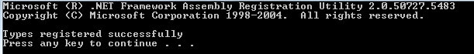

Cu /nologo

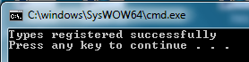

Q:

C:\WINDOWS\Microsoft.NET\Framework\v2.0.50727\RegAsm.exe "D:\ProiecteCSharp\EAAddIn1\EAAddIn1Main\EAAddIn1Main\bin\Release\EAAddIn1Main.dll" /verbose /regFile:.abc.reg

Registry script 'C:\windows\system32\abc.reg' generated successfully

Q:

BackgroundWorker ce dragut

<https://msdn.microsoft.com/en-us/library/system.componentmodel.backgroundworker(v=vs.110).aspx>

Q:

<https://superuser.com/questions/382819/can-you-order-videos-in-windows-explorer-by-last-played-accessed>

That's the theory. **In practice that does not work**, the date shown is usually the same as the 'last modified' date.

The reason why this does not work is that updating each file when it is accessed takes time and would slow down your OS.

So by default Microsoft disabled the update of the "Date Accessed" property.

Open the Registry with regedit.exe and navigate to:

[HKEY_LOCAL_MACHINE\SYSTEM\CurrentControlSet\Control\FileSystem]

There is a value '**NtfsDisableLastAccessUpdate**' that is usually set to 1, meaning this update of the date is disabled. You can change this to 0 to enable it. After rebooting your machine Windows will now update the 'accessed date' property on files. You can test this by just open a text file without editing it and you'll see a fresh "Date Accessed".

This doesn't really help you with your videos because when you last watched them, this feature was disabled.

|  |  |
| --- | --- |
|  |  |

Q:

<https://code.msdn.microsoft.com/Simple-Calculator-d1d8cf4c?SRC=VSIDE>

<https://code.msdn.microsoft.com/Windows-Phone-Calculator-6f44a9f2>

Visual Studio for Windows Phone Express

<https://msdn.microsoft.com/en-us/library/windows/apps/ff630878(v=vs.105).aspx#BKMK_WindowsPhonedevelopmentwithVisualStudio>

<https://developer.microsoft.com/en-us/windows/apps>

UWP apps that work on all Windows 10 devices — PCs, tablets, phones, and more.

Q:

<https://docs.microsoft.com/en-us/dotnet/articles/fsharp/>

C:\Program Files (x86)\FSharp-1.9.4.19\samples\fsharp\Doc.html

"C:\Program Files (x86)\FSharp-1.9.4.19"

<http://geekswithblogs.net/mapfel/archive/2013/05/01/152829.aspx>

<https://www.microsoft.com/en-us/download/details.aspx?id=52590> F# Compiler

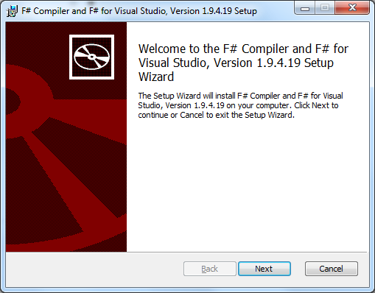

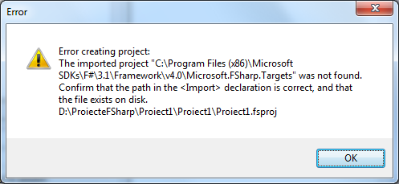

Q:

Thinking in LINQ

<http://www.free-it-ebook.com/download/programming/microsoftnet/Thinking%20in%20LINQ.pdf>

<http://apprize.info/programming/linq/1.html> fain !

Q:

<http://www.albahari.com/nutshell/linqbridge.aspx>

Q:

<http://www.free-it-ebook.com/download/programming/microsoftnet/>

<http://www.free-it-ebook.com/download/programming/microsoftnet/Programming%20Entity%20Framework%20Code%20First.pdf>

<http://www.free-it-ebook.com/download/programming/microsoftnet/AOP_In_.NET.pdf>

<http://www.free-it-ebook.com/download/programming/c/Functional_Programming_In_C.pdf>

<http://www.free-it-ebook.com/download/programming/c/C%23Programming.pdf>

<http://www.free-it-ebook.com/download/programming/c/_5.0_And_The_.NET_4.5_Framework.pdf>

Q: soap request custom encoder

<https://blogs.msdn.microsoft.com/distributedservices/2010/01/06/manipulate-a-wcf-request-response-using-a-custom-encoder/>

<https://www.ptcusercommunity.com/thread/59859>

<https://www.ptcusercommunity.com/message/273036>

<https://social.msdn.microsoft.com/Forums/vstudio/en-US/82cbdb61-354a-4b7e-87de-e47d69af215b/wcf-client-talking-to-java-ws-exception-the-content-type-applicationxopxml?forum=wcf>

<https://www.ptcusercommunity.com/message/488340>

<https://developer.jboss.org/thread/156175>

Q:

System.ServiceModel.CommunicationException: Error creating a reader for the MTOM message ---> System.Xml.XmlException: Root MIME part must contain non-zero length value for 'charset' parameter in Content-Type header.

at System.Xml.XmlMtomReader.ReadRootContentTypeHeader(ContentTypeHeader header, Encoding[] expectedEncodings, String expectedType)

at System.Xml.XmlMtomReader.Initialize(Stream stream, String contentType, XmlDictionaryReaderQuotas quotas, Int32 maxBufferSize)

at System.Xml.XmlMtomReader.SetInput(Stream stream, Encoding[] encodings, String contentType, XmlDictionaryReaderQuotas quotas, Int32 maxBufferSize, OnXmlDictionaryReaderClose onClose)

at System.ServiceModel.Channels.MtomMessageEncoder.MtomBufferedMessageData.TakeXmlReader()

--- End of inner exception stack trace ---

Server stack trace:

at System.ServiceModel.Channels.MtomMessageEncoder.MtomBufferedMessageData.TakeXmlReader()

at System.ServiceModel.Channels.BufferedMessageData.GetMessageReader()

at System.ServiceModel.Channels.BufferedMessage..ctor(IBufferedMessageData messageData, RecycledMessageState recycledMessageState, Boolean[] understoodHeaders, Boolean understoodHeadersModified)

at System.ServiceModel.Channels.MtomMessageEncoder.ReadMessage(ArraySegment`1 buffer, BufferManager bufferManager, String contentType)

at System.ServiceModel.Channels.MessageEncoder.ReadMessage(Stream stream, BufferManager bufferManager, Int32 maxBufferSize, String contentType)

at System.ServiceModel.Channels.HttpInput.ReadChunkedBufferedMessage(Stream inputStream)

at System.ServiceModel.Channels.HttpInput.ParseIncomingMessage(HttpRequestMessage httpRequestMessage, Exception& requestException)

at System.ServiceModel.Channels.HttpChannelFactory`1.HttpRequestChannel.HttpChannelRequest.WaitForReply(TimeSpan timeout)

at System.ServiceModel.Channels.RequestChannel.Request(Message message, TimeSpan timeout)

at System.ServiceModel.Dispatcher.RequestChannelBinder.Request(Message message, TimeSpan timeout)

at System.ServiceModel.Channels.ServiceChannel.Call(String action, Boolean oneway, ProxyOperationRuntime operation, Object[] ins, Object[] outs, TimeSpan timeout)

at System.ServiceModel.Channels.ServiceChannelProxy.InvokeService(IMethodCallMessage methodCall, ProxyOperationRuntime operation)

at System.ServiceModel.Channels.ServiceChannelProxy.Invoke(IMessage message)

Q: Cautare Google

Client found response content type of 'multipart/related; type="application/xop+xml"; start="<rootpart@ws.jboss.org>"; start-info="text/xml";

Q:

System.InvalidOperationException: Client found response content type of 'multipart/related; type="application/xop+xml"; start="<rootpart@ws.jboss.org>"; start-info="text/xml"; boundary="----=_Part_2_393602499.1494413207524"', but expected 'text/xml'.

The request failed with the error message:

--

------=_Part_2_393602499.1494413207524

Content-Type: application/xop+xml; type="text/xml"

Content-Transfer-Encoding: 8bit

Content-ID: <rootpart@ws.jboss.org>

<env:Envelope xmlns:env='http://schemas.xmlsoap.org/soap/envelope/'><env:Header></env:Header><env:Body><ns3:fetchAttachmentsResponse xmlns:ns1="http://webservice.mks.com/10/2/Integrity/schema" xmlns:ns3="http://webservice.mks.com/10/2/Integrity"><return><ns1:Attachment><xop:Include xmlns:xop="http://www.w3.org/2004/08/xop/include" href="cid:Attachment-12b4e7d1-754-404d-a426-34c99087fd59@ws.jboss.org"/></ns1:Attachment></return></ns3:fetchAttachmentsResponse></env:Body></env:Envelope>

------=_Part_2_393602499.1494413207524

Content-Type: image/png

Content-Transfer-Encoding: binary

Content-Id: <Attachment-12b4e7d1-754-404d-a426-34c99087fd59@ws.jboss.org>

?PNG

Q:

<http://stackoverflow.com/questions/2859148/cannot-connect-to-any-online-resource>

|  |
| --- |
| The following worked for me, I got this from the blog entry listed below.  in the **devenv.exe.config** file, in the **<system.net>** section add:  <defaultProxy useDefaultCredentials="true" enabled="true">  <proxy usesystemdefault="True" />  </defaultProxy> |
| <system.net>  <defaultProxy useDefaultCredentials="true" enabled="true">  <proxy proxyaddress="http://your.proxyserver.ip:port"/>  </defaultProxy>  <settings>  <ipv6 enabled="true"/>  <servicePointManager expect100Continue="false" />  </settings>  </system.net>  C:\Program Files (x86)\Microsoft Visual Studio 10.0\Common7\IDE\devenv.exe.config |
| <configuration>  <system.net>  <settings>  <servicePointManager expect100Continue="false" />  </settings>  </system.net>  </configuration> |

<http://server:port/webservices/2009/7/Source/?wsdl>

is not a valid namespace for the service reference

Q

Q:

Data Access Layer is about storage, files and databases

CSV files and INI files are a kind of database, must be in DALC not in Business Logic !

Q:

<http://dailydotnettips.com/2015/07/19/write-unit-test-automatically-using-intellitest-in-visual-studio-2015/>

Q:

<https://www.mathworks.com/matlabcentral/answers/179296-why-do-i-receive-excel-primary-interop-assembly-is-not-found-error-when-creating-excel-add-in-clie?requestedDomain=www.mathworks.com>

Q:

<https://developer.microsoft.com/en-us/windows/apps/getstarted>

<https://developer.microsoft.com/en-us/windows/windows-10-for-developers>

What's a Universal Windows Platform (UWP) app

The Universal Windows Platform (UWP) is the app platform for Windows 10.

<https://docs.microsoft.com/en-us/windows/uwp/get-started/whats-a-uwp>

<https://docs.microsoft.com/en-us/windows/uwp/get-started/universal-application-platform-guide>

Windows 10 introduces the Universal Windows Platform (UWP), which provides a common app platform available on every device that runs Windows 10. With this evolution, apps that target the UWP can call not only the WinRT APIs that are common to all devices, but also APIs (including Win32 and .NET APIs) that are specific to the device family the app is running on.

Some options for writing apps in UWP include:+

* XAML UI and a C#, VB, or C++ backend
* DirectX UI and a C++ backend
* JavaScript and HTML

Q: XAML WPF

<https://msdn.microsoft.com/en-US/library/ms754130(v=vs.110)>

wpf

<https://msdn.microsoft.com/en-us/library/orm-9780596521066-01-19.aspx>

Q:

Update 3

Service Pack 3

<https://www.visualstudio.com/en-us/news/releasenotes/vs2015-update3-vs>

<https://blogs.msdn.microsoft.com/visualstudio/2016/06/27/visual-studio-2015-update-3-and-net-core-1-0-available-now/>

<https://go.microsoft.com/fwlink/?LinkId=708984>

<http://stackoverflow.com/questions/38134857/visual-studio-2015-update-3-offline-installer-iso>

<http://stackoverflow.com/questions/38079986/cant-install-vs-2015-update-3>

<http://www.kunal-chowdhury.com/2016/06/visual-studio-2015-update-3.html#bcqADAFjAQOkUB6w.97>

Note:  
**I don't condone any illegal use** of the offline installer.  
Please **stop piracy** and **follow the EULA**.

The community edition is free even for commercial use, under some condition.  
You can see the EULA in this link below.  
<https://www.visualstudio.com/support/legal/mt171547>  
Thank you.

<https://www.visualstudio.com/downloads/>

Q:

<http://stackoverflow.com/questions/6093239/difference-between-int-and-systemint32>

<http://stackoverflow.com/questions/62503/c-int-or-int32-should-i-care>

The two are indeed synonymous; int will be a little more familiar looking,

Int32 makes the 32-bitness more explicit to those reading your code.

I would be inclined to use int where I just need 'an integer', Int32 where the size is important (cryptographic code, structures)

For example, the keyword int refers to the struct System.Int32

They both declare 32 bit integers

public String ss;

public Int32 ii;

int is the C# language's shortcut for System.Int32

The C# ECMA standard specifically says that int is 32 bit and long is 64 bit.

Q:

<https://blogs.msdn.microsoft.com/csharpfaq/2004/03/12/whats-the-difference-between-string-and-system-string/>

C# defines a number of aliases for CLR types. They may be used interchangably, and even mixed together,

net system.String vs string

string is a reserved word, but String is just a class name

[What is the difference between String and string in C#?](http://stackoverflow.com/questions/7074/what-is-the-difference-between-string-and-string-in-c)

int in C# is the same as System.Int32 of .Net.

Q:

net framework create generic class

<https://msdn.microsoft.com/en-us/library/ms379564(v=vs.80).aspx>

**public** class Box<TYPENAME>   
{  
    // T stands for "Type"  
    **private** TYPENAME *t*;  
  
    **public** Box() {}  
      
    **public** Box(TYPENAME t)    { **this**.*t* = t;}  
      
    **public** void **set**(TYPENAME t) { **this**.*t* = t; }  
    **public** TYPENAME **get**() { return *t*; }  
}  
  
**public** interface Pair<KK, VV>   
{  
     KK **getKey**();  
     VV **getValue**();  
}  
  
**public** class OrderedPair<KEY, VALUE> : Pair<KEY, VALUE>  
{  
  
    **private** KEY *key*;  
    **private** VALUE *value*;  
  
    **public** OrderedPair(KEY key, VALUE value)

{  
     **this**.*key* = key;     **this**.*value* = value;  
    }  
      
    **public**  KEY **getKey**()    { return *key*; }  
    **public**  VALUE **getValue**() { return *value*; }  
      
}

Q:

Box<**int**> integerBox = **new** Box<**int**>();  
                integerBox.**set**(200);  
  
                Pair<**int**, Box<**int**>> pi = **ReturnInterface**();  
                MessageBox.**Show**(integerBox.**get**()+"\r\n"+pi.**getKey**().**ToString**()+ " "+ pi.**getValue**().**get**());  
                  
                 OrderedPair<string, **int**> p1 = **new** OrderedPair<string, **int**>("Even", 9);  
                  OrderedPair<string, string>  p2 = **new** OrderedPair<string, string>("hello", "world");  
                  MessageBox.**Show**(p1.**getKey**()+ " "+p1.**getValue**()+"\r\n"+  
                                  p2.**getKey**()+ " "+p2.**getValue**());  
  
        }  
          
        **private** Pair<**int**, Box<**int**>> **ReturnInterface**()  
        {  
                   Box<**int**> integerBox = **new** Box<**int**>(14);  
                     
                   OrderedPair<**int**, Box<**int**>> p3 = **new** OrderedPair<**int**, Box<**int**>>(8, integerBox);  
                   Pair<**int**, Box<**int**> > pi = p3;  
                     
                   return pi;  
         }

Q:

private class App // da eroare

Elements defined in a namespace cannot be explicitly declared as private, protected, or protected internal

Internal types or members are accessible only within files in the same assembly, as in this example:

Internal methods are public for the same assembly, but invisible for other assemblies

<http://stackoverflow.com/questions/9302236/why-use-a-public-method-in-an-internal-class>

A public member of a class or struct is a member that is accessible

to anything that can access the containing type.

So a public member of an internal class is effectively internal.

So now, given an internal class, should its members that you wish to access in the assembly be marked as public or internal?

My opinion is: mark such members as public.

I use "public" to mean "this member is not an implementation detail".

A protected member is an implementation detail; there is something about it that is going to be needed to make a derived class work.

An internal member is an implementation detail; something else internal to this assembly needs the member in order to work correctly.

A public member says "this member represents the key, documented functionality provided by this object."

|  |  |
| --- | --- |
| public class Sensor  {  public int state;  public Sensor()  {  }  public void turnOn()  {  Heater h = new Heater();  h.turnOn();  h.turnOff();//internal methods are public for the same assembly, but invisible for other assemblies  h.state = 1;  }  internal void turnOff()  {  }  } | internal class Heater  {  public int state;  public Heater()  {  }  public void turnOn()  {  Sensor s = new Sensor();  s.turnOn();  s.turnOff();//internal methods are public for the same assembly, but invisible for other assemblies  s.state = 1;  }  internal void turnOff()  {  }  } |

|  |
| --- |
| Sensor s = new Sensor();  s.turnOn();  //turnOff method is internal in the Sensor class  //s.turnOff();  //'ClassLibraryInternal.Heater' is inaccessible due to its protection level  //Heater h = new Heater(); |

Q:

<http://modeling.codeplex.com/>

[class diagram one-to-many association](http://stackoverflow.com/questions/4416489/class-diagram-one-to-many-association)

For example when I simply create an association between two classes I receive one-to-one relation, when I create property Cars with type List and then apply "Show as Collection Association" I get an error "Cannot show as association because List cannot be found...", how to make one-to-many association?

<http://blog.ondrejsv.com/post/Modeling-Power-Toys-for-Visual-Studio-2012.aspx>

visual studio class diagram one to many relationship

<https://msdn.microsoft.com/en-us/library/dd323862.aspx>

<https://msdn.microsoft.com/en-us/library/dd409416.aspx>

<https://msdn.microsoft.com/en-us/library/dd323862(VS.100).aspx>

<http://stackoverflow.com/questions/2590098/how-to-do-a-one-to-many-relationship-in-uml-with-visual-studio-2010>

This is what I managed to do in VS2010 Professional:

Add Food as a property of a collection type (I used ObservableCollection) to MealEvent.

Then right-click the property and ***Show as Collection Association***.

you will now get a double arrow --->> indicating the multiplicity

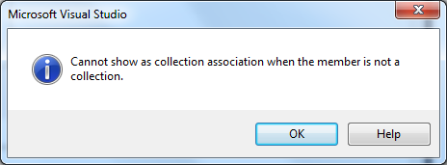

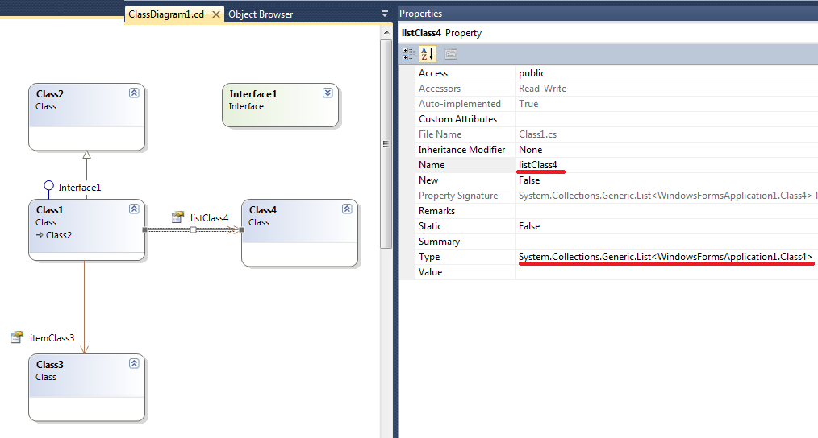

Q:

Visual Studio Code

<https://code.visualstudio.com/docs/?dv=win>

<https://www.froala.com/wysiwyg-editor>

Q:

oozinoz_cs_1.04.zip

ozzi

Q:

WCF Service

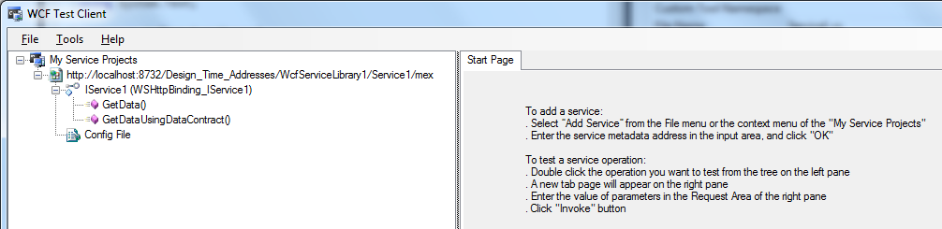

<https://msdn.microsoft.com/en-us/library/bb386386.aspx>

public class Service1 : IService1

{

public string GetData(string value)

{

return string.Format("You entered: {0}", value);

}

}

WCF Client

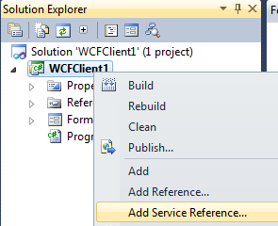

Right-click **WindowsApplication1** and click **Add Service Reference**.

The **Add Service Reference** dialog box will appear.

Q:

<https://mva.microsoft.com/en-US/training-courses/demystifying-linq-12301?l=94qIp9SKB_8804668937>

<https://mva.microsoft.com/en-US/training-courses/querying-with-transactsql-10530?l=TjT07f87_9804984382>

<https://mva.microsoft.com/en-US/training-courses/c-fundamentals-for-absolute-beginners-16169?l=Lvld4EQIC_2706218949>

<https://mva.microsoft.com/en-US/training-courses/programming-in-c-jump-start-14254?l=j0iuozSfB_6900115888>

<https://mva.microsoft.com/en-US/training-courses/twenty-c-questions-answered-8298?l=Rm10ISYy_904984382>

<http://stackoverflow.com/questions/13166019/will-the-base-class-constructor-be-automatically-called>

Q:

<http://www.jeremybytes.com/Downloads/LearnToLoveLambdas.pdf> Fain

<http://www.jeremybytes.com/Downloads/Slides-LearnToLoveLambdas.pdf>

Q:

In file clipboard type DataObject, C# type Byte[], length:4

In file clipboard type Object Descriptor, C# type Byte[], length:148

In file clipboard type Rich Text Format, C# type String

In file clipboard type HTML Format, C# type String

In file clipboard type Text, C# type String

In file clipboard type UnicodeText, C# type String

In file clipboard type EnhancedMetafile, C# type Byte[], length:366224

In file clipboard type Embed Source, C# type Byte[], length:45164

In file clipboard type Native, C# type Byte[], length:45169

In file clipboard type OwnerLink, C# type Byte[], length:43

In file clipboard type Link Source, C# type Byte[], length:197

In file clipboard type Link Source Descriptor, C# type Byte[], length:168

In file clipboard type ObjectLink, C# type Byte[], length:51

In file clipboard type Hyperlink, C# type Byte[], length:783

In file clipboard type Ole Private Data, C# type Byte[], length:440

In file clipboard type Locale, C# type Byte[], length:4

Q:

In file clipboard type DataObject, C# type MemoryStream, length:4

In file clipboard type Visio 15.0 Shapes, C# type MemoryStream, length:44758

In file clipboard type Visio 15.0 Text, C# type MemoryStream, length:44758

In file clipboard type Visio 11.0 Shapes, C# type MemoryStream, length:55731

In file clipboard type Embed Source, C# type MemoryStream, length:49152

In file clipboard type Native, C# type MemoryStream, length:49152

In file clipboard type OwnerLink, C# type MemoryStream, length:72

In file clipboard type Object Descriptor, C# type MemoryStream, length:206

In file clipboard type EnhancedMetafile, C# type Byte[]

In file clipboard type DeviceIndependentBitmap, C# type MemoryStream, length:892536

In file clipboard type Ole Private Data, C# type MemoryStream, length:376

In file clipboard type Bitmap, C# type Bitmap

In file clipboard type Format17, C# type MemoryStream, length:892620

La citirea fisierului serializat

|  |  |
| --- | --- |
| In serialized file | In clipboard |
| 1. DataObject  2. Visio 15.0 Shapes  3. Visio 15.0 Text  4. Visio 11.0 Shapes  5. Embed Source  6. Native  7. OwnerLink  8. Object Descriptor  9. NoteshNote Null data in file  10. NotesDocAction Null data in file  11. EnhancedMetafile  12. DeviceIndependentBitmap  13. Ole Private Data  14. Bitmap  15. Format17 | 1. [49161] DataObject  2. [50000] Visio 15.0 Shapes  3. [50001] Visio 15.0 Text  4. [50002] Visio 11.0 Shapes  5. [49163] Embed Source  6. [49156] Native  7. [49155] OwnerLink  8. [49166] Object Descriptor  9. [CF_ENHMETAFILE] EnhancedMetafile  10. [49893] DeviceIndependentBitmap  11. [49171] Ole Private Data  12. [CF_BITMAP] Bitmap  13. [50207] Format17  14. [CF_METAFILEPICT] MetaFilePict  15. [CF_DIB] DeviceIndependentBitmap  16. [CF_DIBV5] Format17 |

Enhanced Meta file 463x486

**Bitmap Dib** **892 536** I a Pz yyyy

Bitmap 463x486

**Bitmap DIBV5 892 620** I a Pz BGRs yyy

DataObject 4

AC 0F 04 00

Visio 15.0 Shapes PK ! NAU!s i [Content_Types].xml (

PK i N

in fisier 44063

in original 44670

Visio 15.0 Text PK ! NAU!s i [Content_Types].xml (

PK i N

in fisier 44063

in original 44678

Visio 11.0 Shapes Visio (TM) Drawing U eoy ... .v ,t.j

in fisier 55675

in original 55674 Drawing zU U eoy... vC,t.j

Embed Source DI.a+.a > y

Visio Drawing 15 o9 q

in fisier 49152

in original 49152

Native DI.a+.a > y

Visio Drawing 15 o9 q

in fisier 49152

in original 49152

OwnerLink Visio Drawing 15 D:\Visio\LiveSequence.vsdx\Drawing\~Page-1\SELECTION

in fisier 72

in original 72

object Descriptor I A F ^/ n4 4 d Microsoft Visio Drawing D:\Visio\LiveSequence.vsdx....

in fisier 206

in original 206

Ole Private Data x PA yyyy QA yyyy RA yyyy

50C3 51C3 52C3

in fisier 376

in original 376

Q:

c# copy enhanced metafile to clipboard

C# iDataObject EnhancedMetafile copy to clipboard

Q: Serialize enhanced metafile

System.Runtime.InteropServices.ExternalException (0x80004005): A generic error occurred in GDI+.

<http://stackoverflow.com/questions/1053052/a-generic-error-occurred-in-gdi-jpeg-image-to-memorystream>

Q:

c# clipboard enhanced metafile

[**http://stackoverflow.com/questions/18602171/copy-enhanced-metafile-from-clipboard-and-save-it-as-an-image**](http://stackoverflow.com/questions/18602171/copy-enhanced-metafile-from-clipboard-and-save-it-as-an-image) **Meserie**

Metafile metafile = null;

if (OpenClipboard(IntPtr.Zero))

{

if (IsClipboardFormatAvailable(CF_ENHMETAFILE))

{

var ptr = GetClipboardData(CF_ENHMETAFILE);

if (!ptr.Equals(IntPtr.Zero))

{

metafile = new Metafile(ptr, true);

metafile.Save(@"D:\Emails\abc.png");

//copiaza tot ca PNG !

metafile.Save(@"D:\Emails\abc.emf", ImageFormat.Emf);

//too large

//metafile.Save(@"D:\Emails\abc.bmp", ImageFormat.Bmp);

// Get a handle to the metafile

//Trebuie sa fie ultima operatie !

//strica imaginea

IntPtr metaHandle = metafile.GetHenhmetafile();

IntPtr metaHandle2 = CopyEnhMetaFile(metaHandle, @"d:\Emails\abc.emf");

DeleteEnhMetaFile(metaHandle2);

//Arunca exceptie Parameter is not valid

metafile.Save(@"D:\Emails\abc.png");

}

}

// You must close ir, or it will be locked

CloseClipboard();

}

Astea sunt la fel

|  |  |
| --- | --- |
| using (var mem = new MemoryStream())  { {  //metafile.Save(mem, ImageFormat.Bmp);  metafile.Save(mem, ImageFormat.Png);  data = mem.ToArray();  File.WriteAllBytes(@"d:\Emails\abc1.png", data);  } | metafile.Save(@"D:\Emails\abc.png"); |

Astea sunt la fel

|  |  |
| --- | --- |
| IntPtr metaHandle = metafile.GetHenhmetafile();  IntPtr metaHandle2 = CopyEnhMetaFile(metaHandle, @"d:\Emails\abc.emf");  DeleteEnhMetaFile(metaHandle2);  //Arunca exceptie Parameter is not valid  metafile.Save(@"D:\Emails\abc.png"); | IntPtr metaHandle = metafile.GetHenhmetafile();  uint size = GetEnhMetaFileBits(metaHandle, (uint)0, null);  data = new byte[size];  GetEnhMetaFileBits(metaHandle, size, data);  File.WriteAllBytes(@"d:\Emails\abc1.emf", data);  //Arunca exceptie Parameter is not valid  metafile.Save(@"D:\Emails\abc.png"); |

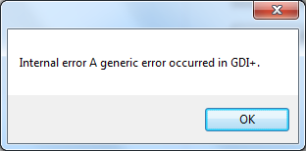

<https://msdn.microsoft.com/en-us/library/windows/desktop/dd183479(v=vs.85).aspx>

Arunca exceptie ! Parameter is not valid

// Get a handle to the metafile

IntPtr metaHandle = metafile.GetHenhmetafile();

IntPtr metaHandle2 = CopyEnhMetaFile(metaHandle, @"d:\Emails\abc.emf");

DeleteEnhMetaFile(metaHandle2);

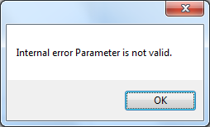

Cannot serialize metafile

<http://floris.briolas.nl/floris/2009/08/c-saving-as-emf/> !!

<https://social.msdn.microsoft.com/Forums/vstudio/en-US/12a1c749-b320-4ce9-aff7-9de0d7fd30ea/how-to-save-or-serialize-a-metafile-solution-found>

<https://msdn.microsoft.com/en-us/library/bb882589.aspx>

nu merge only avoid to use the GetEncoderParameterList for Jpeg codec

<http://stackoverflow.com/questions/7417993/unexpected-error-in-example-using-example-from-msdn-image-encoding-getencoderp>

Save image as EMF

[**http://stackoverflow.com/questions/152729/gdi-c-how-to-save-an-image-as-emf**](http://stackoverflow.com/questions/152729/gdi-c-how-to-save-an-image-as-emf)

var path = @"c:\foo.emf"

var g = CreateGraphics(); // get a graphics object from your form, or wherever

var img = new Metafile(path, g.GetHdc()); // file is created here

var ig = Graphics.FromImage(img);

// call drawing methods on ig, causing writes to the file

ig.Dispose(); img.Dispose(); g.ReleaseHdc(); g.Dispose();

DllImport("gdi32")] static extern uint GetEnhMetaFileBits(IntPtr hemf, uint cbBuffer, byte[] lpbBuffer);

IntPtr h = metafile.GetHenhMetafile();

int size = GetEnhMetaFileBits(h, 0, null);

byte[] data = new byte[size];

GetEnhMetaFileBits(h, size, data);

using (FileStream w = File.Create("out.emf")) {

w.Write(data, 0, size);

}

Asa nu merge da eroare

Bitmap bitmap = new Bitmap(1, 1);

ImageCodecInfo emfEncoder = GetEncoder(ImageFormat.Emf);

EncoderParameters paramList = null;

using (Graphics g = Graphics.FromImage(bitmap))

{

IntPtr hDC = g.GetHdc();

Metafile xmetafile = new Metafile(hDC, EmfType.EmfOnly);

g.ReleaseHdc(hDC);

emfEncoder = GetEncoder(ImageFormat.Emf);

paramList = xmetafile.GetEncoderParameterList(emfEncoder.Clsid);

}

[Convert an image into WMF with .NET?](http://stackoverflow.com/questions/5270763/convert-an-image-into-wmf-with-net)

When you use the Save method to save a graphic image as a Windows Metafile Format (WMF) or Enhanced Metafile Format (EMF) file,

the resulting file is saved as a Portable Network Graphics (PNG) file instead.

This behavior occurs because the GDI+ component of the .NET Framework does not have an encoder

that you can use to save files as .wmf or .emf files.

[**http://stackoverflow.com/questions/5270763/convert-an-image-into-wmf-with-net**](http://stackoverflow.com/questions/5270763/convert-an-image-into-wmf-with-net)

<http://stackoverflow.com/questions/629955/parameter-not-valid-exception-loading-system-drawing-image>

[Flags]

private enum EmfToWmfBitsFlags {

EmfToWmfBitsFlagsDefault = 0x00000000,

EmfToWmfBitsFlagsEmbedEmf = 0x00000001,

EmfToWmfBitsFlagsIncludePlaceable = 0x00000002,

EmfToWmfBitsFlagsNoXORClip = 0x00000004

}

private static int MM_ISOTROPIC = 7;

private static int MM_ANISOTROPIC = 8;

[DllImport ("gdiplus.dll")]

private static extern uint GdipEmfToWmfBits (IntPtr _hEmf, uint _bufferSize,

byte[] _buffer, int _mappingMode, EmfToWmfBitsFlags _flags);

[DllImport ("gdi32.dll")]

private static extern IntPtr SetMetaFileBitsEx (uint _bufferSize,

byte[] _buffer);

[DllImport ("gdi32.dll")]

private static extern IntPtr CopyMetaFile (IntPtr hWmf,

string filename);

[DllImport ("gdi32.dll")]

private static extern bool DeleteMetaFile (IntPtr hWmf);

[DllImport ("gdi32.dll")]

private static extern bool DeleteEnhMetaFile (IntPtr hEmf);

private static MemoryStream MakeMetafileStream (Bitmap image)

{

Metafile metafile = null;

using (Graphics g = Graphics.FromImage (image)) {

IntPtr hDC = g.GetHdc ();

metafile = new Metafile (hDC, EmfType.EmfOnly);

g.ReleaseHdc (hDC);

}

using (Graphics g = Graphics.FromImage (metafile)) {

g.DrawImage (image, 0, 0);

}

IntPtr _hEmf = metafile.GetHenhmetafile ();

uint _bufferSize = GdipEmfToWmfBits (_hEmf, 0, null, MM_ANISOTROPIC,

EmfToWmfBitsFlags.EmfToWmfBitsFlagsDefault);

byte[] _buffer = new byte[_bufferSize];

GdipEmfToWmfBits (_hEmf, _bufferSize, _buffer, MM_ANISOTROPIC,

EmfToWmfBitsFlags.EmfToWmfBitsFlagsDefault);

IntPtr hmf = SetMetaFileBitsEx (_bufferSize, _buffer);

string tempfile = Path.GetTempFileName ();

CopyMetaFile (hmf, tempfile);

DeleteMetaFile (hmf);

DeleteEnhMetaFile (_hEmf);

var stream = new MemoryStream ();

byte[] data = File.ReadAllBytes (tempfile);

//File.Delete (tempfile);

int count = data.Length;

stream.Write (data, 0, count);

return stream;

}

An improved version of what jdehaan posted (kudos btw to him and Vincent)

[Flags]

private enum EmfToWmfBitsFlags

{

EmfToWmfBitsFlagsDefault = 0x00000000,

EmfToWmfBitsFlagsEmbedEmf = 0x00000001,

EmfToWmfBitsFlagsIncludePlaceable = 0x00000002,

EmfToWmfBitsFlagsNoXORClip = 0x00000004

}

private static int MM_ISOTROPIC = 7;

private static int MM_ANISOTROPIC = 8;

[DllImport("gdiplus.dll")]

private static extern uint GdipEmfToWmfBits(IntPtr _hEmf, uint _bufferSize,

byte[] _buffer, int _mappingMode, EmfToWmfBitsFlags _flags);

[DllImport("gdi32.dll")]

private static extern IntPtr SetMetaFileBitsEx(uint _bufferSize,

byte[] _buffer);

[DllImport("gdi32.dll")]

private static extern IntPtr CopyMetaFile(IntPtr hWmf,

string filename);

[DllImport("gdi32.dll")]

private static extern bool DeleteMetaFile(IntPtr hWmf);

[DllImport("gdi32.dll")]

private static extern bool DeleteEnhMetaFile(IntPtr hEmf);

public static MemoryStream MakeMetafileStream(System.Drawing.Bitmap image)

{

Metafile metafile = null;

using (Graphics g = Graphics.FromImage(image))

{

IntPtr hDC = g.GetHdc();

metafile = new Metafile(hDC, EmfType.EmfOnly);

g.ReleaseHdc(hDC);

}

using (Graphics g = Graphics.FromImage(metafile))

{

g.DrawImage(image, 0, 0);

}

IntPtr _hEmf = metafile.GetHenhmetafile();

uint _bufferSize = GdipEmfToWmfBits(_hEmf, 0, null, MM_ANISOTROPIC,

EmfToWmfBitsFlags.EmfToWmfBitsFlagsDefault);

byte[] _buffer = new byte[_bufferSize];

GdipEmfToWmfBits(_hEmf, _bufferSize, _buffer, MM_ANISOTROPIC,

EmfToWmfBitsFlags.EmfToWmfBitsFlagsDefault);

DeleteEnhMetaFile(_hEmf);

var stream = new MemoryStream();

stream.Write(_buffer, 0, (int)_bufferSize);

stream.Seek(0, 0);

return stream;

}

Q:

//crapa asa fara nicio exceptie

Metafile metafile = Clipboard.GetData(DataFormats.EnhancedMetafile) as Metafile;

<https://social.msdn.microsoft.com/Forums/windowsdesktop/en-US/a5cebe0d-eee4-4a91-88e4-88eca9974a5c/excel-copypicture-and-asve-to-enhanced-metafile>

nu MERGE

System.Drawing.Image metafile = Clipboard.GetImage();

<http://dobon.net/vb/dotnet/graphics/getclipboardmetafile.html>

<http://bytes.com/topic/c-sharp/answers/496688-getting-cf_enhmetafile-clipboard>

Use CopyEnhMetaFile to make a copy for your use as the clipboard retains  
ownership of the handle.

<http://www.codeproject.com/Articles/177394/Working-with-Metafile-Images-in-Net>

<https://social.msdn.microsoft.com/Forums/en-US/acdc2ab3-fbc0-46d7-a4ba-99023c06ac5d/richtextbox-and-image?forum=Vsexpressvb>

Copy enhanced meta file to clipboard

[**https://support.microsoft.com/en-us/kb/323530**](https://support.microsoft.com/en-us/kb/323530)

<http://www.codeproject.com/Articles/177394/Working-with-Metafile-Images-in-Net>

<http://forums.codeguru.com/showthread.php?137381-Copy-Enhanced-Metafile-to-Clipboard>

Q:

<http://blog.davidsilvasmith.com/2008/02/creating-metafile-in-net.html>

<http://www.java2s.com/Code/CSharp/2D-Graphics/CreateMetafileMemory.htm>

//returneaza null

System.Drawing.Image metafile = Clipboard.GetImage();

//crapa

Metafile metafile = (Metafile)Clipboard.GetData(**DataFormats.MetafilePict**);

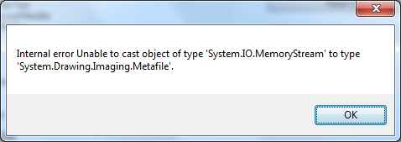

Arunca exceptie

A generic error occurred in GDI+

var ptr = GetClipboardData(CF_METAFILEPICT);

Metafile metafile = new Metafile(ptr, true);

<http://stackoverflow.com/questions/4375324/how-to-convert-a-metafile-to-image-by-dragndroping-in-a-winform>

zice unul despre aceeasi exceptie

I've try your way but I've got an error in the GDI+.

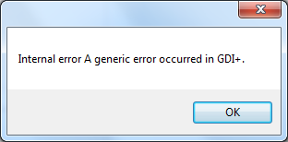

<http://www.ucancode.net/Visual_C_MFC_Samples/Bitmap-metafile-clipboard-OpenClipboard-GetClipboardData-CloseClipboard.htm>

<http://www.codeproject.com/Articles/3355/Getting-a-CF-DIB-or-CF-METAFILEPICT-from-the-clipb>

Ar trebui sa faci PlayMetaFile

CRect metafile(0, 0, 100, 100); *// example location*

if (IsClipboardFormatAvailable(**CF_METAFILEPICT**))

{

// play a metafile from the clipboard if available

GLOBALHANDLE hGMem ;

**LPMETAFILEPICT** lpMFP ;

**OpenClipboard**() ;

hGMem = **GetClipboardData**(CF_METAFILEPICT) ;

lpMFP = (LPMETAFILEPICT)GlobalLock(hGMem) ;

pDC->SaveDC() ;

pDC->SetMapMode(lpMFP->mm) ;

pDC->SetViewportExt(metafile.Width(), metafile.Height()) ;

pDC->SetViewportOrg(metafile.left, metafile.top) ;

pDC->**PlayMetaFile**(lpMFP->hMF) ;

VERIFY(pDC->RestoreDC(-1)) ;

GlobalUnlock(hGMem) ;

**CloseClipboard**() ;

}

if (OpenClipboard(hwnd))

{

hemf = GetClipboardData(uFormat);

GetClientRect(hwnd, &rc);

PlayEnhMetaFile(hdc, hemf, &rc);

CloseClipboard();

}

break;

Q:

Nu face nimic returneaza 0

//// Export metafile to an image file

if (CopyEnhMetaFile(ptr, @"d:\Emails\abc.emf") == IntPtr.Zero)

{

throw new Exception("CopyEnhMetaFile failed");

}

Q:

private String GetClipboardFormatName(uint cf)

{

DataFormats.Format ff = DataFormats.GetFormat((int)cf);

return ff.Name;

//not works reliably with Unicode

//StringBuilder sb = new StringBuilder(1000);

//GetClipboardFormatName(cf, sb, sb.Capacity);

//return sb.ToString();

//http://www.codeproject.com/Articles/15333/Clipboard-backup-in-C

////Get the pointer for the current Clipboard Data

//IntPtr pos = GetClipboardData(format);

////Get the clipboard buffer data properties

//UIntPtr lenght = GlobalSize(pos);

//IntPtr gLock = GlobalLock(pos);

//byte[] buffer;

////Init a buffer which will contain the clipboard data

//buffer = new byte[(int)lenght];

//int l = Convert.ToInt32(lenght.ToString());

////Copy data from clipboard to our byte[] buffer

//Marshal.Copy(gLock, buffer, 0, l);

}

Q:

<http://www.microsoft.com/en-us/download/details.aspx?id=3508>

<https://msdn.microsoft.com/en-us/library/office/ff597925.aspx>

<http://stackoverflow.com/questions/21013912/can-i-still-use-microsoft-office-interop-assemblies-with-office-2013>

<http://viziblr.com/news/2008/10/20/visio-automation-three-hello-world-samples-c-f-and-ironpytho.html>

|  |
| --- |
| [**http://blogs.msdn.com/b/vsofficedeveloper/archive/2008/04/14/rdp-clipboard-ole-limitation.aspx**](http://blogs.msdn.com/b/vsofficedeveloper/archive/2008/04/14/rdp-clipboard-ole-limitation.aspx) |

**embed the interop types instead.**

The PIAs for Office are very large, the great advantage of **embedding the interop types** is that your

assembly only contain the types that you actually use.

My only objection to this answer is that PIA's for Office 2013 ARE still published - for example,

if you have VS2013 installed, you will find them at C:\Program Files (x86)\Microsoft Visual Studio 12.0\Visual Studio Tools for Office\PIA\Office15

<https://channel9.msdn.com/Shows/Going+Deep/Raja-Krishnaswamy-and-Vance-Morrison-CLR-4-Inside-Type-Equivalence>

The workflow is a little different.

Instead of adding a reference to the Microsoft.Office.Interop assemblies as available in the Add Reference dialog, .

NET Framework tab, you **now use the COM tab. And pick, say, "Microsoft Excel 15.0 Object Library**

to generate the interop types for a program that uses Excel.







<http://stackoverflow.com/questions/1922851/c-sharp-excel-interoperability>

Another way to find what the applicable interface is - look at the definition of the class type. The class usually derives from one or more interfaces. Look at the definition of each interface - one of them will have **CoClass** attribute and this is the interface that you are looking for.

<http://blogs.msdn.com/b/mshneer/archive/2009/12/07/interop-type-xxx-cannot-be-embedded-use-the-applicable-interface-instead.aspx>

namespace Microsoft.Office.Interop.Excel

{

[Guid("000208D5-0000-0000-C000-000000000046")]

**[CoClass(typeof(ApplicationClass))]**

public interface **Application** : _Application, AppEvents_Event

{

}

}

<http://stackoverflow.com/questions/11448197/how-to-use-microsoft-office-interop-excel-on-a-machine-without-installed-ms-offi>

You can't use Microsoft.Office.Interop.Excel without having ms office installed.

•http://code.google.com/p/excellibrary/

•http://simpleooxml.codeplex.com/ (only xlsx)

|  |  |  |
| --- | --- | --- |
| |  | | --- | |  | | Yes - the interop assemblies just tell .NET how to call the Excel COM libraries.  They don't have any functionality |

<https://groups.google.com/forum/#!topic/microsoft.public.win32.programmer.kernel/GTG3uwik5m0>

Q:

Word

[**http://stackoverflow.com/questions/15524194/how-to-copy-text-from-one-word-document-to-another-word-document-using-c-sharp**](http://stackoverflow.com/questions/15524194/how-to-copy-text-from-one-word-document-to-another-word-document-using-c-sharp)

<https://social.msdn.microsoft.com/Forums/vstudio/en-US/9851d6a5-6d9e-4a04-a380-9c7e6d8f810c/how-to-get-clipboard-data-that-copied-excel-selection-and-save-it-to-bitmap-file-in-c?forum=vsto>

<http://www.codeproject.com/Articles/61/Clipboard-Copy-in-a-Nutshell>

<http://www.codeproject.com/Articles/18568/Enhanced-Clipboard-Manager-in-NET-using-C-and-Wind>

<https://msdn.microsoft.com/en-us/library/c2thcsx4(v=vs.110).aspx>

<http://stackoverflow.com/questions/9032673/clipboard-copying-objects-to-and-from>

[**http://www.codeproject.com/Articles/8102/Saving-and-obtaining-custom-objects-to-from-Window**](http://www.codeproject.com/Articles/8102/Saving-and-obtaining-custom-objects-to-from-Window)

[**http://stackoverflow.com/questions/2243241/how-do-i-save-a-copy-of-the-clipboard-and-then-revert-back-to-it**](http://stackoverflow.com/questions/2243241/how-do-i-save-a-copy-of-the-clipboard-and-then-revert-back-to-it)

[**http://www.codeproject.com/Articles/15333/Clipboard-backup-in-C**](http://www.codeproject.com/Articles/15333/Clipboard-backup-in-C)

**Warning**

[**https://support.microsoft.com/en-us/kb/287392**](https://support.microsoft.com/en-us/kb/287392)

[**http://stackoverflow.com/questions/645861/disable-warning-you-copied-a-large-amount-of-data-onto-the-clipboard**](http://stackoverflow.com/questions/645861/disable-warning-you-copied-a-large-amount-of-data-onto-the-clipboard) **Trick select**

[**http://superuser.com/questions/382715/how-can-i-avoid-the-clipboard-message-box-when-copying-large-amounts-of-data-in**](http://superuser.com/questions/382715/how-can-i-avoid-the-clipboard-message-box-when-copying-large-amounts-of-data-in) **Display alerts None**

[**https://msdn.microsoft.com/en-us/library/2a9dt54a.aspx**](https://msdn.microsoft.com/en-us/library/2a9dt54a.aspx) **Range in Word**

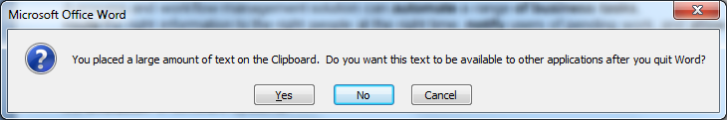

**Q:**

**C# serialize word document clipboard**

**C# copy multiple formats to clipboard**

**http://stackoverflow.com/questions/6001333/c-how-do-i-copy-multiple-objects-to-the-clipboard-and-extract-them-after-it**

You can definitely do this. Copy the bitmap the the clipboard, as usual. Then without clearing the clipboard, call SetClipboardData again to put the text on there

[**http://csharphelper.com/blog/2014/09/copy-and-paste-data-in-multiple-formats-to-the-clipboard-in-c/**](http://csharphelper.com/blog/2014/09/copy-and-paste-data-in-multiple-formats-to-the-clipboard-in-c/)

[**http://www.codeproject.com/Articles/2207/Clipboard-handling-with-NET**](http://www.codeproject.com/Articles/2207/Clipboard-handling-with-NET)

[**https://msdn.microsoft.com/en-us/library/637ys738(v=vs.110).aspx**](https://msdn.microsoft.com/en-us/library/637ys738(v=vs.110).aspx)

// Make a DataObject.

DataObject data_object = new DataObject();

// Add the data in various formats.

data_object.SetData(DataFormats.Rtf, rchSource.Rtf);

data_object.SetData(DataFormats.Text, rchSource.Text);

string html_text;

html_text = "\r\n";

html_text += " The Quick Brown Fox\r\n";

html_text += " \r\n";

html_text += rchSource.Text + "\r\n";

html_text += " \r\n";

html_text += "";

data_object.SetData(DataFormats.Html, html_text);

// Place the data in the Clipboard.

Clipboard.SetDataObject(data_object);

// Make a DataObject.

DataObject data_object = new DataObject();

**Q:**

[**http://microsoft.public.win32.programmer.kernel.narkive.com/dEHuS4wX/is-there-a-way-to-list-all-the-clipboard-formats-known-to-the-system**](http://microsoft.public.win32.programmer.kernel.narkive.com/dEHuS4wX/is-there-a-way-to-list-all-the-clipboard-formats-known-to-the-system)

**CF_RTF**

'#define CF_RTF TEXT("Rich Text Format")  
'#define CF_RTFNOOBJS TEXT("Rich Text Format Without Objects")  
'#define CF_RETEXTOBJ TEXT("RichEdit Text and Objects")

Q

<http://stackoverflow.com/questions/6777422/disposing-of-microsoft-office-interop-word-application> dispose

Q:

<https://social.msdn.microsoft.com/Forums/office/en-US/09f6e80f-411c-43c5-99f2-c3bdc924fc7a/worddocument-serialize>

Q:

Excel

<https://npoi.codeplex.com/documentation>

<http://www.leniel.net/2014/01/npoi-2.0-major-features-enhancements-series-of-posts-scheduled.html#sthash.2GMmZHeX.dpbs>

### OLE/ActiveX Objects Copied from Office in Remote TS Session are Unavailable on Local Client Via RDP Clipboard

[http://blogs.msdn.com/resized-image.ashx/__size/32x32/__key/communityserver-components-avatars/00-00-12-26-81/4TFKVG81W6XP.jpgVSOfficeDeveloper](http://blogs.msdn.com/122681/ProfileUrlRedirect.ashx)

14 Apr 2008 2:26 PM

* Comments [1](http://blogs.msdn.com/b/vsofficedeveloper/archive/2008/04/14/rdp-clipboard-ole-limitation.aspx#comments)

**Problem**

When you attempt to copy an OLE object or ActiveX Control (OCX) from an Office application in a remote Terminal Server session and then paste it into a local application on the client machine, you will only get a static representation of the data (typically a WMF metafile) instead of the OLE/OCX object you intended to copy and paste.  In addition, if you choose Paste Special on the local client, you will notice that there is no option to insert the data as OLE/OCX into the local document.

**Cause**

OLE/OCX data is **not** transferred to the client from the Window Remote Desktop session.  By design, the RDP Clipboard service will exclude clipboard formats that rely on running objects or data sources that are not directly accessible outside of the current machine since those data formats cannot be used properly by external machines.  By excluding these formats, the local client machine's clipboard will only contain the static presentation data of the OLE object, which is typically in WMF, HTML, and/or Text format.  As such, what gets pasted into the client document is static data that cannot be later edited or updated by OLE linking and embedding, or initialized as an OCX for interaction.

**More Information**

Windows Remote Desktop provides clipboard sharing between the remote desktop session and the client using a service called the RDP Clipboard.  This service will take the active contents on the remote desktop and transfer the data to the client clipboard.  However, the service will not handle all clipboard formats.   Specifically, the RDP Clipboard (for both Windows 2003 and Windows 2008) will intentionally exclude the following clipboard formats when copying data to the local client desktop:

|  |  |  |
| --- | --- | --- |
| **Excluded Clipboard Formats (Standard Formats)** | | |
| CF_BITMAP | CF_DSPBITMAP | CF_OWNERDISPLAY |
| CF_ENHMETAFILE | CF_DSPENHMETAFILE | CF_HDROP** |
| **Excluded Clipboard Formats (Named Formats)** | | |
| Link | Embed Source | Preferred DropEffect** |
| OwnerLink | Embedded Object | FileName** |
| ObjectLink | DragContext | FileNameW** |
| Ole Private Data | Office Drawing Shape Format | FileGroupDescriptor** |
| DataObject | RTF in UTF8* | FileGroupDescriptorW** |
| DataObjectAttributes | InShellDragLoop | FileContents** |
| Link Source | Shell IDList Array |  |
| Link Source Descriptor | Shell Object Offsets |  |

* Only applies to WinCE  
** Only applies if drive file is located at is not also mapped as remote drive.

In addition to these fixed formats, the RDP Clipboard will also limited the transfer of IDataObject rendered clipboard formats that are **not** of type TYMED_HGLOBAL.  So data formats that are rendered by direct GDI handle or OLE stream/storage will not be transferred as well. (One exception to this is the "FileContents" clipboard format -- when remote drive access is enabled, that format can be rendered in TYMED_STREAM format, but it is the only non-HGLOBAL type allowed.)

The RDP Clipboard limits certain standard formats for portability reasons.  This includes device dependent bitmaps and enhanced metafiles that may contain device specific draw routines that may not fully supported on all clients. It also includes file copy formats that may not supported unless the user also has the hard drive where the file contents are located mapped as a remote drive in the RDP session.

Also excluded are all the OLE linking and embedding clipboard types, as well as the "Office Drawing Shape Format" type used for copy/paste of OCX controls. The reason the OLE formats and the Office Drawing Shape Format are excluded is because those formats rely on running objects which are private to that Windows desktop. They cannot be ported to the client via the clipboard, so they are removed to avoid errors on the client side.  However, their removal may cause static data to be pasted accidently instead of the OLE/OCX object intended.  This is a side effect of the shared clipboard design.

Q:

<http://studiostyl.es/schemes/son-of-obsidian>

<http://studiostyl.es/home/faq>

<https://msdn.microsoft.com/en-us/library/bb308966.aspx>

<http://stackoverflow.com/questions/3361918/>

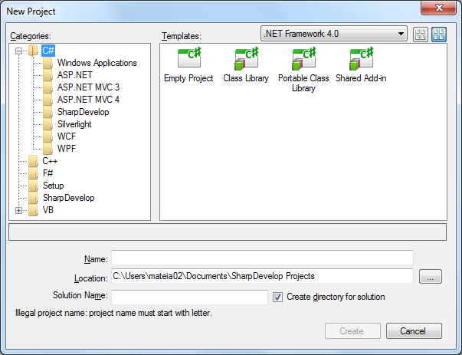

Q:

<http://www.dotnetperls.com/static-property>

public static int DayNumber

{

get

{

return DateTime.Today.Day;

}

}

[Exit code from Windows Forms app](http://stackoverflow.com/questions/3201770/exit-code-from-windows-forms-app)

If your main method returns a value you can return the exit code there. Otherwise you can use [Environment.ExitCode](http://msdn.microsoft.com/en-us/library/system.environment.exitcode.aspx) to set it.

<http://stackoverflow.com/questions/3201770/>

<http://blogs.msdn.com/b/thottams/archive/2006/08/11/696013.aspx>

<https://social.msdn.microsoft.com/Forums/en-US/b7a14400-6d72-4fbf-9927-0966f69ef4a2/how-to-open-console-window-in-windows-apllication?forum=csharplanguage>

Q:

<http://www.dotnetperls.com/messagebox-show>

Q:

Error 1 - **Interfaces cannot contain fields**

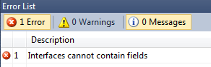

interface IAddOnLauncher

{

protected int exitCode;

public int ExitCode

{

get { return exitCode; }

//set { exitCode = value; }

}

}

IAddOnLauncher appLauncher = new AppLauncher();

appLauncher.Start(exe, arguments,"");

appLauncher.ExitCode

**Corect e asa:** Foloseste o proprietate (property) daca vrei neaparat un câmp.

In that spirit, C# interfaces do allow properties to be defined - which the caller must supply an implementation for.

Interfaces can define methods, properties, indexers and events, but not fields.

<http://stackoverflow.com/questions/2115114/why-cant-c-sharp-interfaces-contain-fields>

Nu merge ca in Java: The one thing I do sometimes miss is a java-like ability to define interface-level constants

interface ICar

{

int Year { get; set; }

}

interface IAddOnLauncher

{

int ExitCode { get; }

void Start(string exe, string arguments, string initialFolder,bool useStartInfo);

}

Q:

Error 1 - **Interfaces cannot declare types**

enum Direction { Right, Left };

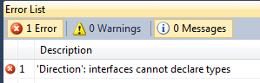

Q:

var ptr = GetClipboardData(CF_ENHMETAFILE);

UIntPtr length = GlobalSize(ptr);

IntPtr gLock = GlobalLock(ptr);

if (gLock == IntPtr.Zero)

{

throw new Exception("GlobalLock failed");

}

else

{

////Init a buffer which will contain the clipboard data

byte[] Buffer = new byte[(int)length];

//Copy clipboard data to buffer

Marshal.Copy(gLock, Buffer, 0, (int)length);

GlobalUnlock(ptr);

File.WriteAllBytes(@"D:\Emails\abc.uuu", Buffer);

}

<http://aspiringcraftsman.com/2008/12/28/examining-dependency-inversion/>

Dependency Injection encompasses a set of techniques for assigning the responsibility of provisioning dependencies for a component to an external source. The goal of Dependency Injection is to separate the concerns of how a dependency is obtained from the core concerns of a component. One dependency injection technique, referred to as constructor injection, defines the dependencies of a component within its constructor which are supplied at the time of the component’s creation

Q:

Microsoft Unit Testing and Viewing Console Output

<http://www.testdriven.net/quickstart.aspx>

Test Driven Development is the practice of writing unit tests for your code before you actually write that code.

By writing a test and then writing the code to make that test pass you have a much better idea of what the goal and purpose of your code is.

Test Driven Development not only increases the quality of your code, but also allows you to refactor the internals of a method or class and quickly and easily test the outside interface of the object.

TestDriven.Net is a unit testing add-in for Visual Studio. It supports multiple unit testing frameworks including NUnit, MbUnit, xUnit and MSTest.

TestDriven.Net can be installed using an administrator or limited user account.

Because limited users don't have write access to the 'Program Files' folder, a limited user installation will install files

in the user's 'Application Data\TestDriven.Net' folder.

An administrator installation will install files in the 'Program Files\TestDriven.Net' folder.

These defaults can be changed by selecting 'Custom' on the 'Choose Setup Type' page.

TestDriven.Net is packaged with several versions of the NUnit unit testing framework.

It also includes an adaptor for executing Visual Studio Team System unit tests when available

<http://stackoverflow.com/questions/2683249/redirect-stdout-and-stderr-to-the-output-debug-console-of-microsoft-visual-studi>

<http://stackoverflow.com/questions/5301232/seeing-the-consoles-output-in-visual-studio-2010>

<http://stackoverflow.com/questions/5248704/how-to-redirect-stdout-to-output-window-from-visual-studio>

<http://blogs.msdn.com/b/saraford/archive/2008/04/21/did-you-know-you-can-redirect-debug-messages-to-the-output-window.aspx>

You can use the [System.Diagnostics.Debug.Write](http://msdn.microsoft.com/en-us/library/system.diagnostics.debug.write.aspx) or System.Runtime.InteropServices method to write messages to the Output Window.

**Click View > Output (or just hold Ctrl + W apoi O)**

**Ctrl+Alt+O**

<http://stackoverflow.com/questions/11209639/can-i-write-into-console-in-a-unit-test-if-yes-why-the-console-window-is-not-o>

TestDriven.Net

System.Diagnostics.Debug.WriteLine("Matrix has you...");

<http://stackoverflow.com/questions/1159755/where-does-system-diagnostics-debug-write-output-appear> **Debugging**

<http://stackoverflow.com/questions/5989938/how-to-the-see-output-from-unit-tests-in-the-test-result-window-in-vs2010> BUN

*I added the column Output(StdOut) to the Test Result window. Desteptii zic:* No, you don't want to see the output.

<http://www.nathanfox.net/blog/10/Microsoft-Unit-Testing-and-Viewing-Console-Output>

<https://www.roelvanlisdonk.nl/?p=1278>

<http://blogs.msdn.com/b/ploeh/archive/2006/10/21/consoleunittesting.aspx> BUN

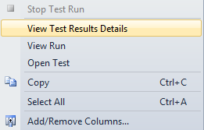

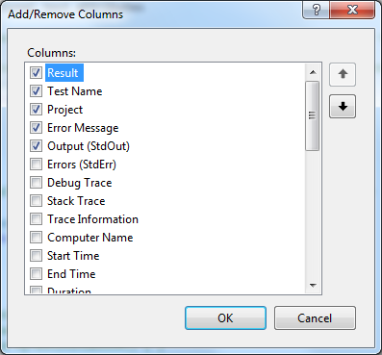

<http://www.codeproject.com/Articles/501610/Getting-Console-Output-Within-A-Unit-Test>

<https://social.msdn.microsoft.com/Forums/en-US/2ec36f4a-3fd3-4c7d-bb3b-3e2323bac296/unit-tests-consoleout-?forum=vststest>

<http://programmers.stackexchange.com/questions/138975/how-to-console-writeline-from-testmethod> Bun

<https://msdn.microsoft.com/en-us/library/system.console.setout.aspx>

<http://www.vtrifonov.com/2012/11/getting-console-output-within-unit-test.html>

<http://stackoverflow.com/questions/16815804/how-to-get-console-output-in-visual-studio-2012-unit-tests>

|  |  |  |  |
| --- | --- | --- | --- |
| |  |  | | --- | --- | |  |  | | **I had to change the "Show output from:" from "General" to "Tests" on the Output** |

However... Your Console.WriteLine() message will show, after your test has completed **double click the test result line in the Test Results** tab, this will open the results for the individual test which contains a "Standard Console Output" section which has your Console.WriteLine() messages

<https://programmersnotebook.wordpress.com/2010/03/11/viewing-unit-test-output-in-visual-studio/>

It turns out to see a test’s output, you **just double-click on the test** summary line, and all the output is down at the bottom of that window.

You get Console.Out messages and (more importantly) {Trace,Debug}.WriteLine()

If you're using **ReSharper**, select your test method in the **Unit Test Sessions pane**, and the output will be in the Output tab:

<https://connect.microsoft.com/VisualStudio/feedback/details/750184/test-results-window-does-not-show-test-results>

The Test Results window in VS2012 RC does not show the results of unit tests that were executed, unlike the Test Results window in VS2010. While VS2012 RC does have the new Test Explorer window that also shows test results, it is not as useful and does not really explain why the Test Results window still exists but does not work.

In VS 2012, we have rearchitected the Unit Test Framework in order to make it more extensible and scalable. As part of this work, we have deprecated Test results viewer and the trx file format. If you run new unit tests, trx file is not generated and therefore it is not shown in the Test Results Window.  
  
If you still need to generate a **trx**, you can do so using the vstest.console.exe. It has command line option to log results in **trx** format

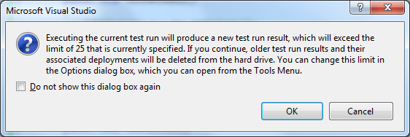

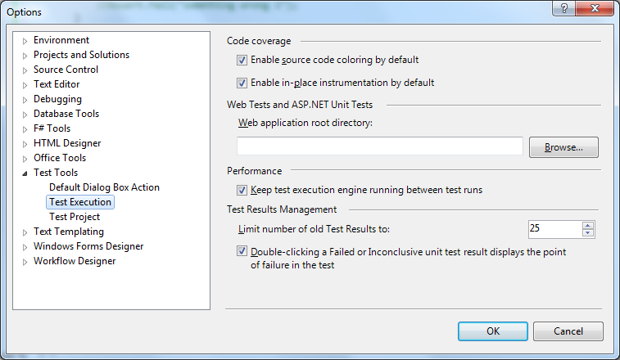

<http://stackoverflow.com/questions/1159755/where-does-system-diagnostics-debug-write-output-appear>

Note: Debug.WriteLine calls may not display in the output window if you have the Visual Studio option "Redirect all Output Window text to the Immediate Window" checked under the menu

Tools > Options > Debugging > General.

To display "Tools > Options > Debugging", check the box next to "Tools > Options > Show All Settings".

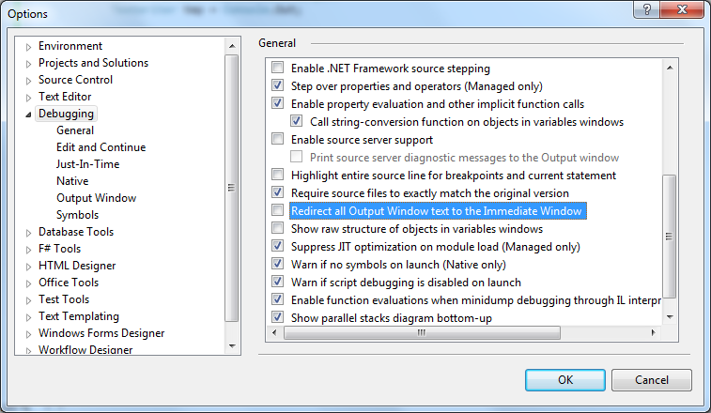

<https://github.com/xunit/xunit/issues/242>

<https://xunit.github.io/docs/capturing-output.html>

Sorry, we do not capture standard output in v2.

The design of xUnit.net v2 makes such designs impossible. The Console is a shared resource, and writing to that Console contains no context information in which to relate the written text back to the writer. Since many unit tests are running in parallel, it is therefore impossible to relate the written text back to the unit test in question.

We did support this in v1, because we didn't support parallelization. MSTest similarly supports this because they do not support parallelization.

<https://github.com/serilog>

Q:

Read Excel

<https://npoi.codeplex.com/>

<http://www.leniel.net/2009/07/creating-excel-spreadsheets-xls-xlsx-c.html#sthash.luguV8Y4.dpbs>

Q:

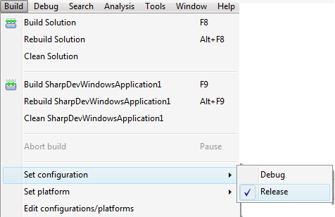

Q:

<https://www.microsoft.com/en-us/download/details.aspx?id=48264> IIS Express 10

iisexpress_x86_en-US.msi

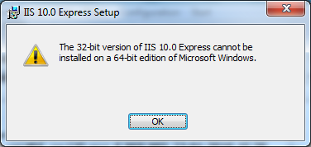

<http://community.sharpdevelop.net/blogs/marcueusebiu/archive/2010/12/28/sharpdevelop-classic-asp-net-websites-using-iis-express.aspx>

<http://community.sharpdevelop.net/forums/19.aspx>

<https://sharpdaspnetaddin.codeplex.com/releases>

<http://www.linqpad.net/>

<http://www.linqpad.net/RichClient/SampleLibraries.aspx>

<http://geekswithblogs.net/terje/Default.aspx>

<http://www.albahari.com/nutshell/whythisbook.aspx>

<http://www.albahari.com/nutshell/linqquiz.aspx>

<http://www.albahari.com/nutshell/linqsyntax.aspx>

C# 6.0 in a Nutshell and C# 5.0 in a Nutshell

Q: LINQ are si o baza de date

LINQPad are si o baza de date

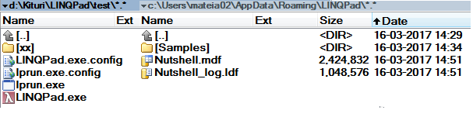

|  |  |
| --- | --- |
|  |  |

"C:\Users\mateia02\AppData\Roaming\LINQPad\Nutshell.mdf"

Q:

<http://www.codedigest.com/Articles/VisualStudio/396_What_is_NuGet_How_to_use_NuGet.aspx>

Q:

VSIX is a Visual Studio extension installer. You must have Visual Studio 2010 or newer in order to install them, but you should be able to install it by **double-clicking the .vsix file**.

Alternatively you should be able to install it from within the **VS Extension Manager (Tools->Extension Manger)**

[**https://superuser.com/questions/73675/how-do-i-install-a-vsix-file-in-visual-studio**](https://superuser.com/questions/73675/how-do-i-install-a-vsix-file-in-visual-studio)

<https://marketplace.visualstudio.com/items?itemName=PeterMacej.MultilineSearchandReplace>

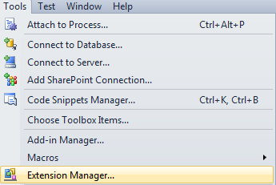

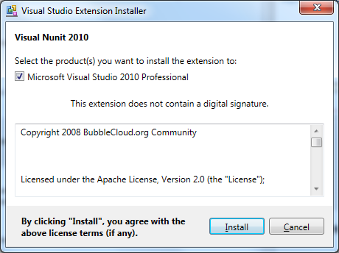

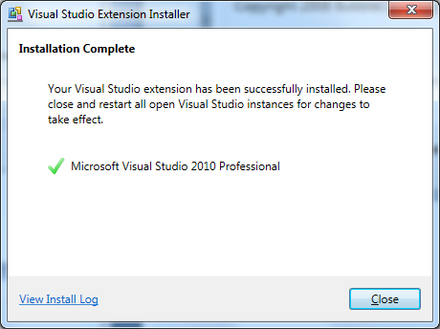

Q: Add web service reference

<http://www.c-sharpcorner.com/uploadfile/anavijai/add-web-reference-in-visual-studio-2010/>

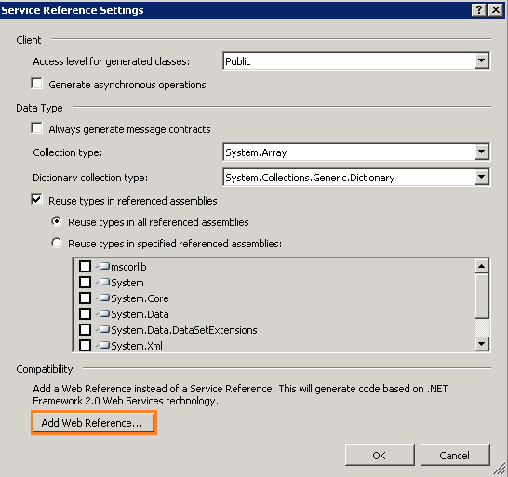

Q:

Q:

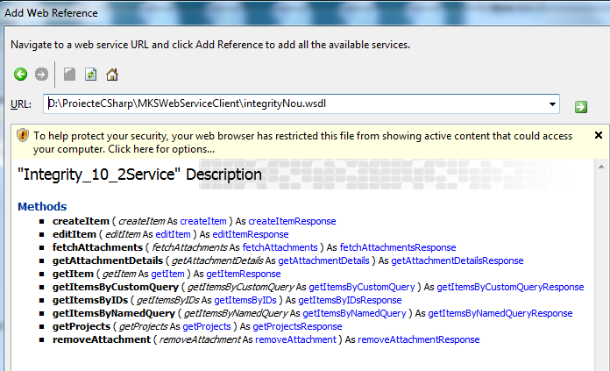

Q:

|  |  |
| --- | --- |
| 8down vote | After having struggled with this for a few days, I found a remarkably simple solution for this problem:   1. Activate the Configuration Editor by selecting Tools->WCF Service Configuration Editor from the main menu in VS2010; 2. Close it again; 3. Right-click on the App.Config file to find a new menu item "Edit WCF Configuration"; 4. Click on the binding; 5. Change the MessageEncoding to Mtom; 6. Save.   I hope this will help someone. |

Q:

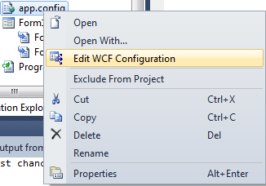

WCF client talking to Java WS

<http://stackoverflow.com/questions/10496186/error-consuming-webservice-content-type-application-xopxml-does-not-match-ex>

<http://stackoverflow.com/questions/17879658/wcf-client-talking-to-java-ws-exception-the-content-type-application-xopxml>

For anyone suffering from the same problem; I've found a solution for consuming the web service as a Service Reference (WCF).

I still haven't found a solution for consuming it as an old style Web Reference yet

<https://developer.jboss.org/thread/102561?start=0&tstart=0&_sscc=t>

System.InvalidOperationException: Client found response content type of 'multipart/related; type="application/xop+xml"; start="<rootpart@ws.jboss.org>"; start-info="text/xml"; boundary="----=_Part_3146_1562476167.1472128221878"', but expected 'text/xml'

Issue above was related to the fact that the proxy class on the C# side was not generated properly ..  
  
Should be derived from  
: Microsoft.Web.Services3.WebServicesClientProtocol  
  
Unfortunatly the there is still an issue related to the content type of the respons sent from the server.  
  
With the request the content type is  
Content-Type: multipart/related; type="application/xop+xml"  
But on the repons of this request the content type is set to :  
Content-Type: text/xml;charset=UTF-8  
  
WSE cannot support this feature !  
<http://forums.microsoft.com/MSDN/ShowPost.aspx?PostID=1099016&SiteID=1>

<binding name="energylinkSOAP">

<mtomMessageEncoding messageVersion="Soap12" />

<httpsTransport requireClientCertificate="true" />

</binding>

<https://social.msdn.microsoft.com/Forums/vstudio/en-US/0b768b2e-bbba-43f4-9b89-f414884bee51/mtom-interop-problem?forum=wcf>

* 1- After install Microsoft WSE 3.0, add reference **Microsoft.Web.Services3** to your project.

2- Configure your app config file by  WSE Configuration utilty, check "**enable this projects web enhancements**"

and **messaging/mtom settings/client mode: on**

3-Replace the text **Microsoft.Web.Services3.WebServicesClientProtocol** instead of **System.Web.Services.Protocols.SoapHttpClientProtocol** in reference.cs file.

your project ready to use MTOM !

<http://stackoverflow.com/questions/3703844/consume-a-soap-web-service-without-relying-on-the-app-config>

<http://stackoverflow.com/questions/3439619/using-a-c-sharp-service-reference-soap-client-with-different-endpoint-uris>

<http://stackoverflow.com/questions/18517122/calling-a-soap-service-from-c-sharp-client>

<https://blogs.msdn.microsoft.com/carlosfigueira/2011/02/15/using-mtom-in-a-wcf-custom-encoder/>

**Message Transmission Optimization Mechanism**

**MTOM**

Q: Incerc in stil nou

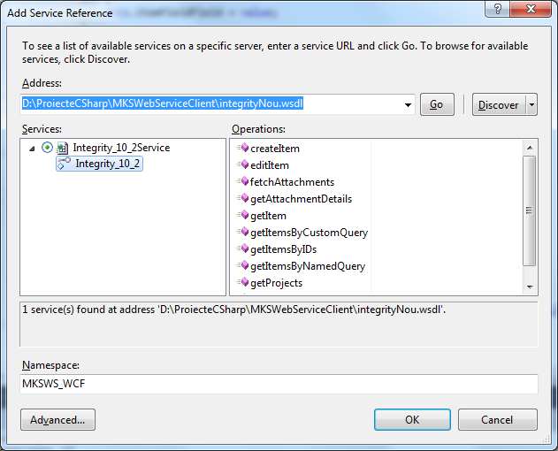

Q:

Notice also that the setter doesn’t take any arguments.

Yet when the class’s client codes something such as ZipCode = "30338", the **rvalue** is somehow accessible from within the setter via a local variable named **value**.

(You’ll soon see how this bit of magic happens in MSIL.)

Q:

Within a setter method, where does the **value** variable come from when there’s no argument list?

Q:

Polymorphism enables you to define a method multiple times throughout your class hierarchy so that the runtime calls the appropriate version of the method for the specific object being used.

A **static method** is a method that exists **in a class as a whole**, rather than in a specific instance of the class.

As with other static members, the key benefit of static methods is that they reside apart from a particular instance of a class **without polluting the application’s global space** and

without going against the object-oriented grain **by not being associated with a class.**

Now let’s look at another aspect of delegates—**defining them as static class members.**

<https://msdn.microsoft.com/en-us/library/bb985784.aspx> Richter

In C/C++, the address of a function is just a memory address.

This address doesn't carry along any additional information such as the number of parameters expected by the function, the types of these parameters, the function's return value type, and the function's calling convention.

In short, C/C++ callback functions are not type-safe.

The .NET Framework has the added bonus of providing a type-safe mechanism called **delegates**.

Notice the **TestSet** class at the top of Figure 1. Pretend that this class contains a set of items that will be processed individually.

When you create a **TestSet** object, you pass the number of items it should manage to its constructor.

The constructor then creates an array of Objects and initializes each to an integer value.

The **TestSet** class also defines **a public delegate**.

The delegate indicates the signature of **a callback method**.

In this example, a **Feedback** delegate identifies a method that takes three parameters

(an Object, an Int32, and another Int32) and returns void.

In a way, a delegate is very much like a C/C++ typedef that represents the address of a function.

In addition, the **TestSet** class defines a public method called **ProcessItems.**

This method takes one parameter, **feedback**, which is a reference to a **Feedback** delegate object.

You define them using the C# **delegate** keyword, you construct instances of them by referring to a **static** mehod

or a public instance method and you invoke the callback using familiar method **call syntax**

(except instead of a method name, you use the **variable** that refers to the delegate object).

 In addition, the **TestSet** class defines a public method called ProcessItems.

ProcessItems iterates through all the elements of the array

and for each element the callback method (specified by the feedback variable) is called.

**Using Delegates to Call Static Methods**

class TestSet

{

// Define a Feedback type

// (NOTE: this type is nested within the TestSet class)

public delegate void Feedback(Object value, Int32 item, Int32 numItems);

public void ProcessItems(**Feedback feedback**)

{

for (Int32 item = 0; item < items.Length; item++)

{

if (feedback != null)

{

// If any callbacks are specified, call them

feedback(items[item], item + 1, items.Length);

}

}

}

}

**Calling Instance Methods**

So far I've discussed how to use delegates to call static methods.

However, delegates can also be used to call **instance methods for a specific objec**t.

For instance methods, the delegate needs to know the instance of the object that is to be operated on by the method.

<https://msdn.microsoft.com/en-us/library/ms173171.aspx>

**Delegates are used to pass methods** as arguments **to other methods**

Callback function also means a function implemented in some other area of code

A button calls a callback function implemented in the form.

When you **instantiate a delegate**, you can **associate its instance** with **any method with a compatible signature and return** **type**.

You can invoke (or call) the method through the delegate instance.

Event handlers are nothing more than methods that are invoked through delegates.

You create a custom method, and a class such as a windows control can call your method when a certain event occurs.

The following example shows a delegate declaration:

public delegate int PerformCalculation(int x, int y);

Any method from any accessible class or struct that matches the delegate signature can be assigned to the delegate.

The method can be either static or an instance method.

<https://msdn.microsoft.com/en-us/library/ms173171.aspx>

This makes it possible to programmatically change method calls, and also **plug** **new code into existing classes**.

Asta e ideea:

intr-o clasa de a **mea** putem apela o **metoda** a unui obiect generic de tip Object

care rezida in alta parte a codului.

In clasa **mea** scriu ceva de genul

**Object[] parameters = new Object[] {i,j};**

**boolean isEditable = (Boolean)oMetoda.invoke(unObiect, parameters);**

Observa cum **oMetoda** si **unObiect** nu depinde de niciun tip specific , variabilele pot contine orice tip de data.

Similar cu ce ai facut in Java cu un pointer la o metoda.

Using **Java** reflection you can inspect the **methods** of **classes** and invoke them at runtime.

<http://tutorials.jenkov.com/java-reflection/methods.html>

This is done via the java.lang.reflect.Method **Java class**

A **Method** provides information about a single **method** of a **class** or interface.

public class **AddOnsGrid** extends JTableMod

{

Class[] **parameterTypes** = new Class[] {int.class, int.class };

Method m = this.getClass().getMethod("**RowIsEnabledInGrid**", **parameterTypes**);

tableModel.**setEnabledFunction(m,this**);

}

public Boolean RowIsEnabledInGrid(int row, int column) throws Exception

{

ArrayList<HAddOnsForGrid> listaSecvente = tableModel.getDataList();

HAddOnsForGrid linie = listaSecvente.get(row);

return linie.enabled;

}

public abstract class **MyTableModelCommon** extends AbstractTableModel

{

**Method** remoteMethodEditable;

**Object** remoteObjectEditable;

public void setEnabledFunction(Method method, Object o)

{

this.remoteMethodEnabled = method;

this.remoteObjectEnabled = o;

}

@Override

public boolean isCellEditable(int i, int j)

{

**Object[] parameters = new Object[] {i,j};**

**boolean isEditable = (Boolean)remoteMethodEditable.invoke(remoteObjectEditable, parameters);**

**}**

Q:

<https://github.com/wwake/dpics>

Q:

[**https://msdn.microsoft.com/ro-ro/library/ms173176.aspx**](https://msdn.microsoft.com/ro-ro/library/ms173176.aspx)

<https://msdn.microsoft.com/ro-ro/library/98dc08ac.aspx>

<https://msdn.microsoft.com/en-us/library/aa288459(v=vs.71).aspx>

C# introduction to delegates

// Declare a delegate.

delegate void Del(string str);

// Declare a method with the same signature as the delegate.

static void Notify(string name)

{

Console.WriteLine("Notification received for: {0}", name);

}

In C# 1.0 and later, delegates must be **declared** and **instantiated** with the new operator !

// Create an instance of the delegate.

Del del1 = **new Del**(Notify);

C# 2.0 provides a simpler way to write the previous declaration, as shown in the following example

// C# 2.0 provides a simpler way to declare an instance of Del.

Del del2 = Notify;

In C# 2.0 and later, it is also possible to use an **anonymous method** to declare and initialize a [delegate](https://msdn.microsoft.com/ro-ro/library/900fyy8e.aspx), as shown in the following example.

// Instantiate Del by using an anonymous method.

Del del3 = delegate(string name)

{ Console.WriteLine("Notification received for: {0}", name); };

In C# 3.0 and later, delegates can also be declared and instantiated by using **a lambda expression**, as shown in the following example.

Del del4 = name => { Console.WriteLine("Notification received for: {0}", name); };

Q: Events (C# Programming Guide)

<https://msdn.microsoft.com/ro-ro/library/awbftdfh.aspx>

Q:

Events and Delegates

<https://msdn.microsoft.com/ro-ro/library/17sde2xt(v=vs.90).aspx>

Q:

<https://msdn.microsoft.com/en-us/library/bb985788.aspx>

<https://msdn.microsoft.com/en-us/library/bb985789.aspx>

Q:

Implement interface methods

<http://stackoverflow.com/questions/3451810/auto-generate-an-interface-implementation-in-c>

<http://stackoverflow.com/questions/708384/automatically-generate-implementations-of-base-class-methods>

Right click the interface

Right click on the interface name, you should see a menu option "Implement Interface" or along those lines.

Q:

In this section, we will describe several C# 2.0 features that are important to LINQ:

* generics
* anonymous methods (which are the basis of lambda expressions in C# 3.0)
* the *yield* keyword
* the *IEnumerable* interface.

You need to understand these concepts well to best understand LINQ.

C# 2.0 solved this problem with generics.

C# generics

<https://msdn.microsoft.com/en-us/library/ms379564(v=vs.80).aspx>

<https://msdn.microsoft.com/ro-ro/library/512aeb7t.aspx>

<https://msdn.microsoft.com/ro-ro/library/d5x73970.aspx>

generic class definition

The basic principle of generics is that type resolution is moved from the C# compiler to the jitter.

Here is the generic version of the *Min* function:

T Min<T>( T a, T b ) where T : IComparable<T>

{

if (a.CompareTo( b ) < 0)

return a;

else

return b;

}

**Note**

The jitter is the run-time compiler that is part of the .NET runtime.

It translates intermediate language (IL) code to machine code.

When you compile .NET source code, the compiler generates an executable image containing IL code,

which is compiled in machine code instructions by the jitter at some point before the first execution.

Moving type resolution to the jitter is a good compromise: the jitter can generate many versions of the same code,

one for each type that is used.

This approach is similar to a macro expansion, but it differs in the optimizations used to avoid code proliferation

All versions of a generic function that use reference types as generic types share the same compiled code,

while the difference is maintained against callers.

**Delegates**

A delegate is a class that encapsulates one or more methods.

Internally, one delegate stores a list of method pointers, each of which can be paired with a reference

to an instance of the class containing an instance method.

delegate void SimpleDelegate();

delegate int ReturnValueDelegate();

delegate void TwoParamsDelegate( string name, int age );

With C# 1.*x*, a delegate instance can be created only through an explicit object creation, such as those shown in [Listing 2-2](mk:@MSITStore:D:\Kituri\Documentatie\Net\LINQ\introducing-microsoft-linq.9780735623910.28011.chm::/final/BBL0011.html#ch02).

public class DemoDelegate {

void MethodA() { … }

int MethodB() { … }

void MethodC( string x, int y ) { … }

void CreateInstance() {

SimpleDelegate a = new SimpleDelegate( MethodA );

ReturnValueDelegate b = new ReturnValueDelegate ( MethodB );

TwoParamsDelegate c = **new** TwoParamsDelegate( MethodC );

// …

}

}

C# 2.0 is aware of this capability and allows you to skip part of the syntax.

The previous delegate instances we have shown can be created without the *new* keyword.

You only need to specify the method name.

The compiler infers the delegate type from the assignment.

public class DemoDelegate {

void MethodA() { … }

int MethodB() { … }

void MethodC( string x, int y ) { … }

void CreateInstance() {

SimpleDelegate a = MethodA;

ReturnValueDelegate b = MethodB;

TwoParamsDelegate c = MethodC;

// …

}

// …

}

public class Writer

{

public string Text;

public int Counter;

public void Dump()

{

//txtInfo.Text += Text+"\r\n";

Counter++;

}

}

public class DemoDelegate

{

public delegate void SimpleDelegate();

public void Repeat10Times(SimpleDelegate someWork)

{

for (int i = 0; i < 10; i++)

{

someWork();

}

}

}

private void btnLinq1_Click(object sender, EventArgs e)

{

Writer writer = new Writer();

writer.Text = "C# chapter";

new DemoDelegate().Repeat10Times(**writer.Dump**);

txtInfo.Text += writer.Counter;

}

**Anonymous Methods**

In this code, we no longer declare the *Writer.Dump* class method.

The compiler does this for us automatically with a hidden and automatically generated class name

The *delegate* keyword for anonymous methods precedes the code block.

When we have a method signature for a delegate that **contains one or more parameters**,

this syntax allows us to define the names of the parameters for the delegate

We define a method inside the *Repeat10Times* **call**,

which might seem as **though we** are really passing a piece of code as a parameter.

public class DemoDelegate2

{

public delegate void SimpleDelegate();

public delegate void TwoParamsDelegate( string name, int age );

public void Repeat10Times(SimpleDelegate someWork)

{

for (int i = 0; i < 10; i++)

{

someWork();

}

}

public void Repeat20Times(TwoParamsDelegate callback)

{

//We are now passing two implicit parameters to the delegate inside the *Repeat10Times* method

for (int i = 0; i < 20; i++)

**callback("Linq book", i);**

}

}

private void btnLinq2_Click(object sender, EventArgs e)

{

int counter = 0;

string mes = "C# chapter";

new DemoDelegate2().Repeat10Times(**delegate**

{

txtInfo.Text += mes + "\r\n";

counter++;

});

txtInfo.Text += counter;

}

When the delegate function has arguments

private void btnLinq3_Click(object sender, EventArgs e)

{

new DemoDelegate2().Repeat20Times(**delegate**(string text, int age)

{

txtInfo.Text += string.Format("{0} {1}\r\n", text, age);

});

}

public class AggDelegate

{

public delegate T Func<T>(T a, T b);

public static T Aggregate<T>(List<T> l, Func<T> f)

{

T result = default(T);

bool firstLoop = true;

foreach (T value in l)

{

if (firstLoop)

{

result = value;

firstLoop = false;

}

else

{

result = f(result, value);

}

}

return result;

}

}

System.Collections.Generic.List<int> Values = new System.Collections.Generic.List<int>();

Values.Add(50);

Values.Add(30);

//Explicitly typed parameter list

int sum = AggDelegate.Aggregate(

Values,

delegate(int a, int b) { return a + b; }

);

//Using lambda expression syntax

//You can read this formula as “given a and b, both integers, return a+b that is the sum of a and b.”

//We removed the delegate keyword before the parameter list and

// added the => token between the parameter list and the method code.

//

//At this stage, the difference is only syntactical because

//the compiled code is identical to the result of the anonymous method syntax

int sum = AggDelegate.Aggregate(

Values,

(int a, int b) => { return a + b; }

);

//Implicitly typed parameter list

int sum = AggDelegate.Aggregate(

Values,

(a, b) => { return a + b; }

);

//The pronunciation of the => token has no official definition.

//A few developers use “such that” when the lambda expression is a predicate and “becomes” when it is a projection.

//Other developers say generically “goes to.”

//You can read this formula as "given a and b, return a+b, whatever '+' means for the type of a and b."

// The "+" operator must exist for the concrete type of a and b

// inferred from the context-otherwise, the code will not compile.

// Expression body

// You can simply omit the brackets and the return statement

int sum = AggDelegate.Aggregate(

Values,

(a, b) => a + b

);

txtInfo.Text += string.Format("\r\nSum = {0}\r\n", sum);

When we worked with lambda expressions for the first time, we felt some confusion until we realized that

they are only a more powerful syntax with which to write an anonymous method.

This is an important concept to remember, because you can always access identifiers that are not defined in the parameter list.

In other words, remember that the parameter list defines the parameters of the anonymous method.

Any other identifier inside the body (either a statement or an expression) of a lambda expression

has to be resolved within the anonymous method definition.

The following code shows an example of this.

The *AggregateSingle<T>* method uses a slightly different delegate for the second parameter,

declared as

public delegate *T* *FuncSingle<T>( T a )*).

int sum = 0;

sum = AggregateSingle(

l.Values,

**( x ) => sum += x**

);}

If there are no parameters for a lambda expression, two parentheses are required before the *=>* token

() => sum + 1 // No parameters

Lambda expression examples

( int a, int b ) => { return a + b; } // Explicitly typed, **statement** **body**

( a, b ) => { return a + b; } // Implicitly typed, statement body

( int a, int b ) => a + b; // Explicitly typed, **expression** **body**

( a, b ) => a + b // Implicitly typed, expression body

( x ) => sum += x // Single parameter with parentheses

x => sum += x // Single parameter no parentheses

Q:

Predicate and Projection

Some **lambda expressions** have a particular name based on their purpose:

A **predicate** is a Boolean expression that is intended to indicate membership of an element in a group.

For example, it is used to define how to filter items inside a loop:

// Predicate

( age ) => age > 21

A **projection** is an expression that returns a type different from the type of its single parameter:

// Projection: takes a string and returns an int

( s ) => s.Length

Q:

A practical use of **lambda expressions** is in writing small pieces of code inside **the parameter list** of a method call.

The following code shows an example of a predicate

passed as a parameter to a generic Display method that iterates

an array of elements and displays only those that make the predicate true.

The predicate and its use are highlighted in the code.

The **Func** delegate shown in Listing 2-18 is explained in the following pages.

public class MyPredicate1

{

public static string Display<T> ( T[] names, **Func**<T,bool> filter)

{

string result = "";

foreach (T s in names)

{

if (filter(s))

{

result += s+"\r\n";

}

}

return result;

}

}

string[] names = { "Marco", "Paolo", "Tom" };

//The execution results in a list of names having more than four characters.

//The conciseness of this syntax is one reason for using lambda expressions in LINQ;

//the other reason is the potential to create an expression tree.

string result = MyPredicate1.Display(names, **s => s.Length > 4**);

txtInfo.Text += result;

To this point, we have considered the difference between **the statement body** and the **expression** **body**

only as a different syntax that can be used to retrieve the same code, but there is something more.

A **lambda expression** can also be assigned to a variable of these delegate types:

public delegate T Func< T >();

public delegate T Func< A0, T >( A0 arg0 );

public delegate T Func<A0, A1, T> ( A0 arg0, A1 arg1 );

public delegate T Func<A0, A1, A2, T >( A0 arg0, A1 arg1, A2 arg2 );

public delegate T Func<A0, A1, A3, T> ( A0 arg0, A1 arg1, A2 arg2, A3 arg3 );

There are no requirements for defining these delegates in a particular way.

LINQ defines such delegates within the System.Linq namespace,

but lambda expression functionality does not depend on these declarations.

You can make your own, even with a name other than Func, except in one case:

if you convert a **lambda expression** to an **expression tree**, the compiler emits a **binary representation** of the lambda expression

that can be manipulated and converted into executable code at execution time.

An expression tree is an instance of a **System.Linq.Expressions.Expression<T> class**,

where T is the delegate that the expression tree represents.

In many ways, the use of **lambda expressions** to create an **expression tree**

makes **lambda expressions** similar to **generic methods**.

The difference is that **generic methods** are already described as **IL code at compile time**

(only the type parameters used are not completely specified), while an expression tree becomes IL code only at execution time.

Only **lambda expressions** with an **expression body** can be converted into an **expression tree** and

this conversion is **not** **possible** if the lambda expression contains a **statement body**.

Listing 2-19 shows how the same **lambda expression** can be converted into **either a delegate** or an **expression tree.**

The highlighted lines show the assignment of the expression tree and its use

**Listing 2-19: Use of an expression tree**

public class ExpressionTree

{

public delegate T Func<T>(T a, T b);

public static string Demo1(Func<int> x)

{

return x.ToString() + "\r\n" + x(40, 15)+"\r\n";

}

public static string Demo2(System.Linq.Expressions.Expression<Func<int>> y)

{

return y.ToString() + "\r\n" + y.**Compile**()(29, 13) + "\r\n";

}

}

txtInfo.Text += "Delegate\r\n";

txtInfo.Text += ExpressionTree.Demo1( (a, b) => a + b);

txtInfo.Text += "Expression tree\r\n";

txtInfo.Text += ExpressionTree.Demo2((a, b) => a + b);

Delegate

WindowsFormsApplication2.lessons.ExpressionTree+Func`1[System.Int32]

55

Expression tree

(a, b) => (a + b)

42

We do not have space here for a deeper investigation of deferred query evaluation,

but it is an important foundation for many parts of LINQ.

For example, LINQ to SQL has methods that navigate an expression tree and convert it into an SQL statement.

That conversion is made at execution time and not at compile time.

Q:

**Extension Methods**

C# is an object-oriented programming language that allows the extension of a class through inheritance.

Nevertheless, designing a class that can be inherited in a safe way and maintaining that class in the future

is hard work.

A safe way to write such code is to declare all classes as **sealed**, unless they are designed as

inheritable. In that case, safety is set against agility.

More Info

Microsoft .NET allows class A in assembly X.DLL to be inherited by class B in assembly Y.DLL.

This implies that a new version of X.DLL should be designed to be compatible even with older versions of Y.DLL.

C# and .NET have many tools to help in this effort.

However, we can say that a class has to be designed as inheritable if you want to allow its derivation;

otherwise, you run the risk that making a few changes in the base classes will break existing code in derived classes.

If you do not design a class to be inheritable, it is better to make the class sealed, or at least private or internal.

We can change this code to extend the *decimal* type.

It is a value type and not inheritable, but we can add the ***this*** keyword before the first parameter type of our methods

and in this way use the method as if it was defined **inside** the decimal type.

An **extension method**

**must** be ***static* and *public***,

**must** be declared inside a ***static* class**,

and **must** have the keyword ***this*** before the first parameter type,

which is the type that the method extends.

Extension methods are public because they can be

(and normally are) called from outside the class where they are declared.

Listing 2-20: Extension methods declaration

static class ExtensionMethods

{

static CultureInfo formatUS = new CultureInfo("en-US");

static CultureInfo formatIT = new CultureInfo("it-IT");

public static string FormattedUS(**this decimal d**)

{

return String.Format(formatIT, "{0:#,0.00}", d);

}

public static string FormattedIT(**this decimal d)**

{

return String.Format(formatUS, "{0:#,0.00}", d);

}

}

decimal x = 1234.568M;

txtInfo.Text += **x.FormattedUS()+**"\r\n";

txtInfo.Text += **x.FormattedIT()**+"\r\n";

txtInfo.Text += ExtensionMethods.FormattedUS(x) + "\r\n"; // Traditional call allowed

txtInfo.Text += ExtensionMethods.FormattedIT(x); // Traditional call allowed

However, the result type of the extension method might be the extended type itself.

In this case, we can extend a type with many methods, all working on the same data.

LINQ very frequently uses extension methods in this way.

We can write a set of extension methods to decimal as shown in Listing 2-21.

Listing 2-21: Extension methods for native value types

static class DecimalExtensionMethods

{

public static decimal Double(**this** **decimal** d)

{

return d + d;

}

public static decimal Triple(**this** **decimal** d)

{

return d * 3;

}

public static decimal Increase(**this** decimal d)

{

return ++d;

}

public static decimal Decrease(this decimal d)

{

return --d;

}

public static decimal Half(this decimal d)

{

return d / 2;

}

}

//The new syntax acts as though our new methods are members of the decimal class

decimal y = 14M;

txtInfo.Text += "DecimalExtensionMethods " + y.Increase().Double().Decrease().Decrease().Triple().Half() + "\r\n";

The most common use of extension methods is to define them in static classes in specific namespaces,

importing them into the calling code by specifying one or more *using* directives in the module.

These precedence rules:

When you call an extension method on a class, it can always be replaced by a specific version of

the method defined as a member method for a particular type.

In other words, the extension method represents a “default” implementation for a method,

which can always be overridden by a specialized version for specific classes.

We can see this behavior in a few examples.

1. The first code example contains an extension method for the *object* type;

in this way, you can call *Display* on an instance of any type. We call it on our own *Customer* class instance:

1. We can customize the behavior of the Display method for the Customer class

defining an overloaded extension method

This time the more specialized version is executed, as we can see from the execution output, shown here:

Name=Marco

1. Without removing these extension methods

we can add other special behavior to Display by implementing it

as an **instance method** in the Customer class.

This **instance method** will have precedence over any other extension method for a type equal to or derived from Customer.

public class Customer

{

protected int Id;

public string Name;

public Customer(int id)

{

this.Id = id;

}

public string Display()

{

return String.Format("Instance Display method {0}-{1}", Id, Name);

}

}

static class Visualizer

{

//

//extension method for the object type !!!

//in this way, you can call Display on an instance of any type

//

public static string Display(this object o)

{

return o.ToString();

}

//We can customize the behavior of the Display method for the Customer class

//defining an overloaded extension method

//This time the more specialized version is executed, as we can see from the execution output, shown here:

//Name=Marco

public static string Display(this Customer c)

{

string s = String.Format("Name={0}", c.Name);

return s;

}

}

Q:

Am o clasa de baza

Base class

Am o metoda cu o anumita implementare

class Employee

{

public string name;

public Employee(string name)

{

this.name = name;

}

public virtual string CalculatePay()

{

return string.Format("Employee.CalculatePay called for {0}", name);

}

}

class ContractEmployee : Employee

{

public ContractEmployee(string name)

: base(name)

{

}

//gresit

public virtual string CalculatePay()

//corect

public override string CalculatePay()

{

return string.Format("ContractEmployee.CalculatePay called for {0}", name);

}

}

class SalariedEmployee : Employee

{

public SalariedEmployee(string name)

: base(name)

{

}

//corect

public override string CalculatePay()

{

return string.Format("SalariedEmployee.CalculatePay called for {0}", name);

}

}

class TestPolymorphic

{

protected Employee[] employees;

public void LoadEmployees()

{

// Simulating loading from a database.

employees = new Employee[2];

employees[0] = new ContractEmployee("Contract - Adam Barr");

employees[1] = new SalariedEmployee("Salaried - Max Benson");

}

public string DoPayroll()

{

String info = "";

for (int i = 0; i < employees.GetLength(0); i++)

{

info += employees[i].CalculatePay();

info += "\r\n";

}

return info;

}

}

|  |  |
| --- | --- |
| Daca nu pun **override** in clasele derivate  Rezultatul e gresit | Employee.CalculatePay called for Contract - Adam Barr (gresit , nu astept asta ci ContractEmployee.CalculatePay)  SalariedEmployee.CalculatePay called for Salaried - Max Benson |
| Daca pun **override** in clasele derivate  Rezultatul e corect | ContractEmployee.CalculatePay called for Contract - Adam Barr  SalariedEmployee.CalculatePay called for Salaried - Max Benson |

Q:

The instance method

X is an extension method for the A class

Y is an extension method for the A class

The B class has no extension methods

X is also an instance method for both A and B classes

public class A

{

public virtual void X() { }

}

public class B : A

{

public override void X() { }

public void Y() { }

}

static public class E

{

public static void **X**(**this A a**) { }

public static void **Y**(**this A b**) { }

}

A a = new A();

B b = new B();

A c = new B();

a.X(); // Call A.X , X is a virtual method in the base class

b.X(); // Call B.X , X is a virtual method **overridden** in the **derived** class

c.X(); // Call B.X , X is a virtual method overridden in the derived class

a.Y(); // Call E.Y , Y is an extension method for the A class

c.Y(); // Call E.Y , Y is an extension method for the A class

b.Y(); // Call B.Y , Y is an instance method for the B class, Y is not an extension method for the B class

Q:

Extension methods for native value types

static class ExtensionMethods

{

public static string DisplayExtension<T>(this T[] names, Func<T, bool> filter)

{

string result = "";

foreach (T s in names)

{

if (filter(s))

{

result += s + "\r\n";

}

}

return result;

}

}

**string[]** names = new string[] { "Marco", "Paolo", "Tom" };

string result = names.DisplayExtension(s => s.Length > 4);

txtInfo.Text += result + "\r\n";

Before it was:

string result = MyPredicate1.Display(names, s => s.Length > 4);

The Display method can be used with a different class (for example, **an array of type int**)

and it will always require a predicate with a **parameter that is the same type as the array**.

The following code uses the same Display method, showing only the **even values in an array of integers:**

int[] ints = { 19, 16, 4, 33 };

result = ints.Display(**i => i % 2 == 0**);

Q:

C# 1.x allows the initialization of a field or a local variable in a single statement. The syntax shown here can initialize a single identifier:

**Customer c = new Customer( "Tom", 32 );**

**Object Initialization Expressions**

C# 3.0 introduces a shorter form of **object initialization syntax** that generates functionally equivalent code

The names assigned in an initialization list can correspond to either fields or properties that are public members of the initialized object

**Listing 2-27: Standard syntax for object initialization**

Customer customer = new Customer();

customer.Name = "Marco";

customer.Country = "Italy";

**Listing 2-28: Object initializer**

// Implicitly calls default constructor before object initialization

// (requires a constructor with zero arguments !!)

**Customer customer = new Customer { Name = "Marco", Country = "Italy" };**

**Listing 2-29: Explicit constructor call in object initializer**

// Explicitly specify constructor to call before object initialization

**Customer c1 = new Customer() { Name = "Marco", Country = "Italy" };**

// Explicitly specify nondefault constructor, followed by initialization

**Customer c2 = new Customer( "Paolo", 21 ) { Country = "Italy" };**

The *c2* assignment above is equivalent to this one:

Customer c2 = new Customer( "Paolo", 21 );

c2.Country = "Italy";

**Listing 2-32: Collection initializers**

// Collection classes that implement ICollection<T>

List<int> integers1 = new List<int> { 1, 3, 9, 18 };

// Collection classes that implement IEnumerable

ArrayList integers2 = new ArrayList() { 1, 3, 9, 18 };

// Collection classes that implement ICollection<T>

List<Customer> list1 = new List<Customer>

{

new Customer( "Jack", 28 ) { Country = "USA"},

new Customer { Name = "Paolo" },

new Customer { Name = "Marco", Country = "Italy" },

};

// Collection classes that implement IEnumerable

ArrayList list2 = new ArrayList

{

new Customer( "Jack", 28 ) { Country = "USA"},

new Customer { Name = "Paolo" },

new Customer { Name = "Marco", Country = "Italy" },

};

In summary, **object and collection initializers** allow the creation and initialization of a set of objects (eventually nested) within a single function.

LINQ makes extensive use of this feature, especially **through anonymous types**.

Q:

One of the advantages of the **object initializer** is that it allows for writing a complete initialization in a functional form:

you can put it inside an expression without using different statements.

Therefore, the **syntax can also be nested, repeating** the syntax for the initial value of a member into an initialized object.

The classic Point and Rectangle class example shown in Listing 2-30 (part of the C# 3.0 specification document) illustrates this.

public class Point {

int x, y;

public int X { get { return x; } set { x = value; } }

public int Y { get { return y; } set { y = value; } }

}

public class Rectangle {

Point tl, br;

public Point TL { get { return tl; } set { tl = value; } }

public Point BR { get { return br; } set { br = value; } }

}

// Possible code inside a method

**Rectangle r = new Rectangle {**

**TL = new Point { X = 0, Y = 1 },**

**BR = new Point { X = 2, Y = 3 }**

**};**

Now that you have seen this code, it should be clear when using the shortest syntax

has a true advantage in terms of code readability

The **object initializer** syntax can be used only for assignment of the initial value of a field or variable.

The *new* keyword is required only for the final assignment.

**Inside** an initializer, **you can skip the *new* keyword in an object member’s initialization**.

**But only on an existing instance of *TL* and *BR*.**

Listing 2-31: Initializers for owned objects

public class Rectangle

{

Point tl = new Point();

Point br = new Point();

public Point TL { get { return tl; } }

public Point BR { get { return br; } }

}

// Possible code inside a method

Rectangle r = new Rectangle {

TL = { X = 0, Y = 1 },

BR = { X = 2, Y = 3 }

};

Q:

**Anonymous Types**

An **object initializer** can also be used without specifying the class that will be created with the *new* operator.

Doing that, a new class, an anonymous type-is created.

var c3 = new { Name = "Tom", Age = 31 };

var c4 = new { c2.Name, c2.Age };

var c5 = new { c1.Name, c1.Country };

var c6 = new { c1.Country, c1.Name };

The type of variables *c3*, *c4*, *c5*, and *c6* cannot be inferred simply by reading the printed code.

The *var* keyword should infer the variable type from the assigned expression,

but this one has a *new* keyword without a type specified.

As you might expect, that kind of **object initializer** generates a new class

The **generated class** has a **public property** and an **underlying private field** for each argument contained in the initializer:

its name and type are inferred from the object initializer itself.

When the name is not explicit, it is inferred from the initialization expression, as in the definitions for *c4*, *c5*, and *c6*.

Usually in C# the order of members inside a type is not important; even standard **object initializers** are based on member names and not on their order.

The need for LINQ to get a different type for two classes that differ only in the order of their members derives

from the need to represent an ordered set of fields, as in a SELECT statement.

The syntax to initialize a typed array has been enhanced in C# 3.0.

Now you can declare an array initializer and infer the type from the initializer content.

This mechanism can be combined with anonymous types and object initializers, as in the code shown in [Listing 2-34](mk:@MSITStore:D:\Kituri\Documentatie\Net\LINQ\introducing-microsoft-linq.9780735623910.28011.chm::/final/BBL0012.html#ch02).

Note

The syntax of C# 1.x needs the assigned variable to be a definite type.

The syntax of C# 3.0 allows the use of the **var** keyword

//Listing 2-34: Implicitly typed arrays

//ints is an array of int

//ca1 is an array of Customers

//ca2 is an array of anonymous types, each containing a string (Name) and an array of strings (Sports).

var ints = new[] { 1, 2, 3, 4 };

var ca1 = new[] {

new Customer { Name = "Marco", Country = "Italy" },

new Customer { Name = "Tom", Country = "USA" },

new Customer { Name = "Paolo", Country = "Italy" }

};

var ca2 = new[] {

new { Name = "Marco", Sports = new[] { "Tennis", "Spinning"} },

new { Name = "Tom", Sports = new[] { "Rugby", "Squash", "Baseball" } },

new { Name = "Paolo", Sports = new[] { "Skateboard", "Windsurf" } }

};

**Query Expressions**

C# 3.0 also introduces **query** expressions, which have a syntax similar to the SQL language and are used to manipulate data.

This syntax is converted into regular C# 3.0 syntax that makes use of specific classes, methods and interfaces

that are part of the **LINQ libraries**.

We would not cover all the keywords in detail because it is beyond the scope of this chapter.

We will cover the syntax of query expressions in more detail in Chapter 4, “LINQ Syntax Fundamentals.”

In this section, we want to introduce the transformation that the compiler applies to a query expression,

just to describe how the code is interpreted.

// Declaration and initialization of an array of anonymous types

var customers = new []{

new { Name = "Marco", Discount = 4.5 },

new { Name = "Paolo", Discount = 3.0 },

new { Name = "Tom", Discount = 3.5 }

};

var query =

from c in customers

where c.Discount > 3

orderby c.Discount

select new { c.Name, Perc = c.Discount / 100 };

foreach( var x in query )

{

//Console.WriteLine( x );

txtInfo.Text += x + "\r\n";

}

That code produces the following results:

{ Name = Tom, Perc = 0.035 }

{ Name = Marco, Perc = 0.045 }

C# 3.0 interprets the *query* assignment as if it was written in this way:

var query1 = customers

.Where(c => c.Discount > 3)

.OrderBy(c => c.Discount)

.Select(c => new { c.Name, Perc = c.Discount / 100 });

A query expression begins with a ***from*** clause (in C#, all query expression keywords are case sensitive) and ends with either a ***select*** or ***group*** clause.

The ***from*** clause specifies the object on which LINQ operations are applied,

which must be an instance of a class that implements the *IEnumerable<T>* interface.

That code produces the following results:

{ Name = Tom, Perc = 0.035 }

{ Name = Marco, Perc = 0.045 }

**Anonymous types** and **object initializers** define how to store the **results of a query**.

**Local type inference** is the glue that holds these pieces together.

**LINQ Syntax Fundamentals**

**Language Integrated Query (LINQ**) allows developers to **query and manage sequences of items**

**(objects, entities, database records, XML nodes, and so on)**

using a unique programming language independent from their original persistence media.

In this chapter, we will describe the main classes and operators on which LINQ is based as a means of understanding

its architecture and to learn its syntax.

LINQ provides a basic infrastructure for many different implementations of querying engines, such as

LINQ to Objects, LINQ to SQL, LINQ to DataSet, LINQ to Entities, LINQ to XML, and so on.

All the query extensions are based on extension methods specialization, which you will read about in this chapter.

The examples in this chapter mainly use LINQ to Objects so that we can focus on queries and operators rather than on specific internal implementations

of the various flavors of LINQ.

**LINQ Queries**

LINQ is based on a set of query operators, defined as **extension methods**, that mainly work with any object that implements IEnumerable<T>

This approach makes LINQ a general-purpose querying framework because many lists implement *IEnumerable<T>* and

any developer can implement his or her own.

This query infrastructure is also very extensible.

Given the architecture of **extension methods**, developers can specialize a method’s behavior based on the type of data they are querying.

For instance, LINQ to SQL and LINQ to XML have specialized LINQ operators to handle relational data and XML nodes, respectively.

**Query Syntax**

To understand query syntax, we will start with a simple example. Consider the following Developer type:

public class Developer

{

public string Name;

public string Language;

public int Age;

}

Imagine that you need to query an array of objects of the *Developer* type, using LINQ to Objects

The syntax of this query (shown in bold in Listing 4-1) reads something like an SQL statement, although its style is a bit different.

To understand it and become familiar with this new syntax, we will try to deconstruct its definition.

**Listing 4-1: A simple LINQ query**

Developer[] developers = new Developer[]

{

new Developer {Name = "Paolo", Language = "C#"},

new Developer {Name = "Marco", Language = "C#"},

new Developer {Name = "Frank", Language = "VB.NET"}

};

IEnumerable<string> developersUsingCsharp =

from d in developers

where d.Language == "C#"

select d.Name;

foreach (string item in developersUsingCsharp)

{

//Console.WriteLine(item);

txtInfo.Text += item + "\r\n";

}

**Query Expression**

A query expression is an expression tree that operates on one or more information sources

by applying one or more query operators from either the group of standard query operators or

domain-specific operators.

In general, the evaluation of a query expression results in a sequence of values.

A query expression is evaluated only when its contents are enumerated.

The expression is defined by:

|  |  |
| --- | --- |
| a selection command: | select d.Name |
| applied to a set of items:  where the from clause targets any instance of a class that implements the IEnumerable<T> interface. | from d in developers |
| The selection applies a specific filtering condition: | where d.Language == "C#" |

The filtering condition simply translates to an invocation of the *Where* extension method of the *Enumerable* class,

defined in the *System.Linq* namespace.

The *select* statement is another extension method, named *Select*, provided by the *Enumerable* class

The Enumerable class, defined in the **System.Linq** namespace, provides many query operators for the LINQ to Objects implementation, defining them as extension methods for types that implement IEnumerable<T>.

Starting from the considerations just mentioned, we can rewrite the query expression and resolve its definition into basic elements:

IEnumerable<string> expr =

developers

.Where(d => d.Language == "C#")

.Select(d => d.Name);

The **Where** method and the **Select** method both receive lambda expressions as arguments.

These lambda expressions translate to **predicates** that are based on a set of generic delegate types, defined within the **System.Linq** namespace.

Here is the entire family of generic delegate types available:

public delegate T Func< T >();

public delegate T Func< A0, T >( A0 arg0 );

public delegate T Func< A0, A1, T > ( A0 arg0, A1 arg1 );

public delegate T Func< A0, A1, A2, T >( A0 arg0, A1 arg1, A2 arg2 );

public delegate T Func< A0, A1, A3, T > ( A0 arg0, A1 arg1, A2 arg2, A3

arg3 );

Many extension methods of the **Enumerable** class accept these delegates as arguments, and we will use them throughout the examples in this chapter.

A final deconstruction of our initial query might be something like Listing 4-2.

**Listing 4-2: The first LINQ query translated into basic elements**

Func<Developer, bool> filteringPredicate = d => d.Language == "C#";

Func<Developer, string> selectionPredicate = d => d.Name;

IEnumerable<string> expr =

developers

.Where(filteringPredicate)

.Select(selectionPredicate);

The C# 3.0 compiler translates the LINQ statement (Listing 4-1) into something like the statement shown in Listing 4-2.

When you have become familiar with the LINQ syntax (Listing 4-1), it is simpler and easier to write and manage,

It is optional, and you can always use the equivalent, more verbose version (Listing 4-2)

Nevertheless, sometimes it is necessary to use the direct call to an extension method because query syntax does not cover all possible extension methods.

Q:

<https://msdn.microsoft.com/en-us/library/bb534803(v=vs.110).aspx>

**Namespace:**  [System.Linq](https://msdn.microsoft.com/en-us/library/system.linq(v=vs.110).aspx)

The following code example demonstrates how to use

Where<TSource>(IEnumerable<TSource>, Func<TSource, Boolean>) to filter a sequence.

System.Collections.Generic.List<string> fruits =

new System.Collections.Generic.List<string>

{ "apple", "passionfruit", "banana", "mango",

"orange", "blueberry", "grape", "strawberry"

};

IEnumerable<string> queryFruits = **fruits.Where**(fruit => fruit.Length < 6);

foreach (string fruit in queryFruits)

{

//Console.WriteLine(fruit);

txtInfo.Text += fruit + "\r\n";

}

source

Type: [System.Collections.Generic.IEnumerable](https://msdn.microsoft.com/en-us/library/9eekhta0(v=vs.110).aspx)<TSource>

An [IEnumerable<T>](https://msdn.microsoft.com/en-us/library/9eekhta0(v=vs.110).aspx) to filter.

predicate

Type: [System.Func](https://msdn.microsoft.com/en-us/library/bb549151(v=vs.110).aspx)<TSource, [Boolean](https://msdn.microsoft.com/en-us/library/system.boolean(v=vs.110).aspx)>

A function to test each element for a condition.

Sau alt exemplu:

<https://msdn.microsoft.com/en-us/library/bb549418(v=vs.110).aspx>

The following code example demonstrates how to use

Where<TSource>(IEnumerable<TSource>, Func<TSource, Int32, Boolean>) to filter a sequence

based on a predicate that involves the index of each element.

int[] numbers = { 0, 30, 20, 15, 90, 85, 40, 75 };

IEnumerable<int> queryNumbers =

numbers.Where((number, index) => number <= index * 10);

foreach (int number in queryNumbers)

{

//Console.WriteLine(number);

txtInfo.Text += "Number: "+number + "\r\n";

}

Q:

## Query Operators

Customer2[] customers = new Customer2[]

{

new Customer2 {Name = "Paolo", City = "Brescia", Country = Countries.Italy, Orders =

new Order[] {

new Order {Quantity = 3, IdProduct = 1 , Shipped = false, Month = "January"},

new Order {Quantity = 5, IdProduct = 2 , Shipped = true, Month = "May"}}},

new Customer2 {Name = "Marco", City = "Torino", Country = Countries.Italy, Orders =

new Order[] {

new Order {Quantity = 10, IdProduct = 1 , Shipped = false, Month = "July"},

new Order {Quantity = 20, IdProduct = 3 , Shipped = true, Month = "December"}}},

new Customer2 {Name = "James", City = "Dallas", Country = Countries.USA, Orders =

new Order[] {

new Order {Quantity = 20, IdProduct = 3 , Shipped = true, Month = "December"}}},

new Customer2 {Name = "Frank", City = "Seattle", Country = Countries.USA, Orders =

new Order[] {

new Order {Quantity = 20, IdProduct = 5 , Shipped = false, Month = "July"}}}

};

Product[] products = new Product[]

{

new Product {IdProduct = 1, Price = 10 },

new Product {IdProduct = 2, Price = 20 },

new Product {IdProduct = 3, Price = 30 },

new Product {IdProduct = 4, Price = 40 },

new Product {IdProduct = 5, Price = 50 },

new Product {IdProduct = 6, Price = 60 }

};

The remaining sections of this chapter describe the main methods and generic delegates provided by the ***System.Linq*** namespace

to query items with LINQ.

### The Where Operator

Imagine that you need to list the names and cities of customers from Italy.

To filter a set of items, you can use the *Where* operator, which is also called a restriction operator because it restricts a set of items.

**Listing 4-3: A query with a restriction**

var expr =

from c in customers

where c.Country == Countries.Italy

select new { c.Name, c.City };

foreach (var x in query)

{

txtInfo.Text += x.Name + " ("+ x.City + ")\r\n";

}

The second signature accepts an additional parameter of type *Integer* for the predicate.

This argument is used as a zero-based index of the elements within the *source* sequence.

You can use the index parameter to start **filtering by a particular** **index**, as shown in Listing 4-4

The result of Listing 4-4 will be the list of Italian customers, skipping the first one.

The capability to filter items of the *source* sequence by using their positional index is useful when you

want to extract a specific page of data from a large sequence of items.

Listing 4-5 shows an example.

**Listing 4-4: A query with a restriction and an index-based filter**

var query2 =

customers

.Where((c, index) => (c.Country == Countries.Italy && index >= 0))

.Select(c => c.Name);

foreach (var x in query2)

{

txtInfo.Text += x + "\r\n";

}

Keep in mind that it is generally not a good practice to store large sequences of data loaded

from a database persistence layer in memory;

usually, it is better to page data at the persistence layer level.

Therefore, use this paging technique only if you have already loaded data into memory.

Reloading the current page from a persistence layer is less efficient than directly

accessing the sequence already loaded “in memory.”

**Listing 4-5: A query with a paging restriction**

int start = 2;

int end = 3;

var query3 =

customers

.Where((c, index) => ((index >= start) && (index <= end)))

.Select(c => c.Name);

foreach (var x in query3)

{

txtInfo.Text += x + "\r\n";

}

**Listing 4-6: The list of orders made by Italian customers**

//Because of the behavior of the Select operator,

//the resulting type of this query will be IEnumerable<Order[]>,

//where each item in the resulting sequence

//represents the array of orders of a single customer

var orders =

customers

.Where(c => c.Country == Countries.Italy)

.Select(c => c.Orders);

foreach (var item in orders)

{

txtInfo.Text += item + "\r\n"; ;

}

**Listing 4-7: The flattened list of orders made by Italian customers**

IEnumerable<Order> orders =

customers

.Where(c => c.Country == Countries.Italy)

.**SelectMany**(c => c.Orders);

Using the query expression syntax, the query in Listing 4-7 can be written with the code shown in Listing 4-8.

**Listing 4-8: The flattened list of orders made by Italian customers, written with a query expression**

IEnumerable<Order> orders =

**from** c in customers

where c.Country == Countries.Italy

**from** o in c.Orders

**select o**;

The *select* keyword in query expressions, for all but the initial *from* clause, is translated to invocations of *SelectMany*.

In other words, every time you see a query expression with more than one *from* clause, you can apply this rule:

the *select* over **the first *from*** clause is converted to an invocation of *Select*, and the other *select* commands are translated into a *SelectMany* call.

**Listing 4-9: The list of Quantity and IdProduct of orders made by Italian customers**

var items = customers

.Where(c => c.Country == Countries.Italy)

.SelectMany(c => c.Orders,

(c, o) => new {o.Quantity, o.IdProduct});

Q:

Using the generic type 'System.Collections.Generic.IEnumerator<T>' requires 1 type arguments

using System.Collections; acesta trebuie folosit nu cel de jos

//using System.Collections.Generic;

The enumeration can be performed by calling the *MoveNext* method until it returns *false*.

//The GetEnumerator call provides the enumerator object.

//We make two loops on it just to show the use of the Reset method.

//We need to cast the Current return value to int because

//we are using **the nongeneric version of the enumerator interfaces**.

//The enumeration is performed by calling the MoveNext method until it returns false.

C# 2.0 introduced enumeration support through generics.

The namespace ***System.Collections.Generic*** contains generic *IEnumerable<T>* and *IEnumerator<T>* declarations.

**These interfaces eliminate the need to convert data in and out from an *object* type**.

This capability is important when enumerating value types because there are no more box or unbox operations that might affect performance.

Since C# 1.*x*, enumeration code can be simplified by using the *foreach* statement

Q:

<https://msdn.microsoft.com/ro-ro/library/d5x73970.aspx>

public class GenericList<T>

{

private Node head;

public GenericList() //constructor

{

head = null;

}

public IEnumerator<T> GetEnumerator()

{

Node current = head;

while (current != null)

{

**yield return current.Data;**

current = current.Next;

}

}

}

Q:

public class CountdownYieldTypeSafe : System.Collections.Generic.IEnumerable<int>

{

public int StartCountdown;

//The strongly typed version contains two GetEnumerator methods:

//one is for compatibility with nongeneric code (returning IEnumerable)

//and the other is the strongly typed one (returning IEnumerator<int>).

IEnumerator IEnumerable.GetEnumerator()

{

return this.GetEnumerator();

}

public System.Collections.Generic.IEnumerator<int> GetEnumerator()

{

for (int i = StartCountdown - 1; i >= 0; i--)

{

yield return i;

}

}

}

Q:

The internal implementation of LINQ to Objects makes extensive use of enumerations and *yield*.

Even if they work under the covers, keep their behavior in mind while you are debugging code.

Q:

<https://social.msdn.microsoft.com/Forums/en-US/9e570d3e-34c5-4c28-b6d6-98e498d94c76/question-in-implementing-icollectiont?forum=netfxbcl>

<http://www.bettersolutions.com/csharp/interfaces/explicit-interface-implementation.htm>

To implement an explicit interface, remove the public access specifier and prefix the method with the name of the interface.

Adding explicit interface implementation can be used when you do not want to

expose those methods on the interface as part of the class's methods.

When a member is explicitly implemented it cannot be accessed through the class instance,

only through the instance of the interface

<http://stackoverflow.com/questions/2669031/compilation-error-the-modifier-public-is-not-valid-for-this-item-while-expl>

Why are explicit members private? Consider:

interface I1 { void M(); }

interface I2 { void M(); }

class C : I1, I2

{

void I1.M() { ... }

void I2.M() { ... }

}

C c = new C();

c.M(); // Error, otherwise: which one?

(c as I1).M(); // Ok, no ambiguity.

If those methods were public, you would have a name-clash that cannot be resolved by the normal overload rules.

For the same reason you cannot even call M() from inside a class C member.

You will have to cast this to a specific interface fist to avoid the same ambiguity.

class C : I1, I2

{

...

void X()

{

M(); // error, which one?

((I1)this).M(); // OK

}

}

You cannot use access modifiers when implementing interface explicitly.

Member will be binded to the interface anyway, so it is no need to specify access modifier,

because all interface members are always public

<https://msdn.microsoft.com/en-us/library/aa288461(VS.71).aspx>

Explicit interface implementation also allows the programmer to inherit two interfaces

that share the same member names and give each interface member a separate implementation

Q:

//ideea este ca atat clasa derivata

//interface IEnumerable<out T> : IEnumerable

//cat si clasa de baza

//interface IEnumerable

//implementeaza o metoda numita GetEnumerator()

//si daca vrei ca si clasa derivata sa ofere doua implementari diferite ale metodei GetEnumerator

//o implementare trebuie sa fie explicita

[**http://stackoverflow.com/questions/39476/what-is-the-yield-keyword-used-for-in-c**](http://stackoverflow.com/questions/39476/what-is-the-yield-keyword-used-for-in-c)

//C# 2.0 introduced the yield statement through which the compiler automatically generates a class

//that implements the **IEnumerator** interface returned by the GetEnumerator method.

//The yield statement can be used only immediately before a return or break keyword

that we are conditioned to see "return" as a function output while preceded by a "yield" it is not.

public class CountdownYieldTypeSafe : System.Collections.Generic.IEnumerable<int>

{

public int StartCountdown;

//The strongly typed version contains two GetEnumerator methods:

//one is for compatibility with nongeneric code (returning IEnumerable)

//and the other is the strongly typed one (returning IEnumerator<int>).

**IEnumerator** IEnumerable.**GetEnumerator**()

{

return this.GetEnumerator();

}

public System.Collections.Generic.**IEnumerator**<int> GetEnumerator()

{

for (int i = StartCountdown - 1; i >= 0; i--)

{

yield return i;

}

}

}

public class CountdownYieldMultiple : IEnumerable

{

public **IEnumerator** GetEnumerator()

{

yield return 4;

yield return 3;

yield return 2;

yield return 1;

yield return 0;

}

}

public System.Collections.Generic.**IEnumerable**<Galaxy> NextGalaxy

{

get

{

yield return new Galaxy { Name = "Tadpole", MegaLightYears = 400 };

yield return new Galaxy { Name = "Pinwheel", MegaLightYears = 25 };

yield return new Galaxy { Name = "Milky Way", MegaLightYears = 0 };

yield return new Galaxy { Name = "Andromeda", MegaLightYears = 3 };

}

}

Q:

In the example, each **yield return** statement returns an instance of a user-defined class.

Q: In

Q:

<https://msdn.microsoft.com/en-us/library/9k7k7cf0.aspx>

<https://msdn.microsoft.com/en-us/library/mt639331.aspx>

<https://blogs.msdn.microsoft.com/oldnewthing/20080812-00/?p=21273>

You use a **yield return** statement to return each element one at a time.

When you use the **yield** keyword in a statement, you indicate that the method in which it appears is an iterator.

yield return <expression>;

yield break;

When a **yield return** statement is reached in the iterator method, expression is returned.

You can use a **yield break** statement to end the iteration

Iterator Methods and get Accessors

--------------------------------------------------------------------------------

The declaration of an iterator must meet the following requirements:

The return type must be IEnumerable, IEnumerable<T>, IEnumerator, or IEnumerator<T>.

The declaration can't have any ref or out parameters.

The yield type of an iterator that returns IEnumerable or IEnumerator is object.

Each call to the iterator function proceeds to the next execution of

the **yield return** statement, which occurs during the next iteration of the **for** loop

public class PowersOf2

{

static void Main()

{

// Display powers of 2 up to the exponent of 8:

foreach (int i in **Power(2, 8))**

{

Console.Write("{0} ", i);

}

}

public static System.Collections.Generic.IEnumerable<int> Power(int number, int exponent)

{

int result = 1;

for (int i = 0; i < exponent; i++)

{

result = result * number;

**yield return result**;

}

}

// Output: 2 4 8 16 32 64 128 256

}

Q:

static void Main()

{

foreach (int number in **SomeNumbers()**)

{

Console.Write(number.ToString() + " ");

}

// Output: 3 5 8

Console.ReadKey();

}

public static System.Collections.IEnumerable SomeNumbers()

{

yield return 3;

yield return 5;

yield return 8;

}

Q:

public static class GalaxyClass

{

public static void ShowGalaxies()

{

var theGalaxies = new Galaxies();

foreach (Galaxy theGalaxy in **theGalaxies.NextGalaxy**)

{

Debug.WriteLine(theGalaxy.Name + " " + theGalaxy.MegaLightYears.ToString());

}

}

public class Galaxies

{

public System.Collections.Generic.IEnumerable<Galaxy> NextGalaxy

{

get

{

yield return new Galaxy { Name = "Tadpole", MegaLightYears = 400 };

yield return new Galaxy { Name = "Pinwheel", MegaLightYears = 25 };

yield return new Galaxy { Name = "Milky Way", MegaLightYears = 0 };

yield return new Galaxy { Name = "Andromeda", MegaLightYears = 3 };

}

}

}

public class Galaxy

{

public String Name { get; set; }

public int MegaLightYears { get; set; }

}

}

Q:

Nuget

<https://github.com/paypal/sdk-core-dotnet/wiki/Using-Nuget-in-Visual-Studio-2010-&-2012>

* Go to Visual Studio 2010 Menu --> Tools
* Select Extension Manager
* Enter NuGet in the search box and click Online Gallery. Let it Retrieve information…
* Select the retrieved NuGet Package Manager, click Download. Let it Download…
* Click Install on the Visual Studio Extension Installer NuGet Package Manager. Wait for the installation to complete.
* Click Close and 'Restart Now'.
* **Go to Visual Studio 2010 Menu --> Tools -> Options**…
* **Click NuGet Package Manager --> Package Sources**
* Verify the following
  + Available package sources - Check box (checked) and NuGet official package source is set to "<https://nuget.org/api/v2/>"
  + Name is set to "NuGet official package source"
  + Source is set to "<https://nuget.org/api/v2/>"
* Click OK.
* Go to Menu --> Tools --> NuGet Package Manager --> **Package Manager Console**

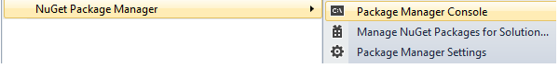

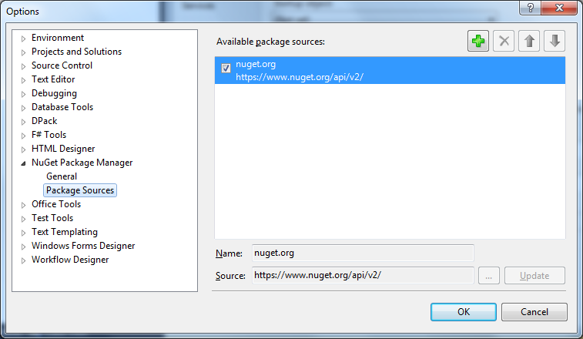

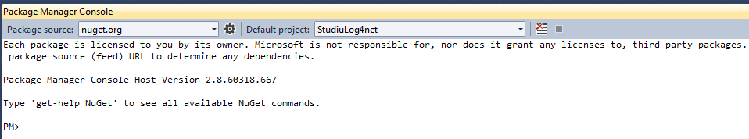

Q:

I was just wondering why there isn't a [TRACE level](http://logging.apache.org/log4net/release/sdk/log4net.Core.Level.html) in log4Net

<https://stackoverflow.com/questions/1394661/why-isnt-there-a-trace-level-in-log4net?utm_medium=organic&utm_source=google_rich_qa&utm_campaign=google_rich_qa>

<level value="WARN"/>

<level value="ERROR"/>

<level value="FATAL"/>

<level value="OFF"/>

Nivele log4net OFF, FATAL, ERROR, WARN, INFO, DEBUG(ALL)

Higher merge de **jos** in sus

| OFF

| [FATAL](http://logging.apache.org/log4j/1.2/apidocs/org/apache/log4j/Level.html#FATAL)

| [ERROR](http://logging.apache.org/log4j/1.2/apidocs/org/apache/log4j/Level.html#ERROR)  
| [WARN](http://logging.apache.org/log4j/1.2/apidocs/org/apache/log4j/Level.html#WARN)  
| [INFO](http://logging.apache.org/log4j/1.2/apidocs/org/apache/log4j/Level.html#INFO)  
| [DEBUG](http://logging.apache.org/log4j/1.2/apidocs/org/apache/log4j/Level.html#DEBUG) (ALL)  
|

Deci logam mesajele de nivel **egal sau superior**

Deci nivelele de sub el nu se logheaza

Daca nivelul este setat pe TRACE, adica cel mai de jos nivel, atunci orice comanda de logare

de deasupra va fi inregistrata, practic logam toate

Daca nivelul este setat pe INFO, atunci orice comanda de logare egal sau de de deasupra va fi inregistrata,

practic logam INFO,WARN,ERROR,FATAL.

Deci nivelele de sub el, DEBUG si TRACE nu se logheaza

Note that by default, the root logger is assigned to Level.DEBUG

More than one appender can be attached to a logger.

The [addAppender](http://logging.apache.org/log4j/1.2/apidocs/org/apache/log4j/Category.html#addAppenderorg.apache.log4j.Appender)method adds an appender to a given logger.

**Each enabled logging request for a given logger will be forwarded to all the appenders in that logger**

**as well as the appenders higher in the hierarchy.**

Deci ceea ce logam in copii, logam de asemenea si in sus, in toti parents si alti ancestors (stramosi)

[RootLogger Fisier] 26/02/2013 15:45:37, Level: WARN, Logger: HelloWorld: - ----------------------

[RootLogger Fisier] 26/02/2013 15:45:37, Level: DEBUG, Logger: HelloWorld: - getMessage() debug

[RootLogger Fisier] 26/02/2013 15:45:37, Level: INFO, Logger: HelloWorld: - getMessage() info

[RootLogger Fisier] 26/02/2013 15:45:37, Level: WARN, Logger: HelloWorld: - getMessage() warn

[RootLogger Fisier] 26/02/2013 15:45:37, Level: TRACE, Logger: HelloWorld: - getMessage() trace

[RootLogger Fisier] 26/02/2013 15:45:37, Level: ERROR, Logger: HelloWorld: - getMessage() error

[RootLogger Fisier] 26/02/2013 15:45:37, Level: FATAL, Logger: HelloWorld: - getMessage() fatal

log4j.rootLogger= INFO, FA, CA

log4j.logger.HelloWorld = **TRACE**, HWCA, HWFA (e setat pe **TRACE**, cel mai de jos nivel, deci orice comanda de logare va fi inregistrata)

log4j.logger.HelloWorld = **INFO**, HWCA, HWFA (e setat pe INFO, deci nivelele de sub el, DEBUG si TRACE nu se logheaza)

[HelloWorldLogger Fisier] 26/02/2013 15:53:15, Level: WARN, Logger: HelloWorld: - ----------------------

[HelloWorldLogger Fisier] 26/02/2013 15:53:15, Level: INFO, Logger: HelloWorld: - getMessage() info

[HelloWorldLogger Fisier] 26/02/2013 15:53:15, Level: WARN, Logger: HelloWorld: - getMessage() warn

[HelloWorldLogger Fisier] 26/02/2013 15:53:15, Level: ERROR, Logger: HelloWorld: - getMessage() error

[HelloWorldLogger Fisier] 26/02/2013 15:53:15, Level: FATAL, Logger: HelloWorld: - getMessage() fatal

log4j.appender.**CA**=**org.apache.log4j.ConsoleAppender**

log4j.appender.CA.target=System.out

log4j.appender.CA.layout=org.apache.log4j.PatternLayout

log4j.appender.CA.layout.ConversionPattern= [**RootLogger Consola**], %d{dd/MM/yyyy HH:mm:ss} Level: %p, Logger: %c{2}: - : %m%n

log4j.appender.**FA=org.apache.log4j.RollingFileAppender**

log4j.appender.FA.File=C:/temp/output.log

log4j.appender.FA.MaxFileSize=5MB

log4j.appender.FA.MaxBackupIndex=5

log4j.appender.FA.layout=org.apache.log4j.PatternLayout

log4j.appender.FA.layout.ConversionPattern= [**RootLogger Fisier**] %d{dd/MM/yyyy HH:mm:ss}, Level: %p, Logger: %c{2}: - %m%n

log4j.appender.**HWCA=org.apache.log4j.ConsoleAppender**

log4j.appender.HWCA.target=System.out

log4j.appender.HWCA.layout=org.apache.log4j.PatternLayout

log4j.appender.HWCA.layout.ConversionPattern= [HelloWorldLogger Consola], %d{dd/MM/yyyy HH:mm:ss} Level: %p, Logger: %c{2}: - : %m%n

log4j.appender.**HWFA=org.apache.log4j.RollingFileAppender**

log4j.appender.HWFA.File=C:/temp/helloWorld.log

log4j.appender.HWFA.MaxFileSize=5MB

log4j.appender.HWFA.MaxBackupIndex=5

log4j.appender.HWFA.layout=org.apache.log4j.PatternLayout

log4j.appender.HWFA.layout.ConversionPattern= [HelloWorldLogger Fisier] %d{dd/MM/yyyy HH:mm:ss}, Level: %p, Logger: %c{2}: - %m%n

Daca numele fisierului nu contine o cale completa, atunci log-ul apare in \bin !!

C:\BitNami\tomcatstack-7.0.35-0\apache-tomcat\bin\rapoarte.log

C:\BitNami\tomcatstack-7.0.35-0\apache-tomcat\bin\output.log

C:\BitNami\tomcatstack-7.0.35-0\apache-tomcat\bin\helloWorld.log

**ConversionPattern**

<http://logging.apache.org/log4j/1.2/apidocs/org/apache/log4j/PatternLayout.html>

<http://stackoverflow.com/questions/1806378/log4j-not-adding-newlines-between-logfile-entries>

Q:

<https://logging.apache.org/log4net/>

Q:

<http://archive.apache.org/dist/logging/log4net/binaries/>

<https://logging.apache.org/log4net/release/manual/configuration.html>

Q:

<https://www.nuget.org/packages/log4net/>

Install-Package log4net

<https://www.nuget.org/packages/log4net/1.2.10>

Install-Package log4net -Version 1.2.10

[**https://csharp.today/log4net-tutorial-great-library-for-logging/**](https://csharp.today/log4net-tutorial-great-library-for-logging/)

log4net.LogManager.GetLogger(System.Reflection.MethodBase.GetCurrentMethod().DeclaringType);

First open AssemblyInfo.cs

[assembly: log4net.Config.XmlConfigurator(ConfigFile = "SystemModelingAddins.dll.config", Watch = true)]

**Merge si asa cu full path**

[assembly: log4net.Config.XmlConfigurator(ConfigFile = "D:\\ProiecteCSharp\\StudiuLog4net\\StudiuLog4net\\bin\\Log4NetConfigFile\\SystemModelingAddins.dll.config", Watch = true)]

Q: Cum citesc din DLL-ul Enterprise Architect valori din app.config ?

<http://sparxsystems.com/forums/smf/index.php?topic=4712.0>

Q:

log4net dll class library

<https://social.msdn.microsoft.com/Forums/vstudio/en-US/7db558e7-ccc0-46f4-b74e-35bd633e014c/use-log4net-in-a-dll-project?forum=csharpgeneral>

<http://dl.dropbox.com/u/74336886/Logging.zip>

<http://logging.apache.org/log4net/release/manual/configuration.html>

<https://stackoverflow.com/questions/26339073/specify-log4net-config-for-use-in-class-library-in-using-parent-project>

You must tell log4net where to find the logging configuration. How you do it is described in the [log4net Manual](http://logging.apache.org/log4net/release/manual/configuration.html).

I prefer to add [assembly: log4net.Config.XmlConfigurator(Watch=true)] to my application's AssemblyInfo.cs file.

<http://www.dreamincode.net/forums/topic/195788-configuring-log4net/>

Which is called as early as possible in the startup process.

public static void ConfigureLocal()

{

if (null == GlobalContext.Properties[myConfig.Constants.LogsDirectorySettingName])

ConfigureBaseSettings();

LoggingConfigSwitch(false);

FileInfo fi = new FileInfo(GetLogConfigFileForCollector());

XmlConfigurator.ConfigureAndWatch(fi);

}

<http://haacked.com/archive/2006/01/13/SettingUpLog4NetForMultiLayeredApplications.aspx/>

Suppose we were’t dealing with Log4Net for a second, but wanted to configure some app settings? Would it require that we add an App.config file to the Business Layer and Data Access layer project? Indeed no. These are class libraries. They do not contain an execution entry point as an executable does. We simply need to add a web.config file to the Web Application Project and we’re set.

The main reason for this is that configuration settings apply to the executable application (in this case a web app). You can certainly include code within the business layer assembly to read app settings, but it reads the settings from the web.config or App.config file in the execution startup path.

Technically, the ASP.NET web application assembly is not an executable, it is a class library. However due to how the ASP.NET runtime works, it exhibits some of the behavior of being an executable and for the purposes of this discussion we’ll leave it at that. One key difference though is that for executables, the config file must be named the same as the assembly with a config extension and put in the same directory as the executable (typically bin), whereas with an ASP.NET application, the config file is always named “web.config” and placed in the web root, not in the bin directory.

Q: log4net config file

log4net.config.xmlconfigurator assemblyinfo.cs

<https://stackoverflow.com/questions/308436/log4net-programmatically-specify-multiple-loggers-with-multiple-file-appenders>

Dar dinamic ?

<https://stackoverflow.com/questions/571876/best-way-to-dynamically-set-an-appender-file-path>

<https://www.codeproject.com/Questions/357529/Log-net-log-file-in-relative-path>

<https://stackoverflow.com/questions/1535736/how-can-i-change-the-file-location-programmatically>

<https://stackoverflow.com/questions/308436/log4net-programmatically-specify-multiple-loggers-with-multiple-file-appenders>

[**https://stackoverflow.com/questions/26349587/log4net-implementation-without-assemblyinfo-cs**](https://stackoverflow.com/questions/26349587/log4net-implementation-without-assemblyinfo-cs)

You can do it in a [global.asax file](http://msdn.microsoft.com/en-us/library/vstudio/2027ewzw%28v=vs.100%29.aspx), which is a way to add application-wide code to your service (as well as for asp.net projects)

<https://hanskindberg.wordpress.com/2013/04/07/log4net-configuration/>

### 1.3 Configure log4net on application start

If you have problems configuring log4net with the XmlConfiguratorAttribute, configure log4net on application-start.

Eg. put the following in your Global.asax.cs:

protected void Application_Start(object sender, EventArgs e)

{

    log4net.Config.XmlConfigurator.ConfigureAndWatch(new System.IO.FileInfo(AppDomain.CurrentDomain.BaseDirectory + "log4net.config"));

}

In the add-in EA_Connect event, specify the full path to the log4net configuration file

 public string EA_Connect(Repository repository)  
{

  string dllFullPath = Assembly.GetExecutingAssembly().Location;  
  String logFile = Path.GetDirectoryName(dllFullPath)+'\\log4net.config';

 FileInfo fileInfo = new FileInfo(logFile);  
  log4net.Config.XmlConfigurator.ConfigureAndWatch(fileInfo);

  ILog log = LogManager.GetLogger(System.Reflection.MethodBase.GetCurrentMethod().DeclaringType);

   log.Info('\r\nEA_Connect '' + repository.ConnectionString + ''');

}

<https://stackoverflow.com/questions/571876/best-way-to-dynamically-set-an-appender-file-path>

use %property{}

appender name="YourAppender" type="log4net.Appender.RollingFileAppender">

<file type="log4net.Util.PatternString" value="~/App_Data/%property{LogName}" />

....

</appender>

This is dynamic -- you just have to set the log4net property "LogName" **before** you initialize log4net. Thus, in your code any time before you configure log4net, set the desired value of this property:

string LogName = GetType().Assembly.GetName().Name + ".log";

log4net.GlobalContext.Properties["LogName"] = LogName;

<https://stackoverflow.com/questions/32892021/log4net-in-a-separate-configuration-file>

<https://stackoverflow.com/questions/16766236/log4net-only-works-when-xmlconfigurator-configure-is-called>

You should not need to explicitly call XmlConfigurator when you include the line in your AssemblyInfo.cs.

The problem comes when the first use of log4net is in an assebmly that doesn't have that line.

The first log line that my application logged was through that.

You could just log a line early in your app or if you don't need to log anything do what I did and add the following at the entry point of the application

LogManager.GetLogger(typeof(Program));

You do not need to call the XmlConfigurator manually if you use:

[assembly: log4net.Config.XmlConfigurator(ConfigFile = "Log.config", Watch = true)]

However you have to **add the tag to all your dlls** (all assambly.cs files).

<https://stackoverflow.com/questions/3971250/log4net-configuration-from-assembly-attribute-does-not-load-configuration-file>

Log4net loads, but doesn't seem to be processing my config file. When I comment out the attribute in AssemblyInfo.cs and run the following code during my program initialization, it works as expected:

var log4netConfig = "Log4net.config";

var log4netInfo = new FileInfo(log4netConfig);

log4net.Config.XmlConfigurator.ConfigureAndWatch(log4netInfo);

What am I doing wrong? I want to load from AssemblyInfo.cs.

<https://stackoverflow.com/questions/31131377/need-to-refer-log4net-config-file-in-assemblyinfo>

The following code in AssemblyInfo will instruct Log4Net to configure using your App.Config:

[assembly: log4net.Config.XmlConfigurator(Watch = true)]

<https://stackoverflow.com/questions/18073268/how-to-set-save-path-dynamicaly-in-the-log4net-configuration-file>

[assembly: XmlConfigurator(Watch = true)]

**Q:**

**Model de app.config care refera un alt config pentru log4net.config**

<?xml version="1.0" encoding="utf-8" ?>

<configuration>

<configSections>

<section name="log4net" type="log4net.Config.Log4NetConfigurationSectionHandler,log4net"/>

</configSections>

<log4net configSource="log4net.config"/>

<startup>

<supportedRuntime version="v4.0" sku=".NETFramework,Version=v4.5"/>

</startup>

</configuration>

Apoi plasezi configurarile in fisierul tau log4net.config

<log4net>

<!-- Configuration -->

</log4net>

<https://mitch-wheat.blogspot.ro/2007/04/log4net-net-logging-tool.html> fain !

Although it is possible to add your log4net configuration settings to your project’s app.config or web.config file, it is preferable to place them in a separate configuration file.

Aside from the obvious benefit of maintainability, it has the added benefit that log4net can place a FileSystemWatcher object on your config file to monitor when it changes and update its settings dynamically.

To use a separate config file, add a file named Log4Net.config to your project and add the following attribute to your AssemblyInfo.cs file:

[assembly: log4net.Config.XmlConfigurator(ConfigFile = "Log4Net.config", Watch = true)]

**Note**: for web applications, this assumes Log4Net.config resides in the web root. Ensure the log4net.config file is marked as “Copy To Output” -> “Copy Always” in Properties.

At the start of each class declare a logger instance as follows:

public class ClassWithLoggingExample

{

private static readonly ILog log =

LogManager.GetLogger( System.Reflection.MethodBase.GetCurrentMethod().DeclaringType);

...

}

You will need to add a “using log4net;" statement to each class file. By defining a logger in each class you have the ability to control the logging level on a class by class basis, simply by using the config file.

**Q:**

Higher merge de jos in sus

Increasing priority merge de jos in sus

^

| OFF – no logging

| FATAL

| ERROR

| WARN

| INFO

| DEBUG

| TRACE (nu exista in .NET)

| ALL – lowest possible rank and is intended to turn on all logging

Deci logam mesajele de nivel egal sau superior

Deci nivelele de sub el nu se logheaza

Cu cât urcam in ierarhie cu atât logam mai putine informatii

Daca nivelul este setat pe TRACE sau pe ALL,

adica cel mai de jos nivel, atunci orice comanda de logare

de deasupra va fi inregistrata, practic logam toate

Daca nivelul este setat pe INFO, atunci orice comanda de logare de deasupra va fi inregistrata,

practic logam INFO,WARN,ERROR,FATAL.

Deci nivelele de sub el, DEBUG si TRACE nu se logheaza

For example, if you specify:

log.Fatal("Fatal message");

log.Error("Error message");

log.Warn("Warning message");

log.Info("Info message");

log.Debug("Debug message");

You can specify what is the highest logging level in the config. Any lower level messages are not logged

|  |  |
| --- | --- |
| OFF | no message will be logged |
| FATAL | only FATAL messages will be logged |
| ERROR | only ERROR and above will be logged FATAL messages will be logged |
| WARN | Only WARN and above will be logged ERROR, FATAL messages will be logged |
| INFO | Only INFO and above will be logged WARN, ERROR, FATAL |
| DEBUG | Only DEBUG and above will be logged INFO, WARN, ERROR, FATAL |
|  |  |
| ALL – every message will be logged | FATAL StudiuLog4net.Form1 - Fatal message  ERROR StudiuLog4net.Form1 - Error message  WARN StudiuLog4net.Form1 - Warning message  INFO StudiuLog4net.Form1 - Info message  DEBUG StudiuLog4net.Form1 - Debug message |

Date pattern

<layout type="log4net.Layout.PatternLayout">

<conversionPattern value="%date{dd/MM/yyyy HH:mm:ss} %level %logger - %message%newline" />

</layout>

Acestea sunt logurile active

**<root>**

**<level value="ALL"/>**

**<appender-ref ref="MyAppender" />**

**<appender-ref ref="MyFileAppender" />**

**<appender-ref ref="EATabAppender"/>**

**</root>**

Q:

<https://logging.apache.org/log4net/release/manual/configuration.html>

Q:

<https://stackoverflow.com/questions/17106559/using-log4net-to-write-to-different-loggers>

You have configured Log4Net so that the root logger logs to both file and event log appenders. All loggers inherit this configuration, so both your loggers "DataIntakeService" and "EventLogAppender" log to these appenders.

If you don't see log messages in event viewer, it may be because your application doesn't have permission to create the Event source.

How can i configure it so the DataIntakeService logs to the file and the other one to the eventviewer ?

Here's a sample configuration:

<log4net>

<root>

<level value="INFO" />

<appender-ref ref="LogFileAppender" />

</root>

<logger name="EventLogAppender" additivity="False">

<level value="INFO" />

<appender-ref ref="EventLogAppender" />

</logger>

<appender>

...

Q:

<https://stackoverflow.com/questions/3335869/what-is-the-root-logger-in-log4net>

<root>

<level value="WARN" />

<appender-ref ref="RollingLogFileAppender" />

</root>

I think the log4net [documentation](http://logging.apache.org/log4net/release/manual/introduction.html#hierarchy) explains this quite nicely:

Loggers are organized in hierarchies. E.g.: The logger Foo.Bar is child of the logger Foo. This way the loggers create a tree and the root logger is simply the root of that tree (in the example Foo is a child of the root logger).

This hiearchy allows for some interesting configuration applications (e.g. disable/enable logging for an entire sub system of your application).

The Root Logger can hold a list of appenders and settings (typically just the log level) used when logging.

Check [this link](http://ondotnet.com/pub/a/dotnet/2003/06/16/log4net.html) for more details about the Root Logger with Log4net.

Here is another good [link](http://logging.apache.org/log4net/release/manual/configuration.html).

Q:

log4net <logger> tag LogManager.GetLog

<http://www.tekniken.nu/utvecklingstips/visual-studio-snippet-for-log4net>

<https://stackoverflow.com/questions/8926409/log4net-hierarchy-and-logging-levels>

<https://stackoverflow.com/questions/4593182/difference-between-logger-and-root-level-in-log4net>

root means all logs in the application, and logger allows to refer to a certain kind of log.

<logger name="File">

<level value="WARN” />

</logger>

<root>

<level value="INFO" />

</root>

In this sample all logs are to INFO, and the the log of the type "File" (or named File) is WARN.

Ce sunt astea ?????

UserErrorLogFileAppender

**<logger** additivity="false" **name="ToolExpertErrorLogFileAppender">**

<level value="ALL"/>

<appender-ref ref="ToolExpertErrorLogFileAppender" />

</logger>

**<logger** additivity="false" **name="UserErrorLogFileAppender">**

<level value="ALL"/>

<appender-ref ref="UserErrorLogFileAppender" />

</logger>

<appender **name="EATabAppender"** **type="EAAddins.Utils.EATabAppender**">

<!-- <level value="ALL"/>-->

<layout type="log4net.Layout.PatternLayout">

<param name="ConversionPattern" value="%date : %-5level : %-logger : %message%newline"/>

</layout>

</appender>

<param name="ConversionPattern" value="%d [%t] %-5p %m%n" />

log4net configuration file location !!!

Q:

2017-05-05 10:50:20,413 FATAL StudiuLog4net.Form1 - Fatal message

2017-05-05 10:50:20,422 ERROR StudiuLog4net.Form1 - Error message

2017-05-05 10:50:20,423 WARN StudiuLog4net.Form1 - Warning message

2017-05-05 10:50:20,424 INFO StudiuLog4net.Form1 - Info message

2017-05-05 10:50:20,425 DEBUG StudiuLog4net.Form1 - Debug message

StudiuLog4net.exe > a.txt

Q:

**A log per day**

<http://stackoverflow.com/questions/615092/log4net-rolling-file-appender-define-extension>

[**http://stackoverflow.com/questions/10349536/having-a-log-per-day**](http://stackoverflow.com/questions/10349536/having-a-log-per-day)

actually RollingFileAppender **simply adds to the file name what you describe in datePattern**.

So, if you want gateway_20120427.log, then you should have

file name gateway and datePattern _yyyyMMdd'.log'.

Current log file will be without extension !!

<appender name="MyFileAppender" type="log4net.Appender.RollingFileAppender">

<file value="d:\emails\TestLog4Net" />

<appendToFile value="true" />

<rollingStyle value="Date"/>

<datePattern value="_yyyy_MM_dd'.txt'" />

<**staticLogFileName** value="false" />

<lockingModel type="log4net.Appender.FileAppender+MinimalLock" />

<layout type="log4net.Layout.PatternLayout">

<conversionPattern value="%date{dd-MM-yyyy HH:mm:ss} %level %logger - %message%newline" />

</layout>

</appender>

<appender name="MyFileAppender" type="log4net.Appender.FileAppender">

<file **type="log4net.Util.PatternString"** value="d:\emails\TestLog4Net%**date{_yyyy_MM_dd}.txt**" />

<appendToFile value="true" />

<**staticLogFileName** value="false" />

<lockingModel type="log4net.Appender.FileAppender+MinimalLock" />

<layout type="log4net.Layout.PatternLayout">

<conversionPattern value="%date{dd-MM-yyyy HH:mm:ss} %level %logger - %message%newline" />

</layout>

</appender>

<appender name="MyFileAppender" type="log4net.Appender.FileAppender">

<file value="d:\emails\TestLog4Net.txt" />

<appendToFile value="true" />

<lockingModel type="log4net.Appender.FileAppender+MinimalLock" />

<layout type="log4net.Layout.PatternLayout">

<conversionPattern value="%date{dd-MM-yyyy HH:mm:ss} %level %logger - %message%newline" />

</layout>

</appender>

Asta ar fi configuratia clasica de RollingFileAppender

When you'll try to write something to log other day, then current **gateway.log** will be renamed to **gateway.log20120427**

and new gateway.log file will be created.

<appender name="FileAppender" type="log4net.Appender.RollingFileAppender">

<file value="c:/paypal/logs/gateway.log" />

<appendToFile value="true" />

<rollingStyle value="Date" />

<datePattern value="yyyyMMdd" />

<layout type="log4net.Layout.PatternLayout">

<conversionPattern value="%date [%thread] %-5level %logger [%property{NDC}] – %message%newline" />

</layout>

</appender>

Q:

log4net appender level

Nivele log4net

OFF,

FATAL,

ERROR,

WARN,

INFO,

DEBUG,

ALL

Higher merge de **jos** in sus

Q:

Daca „ecran” si „fisier” sunt doua appendere din **root logger**

Scriem asa

root.Debug(„debug info” )

root.Error(„error info”)

root.Info(„info error”)

Vrem ca informatiile de Debug sa nu apara in appenderul „fisier”

Vrem ca informatiile de Debug sa apara doar in appenderul „ecran”

Cum facem ?

Varianta a) Setam pe appendere diverse **filtre si treshold-uri**

sau

**Varianta b) Sa nu mai punem in root logger** appenderele „ecranul” si „fisierul”

Ci sa punem appenderul „fisier” intr-un alt logger separat de root logger

<https://social.msdn.microsoft.com/Forums/vstudio/en-US/7db558e7-ccc0-46f4-b74e-35bd633e014c/use-log4net-in-a-dll-project?forum=csharpgeneral>

<http://stackoverflow.com/questions/21186378/log4net-logging-of-two-different-levels-to-two-different-appenders-for-the-same>

<http://stackoverflow.com/questions/1388588/configure-log4net-to-send-errors-to-different-appenders-based-on-level>

<http://stackoverflow.com/questions/39517450/log4net-how-to-define-different-logger-levels-per-appenders>

You should be able to set the threshold property of each appender **separately and include them in the same root.**

<appender name="filelogAppender" type="log4net.Appender.RollingFileAppender">

<threshold value="Error" />

</appender>

<appender name="dblogAppender" type="log4net.Appender.AdoNetAppender">

<threshold value="Info" />

</appender>

<root>

<appender-ref ref="filelogAppender" />

<appender-ref ref="dblogAppender" />

</root>

<appender name="MyFileAppender" type="log4net.Appender.FileAppender">

**<threshold value="FATAL"/>**

<file value="d:\emails\TestLog4Net.txt" />

<appendToFile value="true" />

<lockingModel type="log4net.Appender.FileAppender+MinimalLock" />

<layout type="log4net.Layout.PatternLayout">

<conversionPattern value="%date{dd-MM-yyyy HH:mm:ss} %level %logger - %message%newline" />

</layout>

</appender>

Or you can define a range not just a threshold

**<appender** name="MyFileAppender" type="log4net.Appender.FileAppender">

**<filter type="log4net.Filter.LevelRangeFilter">**

**<levelMin value="DEBUG" />**

**<levelMax value="DEBUG" />**

**</filter>**

<file value="d:\emails\TestLog4Net.txt" />

<appendToFile value="true" />

<lockingModel type="log4net.Appender.FileAppender+MinimalLock" />

<layout type="log4net.Layout.PatternLayout">

<conversionPattern value="%date{dd-MM-yyyy HH:mm:ss} %level %logger - %message%newline" />

</layout>

**</appender>**

Q:

When ***var*** is used, the compiler infers the type from the expression used to initialize the variable

**var** is *absolutely* different because it is a type-safe declaration. In fact, it infers the type just as you wrote it.

The *var* keyword can be used only within a local scope

C# 3.0 introduces lambda expressions, which allow the definition of anonymous methods using more concise syntax.

Lambda expressions can also optionally postpone code generation by creating an *expression tree* that allows further

manipulation before code is actually generated, which happens at execution time.

An expression tree can be generated only for the particular “pieces of code” that are expressions.

Q:

Delegates, Events, and Lambda Expressions

<https://msdn.microsoft.com/en-us/library/orm-9780596516109-03-09.aspx>

Threads

<https://msdn.microsoft.com/en-us/library/orm-9780596516109-03-18.aspx>

Interfaces

<https://msdn.microsoft.com/en-us/library/orm-9780596521066-01-13.aspx>

Delegates and events

<https://msdn.microsoft.com/en-us/library/orm-9780596521066-01-17.aspx>

ADO.NET

<https://msdn.microsoft.com/en-us/library/orm-9780596521066-01-20.aspx>

How to: Implement Interface Events (C# Programming Guide)

<https://msdn.microsoft.com/ro-ro/library/ak9w5846.aspx>

<http://www.jeremybytes.com/Downloads.aspx>

[**http://www.jeremybytes.com/Downloads/DesignPatterns.pdf**](http://www.jeremybytes.com/Downloads/DesignPatterns.pdf)

#### Learn the Lingo: Design Patterns (Sep 2010)

You already use Design Patterns but probably don't know it. Observer, Adapter, Iterator, Proxy -- Learning the lingo allows you to better communicate your ideas with other developers. We'll take a look at several GoF patterns that we regularly use without realizing it. Don't know who the GoF is? Read on to find out.

Q:

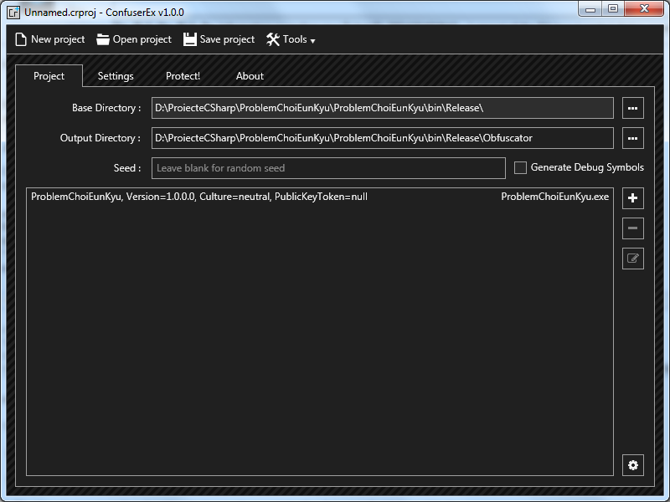

Q:

<https://msdn.microsoft.com/en-us/magazine/mt784654>

<https://msdn.microsoft.com/en-us/magazine/mt784664>

<https://msdn.microsoft.com/en-us/magazine/mt784661>

is bursting with exciting intelligence capabilities

Izbucnește cu capabilități de inteligenta incitante

Q:

