In part two we take a look at how the heart is working and how to attach the electrodes to the human body. We then record an ecg of each participand of the course. If you want to take a photo you need to modify the pushbutton on the Arduino in a way that is holds the dynamic measuring and presents a still picture of you ecg.

These are the electrodes and the cable.



Where to place the electrodes



When contracting the heart:

* pushes oxygen-poor blood into the lungs
* pumps oxygen-rich blood into the body



To do this the muscle heart needs electrical potentials in the range of several tens of millivolts.

The sinoatrial node (SA node) acts as an oscillator generating a pulse about every second

The pulse travels slowly to the muscles of the atria and to the atrioventricular node (AV node).

The muscles of the atria contract and then relax.

* As they contract, they pump blood into the ventricles.
* As they relax, the atria take in blood through the veins from the body or the lungs.

The AV node delays the pulse by 120 -200 mS then sends it to the muscles of the ventricles.

Its period is much longer than the SA oscillator.

It is "prematurely" triggered by the SA oscillator.

If the SA oscillator fails, the AV oscillator can oscillate on its own, a kind of backup system.

The muscles of the ventricles contract and then relax. As they contract, they pump blood to the body or the lungs.

The whole process takes around 500mS.

It takes more power to pump blood round the body so the biggest signal we see is from the muscles of the left ventricle.

The electricity is generated by charged ions.

When an action potential occurs in a cell, the cell next to it is triggered. So, the action potential spreads through the muscle and also via the Purkinje fibers. It's a slow process; no fast nerve conduction involved.

* Muscle cell conduction is 0.3 – 0.4 m/s.
* Purkinje fiber conduction is 2 – 3 m/s.
* Normal neuron conduction is 70 - 120 m/s.

Purkinje fibers can oscillate by themselves at 20-40 bpm and so act as a backup system if the SA and AV oscillators fail.

An ECG records the action potentials of the different muscles. The action potentials of the muscles are transmitted through the chest wall and skin by simple electrical conduction. So, the conduction is fast. By the time it reaches the skin the signal is around 1mV.

With the electrodes at the left and right under the clavicles, you'll get the classical PQRST shape you see in a textbook, usually called "Lead I".

Remember, what an ECG displays is the difference between two electrodes - it's a differential amplifier. The RL electrode acts as a ground to help with common-mode rejection.

The display with 240 pixel width and 360 pixel height.



The complete circuit, operated by 6 V = 4 x 1,5 V batteries.

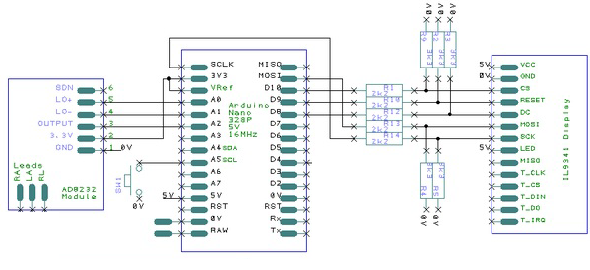

What you see:



We are interested in the large display only.

The large display mode allows you to examine one or two heart beats in detail. It shows a red background grid to make it look more like a ECG standard chart.

An ecg chart has large and small red squares printed on.

The standard scale is the x-axis is time with one large square being 200 ms.

The y-axis is voltage with one large square being 0.5mV.

The display shows the beats per minute in the top left corner. The sketch attempts to recognize "beats" but will be confused by noise or poor electrode connections.

The sketch tries to keep a peak in the left third of the screen so it isn't jumping around too much and is easier to study. It can only do so if the heart beat is regular - but a healthy heart doesn't beat regularly so that feature doesn't work too well.

We analyze this ecg trace.

The first bump is **P** wave. That's the atrial depolarization - the muscles of the atria starting to contract. There's a pause - the "PR segment" - while blood flows into the ventricles.

The big spike is the **QRS** complex. That's the ventricular depolarization - the muscles of the ventricles starting to contract.

There's another pause while blood flows out of the ventricles.

The next bump is the **T** wave. That's ventricular repolarization as the muscles of the ventricles relax. There's another pause and it all happens again.

There ought to be a bump for atrial repolarization but it's hidden under the QRS complex. There can be a U depolarization wave but it's often too small to be seen.

It takes years to train a cardiologist but you should be able to see broadly what's going on.

The P wave can tell you about what's going on in the atria. For instance, the shape of the P wave can tell you whether the left and right atria are acting together. If the P waves and the QRS waves are not synchronised then the two oscillators have become disconnected.

The QRS and ST segments show what's going on in the ventricles. An elevated ST segment can indicate a myocardial infarction ("heart attack"). A depressed ST segment can indicate a myocardial ischaemia ("angina"). Both are due to parts of the ventricle muscles not functioning properly. Ischaemia is when a region of the muscles is struggling due to lack of oxygen; infarction is when a region is in really in a bad way and has given up. But don't panic if you seem to have an elevated ST - it can also be due to the electrodes not being positioned properly.



