# LogWrapper

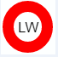

## How To Document

Contents

LogWrapper 1

How To Document 1

Description 4

WSCC compatibility 4

CommTrace and tracelog 4

Release package 5

**Note** 5

**Structure** 6

Bug Tracking 7

Tracker URL 7

User 7

Submitting but 7

How To Start 9

Application executable 9

Configuration 9

configuration options 9

LogWrapper.properties 9

Note 9

Logs 9

Main Frame 10

Menu 11

Settings 12

Drag and Drop Area, Application log 12

File import Methods 14

Drag and drop 14

Default open tool 14

Right click bulk import Windows explorer 14

Preview frame 15

Menu 15

Messages Table 16

Message Preview 16

Export Frame 17

Settings 17

Create SOAPUI Project 17

Extract images 21

WSCC Support 22

# Description

LogWrapper is a Java based tool that provides Preview, Export for easy interaction with CommTrace logs that are provided by PC/E

## WSCC compatibility

* **V02**
* V01(coming)

## CommTrace and tracelog

Preview

* Nice View, xml pretty print
* Sorting
* Filtering
  + ATM ID regexp before message view available
* Colorized view

Export

* Image
  + Auto image conversion for check transactions
  + bulk image conversion for check transactions
* ClipBoard
  + single transaction message
  + bulk transaction export into clipboard
* Soap UI
  + WSCC support
    - Export of selected items as Soap UI project
    - Simulation of transactions directly from CommTrace logs
    - Endpoint selection (JBOSS,WAS)
    - Endpoint URL selection
    - Assertion (coming)
    - Client request number auto increment (coming)

# Release package

Following files and directories are part of release package

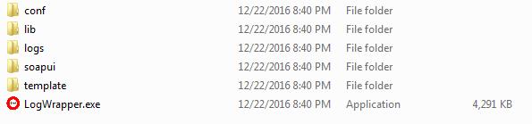

## **Note**

Complete discribution package includes **WSDL folder**

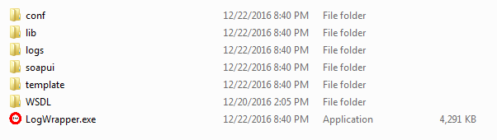

**As WSCC is internal Diebold Nixdorf component, the V02 nad V01 versions of WSDLs are not part of release package.**

**If you work for Diebold Nixdorf, there should be no problem of using it.**

**You can download the V01 and V02 folders from component share or please ask directly me via email [matej.bludsky@dieboldnixdorf.com](mailto:matej.bludsky@dieboldnixdorf.com)**

**For the application to function properly, please create WSDL folder inside the extracted release package and copy V01 and V02 to this folder, you can skip the generated sources.**

**UPDATE :**

**The WSDL file are no longer needed, the project works without them as well.**

### Structure

WSDL/V01 WSDL/V02

#### V01

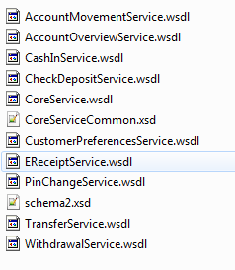

#### V02

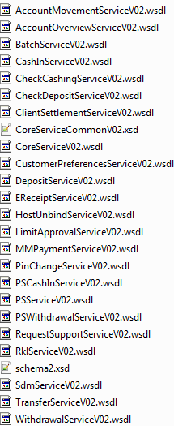

# Bug Tracking

Shall there be bugs or problems with the application, Bug tracker is setup to track progress on the resolution

## Tracker URL

[https://bugtracker.zoho.com/portal/matejbludsky](https://bugtracker.zoho.com/portal/matejbludsky%20)

## User

Account :[LogWrapper@outlook.com](mailto:LogWrapper@outlook.com)

password :LogWrapper

## Submitting but

Please add log files into the bug with detailed description about the problem and timestamps

Go to [https://bugtracker.zoho.com/portal/matejbludsky](https://bugtracker.zoho.com/portal/matejbludsky%20)

Use username and password to log in

Navigate to My Bugs

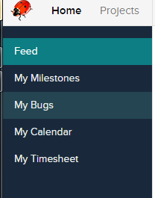

Click on Submit Bug



Enter your detailed description of the problem including timestamp and dont forget to attache logs, when done hit **save and add new**.

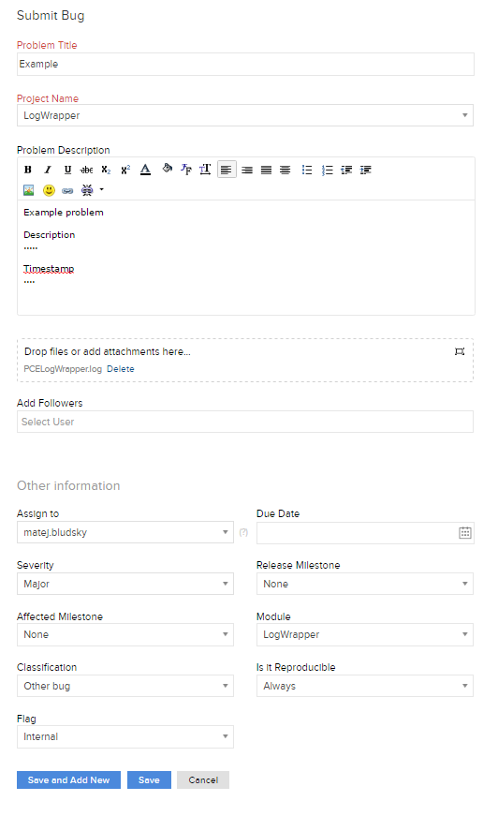

# How To Start

**Download** latest release package from GitHub

<https://github.com/matejbludsky/LogWrapper>

Extract this package to your desired location

## Application executable

Execute LogWrapper.exe inside the downloaded release package



## Configuration

Application uses configuration that can be changed inside the application or directly in the /conf/ LogWrapper.properties that is part of the release package, see below for more info.

### configuration options

### LogWrapper.properties

commtrace.names=^CommTrace.*

tracelog.names=^TraceLog.*

images.location=./tmp/images

images.save=false;

images.clear=true;

soapui.location=./soapui

soapui.clear=false

soapui.clear.before=true

commtrace.names = regular expression for log file names

tracelog.names = the same for trace log

images.location = where to save extracted images

images.save = save images on fly

images.clear = clear directory for images on start

soapui.location = where to export logs to soapui

soapui.clear = clear soapui directory before each export

soapui.clear.before = clear directory on start of application

### Note

folder /conf must be present

## Logs

Logs are generated runtime using log4j to logs directory





In case of issue with the application dont forget to include logs to your created bug

Application GUI description

## Main Frame

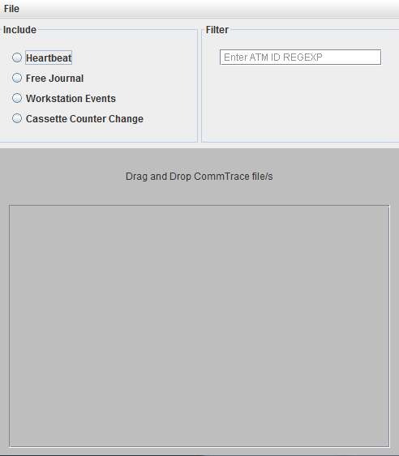

### Menu

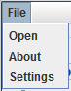

#### Open

Opens a CommTrace file/s and begins import.

#### About

Displays about me page

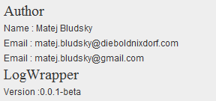

#### Settings

Displays application settings

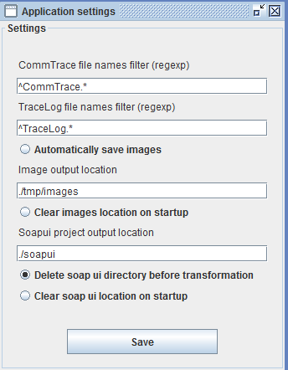

##### Configuration options

* Comm Trace file names
  + You can use file names to match files that you want to import
  + RegExp support
* Soap ui output location – used as a path for exported projects

### Settings

#### Include

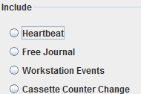

Using this feature you can determine what messages will be included into preview or not, his way you can directly filter out message that you are not interested in.

In case you want to include message, click on the radio button to include

#### Filter

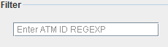

Using this feature, you can filter out only messages that matches your regexp of terminal, regexp is only applied to <ClientId> tag

### Drag and Drop Area, Application log

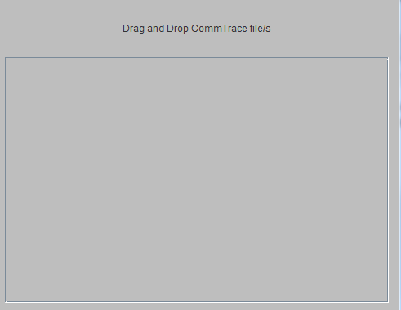

You can drag and drop files into this area to begin import process.

This area also displays log from the import process.

#### Supported files

You can import files with extension

* ctr
* txt
* rtf

Unsupported files will not be imported

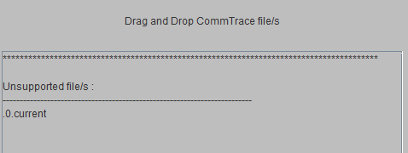

## File import Methods

### Drag and drop

Simply drag and drop your files directly to the application window

### Default open tool

Configure windows explorer to open CommTrace with LogWrapper

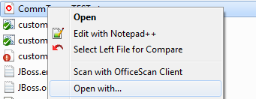

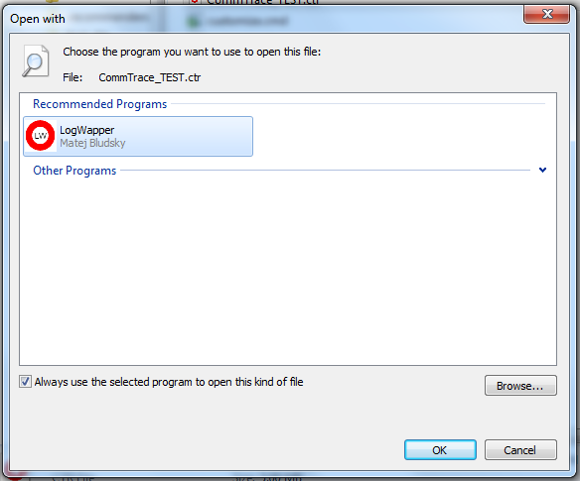

Browse to your release package and select LogWrapper.exe

From now on, you can double click CommTrace file and it will be opened by LogWrapper

### Right click bulk import Windows explorer

Comming soon

## Preview frame

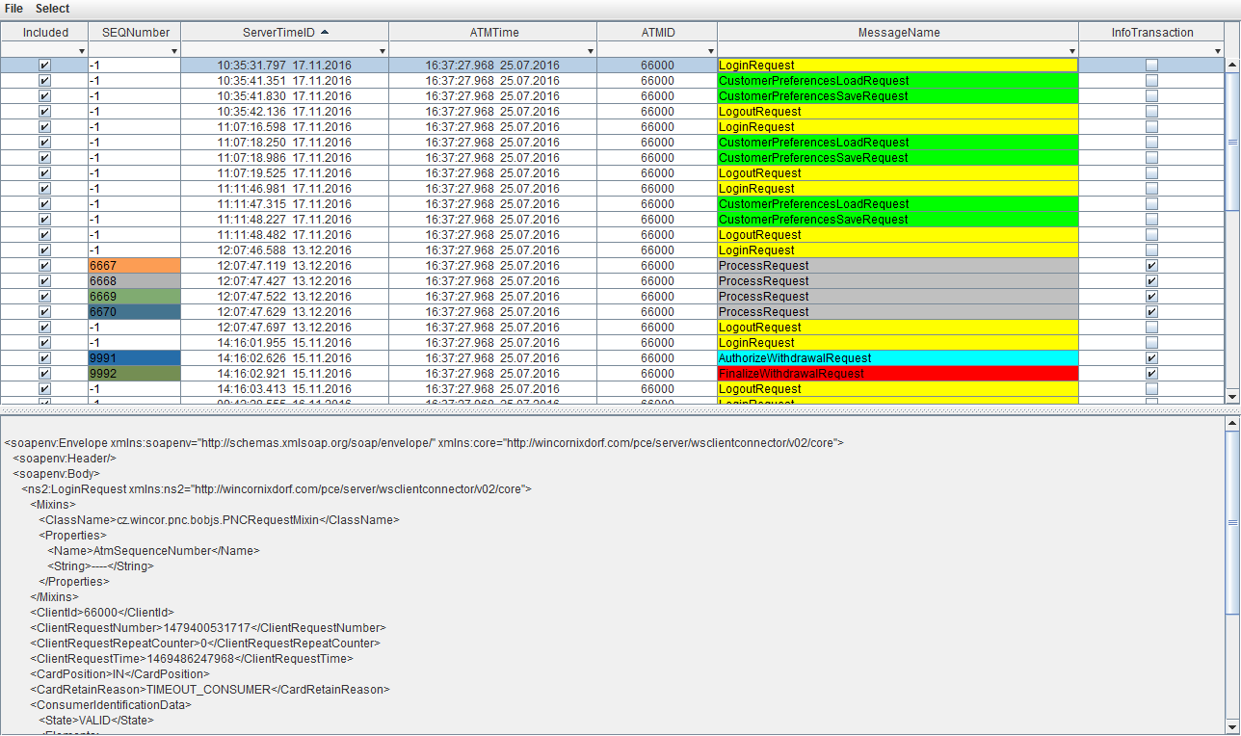

### Menu

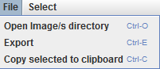

See section Export Frame for more details

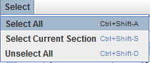

Please use shortcuts as this saves a lot of time.

### Messages Table

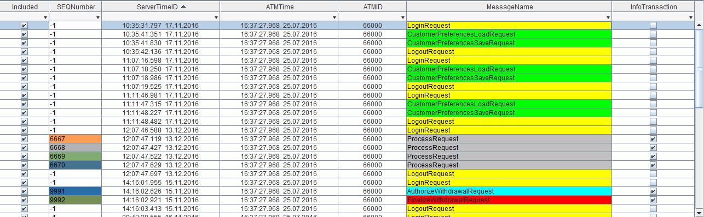

Here you will find all messages that were found and imported into LogWrapper

#### Filter options



Use the table header to perform sort or filter on table content

You can use ctrl+c on row/s to copy pretty printed xml message into system clipboard

### Message Preview

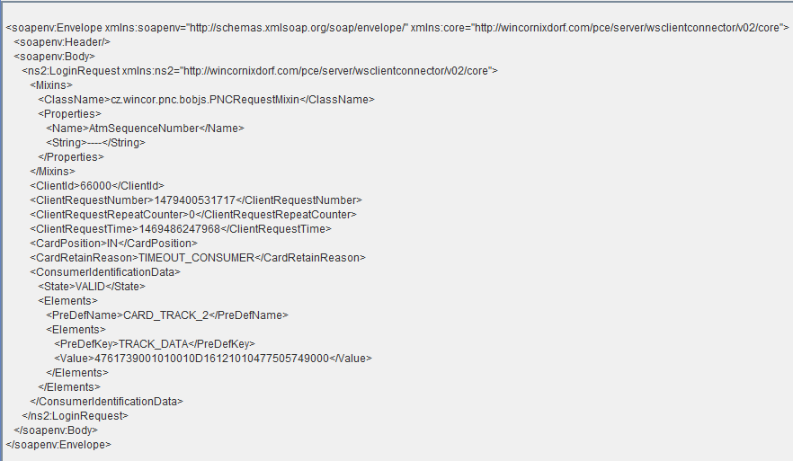

This area displays message in pretty xml format

#### Image view

Coming soon

## Export Frame

This frame is used for export features

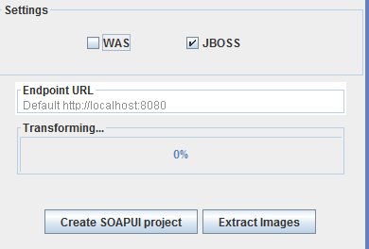

### Settings

#### WAS

Creates endpoint suffix for Websphere

#### JBOSS

Creates endpoint suffix for JBOSS

#### Endpoint URL

Enter URL that you wish to use for the soap ui test steps

### Create SOAPUI Project

This triggers the soap ui transformation of the messages.

This will take messages from the table that are marked with checkbox as included and will create a soap ui project that includes those messages as test step

#### Note

Please download soap ui free to use from

[https://www.soapui.org/](LogWrapper_HowTo.docx)

Version used during development : 5.2.1

#### Example of exported project

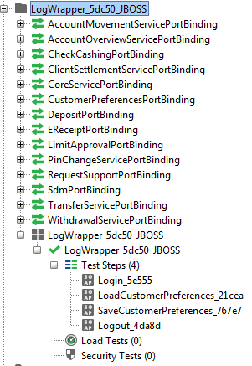

Each message is created as test step, messages are sorted by server time or arrival.

#### Execute the tests

Hit play in order to start the whole test suite

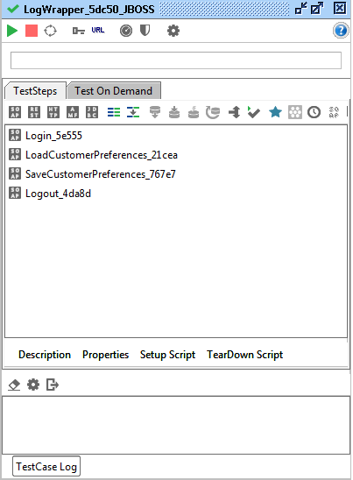

#### Test step overview

You can also execute or view test steps one by one

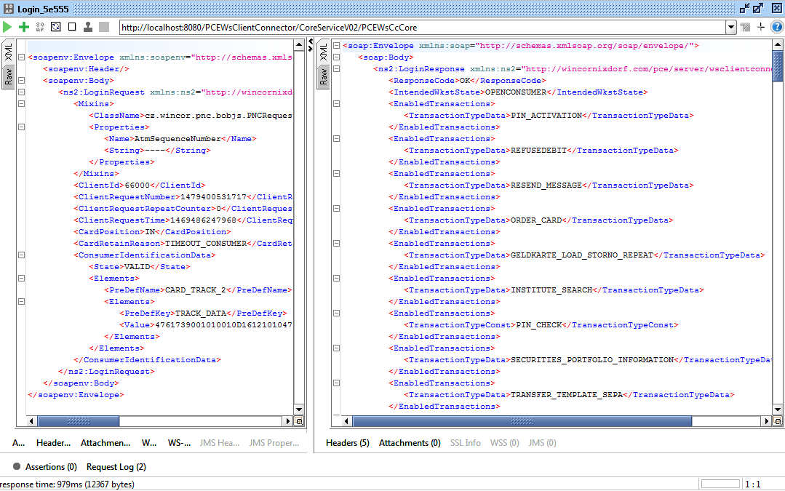

#### Message sequence issue

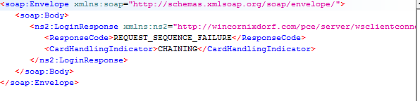

In case you see this you need to delete restart data in webadm

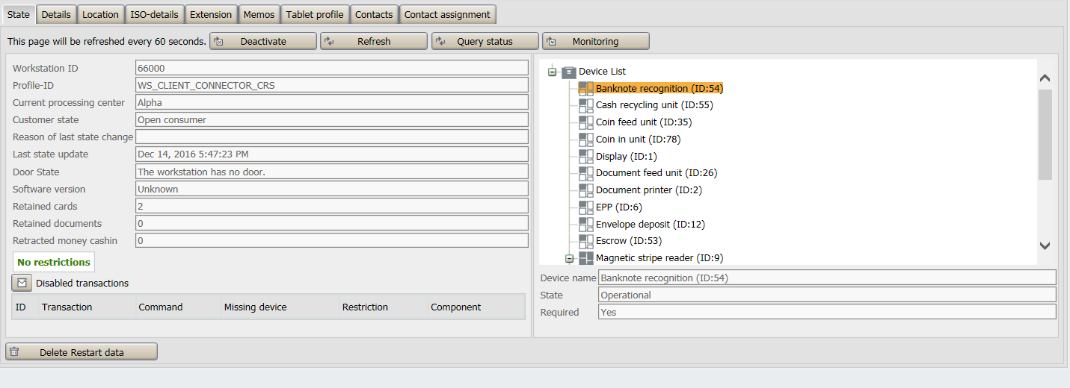

Use button delete restart data to perform the sequence cleaning procedure

### Extract images

This feature will iterate over messages marked as included in the table and will analyze it’s content, if there is images inside the message (<Image>), LogWrapper will convert base64 image data directly to image and store it based of the settings for the image location, after process is done, this folder will be automatically open in windows explorer.

#### Example usage

1. Import file/s into LogWrapper
2. Select which items you want to include
3. Hit extract images

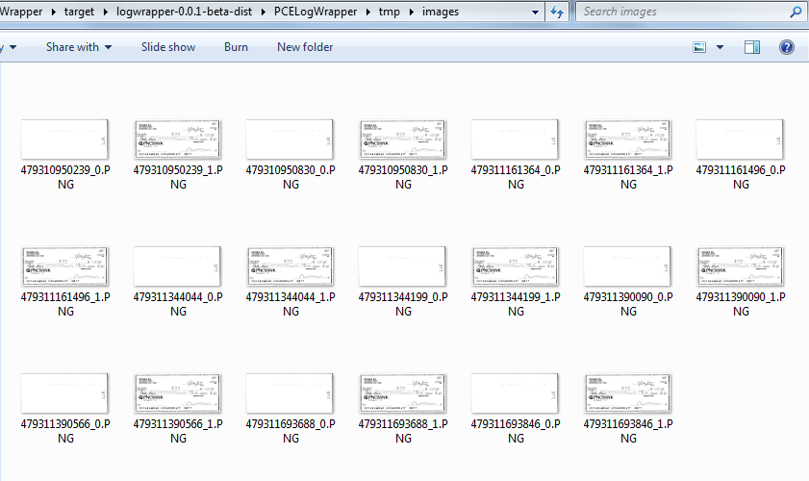

# WSCC Support

As this tool was developed for PNC project, following operations are supported

* *ACCOUNT_MOVEMENT*
* *ACCOUNT_OVERVIEW*
* *CHECK_CASHING*
* *CLIENT_SETTLEMENT*
* *CORE*
* *CUSTOMER_PREFERENCES*
* *DEPOSIT*
* *ERECEIPT*
* *LIMIT_APPROVAL*
* *PINCHANGE*
* *REQUEST_SUPPORT*
* *SDM*
* *TRANSFER*
* *WITHDRAWAL*

You can request to add more support for uncovered messages, please contant me for details