Jednokanalovy
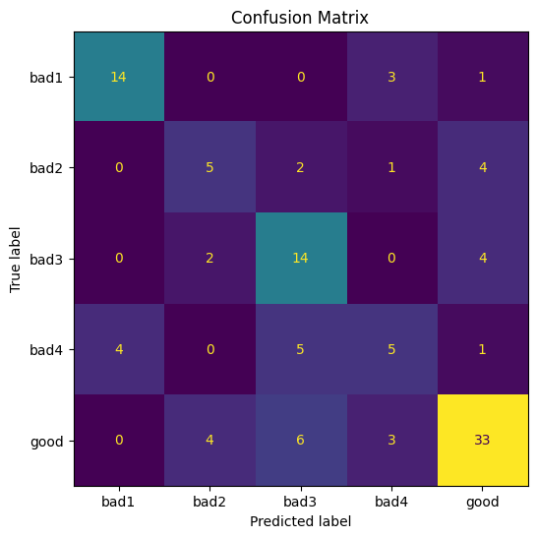
Test loss: 1.1163
Test accuracy: 0.6396

Trojkanalovy
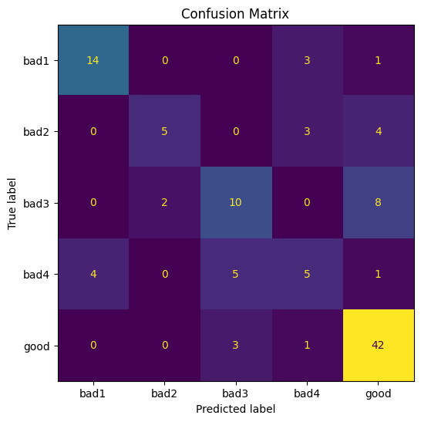
Test loss: 1.0244
Test accuracy: 0.6847
RGB
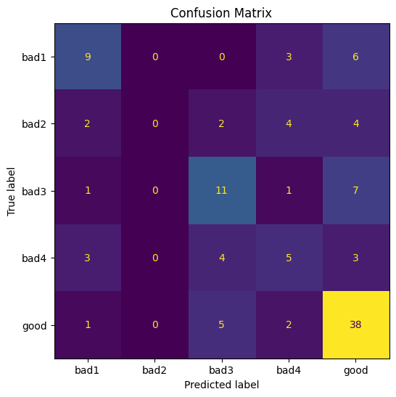
Test loss: 1.2615
Test accuracy: 0.5676

