Example robots moves in 1D corridor  xt​=robot position  Models:  Motion model  Robot moves +1 m each step with Gaussian noise:  x_{t}​=x_{t−1}​+1+ϵ ϵ∼N(0,0.2²)  Sensor model: Robot measures distance to a wall at position 5:  z_{t}​=5−x_{t}​+δ, δ∼N(0,0.5²)  Likelihood:  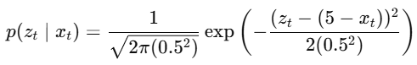 |  | Step 0 — Initial belief  Assume uniform belief in corridor [0,4].  Particles:  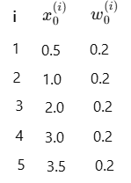 |  | Step 1 — Prediction (motion update)  motion model (example draws):  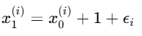  Assume noise samples:  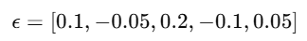
New particles: represent predicted belief  Bel^(x1)  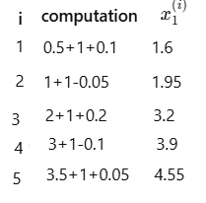 | Step 2 — Measurement update  Sensor reading: z1=1.0  Expected measurement from particle x: z^=5−x  Compute likelihood for each particle.  Gaussian likelihood:  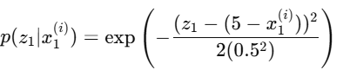  omit constant since weights normalized later | Particle 1  x=1.6, z^=5−1.6=3.4 error=1.0−3.4=−2.4 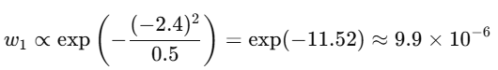  Same way for particle 2 – 5 => sum S  S=9.9e⁻⁶+0.00022+0.278+0.98+0.546≈1.804 => Step 3 normalized  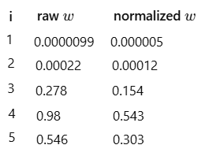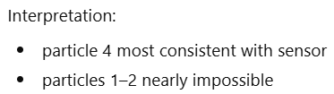
Step 4 Posterior approximation  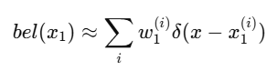  Distribution heavily concentrated near:  x ≈ 3.9, 4.55 ??? |  | Step 5 — Resampling  Draw 5 particles according to weights.  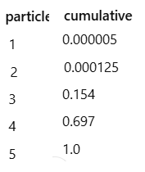 | sample uniform numbers:[0.12, 0.3, 0.6, 0.75, 0.9]  Select:  0.12 → particle 3  0.3 → particle 4  0.6 → particle 4  0.75 → particle 5  0.9 → particle 5  New particle set: [3.2, 3.9, 3.9, 4.55, 4.55]  Weight reset w=1/5

Step 6 — Final belief after one iteration
Posterior now concentrated near true position.

Mean estimate x^=1/5(3.2+3.9+3.9+4.55+4.55)=4.02

Robot likely around x~4
answer requested theory items  1.Effective sample size N_{eff}​ [0.178,0.323,0.337,0.102,0.060]  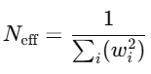 N_{eff}​ = 3.8 Since N=5,  particle diversity reduced → resampling justified. |  | 2. Second iteration interpretation  Observation sequence shrinks uncertainty:  - t=0: uniform  - t=1: cluster near 4  - t=2: tight cluster near 4.9 |  |  | 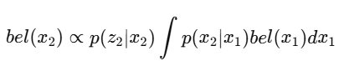  Particles numerically approximate this integral
3. Compare numerically with EKF 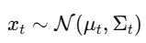  Posterior here is skewed [4.1,4.95,4.9,4.9,5.65] |  | Distribution:  - asymmetric  - heavy tail right  EKF would approximate with mean≈4.9 and variance small → loses asymmetry and multimodality.  Particle filter preserves non-Gaussian shape.
4. Degeneracy without resampling  If resampling skipped:  weights propagate multiplicatively:  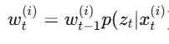  After several steps:  - one particle weight → 1  - others → 0  Example here:  largest weight = 0.337 already dominates.  After few steps: N_{eff}​→1  Filter collapses → poor approximation.  Resampling redistributes particles to high-probability regions. |  | 5. Optimal proposal q(x_{t}∣x_{t−1},z_{t})  General SIS weight:  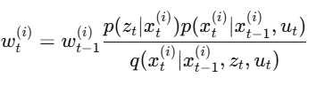  Variance minimized when:  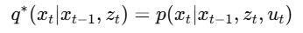  Using Bayes  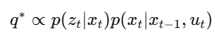  This uses measurement during sampling, not only weighting
This uses measurement during sampling, not only weighting.  Advantages:  - lower variance weights  - fewer particles needed  Disadvantage:  - sampling from p(x_{t}∣x_{t−1},z_{t}) often analytically hard  Hence standard PF uses simpler proposal:  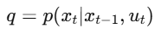 |  | Big picture after full two-step example  We have numerically demonstrated:  - Bayes recursion implemented with samples  - Prediction ≈ sampling motion  - Correction ≈ likelihood weighting  - Degeneracy appears naturally  - Resampling stabilizes filter  - Posterior converges toward robot position  This is the full operational mechanics of Monte Carlo Bayes filtering in robotics

Example Particle filter  1. Problem Setup (Formal Notation)  Grid World: 5 positions [A, B, C, D, E] , discrete state space X={A,B,C,D,E}  Motion model (State Transition):  But because the space is discrete and we have only “right” or “stay”:  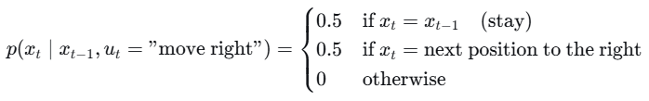  For the rightmost position E, attempting to move right → stay (since no cell beyond).  Observation Model: Let z_{t}∈{Wall,Open}  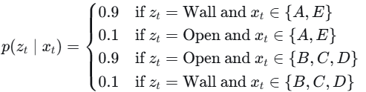  Initial Belief: bel₀​(x)=p(x₀​)=Uniform(X)=1/5​ for each x  Particle Representation:  We use N = 4 particles. Each particle is a state hypothesis  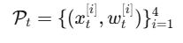  Initially: 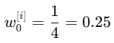  Notice: even true prior is 1/5, we approximate with 4 particles of equal weight  Initial particle set (random draw from prior): [A, C, E, B] | 2. Step 0: Initialization (t=0)  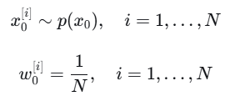  We have 4 particles x₀^{i}, drown i.i.d.from S initially uniform:  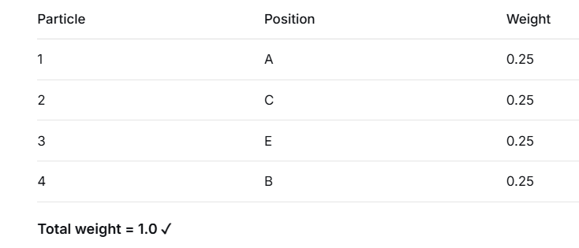  Belief approximation:  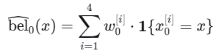  This gives probability 0.25 to states {A, C, E, B} and 0 to D.  This is an approximation of the true uniform prior.  Let in t=0 we are in state C
3.1 step 1. Time t=1 (control and observation)  NIS Only (No Resampling)  Receive Control u₁="move right"  Observation z₁=Open (true robot state is C → moves to D, so D is Open)  For each particle, apply motion model:  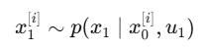 random no. 0.3 > 0.25 go right  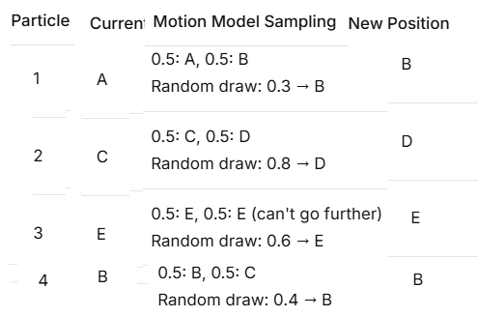  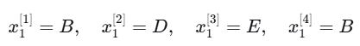  Particles after motion: [B, D, E, B]  Weights remain unchanged before observation: still w0[i]=0.25 | 3.2: Observation update (weighting)  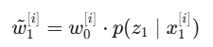than normalize 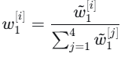  Calculate likelihood p(z₁="Open" | position):  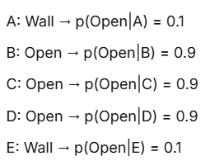  Update unnormalized weights: w_{i} = w_{i} × p(z|x_{i})  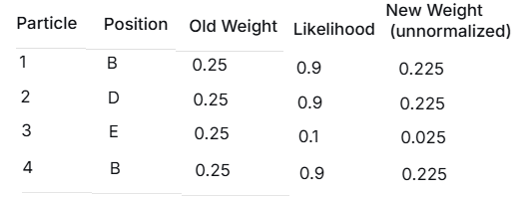  Sum = 0. 225 225 + 0. + 0.025 + 0.225 = 0.700
3.2: Normalize Weights  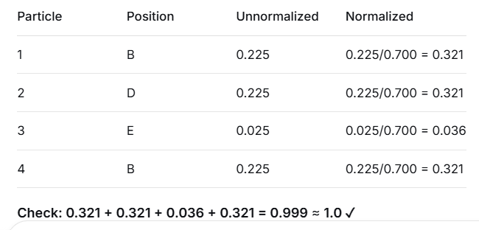 | Details:  Particle set after NIS update
3.3: Effective Sample Size (Degeneracy Measure)  NIS Output & Analysis  State estimate: Weighted average  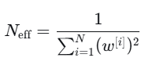  - B: 0.321 + 0.321 = 0.642 weight  - D: 0.321 weight  - E: 0.036 weight  - Estimate = (0.642×B + 0.321×D + 0.036×E) = Between B and D  Effective Sample Size (ESS):  ESS N_{eff}= 1/Σ(w^{i}²) = 1/(0.321² + 0.321² + 0.036² + 0.321²)  = 1 / (0.103 + 0.103 + 0.001 + 0.103) = 1 / 0.310 = 3.23  Observation: We started with 4 particles,  ESS=3.23 → some degeneracy already! (mild degeneracy) | 3.4 : State Estimation (Weighted Mean)  weighted histogram  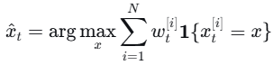  or for continuous approximation we might compute a weighted  average of positions. Here we can compute the most likely state  (maximum weight particle) or weighted average if we assign numerical  values to positions (A=1, B=2, C=3, D=4, E=5).  Maximum weight particle:  Particles at B and D have weight 0.3214, B appears twice, D once.  The highest weight value is at B (two particles with combined weight 0.6428).  So the MAP estimate would be B.  Weighted average (numerical):  Let positions map to numbers: A=1, B=2, C=3, D=4, E=5. ?  x^_{t}=2×0.3214+4×0.3214+5×0.0357+2×0.3214  =0.6428+1.2856+0.1785+0.6428=2.7497 (between B and C) ?
4. Step1 continued: Add Naive Resampling  - Construct a categorical distribution q over particles with probabilities w₁^{[i]}​.  - Sample N indices i_{k}∼q with replacement.  - New particle set: x₁^{new[k]}​=x₁^{[ik​]​}  - Reset weights: w₁^{new[k]}​=1/N1 | 4.1: Build Cumulative Distribution for Resampling From t=1 weights:  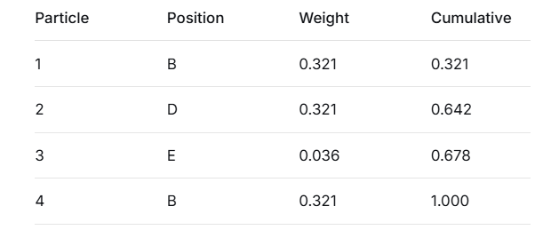
4.1: Resample N=4 particles  Draw 4 random numbers: [0.15, 0.55, 0.70, 0.95]  - 0.15 < 0.321 → Select Particle 1 (B)  - 0.55 between 0.321 and 0.642 → Select Particle 2 (D)  - 0.70 between 0.678 and 1.000 → Select Particle 4 (B)  - 0.95 between 0.678 and 1.000 → Select Particle 4 (B)  Resampled particles: [B, D, B, B]  Reset weights: All become w= 0.25 | 4.2 Low-Variance Resampling (Systematic)  Draw r∼Uniform[0,1/N]  - For k=1,…,N 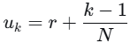  - Select particle j such that cumulative weight at j−1 < u_{k}​ ≤ cumulative weight at j.  For r=0.3 and u1​=0.10, u2​=0.35, u3​=0.60, u4​=0.85  Mapping 0.10 -> B, 0.35 -> D 0.60 still D, 0.85 -> B  Result [B,D,D,B]  E still lost. Low-variance ensures that any particle with weight > 1/N (here 0.25) is guaranteed at least one copy. E's weight 0.0357 < 0.25, so it is not guaranteed and may be lost. If we had a different r, it might be kept, but probability is low.

The state transition probability is
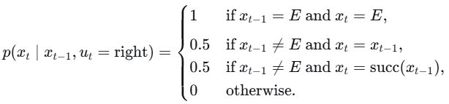
5. Step 2 Time t=2 (Repeat Process) Use 4.1 [B, D, B, B] all weights 0.25  Apply motion model stay 0.5, move right 0.5  Draw random numbers  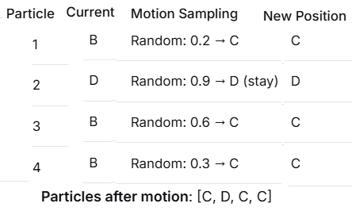 | 3.3: Apply Motion (u="move right")  
3.4: Receive Observation z="Open" (True position is D → Open)  Update weights:  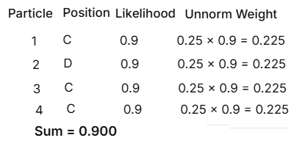 | 3.5: Normalize  All weights = 0.225/0.900 = 0.25  Wait! All particles have equal likelihood, so weights stay uniform!  ESS = 4.0 (perfect)  Step 4: Time t=3 - Low-Variance Resampling  4.1: Start from uniform weights [0.25, 0.25, 0.25, 0.25]  Cumulative: [0.25, 0.50, 0.75, 1.00]
4.2: Low-Variance Resampling  Step A: Pick random start r ∈ [0, 1/N] = [0, 0.25]  Let r = 0.1  Step B: Generate N points: u_i = r + (i-1)/N  - u₁ = 0.10  - u₂ = 0.10 + 0.25 = 0.35  - u₃ = 0.35 + 0.25 = 0.60  - u₄ = 0.60 + 0.25 = 0.85 | Step C: Map to particles:  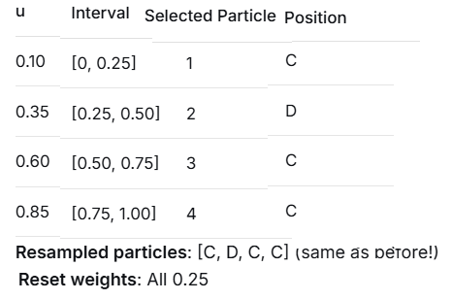
Observation: With uniform weights, low-variance gives same result as random. The power shows when weights vary! | Step 5: Demonstrate Low-Variance Advantage  Let's simulate a degenerate case from Step 1:  Scenario: After NIS, weights were [0.321, 0.321, 0.036, 0.321]  Cumulative: [0.321, 0.642, 0.678, 1.000]
5.1: Naive Resampling (with random draws [0.05, 0.35, 0.65, 0.99])  - 0.05 < 0.321 → Particle 1 (B)  - 0.35 between 0.321 and 0.642 → Particle 2 (D)  - 0.65 between 0.642 and 0.678 → Particle 3 (E) ← Low weight particle selected!  - 0.99 between 0.678 and 1.000 → Particle 4 (B)  Result: [B, D, E, B] → E preserved (low weight) | 5.2: Low-Variance Resampling (r=0.1)  u₁=0.10 → [0, 0.321] → Particle 1 (B)  u₂=0.35 → [0.321, 0.642] → Particle 2 (D)  u₃=0.60 → [0.642, 0.678] → Particle 3 (E)  u₄=0.85 → [0.678, 1.000] → Particle 4 (B)  --- ---  Same result! But let's try r=0.3:  u₁=0.30 → [0, 0.321] → Particle 1 (B)  u₂=0.55 → [0.321, 0.642] → Particle 2 (D)  u₃=0.80 → [0.678, 1.000] → Particle 4 (B) ← Skips E!  u₄=1.05 → Wraps to 0.05 → [0, 0.321] → Particle 1 (B)  Result: [B, D, B, B] → E lost  Key insight: Low-variance guarantees any particle with weight > 1/N will be selected at least once. Here, E had weight 0.036 < 0.25, so it's not guaranteed!
Step 6: KLD-Sampling Demonstration (Conceptual) ne e predavano KLD  From Step 1 particles: [B, D, E, B]  Step A: Create histogram bins (bin size = 1 position):  - A: 0 particles  - B: 2 particles (weight 0.642)  - C: 0 particles  - D: 1 particle (weight 0.321)  - E: 1 particle (weight 0.036) | Step B: Compute KL divergence from uniform: ???  Uniform: [0.2, 0.2, 0.2, 0.2, 0.2]  Empirical: [0, 0.642, 0, 0.321, 0.036] (normalize: divide by 1.0)  Actually, we use histogram of particle counts: [0, 2, 0, 1, 1]  Empirical distribution: [0, 0.5, 0, 0.25, 0.25] (normalized by N=4)  KL = Σ p_{i} log(p_{i}/q_{i})  = 0×log(0/0.2) + 0.5×log(0.5/0.2) + 0×log(0/0.2) + 0.25×log(0.25/0.2) + 0.25×log(0.25/0.2)  = 0 + 0.5×log(2.5) + 0 + 0.25×log(1.25) + 0.25×log(1.25)  = 0.5×0.916 + 0.25×0.223 + 0.25×0.223  = 0.458 + 0.056 + 0.056 = 0.570
Step C: From Fox 2003 formula:  k = number of non-empty bins = 3  ε = 0.05 (desired accuracy)  Required particles = (k-1)/(2ε) = 2/(0.1) = 20 particles!  Conclusion: With only 4 particles, KL divergence is high (0.57). We need ~20 particles to represent this distribution well. This shows why adaptive particle counts help! | 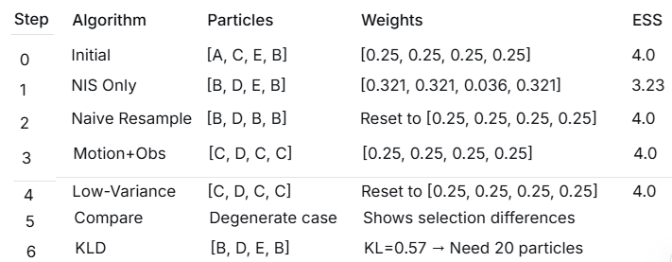
🎯 Key Learning Points:  - NIS degeneracy: After 1 step, ESS dropped from 4.0 to 3.23  - Resampling helps: Brought ESS back to 4.0  - Diversity loss: Resampling lost particle E (was already low weight)  - Low-variance: More systematic, less random than naive resampling  - KLD insight: 4 particles insufficient for this distribution | KLD stands for Kullback-Leibler Divergence (also called Kullback-Leibler Distance).

