at time t, observe state s_{t} ∈ S. Get reward r_{t} agent make choice a_{t}∈ A | State transition model: P(s_{t+1}/s_{t},a_{t}) (Markov)
Optimal policy: policy π, expected utility over all possible state from s0 produced by
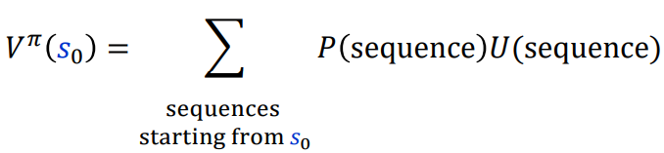 valued function (π, s0)
Policy 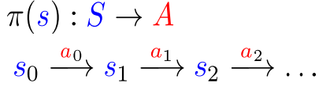 action taken in particular time | Discounting rewards  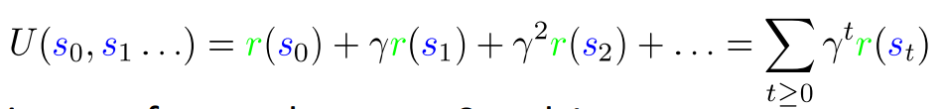  γ ∈ (0,1) how important present vs. future
Optimal policy 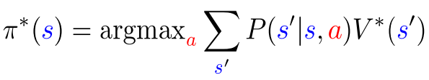  Start with V₀ (s)=0. Update value iteration  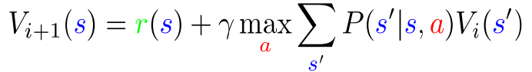  Policy iteration: algorithm  start random π compute value function V^{π} set of linear equation  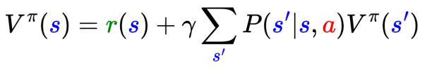  Improve policy obtain π ‘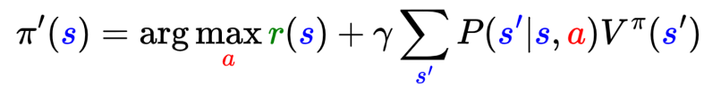  policy iteration. Basic idea:  • Start with random policy π  •Use it to compute value function V^{π} (for that policy) •Improve the policy: obtain π’ | Bellman equation optimal policy  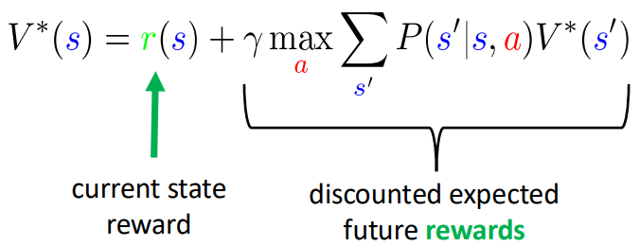
Consider an MDP with 2 states {A, B} and 2 actions: “stay” at current state and “move” to other state. Let r be the reward function such that r(A) = 1, r(B) = 0. Let 𝛾 be the discounting factor. What is the optimal policy (A) and (𝐵)? What are 𝑉* (𝐴), 𝑉* (B)? | If in A:  stay → next state A (reward r(A)=1 again next step)  move → next state B (reward r(B)=0 next step)  If in B:  - stay → next state B (reward 0 next step)  - move → next state A (reward 1 next step)
Immediate reward is received in the current state, independent of action. Then the next state's value is discounted.  Optimal policy reasoning Belman eq. here P deterministic  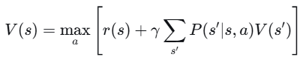  V∗(A)=max_{a}{r(A)+γV∗(A),r(A)+γV∗(B)} V∗(B)=max_{a}{r(B)+γV∗(B),r(B)+γV∗(A)}  - stay: 1+γV(A) stay: 0+γV(B)  - move: 1+γV(B) move: 0+γV(A) | We guess: in A, compare 1+γV(A) vs 1+γV(B)  Since V(A)≥V(B) (A yields higher reward), staying in A is better if V(A)≥V(B). So π(A)=stay.  In B, compare γV(B) vs γV(A).  Clearly V(A)≥V(B) so move is better: π(B)=move.  ---- ----  With π(A)=stay , π(B)=move:  V(A)=1+γV(A) V(B)=0+γV(A)  V(A)(1−γ)=1​ => V(A)=1/(1- γ) Then V(B)=γV(A)=γ/(1−γ)​.
Match with policy π(A)=Stay,π(B)=Move
Values: V∗(A)=1/(1−γ),V∗(B)=γ(1−γ)​
Optimal policy  For policy π, expected utility over all possible state sequences from 𝑠0 produced by following that policy:  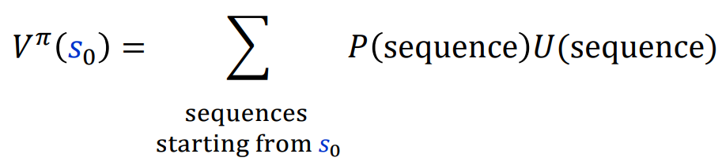  Called the value function (for π, 𝑠0) | Discounting Rewards One issue: these are infinite series. Convergence?  •Solution  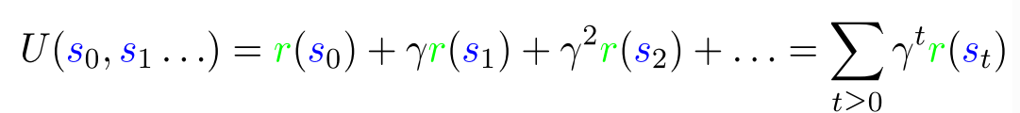  •Discount factor γ between 0 and 1  •Set according to how important present is vs. future  •Note: has to be less than 1 for convergence
From Value to Policy, Obtaining the Optimal Policy  Now that 𝑉^{𝜋} (𝑠₀) is defined what a should we take?  •First, set V*(s) to be expected utility for optimal policy from s  •What’s the expected utility of an action?  •Specifically, action a in state s?  Need some other property of the value function to get it! | 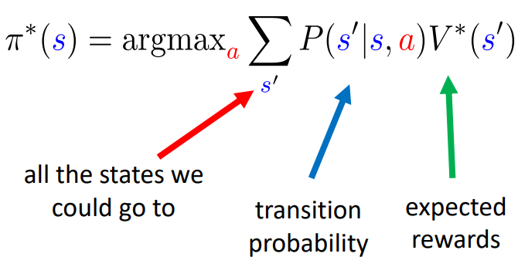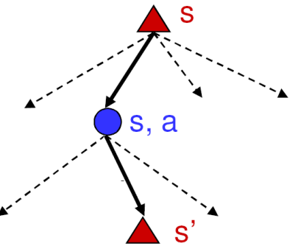
 | 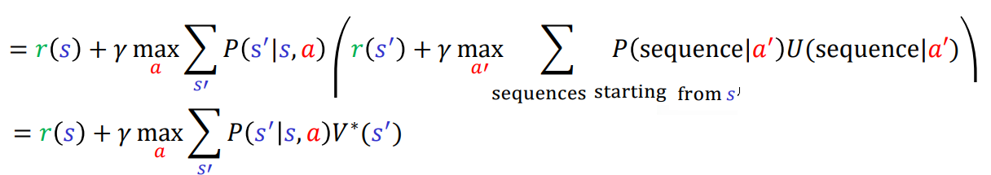
Value iteration  Q: how do we find V*(s)?  •Why do we want it? Can use it to get the best policy  •Know: reward r(s), transition probability P(s’|s,a)  •Also know V*(s) satisfies Bellman equation (recursion above)  A: Use the property. Start with V₀ (s)=0. Then, update | 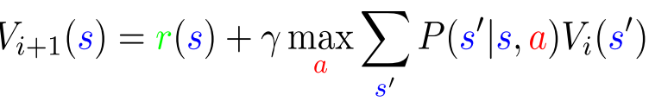
Policy Iteration  With value iteration, we estimate V*  •Then get policy (i.e., indirect estimate of policy)  •Could also try to get policies directly | •This is policy iteration. Basic idea:  • Start with random policy π  •Use it to compute value function Vπ (for that policy)  •Improve the policy: obtain π’
Algorithm Policy iteration.  • Start with random policy π  •Use it to compute value function V^{π} : a set of linear equations | 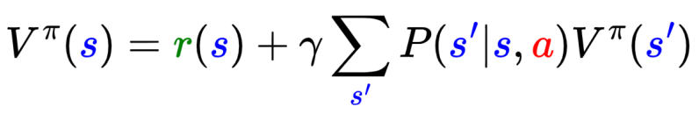
•Improve the policy: obtain π’ | 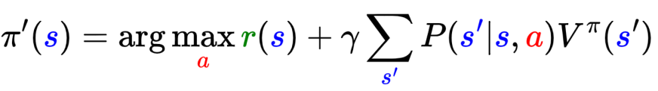
Q-Learning (model-free RL)  What if we don’t know transition probability P(s’|s,a)?  •Need a way to learn to act without it.  •Q-learning: get an action-utility function Q(s,a) that tells us the value of doing a in state s  •Note: V*(s) = max_{a} Q(s,a)  •Now, we can just do 𝜋∗ (𝑠) = arg max_{𝑎}𝑄 (𝑠,a)  • But need to estimate Q! | Q-Learning Iteration  How do we get Q(s,a)?  •Similar iterative procedure learning rate  Idea: combine old value and new estimate of future value.  Note: We are using a policy 𝜋 to take actions 𝑎_{𝑡} = (𝑠_{𝑡}); this policy is based on Q! learning rate
Exploration Vs. Exploitation  General question!  •Exploration: take an action with unknown consequences  •Pros:  • Get a more accurate model of the environment  • Discover higher-reward states than the ones found so far  •Cons:  • When exploring, not maximizing your utility  • Something bad might happen | •Exploitation: go with the best strategy found so far  •Pros:  • Maximize reward as reflected in the current utility estimates  • Avoid bad stuff  •Cons:  • Might also prevent you from discovering the true optimal strategy
Q-Learning: Epsilon-Greedy Policy  How to explore?  • With some 0<ε<1 probability, take a random action at each state, or else the action with highest Q(s,a) value | 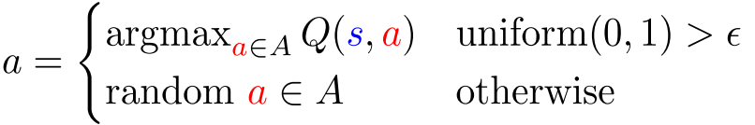
Q-Learning: SARSA  An alternative:  •Just use the next action, no max over actions:  •Called state–action–reward–state–action (SARSA)  •Can use with epsilon-greedy policy | Q-Learning Details Note: if we have a terminal state, the process ends  •An episode: a sequence of states ending at a terminal state  •Want to run on many episodes  •Slightly different Q-update for terminal states
Q-table can be quite large… might not even fit memory  •Solution: use some other representation for a more compact version. Ex: neural networks | 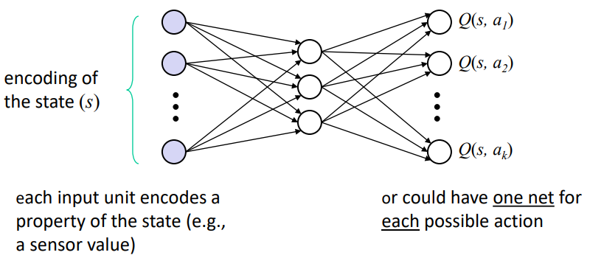
Deep Q-Learning  How do we get Q(s,a)?  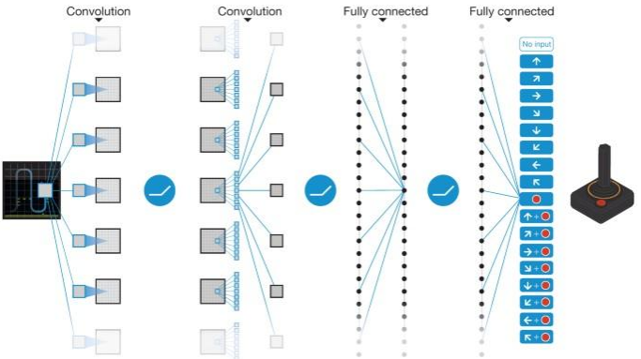 | Q For Q learning to converge to the true Q function, we must  • A. Visit every state and try every action  • B. Perform at least 20,000 iterations. (No: this is dependent on the particular problem, not a general constant).  • C. Re-start with different random initial table values. (No: this is not necessary in general). convergence can occur from any initial Q-values as long as exploration and learning rate conditions are met  • D. Prioritize exploitation over exploration. (No: insufficient exploration means potentially unupdated state action pairs)

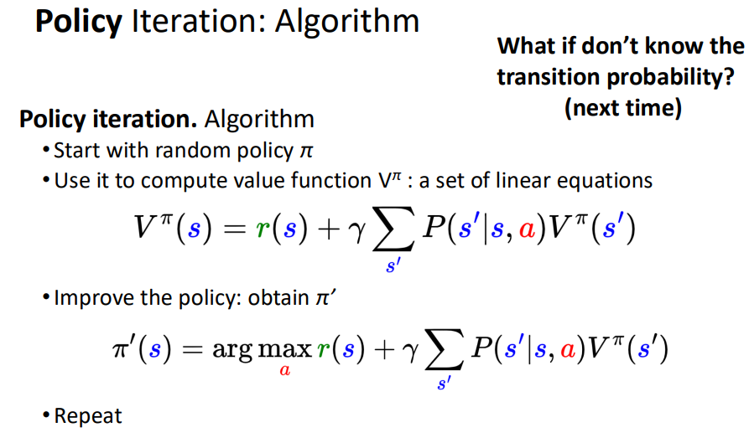 | (Kinez) Not simplified formula (our is simplified)  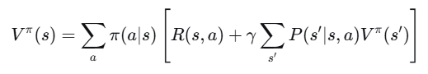  For deterministic policy  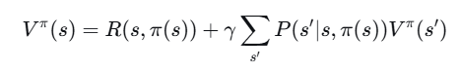  In following exam questions P(s’/s ,a) is deterministic taking action a leads to a unique s'
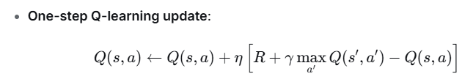  Koristen vo exam | 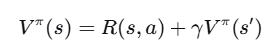  a=π(s) and s′ is the determined next state.

RL 3  Represent by tables: Value V: table size |S|x1 backgammon 10²⁰ go 3³⁶¹  Q function: table size |S|x|A| | Function approximation V, Q functions approximate by models i.e. NN  V ^{𝜋}(s) ≈ V^_{θ}(s) find weights θ  Loss function:  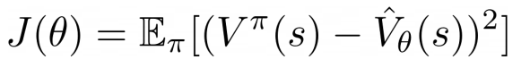
State representation and model  Feature vector  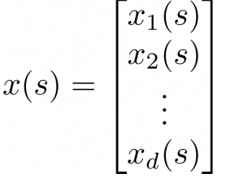 start with linear models 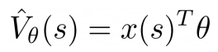 | Linear VFA With an Oracle  •SGD update is  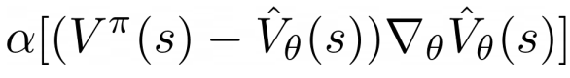  For linear midel  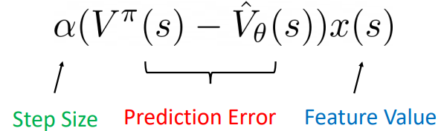
What if We Don’t Have an Oracle? Use Monte-Carlo  •We won’t know V ^{𝜋}(s_{t})  Estimate returns 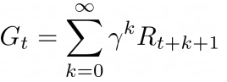  Can just run episodes and estimate, ie, get some noisy estimates as training data  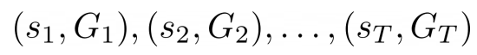 | Q-Function Approximation  Similar idea for Q-function  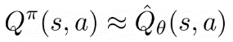  Representation: use both states and values  •Can still use linear models  •Note: quite popular to use deep models
Q-Function Approximation: Deep Models
•Note: quite popular to use deep models
•e.g. CNNs if the states are images (like in video games)
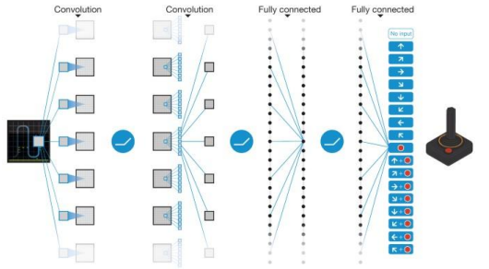
•Policy-based RL  Policy gradient, policy gradient theorem, REINFORCE algorithm  So far, we either approximated V or Q  •Then use these to extract the optimal policy  Could do the same trick but with the policy  • Note: so far our policies were deterministic, now we’ll allow a distribution over actions,  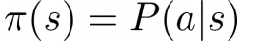  Want: 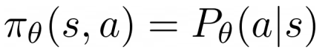 | Policy Gradient  Use the same idea. We’ll define an objective J(θ)  • And then can get gradients:  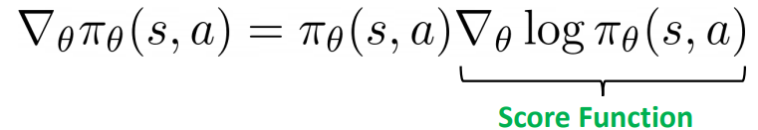  •Example: continuous action space.  •Gaussian policy 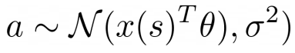  •has score: 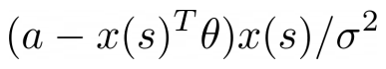
Set objective  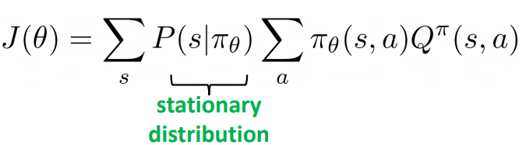  • Compute the gradient via the policy gradient theorem  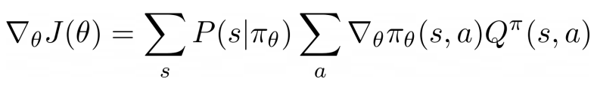 | REINFORCE Algorithm  So, to learn a policy, we can run SGD (actually ascent)  •Compute gradients via policy gradient theorem  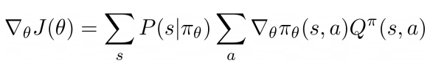  •Just need estimates 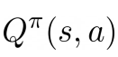  •How? Monte-Carlo again: Use Gt for our estimates.

drugi
Learning Markov  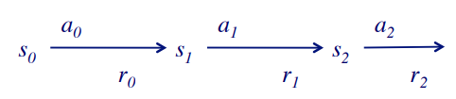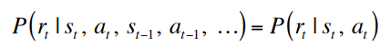 | Goal: learn a policy π : S → A for choosing actions that maximizes  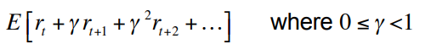  For every possible starting state s₀

CS760 s1994  3. Reinforcement Learning (30 points)  i. Consider the state-space drawn below; states are represented as nodes and actions by directed arrows. The number near an arrow is the current estimate of the Q-value for that state transition. Unless indicated, the reward (R) received upon entering a state is zero.  Assume an agent starts in state A, deterministically follows the policy specified by the current Q function, and wishes to maximize its discounted cumulative reward (with γ = 0.9). Also assume this agent is performing one-step Q-learning (with η = 0.25).  In the drawings below, circle the arcs the agent will take and show the updated Q-function following each of its first four steps. Briefly explain your calculations in space to the right |  | 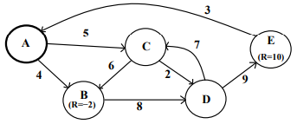  - γ = 0.9 (discount factor) η = 0.25 (learning rate) Rewards are 0 unless specified  - The agent starts in state A and follows the current Q-values (greedy policy w.r.t current Q)  - One-step Q-learning update:  - Q(s,a)←Q(s,a)+η[R+γ max _{a′}​ Q(s′,a′)−Q(s,a)]  - V*(s)=r(s)+ γ max_{a} ∑_{s’}P(s’/s,a)V*(s’)
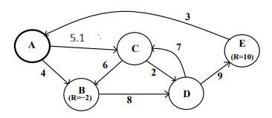  Update Q(A->C) <- 5+0.25*0.4=5.1.  Agent move to C | - Greedy: A → B: Q = 4, A → C: Q = 5  Greedy choice: A → C (Q=5>Q=4).  Update Q(A→C):  s’=C, from C max{6,2}=6, A->C revard R=0 since no revard entering C)  TD target=R+γmaxQ(C)= 0+0.9*6=5.4 TD error =5.4-5=0.4  Update Q(A->C) <-=5+0.25*0.4=5.1. | 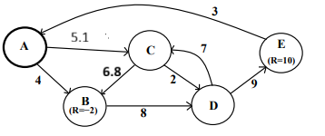  Update A(C->B) <- 6+0.25x3.2=6.8  Agent moves to B | Greedy C->B:Q=6, C->B (Q=2)  Greedy choice C->B: s=B  Update (C->B):  S’=B, from B max(B)=Q(B->D)=8  R=2 (entering B)  TD target =2+0.9x8=9.2  TD error=9.2-6=3.2  Update A(C->B) <- 6+0.25x3.2=6.8
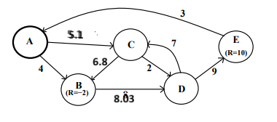  Update Q(B->D)=8.03  Agent move to D | B->D: Q=8, Greedy choice B->D:  Update Q(B->D)  S’=D, from D: max A(D)=max7,9)=9  R=0 (entering D)  TD target =0+0.9x9=8.1  Td error=8.1-8=0.1  Update Q(B->D) <- 8+0.25=0.1=8.03 | 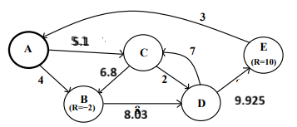  Update Q(D->E)=9.925  Agent moved to E  Path=A->C->B->D->E | Greedy D->C, Q=7, D->E, Q=9  Greed choice D->E Q=9  Update Q(D->E)  S’=E From E: max Q=Q(E->A)=3,  R=10 (entering E)  TD target =10+0.9x3=12.7  Td error=12.7-9=3.7  Update Q(D->E) <- 9+0.25x3.7=9.925  Agent moved to E

CS760 f1997
2. Reinforcement Learning and Neural Networks (25 pts)
Part A Imagine an environment like the Agent World, but where the learner can only move LEFT or RIGHT. The agent’s sensors report the distances to the left wall and right walls. The world is 3 meters wide, the agent’s step size is 1 meter, and the agent always starts 1 meter from the right wall. Finally, the agent gets a reward of +2 when moving left and of +1 when moving right, unless it tries to move into a wall, in which case its reward is -10. (Assume the agent is dimensionless - i.e., has zero width - and that the agent can abut the wall without penalty.)

Apply the one-step, Q-learning algorithm to this problem, using a table to represent your Qfunction (all entries in the table should initially be zero); let gamma = 0.9. In the space below, show the state of the Q-table after the first two (2) steps of the learner. For simplicity, always follow the current policy during learning (i.e., no exploration) and break ties by moving to the right. Briefly explain why the steps were chosen.
initial state of the Q table:
state of the Q table after the agent’s first step:
state of the Q table after the agent’s second step:
Part B. Instead of using a Q-table, imagine you used a perceptron to learn the Q function. Assume your perceptron has two inputs - the (unnormalized) distances to the left and right walls - and that all the free parameters in your perceptron are initialized to 1.
Under the assumptions of Part A, what would be the first training example given to this perceptron? Explain your answer. Finally, show the changes (if any) in the perceptron that result from this training example (using the delta rule with eta = 0.1).
Part C. Describe one (1) important strength and one (1) major weakness of using a compact representation like neural networks, rather than complete tables, to represent Q functions.
Strength:
Weakness:
Part D In HW 4’s Agent World simulator, agents get a reward (penalty) of -2 immediately upon pushing a mineral and a reward of +25 if this mineral later hits another player. Assume that a pushed mineral always hits one (and only one) other player after exactly N time steps. Using gamma = 0.9, for what range of values for N would the optimal policy never involve pushing a mineral?
Obviously, in terms of the real (undiscounted) score of the game, under the above assumptions it would always be a good idea to push minerals. Why, then, do we use discounting in our Q function?
CS760 f1998 2. Reinforcement Learning (25 pts)  Imagine an environment that has two Boolean-valued sensors, S1 and S2, with the legal transitions and immediate rewards shown below The initial state is always (or for short). | 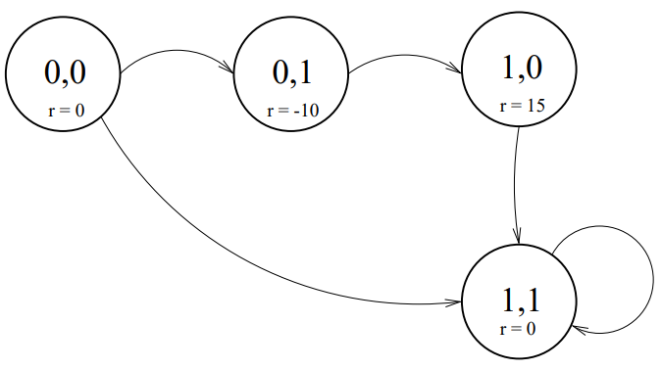
Part A. For what range of values of the discount rate (ie, gamma), would a reinforcement learner prefer the indirect route from state to state ?
Part B. Apply the one-step, Q-learning algorithm to this problem, using a table to represent your Qfunction (assume all entries in the table initially equal 3); let gamma = 0.9. Notice that you can "implement" your Q-table be writing the Q values directly on the arcs of the graph above.
Describe the state of the Q-table after each of the first two (2) steps of the learner. For simplicity, always follow the current policy during learning (ie, no exploration) and break any ties by moving to the lowest-numbered state (treating S1 S2 as a binary number). Briefly explain below your calculations.
Part C. Instead of using a Q-table, imagine that you have chosen to use a nearest-neighbor approach to represent the Q function. Under the assumptions of Part B, what would be the first training example added to your nearest-neighbor memory? Explain your answer.
Part D. Imagine now that you have a task that involves N Boolean-valued features, where all states are reachable from all other states. As a function of N, what is the ratio of memory needed to (i) store the Q function as a table vs. (ii) the memory needed to represent the Q function as a neural network with one layer of 0.5xN hidden units? Use the standard feedforward neuralnetwork topology that you used in HW3. Compute a numeric value for N=50.
Part E. When incrementally updating estimated Q values, commonly alpha times the latest estimate is added to (1 - alpha) times the previous estimate. Is such a technique needed in deterministic environments when the Q-function is represented in a neural network? Explain your answer.
Qualitatively describe any necessary properties of alpha (no need to mention that alpha is in [0,1]).
CS f1999 2 – Reinforcement Learning (16 points)  a. Consider the reinforcement environment drawn below (let γ=0.9). The numbers on the arcs indicate the immediate rewards. | 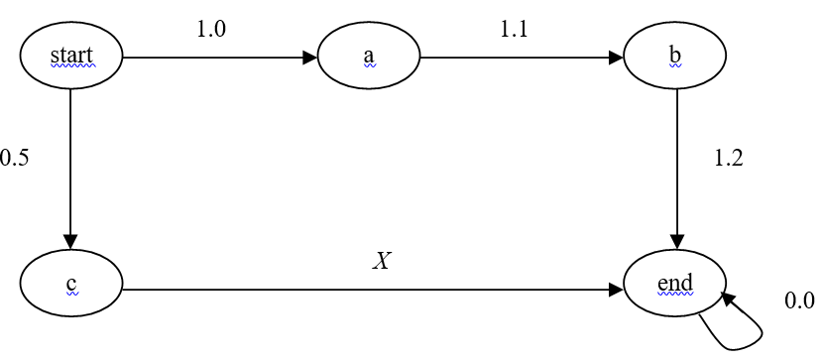
For which values of X would a reinforcement learner end up preferring the lower route over the upper one? Justify your answer.
Assume we create a neural network, with one layer of hidden units, for this environment, and that all the hidden and output units have sigmoidal output functions. Furthermore, assume that all the weights and thresholds on this network are initialized to zero. What “desired output” for this network would be produced the first time the learner went from start to a? (Don’t worry about the details of the representation of the state, i.e., the network’s input.)
b. Explain one (1) strength and one (1) weakness of using a neural-network rather than a look-up table to represent a Q function
strenght
weaknes
CS760 f2001  Problem 4 – Reinforcement Learning (14 points)  Prob 4. Consider the deterministic reinforcement environment drawn below. The numbers on the arcs indicate the immediate rewards. Let the discount rate equal 0.9. | 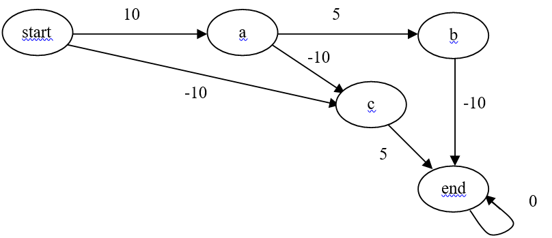
a).What is the best route for going from start to end? Why?
b).Represent the Q table by placing Q values on the arcs on the environment's state-action graph; initialize all of the Q values to 2 except initialize all of the arcs directly involving node a to have a Q value of -1. For Step 1, do exploitation. Show on the graph below the full Q table after Step 1. Specify the action chosen and display the calculations involved in altering the Q table.
c). Assume that after Step 1, the RL agent is magically transported back to the state start. Show the resulting Q table after the learner takes its second step from the starting state. Step 2 should be exploration. Be sure to again state the action chosen and display your calculations.
d). Explain one (1) major advantage and one (1) major disadvantage of using a Q network instead of a Q table in reinforcement learning.
advantage:
disadvantage:
CS760 s2001 Problem 3 – Reinforcement Learning (23 points)  Consider the deterministic reinforcement environment drawn below. The numbers on the arcs indicate the immediate rewards | 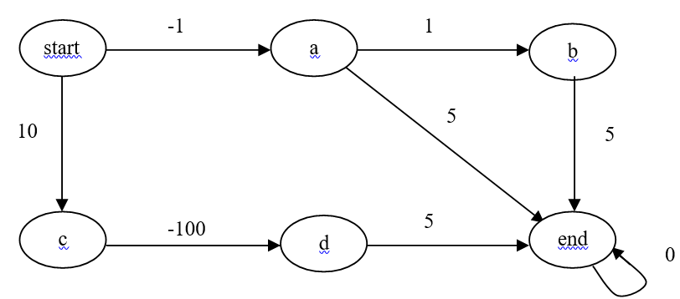
a). For what range of values for the discount rate (γ) would a reinforcement learner end up preferring going directly from a to end, rather than going via b? Justify your answer.
For the remainder of Problem 2, let γ = 0.9. Also, break ties when choosing actions in favor of going to states that appear earlier in alphabetic order.
b).Represent the Q table by placing Q values on the arcs on the environment's state-action graph; initialize all of the Q values to 3 except initialize the arc between a and b to 4. For Step 1, do an exploration action. Show on the graph below the full Q table after Step 1. Specify the action chosen and display the calculations involved in altering the Q table.
c). Assume that after Step 1, the RL agent is magically transported back to the state start. Show the resulting Q table after the learner takes its Step 2 from the starting state. Step 2 should be an exploitation action. Be sure to again state the action chosen and display your calculations.

d).Again the learner is magically transported back to the starting state and it takes Step 3 from there. Step 3, and any subsequent steps, should be exploration actions. This time, however, use the SARSA algorithm (but still use your Q table from Part c). Show all the actions and calculations leading up to the first Q table update due to SARSA.
e). Assume that instead of using a Q table, you decide to switch (starting after Part d's calculations) to using the nearest-neighbor approach to represent the Q function. Show the training examples produced by the actions performed in Parts b-d above. (Do not redo Parts b-d using the nearest-neighbor method; simply show the nearest-neighbor training examples.)

What do you feel is the most important "design decision" you would need to make in order to apply the nearest-neighbors approach to this task?
CS760 f2004 2. Reinforcement Learning (13 points)
Consider the deterministic reinforcement environment drawn below (let γ=0.5). The numbers on the arcs indicate the immediate rewards.
- Assume we use a Q table for this task and initialize all of its entries to the immediate rewards obtained from each state-action pair.
i.A learner follows the path start → a → b → end. Using one-step, regular Q learning, which entries in the Q table change? Show the calculations that produce the new Q table entries
ii. Which of the learner’s steps in Part i are exploration steps? Explain.

iii. Repeat Part i, but this time use one-step SARSA (start with the original Q table, not the one that results from the learning in Part i). For those Q updates that are the same as in Part i, simply say so and do not repeat the calculations.
- Why does the converge proof of Q learning done in class and in Mitchell, not apply to the case of using a function approximator to represent Q functions?
CS760 f2006 Problem 3 – Reinforcement Learning (11 points)  - Consider the deterministic reinforcement environment drawn below (let γ=0.9). The numbers on the arcs indicate the immediate rewards. | 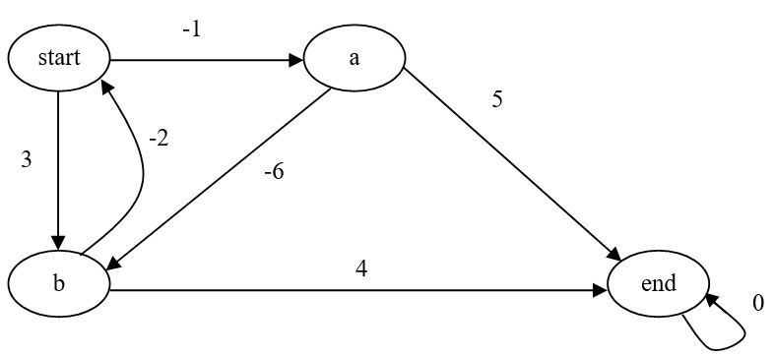
Assume we use a Q table for this task and initialize all of its entries to 2.
A learner follows the path start → b → start → a → end. Using two-step Q learning,
which entries in the Q table change? Show the calculations that produce the new Q table entries. Indicate the changes to the Q table by writing the new Q values on the graph above.
b).What role do options play in reinforcement learning?
CS760 s2003 Problem 2 – Reinforcement Learning (17 points)  Consider the deterministic reinforcement environment drawn below. The numbers on the arcs indicate the immediate rewards. Let the discount rate equal 0.5.  Assume that the current Q table is represented by the Q values on the arcs on the environment's state-action graph below. Also assume that the learner is currently in Node b. | 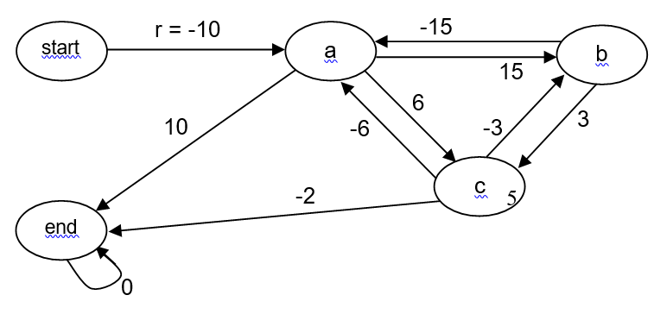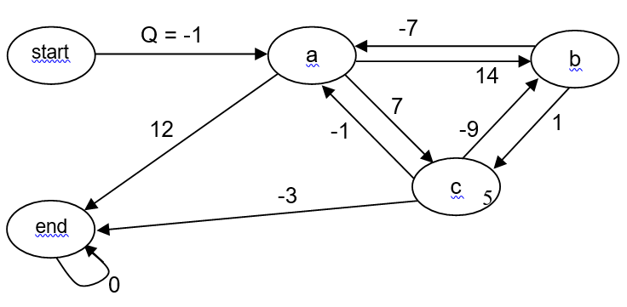
a).The learner chooses to do an exploration step out of Node b, using the “softmax” function. What is the probability is that the learner will choose the action that leads to Node a (be sure to state any assumptions you need to make in order to compute this probability)?

b).Assume that the learner is magically transported to Node c and that the Q table is still in the state shown below. For this question, assume the learner chooses to first go to Node b and then to Node a. Be sure to show the calculations that produce your answers to the questions below.  - Using one-step Q learning, what new value would there be on the c→ b arc?  - Using one-step SARSA learning, what new value would there be on the c→ b arc? | 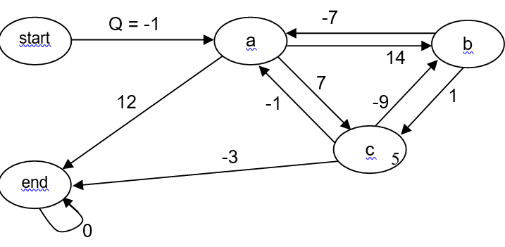
c). This time assume the learner is currently in Node start and the Q table contains the values in the graph above (the values before you answered Part b). The learner does three (3) exploitation steps and employs two-step Q learning along the way. Indicate on the graph above what changes in the Q table this time. Show your calculations below.

CS760 s2009 s2010 f2011,
CS760 s2014 Problem 3- Reinforcement Learning (20 points)  Consider the deterministic reinforcement environment drawn below (let y=0.1). The numbers on the arcs indicate the immediate rewards. Assume we learn a Q-table. Also assume all the initial values in your Q table are 5.  a) Suppose the learner follows the path A B→ C→ E → A. Using one-step, standard learning, show the calculations that produce the new Q table entries and report the final table on the graph above. | 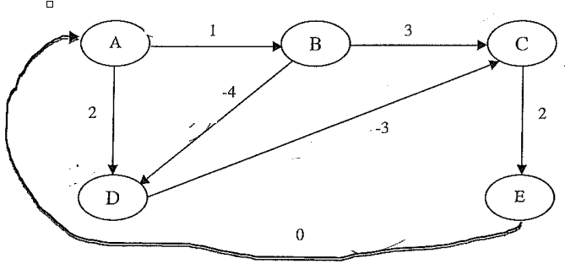
b)After the learning in part (a), what will be the next two states, in order, visited by the agent if it performs no exploration steps? Show the results of one-step, standard Q learning after the agent takes this path.
 | 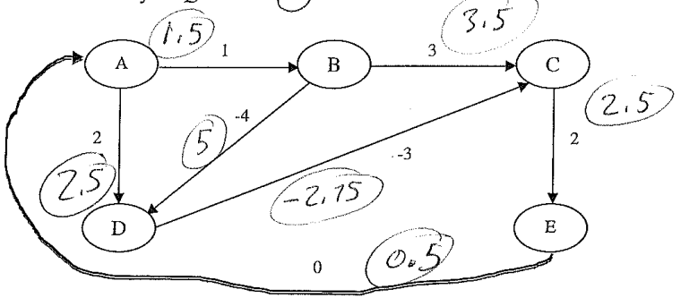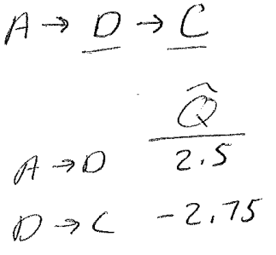

6e.f2001 Assuming one has linearly separable data,what is the key difference between standard perceptron training and Support Vector Machines?
1g f2004

