cheatsheet
PAC Learning: Data  •concept class 𝐶 is set of labeling functions 𝑐: 𝑋 ↦ 𝑌 (𝑋 ↦ {0,1} ) # true rule want to learn  •represents set of possible true labeling functions  • example: circles in ℝ²  • NOT (always) the same thing as the hypothesis class 𝐻  • ideally 𝐻 ⊃ 𝐶 # h model's proposed rule, which it learns from the training data  • unknown data distribution 𝐷 over 𝑋 × 𝑌 # instance space X to classify, D prob. distr. of X  • get 𝑚 samples ( 𝑥 𝑖 , 𝑦 𝑖 ), 𝑖 = 1 , … , 𝑚 i.i.d. from 𝐷  • 𝑦_{𝑖} = 𝑐(𝑥_{𝑖}) for some 𝑐 ∈ C | 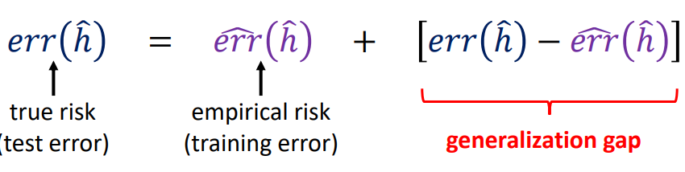  Training data to approximate the unknown target concept 𝑐 ∈ 𝐶 using a hypothesis ℎ ∈ H  True risk 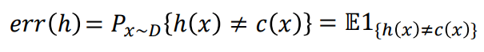
Empirical risk 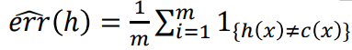
𝐶 is PAC-learnable if there exists a learning algorithm that takes any dataset S of size 𝑚 and outputs a hypothesis ℎ_{𝑆} : 𝑋 ↦ 𝑌 that for any 𝜀, 𝛿 > 0 has the property  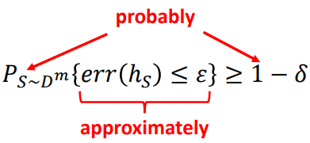 as long 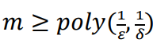 | Consistent case 𝑒𝑟𝑟 ^(ℎ_{𝑆} )= 0  For given m samples 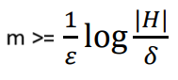  true error with probability >= 1-δ is 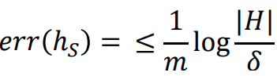
Inconsistent case 𝑒𝑟𝑟 ^(ℎ_{𝑆} )≠ 0 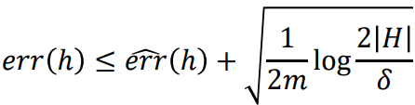
Vapnik-Chervonenkis VC dimension of a hypothesis class 𝑯 is the size of the largest set of points in 𝑋 that can be shattered by H if space R^{d} VC=d+1 (for linear classification)  VC-dimension roughly takes place of log |𝐻| as measure of the capacity of the hypothesis class.  NN with L laer ReLu and W weights O(W L logW) | If 𝐻 has VC dimension 𝑑 and we draw 𝑚 samples i.i.d. from 𝐷 then with probability at least 1 − 𝛿 the following is true for all ℎ ∈ 𝐻:  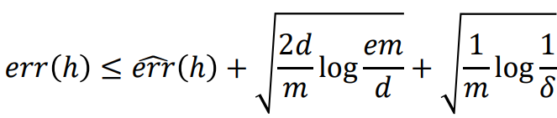

HW4
Let h be the VC dimension of function family F. For any δ > 0, with probability at least 1 − δ we have  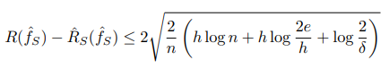  where the log is natural, R(f) = E1[f(x)̸=y] is the risk of f, S = (x1, y1), . . . ,(xn, yn) is a training set of size n, Rˆ_{S}(f) = 1/ n ∑ _{i=1,n} 1[f(xi)̸=yi] is the empirical risk of f on S, and  f^_{S} ∈ arg min _{f∈F} Rˆ S(f) is an empirical risk minimizer (ERM). We now verify the PAC bound ion sample classification task. Let p(x)=uniform([-1,1]). If x>=0 and 0 othervuise.This means the true decision boundary is at x=0. Let f _{θ}(x)=sign(x- θ) which has threshold in θ. Let F={f_{θ} : θ ∈ [−1, 1]}.  1.1 ERM [5 points] Given S, suppose we find the smallest positive item: a = min(xi,yi)∈S: yi=1 xi if one exists, otherwise let a = 1. Is f^_{S} := f_{a} an ERM? Justify your answer. | Yes f^​_{S}​=fa is ERM  The hypothesis class F consists of threshold functions f_{θ}(x)=sign(x−θ) for θ∈[−1,1]. The true labels are deterministic: y=sign(x), so all points with x<0 have y=0 and all points with x≥0 have y=1.  The empirical risk R^_{S}(f) is the fraction of misclassified examples in the training set S. The parameter a is defined as the smallest positive xi in S (i.e., min{xi∈S:yi=1} if such a point exists; otherwise, a=1.  The hypothesis fa​ sets the threshold at θ=a.  - If S contains both negative and positive points, let M be the largest negative point (i.e., max{xi∈S:yi=0}. Since M<0 and a>0, any θ in the interval (M,a) would achieve zero empirical risk because:  - For all negative points x, x≤M<θ, so fθ(x)=0, which matches y=0.  - For all positive points x, x≥a>θ, so f_{θ}(x)=1, which matches y=1.  Setting θ=a also achieves zero empirical risk because:  - For all negative points x, x<0<a, so x<a, thus fa(x)=0, correct.  - For all positive points x, x≥a, so fa(x)=1 correct.  - If S contains only negative points, then a=1. Since all points have x<0 and y=0, and θ=1>x for alll x∈S, then fa(x)=0 for all x, which is correct. Thus, empirical risk is zero.  - If S contains only positive points, then a is the smallest positive point. Since all points have x≥a and y=1, and θ=a≤x for all x, then fa(x)=1 for all x, which is correct. Thus, empirical risk is zero.  In all cases, fa​ achieves zero empirical risk, which is the minimum possible. Therefore, fa​ is an ERM.
Pojasna verzija podobro ispisana
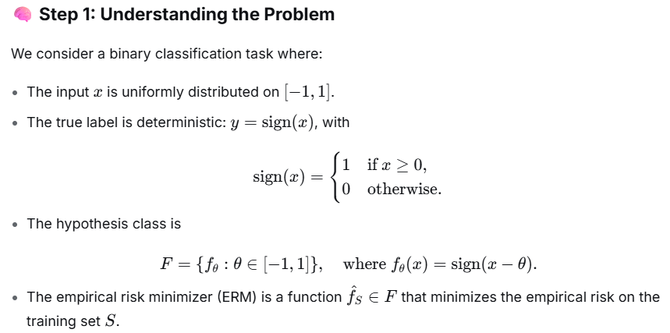 | 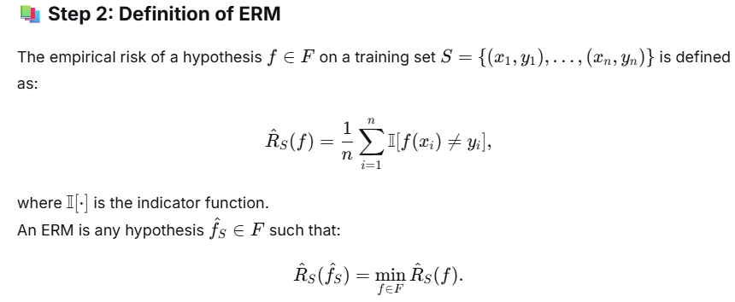
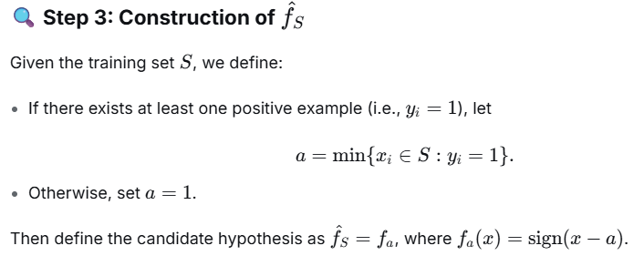 | 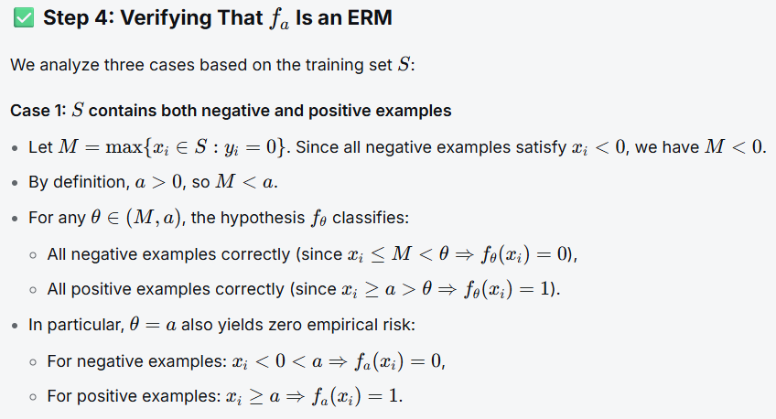
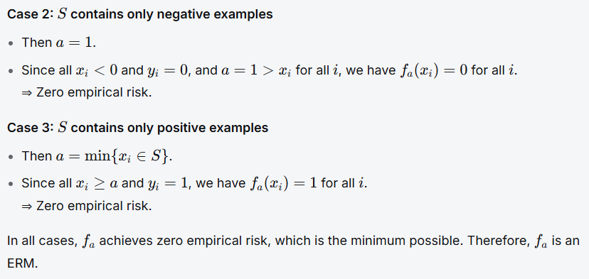
1.2 True risk [5 points] Derive R(fa)  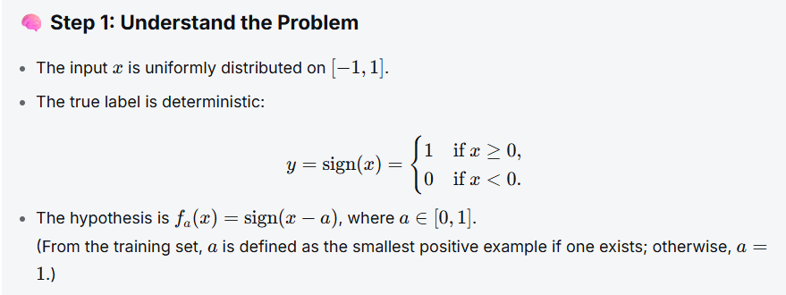  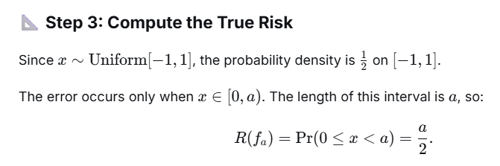 | 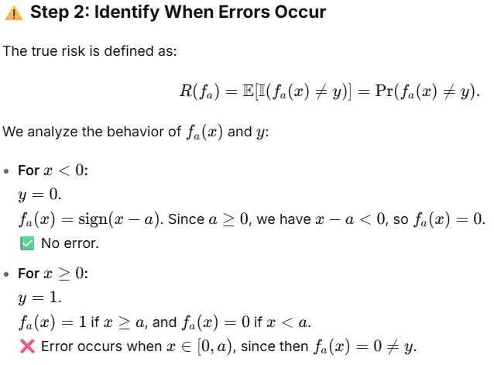
1.3 Empirical risk [5 points] Derive Rˆ_{S}(fa).  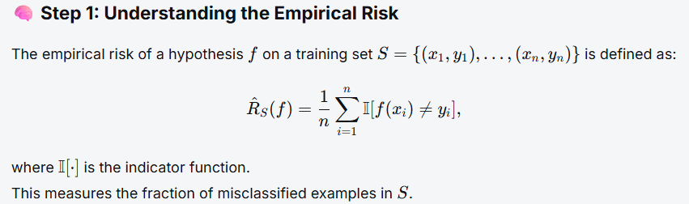 | 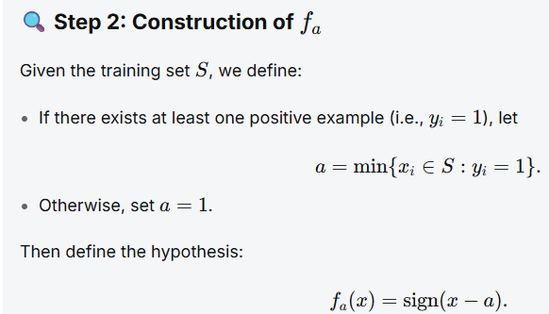
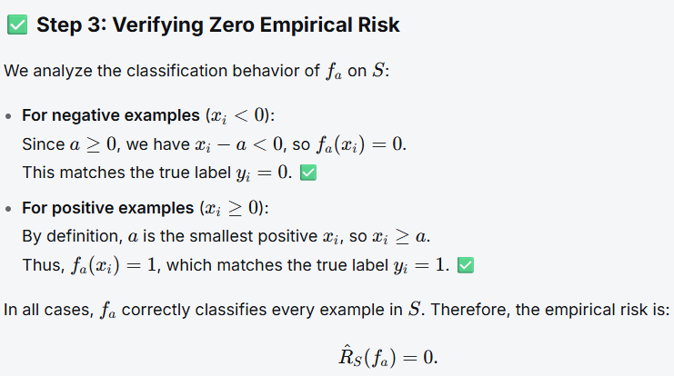
1.4 VC dimension [10 points] What is the VC dimension of F? Note F contains threshold classifiers of the type “left negative, right positive.”  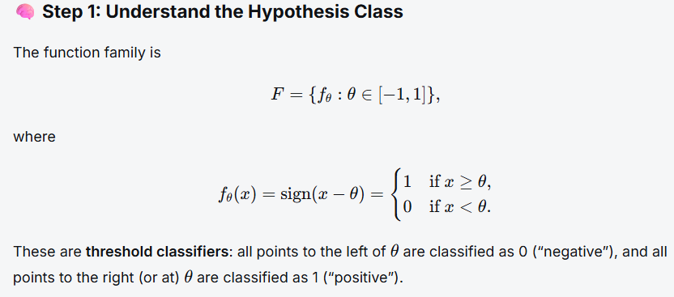 | 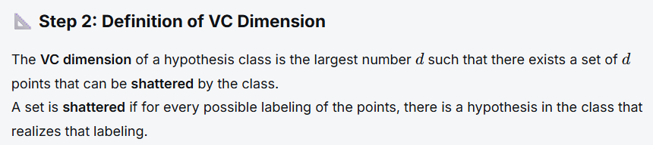  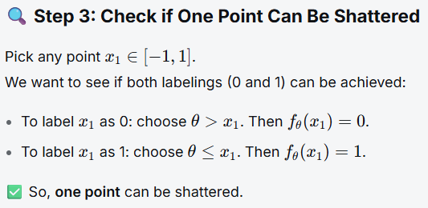
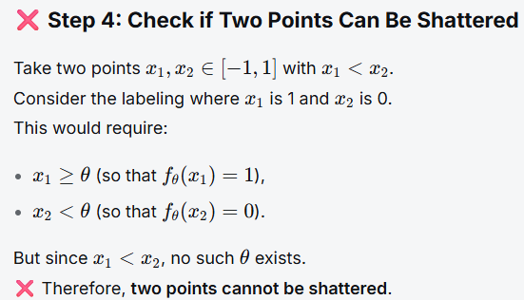 | 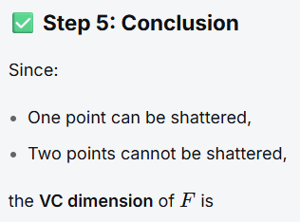
1.5 Generalization error [5 points]  Fix δ = 0.05 (95% confidence) and n = 200. What is the bound on the true risk of f^_{S} given by the PAC bound?  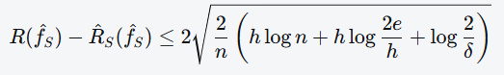  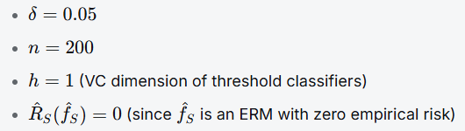  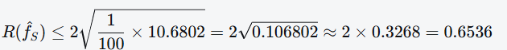 | 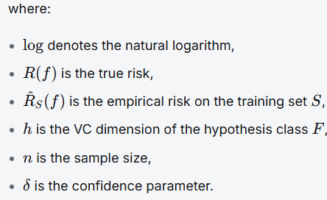
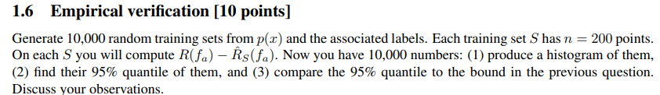  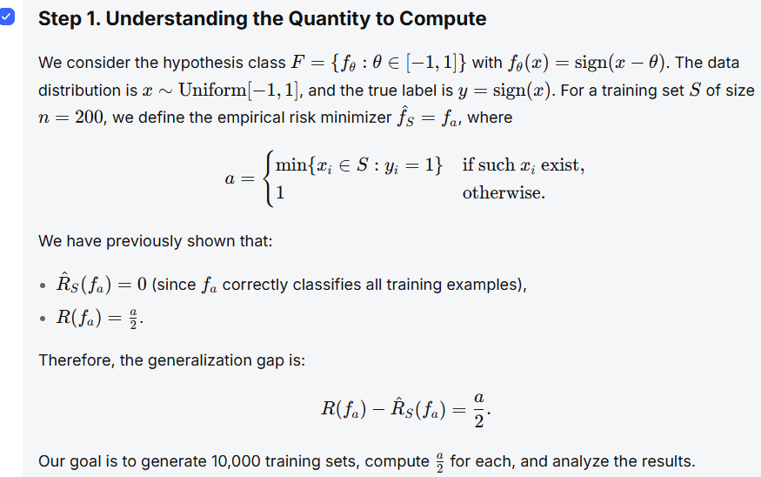 | 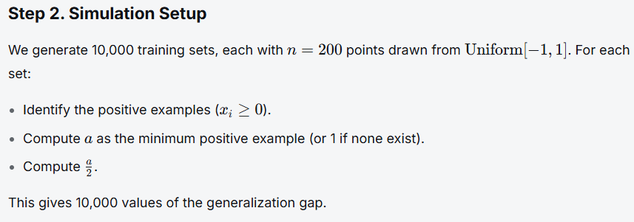  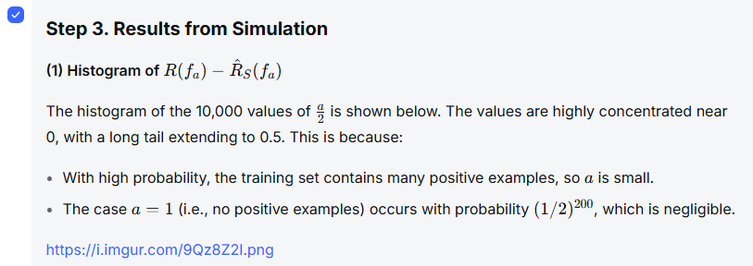
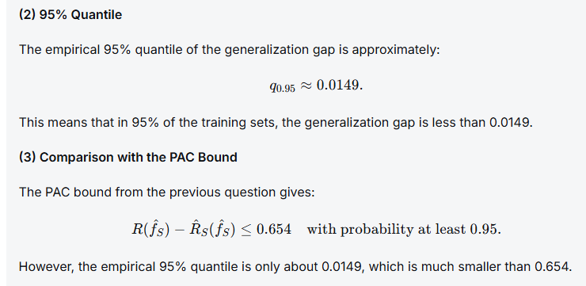 | 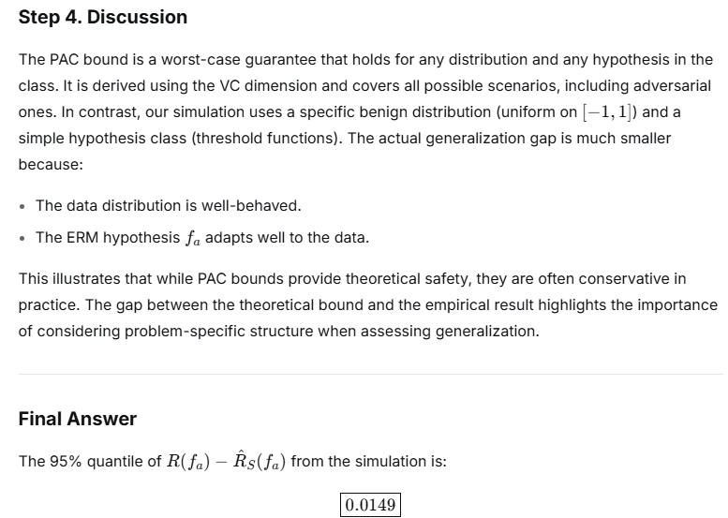
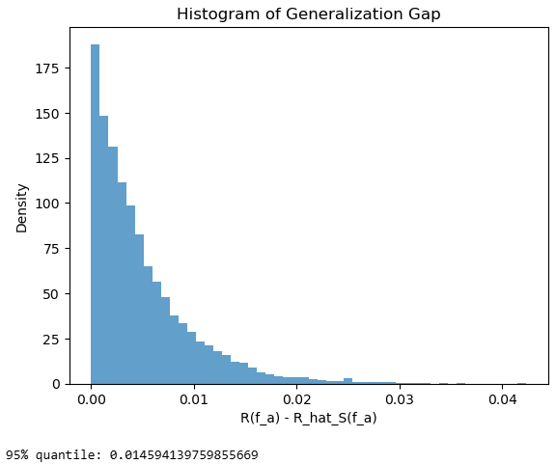
2 VC dimension  2.1 Showing VC dimension [10 points]  Let the input x ∈ X = R. Consider F = {f(x) = sign(ax2 + bx + c) : a, b, c ∈ R}, where sign(z) = 1 if z ≥ 0, and 0 otherwise. Compute the VC-dimension V C(F) of F  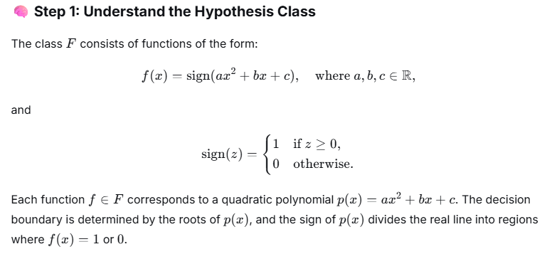 | 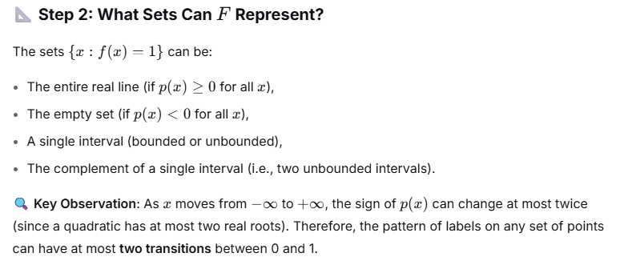  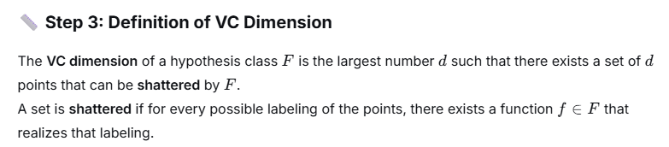
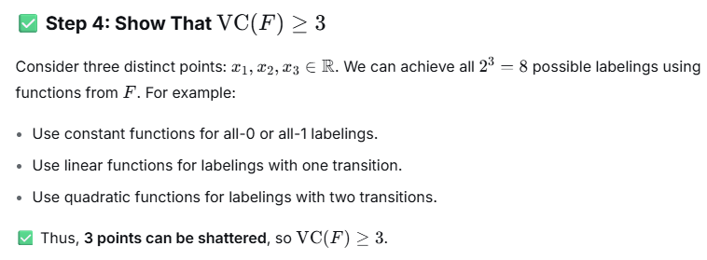 | 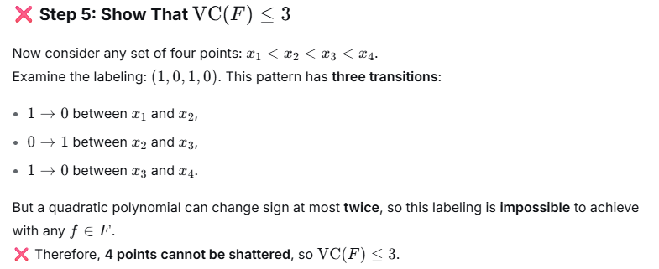  VC(F)=3
2.2 Shatter Coefficients [10 points] The main intuition behind VC theory is that, although a collection of classifiers may be infinite, using a finite set of training data to select a good rule effectively reduces the number of different classifiers we need to consider. We can measure the effective size of class F using shatter coefficient. Suppose we have a training set  Dn = {(xi , yi)} n i=1 for a binary classification problem with labels yi = {−1, +1}. Each classifier in F produces a binary label sequence f(x1), · · · , f(xn) ∈ {−1, +1}^ n  There are at most 2^n distinct sequences, but often no all sequences can be generated by functions in F. Shatter coefficient S(F, n) is defined as the maximum number of labeling sequences the class F induces over n training points in the feature space X . More formally  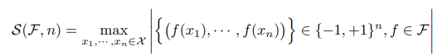  where | · | denotes the number of elements in the set. The Vapnik-Chervonenkis (VC) dimension V (F) of a class F is defined as the largest integer k such that S(F, k) = 2^{k} . Suppose there are n points (x1, · · · , xn) ∈ R. Let F be the collection of 1-d linear classifiers: for each  t ∈ [0, 1], ft ∈ F labels x ≤ t as −1 and x > t as +1, or vice-versa. What is the shatter coefficient S(F, n)? What is VC-dimension V (F)? How can you get it from shatter coefficient? | 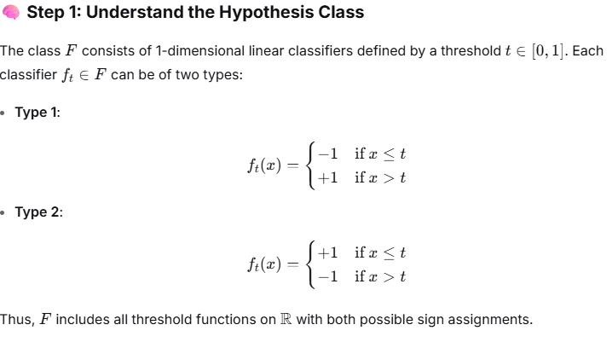
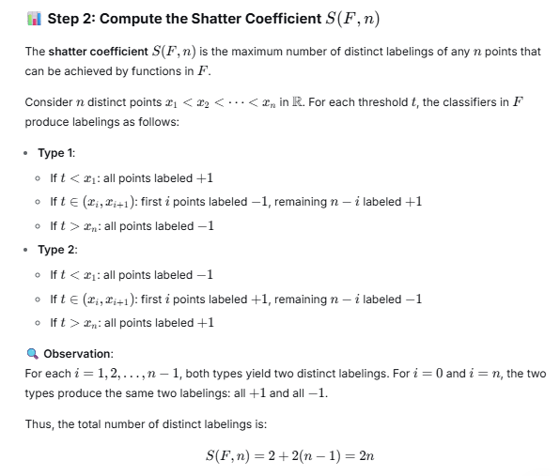 | 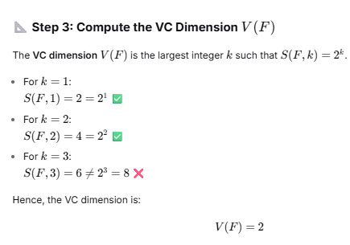  Final Answers ???  2n and 2​
2.3 Monotonicity of VC-dimension [10 points]  Use the shatter coefficients to show the following monotonicity property of VC-dimension:  if F and F ′ are hypothesis classes with F ⊂ F′ , then the VC-dimension of F ′ is greater than or equal to that of F.  Step 1: Definitions  - The shatter coefficient S(F,n) of a hypothesis class F is the maximum number of distinct labelings of any n points that can be achieved by functions in F.  - The VC dimension V(F) is the largest integer dd such that S(F,d)=2dS(F,d)=2d. | 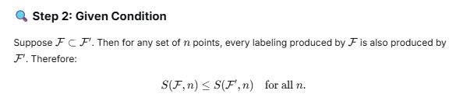  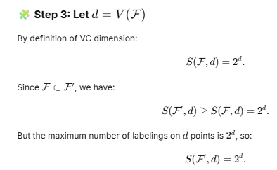
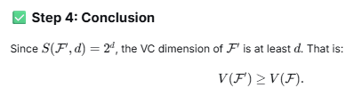 Final answer 2

Online questions
Machine Learning Questions and Answers – PAC Learning  PAC Learning Questions and Answers - Sanfoundry | VC-Dimension Questions and Answers  Vapnik-Chervonenkis Dimension Questions and Answers - Sanfoundry
3. The full form of PAC is ______  a) Partly Approximation Computation  b) Probability Approximation Curve  c) Probably Approximately Correct  d) Partly Approximately Correct  Explanation: Probably Approximately Correct tries to build a hypothesis that can predict with low generalization error (approximately correct), with high probability (probably). | 1. Instance space: X = set of real numbers, Hypothesis space H: the set of intervals on the real number line. a and b can be any constants used to represent the hypothesis. How is H represented?  a) a – b < a + b  b) a + b < x < 2(a+b)  c) a/b < x < a*b  d) a < x < b  H is the set of hypotheses of the form a < x < b, where a and b may be any real constants. It signifies an interval whose lower bound is a and the upper bound is b. X is contained within these bounds.
4. What can be explained by PAC learning?  a) Sample Complexity  b) Overfitting  c) Underfitting  d) Label Function  Explanation: PAC learning can give a rough estimate of the number of training examples required by the learning algorithm to develop a hypothesis with the desired accuracy. | 2. S = {3.1, 5.7}. How many hypotheses are required?  a) 2  b) 3  c) 4  d) 1  Explanation: The four hypotheses (1 < x < 2), (1 < x < 4), (4 < x < 7), and (1 < x < 7) represents each of the four dichotomies over S, covering neither instance, either one of the instances, and both of the instances, respectively.
5. What is the significance of epsilon in PAC learning?  a) Probability of approximation < epsilon  b) Maximum error < epsilon  c) Minimum error > epsilon  d) Probability of approximation = delta – epsilon  Explanation: A concept is PAC learnable by L if L can output a hypothesis with error < epsilon. Hence the maximum error obtained by the hypothesis should be less than epsilon. Epsilon is usually 5% or 1%. | 3. S = {x0, x1, x2}. This set can be shattered by hypotheses of form a < x < b, where a and b are arbitrary constants.  a) True  b) False  Explanation: Without loss of generality, assume x0 < x1 < x2. This set cannot be shattered, because the dichotomy that includes x0 and x2,  bnot x1, cannot be represented by a single closed interval.
6. What is the significance of delta in PAC learning?  a) Probability of approximation < delta  b) Error < delta  c) Probability = 1 – delta  d) Probability of approximation = delta – epsilon  Explanation: A concept C is PAC learnable by L if L can predict a hypothesis with a certain error with probability equal to 1-delta. Delta is usually very low. | 4. S = {x0, x1, x2}. Hypotheses are of the form a < x < b. What is H?  a) infinite  b) 0  c) 2  d) 1  a.Explanation: No hypotheses of the form a < x < b, where a and b can be any constants, can shatter the three points. Suppose a hypothesis wants to shatter (x0, x2) and x1, but there are no such intervals which contain both x0 and x2 but not x1.
7. One of the goals of PAC learning is to give  a) maximum accuracy  b) cross-validation complexity  c) error of classifier  d) computational complexity  Explanation: PAC learning tells us about the amount of effort required for computation so that a learner can come up with a successful hypothesis with high probability. | 5. S = {x0, x1, x2}. Hypotheses are of the form a < x < b. What is VC(H)?  a) 0  b) 2  c) 1  d) infinite  Explanation: No subset S of size three can be shattered. Maximum two points can be shattered by hypotheses of the form a < x < b, where a and b can be any constants. Thus VC(H) = 2.
8. A learner can be deemed consistent if it produces a hypothesis that perfectly fits the  a) cross-validation data  b) overall dataset  c) test data  d) training data  Explanation: PAC learning is concerned with the behavior of the learning algorithm. The learner has access to only the training data set. | 6. S = {x0, x1, x2} and H is finite. What is VC(H)?  a) 1  b) 2  c) 3  d) infinite  Explanation: Instead of random intervals, hypotheses are straight lines. They can shatter all three points. For straight lines, VC(H) = n, where n is the number of instances. Thus VC(H) is 3.
9. Number of hypothesizes |H| = 973, probability = 95%, error < 0.1. Find minimum number of training examples, m, required.  Explanation: Probability = 1 – delta (d) = 0.95; d = 0.05. Error < epsilon (e); e = 0.1.  m >= 1/e (ln |H| + ln (1/d)) i.e. m> = 1/0.1(ln 973 + ln (1/0.05)) i.e. m>=98.8  Since number of training examples, m, has to be an integer, answer is 99. | 7. S = {x0, x1, x2}. Hypotheses are straight lines. What is H?  a) 8  b) 3  c) 4  d) infinite  Explanation: VC(H) = 3. The number of points is 3. Thus, the number of dichotomies is 2³ or 8. Each of the 2³ dichotomies of these three instances is covered by some hypothesis, a straight line. Thus H contains 8 hypotheses.
8. S = {x0, x1, x2, x3}. Hypotheses are straight lines. What is H?
a) 8
b) 3
c) 4
d) infinite
Explanation: VC dimension of straight line hypotheses is 3. Hence, the maximum number of points that can be shattered is 3. 4 points cannot be shattered. Thus H contains an infinite number of hypotheses.
9. S contains 4 instances. H is the hypothesis space and it can shatter S. What is the correct form of hypotheses?
a) Hypotheses are intervals
b) Hypotheses are straight lines
c) Hypotheses are rectangles
d) No such hypotheses exist
Explanation: A rectangle can distinguish between 4 points easily. So, they can shatter S. Number of instances is 4. The number of hypotheses is 2⁴ or 16.
10. For which combination H is infinite and VC(H) is finite?
a) S contains 2 points and hypotheses are intervals
b) S contains 3 points and hypotheses are intervals
c) S contains 3 points and hypotheses are straight lines
d) S contains 2 points and hypotheses are straight lines
Explanation: Suppose S contains x0, x1, and x2. Let x0 < x1 < x2. There are no intervals such that x0 and x2 are within the interval but x1 is not. Thus S is not shattered by H. So, H is infinite. Since the maximum number of instances that can be shattered is 2, VC(H) is 2.

Exam fall2001, importance in machine learning of the following:  6.a What role does the VC Dimension play in machine learning?  It is a fundamental concept in computational learning theory that provides a quantitative measure of a model's capacity or complexity, particularly for binary classifiers.  Core Description  The VC Dimension is defined as the largest number of points that a classification algorithm can shatter.  To "shatter" a set of points means that for every possible way of labeling those points (e.g., some as class 0, others as class 1), the model can perfectly separate them. It's a measure of the model's expressive power.  Exam fall 1997. Short Essays (15 pts) Briefly explain the importance in machine learning of the following: VC Dimension | Key Roles and Motivation in Machine Learning  The VC Dimension plays several crucial theoretical and practical roles:  1. Quantifying Model Complexity enable beyond vague notions of a model being "simple" or "complex." precisely say that: A linear classifier in 2D has a VC dimension of 3 (it can shatter 3 points in general position, but not 4).  A sine wave has an infinite VC dimension (it can shatter any finite set of points).
Exam fall 1998 ; 3. Computational Learning Theory and Experimental Methodology (17 pts)  You are assigned the task of learning a "profile" for individual users of a new software package. A profile’s input vector contains 32 Boolean-valued measurements, and its output is a single Boolean value that indicates whether or not the user needs help. The specification for this task says that on at least 99% of the users of your software, the profiles that your algorithm learns have to make the correct prediction at least 95% of the time.  Part A Imagine that you choose to represent profiles as simple conjunctions of a subset of these features (and their negations). Assume that some such conjunction always exists for all users of the software. Compute how many training examples you need to collect from each user in order to meet this task’s specification. You may assume that all data is noise-free. | 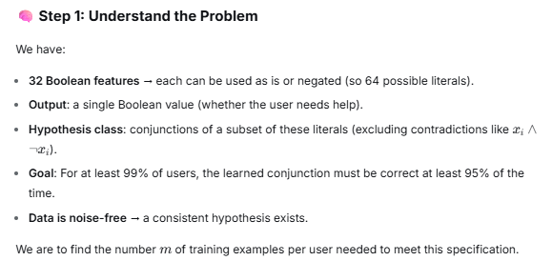
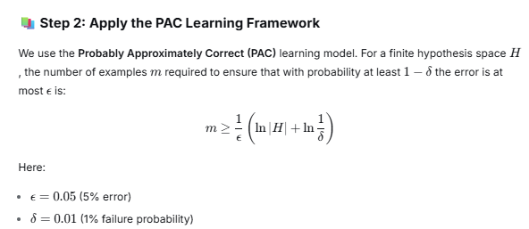 | 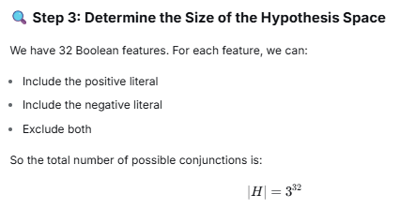
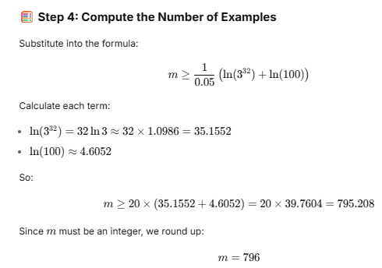 m=796
Exam Fall 1999  Problem 4 – Computational Learning Theory (12 points)  Assume that you are considering noise-free data sets that only contain Boolean-valued features. Consider the hypothesis space:  All possible disjuncts (i.e., ORs and NOTs allowed, but not ANDs).  For a data set of five (5) Boolean features, according to the PAC model how many examples do you need to collect in order to be 95% confident that you’ll learn the underlying Boolean concept to 99% accuracy? You may assume that your training data can be fit (i.e., described) by a disjunction of some subset of these five features and their negations  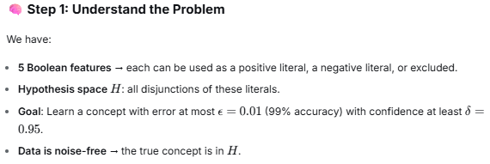 | 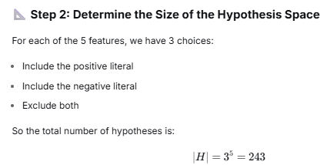  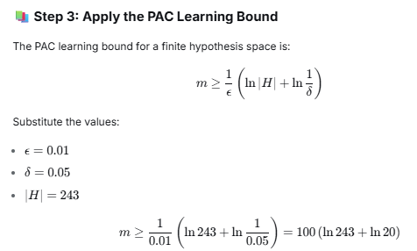 m=849
Exam fall2001  6.g What role does the VC Dimension play in machine learning?  It is a fundamental concept in computational learning theory that provides a quantitative measure of a model's capacity or complexity, particularly for binary classifiers.  Core Description  The VC Dimension is defined as the largest number of points that a classification algorithm can shatter.  To "shatter" a set of points means that for every possible way of labeling those points (e.g., some as class 0, others as class 1), the model can perfectly separate them. It's a measure of the model's expressive power. | Key Roles and Motivation in Machine Learning  The VC Dimension plays several crucial theoretical and practical roles:  1. Quantifying Model Complexity enable beyond vague notions of a model being "simple" or "complex." precisely say that: A linear classifier in 2D has a VC dimension of 3 (it can shatter 3 points in general position, but not 4).  A sine wave has an infinite VC dimension (it can shatter any finite set of points).
2. Providing Theoretical Bounds for Generalization most important role ???
The VC dimension is central to probably approximately correct (PAC) learning theory. It allows us to establish a generalization bound—a theoretical guarantee on how the model will perform on new, unseen data. A simplified version of this bound states that the test error is bounded by:
Test Error ≤ Training Error + Ω(√((VC Dimension) / (Number of Training Examples)))
If 𝐻 has VC dimension 𝑑 and we draw 𝑚 samples i.i.d. from 𝐷 then with probability at least 1 − 𝛿 the following is true for all ℎ ∈ 𝐻:
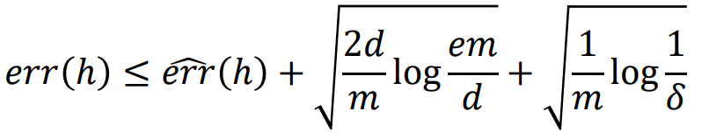
- The Trade-off: As model capacity (VC Dimension) increases, training error may decrease, but second term (generalization error bound) increases. This perfectly captures the Bias-Variance Trade-off.
- The Danger of Overfitting: A model with a very high VC dimension relative to the amount of training data will have a large gap between its training and test performance. It can memorize the training set (low training error) but will fail to generalize (high test error).
Exam spring 2003 3a)b)  b.Consider the Boolean concept class of circles in the space of two numeric features (points on or inside the circle are considered positive). What is the VC-dimension for this concept space? Explain | VC-Dimension of Circles  The concept class consists of circles in $\mathbb{R}^2$, where points on or inside the circle are positive.  - The VC-dimension is 3.  - Explanation:  - Three points in general position (non-collinear) can be shattered by circles. For any labeling of these points, there exists a circle that contains exactly the positive points.  - Four points cannot be shattered. For example, if four points are placed on a circle, the labeling that alternates positive and negative cannot be achieved by any single circle
Exam Fall 2004  Problem 4–Miscellaneous Questions (12 points)  - Assume that you are considering a noise-free data set that contains N Boolean-valued features and are using the hypothesis space:  All possible Boolean functions (there are 2⁽ ^{2)^N} possibilities)  According to the PAC model, how many examples do you need to collect in order to be 99%  confident that you will learn the underlying Boolean concept to 90% accuracy, N = 10?  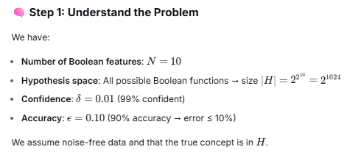 | 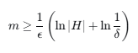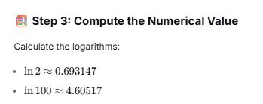  m≥10×(1024×0.693147+4.60517)=  10×(709.782+4.60517)=10×714.38717=7143.8717~1744
Exam fall 2006  Problem 5–Miscellaneous Questions (10 points)  Assume that you are considering a noise-free data set that contains N Boolean-valued features and know that the concept that generated this data is in the hypothesis space:  The disjunction (“or”) of two literals, where a literal is a feature or its negation  What is the size of this hypothesis space as a function of N  According to the PAC model, how many examples do you need in order to be 90%  confident that you will learn the underlying Boolean concept to 80% accuracy when  N = 100? (If you were unable to calculate the size of the hypothesis space, assume the size is 100,000.) | 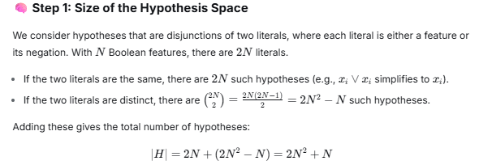  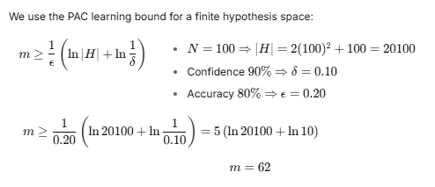
Exam Spring 2009-120min  Problem 5–Miscellaneous Questions (15 points)  - Assume that you are considering a noise-free data set that contains two real-valued features, each of which ranges from 0 to L, where L is a positive integer. Your hypothesis space contains all rectangles that can be created in this 2D feature space, where the boundaries of the rectangles are integer-valued. That is, a hypothesis is of the following form  F₁ ∈ [A, B) ∧ F₂ ∈ [C, D)  where 0 A < B L and 0 C < D L and A, B, C, and D are all integers.  Assuming that the correct concept is in your hypothesis space, according to the PAC model, how many examples do you need to collect in order to be 98% confident that you will learn the underlying Boolean concept to 97% accuracy when L = 4? (Note: you are not required to solve this for any L; it is fine to only solve for this specific value of L.) | 1-δ=0.98, δ= 0.02 and 1-ϵ=0.97, ϵ=0.03  F1​∈[A,B): ∧ F₂ ∈ [C, D)  - Actually A∈{ 0,1,2,3,4} but B must be <=4 and A<B  Possible pairs (A,B)  - A=0: B=1,2,3,4 → 4 choices A=1: B=2,3,4 → 3 choices  - A=2: B=3,4 → 2 choices A=3: B=4 → 1 choice  - A=4 no B since B≤4 and B>A → 0 choices.  Total for F1: 4+3+2+1=10 intervals.  Similarly for F2​: same → 10 intervals.  So total rectangles = 10×10=100. => |H|=100  PAC sample complexity for finite H, realizable case  m≥1/ϵ (ln∣H∣+ln1/δ)  to guarantee that with probability at least 1−δ, error ≤ ϵ  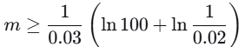 m>=284  ln100=ln(10²)=2ln10≈2×2.302585=4.60517  ln1/0.02≈3.912023  Sum inside: 4.60517+3.912023≈8.517193.  Divide by 0.03:  m≥8.517193/.03≈283.9064 => m>=284

Exam Spring 2009-120min ???  Problem 4 – Computational Learning Theory (12 points)  Assume that you are considering noise-free data sets that only contain Boolean-valued features. Consider the hypothesis space:  All possible disjuncts (i.e., ORs and NOTs allowed, but not ANDs).  For a data set of five (5) Boolean features, according to the PAC model how many examples do you need to collect in order to be 95% confident that you’ll learn the underlying Boolean concept to 99% accuracy? You may assume that your training data can be fit (i.e., described) by a disjunction of some subset of these five features and their negations | 5 Boolean features.  Each feature can be used in three ways:  Include the positive literal, Include the negative literal, Exclude both  This gives 3⁵=243.35=243  Additionally, any disjunction containing both a feature and its negation (e.g., x1∨¬x1x1​∨¬x1​) is equivalent to the constant 1 function. =>244  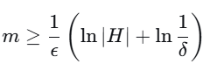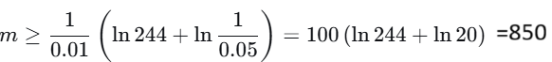
Exam spring 2010  2b Assume we have a supervised-learning task where the examples are represented by 26 Boolean features, A-Z. We guess that the true concept is of the form:  Literal₁ ∨ Literal₂ ∨ Literal₃  Where Literal_{i} is a one of the features A-Z or its negation and where a given feature can appear at most once in the concept (so “C ∨ ¬ M ∨ A” is a valid concept, but “C ∨ ¬ M ∨ M” is not).  If 90% of the time we want to learn a concept whose accuracy is at least 95%, how many training examples should we collect? | The hypothesis space consists of disjunctions of exactly three literals, where each literal is either a feature or its negation from 26 Boolean features (A-Z), and no feature is repeated. The size of the hypothesis space ∣H∣ is calculated as follows:  - The number of ways to choose 3 distinct features from 26 is (26 over 3) =2600 .  - For each set of 3 features, there are 2³=8 possible combinations of positive or negative literals. Thus, ∣H∣=2600×8=20,800.  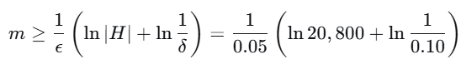 m>-=244.9
Exam 2014  Problem 4 - Computational Learning Theory (20 points)  Consider the problem of PAC-learning 2DNF concepts from n binary variables. 2DNF concepts are disjunctions of conjunctions, where each conjunction consists of at most 2 literals. (Recall that a literal is a binary variable or its negation.) We wish to show that 2DNF is PAClearnable.  (a) How many 2DNF concepts are there over n binary variables? (Your answer should be a function of n, for example 2n+1 or 3".)  Examples: disjunction of terms that are at most 2 literals  x1 ∨ (¬x2∧x3)  x1 ∨¬x1 ​ (which is always true)  Step 2: Count the Number of Possible Terms  We count all possible terms that can appear in a 2DNF formula over n binary variables.  • Terms with 1 literal: There are 2n such terms (each variable can appear positively or negatively).  • Terms with 2 literals: We choose 2 distinct variables from n: (n over 2)​ ways.  - For each pair, there are 2×2=4 combinations of literals.  - Total: 4⋅(n over 2)=2n(n−1)  • Total number of terms: ∣T∣=2n+2n(n−1)=2n² | Step 3: Representing 2DNF Concepts  Any 2DNF formula can be represented as a subset of the set T of all possible terms.  - The empty subset corresponds to the constant false function.  - Other subsets correspond to disjunctions of the selected terms.  Thus, the number of possible 2DNF formulas is:  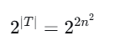  Step 4: PAC Learnability  In the PAC learning framework, the sample complexity m required to learn a concept with error at most ϵ and confidence at least 1−δ is bounded by:  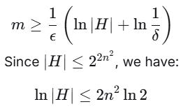  So the sample complexity is polynomial in n, confirming 2DNF is PAC learnable.
(b ) Describe an algorithm for the consistency problem for 2DNF that runs in time polynomial in the number of examples m and number of variables n.  - Separate the examples into:  - P: set of positive examples (label 1)  - N: set of negative examples (label 0)  - Generate all possible terms of size 1 or 2.  There are O(n²) such terms. | - Identify safe terms:  A term t is safe if it is not satisfied by any negative example. For each term t, check whether there exists y∈N such that t(y)=1. If no such y exists, add t to the set S of safe terms.  - Check coverage of positive examples:  For each x∈P, check whether there exists t∈S such that t(x)=1.  If every x∈P is covered by at least one safe term, then a consistent 2DNF exists; otherwise, it does not.
- Output:
If consistent, the disjunction of all terms in S is a valid 2DNF formula. Otherwise, no consistent 2DNF exists.

Time Complexity
- Step 2: O(n2) terms.
- Step 3: For each term, check all negative examples: O(mn²)).
- Step 4: For each positive example, check all safe terms: O(mn²).
Total time: O(mn²), which is polynomial in m and n.

Correctness If a consistent 2DNF exists, it must use only safe terms (since unsafe terms would cover negative examples).The disjunction of all safe terms covers all positive examples (by construction) and no negative examples (by safety). Thus, the algorithm correctly decides consistency.
Exam 2016fall  5. a PAC Learning Theory (15 points): (a) Consider the concept class C, in which each concept is represented by a pair of circles centered at the origin, (0, 0). Let r be the radius of the inner circle and r+a be the radius of the outer circle (a is a positive number). Each training instance is represented by two real-valued features x1 and x2, and a binary class label y ∈ {0, 1}. The concept predicts y=1 for instances that are outside the radius of the inner circle and inside the radius of the outer circle, and y=0 otherwise. Show that C is PAC learnable.  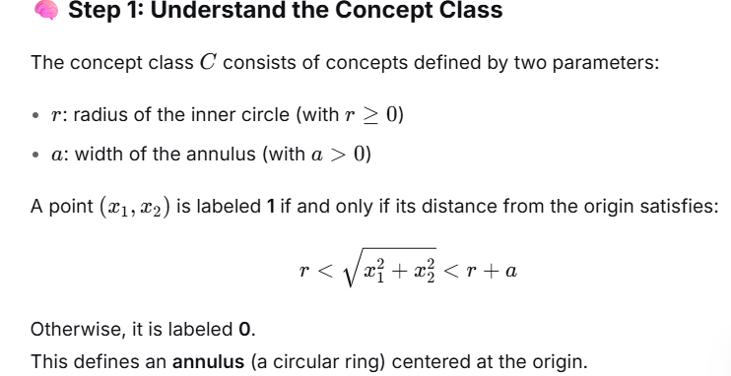  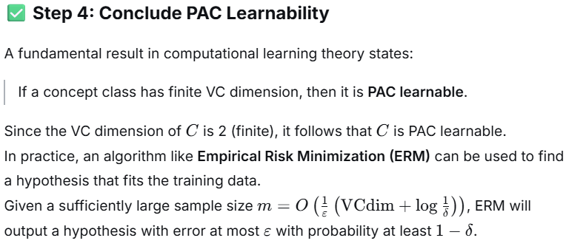 | 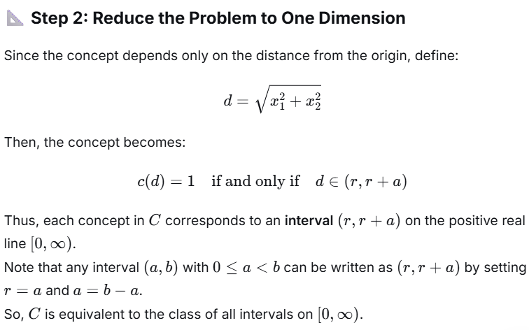  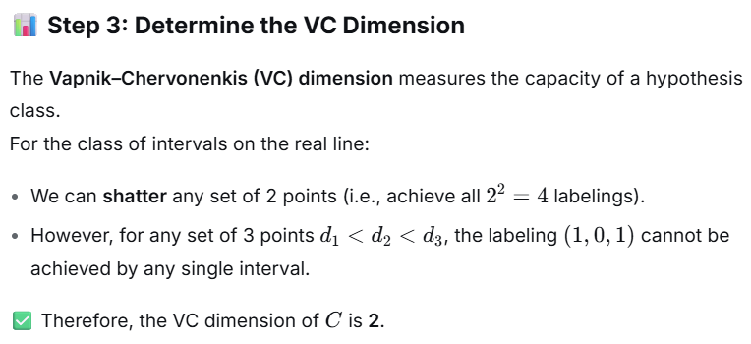
5.b Consider the concept class C in which each concept is represented by  𝑠𝑖𝑔𝑛 sin 𝜔𝑥 + 𝜃 where 𝑥 is a real number and 𝑠𝑖𝑔𝑛(𝑎) predicts 𝑦 = 1 for positive values of 𝑎  and 𝑦 = −1 for negative values of 𝑎. Note that 𝑠𝑖𝑔𝑛 sin 𝜔𝑥 + 𝜃 can shatter any set of  m instances with a sufficiently large value of 𝜔 (frequency) and appropriate 𝜃 (phase).  What does this observation tell us about the PAC learnability of the class C?  Step 1: Understand the Concept Class  The concept class C consists of functions of the form:  f(x)=sign(sin(ωx+θ))  where:  - x∈R is the input,  - ω (frequency) and θ (phase) are real parameters,  - sign(a)=+1 if a>0, and −1 if a<0.  Each function in C partitions the real line into intervals where the output is either +1 or −1,  based on the sign of the sine wave. | Step 2: Shattering Arbitrary Sets of Points  The key observation is that for any set of m distinct points x1,x2,…,xm​, and any assignment of labels y1,y2,…,ym∈{+1,−1} there exist parameters ω and θ such that:  sign(sin(ωxi+θ))=yi for all i.  This is achieved by choosing a sufficiently large frequency ω, which causes the sine function to oscillate rapidly.  By adjusting θ, the phase shifts so that the sine values at each xi​ match the desired signs.  ✅ This means the class C can shatter any finite set of points—i.e., it can realize all possible 2^{m} labelings.  Step 3: Implications for VC Dimension  The Vapnik–Chervonenkis (VC) dimension of a hypothesis class is the largest number of points that can be shattered. Since C can shatter any finite set of points, its VC dimension is infinite.  Step 4: PAC Learnability and VC Dimension  A fundamental result in computational learning theory states:  A hypothesis class is PAC learnable if and only if it has finite VC dimension.  Since the VC dimension of CC is infinite, it is not PAC learnable.
7. Agnostic PAC learning? ??

Explanation of Agnostic PAC Learning
Agnostic PAC (Probably Approximately Correct) learning is a framework in computational learning theory that extends the standard PAC model by removing the realizability assumption.

Key Differences from Standard PAC Learning:
- Standard PAC Learning: Assumes that the target concept (the true function labeling the data) is contained within the hypothesis class H. The goal is to find a hypothesis h∈H
- with error less than ϵ with high probability.
- Agnostic PAC Learning: Does not assume that the target concept is in HH. Instead, the learner aims to find a hypothesis h∈H whose error is close to the best possible error achievable by any hypothesis in H.

Formal Goal:
For any distribution Dover the instance space X×Y, and for any ϵ,δ>0, the agnostic PAC learner outputs a hypothesis h∈H such that with probability at least 1−δ:
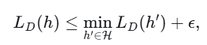
where L_{D}(h) is the true error of h under distribution D.

Implications:
- The learner competes with the best hypothesis in H, even if the best hypothesis still has significant error.
- This model is more realistic, as in practice we often cannot guarantee that our hypothesis class contains the true concept.
- The sample complexity in agnostic PAC learning depends on the VC dimension of H and is generally higher than in the realizable case.
In summary, agnostic PAC learning provides a framework for learning when the hypothesis class may not perfectly fit the data, aiming for performance that
is approximately as good as the best available hypothesis in the class.
Agnostic PAC learning does not assume the target concept is in the hypothesis class; it aims to find a hypothesis whose error is close to the best possible error
in the class.Agnostic PAC learning does not assume the target concept is in the hypothesis class; it aims to find a hypothesis whose error is close to the best
possible error in the class.

