26.10.2021
3 evaluation matrix  + 6 values - 4 values + -  Expected + 4 1 TP FP  Expexted - 2 3 FP TN | • Accuracy (2.5 pts) 0.7  • False positive rate (2.5 pts) FP/(FP+TN)=1/4  • Precision (2.5 pts) TP/(TP+FP)=4/5  • Recall (2.5 pts) TP/(TP+FN)=2/3
4. Suppose you have n samples drawn {xi} n i=1 i.i.d from a Gaussian distribution N (µ, σ2 ). What is the negative log-likelihood (NLL) of these samples? Derive the MLE (Maximum Likelihood Estimator ) for µ and σ using these samples. Comment on the behaviour of your estimators when n → ∞. What can you say about the convexity or strong convexity of the NLL function  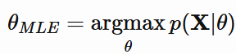  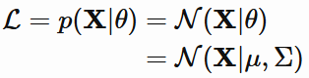  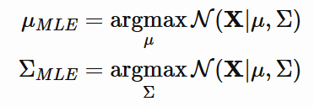 | assume that our Gaussians have diagonal covariance matrices. So the full covariance matrix Σ gets replaced by a diagonal variance vector σ²  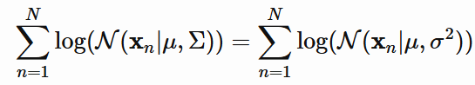  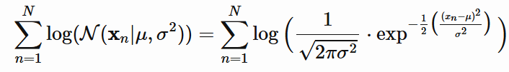  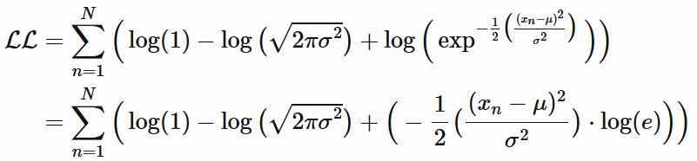  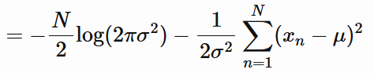
- derive the partial derivative of the function with respect to that parameter, and then  - set that partial derivative to zero, and solve for our parameter  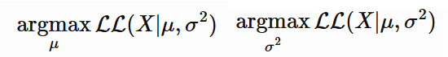  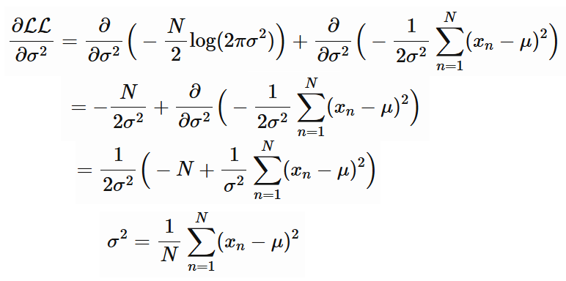 | 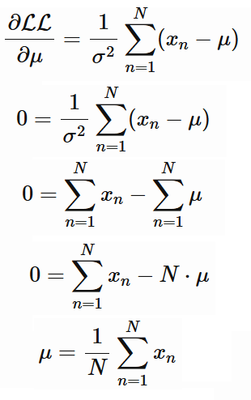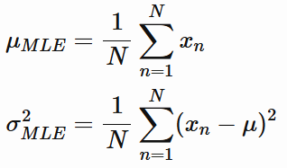
5. w = X⁻¹y = [1, 2, 4] if X not invertible  w = (X^{T} X) ⁻¹Xy = [1, 2, 4] | least squares problem: minimize L(w) = (1/2) * ||Xw - y||^2.  The gradient of L(w) is: ∇ L(w) = X^{T} (Xw - y)  w <- w - learning_rate * gradient.

CS760
5. Given the neural network below, calculate and show the weight changes that would be made by one step of the online version of backpropagation for the training instance x=(1,1), t=(1,1). Assume that the hidden and output units use sigmoid functions, the network is being trained to minimize squared error, and the learning rate is 0.1 (with no momentum term). Edges from constant 1 on the side indicate bias parameters. | 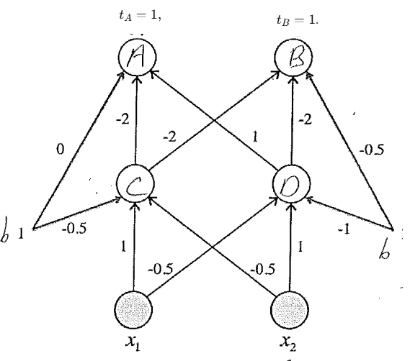 | Forward pass with sigmoid σ(z)=1/(1+e−z)  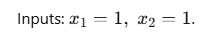  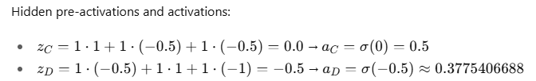  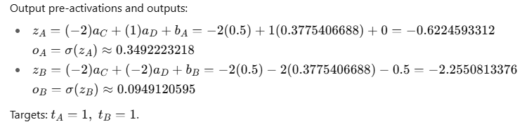
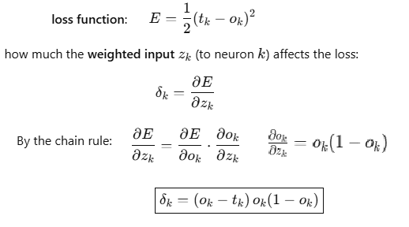  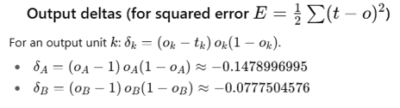 | 