HW5
Agent reach G yields r=+1 and G -> G  Bellman equation for G  V(G)=1+γV(G) V(G)=1/(1-γ) G is highly valuable |  | From any non-goal states r=0 until reaching G  d(si) number steps to reach G from si. Shortest path : chose a0 (right) until sn  Steps from si to G: si -> si+1 -> si+2 ->…..->sn-1 -> G  e.g n=5 G=n5 i=3 s3 -> s4 -> s5=G steps (5-1)-3+1 =2
k=n-1-i+1= steps V(si)=0+γ0+…….+ γ^{k}V(G) reward first 1 one step after entering G  t=0 in si chose action -> to si+1  m=n-1-i+1 =m-i steps before first 1 reward (infinit loop after)  V(si)= γ^{m}⋅1+γ^{m+1}⋅1+… = γ^{m}⋅(1+γ+ γ²+…..)= γ^{m}/(1- γ) m=n-1-i+1 let i=n-1 m=n-1-n+1+1=1  V(s_{n-1})= γ/(1- γ) |  | 1.1.What is the optimal policy, and does it depend on the value of the discount factor γ Explain your answer.  If go left from step i at least 2 more steps are needed to reach G.  0<γ<1 so γ^{m} will reduce value, goal is to minimize m, meaning optimal policy is going right. (γ^{m} > γ^{m+1})
For the policy on each step right
Let m(si) = minimum number of actions before getting the first +1 reward starting from si​ under an optimal policy.
Fom si it take n-i actions to reach G. Next action is r=+1 so
γ ^{n-i} + γ ^{n-i+1}+….. = γ ^{n-I} (1/(1- γ) for G V(G)= 1/(1- γ)
For i=n-1 last state before G
V(s_{n-1})= γ^{n-(n-1)}/(1- γ)= V(s_{n-1})= γ^{n-(n-1)}/(1- γ)= γ/(1- γ)
/(1- γ)
Bellman check V(s_{n-1})= 0 + γ V(G)= γ/(1- γ) for i=1,2,…,n−1
1.3 Adding a constant to each reward
Consider adding a constant c to all rewards (i.e. taking any action from states si has reward c and any action from the goal state G has reward 1 + c. Can adding a constant reward c change the optimal policy? Derive the new optimal value function for all states si and the goal state G. Explain your answer.
1.4 Scaling all the rewards by a constant [15 points]  After adding a constant c to all rewards now consider scaling all the rewards by a constant a (i.e. r_{new} = a(c + r_{old})). Can scaling rewards by a change the optimal policy? Derive the new optimal value function for all states si and the goal state G. |  | Revards: R~(si​,a)=c, R~(G,a)=1+c  From G: V~ (G) =(1+c)+γV~(G) => : V~ (G)=(1+c)/(1-γ)
From non-goal si​:  Assume deterministic policy a0​ (always go right), shortest path to G has m=n−i steps before arriving in G, then rewards forever.  Reward sequence:  First m steps: reward c each step (still in non-goal states).  After arriving in G at step m (after taking action in s_{n−1}​ to G with reward c), at step m+1 you act in G with reward 1+c, etc |  | “always go right”:  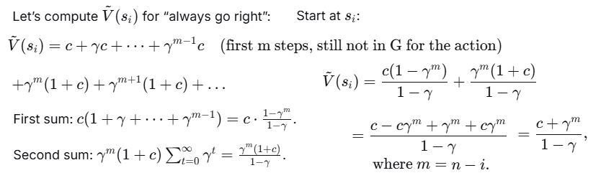
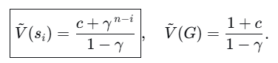
Does adding c change optimal policy?  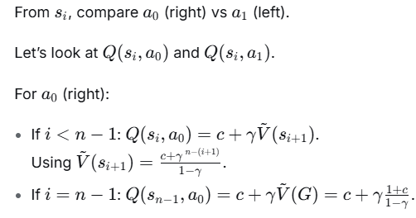 |  | 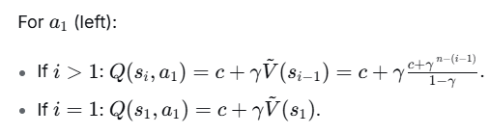
Key observation:  The c term in immediate reward is same for both actions from si​, so difference in Q-values comes only from γV~(next)  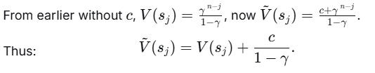  So adding constant c to all rewards adds a constant c/(1−γ)​ to all state values. |  | Q-value difference:  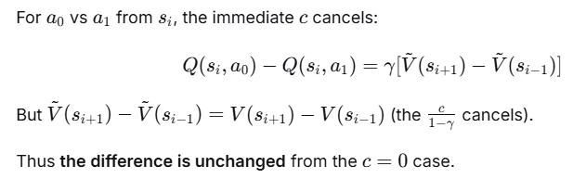  Since in c=0 case, a0​ was strictly better (because V(si+1)>V(si−1) i≥2, and for i=1, staying in s1​ is worse), the same strict ordering holds for any c  Conclusion: Optimal policy unchanged.
Intuition  Adding same constant c to all rewards (all state-action pairs) shifts all values by c/(1−γ​), but relative advantages remain the same.  So no incentive to change the policy to a slower path to G, because sooner arrival in G still yields the stream of 1+c sooner (instead of cc in other states).  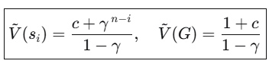 |  | The optimal policy does not change with c, because adding constant reward to all actions does not change relative action advantages.
2 Q-learning  Consider the following Markov Decision Process. It has two states s. It has two actions a: move and stay. The state transition is deterministic: “move” moves to the other state, while “stay’ stays at the current state. The reward r is 0 for move, 1 for stay. There is a discounting factor γ = 0.8  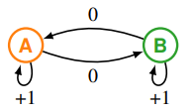 |  | The reinforcement learning agent performs Q-learning. Recall the Q table has entries Q(s, a). The Q table is initialized with all zeros. The agent starts in state s₁ = A. In any state s_{t}, the agent chooses the action a_{t} according to a behavior policy a_{t} = π_{B}(s_{t}). Upon experiencing the next state and reward s_{t+1}, r_{t} the update is:  Let the step size parameter α = 0.5.  Vo predavanjata formula ista
2.1 Greedy [15 points]  Run Q-learning for 200 steps with a deterministic greedy behavior policy: at each state s_{t} use the best action a_{t} ∈ arg max_{a} Q(s_{t}, a) indicated by the current Q table. If there is a tie, prefer move. Show the Q table at the end |  | States: s∈{A,B}  Actions: a∈{move,stay}a∈{move,stay}  - r=0 for "move"  - r=1 for "stay"  - Discount: γ=0.8 | Q-table initialized:  Q(A,move)=0  Q(A,stay)=0  Q(B,move)=0  Q(B,stay)=0  Step size: α=0.5
Behavior policy (greedy): Choose action with highest Q-value in current state;  tie → prefer move.  Start state: s1=A  Q-learning update: |  | 2. Step-by-step simulation  1. step s=A  Q(A, move) = 0, Q(A, stay) = 0 → tie → pick move.  Action a=move  Effect: move → next state s′=B, reward r=0.  Before update: Q(B,move)=0, Q(B,stay)=0 → max = 0.  Update  Q(A,move) <= (1-0.5)x0+0.5x(0+0.8x0) =0  Q table after step1  Q(A,move)=0, Q(A,stay)=0, (B,move)=0, Q(B,stay)=0  No xhange
2. step  S=B (after move A->B)  Q(B, move) = 0, Q(B, stay) = 0 → tie → prefer move.  Action a=move, next state s′=A, reward r=0.  Update Q(B,move)← 0.5×0+0.5×(0+0.8×0)=0  No change in Q values  Q(A,move)=0, Q(A,stay)=0, Q(B,move)=0, Q(B,stay)=0 |  | We can see initially all zeros and when tie we always choose "move", so the loop is:  Step 1: A → move → B, reward 0.  Step 2: B → move → A, reward 0.  Step 3: A → move → B, reward 0.  ... and so on forever.  All Q-values remain 0.  Thus, greedy policy never tries "stay" because tie always chooses move.  No change in 200 steps
2.2 ϵ-greedy [15 points]  Reset and repeat the above, but with an ϵ-greedy behavior policy: at each state s_{t}, with probability 1 − ϵ choose what the current Q table says is the best action: arg max_{a} Q(s_{t}, a)  Break ties arbitrarily. Otherwise, (with probability ϵ) uniformly chooses between move and stay (move or stay both with 1/2 probability). Use ϵ = 0.5 |  | System setup as before: ϵ-greedy policy  - States: A,B Actions: move (→ other state, reward 0), stay (→ same state, reward 1)  - γ = 0.8, α = 0.5, ϵ = 0.5  - Initial Q: all zeros
ϵ-greedy rule:  - With prob 0.5: greedy action:  - If tie (Q equal for move, stay), break tie arbitrarily → I'll break ties by choosing move (same tie-breaker as before, but note: if I need random tie-break in greedy case? The problem says "break ties arbitrarily" for ϵ-greedy; I'll use "move" for consistency in greedy choice unless I explicitly randomize for tie? Actually, "arbitrarily" means any rule, I'll keep move as greedy tie-breaker as before.)  - With prob 0.5: choose random action (move or stay with equal probability 0.5 each). |  | Start: s1=A  Step 1  At state A, current Q(A, move) = 0, Q(A, stay) = 0 → greedy action = move (tie).  ϵ = 0.5: with prob 0.5 greedy, prob 0.5 random.  Simulate randomness: generate random choices for the first few steps  Run until Q-values stabilize; 200 steps will converge with ϵ=0.5 because we try both actions enough.
Process is symmetric  - Q(A, stay) and Q(B, stay) will converge to same value? Not necessarily, because A and B alternate.  Q_{AM}​=Q(A,move)  Q_{AS}= Q(A,stay)  Q_{BM}=Q(B,move)  Q_{BS}= Q(B,stay) |  | Key observation: s-state a-action  - Move from A → B, reward 0, future max is max(Q_{BM},Q_{BS})  - Stay at A → A, reward 1, future max is max(Q_{AM},Q_{AS})  - Similarly for B.  - When ϵ=0.5, we explore enough that both actions get updated.  - For each (s,a)  - Q(s,a)=E[r+γmax _{a′​}Q(s′,a′)] with expectation over s' given (s,a).
Q(s,a)=E[r+γmax _{a′​}Q(s′,a′)]  Q_{AM}​=0+γ max(Q_{BM}​,Q_{BS}​)  Q_{AS}=1+γmax(Q_{AM},Q_{AS}))  Q_{BM}=0+γmax(Q_{AM},Q_{AS})  Q_{BS}=1+γmax(Q_{BM},Q_{BS}) |  | Let m_{A}=max(Q_{AM},Q_{AS}), m_{B}=max(Q_{BM},Q_{BS}). =>  (1) Q_{AM}​=0.8 m_{B}​  (2) Q_{AS}=1+0.8 m_{A}​  (3) Q_{BM}=0.8 m_{A}.  (4) Q_{BS}=1+0.8 m_{B​}
Which is bigger Compare Q_{AS}​ vs Q_{AM}​:  Q_{AS}​=1+0.8m_{A​} Q_{AM}=0.8m_{B}​.  Similarly Q_{BS}=1+0.8 m_{B} , Q_{BM}=0.8m_{A}. |  | Guess m_{A}​=Q_{AS} (since stay in A gives 1 + 0.8 m_A) which is > 0.8 m_B if m_B not huge  and m_{B} = Q_{BS} (same logic) =>  m_{A}​=Q_{AS}​=1+0.8m_{A}​ => 0.2m_{A}=1 => m_{A}=5.  m_{B}=Q_{BS}=1+0.8m_{B​}​ => 0.2m_{B}=1 => m_{B}=5. =>
Q_{AS}​=5, Q_{AM}=0.8×5=4  Q_{BS}=5, Q_{BM}=0.8×5=4 | Check consistency:  mA=max(4,5)=5 ✓  mB=max(4,5)=5 ✓ | Q_{AM}​=4  Q_{AS}​=5  Q_{BM}​=4  Q_{BS}​=5 200 steps with ϵ=0.5 and α=0.5 will converge to this  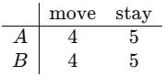

2.3 Bellman equation [20 points] Without doing simulation, use Bellman equation to derive the true Q table induced by the MDP.  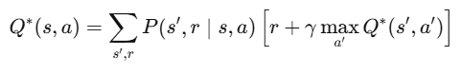  Transitions are deterministic |  |  | From state A:  - Action move:  Deterministic: next state B, reward 0. Q∗(A,move)=0+γ max_{a′} Q∗(B,a′)  - Action stay:  Deterministic: next state A, reward 1. Q∗(A,stay)=1+γmax_{a′} Q∗(A,a′)  From state B:  - 3. Action move:  Deterministic: next state A, reward 0. Q∗(B,move)=0+γmax_{a′}Q∗(A,a′)  - 4. Action stay:  Deterministic: next state B, reward 1. Q∗(B,stay)=1+γmax _{a′} Q∗(B,a′)
Let  m_{A​}=max(Q∗(A,move),Q∗(A,stay))  m_{B}=max(Q∗(B,move),Q∗(B,stay)) => |  | (1) Q∗(A,move)=0.8 mB​  (2) Q∗(A,stay)=1+0.8 mA  (3) Q∗(B,move)=0.8 mA​  (4) Q∗(B,stay)=1+0.8 mB | Guess in both states the optimal action is stay  (since stay gives immediate rev=1 reward, move gives 0), so:  m_{A}​=Q∗(A,stay), m_{B}​=Q∗(B,stay) =>  m_{A}​=1+0.8m_{A}​⟹ 0.2m_{A}​=1 ⟹ m_{A}​=5  mB​=1+0.8m_{B}​⟹ 0.2m_{B}​=1 ⟹ m_{B}​=5
Now plug back:  (1) Q∗(A,move)=0.8×5=4  (2) Q∗(A,stay)=5  (3) Q∗(B,move)=0.8×5=4  (4) Q∗(B,stay)=5 | Check:  m_{A}=max(4,5)=5 ✓  m_{B}=max(4,5)=5 ✓ |  | True table  Q_{AM}​=4  Q_{AS}​=5  Q_{BM}​=4  Q_{BS}​=5
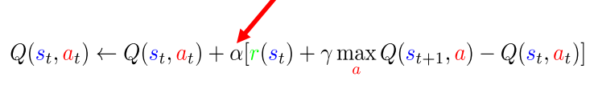
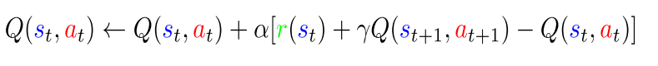no max, next
Can use with epsilon-greedy policy

