Cheat sheet
Informal theorem: if all input points 𝑥 ∈ 𝑋 have norm ≤ 1 then with probability ≥ 1 − 𝛿 all linear models ℎ(𝑥) = 𝑤⊤𝑥 with ||w|| ≤ 1 have 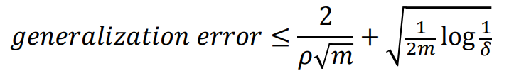  Compare to VC bound for d-dimensional lin.clas.  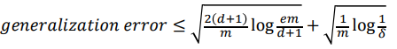  If margin 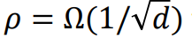first is better |  |  | Distance x to hyperplane 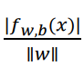  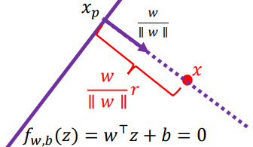 | SVM maximize minimum margin  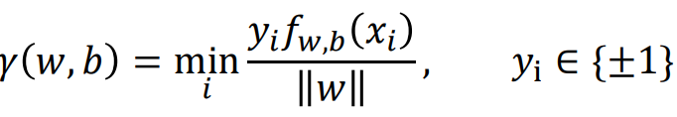  If f_{w,b} incorrect on some xi margin negative  Maximize margin *1  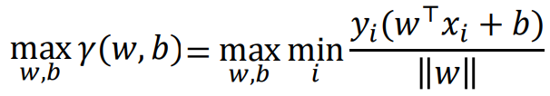
Objective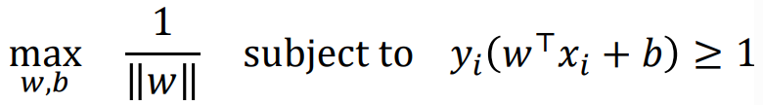  Rewrite as | Optimization problem  Support vectors (points) lay on margin boundary |  | SVM soft margin if not linearly separable add slack C>=0 to tolerate errors  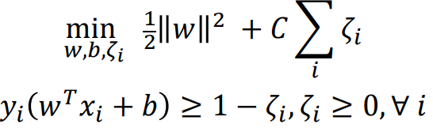 max margin vs. min slack  roughly an inverse regularization parameter
General Constrained optimization Generalized lagrangian 𝛼𝑖 ≥ 0, ’ Larangiang mult.  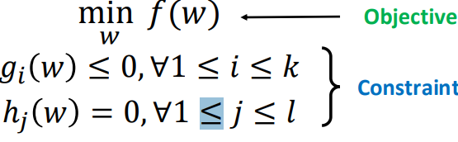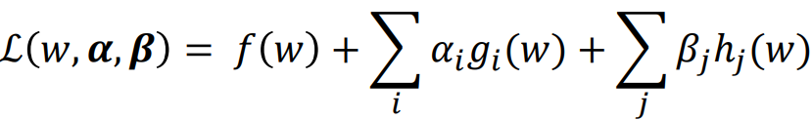 |  |  | Original opt.prob. associates with dual problem  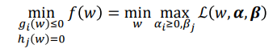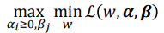  For SVM under certain assumptions the optimal value is same
Dual problem  𝑓_{dual} (𝜶,𝜷) = min_{𝑤} ℒ (𝑤,𝜶,𝜷) often has a closed form solution |  |  | SVM opt.  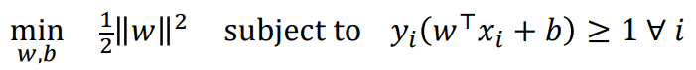  for find dual =>
lagrangian  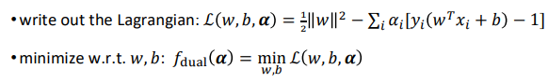  problem is then a maximization over the dual variables 𝜶 ≥ 0 |  | SVM Reformulation  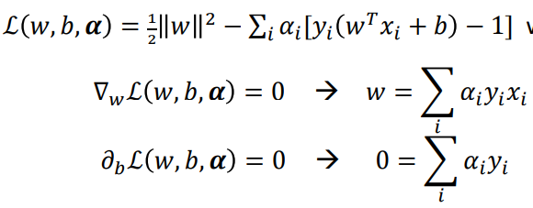  train dual involve 𝑥𝑖⊤𝑥j not xi | 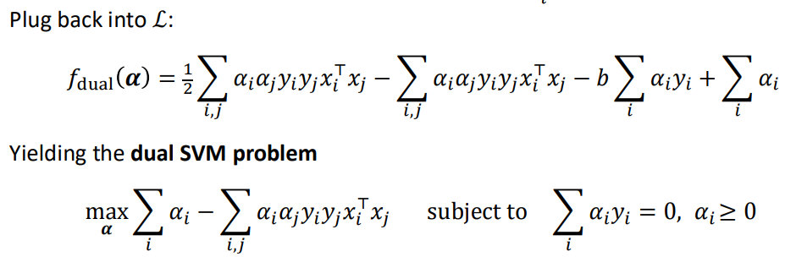 1/2?
Prediction (found 𝜶*) on new x ∈X :  1. compute the new optimal primal variables  • 𝑤∗ = ∑_{𝑖} 𝛼𝑖∗𝑦𝑖𝑥𝑖 (from the first-order conditions)  • 𝑏 ∗ is more involved but can be computed  2. predict 1 if 𝑤∗⊤ 𝑥 + 𝑏∗ = ∑_{𝑖} 𝛼𝑖∗𝑦𝑖𝑥𝑖 ⊤ 𝑥 + 𝑏∗ ≥ 0 and -1 otherwise |  |  | data points 𝑥𝑖 with 𝛼𝑖 ∗ > 0 lie on the margin boundary and are called support vectors  𝑤∗ is a linear combination of support vectors!  solution does not change if we delete points with 𝛼𝑖 = 0
Which of the following statements are true?
A. the solution of an SVM will always change if we remove some instances from the training set. false
B. if we know that our data is linearly separable, then it does not make sense to use slack variables. fals
C. if you only had access to the labels {𝑦𝑖 }𝑖 and the inner products {𝑥𝑖⊤ 𝑥𝑗 }_{𝑖,𝑗} , can find the SVM sol true
Kernel trick  Kernel feature map θ linear to non-linear classifier. Need 𝜙 (𝑥𝑖) ⊤𝜙(𝑥𝑗) not 𝜙 (𝑥𝑖)  All we need is a function 𝑘 that quantifies the similarity:  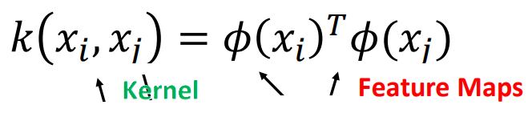 𝑛 × 𝑛 kernel matrix has to be positive definit |  |  | Kernel Types: Polynomial degree d and constant c  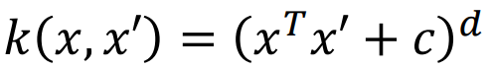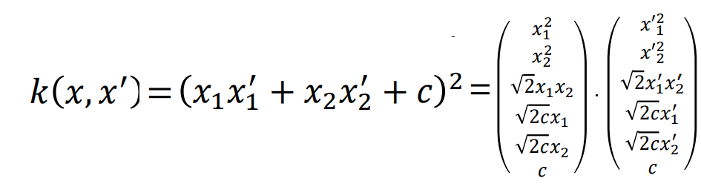
Gaussian/RBF fix y:  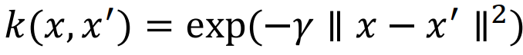 projecting into infinite dim space |  |  | 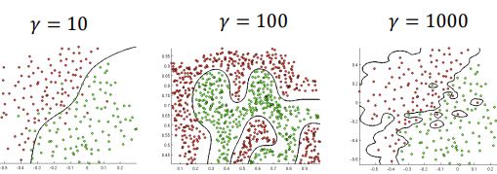
A. SVMs with nonlinear kernels implicitly transform the low dimensional features to a high dimensional space and then performing linear classification in that space. true  B. The “Kernel trick” refers to computing this transformation and then applying the dot product between the transformed points false |  |  | kernel 𝑘(𝑥, 𝑥 ′ ) = (𝑥𝑥 ′ + 1) ³ for 𝑥 ∈ ℝ  = 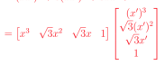
Why might we prefer an SVM over a neural network?  A. With an SVM we can map inputs to an infinite dimensional space. With neural networks, we cannot. B. SVMs are easier to train: An SVM would not get stuck in a local optima, whereas a neural network might.  C. Tuning hyper-parameters in an SVM may be easier than in neural networks. All true |  |  | Extensions of kernel SVM  • soft-margin kernel SVM also works with slack variables  • multi-class classification usually done via 𝐾 one-vs-rest binary classification problems  • regression  • support vector regression  • kernel ridge regression (e.g. Gaussian process regression)
Kernel Methods vs. Neural Networks  Can think of kernel SVM approach as fixing a layer of a neural network, but using kernel feature representations instead:  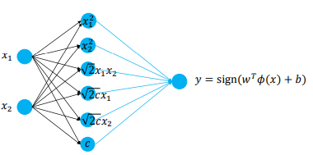 |  |  | Kernel Methods vs. Neural Networks Kernel methods were popular in 90’s and 2000’s  • SVM is one of the biggest successes of learning theory  • still powerful in small / moderate data regimes  Challenges with kernel methods (when we have a lot of data):  • Computational:  • Computing all pairs of kernel values requires 𝑂(𝑛² ) memory  • Overall compute cost is typically 𝑂(𝑛 ³ )  • solving an LP with 𝑛 constraints or inverting an 𝑛 × 𝑛 matrix  • can be accelerated using random Fourier features  • Representation: using a fixed representations is limiting

Example kinez
*1 training points z1​=(1,1) with label y1=+1 and z2=(2,2) with label y2=−1.  f(z)=∑(_{i=1,n}) ​αi​yi​ k(zi​,z)+b with kernel identity matrix. k(zi​,z)=zi^{T}​z  simplify f(z)=w^{T}z+b  w=∑_{(i=1,n)​}αi​yi​zi​. Margin is defined γ(w,b)=min y_{i}​ f(zi​)​/​∥w∥.  Goal find w, b that maximize γ(w,b) | Through optimization we find w=(−​1/​√2​,​-1​/√2), b=3√2/2  f(z1​)=w^{T}z1​+b=(−0.707)(1)+(−0.707)(1)+2.121=0.707, y1 ​f(z1​)=0.707  f(z2​)=w^{T}z1​+b=(−0.707)(2)+(−0.707)(2)+2.121=-0.707, y1 ​f(z1​)=0.707  Since ∥w∥=1,  γ(w,b)=min(0.707,0.707)=0.707=√2/2
Find support vectors 2 points are support vectors with max margin 1/​∥w∥.’  w^{T}z1​+b=1 w^{T}z2+b=−1 solving => w1​+w2​=−2, b=3 | Minimize w1²+w2² subject to w1+w2=−2. By symmetry w1=-1, w2=-1  So w=(-1,-1), b=3 check ∥w∥=√2 margin 1/∥w∥=√2/2 and predictor f(z) correct sep  verified yi(w^{T}zi+b)=1 so both points are support vectors
In SVM, support vectors are the training points that lie exactly on the margin boundaries, i.e., they satisfy: yi(w^{T}zi+b)=1 | 2. Geometric relationship  The separating hyperplane is: wTz+b=0  The margin boundaries are: w^{T}z+b=+1 (for class y=+1) w^{T}z+b=−1(for class y=−1)  The vector w is normal (perpendicular) to the separating hyperplane and also to the margin boundaries

HW4
3. Kernel SVM Consider the following kernel function defined over z, z′ ∈ Z  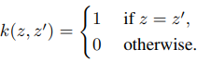 | 3.1 PSD [10 points]  Prove that for any integer m > 0, any z1, . . . , zm ∈ Z, the m × m kernel matrix  K = [Kij ] is positive semidefinite, where Kij = k(zi , zj ) for i, j = 1 . . . m.  (Let us assume that for i ̸= j, we have zi ̸= zj .) Hint: An m × m matrix K is positive semi-definite if ∀v ∈ R ^{m}, v⊤Kv ≥ 0.
  Given distinct points z1,…,zm∈Z, zi≠zj​ for i≠j, the m×m kernel matrix K has entries: Kij=k(zi,zj)​.  All zi​ are distinct => :  - Kii=k(zi,zi)=1, Kij=0 for i≠j thus, K is the identity matrix: K=I_{m}​ | A symmetric matrix M is positive semidefinite if for every vector v∈R^{m}: v⊤Mv≥0  Since K=I_{m} for any : v=(v1,v2,…,vm) v⊤Kv= v⊤Iv= v⊤v= ∑_{I} _{=1,m}vi²>=0  So K is positive semidefinite
3.2 Separability [10 points]  Given a training set (z1, y1), . . . ,(zn, yn) with binary labels, the dual SVM problem with the above kernel k will have parameters α1, . . . , αn, b ∈ R. (Assume that for i ̸= j, we have zi ̸= zj .) The predictor for input z is  f(z) = ∑_{I} _{=1,n} αiyi k(zi , z) + b.  Recall the prediction is sign(f(z)). Prove that there exists α1, . . . , αn, b s.t. f correctly separates the training set. | Kinez  Training set (z1​,y1​),(z2​,y2​),…,(zn​,yn​) with yi∈{+1,−1}, and all zi​ are distinct  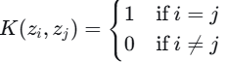  Decision function  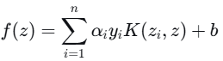 and prediction sign(f(zi))  Dual SVM constraints are  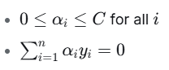  We aim to show that there exist values α1,…,αn,b∈R satisfying these constraints such that f correctly classifies all training points, i.e., 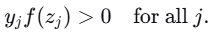
Evaluate f on the Training Point | For any training point zj​, we have:  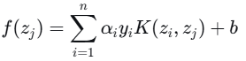  Since K(zi,zj)=0 for i≠j and K(zj,zj)=1, this simplifies to: f(zj)=αjyj+b  We require
Construct a Suitable Choice of Parameters | Let:  - n+​: number of examples with yi=+1  - n−​: number of examples with yi=−1  Define:  - For i with yi=+1, set αi=εn-​  - For i with yi=−1, set αi=εn+​  where ε>0 is a constant to be chosen.  Check the constrains  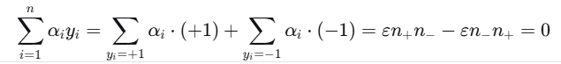  Check the Constraint 0≤αi≤C  We require:  - εn−≤C ⇒ε≤C/n₋​  εn+≤C⇒ε≤C/n₊​  Choose any ε such that  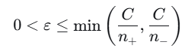  Then all αi​ satisfy 0≤αi≤C.  Check the Classification Condition  Set b=0. Then for any j:  If yj=+1 αj​+byj​=εn₋​+0>0  If yj=−1: αj​+byj​=εn₊​+0>0  Hence, yjf(zj)>0 for all j.
Conclusion | We have constructed α1,…,αn​ and b such that:  - 0≤αi≤C ∑αiyi=0 yjf(zj)>0 for all j  Therefore, the decision function f correctly separates the training set.
3.3 Prediction [10 points] How does that f predict input z that is not in the training set? | For any input z not in the training set:  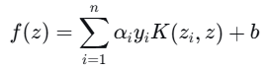  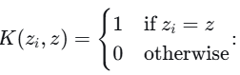  - Since z is not in the training set, z≠zi​ for all i  - Therefore, K(zi,z)=0 for all i  So the prediction becomes:  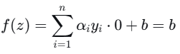  Implications  - Constant prediction: For any input not in the training set, the prediction is always sign(b)  - No generalization: The model cannot distinguish between different unseen inputs - they all get the same prediction  - Pure memorization: The model only "knows" about the training examples it has seen  - This is an example of extreme overfitting - the model perfectly memorizes the training data but has zero generalization capability.
3.2 Separability [10 points]  Given a training set (z1, y1), . . . ,(zn, yn) with binary labels, the dual SVM problem with the above kernel k will have parameters α1, . . . , αn, b ∈ R. (Assume that for i ̸= j, we have zi ̸= zj .) The predictor for input z is  f(z) = ∑_{I} _{=1,n} αiyi k(zi , z) + b.  Recall the prediction is sign(f(z)). Prove that there exists α1, . . . , αn, b s.t. f correctly separates the training set. | GPT  Because k is the identity kernel 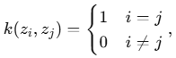for any z from training set predictor evaluate  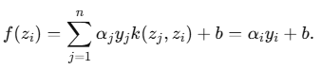  To get correct classification on the training set we need  two construction meet requirements  - Pick b=0 and pick any αi>0 for every i. Then f(z_{i}​)=α_{i}​y_{i}​ sign(α_{i}​)y_{i}​= y_{i}​ due to αi>0i Thus the training set is separated.  - (If the usual dual constraint ∑_{i}αiyi=0 must also hold.)  Let N+ and N−​ be the numbers of positive and negative labeled examples (assume both are positive). Choose a positive constant c and set  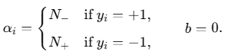  Then αi>0 so sign(αiyi)=yi​, and  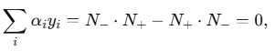  So the balancing constraint is satisfied.  on degenerate case: if all labels are equal (say all +1) the classifier f≡+1 (e.g. choose b>0, all αi=0 trivially classifies correctly; the usual dual sum constraint forces α≡0 in that case and b is then determined in the primal.  Hence in all cases one can choose α1,…,αn​ and b so that f correctly separates the training set
3.3 Prediction [10 points] How does that f predict input z that is not in the training set? | Prediction 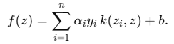If the kernel extends for the whole input space  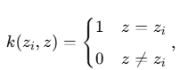  then for any new input z that is not equal to any training point we have k(zi,z)=0 for every i, so  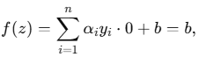  the classifier outputs sign(b) on every unseen point. If z exactly equals some training example zj f(z)=αjyj+b as before.  Consequences and alternatives  - This kernel has no notion of similarity between different inputs, so it generalizes terribly: every unseen point gets the same label (sign of b).  - If you want sensible predictions on new inputs you need a kernel that gives nonzero similarity between different but related points (e.g. RBF, polynomial, linear). With those kernels k(zi,z) can be nonzero for unseen z, and f(z) becomes a meaningful weighted similarity sum.  - If you intended the kernel only on the training set (so it’s not defined for new z), then you cannot evaluate f(z) for unseen z at all — you must extend/choose a kernel on the full input space.
3.2 Separability [10 points]  Given a training set (z1, y1), . . . ,(zn, yn) with binary labels, the dual SVM problem with the above kernel k will have parameters α1, . . . , αn, b ∈ R. (Assume that for i ̸= j, we have zi ̸= zj .) The predictor for input z is  f(z) = ∑_{I} _{=1,n} αiyi k(zi , z) + b.  Recall the prediction is sign(f(z)). Prove that there exists α1, . . . , αn, b s.t. f correctly separates the training set. | Copilot  Kernel K is the identity matrix I_{n} and predictor simplifies to:  f(zj)= αjyj+b since all the terms vanish due to orthogonality.  We want sign(f(zj)=yj for all j=1,…,n  Let chose: αj=1 for all j and b=0  Then: f(zj)= αjyj+b >0 for all j => sign(f(zj))=sign(yj)=yj  So every training points is correctly classified  More generally, for any nonzero αj>1 and b satisfying  yj(αjyj+b)>0 for all j  we have correct classification. This is always achievable because each f(zj) depends only on αj, yj, b and inputs are ortogonal
3.3 Prediction [10 points]  How does that f predict input z that is not in the training set?  on a test input z ∉{ z1,…,zn}  f(z) = ∑_{I} _{=1,n} αiyi k(zi , z) + b  with kernel 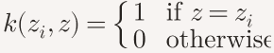  case 1: z ∈{ z1,…,zn} than k(zi,z)=δ_{I,j} and f(z)= αjyj+b  case 2: z ∉{ z1,…,zn} then k(zi,z)=0 for all i so  f(z) = ∑_{I} _{=1,n} αiyi 0 + b =b  thus the prediction is sign(f(z))=sign(b) | interpretation  - The classifier cannot generalize beyond the training set.  - It assigns the same label to all unseen inputs, determined solely by the bias term b.  - This is a form of extreme overfitting: perfect memorization, zero generalization.  The identity kernel maps each training point to an orthogonal basis vector. So:  - The feature space has no structure beyond the training set.  - There’s no notion of similarity between different inputs.  - Unseen inputs are orthogonal to everything, so they get no signal from the learned model.  Conclusion  With the identity kernel:  - f(z)=b for all z\notin \{ z_1,\dots ,z_n\}  - Prediction is constant on unseen data  - The model memorizes the training set but fails to generalize

LINKS to quiz type Question | https://www.aionlinecourse.com/ai-quiz-questions/machine-learning/support-vector-machines

CS760 exam s2017  4.1 What are the advantages/disadvantages of a non-linear SVM? Give examples to justify your reasoning.  ✅ Advantages of Non-Linear SVMs  1. Can Learn Complex Decision Boundaries. Non-linear SVMs can separate datasets that are not linearly separable in original feature space by using kernel to implicitly map data to higher-dimensional space.  Example  Dataset: two concentric circles.  A linear SVM fails (data is not separable by a straight line).  An RBF kernel SVM succeeds because it effectively creates a circular boundary.  2. Kernel Trick Avoids Explicit High-Dimensional Computation  Non-linear kernels compute inner products in an extremely high-dimensional space without actually computing the mapping. This allows:  - Feature spaces of infinite dimension (e.g., RBF kernel).  - Efficient training despite high implicit dimensionality.  3. Good Performance with Small–Medium Datasets  SVMs with RBF or polynomial kernels often outperform neural networks and logistic regression on small data where:  - feature engineering is minimal,  - decision boundary is complex,  - interpretability is not the priority.  Example  Bioinformatics datasets with a few hundred samples:  RBF-SVM is often state-of-the-art because it captures non-linear interactions without overfitting  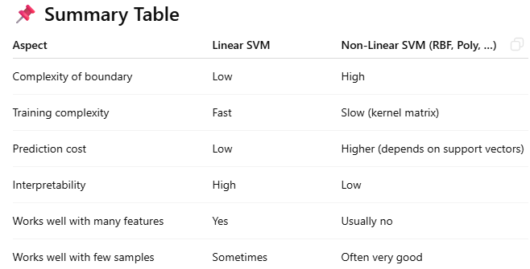 |  |  |  | Disadvantages of Non-Linear SVMs  1. Poor Scalability to Large Datasets  Training non-linear SVMs scales roughly between O(n²) and O(n³) in the number of samples because:  - kernel matrix is n×n and calculation n(n×n_  - optimization becomes expensive  For very large datasets (>50,000 samples), RBF or polynomial SVMs often become too slow or impossible to train.  Example  Image classification dataset with 100,000 images:  RBF-SVM is impractical; CNNs or linear SVMs on embeddings are preferred.  2. Harder Hyperparameter Tuning  Non-linear SVMs introduce additional hyperparameters:  - RBF: γ (gamma) and C  - Polynomial: degree d, coef0, C  - Sigmoid: kernel parameters and C  Model performance is very sensitive to these choices; improper tuning → overfitting or underfitting.  Example  RBF SVM with too large γ forms extremely tight decision boundaries around points → memorization.  3. Less Interpretable  Linear SVMs provide feature weights (w).  Non-linear SVMs only provide support vectors and kernel evaluations → decision boundary is not easily interpretable.  Example  Healthcare dataset: clinicians often prefer linear SVMs/logistic regression due to interpretability regard 4. Prediction Cost Scales with Number of Support Vectors  For non-linear SVMs:  f(x)=∑_{i∈SV} αiyiK(x,xi)  If support vectors are numerous (often thousands):  - prediction becomes slow,  - memory usage increases.  Linear SVMs predict in O(d), non-linear SVMs in O(#SV × d).  Non-linear SVMs:  - powerful for complex, small–medium sized datasets  - use kernels to model sophisticated patterns  − slow to train, hard to tune, low interpretability  They excel where data is limited but boundaries are complex, and fail at extremely large-scale problems.
4.2 What is a kernel function? Why do we need it? |  |  |  | A kernel function computes the inner product of two points in a high-dimensional feature space without explicitly mapping the data into that space.  We need kernels to:  - Make SVMs able to learn non-linear decision boundaries.  - Avoid expensive computation of high-dimensional feature vectors.  - Use the kernel trick in the dual SVM formulation.  - Enable flexible classification for complex datasets.
4.3. Given the following data samples (square and triangle mean two classes), which one(s) of the following kernels can we use in SVM to separate the two classes?  a) Linear kernel b) Polynomial kernel c) Gaussian RBF (radial basis function) kernel d) None of the above |  |  |  | 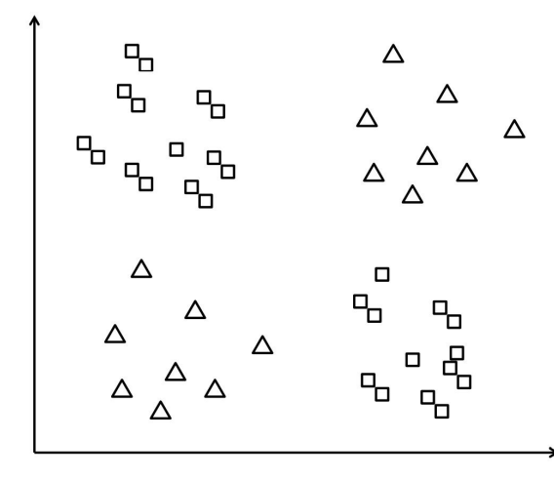
4.4. How does the margin ρ relate to the weight vector w? Express the relation using a formula. |  |  |  | For a (hard-margin) SVM, the geometric margin ρ is inversely proportional to the norm of the weight vector w. ρ=1/∥w∥​
SMO Algorithm solves dual optimization problem  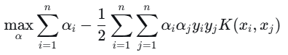 subject to 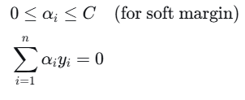  Key idea update two α parameters at a time (can be adjust sum=0)  Step 1: Choose two Lagrange multipliers α1,α2​  - First: Choose an αi​ that violates KKT conditions (using heuristics)  - Second: Choose αj​ to maximize the step size (using second-order information) |  |  |  | Step 2: Optimize these two parameters (analytic solution)  Fixing all other α's, solve a simple 1D quadratic problem in closed form:  Ei​=f(xi​)−yi ​(prediction error)  η=K(x1,x1)+K(x2,x2)−2K(x1,x2)) => 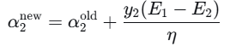  clip to satisfy 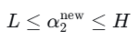 => 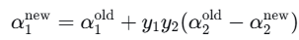  Step 3: Update threshold b based on new α values  Step 4: Repeat until all α's satisfy KKT conditions within tolerance
KKT Conditions  For a point x∗ to be a local minimum (under constraint qualifications), there must exist constants μi​ (i=1,…,m) and λj​ (j=1,…,p) such that: stationary:  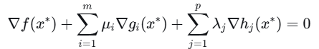  Primal feasible Dual feasible complementary slackness  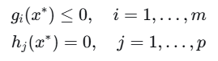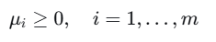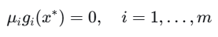 |  |  |  | Interpretation  - Stationarity: The gradient of the objective can be expressed as a combination of the gradients of the constraints.  - Primal feasibility: The point satisfies all constraints.  - Dual feasibility: The multipliers for inequality constraints are non-negative.  - Complementary slackness: For each inequality constraint, either the constraint is active (gi(x∗)=0) or its multiplier is zero (μi=0).
SVM soft margin KKT condition for SVM  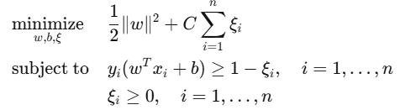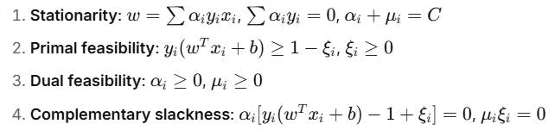 |  |  |  | From these, we get the important SVM KKT gap conditions:  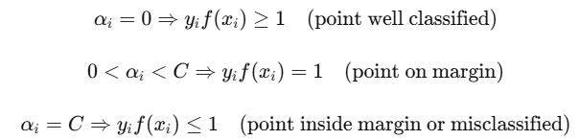
SMO eg. α=[0,0,0],b=0  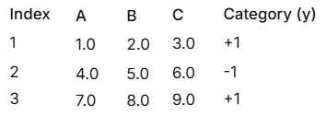 |  | 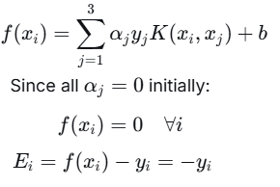 | C=10 γ=0.1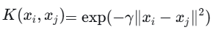 | SMO Step 1: Choose α₁ and α₂  We check KKT violations for each point.  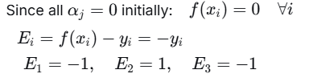 |  | KKT condition for αᵢ in (0,C): y_{i}f(x_{i})=1  For αᵢ = 0: require yif(xi)≥1  Check:  - Point 1: y1f(x1)=1×0=0≥1? No → viol  - Point 2: y2f(x2)=−1×0=0≥1? No → vio  - Point 3: same as point 1 → violation
We can pick the most violating one using yiEi=yi (f(xi)−yi)=yif(xi)−1 for α=0 case:  Actually simpler: choose i with largest |E_i| among violators. Here all have |E_i| = 1.  Let’s choose i=1 as first α. |  |  |  | Now choose j≠I that maximize |E1-E2|=|-1-1|=2  |E1-E3|=|-1-(-1)|=0 So choose j=2  So working set: (i=1, j=2), α₁ and α₂.
3. Compute η and new α₂  η=K11+K22−2K12​ | - K11=exp(−0.1×0)=1, K22=1  - ∥x1−x2∥²=(1−4)²+(2−5)²+(3−6)²=9+9+9=27  - K12=exp(−0.1×27)=exp(−2.7)≈0.0672 =>  η=1+1−2×0.0672=1.8656 |  |  | Update α₂:  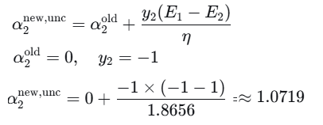 |  |  | Actually formula:  If y1≠y2​:  L=max(0,α2^{old}−α1^{old}))  H=min(C,C+α₂^{old}−α₁^{old}))  Here: y1≠y2y1​=y2​, α₁=0, α₂=0, C=10  L=max(0,α2^{old}−α1^{old}))=0  H=min(C,C+α2^{old}−α1^{old}))=10
Update α₁  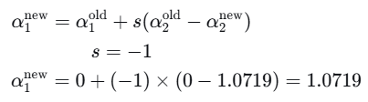 |  |  |  | Update b  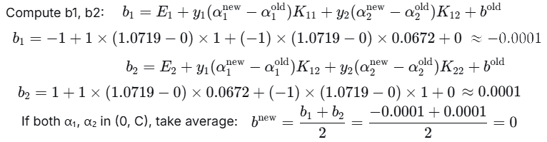
CS760 exam 2014  1. - SVM Learning by the SMO Algorithm (20 points)  You have the small dataset below that involves three features (A, B and C) and the Category  (-1 for negative and +1 for positive). Show one update step of the SMO algorithm on this data, assuming the initial alphas and b are 0. Use a Gaussian kernel. Assume y=1 and C = 10. Show all your work.  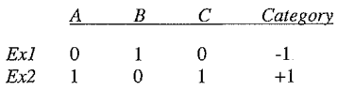 |  |  |  | - Step1: Parameters: Initial α₁ = 0, α₂ = 0, b = 0, C = 10, Gaussian kernel  fix y:   1.Initial error: f(x) = Σ(αᵢyᵢK(xᵢ,x)) + b  For Ex1(i=1)  f(x1)= α₁y₁K(x₁,x₁) + α₂y₂K(x₂,x₁) + b= (0)(-1)K(x₁,x₁) + (0)(1)K(x₂,x₁) + 0 = 0  E1=f(x1)-y1=0-(-1)=1  For Ex2(i=1)  f(x₂) = α₁y₁K(x₁,x₂) + α₂y₂K(x₂,x₂) + b= (0)(-1)K(x₁,x₂) + (0)(1)K(x₂,x₂) + 0 = 0  E₂ = f(x₂) - y₂ = 0 - (+1) = -1  Check KKT conditions  For Ex1 (α1=0): y₁f(x₁) = (-1)(0) = 0 ≥ 1? No (violates KKT)  For Ex2 (α₂ = 0): y₂f(x₂) = (1)(0) = 0 ≥ 1? No (violates KKT)  Proceed optimization
Step2: Check KKT Conditions  For Ex1 (α₁ = 0): y₁f(x₁) = (-1)(0) = 0 ≥ 1? No (violates KKT)  For Ex2 (α₂ = 0): y₂f(x₂) = (1)(0) = 0 ≥ 1? No (violates KKT)  Both examples violate KKT conditions, so we can proceed with optimization.  Step 3: Select First Lagrange Multiplier  We'll choose α₁ as the first multiplier to optimize since it violates KKT.  Step 4: Select Second Lagrange Multiplier  We choose α₂ to maximize |E₁ - E₂|:  |E₁ - E₂| = |1 - (-1)| = 2  Step 5: Compute Kernel Values  Using Gaussian kernel: K(xᵢ,xⱼ) = exp(-γ||xᵢ - xⱼ||²)  Let's assume γ = 1 for this example:  K(x₁,x₁):  ||x₁ - x₁||² = 0  K(x₁,x₁) = exp(-0) = 1  K(x₂,x₂):  ||x₂ - x₂||² = 0  K(x₂,x₂) = exp(-0) = 1  K(x₁,x₂):  ||x₁ - x₂||² = (0-1)² + (1-0)² + (0-1)² = 1 + 1 + 1 = 3  K(x₁,x₂) = exp(-3) ≈ 0.0498  Step 6: Compute η  η = K(x₁,x₁) + K(x₂,x₂) - 2K(x₁,x₂)  = 1 + 1 - 2(0.0498) = 2 - 0.0996 = 1.9004 |  |  |  | Step 7: Compute Unclipped α₂  α₂_new,unc = α₂_old + (y₂(E₁ - E₂))/η  = 0 + (1(1 - (-1)))/1.9004  = 2/1.9004 ≈ 1.0523  Step 8: Compute Bounds for α₂  Since y₁ ≠ y₂:  L = max(0, α₂_old - α₁_old) = max(0, 0 - 0) = 0  H = min(C, C + α₂_old - α₁_old) = min(10, 10 + 0 - 0) = 10  Step 9: Clip α₂  α₂_new = min(max(α₂_new,unc, L), H)  = min(max(1.0523, 0), 10) = 1.0523  Step 10: Update α₁  α₁_new = α₁_old + y₁y₂(α₂_old - α₂_new)  = 0 + (-1)(1)(0 - 1.0523) = 1.0523  Results After One Update Step:  - α₁ = 1.0523  - α₂ = 1.0523  - b = 0 (not updated in this step)  This completes one iteration of the SMO algorithm. The next step would typically update the bias term b, but the problem asked for just one update step focusing on the α values. | 
Step11. We have:  - α₁_old = 0, α₂_old = 0  - α₁_new = 1.0523, α₂_new = 1.0523  - E₁ = +1, E₂ = -1  - K(x₁,x₁) = 1, K(x₂,x₂) = 1, K(x₁,x₂) = 0.0498  Update bias  Option 1: Using α₁_new  b₁ = E₁ + y₁(α₁_new - α₁_old)K(x₁,x₁) + y₂(α₂_new - α₂_old)K(x₁,x₂) + b_old  b₁ = 1 + (-1)(1.0523 - 0)(1) + (1)(1.0523 - 0)(0.0498) + 0= 1 - 1.0523 + 0.0524 + 0  = 0.0001  Option 2: Using α₂_new  b₂ = E₂ + y₁(α₁_new - α₁_old)K(x₁,x₂) + y₂(α₂_new - α₂_old)K(x₂,x₂) + b_old  - b₂ = -1 + (-1)(1.0523 - 0)(0.0498) + (1)(1.0523 - 0)(1) + 0  = -1 - 0.0524 + 1.0523 + 0  = -0.0001 |  |  |  | Step 12: Choose Final b Value  Since both α₁_new and α₂_new are between 0 and C (0 < 1.0523 < 10), we can use either b₁ or b₂. In practice, we often take the average:  b_new = (b₁ + b₂)/2 = (0.0001 + (-0.0001))/2 = 0  Complete Updated Parameters:  - α₁ = 1.0523, α₂ = 1.0523, b = 0  Verification:  Let's verify the decision function after the update:  For Ex1:  f(x₁) = α₁y₁K(x₁,x₁) + α₂y₂K(x₂,x₁) + b  = (1.0523)(-1)(1) + (1.0523)(1)(0.0498) + 0  = -1.0523 + 0.0524 = -0.9999 ≈ -1 ✓  For Ex2:  f(x₂) = α₁y₁K(x₁,x₂) + α₂y₂K(x₂,x₂) + b  = (1.0523)(-1)(0.0498) + (1.0523)(1)(1) + 0  = -0.0524 + 1.0523 = 0.9999 ≈ +1 ✓  The decision function now correctly classifies both examples!

CS760 exam-dec2011
Problem 1 – SVM Learning by the SMO Algorithm (20 points) You have the small dataset below that involves one feature (A) and the Category (-1 for negative and +1 for positive). Show one update step of the SMO algorithm on this data, assuming the initial alphas and b are 0. Use a linear kernel (dot product). Assume C = 10. Show all your work.
A Category
Ex1 0 -1
Ex2 1 +1
Problem 2 a– Support Vector Machines (20 points) a) What helps support vector machines combat over-fitting, and why does this help? | 1. Maximum Margin Principle  SVM finds the hyperplane that maximizes the margin - the distance between the decision boundary and the closest training points.  -A larger margin creates a "buffer zone" that makes the model more robust to noise  -The solution depends only on support vectors (points near the boundary), not the entire dataset  -This reduces model complexity and improves generalization
2. Regularization Parameter C  What it is: The C parameter controls the trade-off between achieving a low training error and a low testing error.  Small C: Allows more margin violations (misclassifications), leading to larger margin and simpler decision boundary → prevents overfitting  - Large C: Strictly penalizes misclassifications, potentially fitting noise → risks overfitting  - By tuning C, we control model complexity explicitly | 3. Feature Space Dimensionality vs. Number of Support Vectors  What it is: In kernel SVM, the effective complexity depends on the number of support vectors rather than the feature space dimensionality.  Why it helps:  -Even when using high-dimensional feature spaces (via kernels), the solution is sparse.  - -The decision function: f(x)=∑_{i∈SV}αiyiK(xi,x)+b  - -Only support vectors contribute, limiting effective capacity
4. Kernel Choice  What it is: Selecting appropriate kernels (linear, polynomial, RBF) controls the hypothesis space flexibility.  Why it helps:  - Linear kernel: Limited capacity, low risk of overfitting  - RBF kernel: Can be very flexible, but γ parameter controls influence range  - Small γ: Wider influence, smoother decision boundary  - Large γ: Each point has local influence, risk of overfitting | 5. Theoretical Generalization Bounds  What it is: SVMs have strong theoretical guarantees based on margin size rather than dimensionality.  Why it helps:  - -Generalization error bound depends on margin size and number of support vectors  - -This provides theoretical justification for maximum margin approach  - -Encourages solutions that generalize well regardless of feature space dimensionality
6. Robustness to Outliers  What it is: The soft-margin formulation allows some misclassification of outliers.  Why it helps:  - Outliers typically become support vectors with αᵢ = C  - The model doesn't bend excessively to accommodate every outlier  - Prevents the decision boundary from being distorted by noisy points | 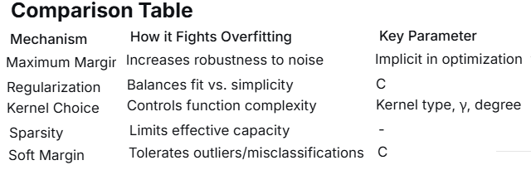
Practical Example  For an RBF kernel SVM:  - Large C + Large γ → High risk of overfitting (complex boundary fitting noise)  - Small C + Small γ → Lower risk of overfitting (smoother, simpler boundary)  - The optimal combination provides good generalization | SVMs combat overfitting through a combination of maximum margin optimization, explicit regularization (C), kernel parameter control, and sparse solutions based on support vectors. This makes them particularly effective in high-dimensional spaces while maintaining good generalization performance.
b) Why can an SVM algorithm learn the exclusive-OR function (XOR, or 2-bit odd parity) of two input binary features if it uses a quadratic kernel but not if it uses a linear kernel? (You may use any representation for binary values that you like in answering this question.)  Linear Kernel Failure  With a linear kernel, the decision function is:  f(x)=w1x1+w2x2+b | Geometric interpretation: The separator must be a straight line.  Why impossible: No single straight line can separate the XOR classes:  - Class +1: points (+1,−1)(+1,−1) and (−1,+1)(−1,+1)  - Class -1: points (+1,+1)(+1,+1) and (−1,−1)(−1,−1)
Quadratic Kernel Solution  A quadratic kernel (polynomial kernel of degree 2):  K(x,z)=(x⋅z+1)² features this kernel implicitly computes.  For input x=(x1,x2) the quadratic kernel with c=1 corresponds to the feature mapping:  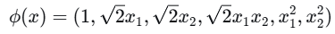 | QOR  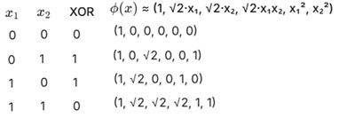 | Consider [x1,x2,x1x2]:  Use: f(x)=x1+x2-2x1x2−0.5  Check:  - (0,0,0): 0 + 0 - 0 - 0.5 = -0.5 → negative (class 0)  - (0,1,0): 0 + 1 - 0 - 0.5 = 0.5 → positive (class 1)  - (1,0,0): 1 + 0 - 0 - 0.5 = 0.5 → positive (class 1)  - (1,1,1): 1 + 1 - 2 - 0.5 = -0.5 → negative (class 0)
c) Describe how SVMs are similar to nearest-neighbor classifiers, and how they are different | 1.Both rely on comparing new inputs to training examples  - Nearest-neighbor: classification is based directly on distances to training point  - SVM: prediction is based on similarities (kernel values) with training points:  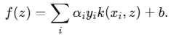
2. Both use only a subset of the training data at prediction time  - Nearest-neighbor: Often uses a small neighborhood (k closest neighbors).  - SVM: Uses only the support vectors — points with αi>0\alpha_i>0αi​>0.  Thus both methods depend on a small, representative subset of the data for prediction | 3. Both can be seen as nonparametric methods  - They do not assume a fixed small parameterized model (like logistic regression)  - Their complexity grows with the dataset size.  4. Both can be viewed through a geometric lens  Both methods depend on the geometry of the data:  - Nearest-neighbor: distances in input space determine class.  - SVM: margin, separating hyperplane, and geometry in feature space.
How different GPT
Cs760 exam 2001  6.e Assuming one has linearly separable data,what is the key difference between standard perceptron training and Support Vector Machines? | - Standard Perceptron: Finds any separating hyperplane that correctly classifies the data.  Support Vector Machine (SVM): Finds the optimal separating hyperplane that maximizes the margin.

The Update Rules
- Perceptron Update Rule: w = w + η * y_i * x_i
This updates the weights whenever a single point is misclassified. It simply "tugs" the decision boundary towards the misclassified point. There is no concept of margin maximization.
- SVM Optimization: The SVM is typically formulated as a constrained optimization problem (maximize margin subject to correct classification), which is solved using Quadratic Programming. The solution is not found by a simple, iterative "tug-of-war" but by a global optimization.

Standard Perceptron: The "Good Enough" Solution
- Goal: The perceptron learning algorithm's only goal is to find a set of weights that results in zero classification error on the training data. It stops updating as soon as it encounters a full pass through the data with no mistakes.
- Result: The algorithm is guaranteed to find *a* solution if the data is linearly separable, but this solution is arbitrary. It depends heavily on the order in which the training examples are processed and the initial values of the weights.
- Analogy: You're given the task to draw a line to separate red and blue dots. The perceptron will quickly draw a line that works, but it might be very close to the red dots on one side.
Why this is a problem? A hyperplane that is very close to the data points of one class is less "confident" and is likely to perform poorly on new, unseen test data. It has poor generalization.

Support Vector Machines: The "Optimal" Solution
- Goal: The SVM is not satisfied with just any separating line. Its explicit objective is to find the unique hyperplane that maximizes the margin.
- Margin: The margin is the distance between the separating hyperplane and the closest data points from either class. These closest points are called support vectors.
- Result: The solution is often called the maximum-margin hyperplane. It is the most "robust" separator, lying in the middle of the widest possible "buffer zone" between the two classes.
- Analogy: Continuing the dot analogy, the SVM will draw the widest possible "street" between the red and blue dots, with the separating line perfectly in the middle of that street. The dots right at the edge of the street are the support vectors.
Why this is better? By maximizing the margin, the SVM builds in a safety buffer. This leads to better generalization to new data and is often more robust to noise.

6.f Briefly explain one (1) connection between the Minimal Description Length principle and Support Vector Machines. ?

CS760-2004  1. Imagine you want to learn to predict which flu patients will respond well to the new drug Pacix, based on three measurements you take. The table below contains the results on a training set of volunteers.  Temp BP Age Result  Ex1 100.0 ave 20 helps  Ex2 98.5 low 41 helps  Ex3 98.6 ave 29 no-effect  Ex4 103.0 high 72 no-effect  Ex5 99.9 low 87 no-effect  1.g Describe how a linear support-vector machine (SVM) could be applied to this problem. Show the expression that would be minimized and the constraints that would need to be satisfied. (Do not assume the data is linearly separable.) Be sure to explain your answer. You do not need to express your solution in terms of the detailed Ax ≥ b matrices and vectors of linear programming, nor do you need to calculate the optimal parameter values that the SVM would find.  minimize explanation  subject to explanation | 1. Data Preprocessing  - Convert categorical features to numerical values: BP is categorical with values "low", "ave", and "high". Use one-hot encoding to represent BP as two binary features (e.g., BP_low and BP_high, where BP_ave is the baseline). Thus, each patient's feature vector xi​ includes:  - Temp (numerical)  - BP_low (1 if BP is low, 0 otherwise)  - BP_high (1 if BP is high, 0 otherwise)  - Age (numerical)  - Assign numerical labels: Let yi=+1 for "helps" and yi=−1 for "no-effect".  - SVM formulation  - Since the data may not be linearly separable, use the soft-margin SVM formulation  - 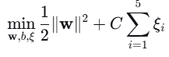  - 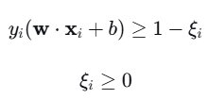
- ∥w∥² is the L2-norm of the weight vector, which maximizes the margin.
- C is a regularization parameter that controls the trade-off between maximizing the margin and allowing misclassifications (a larger C penalizes errors more heavily).
- ξi​ are slack variables that allow for misclassification or margin violations.
These constraints ensure that:
- If ξi=0, the point is correctly classified with a margin of at least 1.
- If ξi>0, the point is inside the margin or misclassified, and the penalty ∑ξi​ is incurred.
- Feature scaling: Since Temp, Age, and the encoded BP features may have different scales, it is advisable to standardize the features (e.g., subtract mean and divide by standard deviation) to improve SVM performance.
- Parameter selection: The value of C is typically chosen via cross-validation or based on domain knowledge, but it is not specified here.
- Solution: After solving the optimization problem (e.g., using quadratic programming), the decision function f(x)=w⋅x+bf(x)=w⋅x+b is used for prediction. For a new patient, if f(x)≥0f(x)≥0, predict "helps" (class +1); otherwise, predict "no-effect" (class -1).
h.Verbally relate your solution to Part g to:
  - minimal description length
  - weight decay
Cs760 2006  Problem 2 – Support Vector Machines (11 points)  Consider the following examples and the kernel function, K, that counts the number of features for which two examples have the same value.  F1 F2 F3 F4 Output  Ex1 T F F F T  Ex2 T T T F F  Ex3 F F F F T  a. What is the kernel matrix for this situation? Be sure to label and explain the axes. | The kernel function K counts the number of features for which two examples have the same value EX1,EX1 4, EX1,EX2 2 equal values  Ex1 Ex2 Ex3  Ex1 4 2 3  Ex2 2 4 1  Ex3 3 1 4  The axes represent the training examples (Ex1, Ex2, Ex3), and each entry K(xᵢ, xⱼ) measures the similarity between examples i and j based on feature value matches.  Given that Ex2 and Ex3 are the only support vectors, the decision function for a new example x is:.  f(x) = α₂·y₂·K(x, Ex2) + α₃·y₃·K(x, Ex3) + b  - α₂, α₃: Lagrange multipliers (≥ 0) for the support vectors  - y₂ = -1 (since Ex2 output is F/T, assuming F = -1)  - y₃ = +1 (since Ex3 output is T, assuming T = +1)  - K(x, Exᵢ): Kernel function measuring similarity between x and support vector Exᵢ  - b: Bias term  - The prediction would be: sign(f(x))  Explanation: In the dual formulation of SVMs, the decision function depends only on the support vectors and their corresponding Lagrange multipliers. Since only Ex2 and Ex3 are support vectors, only these terms appear in the decision function.
a.)Assuming that Ex2 and Ex3 turn out to be the only support vectors for this task, write down the learned decision function, using variables where insufficient information is provided. Be sure to explain your answer. | If Ex2 and Ex3 are the only support vectors, then in the dual form of the kernel SVM, only their dual coefficients α2​ and α3​ are non-zero.
SVM dual 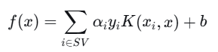 here SV={2,3}  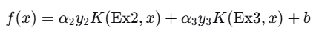  Values from data  - Ex2: y2=−1, feature vector (T,T,T,F) = (1,1,1,0) in binary.  - Ex3: y3=+1, feature vector (F,F,F,F) = (0,0,0,0). | Kernel K(xi,x) = number of matching features between xi​ and x  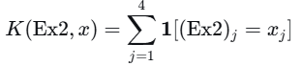. Ex2 = (T, T, T, F) = (1,1,1,0).  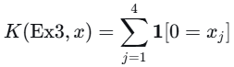 That is, it counts how many features of xx are F (0).
Decision function in terms of α, b  Let m2(x)=K(Ex2,x) =number of features where x matches Ex2.  Let m3(x)=K(Ex3,x) = number of features of x that are F. =>  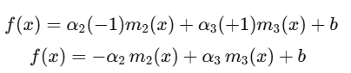 | 4. Constraints from SVM dual  For support vectors Ex2 and Ex3, the KKT conditions give:  y2​f(Ex2)=1 ⇒ (−1)f(Ex2)=1 => f(Ex2)=1  y3f(Ex3)=1 ⇒ (+1)f(Ex3)=1 ⇒ f(Ex3)=1 from linear constraint  α2​y2​+α3​y3​=0 ⇒ −α2​+α3​=0 ⇒ α2​=α3​ let α= α2= α3 =>
solve for α and b For Ex2:  m2(Ex2)=4 (all features match themselves),  m3(Ex2)= # of F's in Ex2 = 1 (only F4 is F) => f(Ex2)=−α⋅4+α⋅1+b=−3α+b we have f(Ex2)=-1 =>  −3α+b=−1  For Ex3:  m2(Ex3)=m2​(Ex3)= matches between Ex2 and Ex3:  Ex2=(1,1,1,0), Ex3=(0,0,0,0) → matches only on F4 (both 0) => 1 match.  m3(Ex3)=4 (all F's). => f(Ex3)=−α⋅1+α⋅4+b=3α+b we have f(Ex3)=1 => 3α+b=1 | Solution −3α+b=−1 3α+b=1 => α=1/3 b=0  Decision function prediction sing f(x)=−1/3 ​m2​(x)+ 1/3​m3​(x)+0  Where:  m2(x) = number of features where x matches Ex2 (T,T,T,F),  m3(x) = number of features of x that are F.  Ex1=[1,0,0,0]  F(Ex1)=-1/3 *2 +1/3 *3=1/3 >0 correctly classified +1
b.)Explain how support vector machines can be viewed as following the minimal description-length principle. | c) SVM and Minimal Description Length Principle  Support Vector Machines follow the Minimal Description Length (MDL) principle through:  - Margin Maximization as Complexity Control:  - The ∥w∥² term in the SVM objective function corresponds to model complexity  - Maximizing the margin minimizes the VC dimension, leading to simpler models  - Support Vectors as Minimal Sufficient Statistics:  - Only support vectors are needed to define the decision boundary  - The number of support vectors represents the "description length" of the model  - Fewer support vectors = shorter description = simpler model  - Structural Risk Minimization:  - SVM explicitly minimizes both training error and model complexity  - This balances empirical risk (fitting training data) and model complexity  - Kernel Trick and Implicit Simplicity:  - Even in high-dimensional feature spaces, the solution depends only on support vectors  - The kernel implicitly defines a complex feature space while maintaining a simple decision boundary  The MDL principle states that the best model is the one that minimizes the sum of:  - The description length of the model  - The description length of the data given the model  SVMs achieve this by finding the simplest possible boundary (maximum margin) that explains the training data, using the minimal number of data points (support vectors) to define this boundary.
5c. You run an SVM on all N of your labeled examples and obtain S support vectors. Without doing any additional experimentation, can you give an upper bound on the future error rate of the model you learned? Be sure to explain your answer.  (nema vo predavanjata ?) | For a hard-margin SVM (separable data) trained on N examples yielding S support vectors, with margin γ, the expected error rate on future test examples is bounded by: E[Error] <= 1/N E[S}] (training set of size N, S support vectors)  With probability 1-δ over draw of test sample error rate  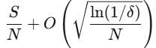 simpler from leave-one-out analysis Error rate<= S/N
CS760 2003
Imagine that you are given the following set of training examples.
Feature F1 can take on the values a, b, or c; Feature F2 is Boolean-valued;
and Feature F3 is always a real-valued number in [0,1].
F1 F2 F3 Category
Example 1 a T 0.2 +
Example 2 b F 0.5 +
Example 3 b F 0.9 +
Example 4 b T 0.6 –
Example 5 a F 0.1 –
Example 6 a T 0.7 –
1e. Show the feature space for this training set. Use only features F2 and F3 (ie, for this part, ignore F1). Show what a linear support-vector machine might learn from this training set. Briefly explain your answer.
5b.Consider creating an ensemble of eleven support-vector machines (SVM’s) using bagging and a standard linear SVM. Dataset A has 100 support vectors and Dataset B has 1000 support vectors (when run on all the data); both datasets contain 10,000 examples and on both datasets the 10-fold cross-validation accuracy of a single SVM is 80%. On which dataset would you expect bagging to improve accuracy the most? Why? | Bagging (bootstrap aggregating) is most effective when the base model has high variance, as it reduces variance by averaging multiple models trained on bootstrap samples of the data. In this case, the base model is a standard linear support-vector machine (SVM).  The key insight lies in the number of support vectors for each dataset:  - Dataset A has 100 support vectors out of 10,000 examples (1%).  - Dataset B has 1000 support vectors out of 10,000 examples (10%).  The number of support vectors is indicative of the model's variance. A higher number of support vectors suggests that the decision boundary is more complex and sensitive to changes in the training data, leading to higher variance. Although both datasets achieve the same 10-fold cross-validation accuracy (80%), meaning they have similar bias, Dataset B likely has higher variance due to its larger number of support vectors.  When bagging is applied with eleven SVMs:  - For Dataset A, the model is relatively stable (low variance) because few support vectors define the boundary. Bootstrap samples may produce similar models, so bagging provides minimal improvement.  - For Dataset B, the model has higher variance, as more support vectors make the boundary more susceptible to changes in the training data. Bootstrap samples create more diverse models, and averaging their predictions reduces variance, leading to greater accuracy improvement.  Therefore, bagging is expected to improve accuracy more on Dataset B.
5d.explain the role of slack variables in support vector machines.  In the hard-margin SVM, is requires: yi(w^{T}xi+b)≥1 ∀I perfectly separable  Due to noise, outliers we allow constrain violation yi(w^{T}xi+b)≥1- ξi​  - ξi=0: Point is correctly classified with margin ≥ 1 no penalty  - 0<ξi<1: Point is correctly classified but inside the margin small penalty  - ξi≥1: Point is misclassified larger penalty | The soft margin  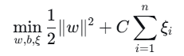subject to 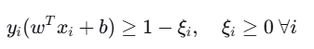  ∥w∥2: Maximize the margin (as before)  C∑ξi​: Minimize the total "penalty" for constraint violations  regularization parameter C controls the trade-off:  - Small C: Emphasizes large margin, allows more violations (underfitting risk)  - Large C: Emphasizes correct classification, allows smaller margin (overfitting risk)
Impact on support vectors  - Margin support vectors: y_{i}f(xi)=1 , ξi=0, 0<αi<C  - Non-margin support vectors: y_{i}f(xi)<1 , ξi>0, αi=C  - Non-support vectors: y_{i}f(xi)>1, ξi=0, αi=0 | In the dual problem, slack variables don't appear explicitly but affect it through:  - Box constraints: 0≤αi≤C  - KKT conditions including: α_{i}[y_{i}f(x_{i})−1+ξ_{i}]=0 μi​ξi​=0 (μi​=C−αi​)
CS760 2009
Problem 2 –Aspects of Supervised Learning (13 points)
2c.Given an informal argument as to why support-vector machines (SVMs) using the “one norm” do a better job of feature selection than do SVMs using the “two norm.” Be sure to explain what “one norm” and “two norm” mean and the role they play in SVMs
- 4c Assume you have trained an ensemble of 100 SVMs for a Boolean-valued task. For each of the test-set examples below, the second column says how many members of the ensemble predicted that example was a positive one, while the third column lists the correct category.

Example Number Predicting True Correct Category
6 89 negative
3 88 positive
2 43 negative
5 29 negative
4 17 positive
1 01 negative

Draw to the right of this table the precision-recall curve
for this ensemble (it is fine to simply ‘connect the dots,’
that is make your curve piece-wise linear).
Be sure to label your axes.
CS760 2010
Problem 1 – Learning from Labeled Examples (20 points)
You have a dataset that involves three features. Feature C’s values are in [0, 1000]. The other two features are Boolean-valued.
A B C Category
Ex1 F T 115 false
Ex2 T F 890 false
Ex3 T T 257 true
Ex4 F F 509 true
Ex5 T T 753 true
1d.Assume a one-norm SVM puts weight = -3 on feature A, weight = 2 on feature B, and
weight = 0 on feature C. What would the cost of this solution be, based on this question’s five training examples? If you need to make any additional assumptions, be sure to state and briefly justify them.

