A discriminative model learns the boundary between classes directly.
It models the conditional probability: P(Y/X) meaning, given the input X, it predicts the class Y.
Model what it learns  Logistic regression Directly models P(Y=1∣X)  SVM Learns separating boundary between classes  Neural Networks Approximate P(Y∣X) or direct decision boundary | Advantages:  - Often more accurate for classification.  - Less computationally expensive, fewer assumptions.  - Works well when we only care about predicting labels, not understanding data distribution.  ❌ Disadvantage:  - Does not model the data distribution P(X).  - Cannot generate new realistic data.
A generative model tries to understand how data is generated.  It models the joint probability distribution: P(X,Y)=P(X∣Y)⋅P(Y)  That means:  - It learns how data features look for each class P(X∣Y))  - And also how likely each class is P(Y)  Then, for prediction it uses Bayes' rule:  P(Y∣X)=P(X∣Y)⋅P(Y)​/P(X) | Advantages:  - Can generate new samples (images, text, etc.).  - Can handle missing data (since it models full data distribution).  - Useful in semi-supervised learning (not all labels needed).  ❌ Disadvantages:  - Often needs more data and strong assumptions.  - More computationally complex.  - Sometimes less accurate than discriminative models for classification.
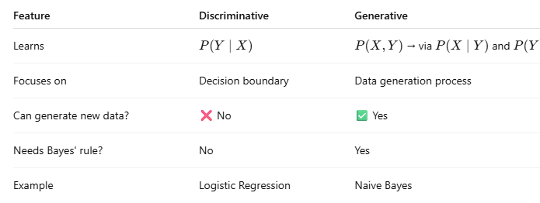

Intuition (in simple language)
- Generative model: "Let me understand how apples and oranges look like. Then I can generate new apples/oranges and also recognize them."
- Discriminative model: "I don’t care how apples or oranges are made—just draw a line that separates them."
