CS760-final2017
- Which of the following statements are true for BOTH decision trees and Naïve Bayes classifiers (you may choose more than one statement)? Explain (4 points)  a) In both classifiers a pair of features are assumed to be independent  b) In both classifiers a pair of features are assumed to be dependent  c) In both classifiers a pair of features are assumed to be independent given the class label  d) In both classifiers a pair of features are assumed to be dependent given the class label  For Naïve Bayes → features are indepenqdent given the class label.  For Decision Trees → no independence assumptions at all. |  |  | a) In both classifiers a pair of features are assumed to be independent False. Only Naïve Bayes assumes independence. Decision trees do not.  b) In both classifiers a pair of features are assumed to be dependent  False. Naïve Bayes explicitly assumes independence given the class.  c) In both classifiers a pair of features are assumed to be independent given the class label  False. Naïve Bayes does; Decision Trees don’t.  d) In both classifiers a pair of features are assumed to be dependent given the class label  False. Again, Naïve Bayes assumes independence, not dependence.
- 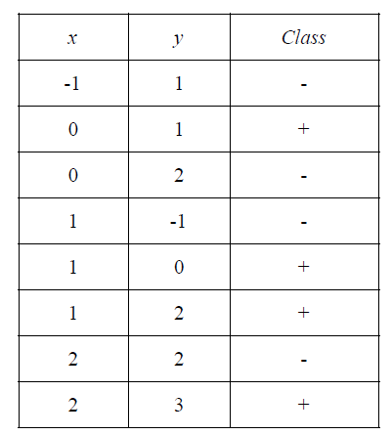 | - What is the prediction of a 3 nearest neighbor classifier at the point (1,1)?  - What is the prediction of a 5 nearest neighbor classifier at the point (1,1)?  - What is the prediction of a 7 nearest neighbor classifier at the point (1,1)? |  | We use Euclidean distance d=sqrt((x−1)²+(y−1)²)  - (−1,1): sqrt((−1−1)²+(1−1)²)=2.000→ Class -  - (0,1): sqrt((0−1)²+(1−1)²)=1.000 → Class +  - (0,2): sqrt((0−1)²+(2−1)²)=1.414 → Class –  - (1,−1):sqrt( (1−1)²+(−1−1)²)=2.000 → Class –  - (1,0): sqrt((1−1)²+(0−1)²)=1.000 → Class +  - (1,2): sqrt((1−1)²+(2−1)²)=1.000 → Class +  - (2,2): sqrt((2−1)²+(2−1)²)=1.414 → Class –  - (2,3): sqrt((2−1)²+(3−1)²)=2.236 → Class +  Sort by distance. majority signs  a. Take first 3: (+, +, +) → 3 +, 0 - Prediction: +  b. Take first 5: (+, +, +, –, –) → 3 +, 2 -. Prediction: +  c. Take first 7: (+, +, +, –, –, –, –) → 3 +, 4 -Prediction: –
3. What is the biggest advantage/disadvantage of decision trees when compared to logistic regression classifiers? (5 points)  Biggest advantage of Decision Trees over Logistic Regression  - Interpretability in non-linear relationships:  Decision trees can naturally capture non-linear decision boundaries and feature interactions without needing feature engineering (e.g., no need to manually add polynomial terms or interaction terms).  - Logistic regression, on the other hand, assumes a linear relationship between features and the log-odds of the outcome.  Advantage (trees): Can model complex, non-linear patterns and feature interactions directly. |  |  | Biggest disadvantage of Decision Trees compared to Logistic Regression  - Overfitting & instability:  Decision trees are prone to overfitting the training data and can become unstable (small changes in the data may lead to a completely different tree).  - Logistic regression is generally more stable, less prone to overfitting (with regularization), and provides well-calibrated probability estimates.  Disadvantage (trees): Less stable, more prone to overfitting than logistic regression
3.Show a decision tree that would perfectly classify the following data set: 5 pionts  Da se pogledne  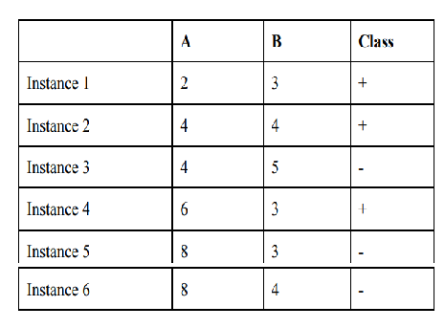 Kinezot  Step 1: Analyze the data  Let's look for patterns:  Looking at feature A:  - A = 2: Instance 1 → +  - A = 4: Instance 2 (+), Instance 3 (-) → mixed  - A = 6: Instance 4 → +  - A = 8: Instance 5 (-), Instance 6 (-) → -  Looking at feature B:  - B = 3: Instance 1 (+), Instance 4 (+), Instance 5 (-) → mixed  - B = 4: Instance 2 (+), Instance 6 (-) → mixed  - B = 5: Instance 3 → -  Step 3: Construct the decision tree  [Root: A ≤ 3?]  ├── Yes: Class = + (Instance 1)  └── No: [A ≤ 7?]  ├── Yes: [B ≤ 4.5?]  │ ├── Yes: Class = + (Instances 2,4)  │ └── No: Class = - (Instance 3)  └── No: Class = - (Instances 5,6) |  |  | Step 2: Find pure splits  Let's try A ≤ 3:  - Yes: Instance 1 only → + (pure)  - No: Instances 2-6  For A > 3: Instances 2-6 (2+, 3-)  Let's split this by A ≤ 7:  - Yes: Instances 2,3,4 (A=4,4,6) → 2+, 1-  - No: Instances 5,6 (A=8,8) → -,- (pure)  Now we need to handle the mixed group  (Instances 2,3,4).  For Instances 2,3,4 (A=4,4,6; B=4,5,3):  - Instance 2: (4,4) +  - Instance 3: (4,5) -  - Instance 4: (6,3) +  Let's split by B ≤ 4.5:  - Yes: Instances 2,4 → +,+ (pure)  - No: Instance 3 → - (pure)  Step 4: Verification  - Instance 1 (2,3,+): A≤3? Yes → + ✓  - Instance 2 (4,4,+): A≤3? No → A≤7? Yes → B≤4.5? Yes → + ✓  - Instance 3 (4,5,-): A≤3? No → A≤7? Yes → B≤4.5? No → - ✓  - Instance 4 (6,3,+): A≤3? No → A≤7? Yes → B≤4.5? Yes → + ✓  - Instance 5 (8,3,-): A≤3? No → A≤7? No → - ✓  - Instance 6 (8,4,-): A≤3? No → A≤7? No → - ✓  All 6 instances are perfectly classified.
Using info gain  Step 1: Calculate initial entropy  Total instances: 6  Class +: 3 instances  Class -: 3 instances  H(S)=−3/6log₂3/6−3/6log₂3/6 ​H(S)=−0.5×(−1)−0.5×(−1)=0.5+0.5=1.0 |  | Step 2: Calculate information gain for all splits  Candidate splits for A: A≤2, A≤3, A≤4, A≤5, A≤6, A≤7  Candidate splits for B: B≤3, B≤3.5, B≤4, B≤4.5  Split A ≤ 2:  - Left (A ≤ 2): Instance 1 only → Class + (pure)  Count: 1 instance, entropy = 0  - Right (A > 2): Instances 2-6 → 2+, 3-  - Entropy= −2/5log₂2/5−3/5log₂3/5= 0.971  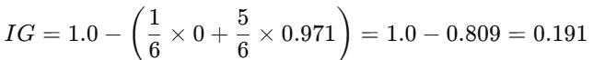 | Split A ≤ 3:  - Left (A ≤ 3): Instance 1 only → Class + (pure)  Count: 1 instance, entropy = 0  - Right (A > 3): Instances 2-6 → 2+, 3-  Entropy = 0.971  IG=1.0−(1/6×0+5/6×0.971)=1.0−0.809=0.191  Split A ≤ 4:  - Left (A ≤ 4): Instances 1,2,3 → 2+, 1-  Entropy = −2/3log₂2/3−1/3log₂1/3=0.918  - Right (A > 4): Instances 4,5,6 → 1+, 2-  Entropy = −1/3log₂1/3−2/3log₂2/3=0.918  IG=1.0−(3/6×0.918+3/6×0.918)=1.0−0.918=0.082
Split A ≤ 5:  Same as A≤4 (no instances with A=5): IG = 0.082 |  | Split A ≤ 6:  - Left (A ≤ 6): Instances 1,2,3,4 → 3+, 1-  Entropy= −3/4log₂3/4−1/4log₂1=0.811  - Right (A > 6): Instances 5,6 → 0+, 2- (pure)  Entropy = 0  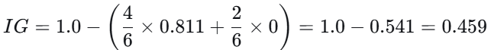  Split A ≤ 7:  Same as A≤6: IG = 0.459 | The same way for B  Split B ≤ 3  - Left (B ≤ 3): Instances 1,4,5 → 2+, 1-  Entropy = 0.918  - Right (B > 3): Instances 2,3,6 → 1+, 2-  Entropy = 0.918  - IG=0.082  Split B ≤ 3.5:  Same as B≤3: IG = 0.082  Split B ≤ 4  IG=0.191  Split B ≤ 4.5  IG=0.191
Step 3: Choose root split  Best IG = 0.459 for splits: A ≤ 6 and A ≤ 7  Choose A ≤ 6 as root.  Step 4: Build left branch (A ≤ 6)  Instances: 1,2,3,4 → 3+, 1-  Current entropy = 0.811  Calculate IG for remaining splits on this subset: |  | Split B ≤ 3:  - Left (B ≤ 3): Instances 1,4 → 2+ (pure, entropy = 0)  - Right (B > 3): Instances 2,3 → 1+, 1- (entropy = 1)  IG=0.811−(2/4×0+2/4×1)=0.811−0.5=0.311  Split B ≤ 3.5:  IG=0.311  Split B ≤ 4:  - Left (B ≤ 4): Instances 1,2,4 → 3+ (pure, entropy = 0)  - Right (B > 4): Instance 3 → - (pure, entropy = 0)  IG=0.811−(3/4×0+1/4×0)=0.811IG=0.811  Perfect split! Choose B ≤ 4.  Step 5: Build right branch (A > 6)  Instances: 5,6 → 0+, 2- (pure)  No further splitting needed. | 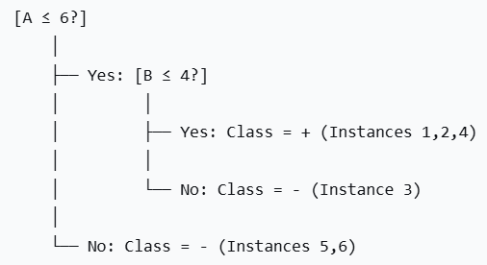  Information Gain Summary:  - Root: A ≤ 6 (IG = 0.459)  - Left branch: B ≤ 4 (IG = 0.811)  This tree perfectly classifies all 6 instances with maximum information gain at each step.
Problem 2 - Neural Networks: 30 points  a) State whether the following statements are true or false and explain why. (12 points)  i) A Perceptron can learn to correctly classify the following data, where each consists of three binary input values and a binary classification value: (111,1), (110,1), (011,1), (010,0), (000,0).  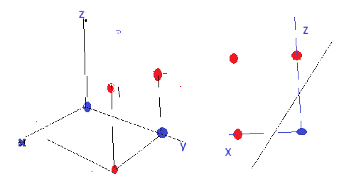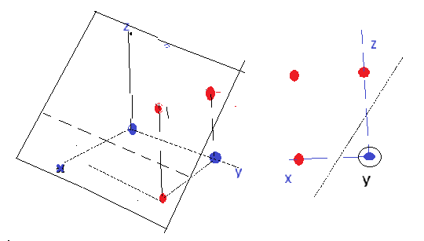 |  |  | Step 1: Check linear separability  - A Perceptron can only learn linearly separable problems.  - Let’s try to see if a hyperplane exists that separates class 1 from class 0.  Class 1: {111, 110, 011}  Class 0: {010, 000}  There exists a linear combination of x₁, x₂, x₃ that separates the classes (for example: w₁=1, w₂=1, w₃=1, θ=1).  Kinezot  w=(1,0.5,1),b=−1
ii) The Perceptron Learning Rule is a sound and complete method for a Perceptron to learn to correctly classify any two-class problem. |  |  | - Sound → If the data is linearly separable, the Perceptron Learning Rule will converge to a solution. ✅  - Complete → “Can correctly classify any two-class problem”: ❌ False.  Reason: The Perceptron cannot solve non-linearly separable problems (like XOR). For non-linear problems, the rule will never converge.  ✅ Conclusion: False.
iii) Training neural networks has the potential problem of overfitting the training data. |  |  | - Overfitting happens when the network memorizes the training data instead of learning a general pattern.  - This is especially true for large networks with many weights and small training datasets.  ✅ Conclusion: True.
b) Answer the following: (12 points)  i) What is the search space and what is the search method used by the backpropagation algorithm for training neural networks?  Search space: kinez  The search space is the space of all possible weight vectors (and biases) of the neural network.  If the network has W weights and B biases, the search space is R^{(W+B)} (each weight/bias is a real number).  Search method: kinez  Backpropagation uses gradient descent (or a variant like stochastic gradient descent, mini-batch GD, Adam, etc.). It is not just "backpropagation" — backpropagation is the algorithm to compute gradients efficiently, and gradient descent is the search method that uses those gradients to update weights. |  |  | GPT  The search space in backpropagation refers to the set of all possible values for the parameters (weights and biases) of the neural network. These parameters define the network's behavior and performance. The size of the search space depends on the architecture of the network, such as:  - The number of layers in the network.  - The number of neurons in each layer.  - The number of weights and biases (each connection between neurons has a corresponding weight, and each neuron, except for input neurons, has a bias term).  For example, if a network has:  - 1 input layer with 3 features,  - 2 hidden layers with 5 neurons each,  - 1 output layer with 2 neurons,  3x5+5+5x5+5+5x2+2 =62.

Search Method (Gradient Descent):
The search method used by backpropagation is gradient descent or its variants. Gradient descent is an optimization algorithm used to minimize the loss function (error function) by iteratively adjusting the parameters (weights and biases) of the network.

Steps involved in the search process:
Forward pass: Input data is passed through the network to generate predictions.
Loss calculation: The loss function (e.g., Mean Squared Error for regression or Cross-Entropy for classification) is calculated by comparing the predictions with the true labels.
Backward pass (Backpropagation): The gradient of the loss function is computed with respect to each parameter using the chain rule of calculus. This gives us the direction and magnitude of change required for each parameter to reduce the error.
Parameter update: The parameters are updated by moving in the direction that reduces the error. This is done by subtracting a fraction of the gradient (learning rate) from the current parameter value.
Mathematically, for each weight wi​, the update rule is:
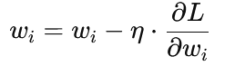 η is the learning rate (step size), ∂L/∂wi​ is the gradient of the loss L with respect to weight wi​.
ii) What quantity does backpropagation minimize?  Backpropagation itself is a gradient computation algorithm, not the minimization algorithm.  But in the context of training neural networks, the method (backpropagation + gradient descent) minimizes the loss function (also called cost function) on the training data. |  |  | Common loss functions:  - For regression: Mean Squared Error (MSE)  - For classification: Cross-Entropy Loss  So: It minimizes the loss function L(θ), where θ represents all network parameters.
iii) Does the back-propagation algorithm, when run until a minimum is achieved, always find the same solution no matter what the initial set of weights are? Briefly explain why or why not.  Answer: No.  - Non-convex loss surface: For neural networks with hidden layers and non-linear activation functions, the loss function is highly non-convex, with multiple local minima and saddle points.  - Different initial weights → different paths through the loss landscape → likely end up in different local minima. |  |  | - Even if training reaches a global minimum, there might be multiple global minima due to symmetries (e.g., permuting hidden units yields same function but different weights).  Thus, different initial weights generally lead to different final weights and possibly different generalization performance.
Demonstrate how the perceptron without bias (i.e. we set the parameter b = 0 and keep it fixed) updates its parameters given the following training sequence:  x1 = (0,0,0,1,0,0,1) y1 = 1  x2 = (1,1,0,0,0,1,0) y2 = -1  x3 = (0,0,1,1,0,0,0) y3 = 1  x4 = (1,0,0,0,1,1,0) y4 = -1  x5 = (1,0,0,0,0,1,0) y5 = -1  Assume initial weights to be 0 and learning rate to be 1.0  Check: with this final www each example is classified correctly (sign of w⋅x matches y):  - x1: w⋅x1=0 — borderline (was updated earlier), but because we updated at step1 it became correctly handled later through subsequent updates; final dot =? actually  final dot = (-10)+(-10)+00 +11 +0*0 +(-1)0 +11 = 1+1 = 2 → positive → class +. (w·x1 = 2)  - x2: w⋅x2=−2x_2:\; w\cdot x_2 = -2x2​:w⋅x2​=−2 → negative → class −.  - x3: w⋅x3=1x_3:\; w\cdot x_3 = 1x3​:w⋅x3​=1 → positive → +.  - x4: w⋅x4=−2x_4:\; w\cdot x_4 = -2x4​:w⋅x4​=−2 → negative → −.  - x5: w⋅x5=−2x_5:\; w\cdot x_5 = -2x5​:w⋅x5​=−2 → negative → −. |  |  | b=0 bias, η=1, initialize w=[0,0,0,0,0,0,0].  Step 1: Process x₁ = (0,0,0,1,0,0,1), y₁ = 1, w⋅x1​=0  Prediction = sign(0) = ? (treat as misclassification if y(w⋅x)≤0)  y1(w⋅x1)=1×0=0≤0 → Misclassification  Update: w←w+y1⋅x1=[0,0,0,0,0,0,0]+1⋅[0,0,0,1,0,0,1]  New w = [0,0,0,1,0,0,1]  Step 2: Process x₂ = (1,1,0,0,0,1,0), y₂ = -1  w⋅x2=0×1+0×1+0×0+1×0+0×0+0×1+1×0=0  y2(w⋅x2)=−1×0=0≤0 → Misclassification  Update: w←w+y2⋅x2=[0,0,0,1,0,0,1]+(−1)⋅[1,1,0,0,0,1,0]  = [0,0,0,1,0,0,1]+[−1,−1,0,0,0,−1,0]  New w = [-1,-1,0,1,0,-1,1]  Step 3: Process x₃ = (0,0,1,1,0,0,0), y₃ = 1  y3(w⋅x3)=(−1)×0+(−1)×0+0×1+1×1+0×0+(−1)×0+1×0=1 → Correct No update….  I t.n. Final w = [-1,-1,0,1,0,-1,1]
Problem 3, 20 points Briefly describe the following:  - Pruning a decision tree is a technique used to reduce the size and complexity of a decision tree by removing sections (branches) that provide little predictive power or may be based on noise/outliers in the training data  Purpose: Avoid overfitting  - Improve generalization to new data  Simplify the model for interpretability. |  |  | - Post-pruning (Cost complexity pruning): Grow the full tree first, then remove branches that do not provide a significant gain in validation performance (e.g., reduced error pruning, minimum cost-complexity pruning).
ii} Auto encoders is a type of neural network used primarily for:  - Data compression (encoding)  - Data reconstruction (decoding)  - Learning meaningful representations of data  Its goal is to reconstruct the input as accurately as possible, but by passing it through a smaller bottleneck layer that forces the model to learn the most important features.  Structure: Input → [Encoder] → Latent Space (Code) → [Decoder] → Output  1. Encoder  - Compresses the input into a smaller representation.  - Learns important features.  - Example: From a 784-dimensional MNIST image to a 32-dimensional code.  2. Latent Space (Bottleneck)  - The compressed version of the data.  - Has fewer neurons than the input.  - Forces the network to learn only key features.  3. Decoder  - Takes the compressed code and reconstructs the original input.  - Tries to make output as close as possible to input.  Objective (Loss Function)  The loss function measures the difference between input and output:  - For images: Mean Squared Error (MSE) or Binary Cross-Entropy.  - Goal: Minimize reconstruction error. |  |  | Why Autoencoders Are Useful  Application Purpose  Dimensionality Reduction Like PCA but non-linear and learned automatically  Noise Removal (Denoising AE) Removes noise by learning clean representations  Anomaly Detection High reconstruction error → anomaly  Data Generation (Variational AE) Generate new data similar to training samples  Feature Extraction Latent space can be used as compact features for ML tasks
- Bagging is an ensemble learning technique used to improve the accuracy and stability of machine learning models — especially decision trees. Instead of using one model, bagging trains multiple models on different versions of the same dataset, and then combines their results. |  |  | Benefit Description  ✅ Reduces overfitting Individual models (like decision trees) often overfit, but averaging many reduces this.  ✅ Reduces variance Small changes in data lead to big changes in a single model. Bagging smooths this out.  ✅ Improves accuracy Multiple weak learners → one strong learner.
- Regularization refers to techniques used in machine learning to prevent overfitting and improve the model's ability to generalize to unseen data. It works by adding constraints or penalties to the model during training.  Lasso Regression 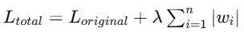  Ridge Regression 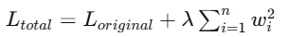  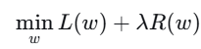 |  |  | Why Regularization is Needed  - Overfitting: When a model learns noise and details from training data too well, performing poorly on new data  - High Variance: Model becomes too complex and sensitive to training data fluctuations  Poor Generalization: Excellent training performance but weak test performance
- Markov Blanket of a node (variable) in a probabilistic graphical model (Bayesian network or Markov random field) is the minimal set of nodes that contains all the information needed to infer the state of that node, making it conditionally independent of all other nodes in the network. |  |  | For a random variable X in a graphical model, its Markov blanket MB(X) is the set of nodes that satisfies: X ⊥ Non-MB(X)∣MB(X)That is, given its Markov blanket, X is conditionally independent of all other variables not in the blanket.
- Occam's razor is a principle that says:
When there are multiple explanations for something, the simplest one is usually the best.
It does not mean the simplest idea is always correct — but it means we should prefer explanations that make fewer assumptions and are less complicated.

CD760 2016
- Information gain and feature selection (15 points):  a.Show how you would use information gain to select two features from the given training set that has two Boolean features and one three-valued nominal feature.  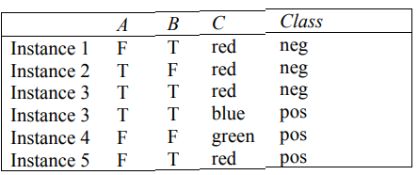  Class counts: 3 neg, 3 pos → base entropy  H(S)=−3/6log₂3/6−3/6log₂3/6=1 bit.  Information gain of each attribute at the root  Attribute A (values T, F)  - A = T: examples 2,3,4 → 2 neg,1 pos → entropy  H= −(2/3)log₂(2/3)−(1/3)log₂(1/3)≈0.9183  - A = F: examples 1,5,6 → 1 neg,2 pos → same entropy 0.9183  Weighted entropy = (3/6)⋅0.9183+(3/6)⋅0.9183=0.9183  (3/6)\cdot0.9183 + (3/6)\cdot0.9183 =  IG(S,A)=1.0−0.9183≈0.0817 → (≈0.08 bits)  Attribute B (values T, F)  - B = T: examples 1,3,4,6 → 2 neg,2 pos → entropy = 1.0  - B = F: examples 2,5 → 1 neg,1 pos → entropy = 1.0  Weighted entropy = 1.0 → IG(S,B)=1.0−1.0=0 | Attribute C (values red, blue, green)  - C = red: examples 1,2,3,6 → 3 neg,1 pos → entropy H(3/4)≈0.8113  - C = blue: example 4 → pure pos → entropy 0  - C = green: example 5 → pure pos → entropy 0  Weighted entropy (4/6)⋅0.8113+(1/6)⋅0+(1/6)⋅0=(4/6)⋅0.8113≈0.5419  - IG(S,C)=1.0−0.5419≈0.4581  Result at root: attribute C has highest IG, so pick C first.  Choosing the second attribute (after splitting on C)  After splitting on C, only the C = red child is impure (4 examples: 3 neg, 1 pos). For the red subset compute IG for the remaining attributes {A,B} restricted to that subset.  Subset SredS_{red}Sred​: examples 1,2,3,6 (3 neg,1 pos). Entropy H(Sred)=H(3/4)≈0.8113H(S_{red})=H(3/4)\approx0.8113H(Sred​)=H(3/4)≈0.8113  A on S_{red} ​  - A = T: examples 2,3 → both neg → entropy 0  - A = F: examples 1,6 → 1 neg,1 pos → entropy 1.0  Weighted entropy = (2/4)⋅0+(2/4)⋅1=0.5  IG(Sred,A)=0.8113−0.5=0.3113I  B on SredS_{red}Sred​  - B = T: examples 1,3,6 → 2 neg,1 pos → entropy H(2/3)≈0.9183  - B = F: example 2 → pure neg → entropy 0  Weighted entropy = (3/4)⋅0.9183+(1/4)⋅0=0.6887  IG(Sred,B)=0.8113−0.6887=0.1226  Result for the red child: attribute A gives the larger gain (≈0.31 vs ≈0.12), so pick A second.  Using information gain you would select C first (highest gain ≈ 0.46 bits), and then A as the second feature (it gives the larger gain on the only impure child C=red. B gives no useful split at the root and less gain on the red subset.
(b) Briefly describe two limitations of using information gain for feature selection. | 2. Sensitivity to noise and overfitting  - Information gain can overestimate the usefulness of features when the dataset is small or noisy.  - Minor fluctuations in class distribution can lead to misleadingly high IG values, resulting in overfitting — the selected feature may perform poorly on unseen data.
(c) For one of the limitations you listed above, briefly describe an alternative feature selection approach that would not be as susceptible to this limitation. | Limitation 1: Bias toward features with many distinct values. Information Gain favors attributes with many unique values  Gain Ratio (used in C4.5 decision trees)  - The Gain Ratio adjusts Information Gain by dividing it by the intrinsic information of a split (a measure of how broadly the attribute splits the data).  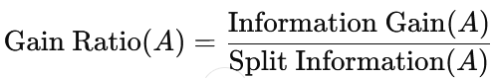  This normalization penalizes attributes with many distinct values, so it’s less biased.
- Neural Networks (15 points):  Suppose you are given the neural network that maps an input value 𝑥 to two output values 𝑦# and 𝑦$. The output units use linear activation functions, and the hidden unit uses an exponential activation function. You can assume that these units do not use biases. Show the specific update rule that would be used for each weight in the network when doing online training with the following error function 1/2 (y1-o1)² +1/2 (y2-o2)² where 𝑦1and 𝑦2 are the target values, and 𝑜1and 𝑜2 are the activations of the two output units  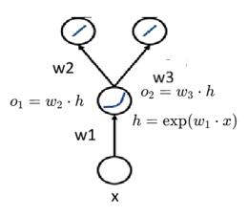 | Input x, hidden unit exponential activation (no bias)  Output y1,y2, (no bias), error E=1/2(𝑦1 – 𝑜1)² +1/2(y2-o2)²  weights  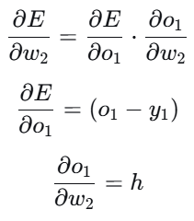  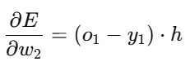 | 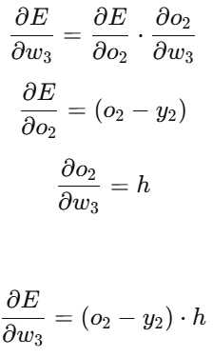
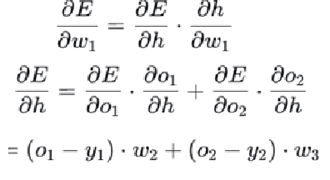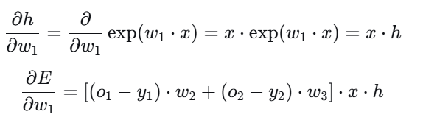 | - Final update rules Using gradient descent with learning rate η:  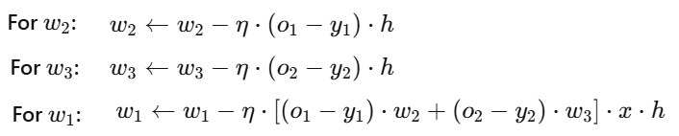
6.Randomization in Supervised Learning (15 points): Several supervised learning approaches employ randomization, including bagging, random forests, and dropout. Briefly describe each of these three approaches in terms of the following aspects. (a) What type of model is used in the approach?  (a) What type of model is used in the approach?  (b) What is randomly selected by the approach?  (c) When during the learning process are the random selections made?  (d) What, if anything, is randomly selected at classification time? | - ? nema vo predavanja
7. Short Answer (10 points): Briefly define each of the following terms.
Autoencoder se problem 3. CS760-final2017
lesion study ? | means systematically removing, disabling, or altering parts of a trained model (such as neurons, layers, attention heads, or modules) to observe how this affects the model’s performance or behavior.  In other words, it’s a way to ask:  “What does this part of the model actually do?
agnostic PAC learning | - ? ne e vo predavanata
lasso regression  Advantages  - Automatic feature selection: Eliminates irrelevant features  - Interpretability: Produces simpler, more interpretable models  - Handles multicollinearity: Can select one feature from correlated groups  - Prevents overfitting: Regularization reduces model complexity  Disadvantages  - Feature selection instability: Small data changes can lead to different selected features  - Poor with strongly correlated features: May arbitrarily select one feature from a correlated group  - Computationally intensive: For very large λ values or high dimensions | Lasso Regression (short for Least Absolute Shrinkage and Selection Operator) is a type of linear regression that adds a penalty for large coefficients, encouraging simpler models that may even set some coefficients exactly to zero.  This makes Lasso both a regularization and feature selection method.  For data with predictors X=(x1,x2,…,xn) and response y, Lasso minimizes:  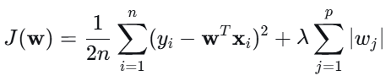
hinge loss  For a training example (xi,yi), where:  - yi∈{−1,+1} is the true class label  - The model predicts a score f(xi)=w⋅xi+b  The total hinge loss is defined as:  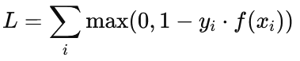 | - Hinge loss is a loss function used for training classifiers, especially binary linear classifiers It helps the model not just classify correctly, but also classify with a margin — meaning it pushes the decision boundary to separate classes confidently.  - If yi⋅f(xi)≥1y_i \cdot f(x_i) \ge 1yi​⋅f(xi​)≥1:  → The point is correctly classified and outside the margin → loss = 0  - If 0<yi⋅f(xi)<10 < y_i \cdot f(x_i) < 10<yi​⋅f(xi​)<1:  → The point is correctly classified but inside the margin → small positive loss  - If yi⋅f(xi)≤0y_i \cdot f(x_i) \le 0yi​⋅f(xi​)≤0:  → The point is misclassified → large loss  So, hinge loss penalizes:  - Wrong predictions heavily  - Correct predictions that are too close to the boundary mildly

