S17-exam
2a 12 poins  2ai A Perceptron can learn to correctly classify the following data, where each consists of three binary input values and a binary classification value: (111,1),  (110,1),  (011,1),  (010,0),  (000,0). |  | a AND b or C true  1  1  1  0  0  Decision plane x1+x2+x3=2
Find the boundary region (label y=0 define as y=-1)  f(w)=(0,0,0) bias: b=0, learning rate η  step 1: x =(1,1,1) y=+1 test wx1=(0,0,0)(1,1,1)+0=0 misclasifie 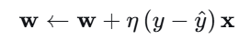 w=(0,0,0)+1(1-0)(1,1,1)=(1,1,1)  b=b+1  w←w+ηyi​xi​, b←b+ηyi​. |  | Step:  w _{t+1}=w_{t} + η (y^{i}-y^{^i} )x^{i} update to our prediction η learning rate y∈{0,1)  w _{t+1}=w_{t} + ηy^{i}x^{i} when y∈{-1,1)  Updation w _{t+1}=w_{t} if prediction is wrong  w_{t} x^{i}+η y^{i} ||x^{i} ||² when y∈{0,1) y^{i}x^{i} on mistakes  bias b is treat as w0 coefficient and x0 =1
Initial Setup  - Initial weights: Let's start with all weights = 0  w = (0, 0, 0), b = 0  - Learning rate: η = 0.5  - Activation: ŷ = 1 if w·x + b ≥ 0, else 0  - Update rule: Δw = η(y - ŷ)x, Δb = η(y - ŷ) | Epch1  x = (1,1,1), y = 1  z = 0×1 + 0×1 + 0×1 + 0 = 0  ŷ = 1 (since 0 ≥ 0) ✓ CORRECT  No update  w = (0,0,0), b = 0 | x = (1,1,0), y = 1  z = 0×1 + 0×1 + 0×0 + 0 = 0  ŷ = 1 ✓ CORRECT  No update  w = (0,0,0), b = 0 | x = (0,1,1), y = 1  z = 0×0 + 0×1 + 0×1 + 0 = 0  ŷ = 1 ✓ CORRECT  No update  w = (0,0,0), b = 0
x = (0,1,0), y = 0  z = 0×0 + 0×1 + 0×0 + 0 = 0  ŷ = 1 (since 0≥ 0)✗ WRONG (predicted 1, true label 0)  Update: error = (0 - 1) = -1  Δw = 0.5 × (-1) × (0,1,0) = (0,-0.5,0)  Δb = 0.5 × (-1) = -0.5  New w = (0,0,0) + (0,-0.5,0) = (0,-0.5,0)  New b = 0 + (-0.5) = -0.5 | x = (0,0,0), y = 0  z = 0×0 + (-0.5)×0 + 0×0 +  (-0.5) = -0.5  ŷ = 0 ✓ CORRECT  No update  w = (0,-0.5,0), b = -0.5 | Epoch2  x = (1,1,1), y = 1  z = 0×1 + (-0.5)×1 + 0×1 + (-0.5) = -1.0  ŷ = 0 ✗ WRONG (predicted 0, true label 1)  Update: error = (1 - 0) = 1  Δw = 0.5 × 1 × (1,1,1) = (0.5,0.5,0.5)  Δb = 0.5 × 1 = 0.5  New w = (0,-0.5,0) + (0.5,0.5,0.5) = (0.5,0,0.5)  New b = -0.5 + 0.5 = 0 | x = (1,1,0), y = 1  z = 0.5×1 + 0×1 + 0.5×0 + 0 = 0.5  ŷ = 1 ✓ CORRECT  No update  w = (0.5,0,0.5), b = 0  ….. 5 epohs  Final weights: w = (1.0, -0.5, 1.0), b = -0.5  2x₁ - x₂ + 2x₃ = 1
Try manually  w₁ = 1, w₂ = 1, w₃ = 1, b = -1.5 |  | - (1,1,1): 1+1+1-1.5 = 1.5 > 0 → Class 1 ✓  - (1,1,0): 1+1+0-1.5 = 0.5 > 0 → Class 1 ✓  - (0,1,1): 0+1+1-1.5 = 0.5 > 0 → Class 1 ✓  - (0,1,0): 0+1+0-1.5 = -0.5 ≤ 0 → Class 0 ✓  - (0,0,0): 0+0+0-1.5 = -1.5 ≤ 0 → Class 0 ✓
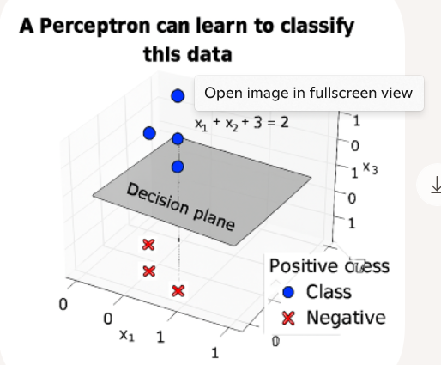
2aii The Perceptron Learning Rule is a sound and complete method for a Perceptron to learn to correctly classify any two-class problem. ≡  The perceptron Learning rule will find a linear separator if one exist ≡  The perceptron rule produces global minimum for squared error  learning rule  - Perceptron Convergence Theorem  This theorem states: If the training data is linearly separable, the Perceptron Learning Rule will find a separating hyperplane in a finite number of steps.  If the data is not linearly separable, the algorithm will not converge — it will keep updating weights indefinitely. |  | Soundness: If the Perceptron converges on a solution, that solution will correctly classify all training examples. In other words, it won’t misclassify any examples it was trained on.  Completeness: If the data is linearly separable, the Perceptron Learning Rule is guaranteed to find a separating hyperplane in a finite number of steps. That’s the completeness part—it will eventually succeed if success is possible.  The Perceptron Learning Rule is not guaranteed to converge if the data is not linearly separable. In such cases, it can oscillate indefinitely without finding a solution
“Sound and complete” meaning
- Sound: If it returns a solution, that solution is correct.
✅ True for Perceptron — once it stops, all training data are correctly classified.
- Complete: It always returns a solution in finite time when a solution exists.
✅ True for Perceptron only if data is linearly separable.
But the statement says: “correctly classify any two-class problem.”
That’s false — there exist two-class problems that are not linearly separable (e.g., XOR), for which the Perceptron cannot find a correct classification, no matter how long it runs.
2a iii) Training neural networks has the potential problem of overfitting the training data. |  | Overfitting occurs when a neural network learns the noise and specific patterns in the training data too well, rather than capturing the underlying general structure.  Why Neural Networks Are Prone to Overfitting  - High capacity: Neural networks, especially deep ones, have millions of parameters and can model extremely complex functions.  - Small or noisy datasets: If the training data is limited or contains outliers, the network may latch onto irrelevant patterns.  - Too many epochs: Training for too long without regularization can lead to memorization.
2b. (12 points)  2bi. What is the search space and what is the search method used by the backpropagation algorithm for training neural networks?  Variants of the Search Method:  Method How It Works Characteristics  Batch Gradient Uses entire dataset Stable but slow, can end in  Descent to compute gradient local min faster  Stochastic GD Uses one random per Noisy but can escape local  (SGD) update minima, faster  Mini-batch GD Uses small random Balance of stability  subsets (batches) and speed |  | The search space is the set of all possible configurations of the network’s parameters—specifically, the weights and biases across all layers  The search method is gradient based optimization a form of Gradient Descent.  1. Gradient Calculation (Backpropagation Proper):  - Forward Pass: Compute predictions and loss  - Backward Pass: Calculate the gradient ∇J(W) - the direction of steepest ascent  - This uses the chain rule to efficiently compute how each parameter affects the final loss  - Parameter Update (Gradient Descent): Wnew = Wold - η * ∇J(W)  - η is the learning rate (step size)  - ∇J(W) is the gradient (direction of steepest ascent)  - We move against the gradient to descend the loss landscape
ii) What quantity does backpropagation minimize? |  | The quantity that is minimized during the training process is the Loss Function (also called the Cost Function or Objective Function).
iii) Does the back-propagation algorithm, when run until a minimum is achieved, always find the same solution no matter what the initial set of weights are? Briefly explain why or why not. |  | back-propagation does not always find the same solution when run until convergence, and the initial set of weights significantly impacts which solution is found.
Step: perceptron border hyperplane if prediction is wrong
w _{t+1}=w_{t} + η (y^{i}-y^{^i} )x^{i} update to our prediction η learning rate y∈{0,1)
w _{t+1}=w_{t} + ηy^{i}x^{i} when y∈{-1,1)
Updation w _{t+1}=w_{t} if prediction is correct do nothing
w_{t} x^{i}+η y^{i} ||x^{i} ||² when y∈{-1,1) y^{i}x^{i} on mistakes
bias b is treat as w0 coefficient and x0 =1
c. Demonstrate how the perceptron without bias (i.e. we set the parameter  b = 0 and keep it fixed) updates its parameters given the following training sequence: x1 = (0,0,0,1,0,0,1) y1 = 1  x2 = (1,1,0,0,0,1,0) y2 = -1  x3 = (0,0,1,1,0,0,0) y3 = 1  x4 = (1,0,0,0,1,1,0) y4 = -1  x5 = (1,0,0,0,0,1,0) y5 = -1 |  | - Weights initialization: Let's start with all weights = 0  w = (0, 0, 0, 0, 0, 0, 0)  - Learning rate: η = 1 (for simplicity)  - Activation: ŷ = sign(w·x) where sign(z) = 1 if z ≥ 0, -1 if z < 0  - Update rule: Δw = η * y * x (only when misclassified)
x₁ = (0,0,0,1,0,0,1), y₁ = 1  w·x₁ = 0×0 + 0×0 + 0×0 + 0×1 + 0×0 + 0×0 + 0×1 = 0  ŷ₁ = sign(0) = 1 ✓ CORRECT  no update |  | x₂ = (1,1,0,0,0,1,0), y₂ = -1  w·x₂ = 0×1 + 0×1 + 0×0 + 0×0 + 0×0 + 0×1 + 0×0 = 0 wx₂ >=0 pred. y^=1  ŷ₂ = sign(0) = 1 ✗ WRONG (predicted 1, true label -1)  Δw = 1 × (-1) × (1,1,0,0,0,1,0) = (-1,-1,0,0,0,-1,0)  New w = (0,0,0,0,0,0,0) + (-1,-1,0,0,0,-1,0) = (-1,-1,0,0,0,-1,0)  Weights after update: w = (-1, -1, 0, 0, 0, -1, 0)
x₃ = (0,0,1,1,0,0,0), y₃ = 1  w·x₃ = (-1)×0 + (-1)×0 + 0×1 + 0×1 + 0×0 + (-1)×0 + 0×0 = 0  ŷ₃ = sign(0) = 1 ✓ CORRECT  no update  w = (-1, -1, 0, 0, 0, -1, 0) |  | x₄ = (1,0,0,0,1,1,0), y₄ = -1  w·x₄ = (-1)×1+(-1)×0+0×0+0×0 +0×1+(-1)×1+0×0 = -1+0+0+0+0-1 + 0 = -2  ŷ₄ = sign(-2) = -1 ✓ CORRECT  no update  - w = (-1, -1, 0, 0, 0, -1, 0)
x₅ = (1,0,0,0,0,1,0), y₅ = -1  w·x₅ = (-1)×1+ (-1)×0+ 0×0+ 0×0+ 0×0 + (-1)×1 + 0×0 = -1+ 0+ 0+ 0+ 0 -1 + 0 = -2  ŷ₅ = sign(-2) = -1 ✓ CORRECT  no update  w = (-1, -1, 0, 0, 0, -1, 0) final result |  | verification  - x₁: (0,0,0,1,0,0,1)→w·x₁=0×0+0×0+0×0+0×1+0×0+(-1)×0+0×1=0→ŷ= 1 ✓  - x₂: (1,1,0,0,0,1,0)→w·x₂ =(-1)×1+(-1)×1+0×0+0×0+0×0+(-1)×1+0×0=-3 → ŷ = -1 ✓  - x₃: (0,0,1,1,0,0,0) → w·x₃ = 0 + 0 + 0 + 0 + 0 + 0 + 0 = 0 → ŷ = 1 ✓  - x₄: (1,0,0,0,1,1,0) → w·x₄ = -1 + 0 + 0 + 0 + 0 -1 + 0 = -2 → ŷ = -1 ✓  - x₅: (1,0,0,0,0,1,0) → w·x₅ = -1 + 0 + 0 + 0 + 0 -1 + 0 = -2 → ŷ = -1 ✓

CD760 2016
CD760 2016  CD760 2016  Suppose you are given the neural network that maps an input value 𝑥 to two output values 𝑦# and 𝑦$. The output units use linear activation functions, and the hidden unit uses an exponential activation function. You can assume that these units do not use biases. Show the specific update rule that would be used for each weight in the network when doing online training with the following error function 1/2 (y1-o1)² +1/2 (y2-o2)² where 𝑦1and 𝑦2 are the target values, and 𝑜1and 𝑜2 are the activations of the two output units. | 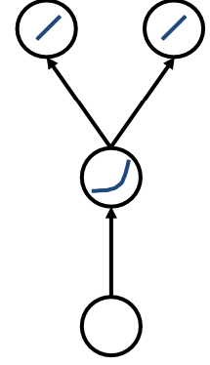 | Input x, hidden unit exponential activation (no bias)  Output y1,y2, (no bias), error E=1/2(𝑦1 – 𝑜1)² +1/2(y2-o2)²  weights
 |  | 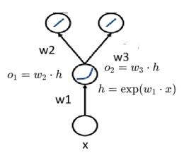 | 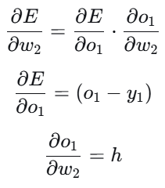  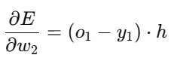 | 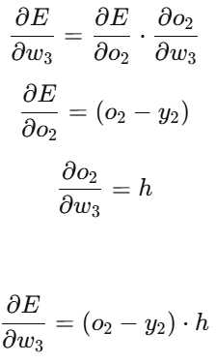
For w1 first term  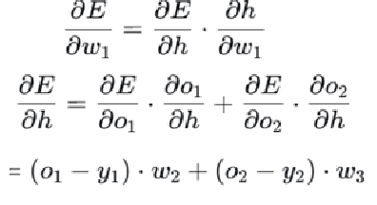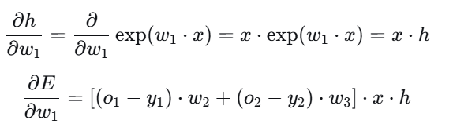 | - Final update rules Using gradient descent with learning rate η:  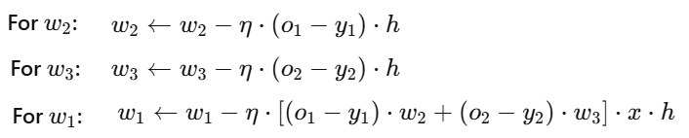
7. Hinge Loss  The hinge loss is used for maximum-margin classification (e.g., in Support Vector Machines).  It doesn’t just want correct classification — it wants predictions to be confident and far from the decision boundary. | For one training example (xi,yi), with yi∈{−1,+1} model predict f(xi​)=w⋅xi​+b  Hinge loss L_{i}(w)=max(0, 1−y_{i}(w⊤x_{i}+b)) Total loss L(w)= ∑_{i}max(0, 1−y_{i}(w⊤x_{i}+b))  Case meaning loss correct&confident  y_{i}(w⊤x_{i}+b) >=1 outside margin 0 correctly class  0 < y_{i}(w⊤x_{i}+b) <1 correct but inside positive penalized correct but to close  margin margins  y_{i}(w⊤x_{i}+b) <=0 misclassified large penalty (>=1) wrong side large
Hinge loss pushes each point not just to be correct,  but to be at least one unit away from the decision boundary —  enforcing a “safe margin” for confident classification.  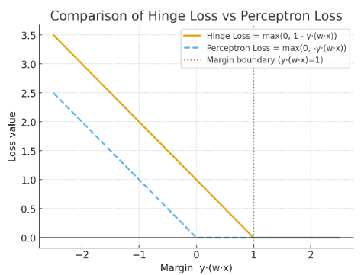 | - For y(w⋅x)<0: both penalize misclassified points.  - For 0<y(w⋅x)<1: hinge loss still penalizes, encouraging a margin ≥ 1, while perceptron loss gives no penalty.  - For y(w⋅x)≥1: hinge loss becomes 0 — the point is correct and safely away from the decision boundary.  So hinge loss = perceptron loss + margin enforcement.

