CS760 2014
5. Given the neural network below, calculate and show the weight changes that would be made by one step of the online version of backpropagation for the training instance x=(1,1), t=(1,1). Assume that the hidden and output units use sigmoid functions, the network is being trained to minimize squared error, and the learning rate is 0.1 (with no momentum term). Edges from constant 1 on the side indicate bias parameters. | 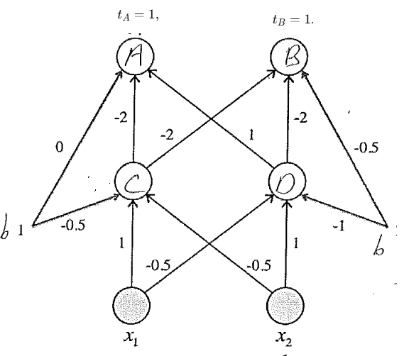 | Forward pass with sigmoid σ(z)=1/(1+e−z)  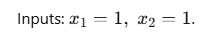  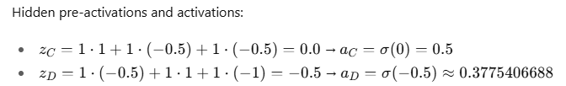  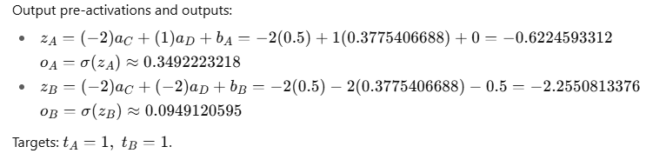
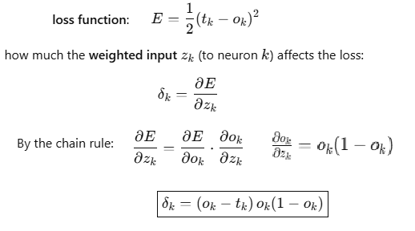  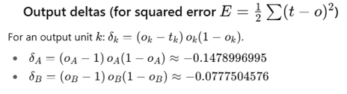 | 