We want to reduce the number of features in a dataset by transforming it into a smaller number of new features (principal components). | Unit eigenvector of the covariance matrix of X corresponding to the largest eigenvalues.
- Step Covariance 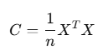  Goal: Find eigenvalues λ and unit eigenvectors v of C such that: Cv=λv | - Step Optimization view v is vector with maximal variance  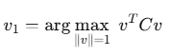  that is constraint maximization max 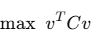where v^{T}v=1  teory is to use Lagrangie multipliers to solve  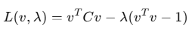  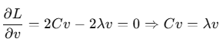  So eigenvectors are the solution of equation Cv=λv
Step 3. First eigenvector v1  1. Start with random vector v⁰  2.Repeat until convergence (when direction stops changing)  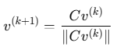  3.Result is v1​ — normalized (unit) eigenvector  Largest eigenvalue:  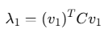 | Next eigenvector v2​ (recursive deflation):  To find the second principal component, we remove the influence of v1v_1v1​ from the matrix:  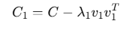  Than apply again  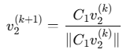  Normalize → get unit eigenvector v2​
General Recursive Formula  k-th eigenvector  - Deflate matrix: 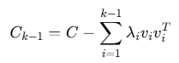  Itearate: 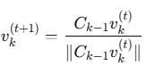  Stop when converged  Now you have orthonormal unit eigenvectors v1,v2,...,vk ​ | Step 4: Feature Reduction (PCA)  To reduce data to m < d features:  - Form matrix of first m eigenvectors:  Vm=[v1 v2 ... vm]  - Transform data:  Z=XVm​  → Z is the data in lower dimensions, preserving max variance.
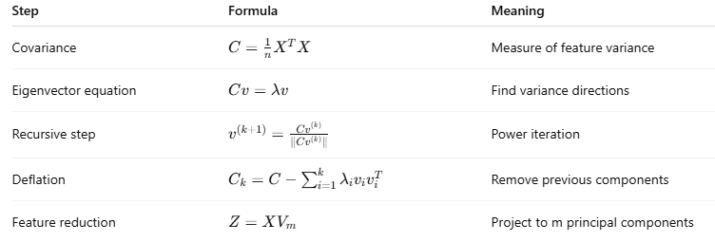
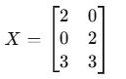 | Step 1: Center the Data (subtract mean from each column)  Column means:  - Feature 1 mean: (2+0+3)/3=5/3≈1.67(2 + 0 + 3)/3 = 5/3 ≈ 1.67(2+0+3)/3=5/3≈1.67  - Feature 2 mean: (0+2+3)/3=5/3≈1.67(0 + 2 + 3)/3 = 5/3 ≈ 1.67(0+2+3)/3=5/3≈1.67  Centered data:  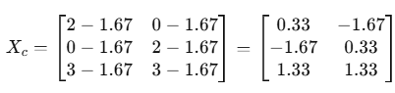
Step 2: Covariance Matrix  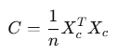  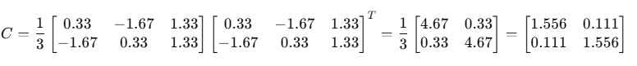 | Step 3: Solve the Eigenvalue Equation  Cv=λv  Compute eigenvalues  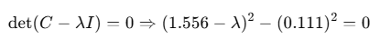  Solution  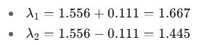  Now solve for eigenvectors:  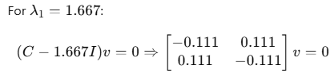  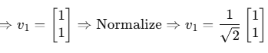  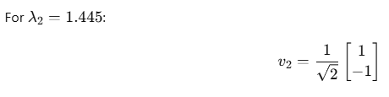
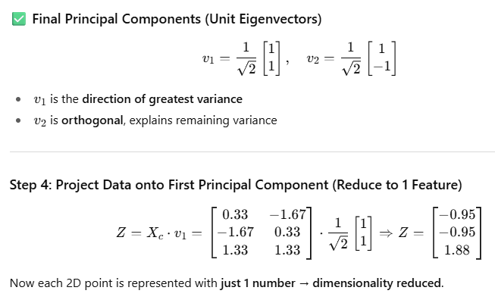 | 